*Fermat’s Principle, Snell’s Law, Optimization*

Consider the problem rotated by $π/4$ angle, so that marsh runs horizontally.

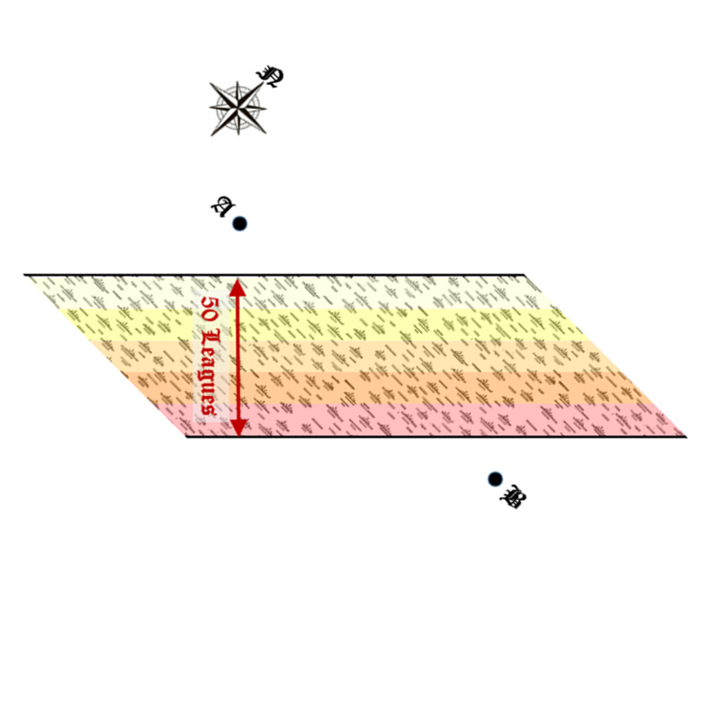

Now, consider variables defined as shown in figure below:

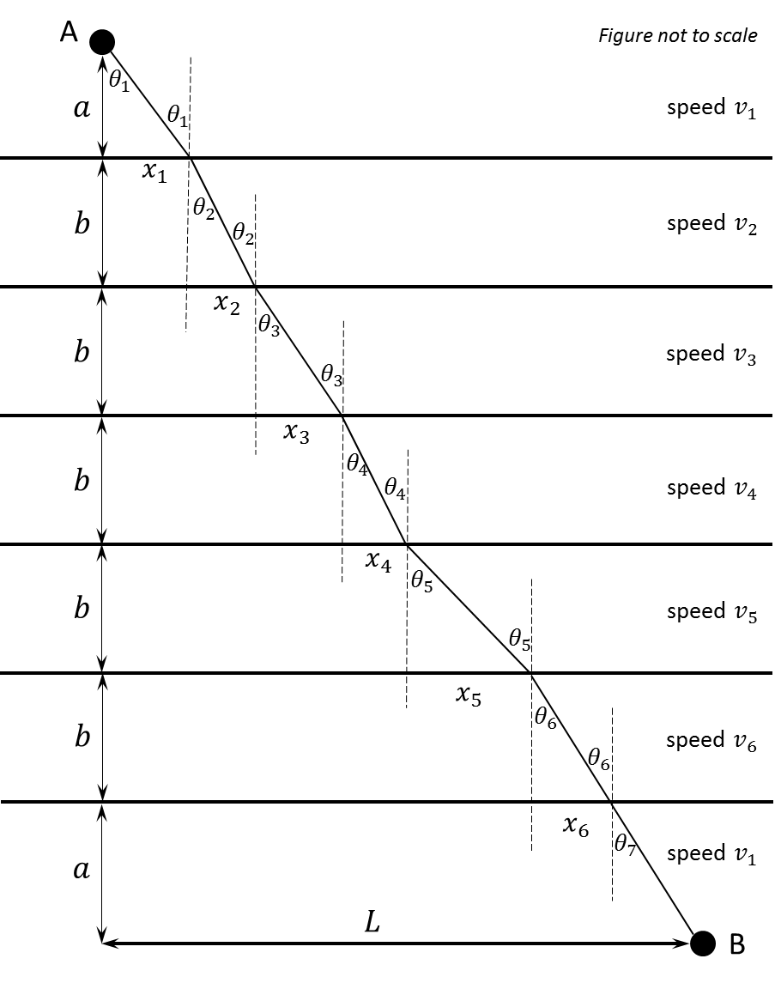

We can assume that path traveled within a region (marsh region or normal terrain) must be straight line, wherever its points lie. Because every region is homogenous, i.e., same speed in any direction, which will cause any curved path to have more distance (and thus more time) than linear path.

We are given $b=10$. Because marsh runs at $π/4$ angle to direct line $AB$ (not shown in figure), the angle this line will make with horizontal must be $π/4$, making $L=100/\sqrt{2}$. Also, $2a+5b=100/\sqrt{2}$, which implies $a=\left(\frac{100}{\sqrt{2}}-50\right)\frac{1}{2}$. We are also given $v_{1}=10, v_{2}=9, v_{3}=8, v_{4}=7, v_{5}=6, v_{6}=5$. We need to find optimal $x_{i}$ or $θ_{i}$ that minimize the time taken. The total time taken by ~~light~~ Frodo and Sam:

$$T=\frac{\sqrt{x_{1}^{2}+a^{2}}}{v_{1}}+\left(\sum_{i=2}^{6}{\frac{\sqrt{x_{i}^{2}+b^{2}}}{v_{i}}}\right)+\frac{\sqrt{{\left(L-\sum_{j=1}^{6}{x_{j}}\right)}^{2}+a^{2}}}{v_{1}}$$

To find its minima, we solve $\frac{∂T}{∂x_{j}}=0$ for $1≤j≤6$:

$$\frac{∂T}{∂x_{1}}=0 \\ ⟹\frac{x_{1}}{v_{1}\sqrt{x_{1}^{2}+a^{2}}}-\frac{L-\sum_{j=1}^{6}{x_{j}}}{v_{1}\sqrt{{\left(L-\sum_{j=1}^{6}{x_{j}}\right)}^{2}+a^{2}}}=0 \\ ⟹\frac{\sin{θ_{1}}}{v_{1}}=\frac{\sin{θ_{7}}}{v_{1}}⟹θ_{1}=θ_{7}$$

And for $2≤i≤6$:

$$\frac{∂T}{∂x_{i}}=0 \\ ⟹\frac{x_{i}}{v_{i}\sqrt{x_{i}^{2}+b^{2}}}-\frac{L-\sum_{j=1}^{6}{x_{j}}}{v_{1}\sqrt{{\left(L-\sum_{j=1}^{6}{x_{j}}\right)}^{2}+a^{2}}}=0 \\ ⟹\frac{\sin{θ_{i}}}{v_{i}}=\frac{\sin{θ_{7}}}{v_{1}}⟹\sin{θ_{i}}=\frac{v_{i}}{v_{1}}\sin{θ_{1}}$$

With $θ_{1}=θ_{7}$, we have the following:

$$L-\sum_{j=1}^{6}{x_{j}}=x_{1} \\ ⟹a\tan{θ_{1}}+b\sum_{i=2}^{6}{\tan{θ_{i}}}+a\tan{θ_{7}}=L \\ ⟹2a\tan{θ_{1}}+b\sum_{i=2}^{6}{\frac{v_{i}\sin{θ_{1}}}{\sqrt{v_{1}^{2}-v_{i}^{2}\sin^{2}{θ_{1}}}}}=L$$

This can be numerically solved to get $θ_{1}$, using which minimum time can be found as:

$$T=\frac{2a}{v_{1}\cos{θ_{1}}}+\sum_{i=2}^{6}{\frac{b v_{1}}{v_{i}\sqrt{v_{1}^{2}-v_{i}^{2}\sin^{2}{θ_{1}}}}}$$

Note that this is same expression as earlier, we have only written it in terms of $θ$ and put values of $θ_{i}$.

This derivation was inspired from <https://en.wikipedia.org/wiki/Snell's_law#Derivation_from_Fermat's_principle>. Also check [Fermat’s Principle](https://en.wikipedia.org/wiki/Fermat%27s_principle). This problem could also have been solved as an optimization problem using gradient descent or any minimization algorithm.