 and R Commander (Rcmdr) by the example

1. Introduction 2
2. Starting R and Rcmdr 4
3. Importing data (from Excel, SPSS, ...) 5
4. Viewing and Editing Data 6
5. Working with Variables (may prefer to do this in Excel before importing) 6
6. Summary and Descriptive Statistics 7
7. Basic tests 8
7.1 Is surgery beneficial? 8
7.2 Is there a difference in pre to post VAS changes by surgery type? 8
7.3 Is there a difference in VAS improvement due to BMI groups? 9
7.4 Is the 30-day complication rate the same for both surgery types? 9
7.5 Can complications be predicted as a function of demographic and operative variables? 9
8. Exiting R and Rcmdr 10
9. Getting help, learning more (in suggested order for consulting) 10
10. Installation 10
12. Giving credit: 10

1. Introduction
The goal of this document is to be an introduction to using R “by-the-example”. That is we assume the reader has already had some –probably short- exposition to R and R commander (Rcmdr from now on) and show how to use R to perform some typical biostatistical analyses.

R is a console-based program, that is, you type the instructions you want to be executed

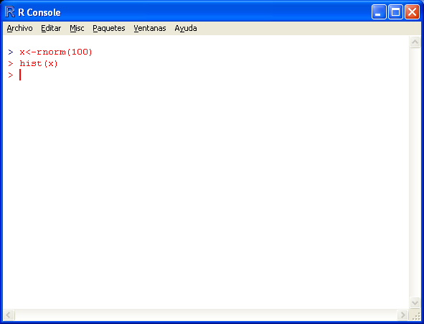

and the result –or an error message- appears in the screen.

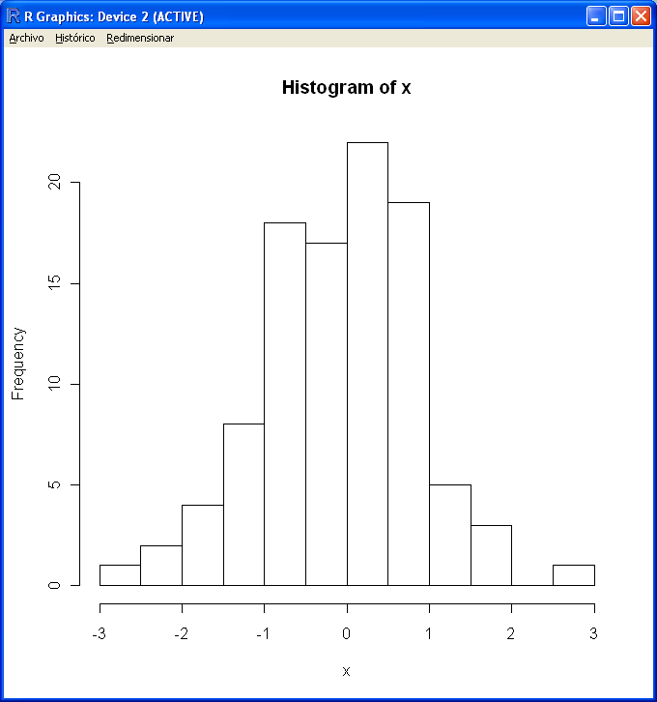

This approach is very powerful but it has a slower learning curve than other typical statistical programs such as SPSS. To help new users to get acquainted with R capabilities, John Fox has developed a basic graphical user interface that allows using many R capabilities through a menu system. The name of this GUI is “R Commander” and it has been a successful project that can be followed at:
(http://socserv.mcmaster.ca/jfox/Misc/Rcmdr/). The project has indeed been so successful that many other developers have contributed their own extensions (called “plugins”). Altogether it has changed the R commander from a within-classroom application, to be used in Statistics courses, into a powerful standalone system, that requires only having R available, allowing to use a great number of statistical techniques in an easy way. And for free, as R.

Conventions:
A sequence of words separated by arrows means the options being performed using the menus.
The “OK” button will not be mentioned, although it is usually the last thing that needs to be clicked on.
- Courier: Menu items, buttons, or text in dialog window, error or warning messages.
- Courier italic: Variables, R objects, user-supplied text; typed in or possibly double clicked
- Large Courier bold italic: First mention of a new variable.
Buttons will be shown as small boxes with the button text’s within them View data set

The following pages assume we are working in windows and the operating system is in Spanish or Catalan, and so are the system menus of the R commander. Changes from this context are possible but should be easily manageable by any reader.

2. Starting R and Rcmdr
Starting R
Inicio -> Archivo de Programas -> R -> R.2.15

R basics:
a. R is case sensitive: foo, Foo, and Foo would refer to three different objects
b. R has variable/object types: numeric, character (factors), ordinal, dates, logical.
c. R objects are persistent within an R session but not within sessions, unless the workspace is saved.
d. The source code is real. The objects are realizations of (“the result of running”) the source code: an object may be worthless unless we know how it was defined. Implication: Save the code generated by your actions in your Rcmdr Script/Log window.

Exiting R (5 ways):
q(),
q(“no”),
q(“yes”),
from File -> Exit in RGui, or
from File -> Exit -> From Commander and R in Rcmdr

Warning: Exiting R from Rcmdr will not save the R workspace (the default memory zone where all objects that have been created during the session are still available).

Starting R Commander (Rcmdr)
> library(Rcmdr) # “>” is the R prompt, “#” the R comment character

The five sections of the Rcmdr Window, top to bottom:
1. Menu bar: File, Edit, etc.
2. Tool bar: Active data set, active model; both are clickable.
3. Script/Log window: R commands. May ignore, but good way of learning R.
4. Output window: R output.
5. Message window: R warnings and errors.

Script and output windows are resizable, via Tools -> Options

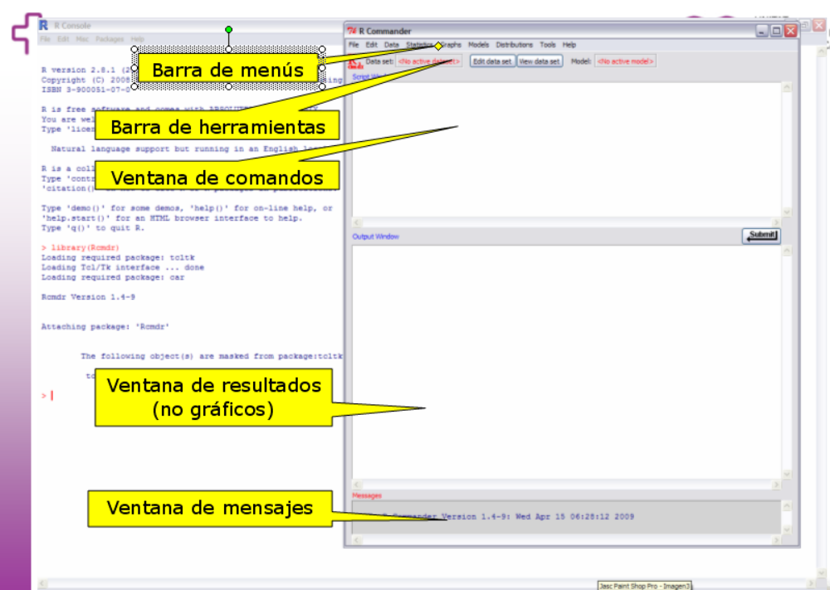

Exiting Rcmdr:
Fichero -> Salir -> De Commander y de R
(will be prompted to save script & output, but not workspace!)

3. Importing data (from Excel, SPSS, ...)
Although it is possible to enter and edit data using the R/Rcomander interface, most of the times the data will be available in other “popular” formats such as excel, access or SPSS.

The following examples assume the spreadsheet “VASopenlap.xls” is available in the working directory, that is the directory (“folder”) where actions are applied if no other directory is specified.

The working directory can be set by doing:
Fichero -> Cambiar directorio de trabajo … -> <PATH TO MY DIRECTORY>

Notice that, when this action is applied using the manus a new line of code appears in the Script window first, and in the Results Window after pressing the OK button.

> setwd("/home/alex/Documents/Classes/einesbioestbioinf/intro-r")

To import a data file we must work with the “Datos” menu. To import an Excel file we proceed as follows:
Datos -> Importar Datos -> desde conjunto de datos Excel, Access o dBase...

- We will be prompted for a dataset name, Enter vas for name of data set
- Choose Excel file “VASopenlap.xls”
- Select the shhet to import (Sheet1)
[Notice how, now, vas is active data set in Rcmdr Tool bar]

Exercise: Proceed similarly to import another excel file or a file with data from other statistical packages such as SPSS or STATA.

4. Viewing and Editing Data
Clicking on Visualizar Conjunto de Datos button in Tool bar shows data in the data set.
This dataset cannot be edited because it contains non-editable (from within Rcmdr) data types such as dates. See next point to handle data.

5. Working with Variables (may prefer to do this in Excel before importing)
Create new variable:

Datos ->
Modificar variables del conjunto de datos activo ->
Calcular nueva variable

bmi for name of new variable
double click on current variables to get weight / height^2
Similarly, compute survyrs as (fudate - surgdate)/365.25
Similarly, compute VASdelta as preVAS - postVAS

Group BMI into three equal-width groups:
Datos ->
Modificar variables del conjunto de datos activo ->
Segmentar variable numérica
Select bmi, name new variable bmigroup, select 3 bins, labeled by ranges

Convert complication (complic30d) from numeric to factor
Datos
-> Modificar variables del conjunto de datos activo ->
-> Convertir variables numéricas en factores
Under Niveles del factor, leave Asignar nombres a los niveles (default) marked;
0 = none, 1 = yes

Convert surgery type (surgtype) from factor to numeric
Datos
-> Modificar variables del conjunto de datos activo ->
-> Recodificar variables

Select surgtype, type surgopen as new variable name, uncheck factor box, and type
“open” = 1 and “lap” = 0 in the Recode directives part of the box.

6. Summary and Descriptive Statistics
Compute easy summaries (a different type of summary for different variable types).
Estadísticos -> Resúmenes -> Conjunto Activo de Datos.

Compute summary statistics at each level of a factor variable
Estadísticos -> Resúmenes -> Tabla de Estadísticas
Choose surgtype as factor, bmi as response

FACT surgopen
none:13 0:12
yes : 9 1:10

Plot from simple to complicated figures

Gráficas -> Gráfico de tallo y hojas
Select bmi and accept all default options.

Gráficas -> Diagrama de caja
Select weight, as variable, bmigroup as grouping variable (“Graficas por grupo”) and press OK

Gráficas -> Matriz de diagramas de dispersión...
Select >2 desired variables (at least three: weight, height, bmi,… )
Uncheck línea de mínimos cuadrados

7. Basic tests

7.1 Is surgery beneficial?
Graficos -> Diagrama de dispersión... -> preVAS (x) vs. postVAS (y)
Check boxes to jitter both x & y
Click on "Plot by groups..." and select surgtype

Paired Student’s t-test of Pre- vs. Post-VAS scores
Statistics -> Means -> Paired t-test, preVAS as 1st variable, postVAS as 2nd one.
P = 0.001116 (two-sided)

Non-parametric equivalent: Wilcoxon signed rank test
Statistics -> Nonparametric tests -> Paired-samples Wilcoxon test
Select preVAS as 1st variable, postVAS as 2nd one.
P-value = 0.003297 (default test)

Equivalent to paired t, one sample Student’s t-test of VAS improvement
Statistics -> Means -> Single-sample t-test, select VASdelta as the response.
P = 0.001116 (two-sided)

7.2 Is there a difference in pre to post VAS changes by surgery type?
Scatterplot of VAS improvement vs. surgery type Note: x and y should both be numeric variables.
Graphs -> Scatterplot... -> surgopen (x) vs. VASdelta (y)
Only checked box should be the one to jitter y (least-squares line will join means)

Boxplot of VAS improvement vs. surgery type Note: y is numeric, grouping must be factor.
Graphs -> Boxplot..., select VASdelta,
Click on "Plot by groups" and select surgtype

Two sample Student’s t-test of VAS improvement by surgery type
Statistics -> Means -> Independent samples t-test,
select surgtype as the grouping variable, VASdelta as the response.
P = 0.7387 (Welch test = default, allows for unequal variances)
P = 0.7396 (variances assumed equal)

Non-parametric equivalent: Wilcoxon rank sum test
Statistics -> Nonparametric tests -> Two-sample Wilcoxon test
Select surgtype as grouping variable, VASdelta as response.
P = 0.5708

7.3 Is there a difference in VAS improvement due to BMI groups?
Boxplot of VAS improvement vs. BMI group
Graphs -> Boxplot..., select VASdelta,
Click on "Plot by groups" and select bmigroup

ANOVA (one-way)
Statistics -> Means -> One-way ANOVA..., check “Pairwise comparison of means”
select bmigroup as the grouping variable, VASdelta as the response.
P = 0.8209 (variances assumed equal; produces means, SDs, counts per group.)

Non-parametric equivalent: Kruskal-Wallis test
Statistics -> Nonparametric tests -> Kruskal-Wallis test
Select bmigroup as grouping variable, VASdelta as response.
P = 0.4892

Scatterplot of VAS improvement by BMI, to prevent sacrificing information due to binning
Graphs -> Scatterplot, select bmi (x) and VASdelta (y)
Uncheck “Smooth line”
Click on “Plot by groups”, select surgtype and check “Plot lines by group”

7.4 Is the 30-day complication rate the same for both surgery types?
Test of two-proportions (Normal approximation)
Statistics -> Proportions -> Two-sample proportions test
Select surgtype as the grouping variable and complic30d as the response variable
P = 1, so no difference between observed complication rates (41.7% lap vs. 40% open)
Note warning: "Chi square approximation may be incorrect."

A better way: Fisher's exact test
Statistics -> Contingency tables -> Two-way table
Select surgtype as the row variable and complic30d as the column variable;
Select row percentages
Check “Fisher's exact test” and “Print expected frequencies”
P = 0.9362, and note two cells have expected totals < 5.

7.5 Can complications be predicted as a function of demographic and operative variables?
Logistic regression
Statistics -> Fit Models -> Generalized linear models...
Click on variables so that the resulting model is:
complic30d ~ bmi + height + sex + surgtype + weight + preVAS
Leave "binomial" and "logit" (defaults) under family and link function untouched.
No variable is significant. We confirm that surgery type does not affect complication rates (P=0.5030).

7.6. Extra questions that can be solved using Regression models

vas$calcio <- calcio <-c(11.0, 10.6, 10.5, 10.6, 10.4, 10.2, 9.5, 8.2, 7.5, 6.0, 5.0)
vas$PH <- c(0.5, 1.12, 1.23, 1.24, 1.31, 1.33, 2.10, 2.15, 2.43, 3.70, 4.27)

8. Exiting R and Rcmdr
Script: File -> Save script…
Output: File -> Save output…
Workspace: File -> Save R workspace…

9. Getting help, learning more (in suggested order for consulting)
Context-specific help in dialog boxes via Help button
R Commander Help (Help menu item)
Getting Started with Rcmdr PDF (Help -> Introduction to the R Commander)
R PDF manuals in c:/path/to/R/version/doc/manual; supply correct path as appropriate
Dalgaard, Peter (2002) Introductory Statistics with R. Springer. ISBN 0-387-95475-9

10. Installation
R installation:
1. Download from a nearby CRAN (Comprehensive R Archive Network) mirror http://cran.es.r-project.org/
2. Select OS (Linux, Mac, Windows)
3. Select base
4. Download R-2.15.0 for Windows (2.15.0 is most recent as of May, 2012)

Rcmdr installation
See http://socserv.mcmaster.ca/jfox/Misc/Rcmdr/installation-notes.html for OS-specific instructions.
- Start R
- From the prompt type: > install.packages("Rcmdr", dependencies=TRUE) #
- and choose repository/mirror,
- If prompted to install missing packages, accept.

12. Giving credit:
> citation() # R
> citation("Rcmdr") # Rcmdr

Acknowledgments:
Andrew Gay, Ebling IT
R: Ross Ihaka, Robert Gentleman, University of Auckland
R Commander: John Fox

Este documento ha sido adaptado a partir de otro (http://www.surgery.wisc.edu/admin/biostats.shtml), propuesto por Glen Leverson, Victoria Rajamanickam y Alejandro Muñoz del Río del departamento de “Surgery” de la Universidad de Wisconsin en Madison y que ya no se encuentra disponible en la red. El crédito es para ellos y los errores debo de haberlos introducido yo.
or whatever version you have installed.
The option for importing from “Excel” is not availabe in linux versions of R/Rcmdr. In this cas you must first export your spreadsheet as a tab-delimited or comma-separated file, and use this as the import source.

