**TARICA: Tangible Augmented Reality Interfaces for Cultural Artifacts**

**Abstract**

Museums are regarded as a collection place of cultural heritage. They abstract visitors to learn and experience the culture. It has been acknowledged that AR technologies are applied in museums to improve the experience of tourists. Many researchers are studying different interactive interfaces affect visitors’ learning and visiting experience. This research investigates the relationship between tangible interactive interface with augmented reality and users’ learning motivation, engagement and outcome. We conducted an experiment to explore users’ learning conditions and preferences of Leaflet, Postcard and CubeMuseum. We also take buying gifts as a method of learning. The result shows applying AR and tangible object into interactive interfaces contribute to users’ learning. They also prefer hybrid gifts as souvenirs. By illustrating users’ feelings and learning motivation and engagement, this study emphasizes the importance of AR technology and tangible objects in interactive interface design and pioneers the future design and use of hybrid gifts.

**Keywords**

Augmented Reality, Cultural Heritage, Interaction interfaces, Tangible interactions

**Introduction**

An increasing number of emerging technologies have been applied in museums, exhibitions and other places. Augment reality (AR) has received significant attention in the past two decades[1]. It supports the presentation of virtual objects in the real world[2], in which case the items that are stored in museum archives can be made accessible to users via virtual displays.AR has been proved to have a positive impact on user experience, including enhanced learning experiences, collaboration creativity and direct feedback [3]. In addition, applying AR to create expensive instrument’s virtual objects can also reduce the costs.

Tangible objects also play an important role in learning. Via the control of a physical object, users can interact with digital information. It offers opportunities to study collaboration, performance, gaming and different types of learning [4]. Cultural heritage in museums is usually fixed and visitors are generally not allowed to touch them. The well-designed interactive interface contributes to heritage learning in museums, for it requires little experience or skills [5], receives information on the premise of not touching them and attracts tourists for more extensive exploration during the exhibition [6].

However, the study on AR and tangible interactive interface for museum learning are still dim. Therefore, we design a comparative study to explore how different interaction interfaces impact user motivation and engagement in learning and the outcomes. Specifically, we developed two AR-based interfaces (Postcard and CubeMuseum) for the learning of cultural artifacts, and compared them with a baseline condition (Leaflet). We conducted a within-subjects study design with 24 participants. Users were invited to experience three interfaces and provide their evaluation using questionnaires and in interviews. The results indicated that users were more motivated to learn when using the Postcard and CubeMuseum than using the Leaflet. They also showed greater engagement with the two AR-based interaction interfaces. Specifically, the CubeMuseum with tangible interactivity yielded the greatest instinct motivation and user engagement. The time consuming of CubeMuseum and Postcard are more than Leaflet, but they all show a great improvement of correct rate after learning in a limited time.

Our study contributes to the interface design for cultural heritage learning. The evaluations have provided empirical evidence that supports the use of AR in cultural heritage, with specific emphasis on the use of tangible interactions. This will contribute to the development of tangible interactive interfaces in the museum.

**Related Work**

Cultural Heritage Learning with Augmented Reality

Augmented Reality brings lots of convenience to learning. In Pollalis’s perspective, museums and cultural institutions cannot offer learners a lot of opportunities to engage directly with authentic objects [7], as well as in the museum. Some cultural heritage is even too vulnerable to be exhibited. Researchers studying in museums gradually emerge with their interest in AR. Koutsabasis reviewed 53 publications of interactive systems in cultural heritage and found 12 mobile apps had 7 using AR[8]. With AR technologies, it is simple to manufacture digital copies of the cultural heritage to be viewed. Compared with physical objects, people can change the size of the virtual objects, rotate them, according to their will. Additionally, text, audio, video, links to supplementary materials and 3D objects can also be implemented in AR environment[9]. Researchers are able to make the information of cultural heritage into video and other forms to add into AR.

Building virtual cultural heritage is an accessible way to solve the museum lacking in space, for virtual objects are no longer confined to the limited physical spaces of museums[10][11]. Moreover, some heritage is sensitive to light and humidity and some cannot be exhibited, due to their quality. Applying AR to build virtual heritage is available for visitors viewing. One thing to be noticed is that visitors like interactive multimedia but have no time or patience to focus on the number of details the multimedia provides[12]. This phenomenon also happens in mobile apps. When creating an interactive program, the layout should be clean and easy to minimize memory load, so that users can pay attention to the effect of the interactive interface.

**Learning Motivation and Engagement**

Research on learning motivation showed that visual attractiveness, reading experience, and feedback have effects on continued use intention [13]. They also indicate that learning and reading experience, confirmation of the system-user fit, and utilization of system functions determine learner’s intrinsic motivation and extrinsic motivation [13]. Therefore, the interactive interface should be concise and readable, and the feedback brought by the interaction must be impressive enough to improve the user's motivation. Hardware and its interactive interface are the part of user experience[14]. Excellent hardware and the interactive interface can attract visitor’s learning engagement. People will engage in learning when they realize the interactive interface is interesting and meaningful. Neale’s team researches virtual museum using touch interaction styles on a tablet interface and discuss the outcome of the engagement. They reported that users found it easier to rotate and scale virtual objects with a tablet interface, which resulted in a higher engagement than the desktop interface[15]. This indicates that users are more likely to engage in interfaces with greater interactivity. The direct relationship between the user’s touch and the effects on the interface makes users concentrating on the learning process[15].

Therefore, we propose H1 and H2:

H1. Users are more motivated to learn with objects of which greater interactivity is afforded.

H2. Users are more engaged with objects of which greater interactivity is afforded.

**Learning with Tangible Objects**

Interactive tabletop with the tangible interactive interface has learning potential. Unlike multi-touch surfaces, large projections, or individual display devices, the tangible interface enables direct, hands-on interaction with physical objects [6]. Using physical objects in the interactive interface can express information and enhance the ability to problem solving. Research[16] finds tangible objects in learning have a positive impact on learning performance and level of enjoyment. In addition, manipulating a physical object can give people an intuitive feeling. As users control the tangible object, the feedback from the virtual object will give them a strong understanding of what they act[17]. Li studied multiuser interaction with AR and VR in cultural heritage. The research creates a physical AR cube to let the user control. Users reported that holding the cube with digital artifacts is comparable to holding the objects in hand[10]. When equipping tangible objects to the interactive interface, the feedback obtained by the user through manipulating the tangible object can give users intensive feelings as if they are controlling the real cultural heritage.

Therefore, we come up with the hypothesis:

H3. Users can achieve better learning outcomes when tangible interactions are afforded.

**Museum Experience and Hybrid Gifting**

Many researchers are exploring what factors can improve the museum experience of visitors. Benford explains the concept of trajectories and demonstrates the relevance of trajectories and user experiences[19]. The trajectories can be defined as participants’ journeys. The journey has elements like places, times, roles and interfaces. Through analyzing trajectories, researchers will have a better understanding of each visitor’s preference and sense of experience.

Elegant souvenirs or gifts will increase tourists' favor of the museum to a certain extent. People regard gifts as the carrier of one experience. Gifting is also a way of sharing and building the relationship. When talking about the museum, gifting can spread culture and raise popularity. The idea of combing digital and physical materials into gifts increases the possibilities and flexibility of sending gifts and enriches the experience of digital gifts as well [20]. One type of hybrid gift can be implemented by overlaying digital layers on physical artifacts or settings[20]. This can give the consumer a digital experience based on physical objects. The design of hybrid gifts varies a lot. It is interesting to investigate what kind of gifts users prefer to buy as souvenirs.

**Implemented Design**

We implemented three different conditions in our comparative user study: Leaflet (baseline), Postcard, and CubeMuseum.

***Leaflet***

Like traditional paper media, the leaflet is distinguished by its exquisite design with images, material and texts to catch people’s eyes for reading. It is often used in museum relic introduction for propaganda. The leaflet was created using commercially available image processing software, Photoshop, developed by Adobe software. The dimensions of the leaflet were 21 x 29.7 centimeters (a4) which adopt the threefold with double-sided design. It is provided four artifacts with images and their basic information and introduction (see figure 2).

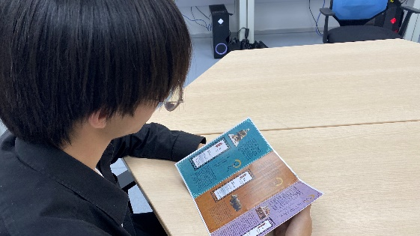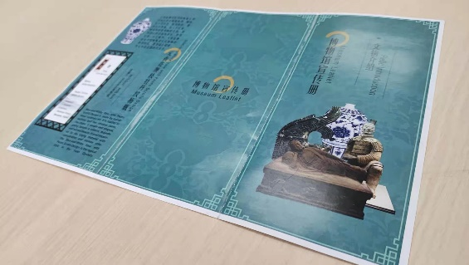

Figure 2. Demonstration of Leaflet. (a) A user using the Leaflet; (b) The physical leaflet.

***Postcard***

The concept of the Magic Book was first proposed by Billingurst[21]. It is based on AR image recognition technology, mainly including AR image recognition software and a picture book[22]. It can scan images from a picture book to identify corresponding digital information, which can stimulate the interest in reading and enhance the understanding of reading. In this study, we took the design of the grimoire and applied it to the museum souvenir postcard which adopted the postcard’s standard sizes - 14.8 x 10 centimeters. Our participants not only can read the text and image on the postcard but also can use the smartphone to see the augmented heritage objects, press the button on the screen to see the basic information and use the finger to rotate and scale these objects (see figure 3).

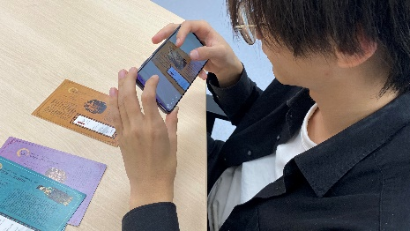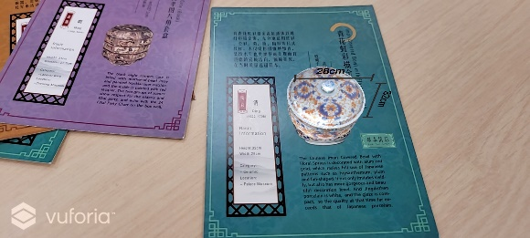

Figure 3. Demostration of Postcard AR. (a) A user using the Postcard AR; (b) The physical postcards; (c) A screenshot showing the 3D model and size of an artifact; (d) A screenshot showing the information label of an artifact; (e) A screenshot showing a zoomed-in view of an artifact.

***CubeMuseum***

This condition provided participants with a 6 cm cube with six sides. It consists of one wooden cube and some cards with cultural heritages. Users can insert the card into the slot of the box and use the particular mobile app to scan the card. Then cube shows the information and augmented heritage objects. (see Fig. 1). The physical cube is a carrier of six artifacts with interactivity which followed the principle of Embodied Interaction[10], [23]. Participants can interact with the cube's cultural artifacts by rotating the cube or using finger gestures on the virtual screen and view the real world of objects with its basic information and introduction.

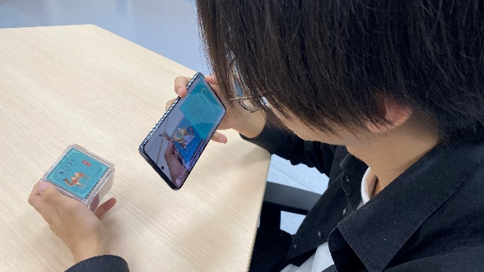

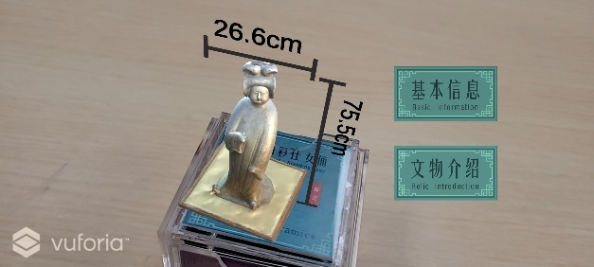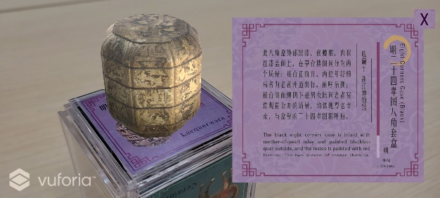

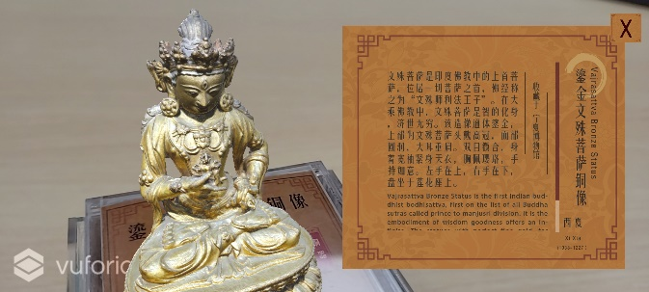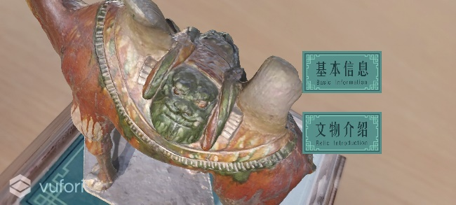

Figure 4. Demostration of CubeMuseum AR. (a) A user using the CubeMuseum AR; (b) The physical CubeMuseum; (c) A screenshot showing the 3D model and size of an artifact; (d) A screenshot showing the information label of an artifact; (e) A screenshot showing a zoomed-in view of an artifact.

**Methodology**

We conduct a within-subjects experiment to evaluate the learning effect under three different conditions: Leaflet (baseline), Postcard, and CubeMuseum. Both Postcard and CubeMuseum used in this study are AR-based interaction interfaces.

**Materials**

Twelve cultural artifacts are used for three experiment conditions, with four objects for each condition. The artifacts images were collected from museums and the 3D models were constructed using the photogrammetry technique. Artifacts used in the study are chosen with a variety of periods and materials (see Table 1).

Table 1. Overview of twelves artifacts

|  |  |  |  |  |  |  |
| --- | --- | --- | --- | --- | --- | --- |
| **#** | **Name** | **Picture** | **Size** | **Time Period** | **Museum** | **Category** |
| 1 | The Bronze Mask with Protruding Pupils |  | Height: 66cm  Width: 138cm | Shang  1600-1046 B.C. | Sanxingdui Museum | Bronze |
| 2 | Bronze Music Instrument |  | Height: 63cm | Western Zhou  1046-771 B.C. | Tianjin Museum | Bronze |
| 3 | Kneeling Archer |  | Height: 182cm  Width: 64cm | Qing  221-207 B.C. | Warriors Museum | Earthenware |
| 4 | Tri-coloured camel |  | Height: 87cm | Tang  618-907 A.D. | Nanjing Museum | Ceramics |
| 5 | Pottery Figure of a standing Lady |  | Height: 138cm  Width: 26.6cm | Tang  618-907 A.D. | National Palace Museum, Taipei | Ceramics |
| 6 | Marble Statue of Sakyamuni |  | Width: 40cm | Liao  907-1125 A.D. | The Capital Museum | Marble |
| 7 | Gilded Bull |  | Height: 45cm  Width: 38cm | Western Xia  1038-1227 A.D. | Ningxia Museum | Bronze |
| 8 | Vajrasattva Bronze Status |  | Height: 58.5cm  Width：46.5cm | Western Xia  1038-1227 A.D. | Ningxia Museum | Bronze |
| 9 | Blue-and-White Vase with Peons Scrools Design |  | Height: 44cm | Yuan  1271-1368 A.D. | Nanjing Museum | Ceramics |
| 10 | Figure of an Assistant to the Judge of Hell |  | Height: 148cm  Width: 36cm | 1368-1644 A.D. | The British Museum | Ceramics |
| 11 | Eight Corners Case (Black) |  | Height: 31cm  Width: 27.3cm | Ming  1368-1644 A.D. | Zhejiang Museum | Lacquerware |
| 12 | Imari Covered Bowl with Floral Sprays |  | Height: 32cm  Width：28cm | Qing  1622-1795 A.D. | Palace Museum | Ceramics |

**Study Design**

In order to investigate how different interaction interfaces can affect intrinsic motivation, engagement and learning outcome, we used a within-subjects design across three conditions (Leaflet, Postcard AR and CubeMuseum AR) for the learning of museum artifacts. Each participant experienced all three conditions (see Table 2) and the sequence of the three conditions was counterbalanced. We used questionnaires to measure participants’ learning outcome, instinct motivation and user engagement. Ethics approval was obtained from the University Ethics Committee prior to any data collection.

Each participant will experience these three conditions after finish the pretest questionnaire and complete the questionnaires after finish each one to measure intrinsic motivation and engagement in different groups. In order to eliminate the order effect for evaluating the learning outcome, we did balance for all of the possible orders between the three conditions.

Table2: The overview of three conditions

|  |  |  |  |  |  |  |
| --- | --- | --- | --- | --- | --- | --- |
| Condition | Reading Style | | | | Interaction Style | |
| Paper | AR System | | |
| 3D model | Basic Information （Size) | Introduction | Tangible (Physical Object) | Intangible ( Finger Gesture) |
| Leaflet | √ | X | X | X | X | X |
| Postcard | √ | √ | √ | X | √ | √ |
| CubeMuseum | X | √ | √ | √ | √ | √ |

**Participants**

24 participants (12 male, 12 female) took part in the experiment (age *M* = 22.04, *SD* = 2.074) (ages ranging from 20 to 27, with different experiences about the museum and AR system). Users were recruited through the media posts in the university. The investigation results of users are given in Figure 5.

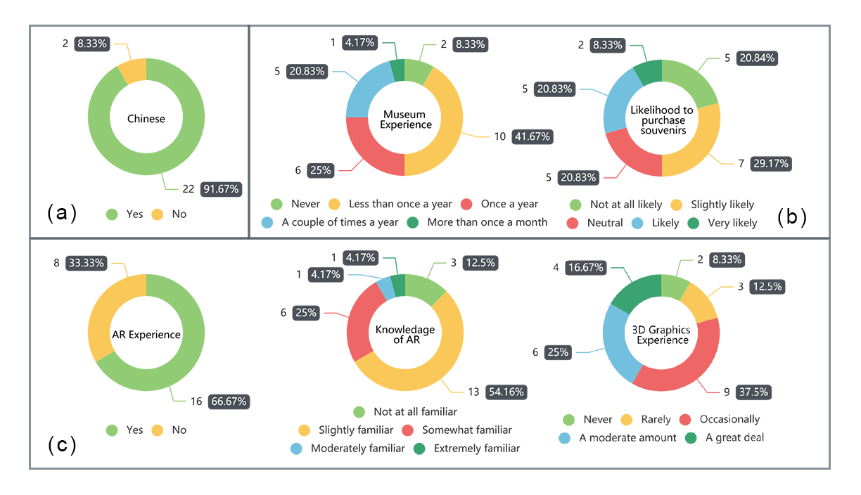

Figure 5. Investigation results of (a) the demographic by nations, (b) the participants’ interest in cultural heritage, (c) the participants’ experience with AR technology.

**Procedure**

Each of the participants completed the pretest questionnaires (the basic user information and AIT) anonymously, in the respective space, in the presence of the researcher. Prior to their actual interaction with each condition, the students learned the operation in tutorial mode (except using leaflet) and were given brief oral instructions on its use by the researcher (see figure 1). Throughout the interventions, the researcher also observed students’ interaction with the applications. After the completion of each intervention, the participants were required to complete the two posttests (the AIT followed by the Feedback Post-Experiment Questionnaire), anonymously, in the presence of the researcher. At the end of the experiment, the participants are invited to interviews.

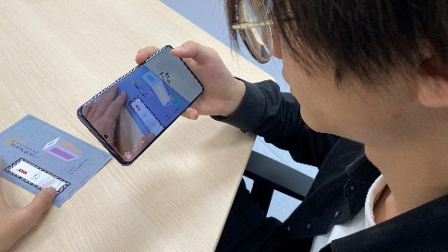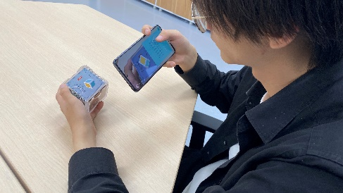

Figure 6. User in tutorial mode (a: Postcard with AR, b: CubeMuseum with AR).

In a pilot study, we determined that one student could complete learning in five minutes under each learning condition. Thus, we set the reminder in each learning when study time arrived 3 min, but we user still can continue learning. The time intervals needed for the completion of the tests were approximately 8 min for the pretest and 6 min for each posttest (Post-Experiment Questionnaire and AIT) which need to be done three times under different interaction conditions. The final interview needed 10 min. The whole procession is shown in Figure 1.

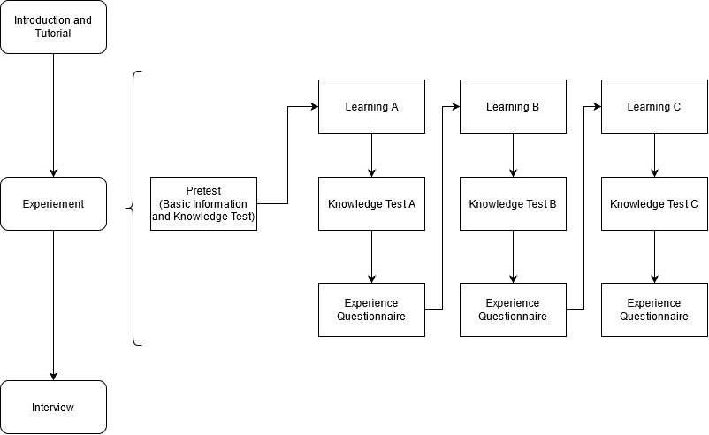

Figure 7. The process of the experiment (the order of A, B, C is counterbalanced)

**Measures**

In order to evaluate the following measures and indicators, we collected both quantitative and qualitative data to evaluate the intrinsic motivation, engagement and learning outcome by using the following research tools. Meanwhile, we also focus on the advantages and disadvantages of these interaction interfaces through the interview.

***Feedback Post-Experiment Questionnaire***

We measured participants’ intrinsic motivation and engagement with a series of questions loosely based on the Intrinsic Motivation Instrument Questionnaire (IMI) and User Engagement Scale Questionnaire Short Form (UES) respectively[24]–[27], which both consists of four corresponding underlying dimensions or factors( see Table 3 and 4). Specifically, through a series of closed questions, students were asked to rate on a 5-point scale or 7-point scale respectively.

|  |  |
| --- | --- |
| **Factor** | **Description** |
| **Interest and Enjoyment (IE)** | **Self-report measure of** **Intrinsic Motivation** |
| **Perceived Competence (PCO)** | **Positive predictor of** **Intrinsic Motivation** |
| **Perceived Choice (PCH)** | **Positive predictor of** **Intrinsic Motivation** |
| **Pressure and Tension (PT)** | **Negative predictor of** **Intrinsic Motivation** |

Table 3. The factors of IMI with descriptions.

|  |  |
| --- | --- |
| **Factor** | **Definition** |
| **Aesthetic Appeal (AE)** | **The users' perception of the visual appearance of a computer application interface** |
| **Focused Attention (FA)** | **The concentration of mental activity**[28]**; contained some elements of Flow, specifically focused concentration, absorption, and temporal dissociation**[29]**.** |
| **Reward Factor (RW)** | **Reward factor, labeled RW, which is a single set of items made up of the EN, NO and FI components in the original UES**[26]**. （****O’Brien, H. L., Cairns, P., & Hall, M. (2018).** |
| **Perceived Usability (PU)** | **Users' effective (e.g., frustration) and cognitive (e.g., effort) responses to the system** |

Table 4. The factors of UES with definitions.

***Artifact Information Test***

We adopt the pretest and posttest experimental design[30] to create the Artifact Information Test (AIT). The AIT aims to determine whether it can improve participants’ comprehension of the artifacts after using the different interaction interfaces. In our test design, we measured thirty-six questions of the artifacts across all three interaction interfaces which were divided into six themes including history, location, material, size, feature and description (See the appendix). Each correct answer is scored 1.

***Interview***

The interview questions are inspired by Pollalis et al ’s research [8]. It aims to explore the perspective and acceptance of participants, discuss the strengths and weaknesses of the interactive interfaces they experienced. In addition, participants were quizzed on their choice about souvenirs shopping among these three implements. The interviewer used neutral statements in the whole process of the interview so as not to interfere with the participants' thinking.

**Data Analysis**

In each of the Questionnaires (IMI, UES and AIT), the scale scores are calculated for each participant by summing scores for the items in each of the subscales and dividing by the number of items. Thus, the possible scores in each test are ranged from 0 to 5 points, 0 to 7 points and 0 to 1 points respectively.

Quantitative data was performed using the IBM SPSS Statistics package. For comparing the difference in IMI and UES scales, mean comparison was conducted using one-way within-groups analyses of variance (ANOVAs), and the differences between conditions were analyzed with Tukey's post-hoc test. To investigate participants’ potential initial difference between these three conditions as to the knowledge background of different artifacts, one-way between-groups analyses of variance (ANOVAs) and Tukey's post-hoc test compared the three groups AIT (pretest) were performed. And we adopted pair T-test and one-way between-groups analyses of variance (ANOVAs) to explore the learning effect in AITs (pretest and posttest) and the difference between three conditions respectively. Friedman test with Pairwise Comparisons was adopted to explore the difference in AIT subscales grouped by themes since the data were abnormally distributed.

**Results**

We conducted the study on collected quantitative data and some of the results coincide with the former hypotheses. The overview result is showed in Figure 8.

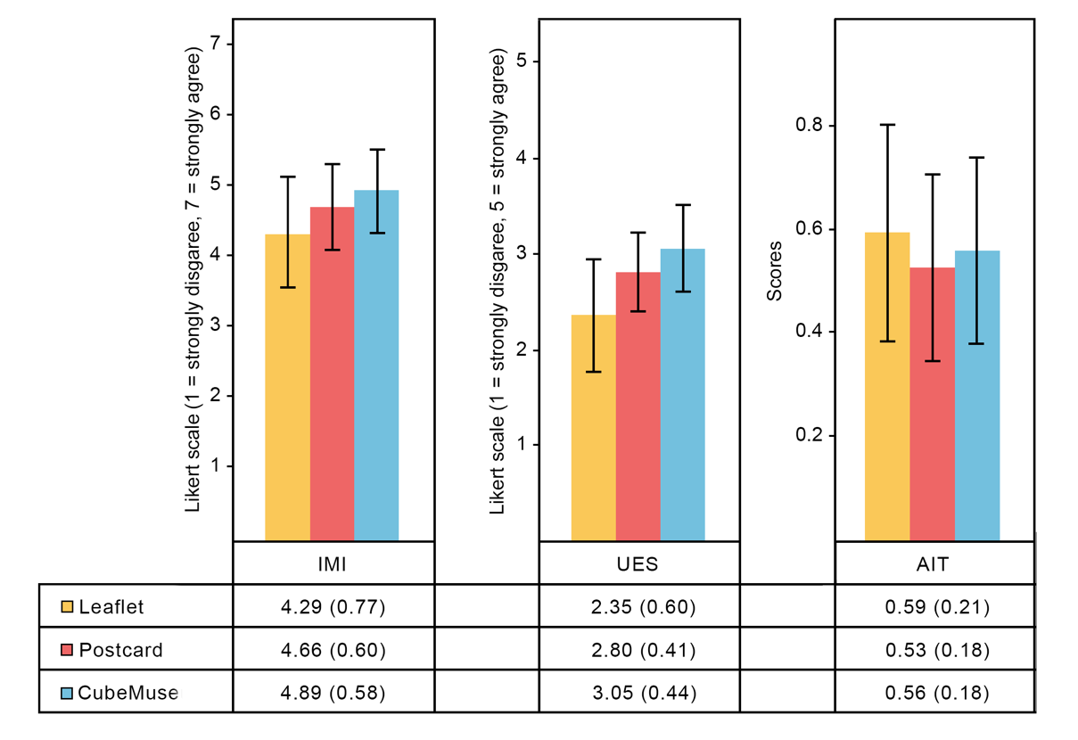

Figure 8. Averages (with standard deviation) of the Intrinsic Motivation Instrument (IMI), User Engagement Scale (UES) and Artifact Information Test (AIT).

**Intrinsic Motivation**

The different performance of participants among these three interaction interfaces responses on the four subscales of IMI was analyzed using one-way ANOVA since the response data was normally distributed. A one-way ANOVA showed that there was a statistically significant difference in IMI between Leaflet, Postcard AR and CubeMuseum AR (F(2, 69) = 5.030, p = .009). Post-hoc tests indicated significant differences between Leaflet and Postcard (p = .132), and between Leaflet and CubeMuseum (p = 0.007). The differences between Postcard and CubeMuseum were insignificant (p = .464). Users were more motivated when using CubeMuseum AR (M = 4.86, SD = 0.58) and Postcard AR (M = 4.66, SD = 0.60) than using Leaflet (M = 4.29, SD = 0.77). Specifically, significant differences were reported in Interest and Enjoyment (F(2, 69) = 6.939, p = .002) and Perceived Choice (F(2, 69) = 3.632, p = .032) for IMI. Although the differences in Pressure and Tension and Perceived Competence were insignificant, the scores on these two subscales show a slight trend (see Figure 9).

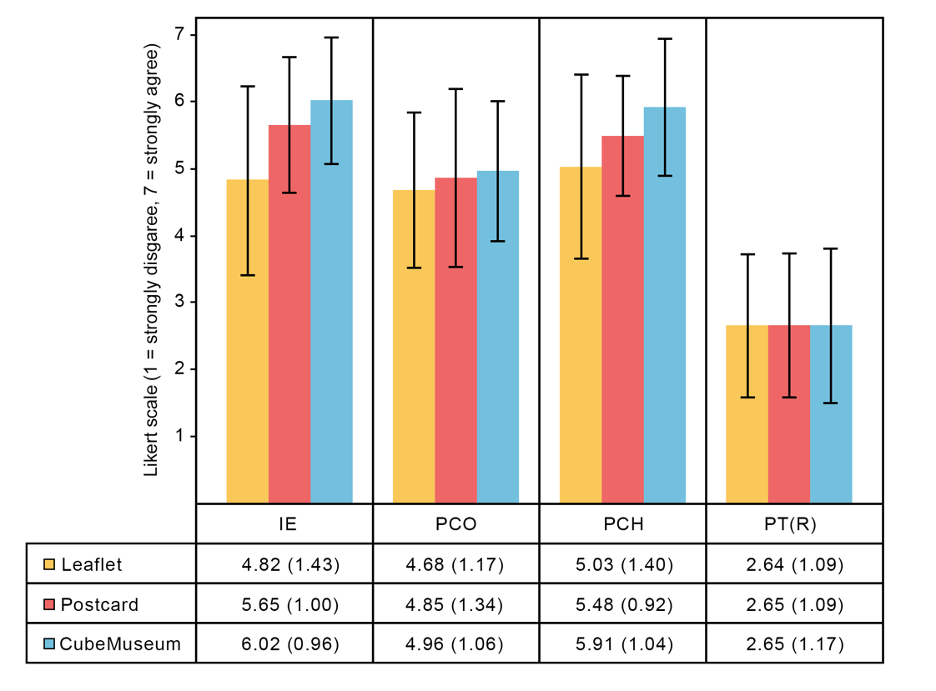

Figure 9. Averages (with standard deviation) of the Interest and Enjoyment (IE), Perceived Choice (PCH), Perceived Competence (PCO) and Pressure and Tension (PT).

**Engagement**

The different performance of participants among these three interaction interfaces responses on the four subscales of UES was analyzed using one-way ANOVA since the response data was normally distributed. A one-way ANOVA showed that there was a statistically significant difference in UES between Leaflet, Postcard AR and CubeMuseum AR (F(2, 69) = 14.105 p < .001). Post-hoc tests indicated significant differences between Leaflet and Postcard (p <.001), and between Leaflet and CubeMuseum (p <.001). The differences between Postcard and CubeMuseum were insignificant (p = .377). Users were more engaged when using CubeMuseum AR (M = 3.05, SD = 0.44) and Postcard AR (M = 2.80, SD = 0.41) than using Leaflet (M = 2.35, SD = 0.60). Specifically, significant differences were reported in Focused Attention (F(2, 69) = 11.174, p <.001) , Aesthetic Appeal (F(2, 69) = 16.607, p <.001) , Reward Factor (F(2, 69) = 8.662, p <.001) for UES. Although the differences in Perceived Usability were insignificant, the scores on this subscale show a slight trend on numeric value (see Figure 10).

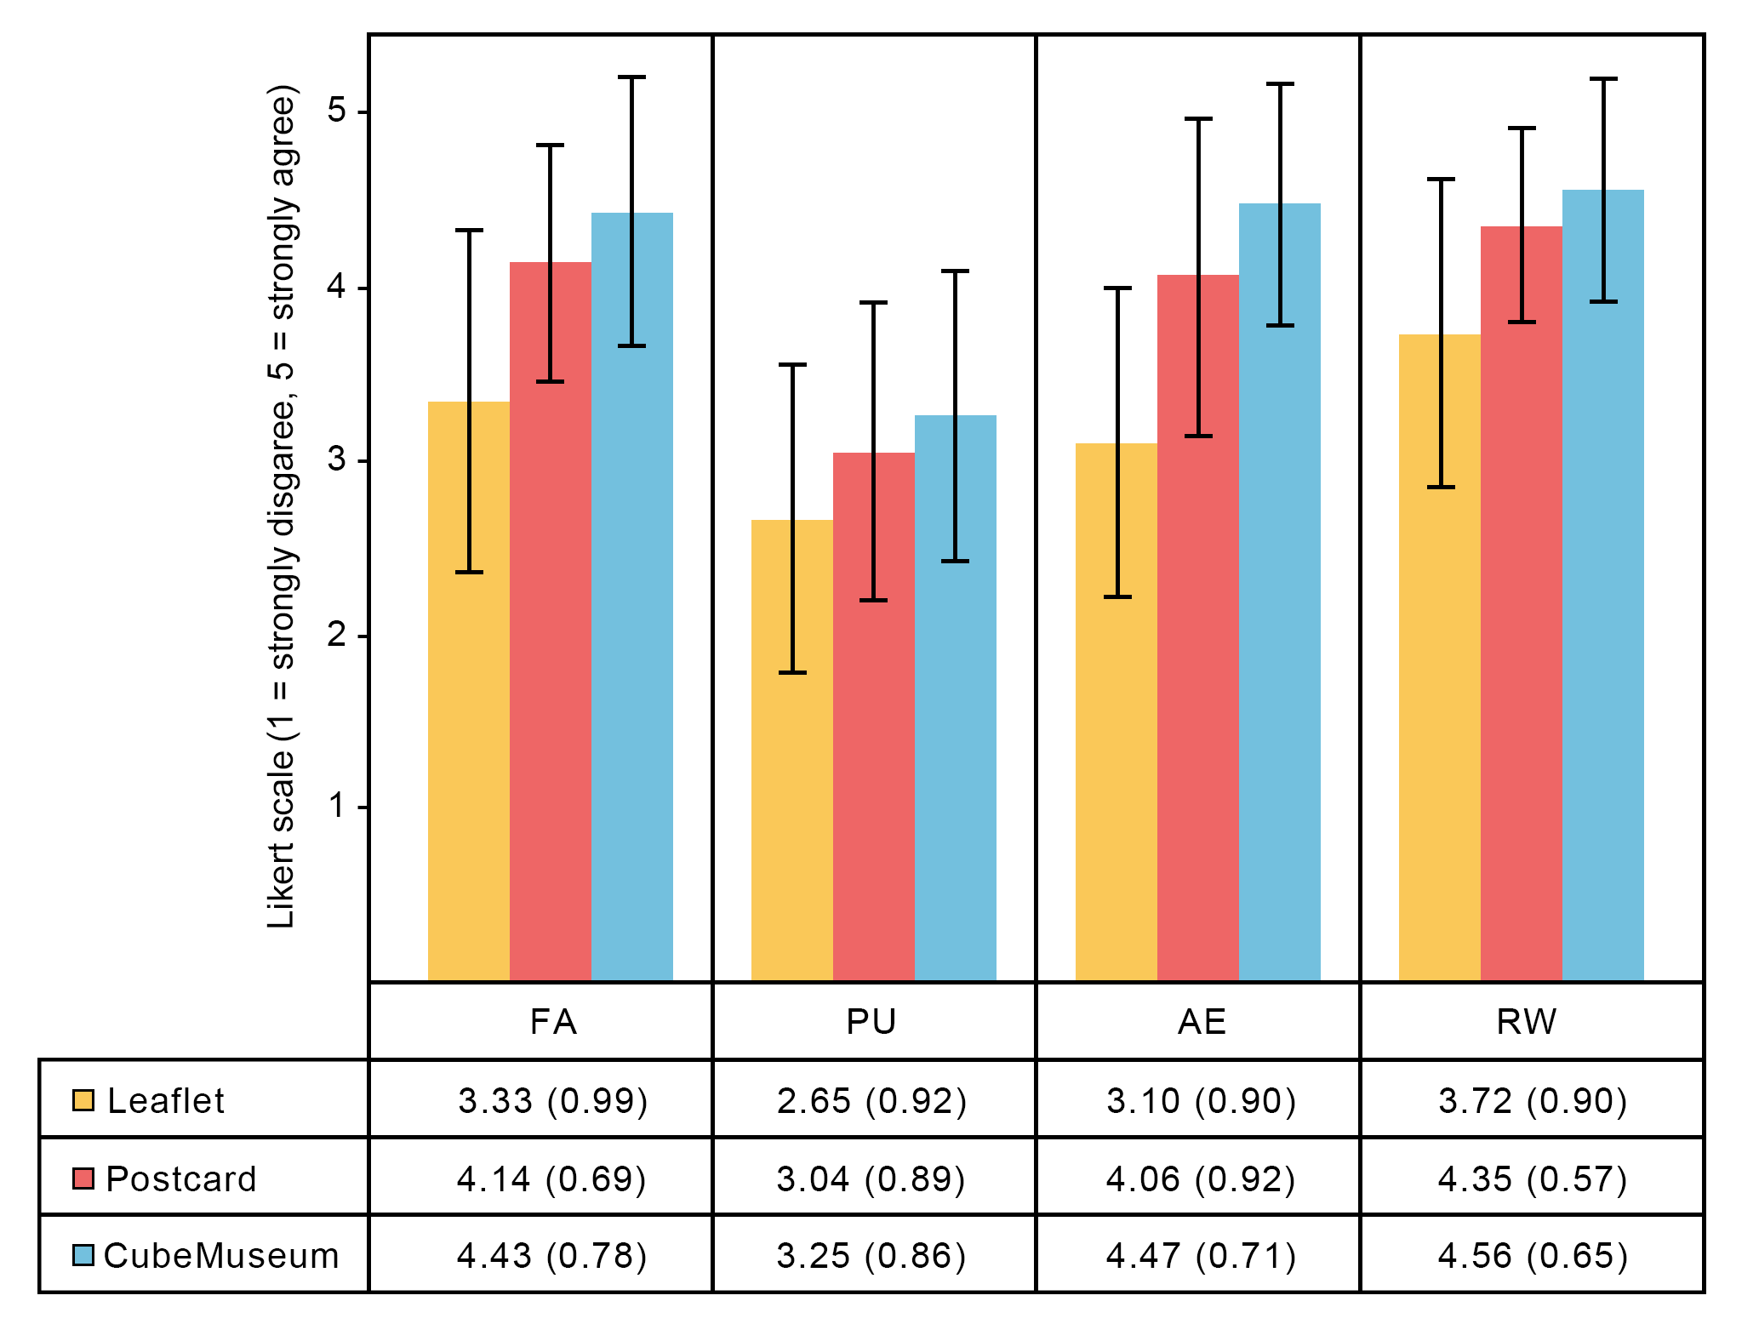

Figure 10. Averages (with standard deviation) of theFocused Attention (FA), Aesthetic Appeal (AE), Reward Factor (RW) and Perceived Usability (PU).

**Learning Outcome**

The analysis of the AIT(pretest) resulted in participants’ background knowledge among these artifacts in no statistically significant differences (F (2, 69) = .664, p =.518). Furthermore, the Pair T-test that was compared for the AIT(pretest) and AIT(posttest) showed statistically significant differences (p <.001) in all of the three conditions. A one-way ANOVA showed that there was no significant difference in AIT(posttest) between Leaflet, Postcard AR and CubeMuseum AR (F(2, 69) =.755, p =.474). The different performance of participants among these three interaction interfaces responses on the six subscales grouped by themes in AIT was analyzed using Friedman test since the response was abnormally distributed in feature. Friedman showed that there was a statistically significant difference in Location between Leaflet, Postcard AR and CubeMuseum AR (p <.001). Pairwise Comparisons indicated significant differences between CubeMuseum and Leaflet (p =.004), and between CubeMuseum and Postcard (p =.012). Friedman showed that there was no significant difference in history (p =.801), material (p =.458), size (p =.302), feature (p =.073) and description (p =.124) between Leaflet, Postcard AR and CubeMuseum AR. The statistical analysis is shown in Figure 11.

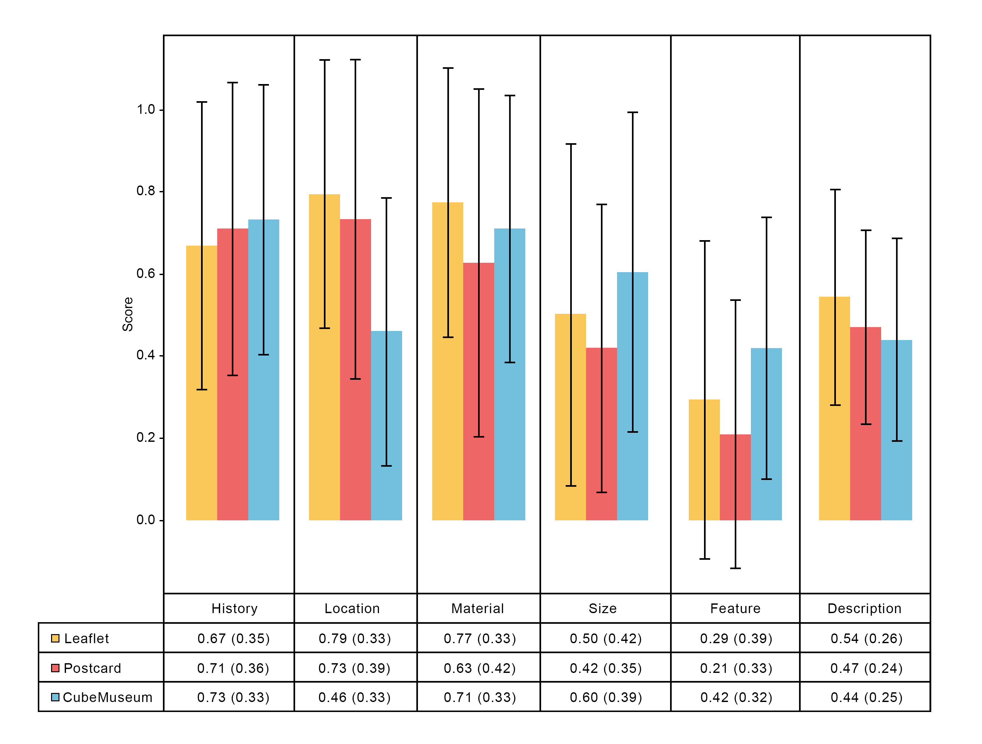

Figure 11. Averages (with standard deviation) of the AIT pretest and posttest.

**Additional Findings**

Although we have the remind in each learning when study time arrived 3 min, we have no limitation of the time in the learning process and time of learning is recorded. A one-way ANOVA showed that there was a statistically significant difference in learning time between Leaflet, Postcard AR and CubeMuseum AR (F (2, 69) = 9.540, p < .001). Post-hoc tests indicated significant differences between Leaflet and Postcard (p = .011), and between Leaflet and CubeMuseum (p < .001). The differences between Postcard and CubeMuseum were insignificant (p = .420). Users spent more time on using CubeMuseum AR (M = 3.96, SD = 1.27) and Postcard AR (M = 3.50, SD = 1.32) than using Leaflet (M = 2.42, SD = 1.18). The Descriptive statistics for time are shown in Figure 10. This was confirmed by the qualitative feedback we received. When asked which interaction interface they willingly used, most of the participants choose the interface with AR system (Postcard or CubeMuseum).

**Observation** **and Interview**

The qualitative analysis was based on observation notes and the recordings of the interview. Here we summarize a list of the four themes in Table 5, which were hypothesized to be important factors in evaluating these interactions: Tangible Manipulation, Efficiency, Spatial Presence and Preference. Furthermore, we are also interested in the application of these interaction interfaces in Museum gifting and it was grouped using four main themes in Table 6, which were hypothesized to be important factors that affect people’s choice: Target Group, Value, Design and Material. The specific analysis of qualitative feedback will be conducted in the discussion.

Table 5． The important factors of interaction interfaces evaluation

|  |  |  |  |
| --- | --- | --- | --- |
| Theme | Interaction Interfaces | Description | Participant ID |
| Tangible Manipulation (9) | CubeMuseum (3) | Entity rotation is more feelings of operation. | p8, p11, p22 |
| Postcard (3) | Turning the postcard may obstruct the words. | p1, p14, p15 |
| Leaflet (6) | Too ordinary | p3, p6, p8, p11, p13, p21 |
| Efficiency (22) | CubeMuseum (5) | Size and knowledge cannot be displayed on the screen at the same time. | p2, p10 |
| CubeMuseum is effective | p3, p13, p17 |
| Postcard (8) | Free combination card sequence. | p2, p21, p19 |
| Paper reading is more effective (e.g: markdown, highlight) | p1, p2, p9, p15, p18 |
| Leaflet (9) |
| It can focus on learning | p9, p18 |
| All information can be seen together | p9, p19 |
| Preference (20) | CubeMuseum (8) | *I like paperless reading* | p13 |
| The new interaction interface is attractive | p6, p7, p9, p11 |
| It can stimulate the interest in artifacts | p1, p2, p18 |
| Postcard (5) |
| Simple operation with 3D graphics | p2, p18 |
| Leaflet (7) | The classic way is easier to be acceptable | p9, p21 |
| No interest to use it | p3, p6, p7, p19, p22 |
| Spatial Presence(17) | CubeMuseum (8) | *I can scale the models to see more detail about the artifact* | p11 |
| *I can disable the words to concentrate on pictures or models* | p22 |
| The 3D model enhances my impression of artifacts | p2, p3, p4, p9, p20, p23 |
| Postcard (8) |
| Watching 3d models as well as text can enhance memory | p15 ,p18 |
| Leaflet (1) | *It has no extra operations, so it can let me concentrate on memorizing* | p14 |

Table 6. The important factors of people’s choice in Museum gift

|  |  |  |  |
| --- | --- | --- | --- |
| Theme | Interaction Interfaces | Description | Participant ID |
| Target Group(16) | CubeMuseum (6) | *Children would like it* | p1 |
| *AR technology is not easy to be accepted for elder* | p1 |
| Young people like new things. | p2, p9, p16, p23 |
| Postcard (3) | Some people have the habit of collecting postcards | p21, p24 |
| Leaflet (7) | A way to express emotion for elder and young people | p21 |
| Too boring for young people | p1, p3, p6, p16, p22, p19 |
| Value (4) | CubeMuseum (1) | *If the price is not expensive, I will consider buying it* | p15 |
| Postcard (1) |
| Leaflet (2) | Useless | p11 p3 |
| Design (28) | CubeMuseum (12) | It is a novel interaction style | p11, p9, p23 |
| The 3D model can be seen at different angles by rotating the cube | p1, p5, p12 |
| Simply information on each side of the cube, all of the detailed information is demonstrated on the screen | p19 |
| Unable to perceive true size among these artifacts | p1, p3, p8, p15, p21 |
| Postcard (9) |
| *I don’t think there should be too much text on the postcard* | p19 |
| Scale up the 3D model may block the text information | p1, p14, p15 |
| Leaflet (7) | *It is inconvenient to flip it* | p1 |
| Leaflet is ordinary | p3, p6, p8, p11, p13, p21 |
| Material (11) | CubeMuseum (9) | Too heavy | p1, p2, p6, p8, p11 |
| It is inconvenient to carry | p1, p11, p21 |
| *The edges are very thorn in hand* | p3 |
| Postcard (1) | *It has a reflective surface that I can't read the information directly* | p23 |
| Leaflet (1) |

**Discussion**

**Learning Outcome**

The purpose of our study is to explore the impact of AR on learning outcome heritage knowledge and interest in heritage. Although no significant differences were found in the AIT questionnaire. The possible reason for this phenomenon is the time reminder operation affects the learning. Through our observations, we noticed that users spend their time using CubeMuseum and Postcard for more than 3 minutes, while they have completed their learning in less than 3 minutes on Leaflet. We think that the reminder at the time of three minutes will give users psychological hints, although we have told users before the test that the three minutes is just a reminder time and not an end time, they still affect their learning to some extent. Due to the display of 3D graphics, users need to constantly switch their eyes back and forth between the 3D model and the text information, which leads to an increase in learning time, but 3 minutes is not enough for the user to truly complete the learning. Meanwhile, compared to the Baseline, the correct rate of answering feature related to using CubeMuseum is significantly higher than the correct rate of using the baseline. As mentioned by participant 3: *“I believe the Postcard and CubeMuseum are effective for learning, I just don’t know what the knowledge needs to be memorized before I filled the AIT questionnaire”*. As the result showed, the learning outcome in CubeMuseum has a significant disadvantage in the theme of location although the three conditions provided the same text information. We inferred that the interface design of the text information may cause the unexpected difference that indicated CubeMuseum has a big improved space on this aspect. These findings indicated that CubeMuseum and Postcard have the potential to have better effects on learning outcome.

**Intrinsic Motivation**

Compared to the Baseline, Leaflet and CubeMuseum overall significantly increased the motivation of the user measured by the IMI questionnaire. It is worth noting that in the final comparison, the participants' scores in the CubeMuseum interaction are slightly higher than Postcard and slightly higher than Leaflet. This shows that the application of AR does improve motivation. This also further shows that our design has a positive impact on the user's increased interest in heritage.

Summarized we found that CubeMuseum and Postcard are more motivated, and CubeMuseum was slightly higher than Postcard in all indicators. However, when we asked users to rank the three interaction methods in the final interview stage, we found that the number of people who liked CubeMuseum most and Postcard was the same, which was different from our initial expectations and the results of the questionnaire. Therefore, the next section explains this phenomenon from an interactive perspective.

**Engagement**

Not similar to learning outcome, there are significant differences were found for the UES questionnaire, this is because AR technology tends to attract users’ attention more easily than Baseline. The application of AR technology can display the full picture of the cultural relics, while traditional paper reading can only simulate the original appearance of the cultural relics in the mind through simple flat 2D pictures.

Interaction also affects the sense of participation. We have observed that users frequently operate mobile phones or objects when using Postcard and Cube Museum, while when using Leaflet, the operation method is only simple page-turning operations. Users also shared their subjective interpretations. Some users feel that when using Postcard, they can sort the placement of Postcard freely according to their preferences. At the same time, they can choose to rotate the Postcard or the virtual screen due to personal preference. They say this is done for observe the 3D model from multiple angles, which helps them to observe the whole picture of the cultural relics in detail. Users also mentioned that turning CubeMuseum is more flexible and convenient than Postcard. it proved that AR arouses learning enthusiasm and promotes concentration.

**Evaluation of the Interaction Interface**

We evaluate the interactive interface in four factors which grouped on insights we collected from the user operation and interview.

***Tangible Manipulation***

Under the two conditions on Postcard and the CubeMuseum, we provided two options to rotate. We observed that over half of the participants preferred rotating on the physical interface rather than using finger gestures on a virtual screen that indicated participants were effectively moving to a more direct style of interaction.

***Efficiency***

The complexity of the operations also affects the learning time. The statistics of the observation also indicated that most participants spent less time on Leaflet than other learning. Like participant 9 mentioned: “*I can focus on learning by Leaflet since taking all of the artifact information at a glance*.” That indicated some people are more emphasis on efficiency.

This finding seems to point to reading style. People received all information on paper reading as it showed on Leaflet which enhances information memory in text, whereas in Postcard AR and CubeMuseum AR, they need extra operations to switch the view frequently and they are more dependent on spatial memory. The too-high degree of tangible will increase the time of learning but too low tangible result in boring for user.

***Spatial Presence***

When asked *“which interaction interface leaves the most concrete mental graphics of the artifact,”* most of the participants ranked the CubeMuseum the highest, although it was not the only condition that had the 3D model in the AR system in the study. The virtual 3D models present more physical features of the artifacts, such as color and texture, which led to stronger mental images and lasting impressions. And compare with the Postcard, participants confirmed the CubeMuseum enhances the immersive when they watch the 3D graphics since it can disable the text information.

***Preference***

After the interview, we count the number of users who like CubeMuseum and Postcard as are similar and more than Leaflet. Both CubeMuseum and Postcard interaction can stimulate user interest in artifacts because they fare better at the perception attributed to the 3D model, especially on size, color and structure. The [descriptive](javascript:;) [statistics](javascript:;) results in AIT also support this point. However, a few of the inspectorate prefer Leaflet since paper reading is more accustomed. They insisted the AR interaction is complex and classic way is easier to be acceptable. Interestingly, we found all of them are business students by asking, and we will discuss it more in the limitation section.

1. **Museum Gifting**

We also asked some questions about choosing museum gifting, which contribute a lot to our study.

***Target Group***

As an innovative product, CubeMuseum is more easily accepted by Young, especially it has the AR attribute. The users in the interview also illustrate this point: they prefer new things, so if the purpose of buying souvenirs for young or children, they are more willing to choose CubeMuseum. On the contrary, older people are less interested the new things, so users are more willing to choose Postcard or Leaflet as souvenirs for the elder, and due to the universality, it is also easier to be accepted by more people.

***Value***

People also consider the performance ratio when they purchase things. Some people also consider this point. Based on the assumption of already owned a CubeMuseum, almost all of the participants are willing to collect the extra cards. Due to the price of the CubeMuseum’s card is not very expensive, it will have a positive effect on increasing the probability of purchase CubeMuseum.

***Design***

Throughout the interview, we found that the design is the key factor that is most frequently to be mentioned. 3D graphics and the novel tangible interaction with AR are the keys for participants to choose CubeMuseum. Although Postcard also provides 3D experience with simply operation, some participants point out that it existed some limitation on the design. Due to Postcard provide users more text information on the real 2D picture, the zoom in the function of the 3D model may block the text which affects reading, and they also insisted the postcard should not have too much text. For leaflet, some people think it is inconvenient to flip it and it is too ordinarily.

***Material***

Some of the participants focus on the material of the hybrid gifts. They indicated that the wooden cube is too heavy which may affect the tangible interaction. And for the choosing of the paper should avoid reflective paper to ensure the information can be read in a comfortable environment.

1. **Implications for Design**

From the findings of this study and own experience we see several implications for the design of interactive tangibles for museum gifting such as CubeMuseum, and summarized four guidelines.

***Perceive the size***

Throughout our study, we found the learning of the artifact size has no significant between three conditions which are not quite our expectation. When participants checked the size on 3D models, they cannot perceive the real size easily since the virtual artifact has a similar initial size displayed on the screen. And we concluded that adding a reference virtual object may improve the experience.

***Adaptable***

AR as a novel interactive technology provided an immerse experience so that it is popular in youth groups, but it is not suitable for the elder since they are not very open to accepting new things. So we can add extra paper reading information on the back of the card to link the traditional way and the new way.

***Customized***

Some participants pointed out that the strength of the paper materials is to mark down or highlight things. This function also should be extended and implemented in digital reading on mobile.

***Expansibility***

When asked *“If willingly to buy the extra expanded card for CubeMuseum,”* most of the participants expressed the CubeMuseum very high purchase Intention to collect cards that indicated the collection mechanism can be promoted in it.

**Limitations and Future Work**

During our user evaluation, we set three minutes as notice time, but we found that most of the users finished their interaction shortly after we remind the time. remind the time may give psychological hint for users, even we have been told user the time just for reminding rather than We think it will affect the user learning outcome, it may affect the learning outcome. Future work should set two experimental one is timed one is unlimited to explore.

Furthermore, the sample size and composition of our participants need to be considered when interpreting our findings. We keep the balance of gender, and results show that there is no difference caused by gender from statistical results. Interestingly, we found there are distinct differences among the subject, major and the level of the school will influence the result, science students more inclined to choose CubeMuseum or Postcard and all of the business students choose Leaflet in preference question. However, with only 6 business students as participants, there is a high subject bias in our study results. Further, we should consider it. And the difference with educational learning, Museum learning can be regarded as an osmosis process. It could be better to measure the learning outcome in a long-term way in further research.

Extrinsic Motivation:

虽然总体来看IMI有显著差异,但在紧张方面却不显著且整体分数较低，但是学习效果上整体不显著，尤其我们的文物信息问卷内容需要记忆不少知识这对于participant来更需要外在动机的支持。所以我们在实验中应该设置一定的外部动机去衡量学习效果，例如按照答案正确数量给予一定奖励。这使得我们能够充分研究我们所做的CubeMuseum和Postcard在学习方面的影响。

**Conclusion**

We explored and concluded the differences related to learning intrinsic motivation, engagement and learning outcome between three different interaction interfaces. Our findings indicated that Users are more motivated and engaged to learn with objects of which greater interactivity is afforded. For learning outcome, the result showed that there was no significant difference between the three interaction interfaces in general which is needed for further study. Whereas, we can see a slighted trend of the difference in some learning evaluation dimeson such as feature and size since the 3D models enhance the mental graphics. From observation and interview, we found that participants' perspectives and preferences of these three interaction interfaces were different which depend on weighing up the pros and cons on multiply aspects.

The Leaflet, despite its [ordinary](javascript:;), can present information effectively. The postcard provides simple operation with 3D graphics and it keeps the learning advantage of paper reading. CubeMuseum provided the highest tangible interaction and immersive nature of AR which can stimulate the interest in learning. And these findings also contribute to the further design of hybrid gifts. In summary, this study demonstrates the feasibility and practical value of Tangible Augmented Reality Interfaces to enhance learning.

**Reference**

[1] K. H. Cheng and C. C. Tsai, “Affordances of Augmented Reality in Science Learning: Suggestions for Future Research,” *J. Sci. Educ. Technol.*, vol. 22, no. 4, pp. 449–462, 2013, doi: 10.1007/s10956-012-9405-9.

[2] R. Azuma, Y. Baillot, R. Behringer, S. Feiner, S. Julier, and B. MacIntyre, “Recent Advances Augmented Reality,” *IEEE Comput. Graph. Appl.*, vol. 21, pp. 34–47, 2001.

[3] A. Theodoropoulos and G. Lepouras, “Augmented Reality and programming education: A systematic review,” *Int. J. Child-Computer Interact.*, vol. 30, p. 100335, 2021, doi: 10.1016/j.ijcci.2021.100335.

[4] M. S. Markova, “How does the tangible object affect motor skill learning?,” *TEI 2014 - 8th Int. Conf. Tangible, Embed. Embodied Interact. Proc.*, pp. 305–308, 2014, doi: 10.1145/2540930.2558150.

[5] J. H. Seo, J. Arita, S. L. Chu, F. Quek, and S. Aldriedge, “Material significance of tangibles for young children,” *TEI 2015 - Proc. 9th Int. Conf. Tangible, Embed. Embodied Interact.*, pp. 53–56, 2015, doi: 10.1145/2677199.2680583.

[6] J. Ma, L. Sindorf, I. Liao, and J. Frazier, “Using a tangible versus a multi-touch graphical user interface to support data exploration at a museum exhibit,” *TEI 2015 - Proc. 9th Int. Conf. Tangible, Embed. Embodied Interact.*, pp. 33–40, 2015, doi: 10.1145/2677199.2680555.

[7] C. Pollalis *et al.*, “Evaluating learning with tangible and virtual representations of archaeological artifacts,” *TEI 2018 - Proc. 12th Int. Conf. Tangible, Embed. Embodied Interact.*, vol. 2018-Janua, pp. 626–637, 2018, doi: 10.1145/3173225.3173260.

[8] P. Koutsabasis, “Empirical Evaluations of Interactive Systems in Cultural Heritage,” *Int. J. Comput. Methods Herit. Sci.*, vol. 1, no. 1, pp. 100–122, 2017, doi: 10.4018/ijcmhs.2017010107.

[9] M. Akçayir, G. Akçayir, H. M. Pektaş, and M. A. Ocak, “Augmented reality in science laboratories: The effects of augmented reality on university students’ laboratory skills and attitudes toward science laboratories,” *Comput. Human Behav.*, vol. 57, pp. 334–342, 2016, doi: 10.1016/j.chb.2015.12.054.

[10] Y. Li, E. Ch’Ng, S. Cai, and S. See, “Multiuser Interaction with Hybrid VR and AR for Cultural Heritage Objects,” *Proc. 2018 3rd Digit. Herit. Int. Congr. Digit. Herit. 2018 - Held jointly with 2018 24th Int. Conf. Virtual Syst. Multimedia, VSMM 2018*, 2018, doi: 10.1109/DigitalHeritage.2018.8810126.

[11] E. Ch’ng, “New ways of accessing information spaces using 3D multitouch tables,” *Proc. 2012 Int. Conf. Cyberworlds, Cyberworlds 2012*, no. September, pp. 144–150, 2012, doi: 10.1109/CW.2012.27.

[12] B. SERRELL and B. RAPHLING, “Computers on the Exhibit Floor,” *Curator Museum J.*, vol. 35, no. 3, pp. 181–189, 2010, doi: 10.1111/j.2151-6952.1992.tb00753.x.

[13] R. Wang, L. Chen, and I. Solheim, “Modeling dyslexic students’ motivation for enhanced learning in E-learning systems,” *ACM Trans. Interact. Intell. Syst.*, vol. 10, no. 3, 2020, doi: 10.1145/3341197.

[14] X. Xin, J. Li, M. Jin, W. Liu, C. Liu, and Y. Zhang, “Improving the user experience in museum: A Joint course with Beijing Museum of Natural History,” *ACM Int. Conf. Proceeding Ser.*, pp. 30–36, 2019, doi: 10.1145/3332169.3333580.

[15] S. Neale, W. Chinthammit, C. Lueg, and P. Nixon, “Facilitating learning through hands-on engagement with virtual museum artefacts,” *Proc. 28th Int. BCS Hum. Comput. Interact. Conf. Sand, Sea Sky - Holiday HCI, HCI 2014*, pp. 222–227, 2014, doi: 10.14236/ewic/hci2014.27.

[16] C. K. Tsong, T. S. Chong, and Z. Samsudin, “Tangible multimedia: A case study for bringing tangibility into multimedia learning,” *Turkish Online J. Educ. Technol.*, vol. 11, no. 4, pp. 442–450, 2012, doi: 10.1016/j.sbspro.2012.11.045.

[17] C. Havrez, S. Lepreux, Y. Lebrun, S. Haudegond, P. Ethuin, and C. Kolski, “A Design Model for Tangible Interaction: Case Study in Waste Sorting,” *IFAC-PapersOnLine*, vol. 49, no. 19, pp. 373–378, 2016, doi: 10.1016/j.ifacol.2016.10.594.

[18] D. Petrelli, M. T. Marshall, S. O’Brien, P. McEntaggart, and I. Gwilt, “Tangible data souvenirs as a bridge between a physical museum visit and online digital experience,” *Pers. Ubiquitous Comput.*, vol. 21, no. 2, pp. 281–295, 2017, doi: 10.1007/s00779-016-0993-x.

[19] S. Benford, G. Giannachi, B. Koleva, and T. Rodden, “From interaction to trajectories: Designing coherent journeys through user experiences,” *Conf. Hum. Factors Comput. Syst. - Proc.*, pp. 709–718, 2009, doi: 10.1145/1518701.1518812.

[20] B. Koleva *et al.*, “Designing Hybrid Gifts,” *ACM Trans. Comput. Interact.*, vol. 27, no. 5, 2020, doi: 10.1145/3398193.

[21] M. Billinghurst, H. Kato, and I. Poupyrev, “MagicBook: Transitioning between reality and virtuality,” *Conf. Hum. Factors Comput. Syst. - Proc.*, no. figure 3, pp. 25–26, 2001, doi: 10.1145/634067.634087.

[22] R. Pingxuan, “AR 3D Magic Book,” no. Cipae, pp. 244–250, 2020, doi: 10.1145/3419635.3419714.

[23] P. Dourish, “Where the Action Is: The Foundations of Embodied Interaction,” *Where action is Found. embodied Interact.*, vol. 36, no. 3, p. 233, 2001, doi: 10.1162/leon.2003.36.5.412.

[24] R. M. Ryan and E. L. Deci, “Intrinsic and Extrinsic Motivations: Classic Definitions and New Directions,” *Contemp. Educ. Psychol.*, vol. 25, no. 1, pp. 54–67, 2000, doi: 10.1006/ceps.1999.1020.

[25] R. M. Ryan and E. L. Deci, “Self-determination theory and the facilitation of intrinsic motivation, social development, and well-being,” *Univ. Dar es Salaam Libr. J.*, vol. 13, no. 1, pp. 04–19, 2018.

[26] H. L. O’Brien, P. Cairns, and M. Hall, “A practical approach to measuring user engagement with the refined user engagement scale (UES) and new UES short form,” *Int. J. Hum. Comput. Stud.*, vol. 112, no. December 2017, pp. 28–39, 2018, doi: 10.1016/j.ijhcs.2018.01.004.

[27] M. Papastergiou, “Digital Game-Based Learning in high school Computer Science education: Impact on educational effectiveness and student motivation,” *Comput. Educ.*, vol. 52, no. 1, pp. 1–12, 2009, doi: 10.1016/j.compedu.2008.06.004.

[28] M. Matlin and T. Gullickson, “Cognition Without Reason: A Farewell to the Cognitive Revolution,” *Psyccritiques*, vol. 40, no. 7, 1995.

[29] M. Csikszentmihalyi and M. Csikzentmihaly, *Flow: The psychology of optimal experience*, vol. 1990. Harper \& Row New York, 1990.

[30] E. L. C. Law and X. Sun, “Evaluating user experience of adaptive digital educational games with Activity Theory,” *Int. J. Hum. Comput. Stud.*, vol. 70, no. 7, pp. 478–497, 2012, doi: 10.1016/j.ijhcs.2012.01.007.

**Appendix**

|  |  |  |  |
| --- | --- | --- | --- |
| **Theme** | **Interaction Interface** | **Code** | **Question** |
| **Material** | **Leaflet** | O3M | What is the material of the Kneeling Archer? |
| O7M | What is the material of the Gilded Bull? |
| **Postcard** | O10M | What is the material of the Figure of an Assistant to the Judge of Hell? |
| O11M | What is the material of the Eight Corners Case? |
| **CubeMuseum** | O5M | What is the material of the Figure of a Standing Lady? |
| O8M | What is the material of the Vajrasattva Statue? |
| **Feature** | **Leaflet** | O3F | Which of the following feature is not mentioned or incorrect about the Kneeling Arche? |
| O6F | Which of the following colors does not belong to the Marble Statue of Sakyamunit? |
| **Postcard** | O11F | Which of the following colors does not belong to the Eight Corners Case? |
| O12F | The texture that does not belong to the Chinese lmari Covered Bowl with Floral Sprays is: |
| **CubeMuseum** | O1F | Which of the following is characteristic of the Bronze Mask with Protruding Pupils? |
| O4F | Which of the following colors does not not belong to the Tri-Colored camel? |
| **Size** | **Leaflet** | O3S | What is the correct size of the Kneeling Arche? |
| O7S | What is the correct size of the Gilded Bull? |
| **Postcard** | O2S | What is the correct size of the Bronze Music Instrument? |
| O10S | What is the correct size about Figure of an Assistant to the Judge of Hell? |
| **CubeMuseum** | O4S | The height of the Tri-Colored camel is: |
| O5S | The height of the Figure of a Standing Lady is: |
| **History** | **Leaflet** | O7H | Which dynasty does the Gilded Bull belong to? |
| O9H | Which dynasty does the Blue-and-White Vase with Peons Scrolls Design belong to? |
| **Postcard** | O2H | Which dynasty does the Bronze Music Instrument belong to? |
| O12H | Which dynasty does the Chinese lmari Covered Bowl With Floral Sprays belong to? |
| **CubeMuseum** | O1H | Which dynasty does the Bronze Mask with Protruding Pupils belong to? |
| O8H | Which dynasty does the Vajrasattva Statue belong to? |
| **Description** | **Leaflet** | O6D | Which of the following descriptions of the Marble Statue of Sakyamuni are incorrect? |
| O9D | Which of the following description is not mentioned or incorrect about the Blue-and-White Vase with Peons Scrolls Design? |
| **Postcard** | O2D | What is the research direction available to the Bronze Music Instrument？ |
| O11D | The cover surface of the Eight Corners Case reflects: |
| **CubeMuseum** | O1D | Which of the following descriptions of the Bronze Mask with Protruding Pupils are incorrect? |
| O8D | Which of the following descriptions of the Vajrasattva Statue are incorrect? |
| **Location** | **Leaflet** | O6L | Where is the Marble Statue of Sakyamuni collected? |
| O9L | Where is the Blue-and-White Vase with Peons Scrolls Design collected? |
| **Postcard** | O10L | Where is the Figure of an Assistant to the Judge of Hell collected? |
| O12L | Where is the Chinese lmari Covered Bowl With Floral Sprays collected? |
| **CubeMuseum** | O4L | Where is the Tri-Coloured camel collected? |
| O5L | Where is the Figure of a Standing Lady collected? |

Appendix I: The overview of the AIT items