**TARICA: Tangible Augmented Reality Interfaces for Cultural Artifacts**

**Abstract**

Cultural artifacts in museums are the main way for visitors to learn and experience cultural heritage. Augmented reality (AR) allows for high interactivity and is increasingly applied in museums to improve tourists’ experience and learning. In this paper, we present our design of two AR-based interfaces for cultural artifacts: Postcard AR and CubeMuseum AR. We conducted a within-subjects study with 24 participants and compared them with a baseline condition (Leaflet). Our results demonstrate the positive effects of tangible AR interfaces on users’ motivation and engagement in the learning of cultural artifacts. We also provide insights to the future design of hybrid gifts in museums.

**Keywords**

Augmented Reality, Cultural Heritage, Interaction interfaces, Tangible interactions

**Introduction**

An increasing number of emerging technologies have been applied in museums, exhibitions and other places. Augment Reality (AR) has received significant attention in the past two decades [1]. It supports the presentation of making virtual objects exist in real world [2], in which case the items stored in museum archives can be made accessible to users via virtual displays. AR has been proved to positively impact user experience, including enhanced learning experiences, collaboration creativity, and direct feedback [3]. In addition, applying AR to create virtual replicas for expensive instruments can reduce costs.

Tangible objects also play an important role in learning. Via the control of a physical object, users can interact with digital information. It offers opportunities to study collaboration, performance, gaming and different types of learning [4]. The interaction with cultural heritage is limited since visitors are generally not allowed to touch them. The well-designed interactive interface contributes to heritage learning in museums, for it requires little experience or skills [5], receives information on the premise of not touching them and attracts tourists for more extensive exploration during the exhibition [6].

However, the study on AR and tangible interactive interface for museum learning are still dim. Therefore, we design a comparative study to explore how different interaction interfaces impact user motivation and engagement and the outcomes in learning. Specifically, we developed two AR-based interfaces (Postcard and CubeMuseum) to learn cultural artifacts, and compared them with a baseline condition (Leaflet). We conducted a within-subjects study design with 24 participants. Users were invited to experience three interfaces and provide their evaluation using questionnaires and in interviews. The results indicated that users were more motivated to learn when using the Postcard and CubeMuseum than using the Leaflet. They also showed greater engagement with the two AR-based interaction interfaces. Specifically, the CubeMuseum with tangible interactivity yielded the greatest instinct motivation and user engagement. Furthermore, the time-consuming CubeMuseum and Postcard are more than Leaflet, but they all show a significant improvement of correct rate after learning.

Our study contributes to the interface design for cultural heritage learning. The evaluations have provided empirical evidence that supports the use of AR in cultural heritage, with specific emphasis on the use of tangible interactions. It will contribute to the development of tangible interactive interfaces in the museum.

We conducted a comprehensive user study of 24 students that incorporates questionnaires, Artifact Information Test (AIT) and interviews to explore the impact of the above three interactive technologies on the learning effect.

**Related Work**

**Cultural Heritage Learning with Augmented Reality**

Augmented Reality brings lots of convenience to learning. In Pollalis’s perspective, museums and cultural institutions the disciplines with physical artifacts cannot offer learners a lot of opportunities to engage directly with authentic objects [7], as well as in the museum. Some cultural heritage is even too vulnerable to be exhibited. Researchers studying in museums gradually emerge with their interest in AR. Koutsabasis reviewed 53 publications of interactive systems in cultural heritage and found 12 mobile apps had 7 using AR [8]. With AR technologies, it is simple to manufacture digital copies of the cultural heritage to be viewed. Compared with physical objects, people can change the size of the virtual objects, rotate them, according to their will. Additionally, text, audio, video, links to supplementary materials and 3D objects can also be implemented in AR environment [9]. Researchers are able to make the information of cultural heritage into video and other forms to add into AR.

Building virtual cultural heritage is an accessible way to solve the museum lacking in space, for virtual objects are no longer confined to the limited physical spaces of museums [10], [11]. Moreover, some heritage is sensitive to light and humidity and some cannot be exhibited, due to their quality. Applying AR to build virtual heritage is available for visitors viewing. One thing to be noticed is that visitors like interactive multimedia but have no time or patience to focus on the number of details the multimedia provides [12]. This phenomenon also happens in mobile apps. When creating an interactive program, the layout should be clean and easy to minimize memory load so that users can pay attention to the effect of the interactive interface.

**Learning Motivation and Engagement**

Research on learning motivation showed that visual attractiveness, reading experience, and feedback affect continued use intention [13]. They also indicate that learning and reading experience, confirmation of the system-user fit, and system function utilization determine intrinsic and extrinsic motivation [13]. Therefore, the interactive interface should be concise and readable, and the feedback brought by the interaction must be impressive enough to improve the motivation. Hardware and its interactive interface are part of the user experience [14]. Excellent hardware and interactive interface can attract people’s learning engagement. People will engage in learning when they realize the interactive interface is interesting and meaningful. Neale’s team researches virtual museums using touch interaction styles on a tablet interface and discusses the engagement outcome. They reported that users found it easier to rotate and scale virtual objects with a tablet interface, which resulted in a higher engagement than the desktop interface [15]. It indicates that users are more likely to engage in interfaces with greater interactivity. The direct relationship between the user’s touch and the interface effects makes users concentrate on learning [15].

Therefore, we propose H1 and H2:

H1. Users are more motivated to learn with objects of which greater interactivity is afforded.

H2. Users are more engaged with objects of which greater interactivity is afforded.

**Learning with Tangible Objects**

Interactive tabletop with the tangible interactive interface has learning potential. Unlike multi-touch surfaces, large projections, or individual display devices, the tangible interface enables direct, hands-on interaction with physical objects [6]. Using physical objects in the interactive interface can express information and enhance the ability to problem solving. Research [16] finds tangible objects in learning have a positive impact on learning performance and level of enjoyment. In addition, manipulating a physical object can give people an intuitive feeling. As users control the tangible object, the feedback from the virtual object will give them a strong understanding of what they act [17]. Li studied multiuser interaction with AR and VR in cultural heritage. The research creates a physical AR cube to let the user control. Users reported that holding the cube with digital artifacts is comparable to holding the objects in hand [10]. When equipping tangible objects to the interactive interface, the feedback obtained by the user through manipulating the tangible object can give users intensive feelings as if they are controlling the real cultural heritage.

Therefore, we come up with the hypothesis:

H3. Users can achieve better learning outcomes when tangible interactions are afforded.

**Museum Experience and Hybrid Gifting**

Many researchers are exploring what factors can improve the museum experience of visitors. Benford explains the concept of trajectories and demonstrates the relevance of trajectories and user experiences [19]. The trajectories can be defined as visiting journeys. The journey has elements like places, times, roles and interfaces. By analyzing trajectories, researchers will better understand the preference of each visitor and sense of experience.

Elegant souvenirs or gifts increase visitors' favor of the museum to a certain extent. People regard gifts as the carrier of one experience. Gifting is also a way of sharing and building the relationship. When talking about the museum, gifting can spread culture and raise popularity. The idea of combing digital and physical materials into gifts increases the possibilities and flexibility of sending gifts and enriches the experience of digital gifts as well [20]. One type of hybrid gift overlays digital layers on physical artifacts or settings to be implemented [20]. It can provide a digital experience based on physical objects in various methods of design. Thus, it is meaningful to investigate what kind of gifts users prefer to buy as souvenirs.

**Implemented Design**

We implemented three interaction interfaces in our comparative user study: Leaflet (baseline), Postcard AR, and CubeMuseum AR.

***Leaflet***

Based on the traditional paper media, Leaflet presents users with an exquisite design with imagesand text information about cultural artifacts. It is arguably the most adopted approachin museums to present relic introduction for propaganda. The Leaflet is created using commercially available image processing software, Photoshop, developed by Adobe software. The leaflet dimensions were 21 x 29.7 centimeters (A4) which adopt the threefold with double-sided design. It presents four cultural artifacts with images and their basic information, including the name, material, cultural period, affiliated museum, and a paragraph of descriptions and stories.(see Fig. 2).

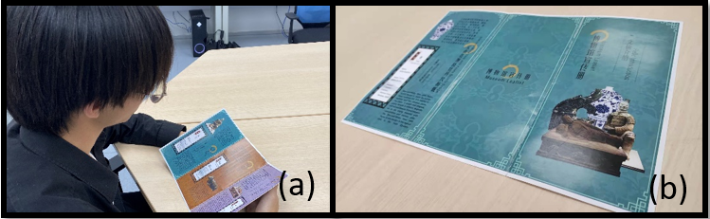

Figure 2. Demonstration of Leaflet. (a) A user using the Leaflet; (b) The physical Leaflet with text descriptions of artifacts.

***Postcard AR***

The design of Postcard AR is inspired by the Magic Book concept proposed by Billinghurst et al. [21]. They presented a prototype based on AR image recognition technology, including AR image recognition software and a physical book with image targets [22]. Users can scan the image targets from the book to trigger corresponding digital information. In this study, we apply the Magic Book design to the museum souvenir postcard. We adopt a standard postcard size of 14.8 x 10 centimeters. Users can view the artifact image and read the text descriptions on the postcard. In addition, they can use a smartphone to view the augmented cultural artifacts, its size information, and use touchscreen gestures to rotate and scale the object (see Fig. 3).

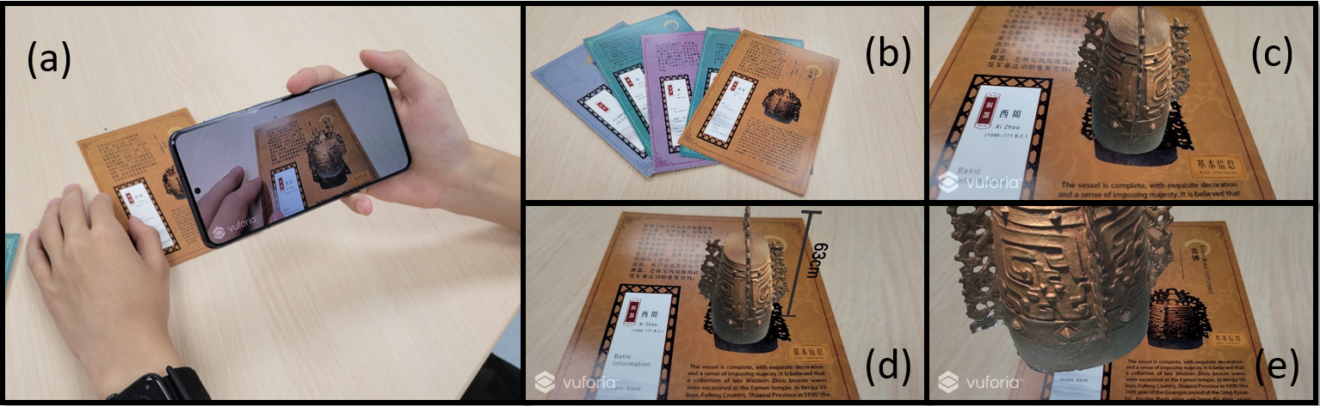

Figure 3. Demonstration of Postcard AR. (a) A user using the Postcard AR; (b) The physical postcards with text descriptions of artifacts; (c) A screenshot showing the 3D model of an artifact and the size information button; (d) A screenshot showing the 3D model and size of an artifact; (e) A screenshot showing a zoomed-in view of an artifact.

***CubeMuseum AR***

CubeMuseum AR provides participants with a 6 cm cube with six sides. The physical prototype consists of a wooden cube with acrylic card slots, and some cards with images of cultural artifacts. The cards can be replaced and reorganized and thus allow for personalization of the cube. Similar to the Postcard AR. users can use a smartphone to scan the card and trigger the augmented information, including a 3D model of the cultural artifact and two buttons for size information and text descriptions (see Fig. 4). The design of CubeMuseum follows the principle of embodied interaction [10], [23]. Users can interact with the cultural artifacts by rotating the physical cube. They can also use touchscreen gestures to rotate the view or zoom in and out to scale the virtual objects.

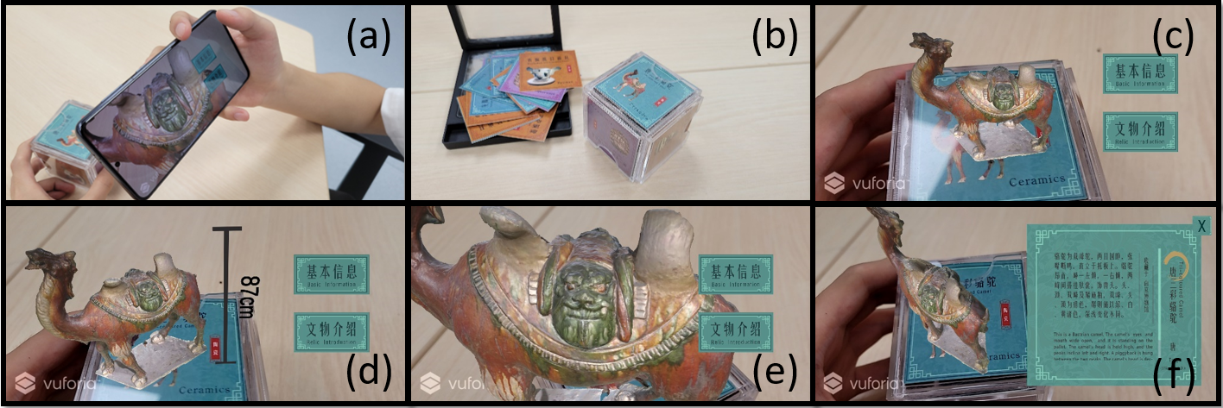

Figure 4. Demonstration of CubeMuseum AR. (a) A user using the CubeMuseum AR; (b) The physical CubeMuseum; (c) A screenshot showing the 3D model of an artifact, size information button, and text descriptions button; (d) A screenshot showing the 3D model and size of an artifact; (e) A screenshot showing a zoomed-in view of an artifact; (f) A screenshot showing the text descriptions of an artifact.

**Methodology**

We conducted a within-subjects experiment to evaluate user experience and learning effects with three different interaction interfaces: Leaflet (baseline), Postcard, and CubeMuseum. Both Postcard and CubeMuseum used in this study are AR-based interaction interfaces.

**Materials**

Twelve cultural artifacts were used for three experimental conditions, with four objects for each condition. The artifacts images were collected from museums and the 3D models were constructed using the close-range photogrammetry technique. To facilitate a valid comparison, we used four different artifacts applied in each implementation (see Table 1). Vuforia SDK was used for the AR development. The applications were deployed on a Samsung Galaxy S21 smartphone. All surveys were hosted on the LimeSurvey.

Table 1. Overview of twelve cultural artifacts

|  |  |  |  |  |  |  |
| --- | --- | --- | --- | --- | --- | --- |
| **#** | **Name** | **Picture** | **Size** | **Time Period** | **Museum** | **Category** |
| 1 | The Bronze Mask with Protruding Pupils |  | Height: 66cm  Width: 138cm | Shang  1600-1046 B.C. | Sanxingdui Museum | Bronze |
| 2 | Bronze Music Instrument |  | Height: 63cm | Western Zhou  1046-771 B.C. | Tianjin Museum | Bronze |
| 3 | Kneeling Archer |  | Height: 182cm  Width: 64cm | Qing  221-207 B.C. | Warriors Museum | Earthenware |
| 4 | Tri-coloured camel |  | Height: 87cm | Tang  618-907 A.D. | Nanjing Museum | Ceramics |
| 5 | Pottery Figure of a Standing Lady |  | Height: 138cm  Width: 26.6cm | Tang  618-907 A.D. | National Palace Museum, Taipei | Ceramics |
| 6 | Marble Statue of Sakyamuni |  | Width: 40cm | Liao  907-1125 A.D. | The Capital Museum | Marble |
| 7 | Gilded Bull |  | Height: 45cm  Width: 38cm | Western Xia  1038-1227 A.D. | Ningxia Museum | Bronze |
| 8 | Vajrasattva Bronze Status |  | Height: 58.5cm  Width:46.5cm | Western Xia  1038-1227 A.D. | Ningxia Museum | Bronze |
| 9 | Blue-and-White Vase with Peons Scrools Design |  | Height: 44cm | Yuan  1271-1368 A.D. | Nanjing Museum | Ceramics |
| 10 | Figure of an Assistant to the Judge of Hell |  | Height: 148cm  Width: 36cm | 1368-1644 A.D. | The British Museum | Ceramics |
| 11 | Eight Corners Case (Black) |  | Height: 31cm  Width: 27.3cm | Ming  1368-1644 A.D. | Zhejiang Museum | Lacquerware |
| 12 | Imari Covered Bowl with Floral Sprays |  | Height: 32cm  Width:28cm | Qing  1622-1795 A.D. | Palace Museum | Ceramics |

**Study Design**

In order to investigate how different interaction interfaces can affect intrinsic motivation, engagement and learning outcome, we used a within-subjects design across three conditions (Leaflet, Postcard AR and CubeMuseum AR). Each participant experienced all three conditions (see Table 2) and the sequence of the three conditions was counterbalanced. We used questionnaires to measure participants’ learning outcome, instinct motivation and user engagement. Ethics approval was obtained from the University Ethics Committee prior to any data collection.

Each participant will experience these three conditions after finish the pretest questionnaire and complete the questionnaires after finish each one to measure intrinsic motivation and engagement in different groups. In order to eliminate the order effect for evaluating the learning outcome, we did balance for all of the possible orders between the three conditions.

Table2: Overview of three experimental conditions.

|  |  |  |  |  |  |  |
| --- | --- | --- | --- | --- | --- | --- |
|  |  | | | |  | |
|  |  | | |
|  |  |  |  |  |
|  |  |  |  |  |  |  |
|  |  |  |  |  |  |  |
|  |  |  |  |  |  |  |

Table 2: Overview of three experimental conditions.

|  |  |  |  |  |  |
| --- | --- | --- | --- | --- | --- |
|  | Physical materials | | Digital presentations | | |
| Image, Name, Material | Text descriptions | 3D model | Size information | Text descriptions |
| Leaflet | **√** | **√** | X | X | X |
| Postcard | **√** | **√** | √ | √ | X |
| CubeMuseum | **√** | X | √ | √ | √ |

**Participants**

24 participants (12 males, 12 females) took part in the experiment (age M = 22.04, SD = 2.074). Most participants are university students recruited through media posts. Demographic information of participants are presented in Figure 5.

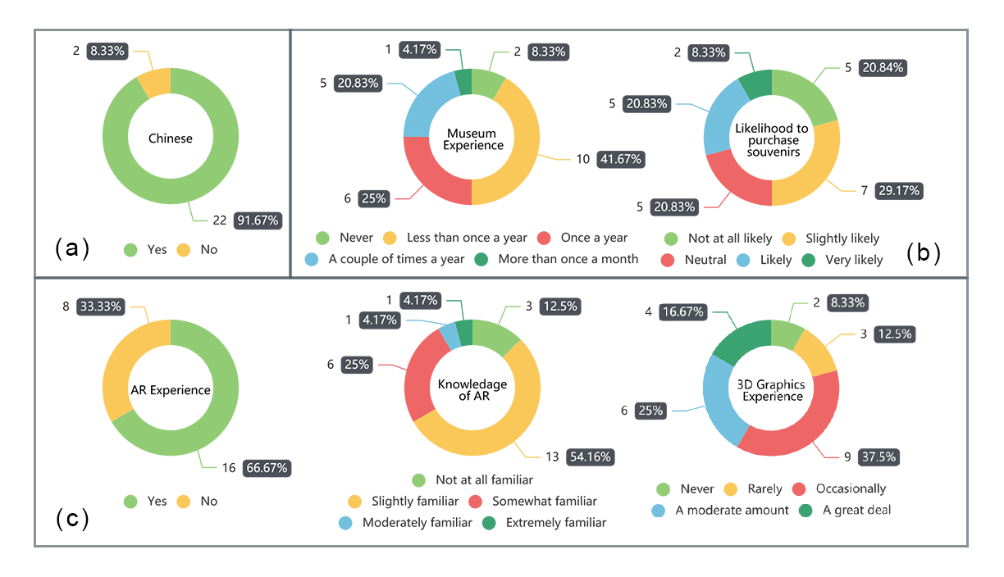

Figure 5. Participant demographic information of (a) nationality, (b) museum experience, and (c) prior experience with AR and 3D graphics.

**Measures**

We collected both quantitative and qualitative data to evaluate users’ intrinsic motivation, engagement and learning outcome. Our measures include the Intrinsic Motivation Instrument Questionnaire (IMI), User Engagement Scale Questionnaire (UES), and Artifact Information Test (AIT) that consists of object-specific questions. In addition, we conducted semi-structured interview with participants to discuss the advantages and disadvantages of the three interaction interfaces.

***Post-Experiment Questionnaire***

We measured participants’ intrinsic motivation and engagement with a series of questions based on the Intrinsic Motivation Instrument Questionnaire (IMI) and User Engagement Scale Questionnaire (UES) respectively [24]–[27]. Both measures consist of four dimensions or factors, of which the descriptions are summarized in Table 3 and 4. We followed the original questionnaire structure and asked participants to rate the IMI on a 7-point Likert scale, and the UES on a 5-point Likert scale.

Table 3. The factors of IMI with descriptions.

|  |  |
| --- | --- |
| **Factor** | **Description** |
| Interest and Enjoyment (IE) | Self-report measure of Intrinsic Motivation |
| Perceived Competence (PCO) | Positive predictor of Intrinsic Motivation |
| Perceived Choice (PCH) | Positive predictor of Intrinsic Motivation |
| Pressure and Tension (PT) | Negative predictor of Intrinsic Motivation |

Table 4. The factors of UES with definitions.

|  |  |
| --- | --- |
| **Factor** | **Definition** |
| Aesthetic Appeal (AE) | The users' perception of the visual appearance of a computer application interface |
| Focused Attention (FA) | The concentration of mental activity [28]; contained some elements of Flow, specifically focused concentration, absorption, and temporal dissociation [29]. |
| Reward Factor (RW) | Reward factor, labeled RW, which is a single set of items made up of the EN, NO and FI components in the original UES [26]. （O’Brien, H. L., Cairns, P., & Hall, M. (2018). |
| Perceived Usability (PU) | Users' effective (e.g., frustration) and cognitive (e.g., effort) responses to the system |

***Artifact Information Test***

In order to study the learning outcome, we adopt a pretest and posttest experimental design [30] and asked participants to provide answers to the Artifact Information Test (AIT). By comparing participants’ responses in the pretest and posttest, it allows us to determine how well each interaction interface can improve participants’ understanding of the cultural artifacts. Specifically, our design of the AIT allows us to measure users’ learning of cultural artifacts from six dimensions, including history, location, material, size, feature and description. Table X provides an example question for each dimension. The full list of AIT questions can be found in Appendix X. We used multiple choice questions in the test. Each question has one correct answer, three distractors, and an “I don’t know” option. We prepared 3 questions for each object, resulting in 12 questions for each condition and 36 questions in total.

***Interview***

We constructed a semi-structure interview outline with three parts: 1) participants’ subjective preferences of the three interaction interfaces, 2) open discussions on the strengths and weaknesses, and 3) potentials for gifting experiences. The first two parts of the interview questions are inspired by Pollalis et al ’s research [8]. We aim to explore participants’ subjective perspectives and acceptance of the interfaces, and encourage them to discuss the strengths and weaknesses of each interactive interface. In addition, participants were asked about their choices of souvenirs among the three options.

**Procedure**

Participants are briefed about the experiment, read the information sheet and sign the consent form at the start of each experiment. Prior to the experiment, tutorial sessions are provided for the two AR-based interaction interfaces (see Figure 6), with brief oral instructions given by the researcher.

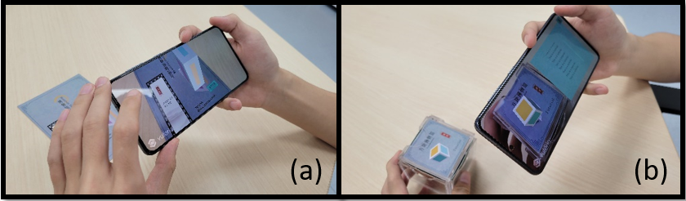

Figure 6. User in tutorials of the(a) Postcard AR and(b) CubeMuseum AR.

Each participant completed the pretest questionnaire, including demographic information and the AIT pretest. Our pilot studies showed that users spent about 3 minutes on average for each condition. Thus, we reminded participants of the time at 3 minutes, but allowed them to continue if they want. Throughout the three experimental sessions, we also observed participants’ interactions with the applications. The sequence of the three conditions were counterbalanced, as indicated in the condition boxes After completing each session, participants were required to complete the two posttests: 1) the AIT posttest, followed by 2) Post-Experiment Questionnaire that measures intrinsic motivation and engagement.. At the end of the experiment, the participants were invited to interviews. Figure 7 illustrates our experimental procedure.

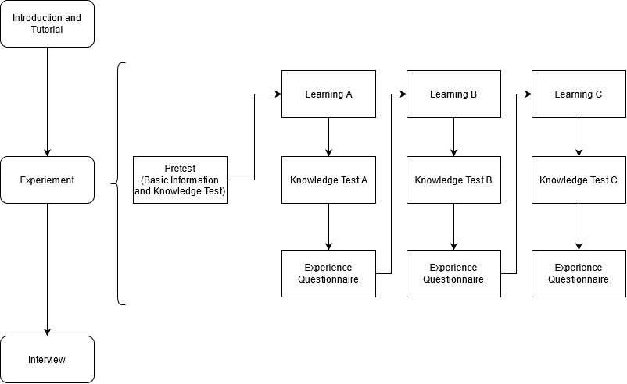

Figure 7. Experimental procedure. L = Leaflet, P = Postcard AR, C = CubeMuseum AR.

**Results**

We examined the data distribution of the post-experiment questionnaires and ensured the assumptions for parametric tests. One-way ANOVA was used for the comparison of questionnaire data rated on 7-point and 5-point Likert scales. The differences between conditions were analyzed with Tukey's post-hoc test. AIT yielded scores of either 1 (correct) or 0 (incorrect) for each question. We calculated the mean score of participants’ responses to the 12 questions for each condition and performed one-way ANOVA to compare differences between three conditions. We also performed paired-samples t-tests to compare the differences between the pretest and posttest of AIT. Figure 8 presents an overview of the questionnaire data analysis results.

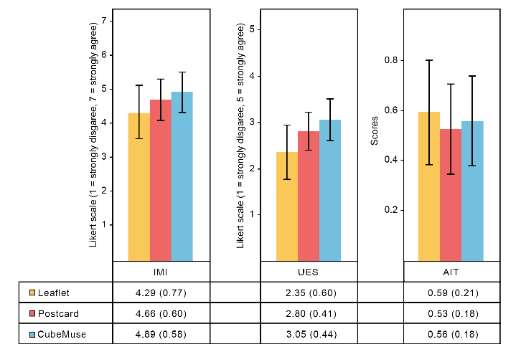

Figure 8. Means (with standard deviations) of the Intrinsic Motivation Instrument (IMI), User Engagement Scale (UES) and Artifact Information Test (AIT).

**Intrinsic Motivation**

A one-way ANOVA showed that there was a statistically significant difference in IMI between Leaflet, Postcard AR and CubeMuseum AR (F (2, 69) = 5.030, p = .009). Post-hoc tests indicated significant differences between Leaflet and Postcard (p = .132), and between Leaflet and CubeMuseum (p = 0.007). The differences between Postcard and CubeMuseum were insignificant (p = .464). Users were more motivated when using CubeMuseum (M = 4.86, SD = 0.58) and Postcard (M = 4.66, SD = 0.60) than using Leaflet (M = 4.29, SD = 0.77). Specifically, significant differences were reported in Interest and Enjoyment (F (2, 69) = 6.939, p = .002) and Perceived Choice (F (2, 69) = 3.632, p = .032) for IMI. Although the differences in Perceived Competence were insignificant, the scores on these two subscales show a slight trend (see Figure 9).

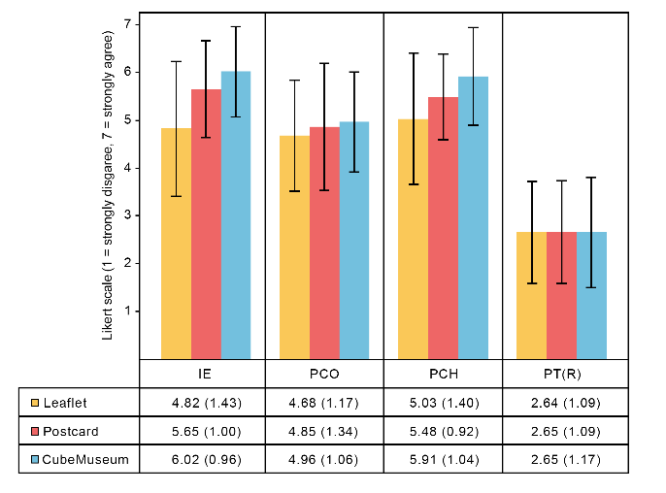

Figure 9. Means (with standard deviations) of the Interest and Enjoyment (IE), Perceived Competence (PCO), Perceived Choice (PCH), and Pressure and Tension (PT) in Intrinsic Motivation Instrument (IMI).

**Engagement**

A one-way ANOVA showed that there was a statistically significant difference in UES between Leaflet, Postcard AR and CubeMuseum AR (F (2, 69) = 14.105 p < .001). Post-hoc tests indicated significant differences between Leaflet and Postcard (p <.001), and between Leaflet and CubeMuseum (p <.001). The differences between Postcard and CubeMuseum were insignificant (p = .377). Users were more engaged when using CubeMuseum (M = 3.05, SD = 0.44) and Postcard (M = 2.80, SD = 0.41) than using Leaflet (M = 2.35, SD = 0.60). Specifically, significant differences were reported in Focused Attention (F (2, 69) = 11.174, p <.001), Aesthetic Appeal (F (2, 69) = 16.607, p <.001), and Reward Factor (F (2, 69) = 8.662, p <.001) for UES. Although the differences in Perceived Usability were insignificant, the scores on this subscale show a slight trend on numeric value (see Figure 10).

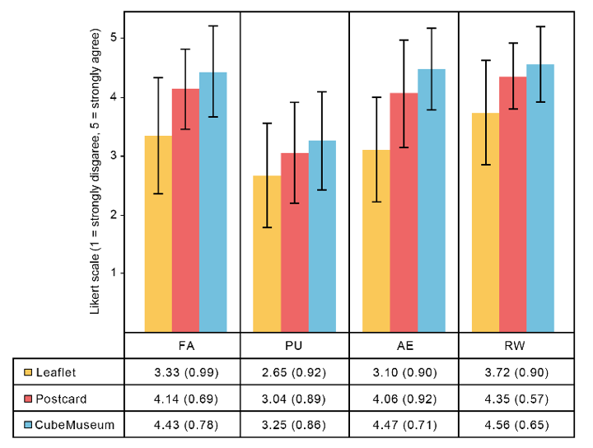

Figure 10. Means (with standard deviations) of the Focused Attention (FA), Aesthetic Appeal (AE), Reward Factor (RW) and Perceived Usability (PU) in User Engagement Scale (UES).

**Learning Outcome**

The analysis of the AIT showed no statistically significant differences between the three conditions in either the pretest (F (2, 69) = .664, p =.518) or the posttest (F (2, 69) =.755, p =.474). Nevertheless, paired-samples t-tests showed that the AIT posttest scores were significantly higher than the AIT pretest scores (p < .001). We further analyzed the 6 dimensions of AIT using the Friedman test since the data of the Feature dimension was not normally distributed. The results showed that there was a statistically significant difference in Location between Leaflet, Postcard AR and CubeMuseum AR (p <.001). Pairwise comparisons indicated significant differences between CubeMuseum and Leaflet (p =.004), and between CubeMuseum and Postcard (p =.012). The scores for CubeMuseum was significantly lower than Leaflet and Postcard (see Figure 11). No significant differences were found for the other dimensions.

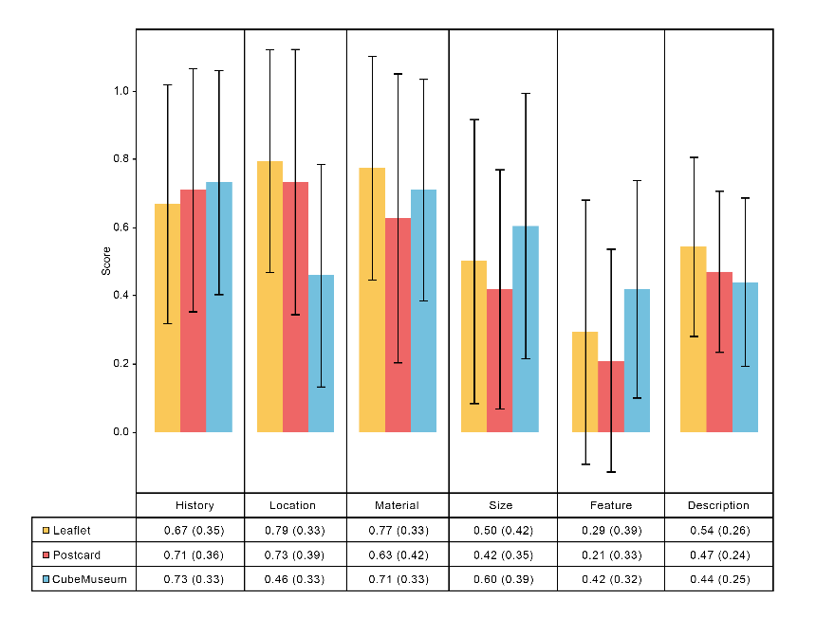

Figure 11. Means (with standard deviations) of the AIT pretest and posttest results.

**Additional Findings**

Although we reminded users of the time at 3 minutes, we did not limit the time of use for each condition. A one-way ANOVA showed that there was a statistically significant difference in learning time between Leaflet, Postcard AR and CubeMuseum AR (F (2, 69) = 9.540, p < .001). Post-hoc tests indicated significant differences between Leaflet and Postcard (p = .011), and between Leaflet and CubeMuseum (p < .001). The differences between Postcard and CubeMuseum were insignificant (p = .420). Users spent more time on using CubeMuseum (M = 3.96, SD = 1.27) and Postcard (M = 3.50, SD = 1.32) than using Leaflet (M = 2.42, SD = 1.18). This is in accordance with the qualitative feedback that we received in the interview. When asked which interaction interface they are more willing to use, most participants chose the AR-based interfaces, namely Postcard AR and CubeMuseum AR.

**Observations and Interviews**

At the start of the interview, we ask participants to rank the three interaction interfaces based on their subjective preferences. A Friedman test showed that there was a statistically significant difference in the ranking, χ2(2) = 12.583, p = .002. Post hoc analysis with Wilcoxon signed-rank tests was conducted with a Bonferroni correction applied, resulting in a significance level set at p < 0.017. There were no significant differences between Postcard and CubeMuseum (Z = -0.646, p = 0.518) or between Leaflet and Postcard (Z = -2.328, p = 0.020). However, the ranking for CubeMuseum was statistically higher than Leaflet (Z = -3.258, p = 0.001).

The qualitative analysis was based on observation notes and the recordings of the interview. Here we summarize a list of four themes in Table 5, which were found to be important factors in participants’ evaluations of interaction interfaces: Tangible Manipulation, Efficiency, Subjective Preferences, and Spatial Presence. Furthermore, we are also interested in the application of these interaction interfaces in museum gifting. Factors influencing users’ choices on this are summarized in Table 6, including Target Group, Value, Design and Material. We will present more detailed analysis of qualitative feedback in the discussion.

Table 5． Summary of important factors of interaction interfaces identified by participants.

Table 6. Summary of important factors of users’ choices in museum gifting.

**Discussion**

**Learning Outcome**

We explored the learning outcome based on the results of the AIT questionnaires. Although participants have distinct improvement under all three interactions, no significant differences were found in their respective effects on learning. The possible reason for this phenomenon is related to the time participants spent with each interaction interface. Through our observations and time records, we found that the time of participants using CubeMuseum and Postcard was around 3.5 minutes, and most of them spent less than 3 minutes on Leaflet. Although we have told participants before the experiments that the three minutes was just a reminder time but not an end time, many of them opted to stop once reminded. However, many participants did not finish their learning of all objects at 3 minutes. This is because the additional operations required for the text descriptions and the interactions afforded by the AR-based interfaces (such as rotation and scaling) have led to an increase in learning time. It is reasonable to speculate that the limitation can be mitigated if time is not controlled. The results of the six dimensions of learning showed that the learning outcome in CubeMuseum has a significant disadvantage in the Location dimension, although the three conditions provided the same amount of text information. This is possibly because the Location information was highlighted on the Leaflet and Postcard, but not on the image targets of the CubeMuseum. On the other hand, the correct rate of the Feature and Size dimensions were significantly higher for CubeMuseum than using the Leaflet. This further shows thatCubeMuseum could contribute to the visual aspects of learning. To conclude, users require more time in learning when using AR-based interfaces. Users’ learning outcome was significant under all three conditions, but the difference was not significant. An examination of the dimensions of AIT showed that CubeMuseum could better facilitate the visual aspects of learning, such as object sizes and features.

**Intrinsic Motivation**

The results of the IMI questionnaire indicated that usersfound more motivated to learn with CubeMuseum and Postcard than using Leaflet, and the scores for CubeMuseum were slightly higher than Postcard in most indicators. We infer that AR technology and 3D graphics have improved users’ intrinsic motivation, and our design has positively impacted users’ increased interest in cultural artifacts. Furthermore, users’ significantly higher rankings for CubeMuseum than Leaflet demonstrate that in addition to the 3D graphics presented in AR, the tangible interactions afforded by the CubeMuseum could further motivate users to learn about cultural artifacts.

**Engagement**

Users found AR-based interaction interfaces more engaging than the traditional paper-based approach. The significant differences found for the UES questionnaire showed that AR technology tends to better attract and sustain users' attention in learning cultural artifacts. AR-based interfaces can display the virtual replica of the cultural artifacts with 3D graphics, which provide users with more visual details of artifact appearances. This is a distinguishing advantage of AR systems compared to the traditional paper-based approaches.

Aside from the visual display, interactions also affect engagement. We have observed that users had frequent interactions with the smartphone to rotate or scale an object when using Postcard and CubeMuseum, whereas the interactions with Leaflet was very limited. The sense of control also played an important role in user engagement with cultural artifacts. Some participants reported that one aspect they like Postcard is that they can sort the placement of Postcard freely according to their preferences. At the same time, they can choose to rotate the Postcard or adjust the smartphone camera’s perspective based on their personal preferences. Both ways allow them to observe the 3D model from multiple angles, which helps them obtain detailed looks as well as a comprehensive view of an artifact. Users also mentioned that they have a greater sense of control with the CubeMuseum than Postcard. This has contributed to their engagement with cultural artifacts.

**Evaluation of the Interaction Interface**

Each of the interfaces has some strength in learning. We evaluate the interactive interface in four factors grouped on insights from the user operation and interview.

***Tangible Manipulation***

Under the two conditions on Postcard and the CubeMuseum, we provided two options to rotate. We observed that over half of the participants preferred rotating on the physical interface rather than using finger gestures on a virtual screen, indicating participants were effectively moving to a more direct interaction style.

***Efficiency***

The complexity of the operations also affects the learning time. The statistics of the observation also indicated that most participants spent less time on Leaflet than other learning. Like participant 9 mentioned: "I can focus on learning by Leaflet since taking all of the artifact information at a glance." That indicated some people are more emphasis on efficiency.

This finding seems to point to reading style. People received all information on paper reading as it showed on Leaflet, which enhances information memory in text, whereas in Postcard AR and CubeMuseum AR, they need some extra operations to switch the view frequently, and they are more dependent on spatial memory. The too-high degree of tangible will increase the time of learning but too low tangible result in boring for user.

***Spatial Presence***

When asked "which interaction interface leaves the most concrete mental graphics of the artifact," most of the participants ranked the CubeMuseum the highest, although it was not the only condition that had the 3D model in the AR system in the study. The virtual 3D models present more physical features of the artifacts, such as color and texture, which led to more vital mental images and lasting impressions. And compare with the Postcard, participants confirmed that the CubeMuseum enhances the immersive when they watch the 3D graphics since it can disable the text information.

***Preference***

After the interview, we count the number of users who like CubeMuseum and Postcard as are similar and more than Leaflet. Both CubeMuseum and Postcard interaction can stimulate user interest in artifacts because they fare better at the perception attributed to the 3D model, especially on size and feature. The descriptive statistics results in AIT also support this point. However, a few of the inspectorate prefer Leaflet since paper reading is more acceptable than new ways. They insisted the AR interaction is complex and classic way is easier to be acceptable. Interestingly, we found all of them are business students by asking, and we will discuss it more in the limitation section.

**Museum Gifting**

We also asked some questions about choosing museum gifting in interview, which contribute a lot to our study.

***Target Group***

As an innovative product, CubeMuseum is easily accepted by young people. In the interview, some users point out that they are more willing to choose CubeMuseum as a gift for children. On the contrary, older people are less interested the new things, so users are more willing to choose Postcard or Leaflet as souvenirs for the elder, and due to the universality, it is also easier to be accepted by more people.

***Value***

People also consider the performance ratio when they purchase things. Some people also consider this point. Based on the assumption of already owned a CubeMuseum, almost all participants are willing to collect the extra cards. Since the price of the extra cards is not very high, it will positively increase the probability of purchasing CubeMuseum.

***Design***

Throughout the interview, we found that the design is the crucial factor that is most frequently to involved. 3D graphics and the novel tangible interaction with AR are the keys for participants to choose CubeMuseum. Although Postcard also provides 3D experience with simple operation, some participants point out that some limitations existed on the design. Due to Postcard provide users more text information on the actual 2D picture, the zoom in the function of the 3D model may block the text that affects reading, and they also insisted the Postcard should not have too much text. For Leaflet, some people think it is inconvenient to flip it, and it is too ordinarily.

***Material***

Some of the participants focus on the material of the hybrid gifts. They indicated that the wooden cube is too heavy, which may affect the tangible interaction. And for the choosing of the paper should avoid reflective paper to ensure the information can be read in a comfortable environment.

***Implications for Design***

From the findings of this study and own experience, we see several implications for the design of interactive tangibles for museum gifting such as CubeMuseum, and summarized four guidelines.

***Perceive the size***

Throughout our study, we found the learning of the artifact size has no significant between three conditions, which are not quite our expectation. When participants checked the size on 3D models, they cannot perceive the actual size easily since the virtual artifact has a similar initial size displayed on the screen. And we concluded that adding a virtual object as a reference may improve the experience.

***Adaptable***

AR as a novel interactive technology provided an immerse experience so that it is popular in youth groups, but it is not suitable for the elder since they are not very open to accepting new things. So we can add extra paper reading information on the back of the card to link the traditional and new ways.

***Customized***

Some participants pointed out that the strength of the paper materials is to markdown or highlight things. This function also should be extended and implemented in digital reading on mobile.

***Expansibility***

When asked "If willingly to buy the extra expanded card for CubeMuseum," most participants expressed the CubeMuseum very high purchase Intention to collect cards that indicated the collection mechanism could promote in it.

**Limitations and Future Work**

We found that most users stopped their experience when they received the three-minute reminder. With an experimental design, the reminder of time could have given users the psychological hint that they need to stop. As a result, user took the AIT posttest before completing all the learning, which could have affected the learning outcome to a certain extent. Despite the intervention, the learning outcome has significantly increased as compared to the pretest results. Future work could consider setting up two groups to see if unlimited time could further increase the learning outcome, and to what extent. Nevertheless, unlike learning in the classroom, learning in museums is a long-term and informal process, and is largely influenced by the physical and sociocultural contexts. Future research may explore the impact of AR on users' long-term learning, and learning within the museum space. Some interesting findings were observed but our samples do not allow us to draw general conclusions. For example, we found that science students are more inclined to rank higher on CubeMuseum and Postcard, but all (N = 6) business students choose Leaflet as the one they prefer. Participants’ comments in the interview also showed that they believe AR has specific target users, such as children and young people. It is worth investigating in future work if such conception is true with empirical studies.

**Conclusion**

In this paper, we present a study based on three interaction interfaces for cultural artifacts: Leaflet, Postcard AR and CubeMuseum AR. We explored the differences in intrinsic motivation, engagement and learning outcome. Our findings indicated that users are more motivated and engaged in learning with AR interfaces, i.e., CubeMuseum and Postcard. The difference in learning outcome was insignificant, although we can see slightly better learning outcomes in the visual dimensions of artifact information tests, such as Feature and Size. Based on our observations and interviews, we provide an in-depth analysis on participants' perspectives and preferences of these three interaction interfaces. The Leaflet, despite its ordinariness, can present information effectively. The Postcard provides intuitive interactions with 3D graphics and maintains the learning advantage of paper reading. CubeMuseum provides greatest sense of control via tangible interactions, which largely stimulates users’ interest in learning of cultural artifacts. We further discussed the implications of our findings on the further design of hybrid gifts. Our study demonstrates the feasibility and practical value of tangible augmented reality interfaces for cultural artifacts. The results provide insights to museum practitioners in experience design, and have implications for technology-enhanced learning.

**Reference**

[1] K. H. Cheng and C. C. Tsai, “Affordances of Augmented Reality in Science Learning: Suggestions for Future Research,” *J. Sci. Educ. Technol.*, vol. 22, no. 4, pp. 449–462, 2013, doi: 10.1007/s10956-012-9405-9.

[2] R. Azuma, Y. Baillot, R. Behringer, S. Feiner, S. Julier, and B. MacIntyre, “Recent Advances Augmented Reality,” *IEEE Comput. Graph. Appl.*, vol. 21, pp. 34–47, 2001.

[3] A. Theodoropoulos and G. Lepouras, “Augmented Reality and programming education: A systematic review,” *Int. J. Child-Computer Interact.*, vol. 30, p. 100335, 2021, doi: 10.1016/j.ijcci.2021.100335.

[4] M. S. Markova, “How does the tangible object affect motor skill learning?,” *TEI 2014 - 8th Int. Conf. Tangible, Embed. Embodied Interact. Proc.*, pp. 305–308, 2014, doi: 10.1145/2540930.2558150.

[5] J. H. Seo, J. Arita, S. L. Chu, F. Quek, and S. Aldriedge, “Material significance of tangibles for young children,” *TEI 2015 - Proc. 9th Int. Conf. Tangible, Embed. Embodied Interact.*, pp. 53–56, 2015, doi: 10.1145/2677199.2680583.

[6] J. Ma, L. Sindorf, I. Liao, and J. Frazier, “Using a tangible versus a multi-touch graphical user interface to support data exploration at a museum exhibit,” *TEI 2015 - Proc. 9th Int. Conf. Tangible, Embed. Embodied Interact.*, pp. 33–40, 2015, doi: 10.1145/2677199.2680555.

[7] C. Pollalis *et al.*, “Evaluating learning with tangible and virtual representations of archaeological artifacts,” *TEI 2018 - Proc. 12th Int. Conf. Tangible, Embed. Embodied Interact.*, vol. 2018-Janua, pp. 626–637, 2018, doi: 10.1145/3173225.3173260.

[8] P. Koutsabasis, “Empirical Evaluations of Interactive Systems in Cultural Heritage,” *Int. J. Comput. Methods Herit. Sci.*, vol. 1, no. 1, pp. 100–122, 2017, doi: 10.4018/ijcmhs.2017010107.

[9] M. Akçayir, G. Akçayir, H. M. Pektaş, and M. A. Ocak, “Augmented reality in science laboratories: The effects of augmented reality on university students’ laboratory skills and attitudes toward science laboratories,” *Comput. Human Behav.*, vol. 57, pp. 334–342, 2016, doi: 10.1016/j.chb.2015.12.054.

[10] Y. Li, E. Ch’Ng, S. Cai, and S. See, “Multiuser Interaction with Hybrid VR and AR for Cultural Heritage Objects,” *Proc. 2018 3rd Digit. Herit. Int. Congr. Digit. Herit. 2018 - Held jointly with 2018 24th Int. Conf. Virtual Syst. Multimedia, VSMM 2018*, 2018, doi: 10.1109/DigitalHeritage.2018.8810126.

[11] E. Ch’ng, “New ways of accessing information spaces using 3D multitouch tables,” *Proc. 2012 Int. Conf. Cyberworlds, Cyberworlds 2012*, no. September, pp. 144–150, 2012, doi: 10.1109/CW.2012.27.

[12] B. SERRELL and B. RAPHLING, “Computers on the Exhibit Floor,” *Curator Museum J.*, vol. 35, no. 3, pp. 181–189, 2010, doi: 10.1111/j.2151-6952.1992.tb00753.x.

[13] R. Wang, L. Chen, and I. Solheim, “Modeling dyslexic students’ motivation for enhanced learning in E-learning systems,” *ACM Trans. Interact. Intell. Syst.*, vol. 10, no. 3, 2020, doi: 10.1145/3341197.

[14] X. Xin, J. Li, M. Jin, W. Liu, C. Liu, and Y. Zhang, “Improving the user experience in museum: A Joint course with Beijing Museum of Natural History,” *ACM Int. Conf. Proceeding Ser.*, pp. 30–36, 2019, doi: 10.1145/3332169.3333580.

[15] S. Neale, W. Chinthammit, C. Lueg, and P. Nixon, “Facilitating learning through hands-on engagement with virtual museum artefacts,” *Proc. 28th Int. BCS Hum. Comput. Interact. Conf. Sand, Sea Sky - Holiday HCI, HCI 2014*, pp. 222–227, 2014, doi: 10.14236/ewic/hci2014.27.

[16] C. K. Tsong, T. S. Chong, and Z. Samsudin, “Tangible multimedia: A case study for bringing tangibility into multimedia learning,” *Turkish Online J. Educ. Technol.*, vol. 11, no. 4, pp. 442–450, 2012, doi: 10.1016/j.sbspro.2012.11.045.

[17] C. Havrez, S. Lepreux, Y. Lebrun, S. Haudegond, P. Ethuin, and C. Kolski, “A Design Model for Tangible Interaction: Case Study in Waste Sorting,” *IFAC-PapersOnLine*, vol. 49, no. 19, pp. 373–378, 2016, doi: 10.1016/j.ifacol.2016.10.594.

[18] D. Petrelli, M. T. Marshall, S. O’Brien, P. McEntaggart, and I. Gwilt, “Tangible data souvenirs as a bridge between a physical museum visit and online digital experience,” *Pers. Ubiquitous Comput.*, vol. 21, no. 2, pp. 281–295, 2017, doi: 10.1007/s00779-016-0993-x.

[19] S. Benford, G. Giannachi, B. Koleva, and T. Rodden, “From interaction to trajectories: Designing coherent journeys through user experiences,” *Conf. Hum. Factors Comput. Syst. - Proc.*, pp. 709–718, 2009, doi: 10.1145/1518701.1518812.

[20] B. Koleva *et al.*, “Designing Hybrid Gifts,” *ACM Trans. Comput. Interact.*, vol. 27, no. 5, 2020, doi: 10.1145/3398193.

[21] M. Billinghurst, H. Kato, and I. Poupyrev, “MagicBook: Transitioning between reality and virtuality,” *Conf. Hum. Factors Comput. Syst. - Proc.*, no. figure 3, pp. 25–26, 2001, doi: 10.1145/634067.634087.

[22] R. Pingxuan, “AR 3D Magic Book,” no. Cipae, pp. 244–250, 2020, doi: 10.1145/3419635.3419714.

[23] P. Dourish, “Where the Action Is: The Foundations of Embodied Interaction,” *Where action is Found. embodied Interact.*, vol. 36, no. 3, p. 233, 2001, doi: 10.1162/leon.2003.36.5.412.

[24] R. M. Ryan and E. L. Deci, “Intrinsic and Extrinsic Motivations: Classic Definitions and New Directions,” *Contemp. Educ. Psychol.*, vol. 25, no. 1, pp. 54–67, 2000, doi: 10.1006/ceps.1999.1020.

[25] R. M. Ryan and E. L. Deci, “Self-determination theory and the facilitation of intrinsic motivation, social development, and well-being,” *Univ. Dar es Salaam Libr. J.*, vol. 13, no. 1, pp. 04–19, 2018.

[26] H. L. O’Brien, P. Cairns, and M. Hall, “A practical approach to measuring user engagement with the refined user engagement scale (UES) and new UES short form,” *Int. J. Hum. Comput. Stud.*, vol. 112, no. December 2017, pp. 28–39, 2018, doi: 10.1016/j.ijhcs.2018.01.004.

[27] M. Papastergiou, “Digital Game-Based Learning in high school Computer Science education: Impact on educational effectiveness and student motivation,” *Comput. Educ.*, vol. 52, no. 1, pp. 1–12, 2009, doi: 10.1016/j.compedu.2008.06.004.

[28] M. Matlin and T. Gullickson, “Cognition Without Reason: A Farewell to the Cognitive Revolution,” *Psyccritiques*, vol. 40, no. 7, 1995.

[29] M. Csikszentmihalyi and M. Csikzentmihaly, *Flow: The psychology of optimal experience*, vol. 1990. Harper \& Row New York, 1990.

[30] E. L. C. Law and X. Sun, “Evaluating user experience of adaptive digital educational games with Activity Theory,” *Int. J. Hum. Comput. Stud.*, vol. 70, no. 7, pp. 478–497, 2012, doi: 10.1016/j.ijhcs.2012.01.007.

**Appendix**

Appendix I: The overview of the AIT items

|  |  |  |  |
| --- | --- | --- | --- |
| **Theme** | **Interaction Interface** | **Code** | **Question** |
| **Material** | **Leaflet** | O3M | What is the material of the Kneeling Archer? |
| O7M | What is the material of the Gilded Bull? |
| **Postcard** | O10M | What is the material of the Figure of an Assistant to the Judge of Hell? |
| O11M | What is the material of the Eight Corners Case? |
| **CubeMuseum** | O5M | What is the material of the Figure of a Standing Lady? |
| O8M | What is the material of the Vajrasattva Statue? |
| **Feature** | **Leaflet** | O3F | Which of the following feature is not mentioned or incorrect about the Kneeling Arche? |
| O6F | Which of the following colors does not belong to the Marble Statue of Sakyamunit? |
| **Postcard** | O11F | Which of the following colors does not belong to the Eight Corners Case? |
| O12F | The texture that does not belong to the Chinese lmari Covered Bowl with Floral Sprays is: |
| **CubeMuseum** | O1F | Which of the following is characteristic of the Bronze Mask with Protruding Pupils? |
| O4F | Which of the following colors does not belong to the Tri-Colored camel? |
| **Size** | **Leaflet** | O3S | What is the correct size of the Kneeling Arche? |
| O7S | What is the correct size of the Gilded Bull? |
| **Postcard** | O2S | What is the correct size of the Bronze Music Instrument? |
| O10S | What is the correct size about Figure of an Assistant to the Judge of Hell? |
| **CubeMuseum** | O4S | The height of the Tri-Colored camel is: |
| O5S | The height of the Figure of a Standing Lady is: |
| **History** | **Leaflet** | O7H | Which dynasty does the Gilded Bull belong to? |
| O9H | Which dynasty does the Blue-and-White Vase with Peons Scrolls Design belong to? |
| **Postcard** | O2H | Which dynasty does the Bronze Music Instrument belong to? |
| O12H | Which dynasty does the Chinese lmari Covered Bowl With Floral Sprays belong to? |
| **CubeMuseum** | O1H | Which dynasty does the Bronze Mask with Protruding Pupils belong to? |
| O8H | Which dynasty does the Vajrasattva Statue belong to? |
| **Description** | **Leaflet** | O6D | Which of the following descriptions of the Marble Statue of Sakyamuni are incorrect? |
| O9D | Which of the following description is not mentioned or incorrect about the Blue-and-White Vase with Peons Scrolls Design? |
| **Postcard** | O2D | What is the research direction available to the Bronze Music Instrument？ |
| O11D | The cover surface of the Eight Corners Case reflects: |
| **CubeMuseum** | O1D | Which of the following descriptions of the Bronze Mask with Protruding Pupils are incorrect? |
| O8D | Which of the following descriptions of the Vajrasattva Statue are incorrect? |
| **Location** | **Leaflet** | O6L | Where is the Marble Statue of Sakyamuni collected? |
| O9L | Where is the Blue-and-White Vase with Peons Scrolls Design collected? |
| **Postcard** | O10L | Where is the Figure of an Assistant to the Judge of Hell collected? |
| O12L | Where is the Chinese lmari Covered Bowl With Floral Sprays collected? |
| **CubeMuseum** | O4L | Where is the Tri-Coloured camel collected? |
| O5L | Where is the Figure of a Standing Lady collected? |