CPT202

Assignment 2

Individual Report

Xingbo Wei

1824150

Group [23]

[Developer]

Table of Contents

Personal Project Summary 2

Personal Reflections on Projects 2

Contributions to the Project 2

Summary of Lessons Leant 3

References 3

# Personal Project Summary

ChuangSen is our sponsor of this coursework, this company want us to develop an app about booking gymnasium courts which is convenient for client to booking court and company to manage the gym. WeChat Mini Program is a trend of application development, it is an application that does not need to download, and easiness to control the background for clerk[1]. That is one of reason we choose this way to develop rather than independent application, the vital reason because WeChat is the most popular application in China, we based on WeChat to development our program is convenient for user, in user perspective, who prefer to use WeChat Mini Program rather than additional application. We chose agile software development for development as our developing methods. It requires the developer to intimate links with the product owner, and it is efficiently, quickly and high customer satisfaction and agile software is the becoming more and more popular in current year. But, it also has weakness, because all of us are a novice for the developer and we encountered a bottleneck in the development process, I will evaluate and analyse these issues later. When this app is official launch, ChuangSen can profit from this app. Not only for ChuangSen but our team also ‘profit’ from this software development. As a developer in our team, the ability of JavaScript coding is multiplied rapidly, and learn how to construct the struct of the database, in this project I present the number list and how to connect the database with the user interface. But I think the most important thing I learned is cooperating with other developers using azure and confer with the scrum master product owner. Developing a program not complete by one person, co-development is the only way to develop a program. next, I will critical of the project management and development process.

# Personal Reflections on Projects

We divide our project into four parts, UI design, Front-end, Back-end and Database. All of the processes are completely before sprint 4, in sprint 5 we will optimize the UI and online the program. we plan to construct the database and connect it with the servers, the first difficult problem is what is the suitable container for store the user info and court status in the case of ChuangSen don’t give us any database information. Initially we analyze the count of user’s information such as name, phone number, order information and court status. Unfortunately, we don’t consider which items can be used as a certificate to log in. We initially consider the Wechat UUID[2] as the user identity to log in and as the primary key to store in the database. But I deny this scheme because it does not satisfy the Do Not Surprise the User design principle, because when using access this Wechat Mini Program the first time who cannot find registered or log inbox, it will confuse the user because user don’t know whether login success. Consider that, I design a log entrance in My page. When the user first access our WeChat Mini Program, the My page[pic1] will show users the entrance of login/register in the canter in this page, and user can only press entrance button. After login, the page will show the user Wechat profile photo to let user know login success. Apply this design will satisfy the Provide Feedback design principle.

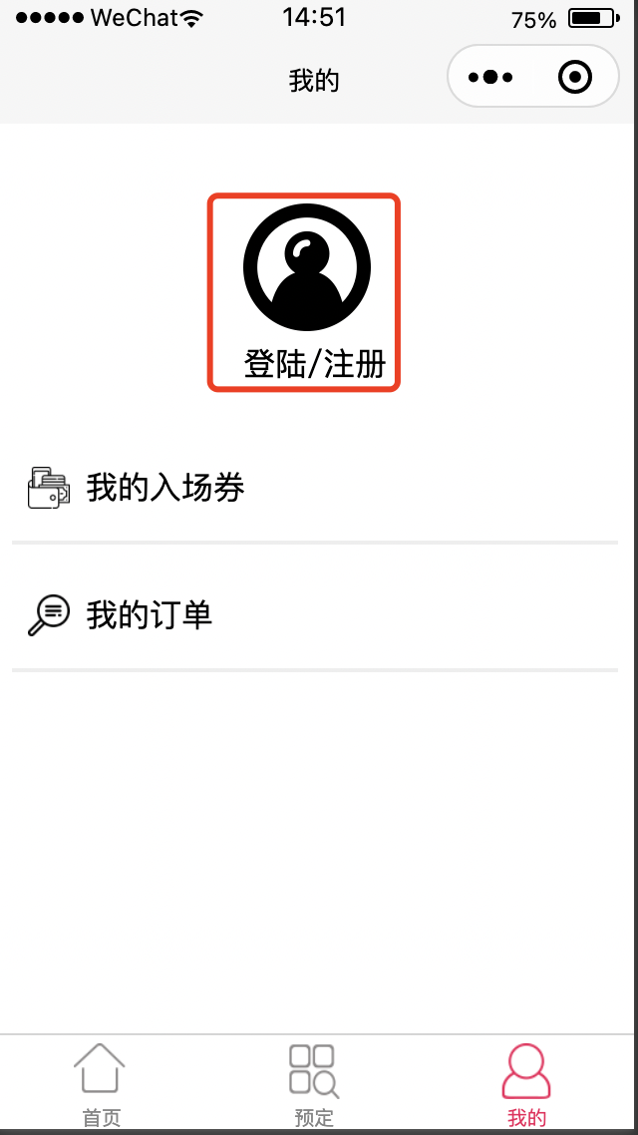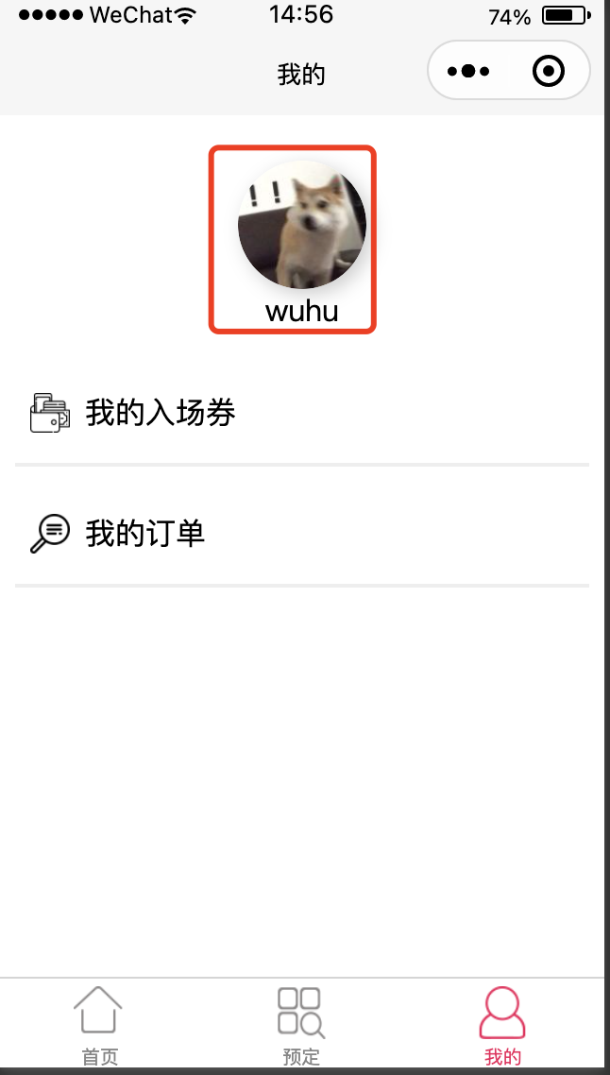

[pic1] [pic2]

Finished this sprint, we invite five students as a volunteer to test this mini-program use usability evaluation methods. volunteer experience our the alpha version and write our questionnaire, we set three questions, if this app easy to accomplish register the first time? How quickly to accomplish booking court? How pleasant to use the design? All of the volunteers give a positive comment. Although the UUID I mentioned above is not used in the id identify the key in the login function, but it important for order identify the primary key, next I will why it is important and give more detail about what I responsible for this program.

# Contributions to the Project

I am responsible for the database design and connect it with back-end, during the application develop I meet two problems. Initially, we can’t recognize order, because it has a lot of order items in the database. This time, I apply UUID to identify the order, use this identify method, every items has _id(UUID) in the order list. When user register a count, back-end will add user information, meanwhile, it will create a UUID store into this item. When user booking a court, the order information will add UUID into database item. In this way, we solve the problem that order item don’t know who belongs to.

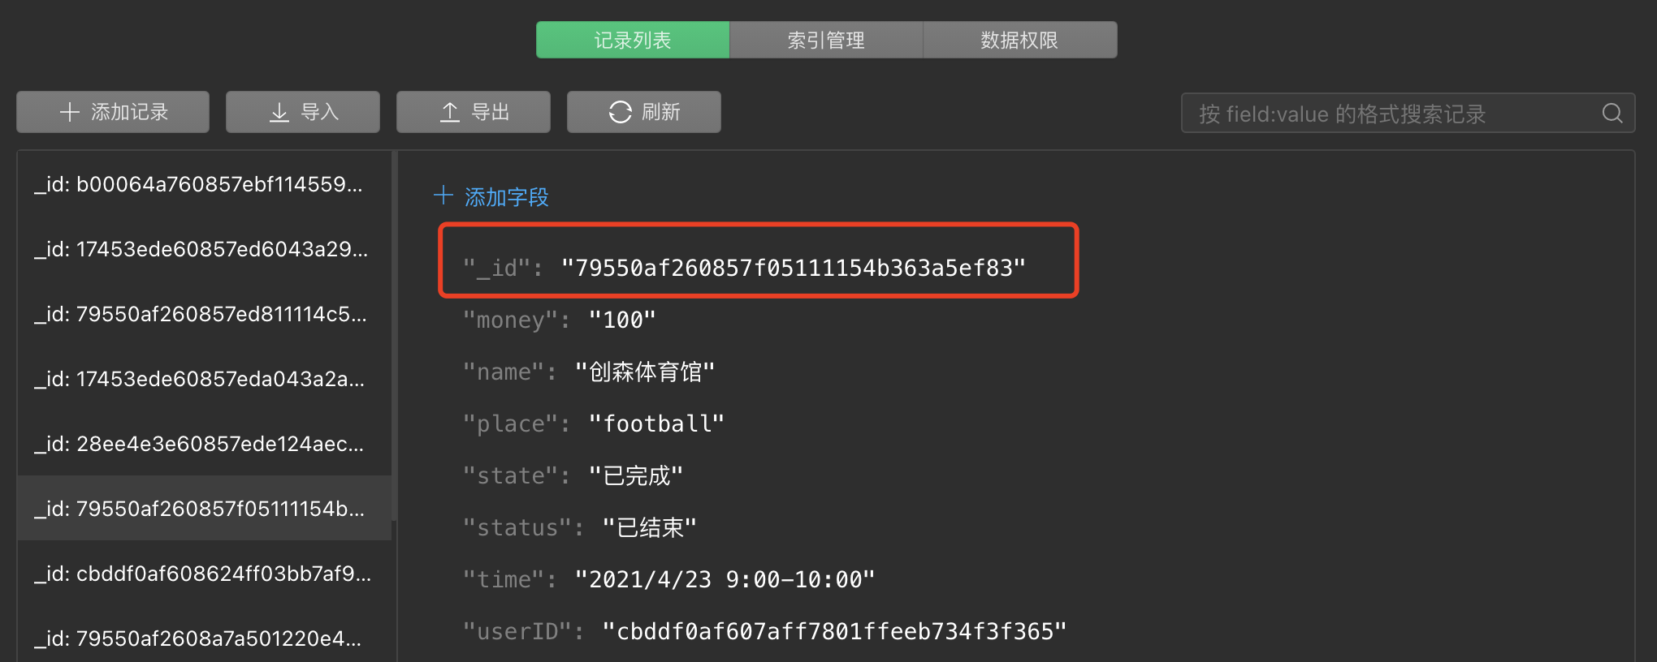

The second problem is about order QR code. ChuangSen company request us there should have a QR code about the next order information, when user enter gym, and show QR code to machine, the machine will record the login time and charge if user overtime. The problem is how to create the QR code and how to let the QR code show the correct information. To solve this problem, I use the npm[3] package to draw the QR code and write the SQL instruct to find the newest order.

Database is my duty. In a real application, application is failed until the payment function finished, payment function will determine whether ChuangSen can earn money. Because the database structure is design by me, the other developer doesn’t know how to design the payment interface, and hot to connected with the database when user may success.

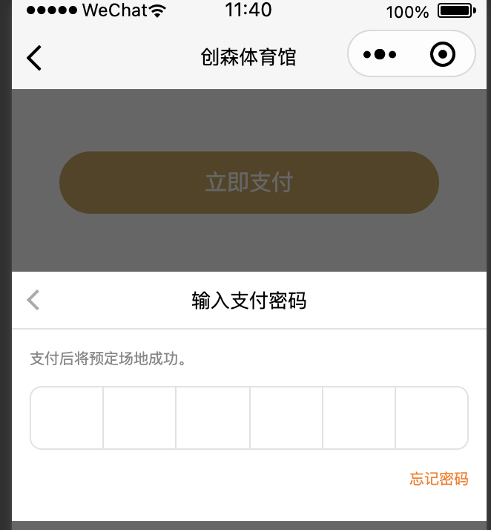

In this program developing I get the more skills about database: how to build the suitable table and how to cooperate with Front-end developer member. Developing this application, I apply many knowledge which I learned in XJTLU for the first time, when design a function, you should draw suitable UML scheme as develop background, it can improve efficient of development. In database design, this knowledge also from year 2 course. In this coursework, I am response for many part and I communication with other developer positive and guide the front-end developer to design suitable interface so I think I have qualification to get full percentage of the project marks. Next I will give the summary about this coursework and what I assimilate and how to apply in the feature.

# Summary of Lessons Leant

In this group project, all of the members are the first time to contribute a real application. For me, the level of coding has been improved rapidly, as a developer communication is crucial, you have to read other member’s code and write a low coupling code to coinvent other developers to call the special method which you write. The version control is also important so we use git to manage our version, a real app development process is complex, we don’t not which version is suitable so we need to continually evaluate every function. Continue to evaluate it means you should connect with other developers, connect with the product owner and scrum master, that why I think communication is most important. A real program is not one person’s task, it should cooperate with other members. In feature development, I think the first things is to write a complete software document and continuously adjust after communication. The second things is to read official document, finally and most important: communication with others developer.

# References

[1] Tencent. ”WeChat-Mini-Program Development Guide”. Weixin public doc. <https://developers.weixin.qq.com/miniprogram/en/dev/framework/>(2016.9.21)

[2] <https://opensource.apple.com/source/CF/CF-299.35/Base.subproj/uuid.c.auto.html>

[3] https://github.com/yingye/weapp-qrcode