CRUD to Articles.

Create Article: first Login: and put the Token in Auth, always put images

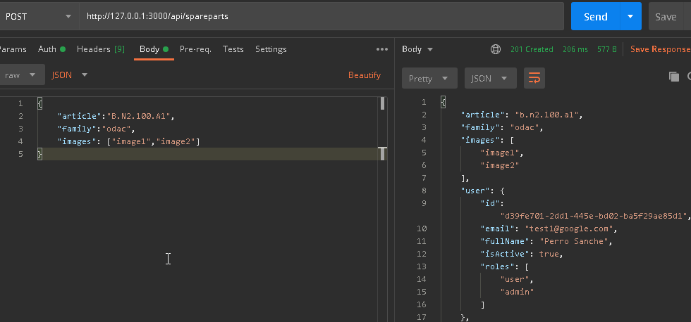

Update by Article or by ID. Sen the token in Auth

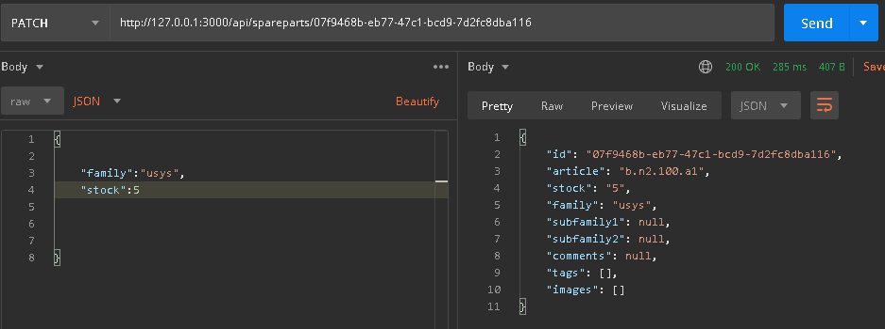

Get All Articles
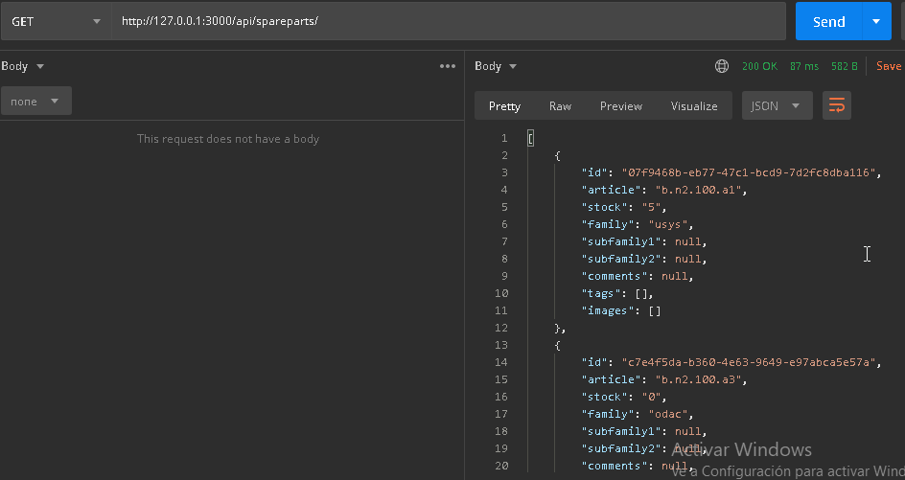

or using limit and offset:
http://127.0.0.1:3000/api/spareparts/?limit=10&offset=1

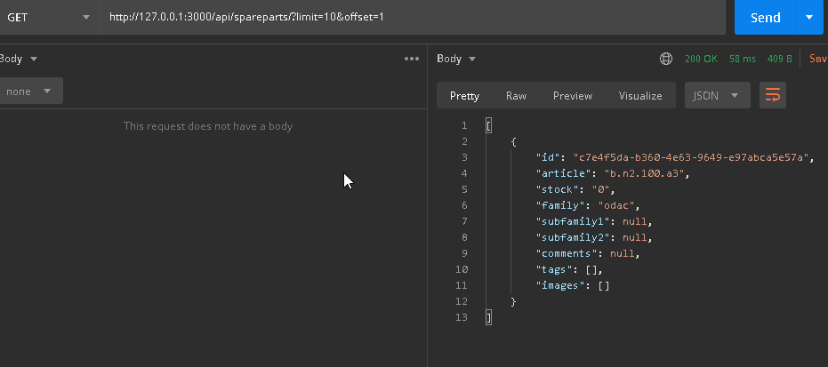

Delete:

http://127.0.0.1:3000/api/spareparts/c7e4f5da-b360-4e63-9649-e97abca5e57a (ID to Delete)

but consider only disabling to avoid referential losses in the DB.
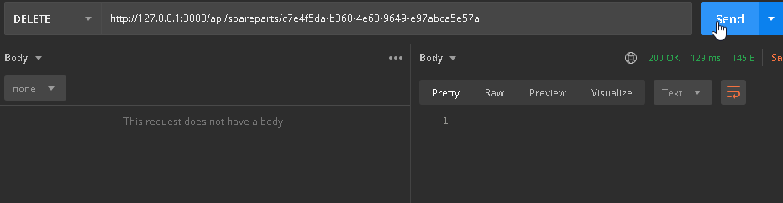
Upload File:

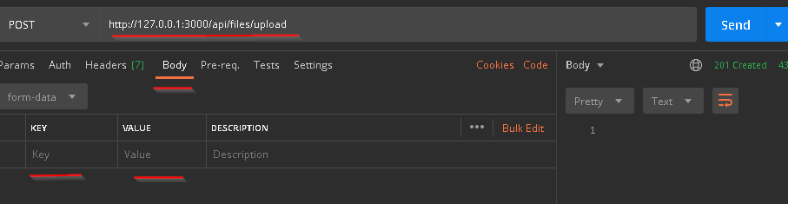
sellect:
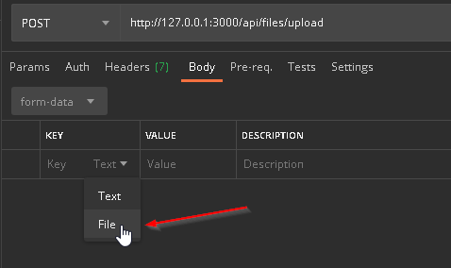

sellect file:
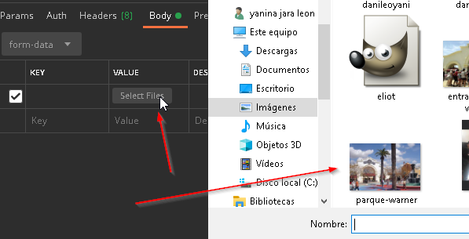

Key = MyFile is the key used in the backend

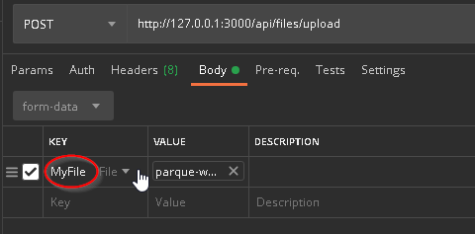

files/upload

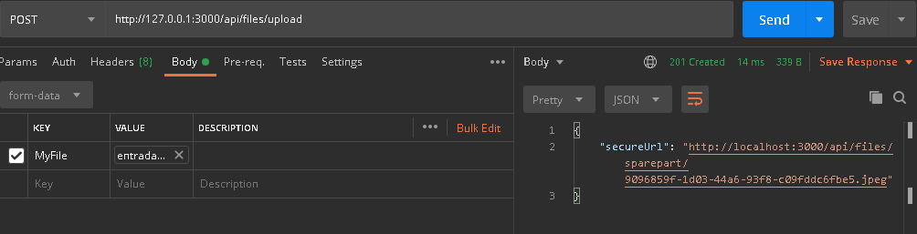

secureUrl= link to image

or find using image name:
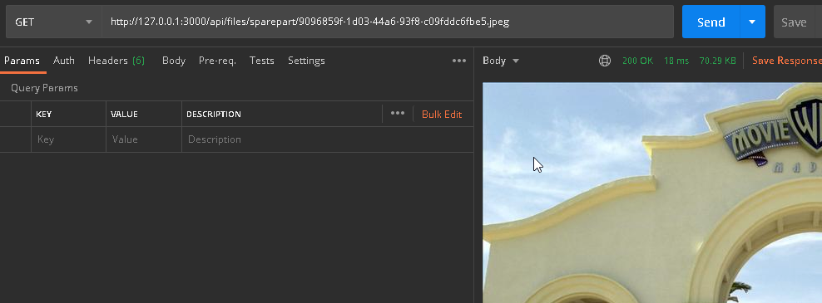

user register: by default the user is create whit role: user; to create a role admin is directly made in the BD in the column roles;

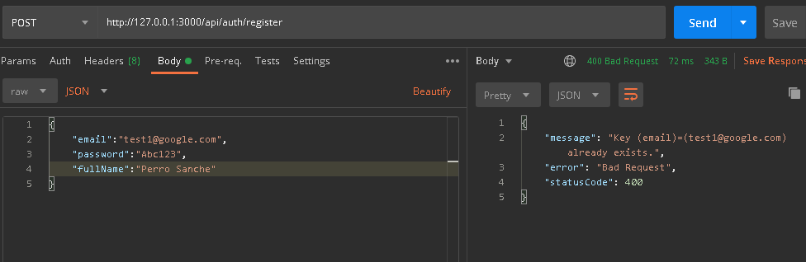

login user:

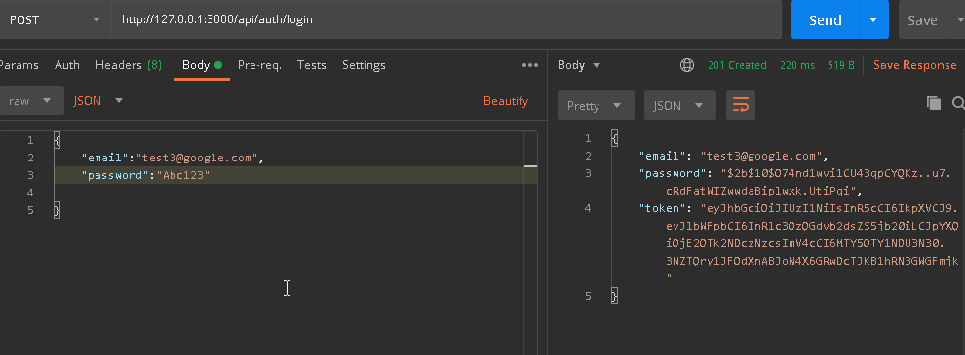

whit this token, we need to validate the areas in the backend; copy the token and paste it in the
Auth -- Type: BearerToken; to browse to private and private1 link
also need this to create update or delete (desactive) spareparts

