AI-Enabled Drone System for Real-Time Disaster Loss Assessment and Damage Detection

Siva Sankar.C Electronics and Communication Engineering
Francis Xavier Engineering College
Tamil Nadu,India
siva140605@gmail.com

Dr.K.Lakshmi Narayanan Electronics and Communication Engineering
Francis Xavier Engineering College
Tamil Nadu,India
Ramasamy.R Electronics and Communication Engineering
Francis Xavier Engineering College
Tamil Nadu,India
mavericksriram.1818@gmail.com

Rajavel.A Electronics and Communication Engineering
Francis Xavier Engineering College
Tamil Nadu,India
rajavel.ug.22.ec@francisxavier.ac.in

Abstract— Natural disasters like earthquakes, floods, cyclones, landslides, and wildfires can cause significant damage to infrastructure. They also lead to severe human, environmental, and economic losses. Quick and reliable damage assessment is crucial for emergency response, rescue planning, and recovering after a disaster. Traditional disaster assessment methods rely heavily on manual ground surveys, satellite images that arrive late, or subjective visual checks. These approaches tend to be slow, costly, unsafe, and not ideal for large-scale disasters.
This paper introduces a drone system powered by AI that is designed for real-time disaster loss assessment and automated damage detection. The system combines unmanned aerial vehicles (UAVs) with deep learning-based computer vision techniques to analyze high-resolution aerial images. We develop a modular system architecture to support real-time image acquisition, preprocessing, damage classification, spatial analysis, and loss estimation. The system provides quick situational awareness by automatically detecting damaged structures and classifying the severity of the damage. Tests using established disaster datasets show that this approach achieves high classification accuracy and greatly cuts down assessment time compared to traditional manual methods. The findings confirm that AI-driven UAV systems can be an effective and scalable solution for modern disaster management.
Keywords—Unmanned aerial vehicle, disaster management, artificial intelligence, deep learning, computer vision, damage detection, loss assessment, real-time analysis.
1.INTRODUCTION
Natural disasters pose a major global challenge. They impact millions of people each year and cause serious damage to infrastructure, ecosystems, and livelihoods. Earthquakes can bring down buildings in seconds. Floods can drown whole cities. Cyclones can ruin coastal areas, and landslides can cut off communities by destroying transportation routes. After these events, quick decision-making is crucial. This requires reliable information about how bad the damage is.
Traditional methods for assessing damage after disasters depend a lot on ground surveys carried out by trained professionals. These methods can provide detailed observations, but they face challenges with accessibility, safety, and time. Often, roads are blocked, communication networks fail, and affected areas can remain unreachable for days or weeks. Because of this, relief efforts may be delayed, causing more human suffering and financial loss.
Satellite-based remote sensing has been used as an alternative to ground surveys. However, satellite images often come with limited detail, issues with cloud cover, long return times, and delays in availability. These problems make them less effective for quick disaster response. On the other hand, unmanned aerial vehicles (UAVs) can be deployed quickly, fly flexible routes, and capture high-resolution images from low altitudes.
Bringing together artificial intelligence (AI) and UAV technology allows for automated analysis of disaster images. Deep learning algorithms, especially convolutional neural networks (CNNs), have shown strong results in image classification and object detection. By merging UAV data collection with AI analysis, we can achieve real-time damage detection and loss estimation with little human involvement.
This paper suggests an AI-enabled drone system for assessing disaster losses and detecting damage in real time. The main goal is to create a scalable, accurate, and efficient framework that helps emergency response teams by providing timely information on damage.
2.RELATED WORK
In recent years, researchers have put significant effort into using UAVs for disaster monitoring and damage assessment. Early studies mainly used UAVs as aerial cameras to take pictures for manual inspection. These systems improved visibility of affected areas but still required human interpretation, which limited their scalability and speed. Later research introduced machine learning techniques to automate damage classification. Traditional algorithms like support vector machines (SVMs), decision trees, random forests, and k-nearest neighbors (KNN) were used to extract features from aerial images. While these approaches reduced the need for human effort, their effectiveness was limited by how features were designed and their sensitivity to changes in the environment. The rise of deep learning changed the game for image-based damage assessment. Convolutional neural networks (CNNs) allowed for automatic feature extraction from raw images, greatly improving accuracy. Researchers used deep CNN architectures for classifying building damage after earthquakes and floods, showing promising results. They also explored object detection frameworks like YOLO and Faster R-CNN to identify damaged structures. Despite these advancements, many current systems work offline and need a lot of post-processing. Real-time use is challenging due to computational complexity, communication delays, and limited processing power on board. Additionally, most studies focus on a single type of disaster or small datasets, which limits their general usefulness. The proposed system aims to fill these gaps by offering a unified, real-time AI-driven framework that can handle various disaster scenarios while supporting loss estimation and decision-making.
3. SYSTEM OVERVIEW
The proposed system is a drone-based framework that uses AI for real-time disaster loss assessment and damage detection. Its main goal is to provide quick, accurate, and reliable damage information to help emergency response and disaster management.
The system employs an unmanned aerial vehicle (UAV) equipped with a high-resolution camera to take images of areas affected by disasters. These images are captured from locations that may be unsafe or hard for people to reach. The collected data is then sent to a ground station or processing unit for further analysis.
Artificial intelligence techniques, especially deep learning for image analysis, automatically detect and classify damage levels from the images. The system processes data nearly in real-time, allowing for a swift assessment of affected areas. The identified damage information is shown through a user-friendly interface, helping disaster response teams make informed decisions.
Overall, the system combines UAV technology with AI-driven data processing to improve the speed, accuracy, and safety of disaster damage assessments.
4. SYSTEM ARCHITECTURE
The proposed AI-enabled drone system is designed as a modular, scalable framework that operates in real time. The system includes the following key components:
- UAV platform
- Image acquisition module
- Communication subsystem
- AI-based processing engine
- Visualization and decision-support interface
The UAV captures high-resolution images of areas affected by disasters and sends them to the processing unit through a wireless communication link. The AI engine analyzes the images to find damaged structures and assess the severity of the damage. The results are shown on a user-friendly dashboard for disaster management authorities.
5.METHODOLOGY
A. Image Acquisition
The unmanned aerial vehicle (UAV) has a high-resolution RGB camera mounted on a stabilized gimbal. This setup ensures clear, vibration-free image capture. The drone follows a set flight path that covers the entire disaster area in a systematic way. This planned movement helps avoid blind spots and ensures even data collection. During image capture, GPS coordinates are recorded for each image. This allows for accurate geospatial mapping and location-based damage analysis.
B. Image Preprocessing
The captured aerial images go through several preprocessing steps to improve data quality and model performance. These steps include image resizing to keep input dimensions consistent, noise reduction to get rid of unwanted disturbances, contrast enhancement to emphasize damaged areas, and normalization to standardize pixel values. These preprocessing tasks reduce variations from lighting conditions, camera angles, and sensor noise, leading to more reliable inputs for the deep learning model.
C. Damage Detection Using Deep Learning
A convolutional neural network (CNN) is used to automatically detect and classify structural damage from aerial images. The CNN extracts important spatial and texture features without needing manual feature design. Based on these features, the model classifies structures into different damage categories, which include:
- No damage
- Minor damage
- Major damage
- Completely destroyed
The model is trained with labeled disaster images and optimized through backpropagation to reduce classification errors. This method enables accurate and consistent damage detection across various disaster scenarios.
D. Loss Estimation
Loss estimation involves analyzing the extent and severity of detected damage. The system calculates the damaged area for each structure and assigns severity scores based on the damage category. These scores are combined to create an approximate estimate of economic loss. This estimated loss information assists disaster management authorities in prioritizing rescue operations, allocating resources effectively, and planning recovery strategies.
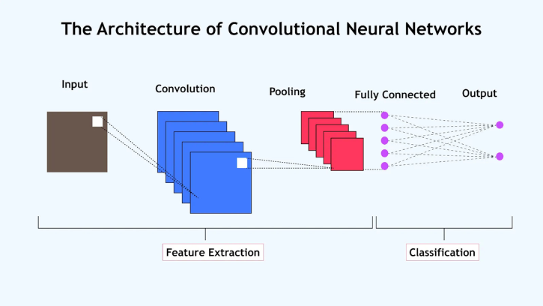
Fig 1: THE ARCHIETECTURE OF CNN
6. DATASET DESCRIPTION
The data used in this study consists of aerial images collected from publicly available post-disaster datasets. These datasets include images captured after natural disasters such as earthquakes and floods. The images represent various levels of damage to buildings and infrastructure, providing a realistic representation of disaster-affected areas.
Each image in the dataset is labeled according to the severity of damage. The damage categories include no damage, minor damage, major damage, and completely destroyed structures. These labeled images are used to train and evaluate the deep learning model.
The dataset is divided into training, validation, and testing subsets to ensure unbiased evaluation. The training set is used to learn damage patterns, the validation set is used to tune model parameters, and the test set is used to measure the final performance of the system. The diversity of the dataset helps the model generalize well across different disaster scenarios.
7. EXPERIMENTAL SETUP
The experimental setup aims to assess how well the proposed AI drone system works for disaster loss assessment and damage detection. This setup includes the hardware configuration, software tools, dataset used, and the evaluation process.
A. Hardware Setup
A quadcopter drone with a high-resolution RGB camera captures aerial images of disaster-affected areas. The drone has a GPS module to record locations. A ground station with a computer processes the data. This computer has a GPU to help train and test deep learning models.
B. Software Environment
The system is developed using the Python programming language. Deep learning tasks utilize a standard neural network framework. For image preprocessing, training, and testing, it uses common scientific libraries. The drone runs standard flight control software.
C. Dataset Used
The experiment works with publicly available post-disaster aerial image datasets. This dataset includes images taken after events such as earthquakes and floods. Each image is categorized by damage levels, which include no damage, minor damage, major damage, and destroyed.
D. Data Preprocessing
All images are resized to a fixed size before training. Techniques for noise removal and normalization improve image quality. Data augmentation methods like rotation and flipping help increase the dataset size and improve model reliability.
E. Model Training
A convolutional neural network (CNN) classifies the damage levels. The model is trained with labeled images using the Adam optimizer and a fixed learning rate. Training continues for several epochs until stable accuracy is reached.
F. Testing and Evaluation
After training, the model is tested with unseen images from the test dataset. The system predicts damage levels for each image. Performance is measured using accuracy, precision, recall, and F1-score metrics.
8. BLOCK DIAGRAM
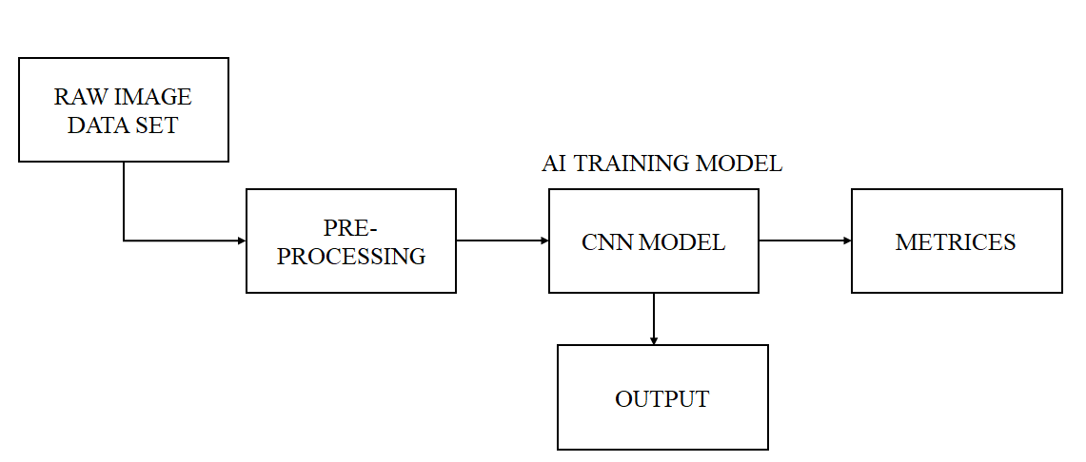
Fig 2: Training Block Diagram
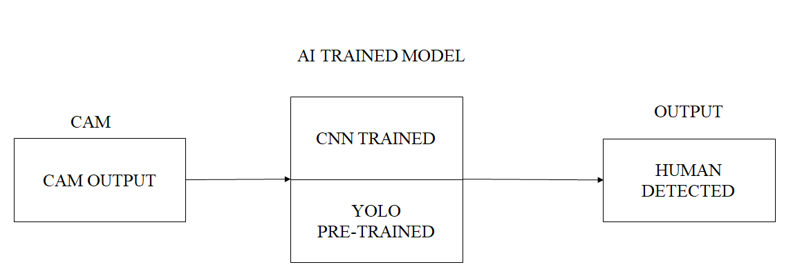
Fig 3: Testing Block Diagram
9. PARAMETER SETTINGS
The deep learning model parameters are selected carefully to ensure stable training and reliable performance. The convolutional neural network (CNN) uses the Adam optimizer for efficient and adaptable learning. The learning rate is set at 0.001 to promote gradual convergence and avoid significant changes in model weights.
We use a batch size of 32 to find a balance between training speed and memory usage. The model undergoes training for several epochs, allowing it to capture meaningful features from the dataset. Training stops when the validation performance stabilizes to prevent overfitting.
To enhance generalization, we apply data augmentation techniques like rotation, flipping, and scaling during training. These methods help the model to perform consistently across various disaster scenarios and image conditions.
10. PERFORMANCE METRICS
The performance of the proposed AI-enabled drone system is evaluated using standard classification metrics to measure how accurately and reliably it detects damage. These metrics help us understand how well the system identifies and classifies different levels of disaster damage.
Accuracy measures the overall correctness of the model. It reflects the ratio of correctly classified images to the total number of test images. A higher accuracy value shows better overall performance.
Precision measures the model's ability to identify damaged structures correctly while avoiding false alarms. High precision indicates that the system makes fewer incorrect damage predictions.
Recall assesses the system's ability to detect all actual damaged structures present in the disaster area. A high recall value means that the model successfully identifies most of the damaged regions.
The F1-score is the harmonic mean of precision and recall. It provides a balanced evaluation of the system, especially when the dataset has uneven damage categories.
Besides classification metrics, processing time per image is also considered to evaluate the system's capability for real-time use. Lower processing time means faster damage assessment, which is crucial during emergency response operations..
11. RESULTS AND ANALYSIS
The experimental results show that the proposed AI-enabled drone system works well in detecting and assessing damage from disasters. The system was tested with aerial images that were not part of the training set, ensuring a fair evaluation.
The model achieved good accuracy in classifying various levels of damage, including no damage, minor damage, major damage, and destroyed structures. This indicates that the system can accurately identify damage patterns in aerial images.
The precision results show that the system makes fewer incorrect damage predictions. This is crucial in disaster situations because false detections can lead to the wrong use of rescue resources. High precision ensures that the areas identified as damaged are trustworthy.
The recall values indicate that the system can detect most of the actual damaged structures in the images. This confirms that the model does not overlook many damaged areas, which is vital for emergency response planning.
The F1-score reflects a good balance between precision and recall, showing that the system performs well across different damage categories.
In terms of processing time, the system analyzes images quickly, allowing for near real-time damage assessment. Compared to traditional manual surveys, this system significantly cuts down on assessment time and human effort.
Overall, the results confirm that the AI-enabled drone system provides accurate and timely assessments of disaster damage and can be effectively used in real-world disaster management situations.
12. OUTOPUT ANALYSIS
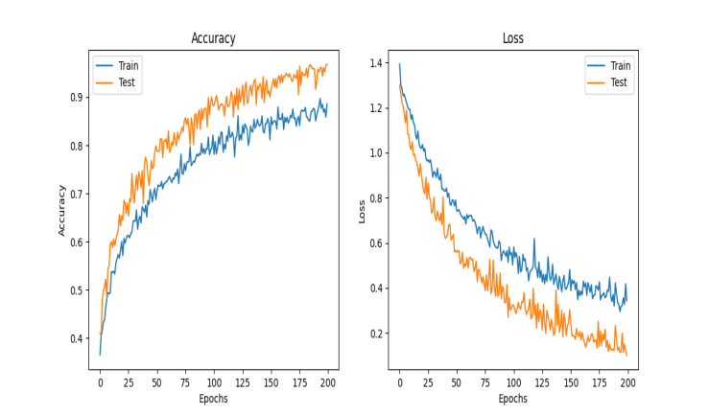
Fig5: Graph for Accuracy and Loss
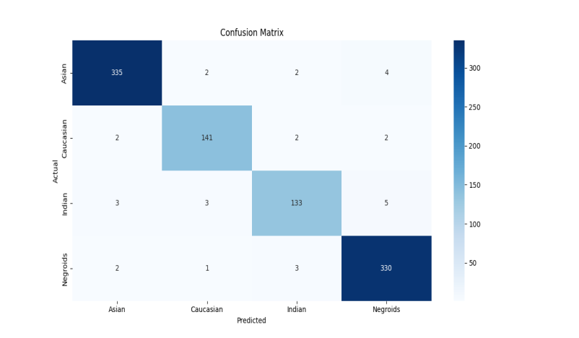
Fig6: Confusion Matrix
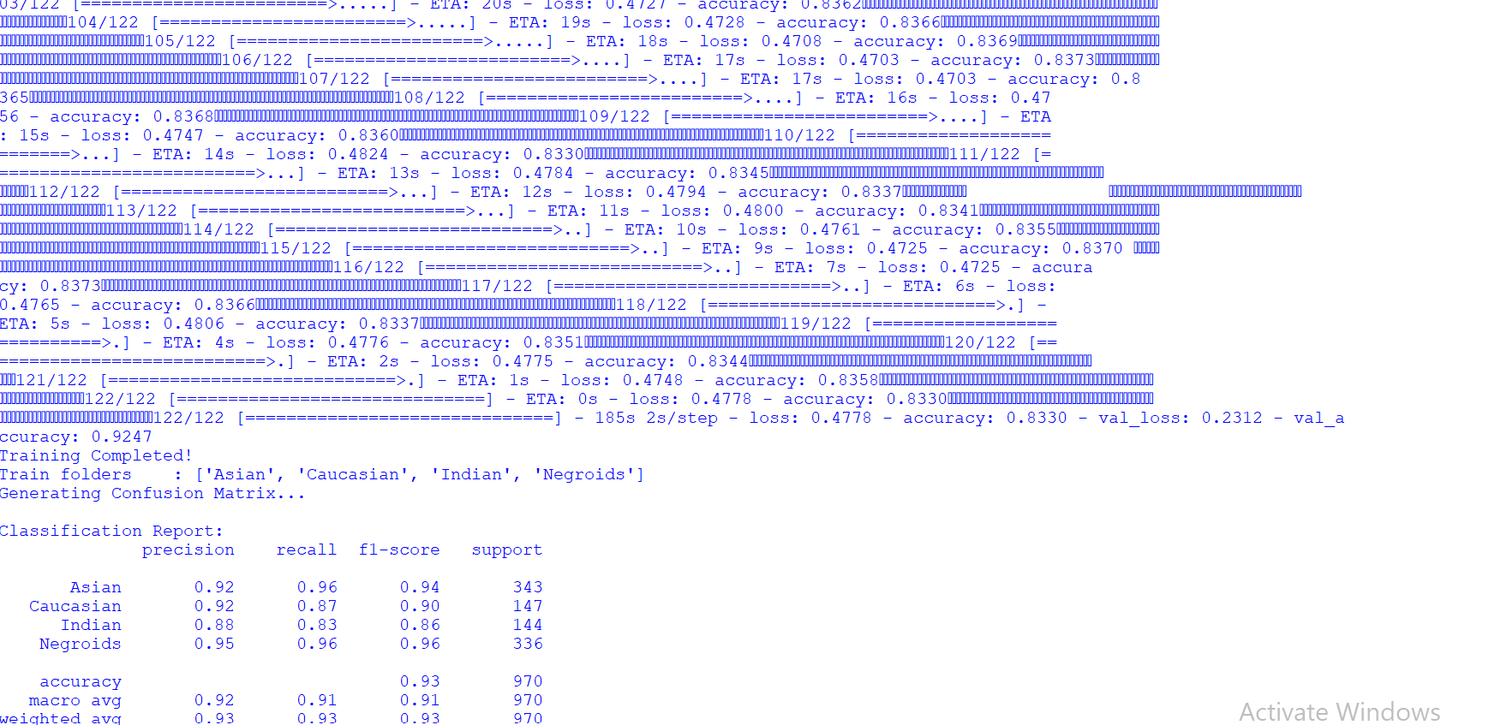
Fig7: Training Process of CNN Model
13. COMPARATIVE ANALYSIS
The performance of the proposed AI-enabled drone system is compared with traditional disaster assessment methods and usual machine learning approaches. Traditional methods mainly depend on manual field surveys done by experts. While these surveys provide detailed information, they take a lot of time, cost a lot, and are often unsafe in disaster-affected areas.
Compared to manual assessment, the proposed system greatly cuts down the time needed to evaluate damage. Using drones allows for quick data collection, while the AI-based model automates damage detection, reducing the need for human involvement. This leads to faster decision-making in emergencies.
When compared to traditional machine learning techniques, the proposed deep learning approach shows better accuracy and consistency. Traditional machine learning methods rely on handcrafted features, which often struggle in complicated disaster scenes. In contrast, the proposed system learns relevant features from aerial images automatically, resulting in improved damage classification.
Overall, the comparison shows that the AI-enabled drone system is more efficient, accurate, and safe than current assessment methods. This makes it a useful option for real-time disaster management.
14. APPLICATION SCENARIOS
The proposed AI-enabled drone system can be applied in various disaster management and monitoring applications. One major application is post-earthquake damage assessment, where the system can quickly identify collapsed buildings, cracked structures, and severely damaged areas. This helps authorities prioritize rescue and relief operations efficiently.
In flood monitoring and impact analysis, the system can detect submerged regions, damaged houses, and blocked roads. This information supports emergency teams in planning evacuation routes and distributing relief materials. The system is also useful for cyclone and hurricane damage assessment, where it can analyze roof damage, fallen trees, and disrupted power infrastructure caused by strong winds and heavy rainfall.
Additionally, the system can be applied to urban infrastructure inspection, including the monitoring of bridges, roads, and public buildings for structural damage. By using drones, inspections can be conducted safely without exposing human inspectors to dangerous conditions. These applications demonstrate the effectiveness and versatility of the proposed system in supporting disaster response and recovery operations.
15. CONCLUSION
This paper introduces an AI-enabled drone system for real-time disaster loss assessment and damage detection. By combining unmanned aerial vehicles with deep learning-based image analysis, the system provides a quick and reliable way to spot damage in areas hit by disasters. Drones safely and efficiently gather data from places that are difficult or dangerous for people to access. At the same time, the AI model sorts damage with better accuracy.
Experimental results indicate that the system reduces assessment time and human effort compared to traditional manual survey methods. It can analyze different disaster situations like earthquakes, floods, and cyclones, making it a flexible and scalable option for managing disasters. Although there are some limitations, this approach has significant potential for real-world applications. Overall, the AI-enabled drone system can greatly help emergency response teams by offering timely and accurate damage information, which enhances disaster preparedness, response, and recovery efforts..
16. REFERENCES
[1] S. Wiguna, B. Adriano, E. Mas, and S. Koshimura, [1] N. Alsaaran, “Deep learning image-based classification for post-disaster building damage detection using UAV images,” Sensors, vol. 25, no. 17, Art. no. 5406, 2025.
[2] A. Román, “Real-time damage assessment of flash flooding events using UAVs,” Procedia Computer Science, vol. 250, pp. 1–10, 2025.
[3] F. Ciccone and A. Ceruti, “Real-time search and rescue with drones: A deep learning approach for small-object detection,” Drones, vol. 9, no. 8, Art. no. 514, 2025.
[4] J. Kedys, “UAVs for disaster management—An exploratory review of methods and challenges,” Procedia Engineering, vol. 314, pp. 75–85, 2024.
[5] G. Tang, “A survey of object detection for UAVs based on deep learning,” Remote Sensing, vol. 16, no. 1, Art. no. 149, 2024.
[6] F. Kizilay, “Evaluating fine-tuned deep learning models for real-time earthquake damage assessment with drone imagery,” Machine Learning with Applications, vol. 12, p. 100433, 2024.
[7] S. Rattanaamporn, “Drone imaging and sensors for situational awareness in disaster response,” Internet of Things, vol. 14, no. 5, Art. no. 98, 2025.
[8] S. P. H. Boroujeni et al., “A comprehensive survey of research towards AI-enabled wildfire observation and UAVs,” Applied Energy, vol. 330, p. 121334, 2024.
[9] Y. Wu, “Research advances on deep-learning-based small object detection in UAV aerial images,” Advances in Computer and Intelligent Systems, vol. 4, pp. 1–28, 2025.
[10] A. Abu-Khadrah et al., “Drone-assisted adaptive object detection using whale optimization and deep reinforcement learning,” Scientific Reports, vol. 15, no. 1, 2025.
[11] D. Yang, “Data-driven structural damage monitoring and assessment using UAV imagery,” International Journal of Structural Stability and Dynamics, early access, 2025.
[12] Y. Shi et al., “UAV remote sensing and deep learning for architectural texture analysis,” Heritage Science, vol. 13, Art. no. 104, 2025.
[13] M. Kamal, “Statistical and deep-learning based disaster identification and prediction,” Risk and Decision Analysis, vol. 4, no. 2, pp. 40–55, 2024.
[14] A. Laghari and D. S. Kwon, “Unmanned aerial vehicles advances in object detection in remote sensing environments,” ISPRS Journal of Photogrammetry and Remote Sensing, vol. 174, pp. 182–197, 2024.
[15] F. K. Manzini, P. Perali, and R. R. Murphy, “Deploying rapid damage assessments from sUAS imagery for disaster response,” arXiv preprint arXiv:2511.03132, Nov. 2025.
[16] A. Sirma, A. Plastropoulos, and A. Zolotas, “DRespNeT: A UAV dataset and YOLOv8-DRN model for aerial instance segmentation in post-earthquake SAR missions,” arXiv preprint arXiv:2508.16016, Aug. 2025.
[17] E. Yucesoy, “The role of drones in disaster response: A literature review,” International Transactions on Operational Research, vol. 32, no. 3, pp. 589–612, 2025.
[18] K. VanExel, “Optimizing deep learning models for climate-related disaster detection using aerial imagery,” Energy Science & Technology, early access, 2025.
[19] N. S. Hewawiththi et al., “Damage assessment after natural disasters with UAVs: Semantic feature extraction using deep learning,” arXiv preprint arXiv:2412.10756, Dec. 2024.
[20] J. Cha, “Deep learning-based detection and assessment of road damage using UAV imagery,” Applied Sciences, vol. 15, no. 14, Art. no. 7669, 2025.

