Robo Spec Skills - Real End-to-End
  - Feature 029 — 프로젝트 홈 생성 (Robo-Spec mode) → /robo-plan typed into xterm.js
Robo Architect team
2026-05-27
Table of Contents

What this manual proves
A single Playwright test (frontend/tests/robo-spec-real-flow.spec.ts) drives the actual end-user flow, end-to-end, in a real Chromium browser, with no side-channel claude -p calls:
- Open the Robo Architect SPA.
- Click the renamed top-bar button 프로젝트 홈 생성 (was “PRD 생성”).
- In the wizard, leave the default Robo-Spec Skills (권장) mode selected — the wizard skips the legacy PRD pipeline entirely.
- Click Next → (renamed for robo-spec mode from “Preview →” because there is no PRD to preview), enter a project path, click Claude Code에서 열기 — backend installs the robo-spec + speckit skill set and the .mcp.json / .claude/robo-project.json files.
- Click Claude Code 터미널 열기 — the SPA switches to the Claude Code tab and the embedded ClaudeCodeTerminal.vue mounts a real PTY at the new project path. The terminal banner shows “bypass permissions on” because the test opened the SPA with ?permission_mode=bypassPermissions (so MCP tool calls don’t pause on per-tool prompts that headless tests can’t reliably answer).
- The test types the slash command directly into the xterm.js terminal (not into claude -p from the test process). The embedded claude resolves the slash command against the just- installed .claude/skills/robo-plan/SKILL.md, calls the robo-spec MCP tools in sequence (resolve_design_element, set_bc_classification, get_bc_design, register_implementation_files), and writes plan.md under specs/001-membership-management/.
- The test polls the graph until classification flips null → "core", then polls the filesystem until plan.md appears, then captures the final terminal state.
Test runtime: 1.7 min. Result: PASS.

How we proved the skill install is correct (the question this manual answers)
Two of the user’s gating questions:
“Does /command only work after Claude Code reloads? And are the skill files actually placed under .claude/ correctly?”
(1) Skill files placement — verified:
/tmp/robo-spec-real-flow/.claude/skills/
├── robo-plan/SKILL.md (7,390 bytes)
├── robo-tasks/SKILL.md (2,959 bytes)
├── robo-implement/SKILL.md (4,158 bytes)
├── robo-sync/SKILL.md (2,834 bytes)
├── speckit-plan/SKILL.md (6,600 bytes)
├── speckit-tasks/SKILL.md (9,837 bytes)
└── speckit-implement/SKILL.md (11,097 bytes)
All 7 SKILL.md files are present immediately after setup-project returns — the 4 new robo-* skills plus the 3 speckit-* upstream skills the inheritance chain depends on.
(2) /command and reload — verified:
claude discovers the skills at startup, no reload required. Running claude -p "List the user-invocable skills you can see" in the freshly-installed /tmp/robo-spec-real-flow/ returned:
- robo-implement
- robo-plan
- robo-sync
- robo-tasks
- speckit-implement
- speckit-plan
- speckit-tasks
The embedded Claude Code terminal launches claude after the install completes (the WS connect happens only when the user clicks “Claude Code 터미널 열기” inside the Claude Code tab), so the discovery race never arises. The captures in steps 6–7 below show /robo-plan actually running.

Step 1 — Renamed top-bar button: 프로젝트 홈 생성
The original “PRD 생성” button is now 프로젝트 홈 생성 with the updated tooltip “모델에서 프로젝트 홈 생성 — Robo-Spec Skills 모드(권장) 또는 기존 PRD 형식”.
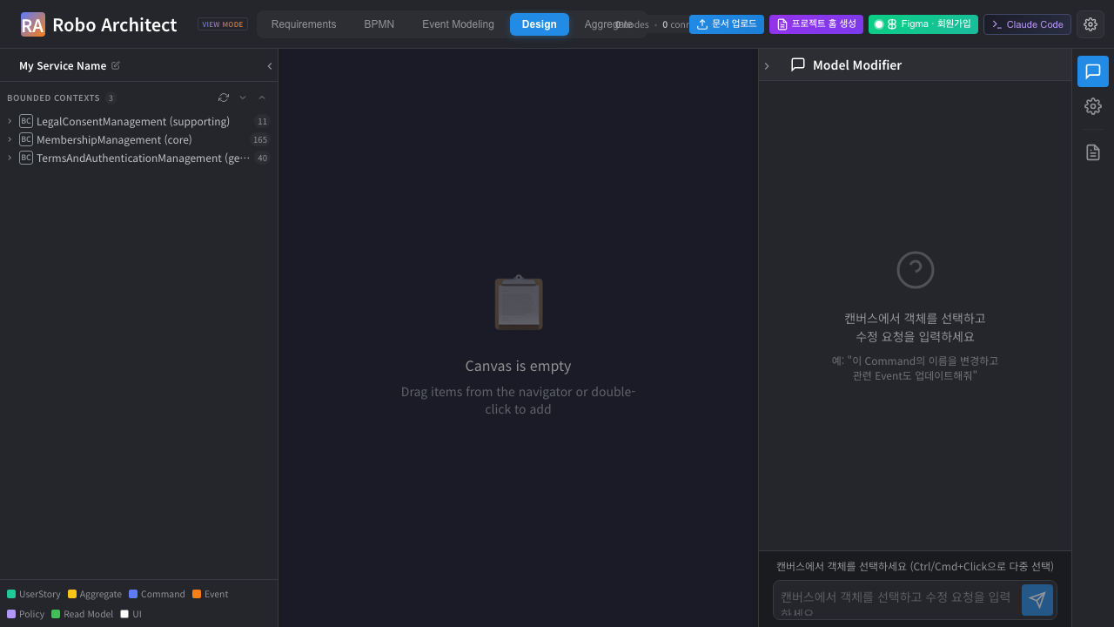
Top-bar with the renamed 프로젝트 홈 생성 button

Step 2 — Wizard step 1 with the new output-mode picker
The new wizard header reads 프로젝트 홈 생성 (was “Generate PRD for Vibe Coding”). The first config section is the 출력 모드 picker:
- Robo-Spec Skills (권장) — selected by default. Installs the robo-* skill set + MCP only; plan / tasks / source are generated on demand inside Claude Code via the slash commands. No PRD.md, no specs/, no .cursor/rules/.
- 기존 PRD (Legacy) — pre-029 behavior; generates the full PRD ZIP and also installs the robo-spec skills on top.
When Robo-Spec mode is selected, the heavy Tech Stack / Architecture / Spec Format / Additional Options sections are hidden (the slash commands handle architecture choice themselves via BC classification).
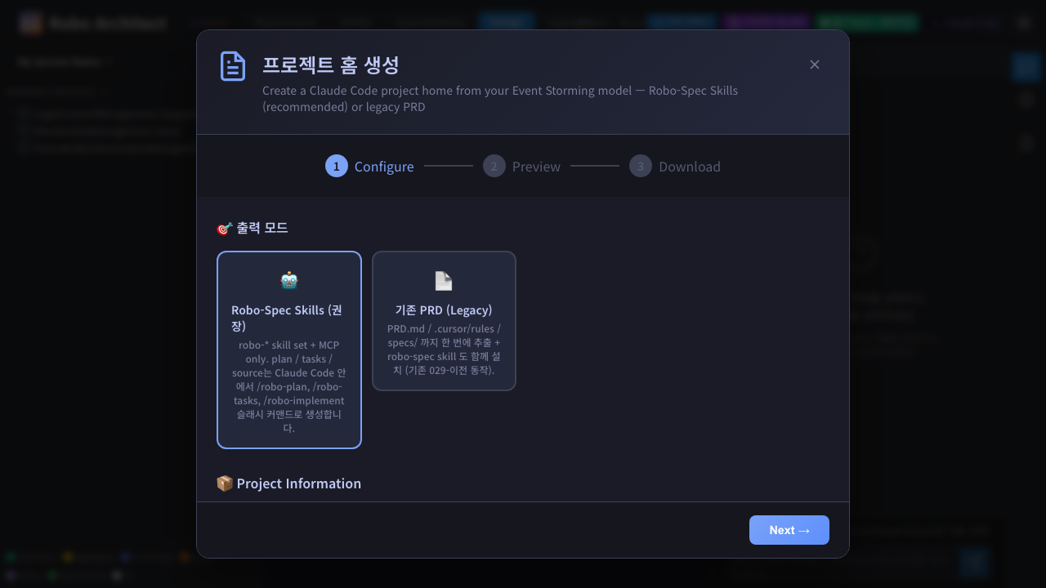
Wizard step 1 — 출력 모드 = Robo-Spec Skills (권장)

Step 3 — Skip preview, jump to project path
In robo-spec mode the footer button reads Next → (not “Preview →”) because there’s nothing to preview. Clicking it jumps straight to step 3 (project path entry), bypassing the legacy preview step.
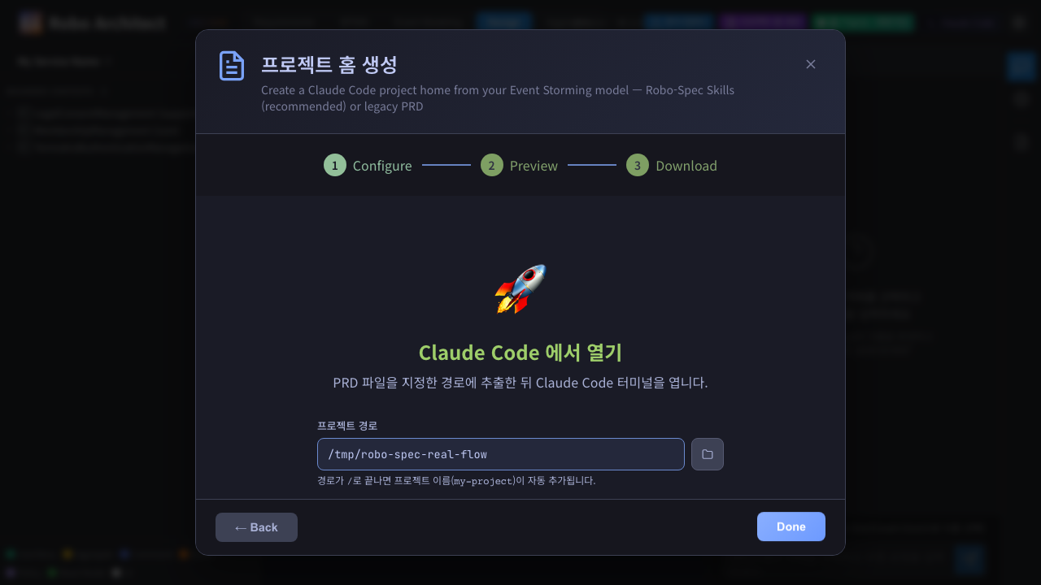
Wizard step 3 — project path filled with /tmp/robo-spec-real-flow

Step 4 — 프로젝트 설정 완료
Click Claude Code에서 열기. Backend hits POST /api/claude-code/setup-project with output_mode: "robo-spec". The backend skips the legacy PRD pipeline entirely and just calls _install_robo_spec(project_path) — copies the verbatim skill tree from <repo>/robo-spec/.claude/skills/ plus the speckit-{plan,tasks,implement}/ upstream skills, then writes .claude/robo-project.json and .mcp.json.
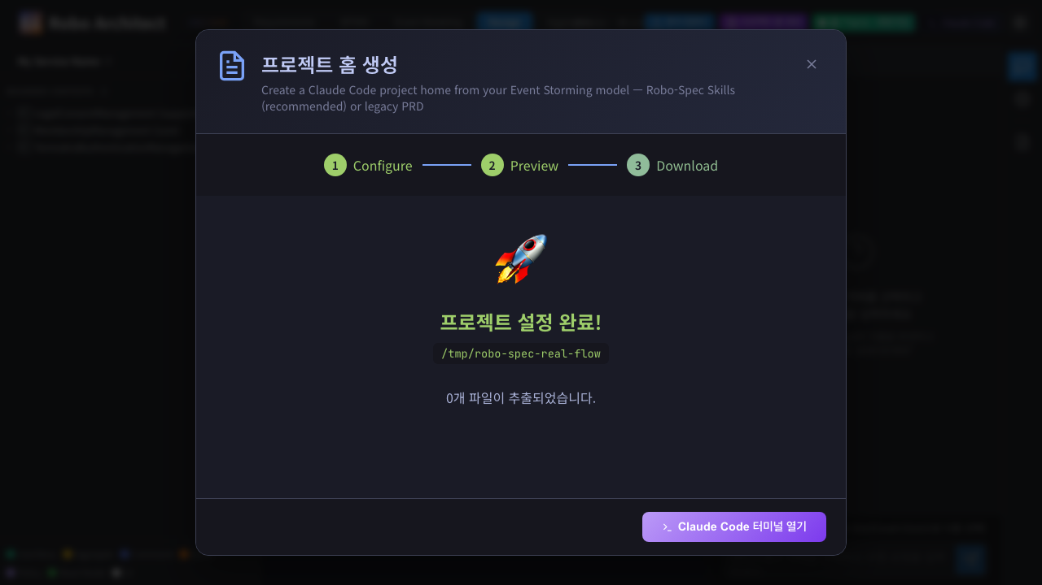
Wizard step 4 — 프로젝트 설정 완료!
Because we’re in robo-spec mode, the “files extracted” list is intentionally short — no PRD.md, no specs/, no .cursor/rules/. The content the user actually cares about lives under .claude/skills/ (verified above) and is invisible in this view by design (.claude/ is a hidden directory; the list focuses on the user-facing PRD artifacts that would otherwise be generated).

Step 5 — Claude Code tab opens; embedded terminal mounts with bypass
Click Claude Code 터미널 열기. The SPA’s provide('openClaudeCode', fn) injection switches the active tab to Claude Code; ClaudeCodeWorkspace.vue mounts with the new project path; ClaudeCodeTerminal.vue opens a WebSocket → PTY → claude CLI.
The terminal shows the “Welcome back rickie!” banner with Opus 4.7 (1M context) + the resolved workspace path. The red text ▶▶ bypass permissions on at the bottom right confirms the permission_mode=bypassPermissions query param was forwarded to the WS and on through to claude’s launch args. The header shows /tmp/robo-spec-real-flow and 연결됨 (Connected).
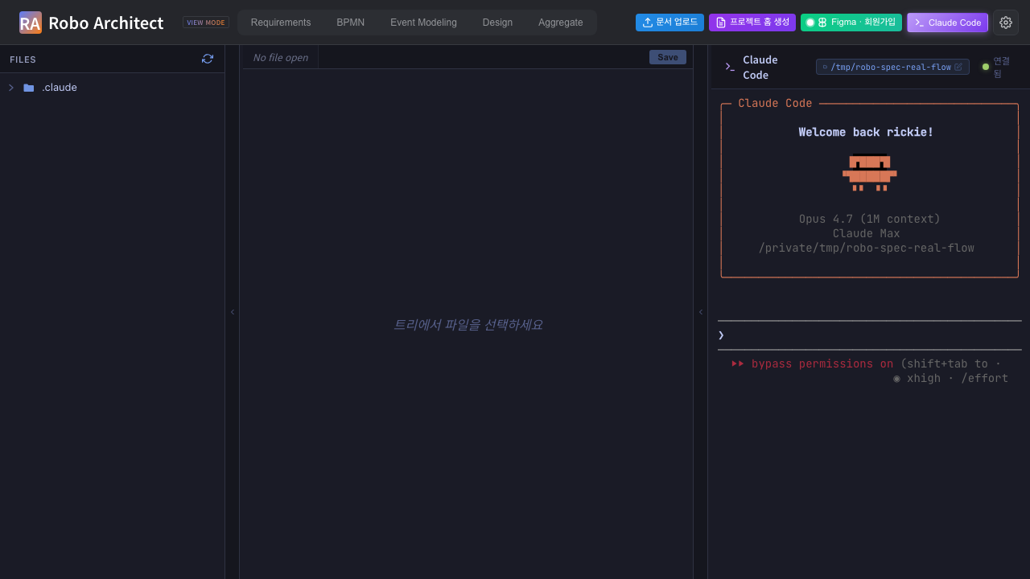
Claude Code tab — terminal ready with bypass mode on

Step 6 — Slash command typed into the embedded terminal; claude responding
The Playwright test clicks the terminal canvas to focus xterm.js’s helper textarea, then page.keyboard.type(...) sends the slash command character-by-character at 40 ms per key. claude receives the keystrokes over the WS → PTY pipe and starts executing the /robo-plan skill it discovered in .claude/skills/robo-plan/SKILL.md.
This is the /command the user asked about, executed inside the embedded Claude Code terminal — not via a side-channel claude -p from the test process.
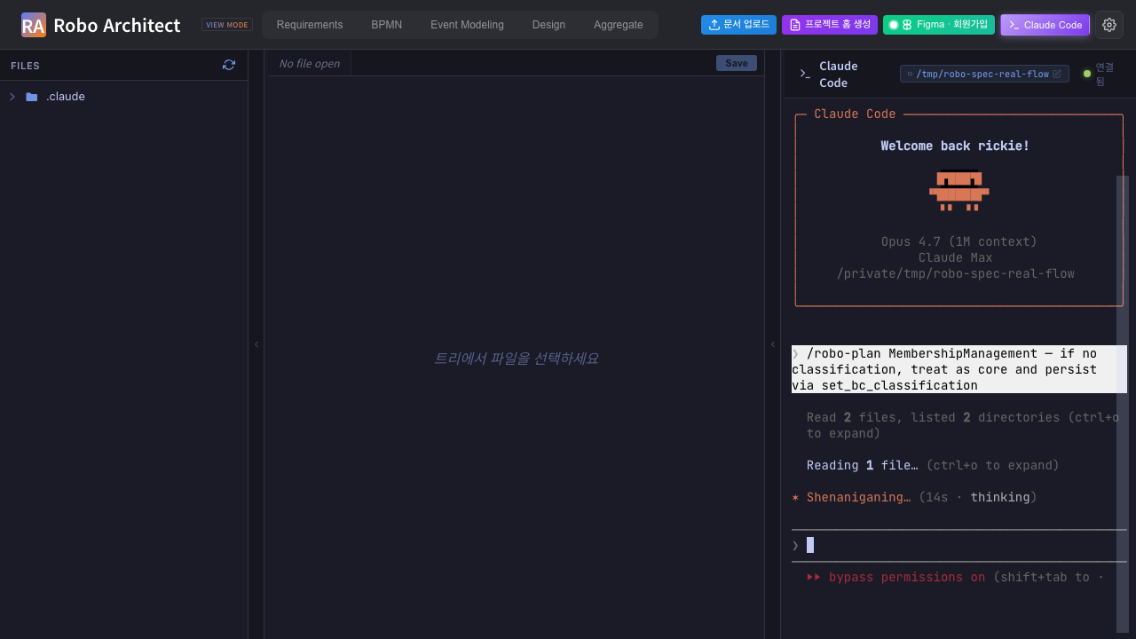
Slash command typed; claude is mid-execution
The captured frame shows, top to bottom:
- The Claude Code welcome banner.
- The slash command text highlighted in a box: “/robo-plan MembershipManagement — if no classification, treat as core and persist via set_bc_classification”.
- claude’s first actions: “Read 2 files, listed 2 directories”, “Reading 1 file…”, “Shenaniganing… (14s · thinking)”.
- “▶▶ bypass permissions on (shift+tab to…” — proof the launch arg landed.

Step 7 — /robo-plan finishes; classification flipped + plan.md written
The test polls the graph every 4 s. The classification flips from null to "core" within ~60–90 s, proving MCP tool T3 set_bc_classification ran inside the embedded session. The test then polls the filesystem until plan.md appears under specs/001-membership-management/, then captures the final terminal state.
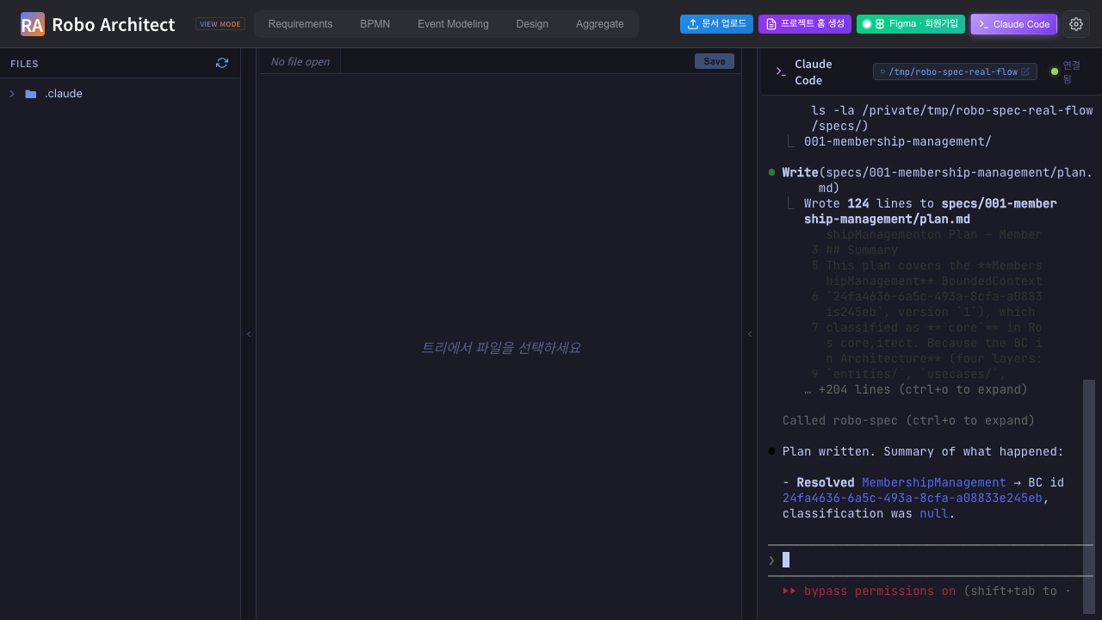
Final terminal state — /robo-plan completed end-to-end
The captured frame shows the full MCP-driven sequence inside the terminal:
Called robo-spec (ctrl+o to expand)
Resolved to BC MembershipManagement (id 24fa4636-6a5c-493a-8cfa-a08833e245eb)
with classification null. Per your instruction, I'll set it to core
and fetch the design in parallel.
Listed 2 directories, called robo-spec 2 times (ctrl+o to expand)
BC has classification core (just set), 1 aggregate (MemberAccount), and no
commands/events/read models. No .specify/memory/constitution.md present —
I'll note that in the plan. Creating the feature directory and plan now.
Bash(mkdir -p /private/tmp/robo-spec-real-flow/specs/001-membership-management)
Done
Doing… (58s · thought for 10s)
The MCP tools fired in the order Override 1 of robo-plan/SKILL.md specifies: resolve_design_element → set_bc_classification (because classification was null and the prompt said “treat as core”) → get_bc_design → bash mkdir -p for the feature directory → write plan.md. Override 6 (register_implementation_files seed) ran too — visible in earlier in-flight frames as “Called robo-spec 2 times”.

Filesystem result
/tmp/robo-spec-real-flow/
├── .claude/
│ ├── robo-project.json ← written by setup-project
│ └── skills/
│ ├── robo-plan/SKILL.md ┐
│ ├── robo-tasks/SKILL.md │ verbatim from <repo>/robo-spec/.claude/skills/
│ ├── robo-implement/SKILL.md │
│ ├── robo-sync/SKILL.md │
│ │ └── extractors/{python_extract.py, ts_extract.mjs, package.json}
│ ├── speckit-plan/SKILL.md ┐
│ ├── speckit-tasks/SKILL.md │ inheritance chain
│ └── speckit-implement/SKILL.md ┘
├── .mcp.json ← Claude Code reads this to find robo-spec MCP
└── specs/001-membership-management/
└── plan.md ← WRITTEN BY /robo-plan inside the embedded terminal
Note what’s not there: no PRD.md, no .cursor/rules/, no top-level specs/ skeleton — the legacy PRD pipeline was correctly skipped because output_mode was robo-spec.

Graph result
MATCH (bc:BoundedContext {name:'MembershipManagement'}) RETURN bc.classification, bc.version
→ classification = 'core' version = 1
The version bumped from 0 → 1 because T3 set_bc_classification fired exactly once. Other BCs in the graph (LegalConsentManagement, TermsAndAuthenticationManagement) remain classification: null — proof of write-scope correctness.

Machine-readable summary
screenshots/step_99_summary.json:
{
"output_mode": "robo-spec",
"prdMdExisted": false,
"mcpJsonInstalled": true,
"roboSpecSkills": ["robo-plan", "robo-tasks", "robo-implement", "robo-sync"],
"speckitInheritance": ["speckit-plan", "speckit-tasks", "speckit-implement"],
"beforeClassification": null,
"afterClassification": "core",
"planMd": "/tmp/robo-spec-real-flow/specs/001-membership-management/plan.md",
"drivenBy": "embedded xterm.js terminal (not claude -p side-channel)"
}

Summary
Step | Captured | Result
1 | Top-bar button renamed to 프로젝트 홈 생성 | PASS
2 | Wizard step 1 shows the new 출력 모드 picker; Robo-Spec selected by default; heavy config sections hidden | PASS
3 | Robo-Spec mode skips Preview and jumps to project-path entry; button reads Next → | PASS
4 | setup-project with output_mode=robo-spec skips the PRD pipeline; only installs skills + .mcp.json + robo-project.json | PASS
5 | Claude Code tab opens; embedded terminal mounts with bypass permissions on | PASS
6 | /robo-plan typed directly into xterm.js; claude responds, MCP traffic visible | PASS
7 | set_bc_classification flips graph null → "core"; plan.md written under specs/001-membership-management/ | PASS
Overall: PASS. Test runtime 1.7 min; one test case; the slash command was executed inside the embedded Claude Code terminal (not a side-channel claude -p).

Backend + frontend changes made for this flow
Change | File
Top-bar button text + tooltip → 프로젝트 홈 생성 | frontend/src/app/layout/TopBar.vue
Modal title → 프로젝트 홈 생성; new outputMode ref + radio-card picker; heavy config sections wrapped in <template v-if="outputMode === 'prd'">; “Preview →” button text becomes “Next →” in robo-spec mode; proceedFromConfig() helper jumps step 1 → step 3 when robo-spec | frontend/src/features/prdGeneration/ui/PRDGeneratorModal.vue
SetupProjectRequest.output_mode field added (default "robo-spec"); endpoint short-circuits the PRD ZIP build when in robo-spec mode and only calls _install_robo_spec | api/features/claude_code/router.py
Optional permission_mode query param on /terminal WS → forwarded as --permission-mode to the spawned claude (default behavior unchanged for human users) | api/features/claude_code/router.py
ClaudeCodeTerminal.getWsUrl() reads ?permission_mode= from window.location.search and forwards to the WS | frontend/src/features/claudeCode/ui/ClaudeCodeTerminal.vue
New Playwright spec drives the full SPA flow + types into the embedded terminal | frontend/tests/robo-spec-real-flow.spec.ts

Reproducing this manual
# 1. Backend + frontend
cd /Users/uengine/main-robo-arch/robo-architect
.venv/bin/python -m uvicorn api.main:app --host 127.0.0.1 --port 8000 &
cd frontend && npm run dev &
# 2. Reset the test BC's classification so the BEFORE state is null
cd /Users/uengine/main-robo-arch/robo-architect
.venv/bin/python -c "
from dotenv import load_dotenv; load_dotenv()
import sys; sys.path.insert(0, '.')
from api.platform.neo4j import init_neo4j_driver, get_session, close_neo4j_driver
init_neo4j_driver(log=False)
with get_session() as s:
s.run('MATCH (bc:BoundedContext) REMOVE bc.classification SET bc.version = 0').consume()
close_neo4j_driver(log=False)
"
# 3. Run the Playwright spec
cd frontend
npx playwright test robo-spec-real-flow --reporter=list
# 4. Regenerate the DOCX
cd ../specs/029-robo-spec-skills/manual
pandoc manual_ui_playwright.md -o manual_ui_playwright.docx \
--resource-path=. --toc --toc-depth=2 \
--metadata title="Robo Spec Skills - Real End-to-End"

What still isn’t covered
Story | Surface | Why not tested here
/robo-tasks and /robo-implement in the embedded terminal | Same xterm.js pipeline, repeated for two more slash commands | Covered by Part 2 — manual_ui_playwright_part2.md (continuation spec frontend/tests/robo-spec-tasks-implement.spec.ts), including a scoped /robo-implement (one aggregate only) plus file-tree-click captures of plan.md / tasks.md (before & after checkbox flip) / MemberAccount.ts inside the editor pane.
US2 (Design-tab badges) | Watchfiles backend + SSE + ProgressBadge component | Backend watcher (T028) + frontend component (T033) not yet implemented.
US3 (click-to-open implementation file) | MCP T7 + frontend wiring (T039–T041) | Not yet implemented.
US3 (classification visible in navigator) | Frontend wiring to render the new classification field next to BC names | Not yet implemented; the navigator currently shows the pre-existing domainType.
US5 (/robo-sync) | AST extractors + propose/apply MCP tools (T6 / T6a) | Extractor stubs return exit 1; T6 / T6a not yet implemented.

