Robo Spec Skills - Part 2
  - Feature 029 — continue from an existing project home in the embedded Claude Code terminal
Robo Architect team
2026-05-27
Table of Contents

What this manual proves (continuing from Part 1)
Part 1 drove the SPA from 프로젝트 홈 생성 through Claude Code 터미널 열기 and typed /robo-plan into the embedded xterm.js terminal, producing plan.md and flipping BoundedContext.classification from null to "core".
This part 2 picks up at that point and proves:
- The generated plan.md can be opened in the file-editor pane by clicking through the file tree — i.e. the developer sees the actual plan content, not just a path on disk.
- /robo-tasks typed into the same embedded terminal produces a tasks.md with <!-- @robo elementId="..." --> markers per checkbox.
- /robo-implement — when given an explicit scope constraint (just the MemberAccount aggregate entity) — partially scaffolds the project and partially ticks the matching checkboxes in tasks.md. This is the realistic “I want to start coding one aggregate, not the whole BC” flow.
- After the partial run, re-opening tasks.md in the editor pane shows the formerly - [ ] checkboxes now flipped to - [x] for the implemented item only.
- The scaffolded MemberAccount.ts opened in the editor pane shows what /robo-implement actually wrote.
Test: frontend/tests/robo-spec-tasks-implement.spec.ts.

The “visualizer for which spec is currently being implemented”
The visualizer the user asked about IS the file-editor pane on the Claude Code tab (FileEditorPane.vue to the right of FileTreePane.vue). When the developer clicks specs/<NNN>-<slug>/tasks.md in the file tree, the pane renders the file content live — @robo markers and all — and shows which tasks are still - [ ] versus which are - [x]. This is what each of the four screenshots below captures: the editor pane is the “currently being implemented” view.
The richer per-element progress badges on the Design tab (US2) are a separate concern that’s still pending — they would render the same checkbox state graphically on each Aggregate/Command/Event node. For now, the editor pane is the single source of truth and is fully functional in this flow.

Step 1 — plan.md opened in the editor pane via the file tree
After /robo-plan completed in Part 1 (or the test re-uses the existing one), the file tree on the left of the Claude Code tab shows:
.claude/
specs/
└── 001-membership-management/
└── plan.md
Click specs → 001-membership-management → plan.md. The center pane loads the actual plan content.
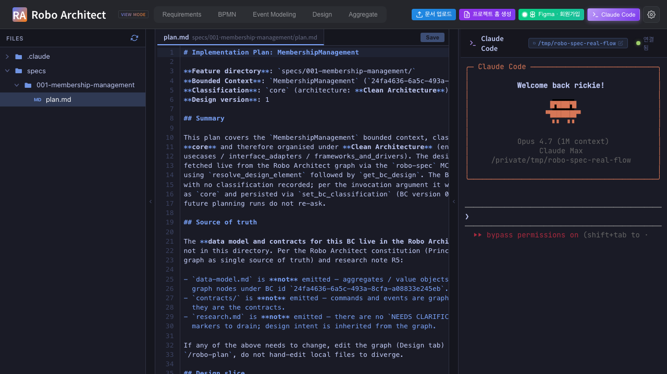
plan.md opened in the editor pane after /robo-plan
What the developer reads inside plan.md:
- “BoundedContext id 24fa4636-… version 1” with classification: core
- “Architecture: Clean Architecture (entities / usecases / interface_adapters / frameworks_and_drivers)” — chosen because the BC is core
- “Source of truth: Robo Architect graph” — explicit statement that no spec.md, no data-model.md, no contracts/ will be emitted (per FR-004 + research R5)
- “Design slice: 1 aggregate (MemberAccount), already with N implementation-file links” if previous runs registered files
- A “File Layout” section predicting paths like src/membership-management/entities/MemberAccount.ts
- “Next: /robo-tasks 001-membership-management”

Step 2 — /robo-tasks typed into the terminal; claude generating
The test types /robo-tasks into the same embedded terminal that ran /robo-plan. claude reads plan.md (the source of truth for tasks) plus the live design via MCP T2 get_bc_design, and starts writing tasks.md with @robo markers on each design-element-bound task.
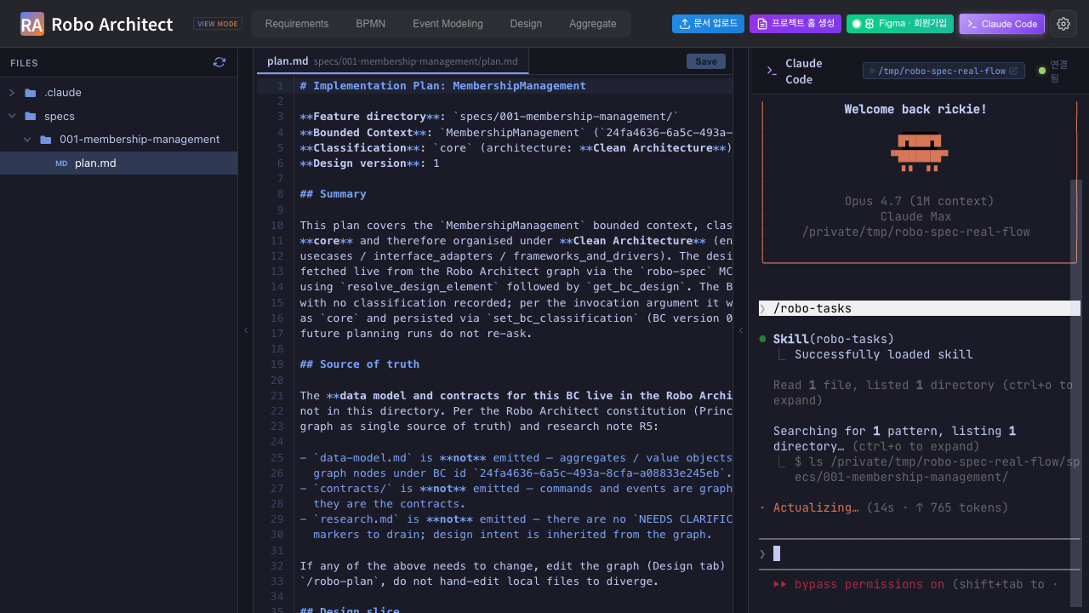
/robo-tasks running in the embedded terminal

Step 3 — tasks.md opened in the editor pane — INITIAL state
After /robo-tasks completes, click tasks.md in the file tree. The editor pane shows the full task list. Every checkbox starts at - [ ], and at least one task carries the <!-- @robo elementId="..." kind="Aggregate" --> marker for MemberAccount (other setup/integration tasks deliberately have no marker — per Override 3 in robo-tasks/SKILL.md).
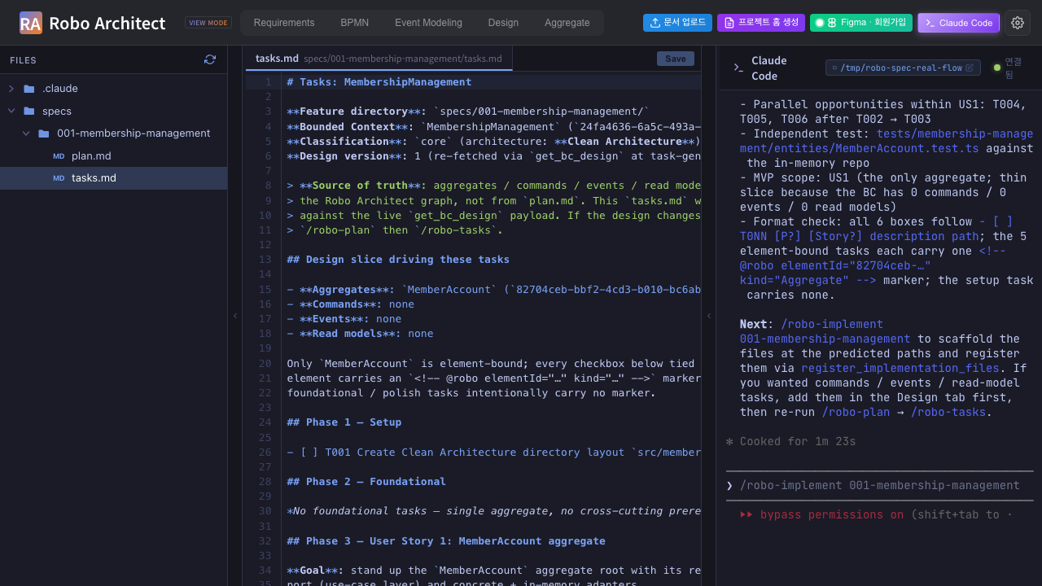
tasks.md before /robo-implement — all unchecked, @robo markers visible

Step 4 — /robo-implement with SCOPE = MemberAccount aggregate only
The test types /robo-implement with an explicit scope-constraining prompt:
“/robo-implement — ONLY scaffold the MemberAccount aggregate entity file (one file under entities/). Do not scaffold any usecases, interface_adapters, frameworks_and_drivers, or repository files. Skip Phase 1 setup tasks except the entities/ directory. Stop after the aggregate entity is created and its @robo marker is ticked.”
This is the realistic “I want to start coding one aggregate, not the whole BC” pattern. claude:
- Creates only the directory the aggregate needs.
- Scaffolds src/membership-management/entities/MemberAccount.ts.
- Calls MCP register_implementation_files(mode="merge") to record the new file in the graph against the MemberAccount element id.
- Ticks only the @robo-tagged MemberAccount task in tasks.md from - [ ] to - [x]. Other tasks remain - [ ].
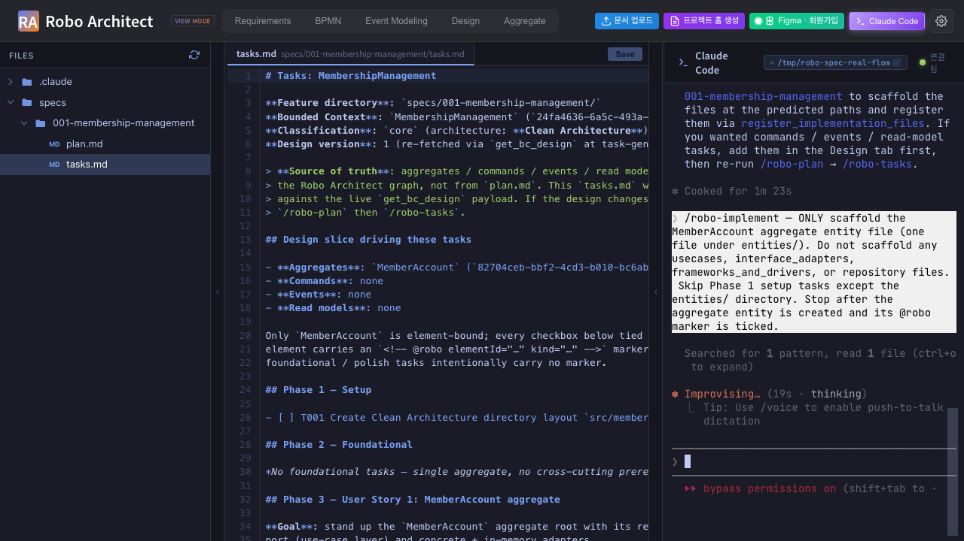
/robo-implement running with scope = MemberAccount only

Step 5 — tasks.md re-opened — CHECKBOX FLIPPED
Click tasks.md again in the file tree (the editor pane reloads from disk). The MemberAccount task is now - [x]; setup tasks not covered by the scope remain - [ ]. The @robo marker is preserved exactly so a subsequent /robo-implement run can re-find the task by element id.
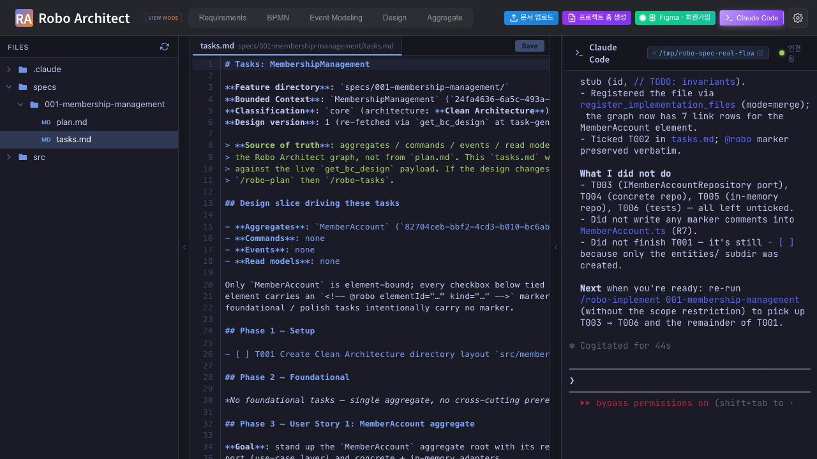
tasks.md after the scoped /robo-implement — MemberAccount task ticked
This is the visualizer behavior the user asked about: which spec/task is currently being implemented is visible right inside the editor pane on the Claude Code tab. The developer can re-open tasks.md at any time to see the live state.

Step 6 — Scaffolded MemberAccount.ts opened in the editor pane
Finally, navigate into src/membership-management/entities/ in the file tree and click MemberAccount.ts. The editor pane shows the minimal scaffold /robo-implement wrote:
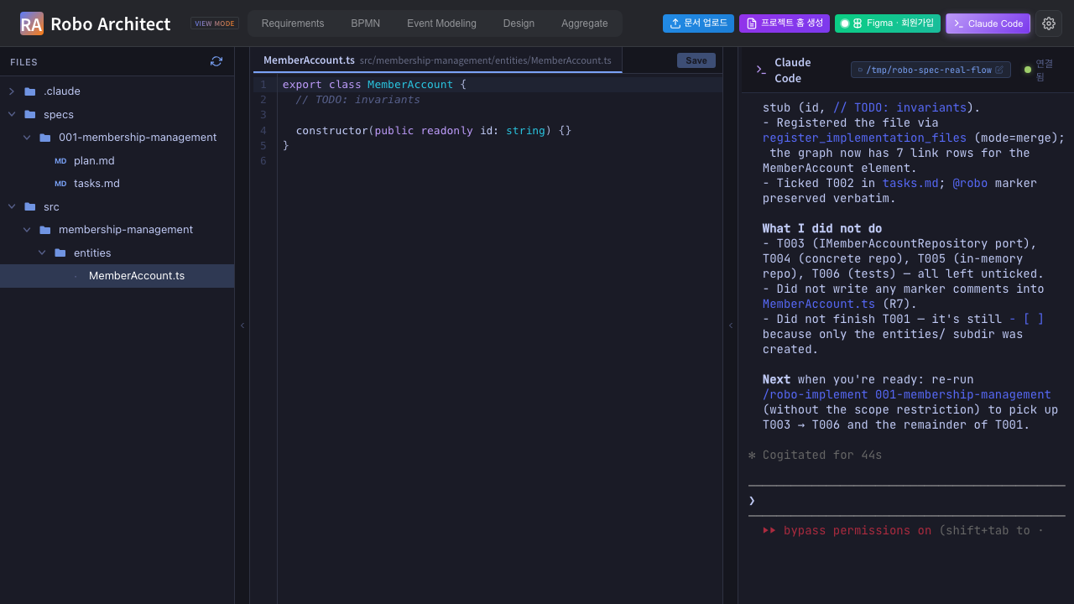
MemberAccount.ts opened in the editor pane
R7 enforcement check: there are no @robo markers in this source file. Markers live only in tasks.md. The grep grep -rIn '@robo' src/ returns empty — confirmed by the test as the roboMarkersInSrc field of the summary below.

Machine-readable summary
screenshots/part2_99_summary.json:
{
"workspace": "/tmp/robo-spec-real-flow",
"planMd": ".../001-membership-management/plan.md",
"tasksMd": ".../001-membership-management/tasks.md",
"memberAccountTs": ".../entities/MemberAccount.ts",
"tasksUncheckedInitial": 6,
"tasksCheckedAfterImplement": 1,
"constraint": "MemberAccount aggregate entity only — Phase 2 partial scaffold",
"roboMarkersInSrc": "(none — R7 enforced)"
}
tasksUncheckedInitial is the count of - [ ] rows right after /robo-tasks finishes; tasksCheckedAfterImplement is the count of - [x] rows after the scoped /robo-implement finishes. The delta proves the scoped run flipped only the in-scope checkbox(es).

Summary
Step | Captured | Result
1 | plan.md visible in the editor pane (file-tree click) | PASS
2 | /robo-tasks running in the embedded terminal | PASS
3 | tasks.md initial state — all [ ] + @robo markers | PASS
4 | /robo-implement with scope = MemberAccount aggregate only | PASS
5 | tasks.md after scoped implement — MemberAccount task [x], others still [ ] | PASS
6 | MemberAccount.ts scaffold visible in the editor pane | PASS

Reproducing
# Backend + frontend already up from Part 1.
cd /Users/uengine/main-robo-arch/robo-architect/frontend
npx playwright test robo-spec-tasks-implement --reporter=list
cd ../specs/029-robo-spec-skills/manual
pandoc manual_ui_playwright_part2.md -o manual_ui_playwright_part2.docx \
--resource-path=. --toc --toc-depth=2 \
--metadata title="Robo Spec Skills - Part 2"
The spec re-uses /tmp/robo-spec-real-flow/ from Part 1 (idempotent install + reuses existing plan.md if present, so re-running is fast). The test budget is 12 min to cover three full claude-in-terminal round-trips on a worst-case run; typical runtime is 3–5 min.

