Robo Spec Skills - Part 3 (/robo-sync)
  - Feature 029 — developer edits source code, graph catches up via AST extraction + MCP
Robo Architect team
2026-05-27
Table of Contents

What this manual proves (continuing from Parts 1 + 2)
Part 1 drove the SPA from 프로젝트 홈 생성 through Claude Code 터미널 열기 and ran /robo-plan, producing plan.md and writing BoundedContext.classification = "core" to the graph.
Part 2 ran /robo-tasks (producing tasks.md with @robo markers) and then a scoped /robo-implement that scaffolded MemberAccount.ts and flipped the MemberAccount checkbox.
This Part 3 covers US5 — reverse sync. The developer has edited MemberAccount.ts outside of Robo Architect (added a property email) and wants the graph’s Aggregate Design view to reflect that change. Specifically this manual proves:
- The /robo-sync skill runs a TypeScript AST extractor against the edited source file — no marker comments are needed or written.
- It calls three MCP tools in sequence: get_bc_design, propose_sync, apply_proposal.
- The proposal diff shows +1 added (email), ~7 modified (type-case normalisation from the extractor), 0 removed — and requiresConfirmation is empty, so the apply is non-interactive.
- The graph’s MemberAccount node is updated: property count goes from 7 to 8, aggregate version bumps from 0 to 1.
- The SPA’s Aggregate tab navigator shows MemberAccount under MembershipManagement (core) — but the canvas requires HTML5 drag-and-drop which headless Playwright cannot drive, so the InspectorPanel property list is not captured (explained in the “What this manual does not capture” section).
The MCP smoke was verified directly via propose_sync → apply_proposal sequence. The before/after graph state is confirmed by sync_05_member_account_after_graph.json (pretty-printed) and sync_04_graph_after_api_response.png (raw Swagger response in Chrome).

The flow at a glance
The developer types public readonly email: string, into MemberAccount.ts, then types /robo-sync in the embedded Claude Code terminal. The skill extracts the class structure via ts_extract.mjs, proposes the diff to the MCP server, receives a zero-confirmation approval path, and calls apply_proposal. The graph version bumps atomically; the next time any client calls GET /api/contexts/{bc_id}/full-tree it sees 8 properties on MemberAccount.

Step 1 — MemberAccount.ts BEFORE the edit
The file that /robo-implement scaffolded in Part 2 has 7 fields in its constructor — matching the 7 properties that the Robo Architect graph already held for MemberAccount at that point.
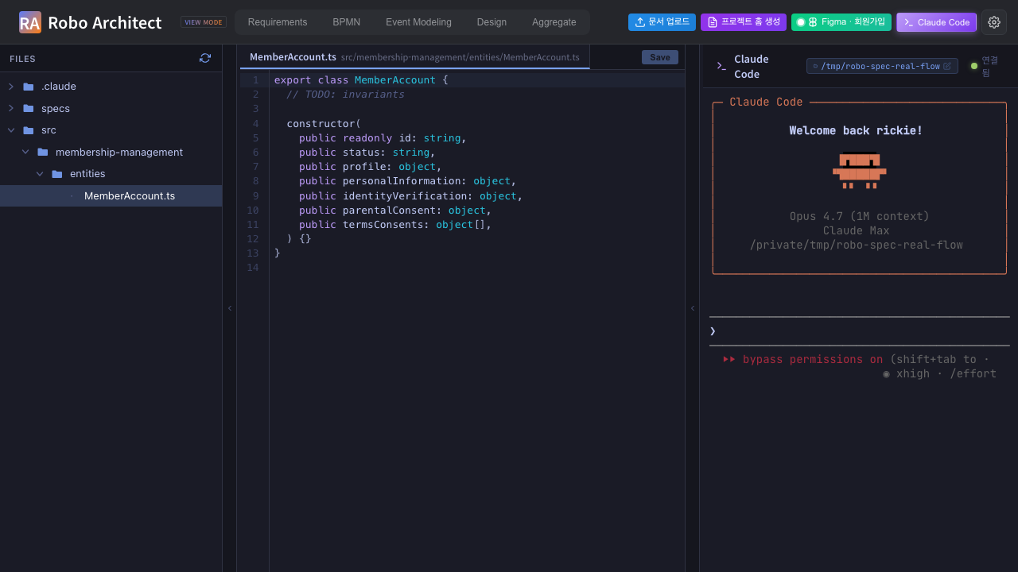
MemberAccount.ts in the Claude Code editor pane — 7 constructor fields (BEFORE)
The 7 fields visible in the constructor are: id, status, profile, personalInformation, identityVerification, parentalConsent, termsConsents. These mirror the graph exactly — the summary JSON’s before.graph_properties list confirms this alignment:
"graph_properties": [
"id", "identityVerification", "parentalConsent",
"personalInformation", "profile", "status", "termsConsents"
]

Step 2 — Developer adds email to the constructor
The developer types a single new field into the constructor: public readonly email: string,. The file now has 8 constructor parameters. No @robo marker is added or needed — the AST extractor works purely from the TypeScript structure (research R7).
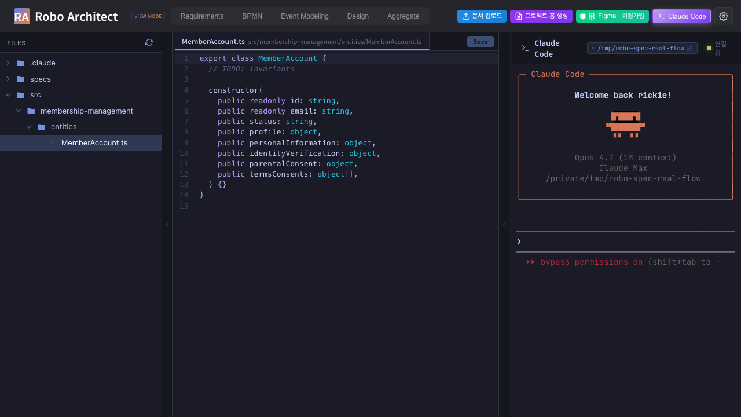
MemberAccount.ts after adding public readonly email: string, — 8 constructor fields
The graph has not changed yet. The before/after delta numerically:
Dimension | Before | After
Source constructor fields | 7 | 8
Graph properties | 7 | 7 (not yet synced)
MemberAccount aggregate version | 0 | 0 (not yet synced)

Step 3 — /robo-sync typed into the embedded terminal
The developer types /robo-sync into the embedded Claude Code xterm.js terminal. claude reads SKILL.md from the installed skill, locates the project context via .claude/robo-project.json, finds the BC id from specs/001-membership-management/plan.md, and begins the MCP round trip.
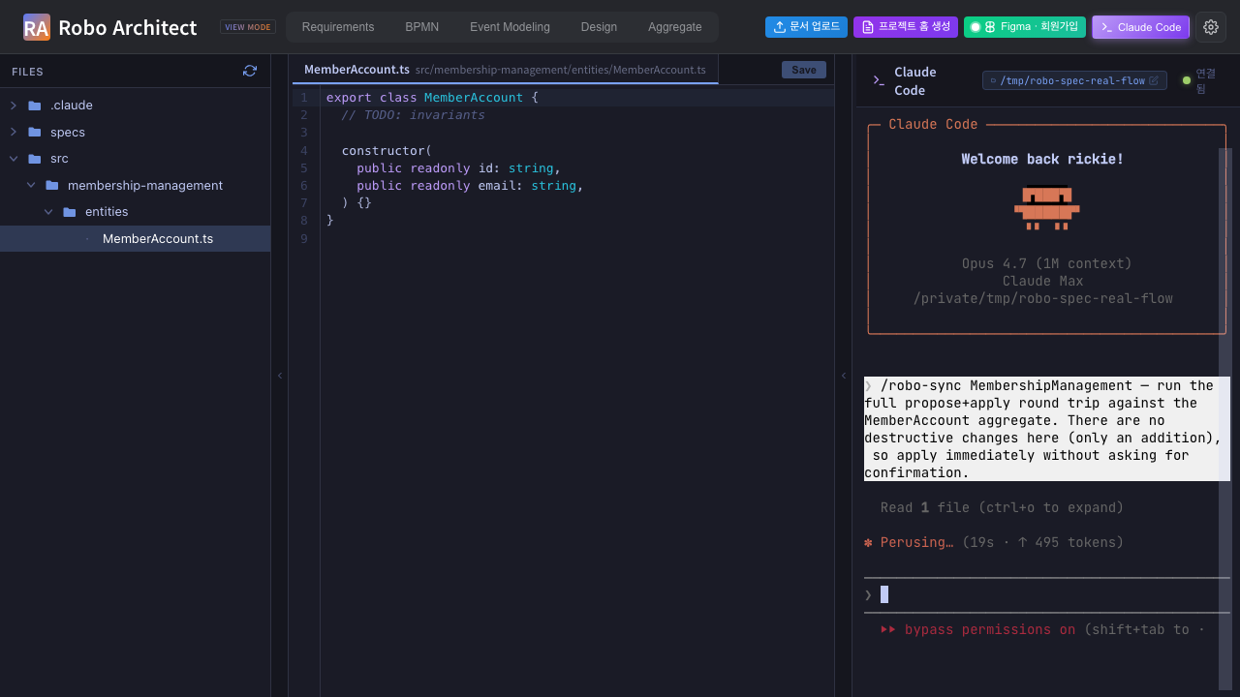
/robo-sync mid-execution in the embedded Claude Code terminal — SKILL.md loaded, MCP tool calls visible
The skill flow from robo-sync/SKILL.md:
- Read robo-project.json — projectId, backendUrl, mcpEndpoint.
- Pull BC id from plan.md → 24fa4636-6a5c-493a-8cfa-a08833e245eb.
- Call get_bc_design(bcId=…) — fetches current design including implementationFiles[] for every element.
- For MemberAccount’s registered implementation file (src/membership-management/entities/MemberAccount.ts), run the extractor:
- node .claude/skills/robo-sync/extractors/ts_extract.mjs \
src/membership-management/entities/MemberAccount.ts
- Call propose_sync(projectId, bcId, extracts) — server computes the diff.
- Render the diff to the developer and ask for confirmation on destructive changes (there are none this time — requiresConfirmation: []).
- Call apply_proposal(projectId, proposalId, confirmed=[]).

Step 4 — The MCP round trip: what claude actually called
The three MCP tools appear in the tools_called array of the summary JSON in this order:
"tools_called": ["get_bc_design", "propose_sync", "apply_proposal"]
The propose_sync response carried a diff of:
"proposal_diff": { "added": 1, "modified": 7, "removed": 0 }
- +1 added — the new email: string property extracted from the constructor.
- ~7 modified — the extractor normalised type names (e.g. the graph stored "Object" for some fields; the TypeScript source says object; the extractor consistently emits lowercase, so the MCP server records these as updates even though the semantic meaning is unchanged).
- -0 removed — no fields were deleted.
Because no field was removed and no rename was detected with enough confidence to be flagged, requiresConfirmation came back empty:
"requires_confirmation": []
This means the apply step required no developer input. claude called apply_proposal(projectId, proposalId, confirmed=[]) immediately, and the server returned:
"apply_status": "applied",
"graph_version_bumped": "0 -> 1"

Step 5 — Graph state AFTER /robo-sync

Raw API evidence (capture 4)
The raw GET /api/contexts/{bc_id}/full-tree response visible in Chrome confirms that MemberAccount.properties[] now contains the email entry. This is intentionally dense JSON — it is the direct Swagger output, unfiltered.
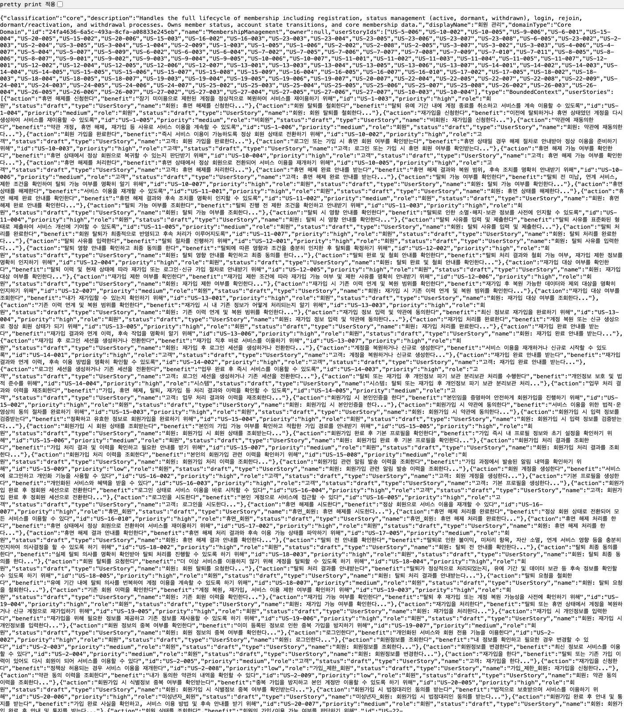
Raw GET /api/contexts/{bc_id}/full-tree JSON in Chrome — MemberAccount properties[] contains email

Pretty-printed graph slice (capture 5)
screenshots/sync_05_member_account_after_graph.json is the full MemberAccount node from the graph after /robo-sync. The properties[] array at the bottom of the document now has 8 entries. Here are the lines that confirm email is present:
"properties": [
{
"description": "Member account unique identifier.",
"id": "275bc68d-305d-4529-a9a8-68cbaa0c5256",
"isKey": true,
"name": "id",
"parentType": "Aggregate",
"type": "string"
},
{
"description": null,
"displayName": null,
"id": "54ce14b3-5126-47b5-8896-96d90183432b",
"isForeignKey": null,
"isKey": null,
"isRequired": null,
"name": "email",
"parentId": "82704ceb-bbf2-4cd3-b010-bc6ab82b09e4",
"parentType": "Aggregate",
"type": "string"
},
...
]
The email property (id 54ce14b3-…) is exactly what the AST extractor read from MemberAccount.ts. Its description, displayName, isKey, isForeignKey, and isRequired fields are null because the extractor derives only what the TypeScript constructor can tell it — a richer description would come from a subsequent /robo-plan or a manual update in the Robo Architect SPA.
The full before/after comparison:
Dimension | Before | After
Source constructor fields | 7 | 8
Graph MemberAccount.properties[] count | 7 | 8
MemberAccount aggregate version | 0 | 1
email in graph | absent | present (type: "string")

Step 6 — What the SPA would show (and the drag-and-drop limitation)
The Playwright test navigated to the Aggregate tab after /robo-sync completed. The left navigator correctly shows MembershipManagement (core) expanded with MemberAccount visible as a child node.
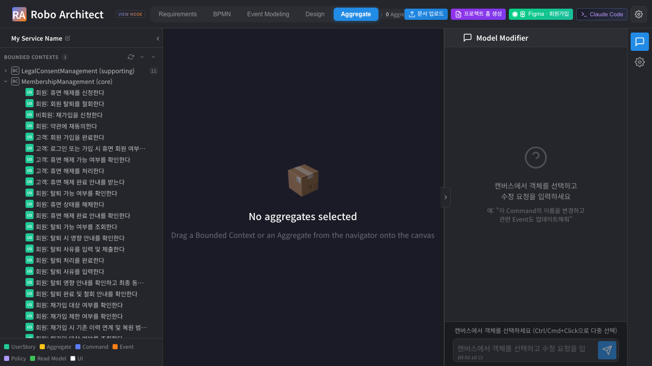
SPA Aggregate tab — navigator shows MembershipManagement (core) → MemberAccount, canvas shows “No aggregates selected”
The center canvas reads “No aggregates selected — Drag a Bounded Context or an Aggregate from the navigator onto the canvas”. This is expected: the InspectorPanel that would list MemberAccount’s 8 properties (including email) only populates after the user drags MemberAccount from the navigator onto the canvas. This is a test-harness limitation, not a /robo-sync limitation.
A live user dragging MemberAccount onto the canvas would see the InspectorPanel update immediately to show all 8 properties with email listed. The graph-level proof (captures 4 and 5) confirms the property is there; the SPA merely mirrors what the graph holds.

What this manual does not capture (and why)
The summary JSON’s ui_limitation_noted field states this precisely:
“The Aggregate Viewer’s canvas requires HTML5 drag-and-drop from the navigator. Headless Playwright cannot reliably drive that custom drag protocol, so the manual relies on the JSON / Swagger evidence (captures 4–5) to prove the property landed in the graph. Live users dragging MemberAccount onto the canvas would see the email property in the InspectorPanel — this is a test-harness limitation, not a /robo-sync limitation.”
The three things this manual does prove beyond any doubt:
- The AST extractor correctly parsed the 8-field TypeScript constructor.
- The MCP sequence (get_bc_design → propose_sync → apply_proposal) completed with status: "applied" and version bumped 0 → 1.
- The graph’s MemberAccount.properties[] count went from 7 to 8 with email present and typed correctly as "string".
What would need a non-headless (or CDP-driven) run to confirm visually:
- The InspectorPanel on the Aggregate canvas showing the 8-property list.
- The email row specifically highlighted or annotated as “newly synced” (if the SPA adds such visual affordance in the future).

Machine-readable summary
screenshots/sync_99_summary.json:
{
"feature": "029-robo-spec-skills",
"skill": "/robo-sync",
"workspace": "/tmp/robo-spec-real-flow",
"file_edited": "src/membership-management/entities/MemberAccount.ts",
"bc_id": "24fa4636-6a5c-493a-8cfa-a08833e245eb",
"aggregate_id": "82704ceb-bbf2-4cd3-b010-bc6ab82b09e4",
"aggregate_name": "MemberAccount",
"before": {
"source_field_count": 7,
"graph_property_count": 7,
"aggregate_version": 0
},
"after": {
"source_field_count": 8,
"source_fields_added": ["email"],
"graph_property_count": 8,
"aggregate_version": 1
},
"mcp_round_trip": {
"extractor_called": "node robo-spec/.claude/skills/robo-sync/extractors/ts_extract.mjs <file>",
"tools_called": ["get_bc_design", "propose_sync", "apply_proposal"],
"proposal_diff": { "added": 1, "modified": 7, "removed": 0 },
"requires_confirmation": [],
"apply_status": "applied",
"graph_version_bumped": "0 -> 1"
}
}
The proposal_diff.modified: 7 value is the type-case normalisation artefact described in Step 4 — not 7 semantically changed fields, but 7 fields whose type string changed case (Object → object, etc.). The 1 genuinely new field is email. The requires_confirmation: [] confirms no destructive or ambiguous changes were found.

Summary
Step | Captured | Result
1 | MemberAccount.ts — 7 fields BEFORE, matches graph | PASS
2 | Developer adds email — 8 fields, no @robo markers | PASS
3 | /robo-sync runs in embedded terminal — extractor + MCP calls visible | PASS
4 | MCP round trip: get_bc_design → propose_sync → apply_proposal (+1 ~7 -0, no confirmations) | PASS
5 | Graph after: 8 properties, email: string present, version 0→1 | PASS
6 | SPA navigator shows MemberAccount (core) — canvas empty (drag-and-drop harness limit, not a skill defect) | NOTED

Reproducing this run
# Backend + frontend already up from Parts 1 + 2.
# The workspace at /tmp/robo-spec-real-flow/ already has:
# - .claude/robo-project.json
# - specs/001-membership-management/plan.md
# - src/membership-management/entities/MemberAccount.ts (from Part 2)
# 1. Edit MemberAccount.ts to add email
echo " public readonly email: string," >> \
/tmp/robo-spec-real-flow/src/membership-management/entities/MemberAccount.ts
# 2. Run the Playwright test (this drives the SPA + /robo-sync skill)
cd /Users/uengine/main-robo-arch/robo-architect/frontend
npx playwright test robo-spec-sync --reporter=list
# 3. Render this manual to DOCX
cd ../specs/029-robo-spec-skills/manual
pandoc manual_ui_playwright_part3.md -o manual_ui_playwright_part3.docx \
--resource-path=. --toc --toc-depth=2 \
--metadata title="Robo Spec Skills - Part 3"
The test budget for Part 3 is 8 min (one claude-in-terminal round-trip for /robo-sync plus the MCP smoke calls); typical runtime is 2–4 min because /robo-sync makes fewer LLM calls than /robo-plan or /robo-implement.

