

#### SSN COLLEGE OF ENGINEERING

DEPARTMENT OF COMPUTER SCIENCE AND ENGINEERING

III year CSE – V Semester

### UCS 2501 Computer Networks Team Project

Title : RIP v2

###### Academic year : 2023-2024 Batch: 2021 - 2025

Faculty Incharge**:** Dr. S.V.Jansi Rani

|  |  |  |  |  |  |
| --- | --- | --- | --- | --- | --- |
| Team members |  | | | | |
| Shobika K M | – | 3122 | 21 | 5001 | 101 |
| Vaidhegi D | – | 3122 | 21 | 5001 | 118 |
| Rajasekar S | – | 3122 | 21 | 5001 | 076 |
| Pranes | – | 3122 | 21 | 5001 | 309 |

# INDEX

|  |  |  |
| --- | --- | --- |
| **S.NO** | **CONTENT** | **PAGE NO** |
| 1 | Problem Statement | 3 |
| **2** | Protocol / Method Explanation | 4 |
| **3** | Code | 9 |
| **4** | Output | 11 |
| **5** | Learning outcomes | 13 |
| **6** | Readme File | 14 |
| **7** | Github link | 15 |

## PROBLEM DEFINITION:-

* In this project, we aim to set up a network with two routers (R0 and R1) and two PCs (PC0 and PC1).
* The primary goals include assigning IP addresses,

implementing Routing Information Protocol (RIP) version 2 and analyze the performance of it by testing the connectivity by pinging a remote router.

## PROJECT OVERVIEW:-

###### Setup of Components in Cisco

Introduction to the Cisco environment, outlining the physical and logical components, including routers, switches, and PCs, to establish a foundational understanding of the network architecture.

###### Configuration

Configuration of Cisco devices, focusing on router interfaces and the implementation of Routing Information protocol version 2 to enable secure communication between two networks.

###### Connectivity

Explanation of how routers play a central role in facilitating connectivity between internal and external networks, considering routing tables and network segmentation.

###### Testing

Instructions for conducting connectivity tests, such as ping tests, to verify the effectiveness of the RIP version 2 setup, along with troubleshooting tips for common issues that may arise during testing.

###### Documentation

Provide comprehensive documentation that provides overview about the project, define the components used and configuration required and a readme file on how to run the project.

## PROTOCOL/METHOD EXPLANATION:-

What is Routing Information Protocol(RIP):-

**Routing Information Protocol** (RIP) is a dynamic routing protocol that uses hop count as a routing metric to find the best path between the source and the destination network. It is a distance-vector routing protocol that has an AD value of 120 and works on the Network layer of the OSI model. RIP uses port number 520.

**Hop Count:**

Hop count is the number of routers occurring in between the source and destination network. The path with the lowest hop count is considered as the best route to reach a network and therefore placed in the routing table. RIP prevents routing loops by limiting the number of hops allowed in a path from source and destination. The maximum hop count allowed for RIP is 15 and a hop count of 16 is considered as network unreachable.

**Features of RIP:**

1. Updates of the network are exchanged periodically.   
2. Updates (routing information) are always broadcast.   
3. Full routing tables are sent in updates.   
4. Routers always trust routing information received from neighbor routers. This is also known as *Routing on*rumors.

**Comparing RIPv1, RIPv2, RIPng**

| **RIP v1** | **RIP v2** | **RIPng** |
| --- | --- | --- |
| Sends update as broadcast | Sends update as multicast | Sends update as multicast |
| Broadcast at 255.255.255.255 | Multicast at 224.0.0.9 | Multicast at FF02::9 (RIPng can only run on IPv6 networks) |
| Doesn’t support authentication of updated messages | Supports authentication of RIPv2 update messages | – |
| Classful routing protocol | Classless protocol updated supports classful | Classless updates are sent |

**RIP timers:**

* **Update timer:**The default timing for routing information being exchanged by the routers operating RIP is 30 seconds. Using an Update timer, the routers exchange their routing table periodically.
* **Invalid timer:**If no update comes until 180 seconds, then the destination router considers it invalid. In this scenario, the destination router mark hop counts as 16 for that router.
* **Hold down timer:**This is the time for which the router waits for a neighbor router to respond. If the router isn’t able to respond within a given time then it is declared dead. It is 180 seconds by default.
* **Flush time:**It is the time after which the entry of the route will be flushed if it doesn’t respond within the flush time. It is 60 seconds by default. This timer starts after the route has been declared invalid and after 60 seconds i.e time will be 180 + 60 = 240 seconds.

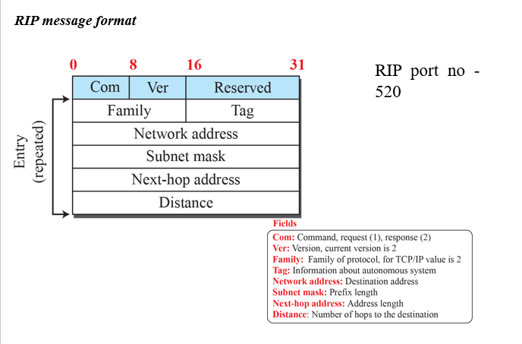

## Device configuration

## 

#### Router R1 CONFIGURATION

Interface Configuration*:* Router R1's interface setup is pivotal to network connectivity. The serial interface, assigned the IP address 192.168.1.1, establishes communication with external networks. Simultaneously, the fast Ethernet interface, configured with the IP address 192.168.101.1, interfaces with the internal network. Enabling both interfaces ensures their operational status.

RIP Routing Configuration: The implementation of RIP on Router R1 is crucial for dynamic routing. Utilizing the router rip command and specifying relevant network addresses via the network commands ensures that Router R1 participates in the RIP routing process.

#### Router R2 CONFIGURATION

Interface Configuration: Router R2's setup mirrors that of Router R1. The fast Ethernet interface is assigned the IP address 192.168.100.1, while the serial interface is configured with the IP address 192.168.1.2. The no shutdown command activates both interfaces.

RIP Routing Configuration: RIP is also configured on Router R2 using the router rip command. The network commands identify the networks to be included in the RIP routing updates.

#### PC0 Configuration:

IP Address Assignment: PC0's IP address assignment is a critical step in establishing communication within the internal network. With the IP address 192.168.101.2 and subnet mask 255.255.255.0.

#### PC1 Configuration:

IP Address Assignment: PC1's IP address assignment is a critical step in establishing communication within the internal network. With the IP address 192.168.100.2 and subnet mask 255.255.255.0.

## Routing protocol implementation

RIP Selection: The decision to implement the Routing Information Protocol (RIP) is grounded in its distance-vector algorithm. RIP's dynamic routing capabilities are well-suited for smaller networks, making it a pragmatic choice for this project.

#### Router R1 Configuration (RIP):

RIP Configuration: Router R1's participation in RIP is facilitated by the router rip command. Within RIP configuration mode, the network commands delineate the networks that will be part of the RIP routing process. Add a WIC-1T to the router and switch on the router. The WIC-1T provides a single port serial connection to remote sites or legacy serial network devices such as Synchronous Data Link Control (SDLC) concentrators, alarm systems, and packet over SONET (POS) devices.

#### Router R2 Configuration (RIP):

RIP Configuration: Router R2's RIP configuration mirrors that of Router R1. The router rip command, followed by appropriate network commands, ensures that Router R2 actively engages in the RIP routing protocol. Add a WIC-1T to the router and switch on the router. The WIC-1T provides a single port serial connection to remote sites or legacy serial network devices such as Synchronous Data Link Control (SDLC) concentrators, alarm systems, and packet over SONET (POS) devices.

## Connectivity testing

#### Ping Test from PC0 to PC1:

Verification Test: A crucial step in network deployment is the validation of connectivity. The ping 192.168.100.2 command, executed from PC0, serves as a verification test, ensuring that communication is established between PC0 and PC1.

#### Ping Test from PC1 to PC0:

Verification Test: A crucial step in network deployment is the validation of connectivity. The ping 192.168.101.2 command, executed from PC1, serves as a verification test, ensuring that communication is established between PC1 and PC0.

## TOPOLOGY:-

## 

CODE:-

#### Router R0

#### Router>en

#### Router#conf t

#### Enter configuration commands, one per line. End with CNTL/Z.

#### Router(config)#int f0/0

#### Router(config-if)#ip add 192.168.101.1 255.255.255.0

#### Router(config-if)#no shut

#### Router(config-if)#

#### Router(config-if)#exit

#### Router(config)#int s0/0/0

#### Router(config-if)#ip add 192.168.1.1 255.255.255.0

#### Router(config-if)#no shut

#### Router(config-if)#exit

#### Router(config)#

#### Router#

#### Router R1

#### Router>en

#### Router#conf t

#### Enter configuration commands, one per line. End with CNTL/Z.

#### Router(config)#int f0/0

#### Router(config-if)#ip add 192.168.100.1 255.255.255.0

#### Router(config-if)#no shut

#### Router(config-if)#

#### Router(config-if)#exit

#### Router(config)#int s0/0/0

#### Router(config-if)#ip add 192.168.1.2 255.255.255.0

#### Router(config-if)#no shut

#### Router(config-if)#exit

#### Router(config)#

#### Router#

## OUTPUT:-

## 

#### From PC0 TO PC1:-

#### 

#### From PC0 TO R0:-

#### 

From PC1 TO PC0:-

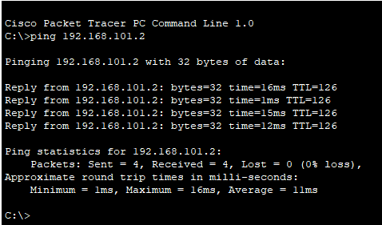

#### From PC1 TO R1:-

#### 

## LEARNING OUTCOMES:-

1. IP Addressing Mastery:

Gain proficiency in assigning IP addresses, distinguishing between private and public IP address spaces, and understanding subnetting principles.

1. Router Configuration Expertise:

Develop skills in configuring routers with multiple interfaces, implementing dynamic routing protocols (RIP), and establishing inter-router connectivity.

1. Network Topology Design Proficiency:

Understand the essentials of designing basic network topologies, identifying components such as routers, switches, and PCs, and recognizing their interconnections for optimal network functionality.

# README FILE

### Requirements:-

* 1. Cisco packet tracer

### Configuration:-

1.Access the router's command-line interface. 2.Configure the necessary interfaces with appropriate IP addresses. For example:

For Router 0:

interface Serial0/0

ip address 192.168.1.1 255.255.255.0

no shutdown exit

interface FastEthernet0/0

ip address 192.168.101.1 255.255.0.0

no shutdown exit

For Router 1:

interface Serial0/0

ip address 192.168.1.2 255.255.255.0

no shutdown exit

interface FastEthernet0/0

ip address 192.168.100.1 255.255.0.0

no shutdown exit

1. Save the configuration.

### Usage:-

Make sure the WIC-1T is attached, router is powered on and connected to the network. The RIP version 2 should now be in effect.

Connectivity Testing:-

To test the connectivity, initiate ping tests between devices:

* 1. From PC0, ping another external device PC1
  2. From PC1, ping PC0.