**Developer Name:** Utku ERKASAP

**Project:** Assiginment 1 (Course-end Project 1)

**GitHub Link:** https://github.com/uerkasap/Assignment_1.git

Our USP is better user interface and there are some control mechanism in order to mitigate errors and in case of an error the application gives information about the type of the error and keep to run the applcaiton. This feature ensure to save time to the user.

Scrum and Kanban (Scrumban) methodologies are implemented for the project.



* Welcome screen when the code runs.

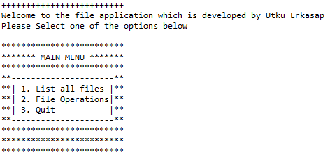

* When the user enters 1, the program lists all files with ascending order in the current directory.



* When the user enters 2, sub-menu appears regarding file operations such as adding, deleting, seaching. The user also have a option to going back if 7 is selected.

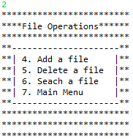

* For option 4, If the file name doesn’t exist in the current directory, it creates a new file according to input.

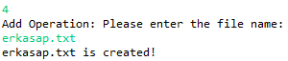

* If the file name already exists in the current directory, it doesn’t create a new file and turns a exception message. After the message, the program doesn’t terminate and runs again.

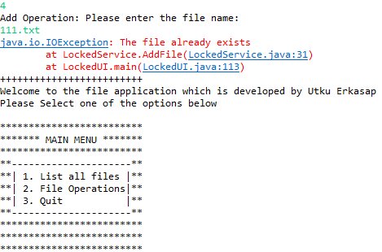

* If the file name exists in the current directory, it deletes the file according to input when 5th option is selected.

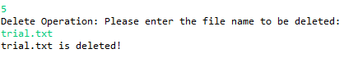

* If the file name already doesn’texist in the current directory, it doesn’t delete any file and turns a exception message. After the message, the program doesn’t terminate and runs again.

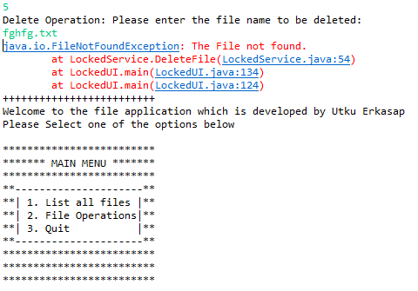

* 6th option searches filename between files in the current directory what the user types and if it is found, turns a message that the operation is successful.



* If the file does not exist, then turns a message about the file is not found.



* When the input is 7, the program goes back to main menu.

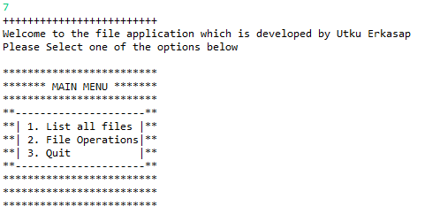

* If the user gives value 3, “Bye!” message appears and the program terminates immediately.

