EE120B Final Lab Report

Uriel Escobar

861219219

Project: JukeBox

* **LCD Screen in start mode**: Welcome note and display list of songs in juke box *(10pts)*
* **User presses buttons to select Song**: show some functionality with buttons like skip song, stop song, increase speed or decrease speed *(40pts)*
* **LCD Screen must display song being played**: Always display which song you are playing *(10pts)*
* **User may press stop button to stop song**: *(10pts)*

***Bonus: Visual Feature that reacts to song being played*** *(20pts)*

**Steps in creating JukeBox**

**IDEA**

First and foremost, I began by thinking how what components I required for this project. Atmel 1284, LCD, Buttons, Potentiometer, wires, buzzer/speaker, and a power supply. After I had to decide how many buttons I want and what i want their functionality to be. Next, I had to decide how I would like to access songs. As I began to decide the the individual functionalities of each individual part, I began making a statemachine:

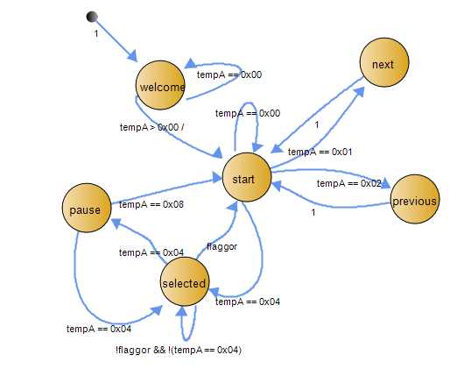

The statemachine does not show the actions of states due to the large amount of code that will overlap.

**Implementation**

The wiring was the easiest part (as shown below)

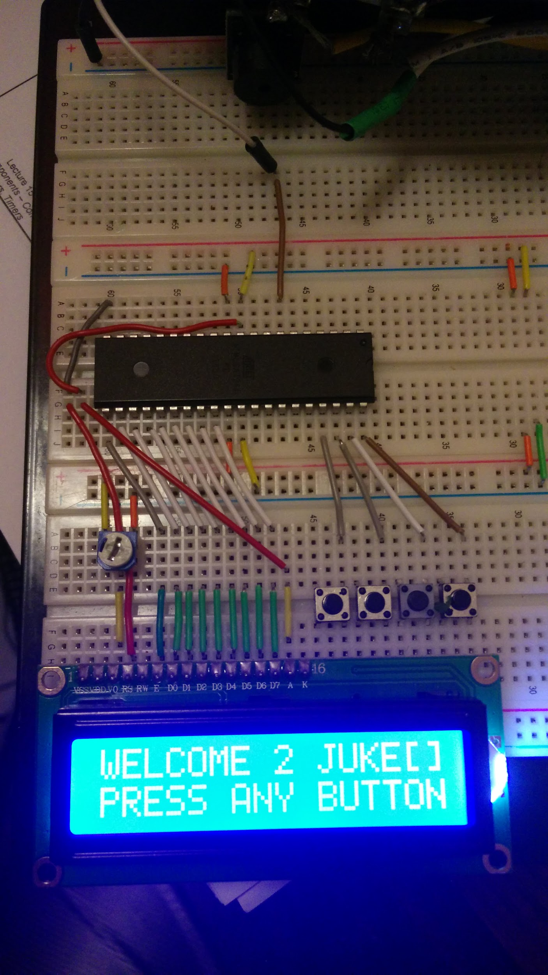

At the very bottom is the LCD screeN. There are four buttons above the top right hand corner of the LCD. The left most button is functions as a Stop while playing a song or at the paused state. The button right to it is the select. When maneuvering through the songs pressing the select will start playing the song displayed on the LCD. While playing it will act as a pause/play. The button to the right of that one maneuvers the song selection to the left. The right most button maneuvers the song selection to the right.

**PROBLEMS & Learning**

Most of the problems I encountered were usually syntax errors. Others had to do with my lack or practise or knowledge of the C language. Like where it was acceptable to declare a variable used but multiple functions or how to properly use a 2d array for songs. All of these problems I googled and learned more about them.

**CONCLUSION**

The project was fun and a good learning experience. I hope to do more as my C need to be more redefined

LINKS:  
 GITHUB CODE <https://github.com/uesco001/EE120B-Final/blob/master/FinalPorject_Code.c>

VIDEO

<https://www.youtube.com/watch?v=iNT_7wBAPZ8>