
IT-SIMPLERA INSTITUTE
Network Administration Internship Program
Weekly Progress Report
WEEK 3 - TASK 3
Multi-Protocol Routing (OSPF & RIP)
Prepared by: Shayan Khan

Intern Name: | Shayan Khan
Institute | ITsimplera Solutions
Registration No.: | NETB01-3875
Internship Role: | Network Administration Intern
Supervisor: | Jawad Qayum - Senior Network Administrator
Report Topic: | Multi-Protocol Routing (OSPF & RIP) - GNS3 Lab

GNS3 Project File: week3_multi_protocol_routing

Table of Contents
Table of Contents 2
1. Objectives 3
2. Tools & Environment 3
3. Network Topology 3
4. IP Addressing Plan 4
5. Router Interface Configuration 4
5.1 R1 - Interface Configuration 5
5.2 R2 - Interface Configuration 5
5.3 R3 - Interface Configuration 6
5.4 R4 - Interface Configuration 6
5.5 R5 - Interface Configuration 7
6. Routing Protocol Configuration 8
6.1 OSPF Configuration - R2 (Sample) 8
6.2 OSPF Configuration & Verification - R3 9
6.3 RIP Configuration - R5 9
7. Verification & Testing 10
7.1 Observed Results 11
8. Conclusion 11
9. Interview Preparation Questions 12

1. Objectives
This report documents Week 3 of the network administration internship, focused on building and configuring a multi-router, multi-protocol network topology in GNS3. The objective was to design a five-router network in which the core backbone runs OSPF as a link-state routing protocol while a branch segment runs RIPv2 as a distance-vector protocol, and to verify end-to-end reachability, routing adjacencies, and route propagation across both domains.
Specific goals for the week included:
- Build the network topology in GNS3 using five routers, three switches, and three VPCS end devices.
- Assign IP addressing to all router interfaces and end-device LANs using structured /30 point-to-point links and /24 LAN subnets.
- Configure OSPF (Process 1, Area 0) on R1, R2, R3, and R4 to form the network backbone.
- Configure RIPv2 on R5 to simulate a separate routing domain connected at the network edge.
- Verify OSPF neighbor adjacencies, routing tables, and interface states using Cisco IOS 'show' commands.
- Document configuration steps, verification output, and prepare related interview/theory questions.

2. Tools & Environment
Tool / Platform | Purpose
GNS3 | Network simulation platform used to build and run the router/switch topology.
Cisco IOS (Router Image) | Provided router CLI for interface, OSPF, and RIP configuration.
VPCS | Lightweight virtual PC simulator used for PC1, PC2, and PC3 end devices.
SolarWinds Solar-PuTTY | Terminal client used to access and configure each router's console.

3. Network Topology
The topology consists of five Cisco routers (R1-R5) interconnected in a partial-mesh backbone, three Layer 2 switches, and three VPCS end devices representing client PCs on separate LANs. R1, R4, and R5 each host a LAN segment (192.168.10.0/24, 192.168.20.0/24, and 192.168.30.0/24 respectively) reachable through Switch1, Switch2, and Switch3. R2 and R3 act as transit routers with no directly attached end-user LAN. The R3-R5 link forms the boundary between the OSPF backbone and the RIP domain.
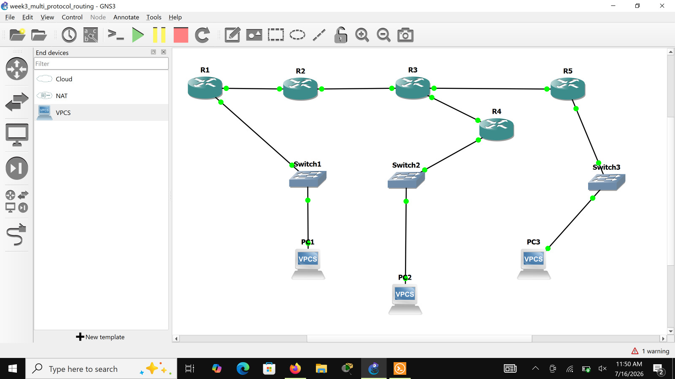
Figure 1: GNS3 topology - R1 through R5, three switches, and three VPCS end devices (PC1, PC2, PC3).

4. IP Addressing Plan
The table below summarizes the IP address assigned to every router interface, the subnet mask, and the corresponding remote connection, as configured on each device during this week's lab.
Device | Interface | IP Address | Subnet Mask | Connected To
R1 | Fa0/0 | 192.168.10.1 | 255.255.255.0 | Switch1 / PC1 (LAN)
R1 | Fa0/1 | 10.0.12.1 | 255.255.255.252 | R2 Fa0/0
R2 | Fa0/0 | 10.0.12.2 | 255.255.255.252 | R1 Fa0/1
R2 | Fa0/1 | 10.0.23.1 | 255.255.255.252 | R3 Fa0/0
R3 | Fa0/0 | 10.0.23.2 | 255.255.255.252 | R2 Fa0/1
R3 | Fa0/1 | 10.0.34.1 | 255.255.255.252 | R4 Fa0/0
R3 | Fa1/0 | 10.0.35.1 | 255.255.255.252 | R5 Fa0/0
R4 | Fa0/0 | 10.0.34.2 | 255.255.255.252 | R3 Fa0/1
R4 | Fa0/1 | 192.168.20.1 | 255.255.255.0 | Switch2 / PC2 (LAN)
R5 | Fa0/0 | 10.0.35.2 | 255.255.255.252 | R3 Fa1/0
R5 | Fa0/1 | 192.168.30.1 | 255.255.255.0 | Switch3 / PC3 (LAN)

5. Router Interface Configuration
Each router's physical interfaces were configured with a hostname, IP address, and 'no shutdown' to bring the link up. The relevant configuration commands and resulting UPDOWN log messages for each router are shown below.

5.1 R1 - Interface Configuration
R1 was configured with Fa0/0 on the 192.168.10.0/24 LAN and Fa0/1 as the point-to-point uplink to R2.
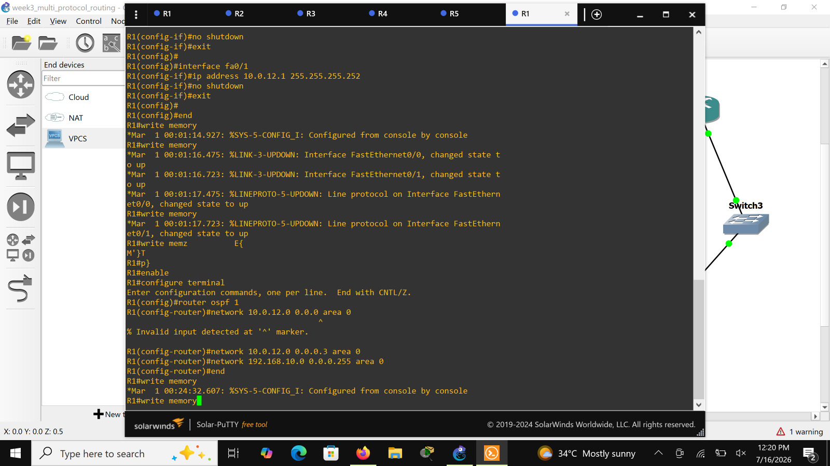
Figure 2: R1 interface configuration - Fa0/0 (LAN) and Fa0/1 (link to R2) brought up with 'no shutdown'.

5.2 R2 - Interface Configuration
R2 was configured as a transit router with Fa0/0 facing R1 and Fa0/1 facing R3.
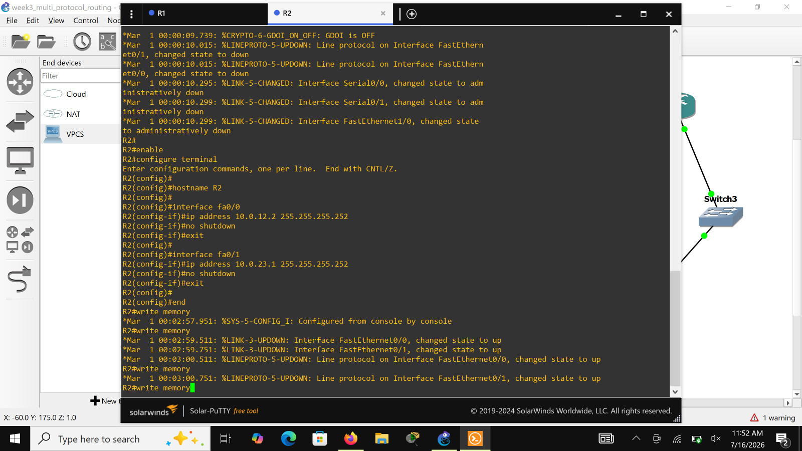
Figure 3: R2 interface configuration - Fa0/0 (10.0.12.2/30) and Fa0/1 (10.0.23.1/30).

5.3 R3 - Interface Configuration
R3 is the central transit router, connecting to R2, R4, and R5 via three separate point-to-point links (Fa0/0, Fa0/1, and Fa1/0).
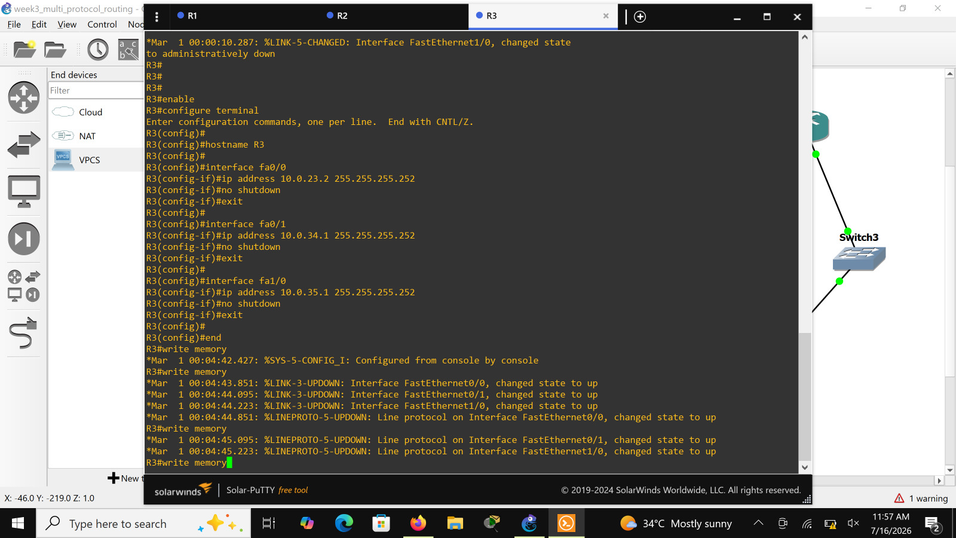
Figure 4: R3 interface configuration - Fa0/0 (to R2), Fa0/1 (to R4), and Fa1/0 (to R5).

5.4 R4 - Interface Configuration
R4 was configured with Fa0/0 as the uplink to R3 and Fa0/1 on the 192.168.20.0/24 LAN serving PC2 via Switch2.
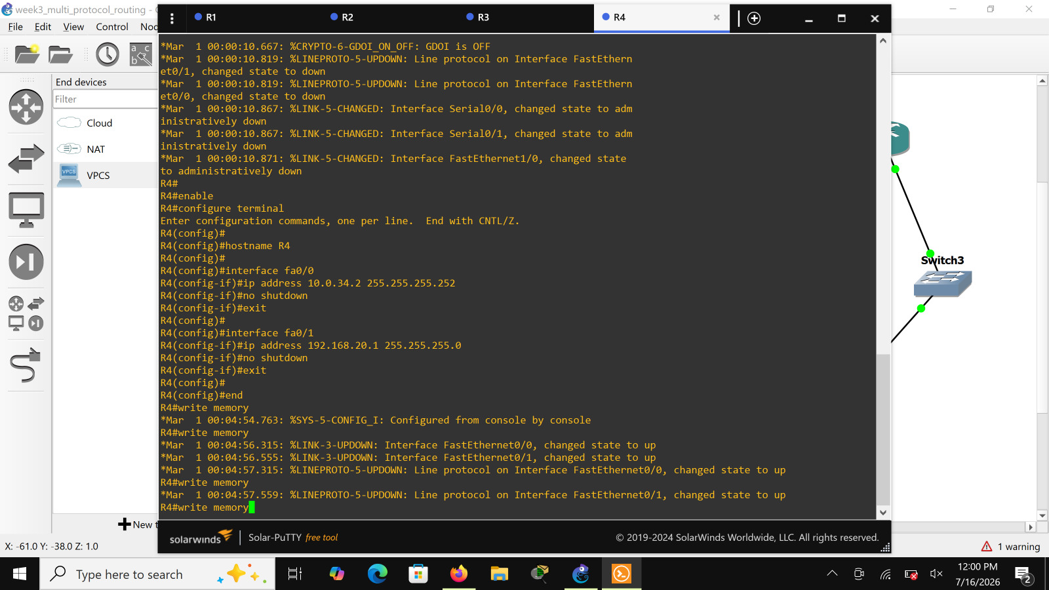
Figure 5: R4 interface configuration - Fa0/0 (10.0.34.2/30) and Fa0/1 (192.168.20.1/24).

5.5 R5 - Interface Configuration
R5 was configured with Fa0/0 as the uplink to R3 and Fa0/1 on the 192.168.30.0/24 LAN serving PC3 via Switch3.
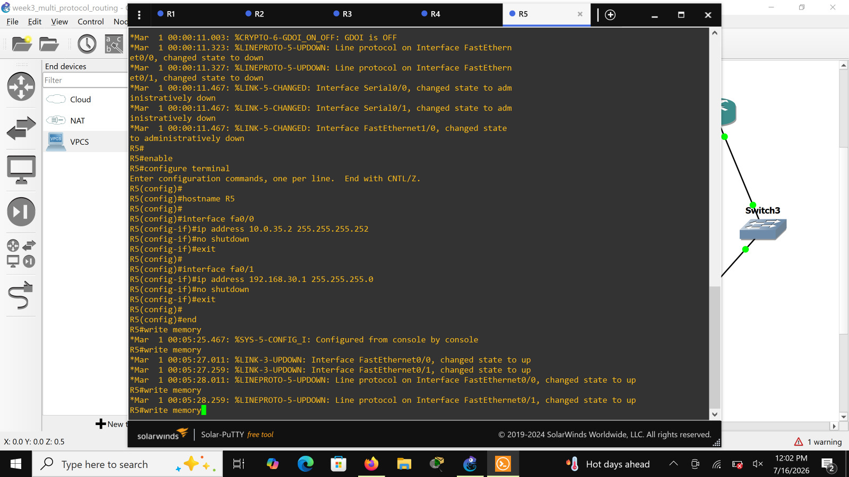
Figure 6: R5 interface configuration - Fa0/0 (10.0.35.2/30) and Fa0/1 (192.168.30.1/24).

6. Routing Protocol Configuration
This lab demonstrates a multi-protocol environment: OSPF runs across the R1-R2-R3-R4 backbone as a single area (Area 0), while R5 runs RIPv2 independently, advertising its connected networks with classless (no auto-summary) behavior. The routing protocol assignment for each router is summarized below.
Router | Routing Protocol | Networks Advertised | Area / Process
R1 | OSPF | 10.0.12.0/30, 192.168.10.0/24 | Process 1, Area 0
R2 | OSPF | 10.0.12.0/30, 10.0.23.0/30 | Process 1, Area 0
R3 | OSPF | 10.0.23.0/30, 10.0.34.0/30 | Process 1, Area 0
R4 | OSPF | 10.0.34.0/30 (learned via OSPF), 192.168.20.0/24 | Process 1, Area 0
R5 | RIPv2 | 10.0.0.0 (classful, covers 10.0.35.0/30), 192.168.30.0 | no auto-summary

6.1 OSPF Configuration - R2 (Sample)
OSPF process 1 was enabled on each backbone router, with each directly connected /30 or /24 network explicitly placed into Area 0 using a wildcard mask. R2's configuration is shown as a representative example; R1, R3, and R4 follow the same pattern for their own directly connected networks.
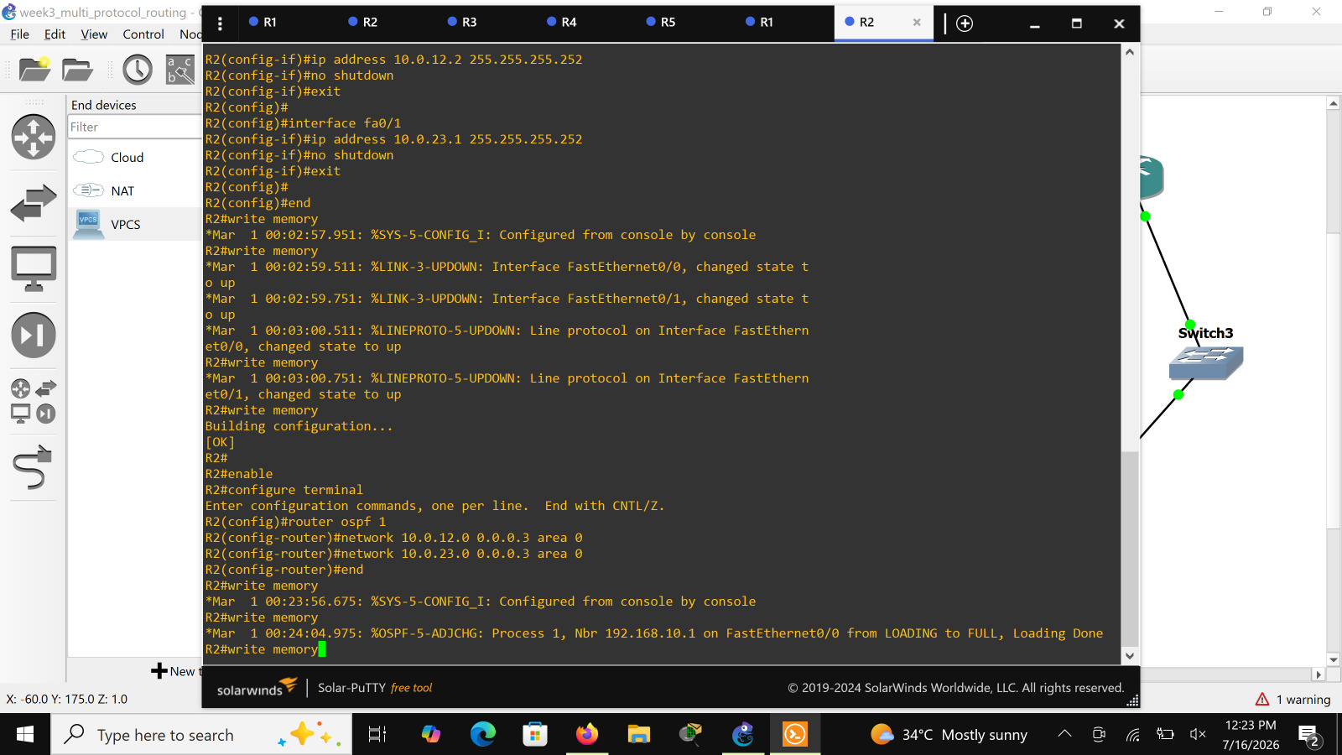
Figure 7: R2 OSPF configuration - 'router ospf 1' with both connected /30 networks placed in Area 0; OSPF adjacency with R1 (10.0.12.1) reaches FULL state.
router ospf 1
network 10.0.12.0 0.0.0.3 area 0
network 10.0.23.0 0.0.0.3 area 0

6.2 OSPF Configuration & Verification - R3
R3, positioned at the center of the backbone, advertises its links toward R2 and R4 into OSPF Area 0. The 'show ip ospf neighbor' output confirms a FULL/DR adjacency has formed with the neighboring router over FastEthernet0/0.
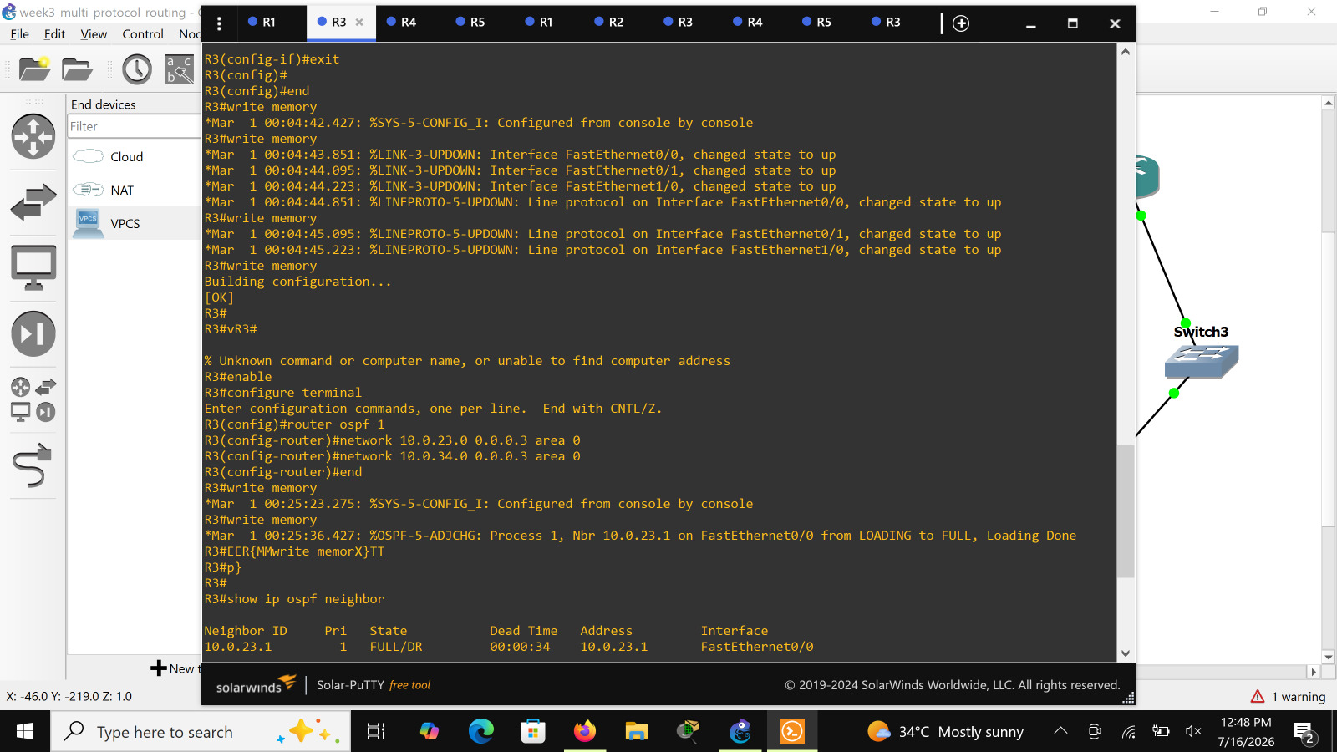
Figure 8: R3 OSPF configuration ('router ospf 1', networks 10.0.23.0/30 and 10.0.34.0/30 in Area 0) and neighbor verification showing FULL/DR state.

6.3 RIP Configuration - R5
R5 was configured with RIP version 2 and 'no auto-summary' to prevent classful summarization, advertising the 10.0.0.0 major network (covering the 10.0.35.0/30 link to R3) and the 192.168.30.0 LAN.
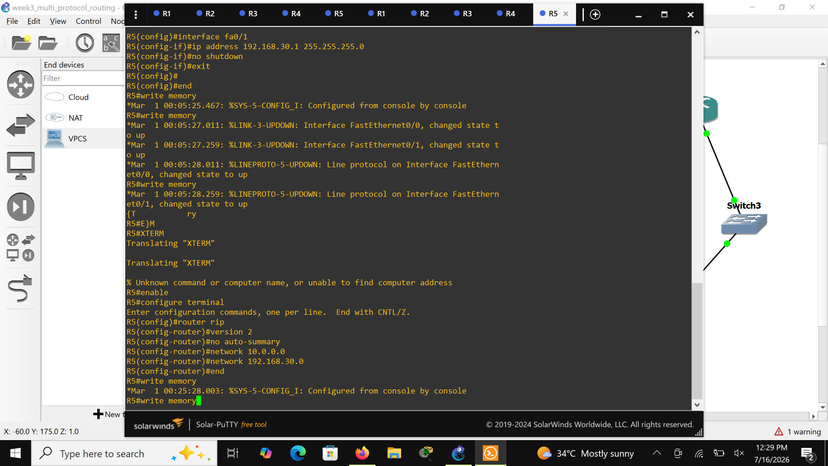
Figure 9: R5 RIPv2 configuration - version 2, no auto-summary, and network statements for 10.0.0.0 and 192.168.30.0.
router rip
version 2
no auto-summary
network 10.0.0.0
network 192.168.30.0
Note: For end-to-end reachability between the OSPF backbone and the RIP domain, R3 (or R5) must ultimately act as the redistribution boundary between the two routing processes. This is a normal next step in a multi-protocol design and would typically be configured with mutual 'redistribute ospf 1' / 'redistribute rip' statements on the boundary router.

7. Verification & Testing
Routing tables and OSPF adjacency state were verified on R1 using 'show ip route' and 'show ip ospf neighbor'. The output confirms that R1 has learned the 10.0.23.0/30 and 10.0.34.0/30 backbone routes via OSPF (marked 'O') in addition to its own directly connected networks, and that its OSPF neighbor relationship with R2 (10.0.23.1) is FULL.
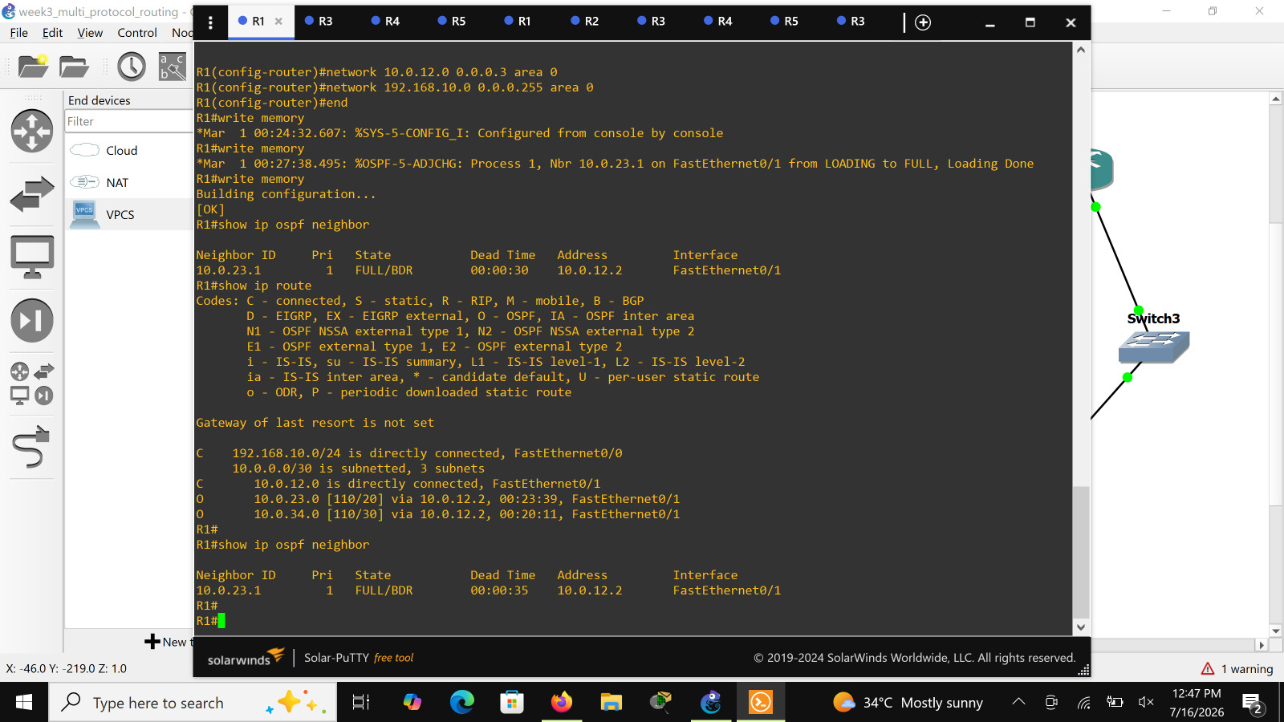
Figure 10: R1 verification - 'show ip ospf neighbor' (FULL/BDR) and 'show ip route' showing directly connected and OSPF-learned (O) routes.

7.1 Observed Results
- All five routers successfully brought up their configured interfaces (LINK-3-UPDOWN and LINEPROTO-5-UPDOWN messages confirmed on every link).
- OSPF adjacencies between R1-R2 and R2-R3 reached FULL state, confirming successful link-state database synchronization across the backbone.
- R1's routing table correctly reflects OSPF-learned routes to the R2-R3 (10.0.23.0/30) and R3-R4 (10.0.34.0/30) links, in addition to its own connected networks.
- RIPv2 was successfully enabled on R5 and configured to advertise both its LAN and its uplink network toward R3.
- All configurations were saved to NVRAM using 'write memory' to persist across device restarts.

8. Conclusion
This week's lab provided hands-on experience designing and verifying a multi-protocol routed network, combining a link-state protocol (OSPF) on the network core with a distance-vector protocol (RIP) at a branch edge. The exercise reinforced core routing concepts including wildcard masks, OSPF area design, RIP classless configuration, and the use of Cisco IOS verification commands to confirm neighbor adjacencies and route propagation. It also highlighted the practical need for route redistribution when interconnecting two distinct routing domains, a concept that will be addressed as a follow-up configuration task.

9. Interview Preparation Questions
The following questions and model answers were prepared based on this week's topic of multi-protocol (OSPF/RIP) routing, for use in internship review sessions and interview practice.
Q1. What is the main difference between a distance-vector and a link-state routing protocol?
A: Distance-vector protocols (like RIP) share the entire routing table with directly connected neighbors and choose routes based on hop count, while link-state protocols (like OSPF) share link-state information with all routers in an area and calculate the shortest path using the Dijkstra (SPF) algorithm, offering faster convergence and better scalability.
Q2. Why does this topology use OSPF on the R1-R2-R3-R4 backbone but RIP on the R3-R5 link?
A: The lab is designed to demonstrate multi-protocol routing, where different autonomous parts of a network run different routing protocols. This reflects real-world scenarios where a network may have grown over time or where different administrative domains use different protocols, requiring redistribution or boundary configuration to exchange routes between them.
Q3. What does the wildcard mask 0.0.0.3 represent in an OSPF network statement?
A: It is the inverse of a /30 subnet mask (255.255.255.252) and tells OSPF to match exactly the 4 addresses of that point-to-point subnet when placing the interface into the specified area.
Q4. What is the purpose of the 'no auto-summary' command under RIP?
A: It disables automatic summarization of routes at classful network boundaries, allowing RIPv2 to advertise subnetted (classless) routes such as the /30 point-to-point links instead of summarizing them into a single classful network.
Q5. In the 'show ip ospf neighbor' output, what does the state 'FULL/DR' or 'FULL/BDR' indicate?
A: FULL means the two routers have fully synchronized link-state databases. DR/BDR indicates the neighbor's role on a multi-access segment: Designated Router or Backup Designated Router, roles used to reduce the number of adjacencies on broadcast networks.
Q6. Why is 'write memory' used after every configuration change in the terminal output?
A: It saves the running-configuration to NVRAM (startup-configuration) so that the settings persist across a device reboot or restart.
Q7. What would happen if R3 did not include the 10.0.35.0/30 link in either OSPF or RIP?
A: The link would remain unadvertised, so neither protocol would have a route to it, and any traffic destined to or through the R3-R5 segment from the rest of the network would fail, since routers rely on advertised routes to build their routing tables.
Q8. What is the significance of the OSPF process ID (e.g., 'router ospf 1')?
A: The process ID is locally significant to the router only; it does not need to match between neighboring routers and is simply used to distinguish between multiple OSPF processes running on the same device.
Q9. How does OSPF determine the best path when multiple routes exist to the same destination?
A: OSPF calculates cost based on cumulative bandwidth of the outgoing interfaces along the path (using the SPF algorithm) and selects the path with the lowest total cost as the best route.
Q10. What is the default administrative distance of OSPF versus RIP, and why does this matter?
A: OSPF has a default administrative distance of 110, while RIP has 120. If a router learns the same route via both protocols, it prefers the route with the lower administrative distance (OSPF), which matters at any point where the two routing domains might overlap or be redistributed.
Q11. What does the 'FastEthernet0/0, changed state to up' and corresponding LINEPROTO message tell you?
A: The LINK-3-UPDOWN message reflects the physical/data-link layer state of the interface (cable connected, carrier detected), while the LINEPROTO-5-UPDOWN message confirms the Layer 2 protocol on that link has also come up, meaning the interface is fully operational.
Q12. Why are point-to-point router links in this topology addressed with /30 subnets instead of /24?
A: A /30 subnet provides exactly two usable host addresses, which is sufficient and efficient for a link connecting only two router interfaces, minimizing wasted IP address space compared to a /24 subnet.
Q13. What command would you use on R3 to verify which networks it is advertising and receiving through OSPF?
A: 'show ip ospf neighbor' verifies adjacencies, and 'show ip route' displays the full routing table including routes learned via OSPF (marked with 'O') and any other protocol in use.
Q14. What is route redistribution, and would it be needed in this topology?
A: Route redistribution is the process of taking routes learned by one routing protocol and injecting them into another routing protocol so that both domains can reach each other. Since this topology runs OSPF on one segment and RIP on another, redistribution (typically configured on the boundary router, R3 or R5) would be required for full end-to-end reachability between all three LANs.
Q15. Why is VPCS (Virtual PC Simulator) used for PC1, PC2, and PC3 instead of full virtual machines?
A: VPCS is a lightweight simulator that provides basic IP connectivity (ping, IP configuration) without the overhead of a full operating system, making it efficient for verifying end-to-end reachability in a GNS3 lab.

