Human detection by Histogram Oriented Gradient

## HOG Feature

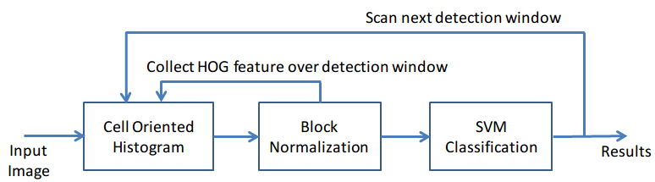

## 

## Histogram Calculation

* Input : $dx, dy$
* Output: $k, m_{1}, m_{2}$
$\tan{θ}=\frac{dy}{dx}$

$\tan{θ_{i}}<\tan{θ}<\tan{θ_{i+1}}$

$dx\tan{θ_{i}}<dy<dx\tan{θ_{i+1}}$

* => determinate bin
$m1=\frac{\sin{θ_{i+1}}dx-\cos{θ_{i+1}}dy}{\cos{θ_{i}\sin{θ_{i+1}}-\cos{θ_{i+1}}\sin{θ_{i}}}}$

$m2=\frac{\cos{θ_{i}}dy-\sin{θ_{i}}dx}{\cos{θ_{i}\sin{θ_{i+1}}-\cos{θ_{i+1}}\sin{θ_{i}}}}$

* With $θ_{i}, θ_{i+1}$ known, determinate m1 and m2

