**LSI Contest 2017 Report**

***Human Detection by Histogram of Oriented Gradients***

# GENERAL INFORMATION

|  |  |
| --- | --- |
| Team: | SISLAB-VNU |
| Member: | Huy Hung Ho |
| School name: | University of Engineering and Technology (UET-VNU) |
| Address: | 144, Xuan Thuy Street, Hanoi, Vietnam |
| Size of team member's T-shirt: | M |
| The tasks level of design: | Level 1 |

Table of content

GENERAL INFORMATION 1

Contents 2

CONTENTS 3

1. Purpose 3

2. Architecture 3

2.1. General Architecture 3

2.2. Cell Input Generation 3

2.3. Cell Histogram Generation 4

2.4. Histogram Normalization 4

2.5. SVM Classification 5

2.6. Processing 5

3. Originality point 6

3.1. Scan image by shift register 6

3.2. Using LUT (Look Up Table) when calculating magnitude gradient 6

3.3. Calculating SVM Classification by combined serial and parallel 7

4. C Code 8

4.1. Introduction 8

4.2. lsi_2017.c 8

4.3. helper.h 10

4.4. human_detection.h 12

4.5. Cal_HOG_block.h 14

5. The display of a simulation waveform which the design is operating 16

6. Others 16

6.1. Acknowledge 16

6.2. Detail C code 17

6.2.1. helper.c 17

6.2.2. human_detection.c 21

6.2.3. Cal_HOG_block.c 30

# CONTENTS

# HOG, SVM introduction

Gray data ->

# Purpose

My purpose is can simulation hardware of this project by HDL code. Currently, I designed hardware architecture and simulation it in C code. The most important in my architecture is optimized performance and timing.

# Architecture

## General Architecture

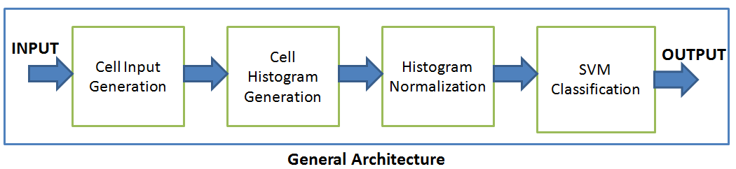

OUTPUT will be compared with BIAS_SVM to determine human in current window.

## Cell Input Generation

In the first processing, human detection is showed by these flowcharts:

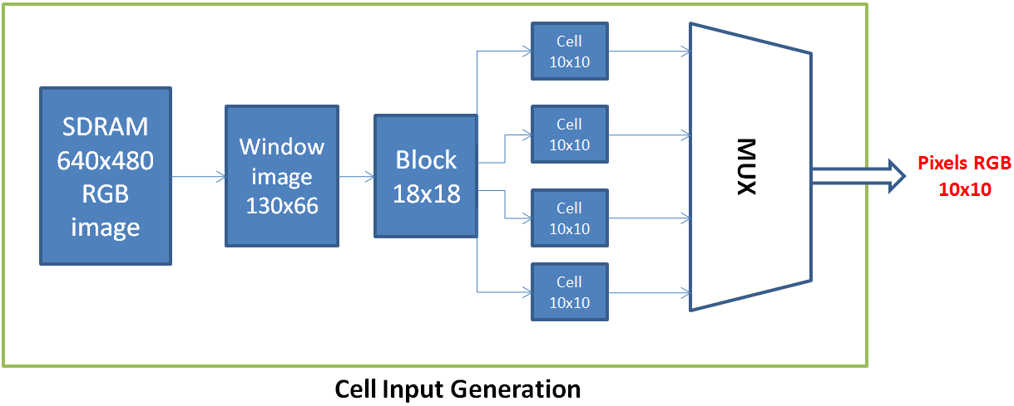

In **Cell Input Generation,** I scan extend window of 128x64, I scan extend cell of 8x8 later.

## Cell Histogram Generation

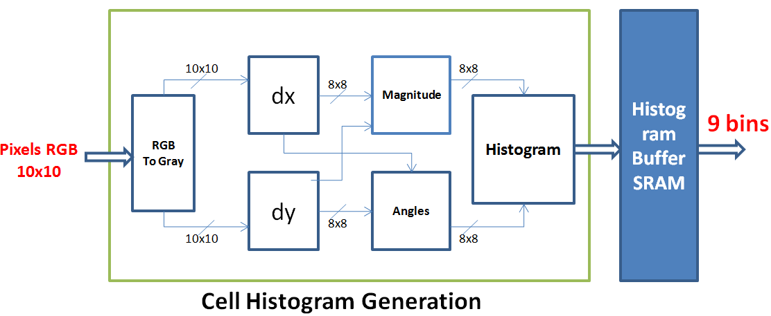

Because I will calculate derivative with respect to x and y, I do not use 8x8 but 10x10.

Then, HOGs are saved **BUFFER.**

## Histogram Normalization

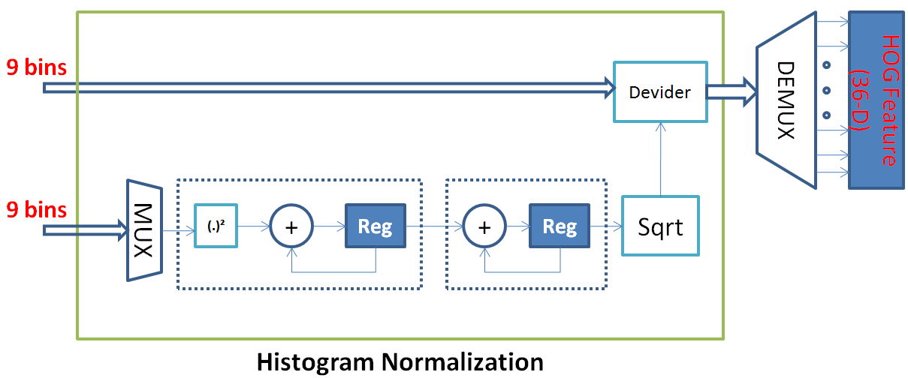

## SVM Classification

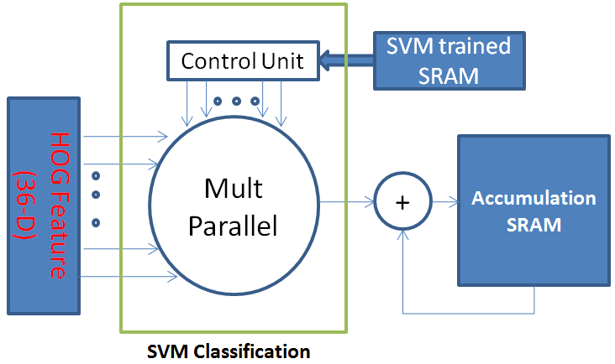

## Processing

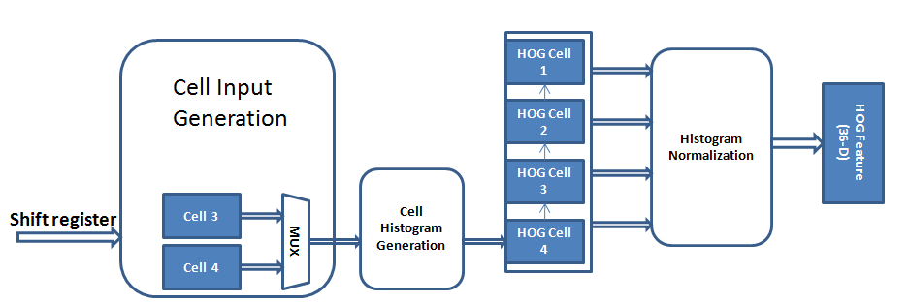

The 1st processing, I calculate HOG Cell follow previous flowcharts.

Since the 2nd processing, I just calculate HOG Cell 3 and HOG Cell 4. Similarly, when shift window image, I keep HOG overlapping section and calculate HOG of next section.

# Originality point

I found 3 point to optimization:

## Scan image by shift register

Instead of scan window image and block image as usual, I shift register 8 pixel to pass next window.

## Using LUT (Look Up Table) when calculating magnitude gradient

When calculating magnitude gradient, I realize derivative and derivative usually valued in the range of 0 to 15.

In expression:

I use LUT to quickly calculate and , and I do not use a multiplier.

Pseudo code:

|  |  |
| --- | --- |
| if < 16  then  = LUT()  else  = | if < 16  then  = LUT()  else  = |

## Calculating SVM Classification by combined serial and parallel



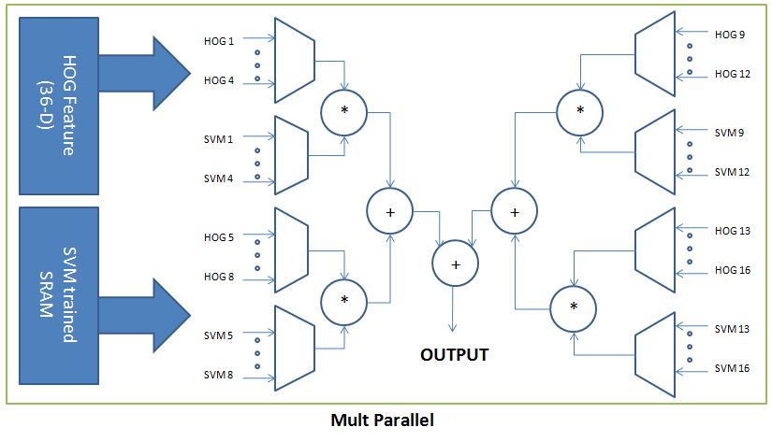

I use 4 **multipliers** to calculate, increase size hardware but decrease timing

# The display of a simulation waveform which the design is operating

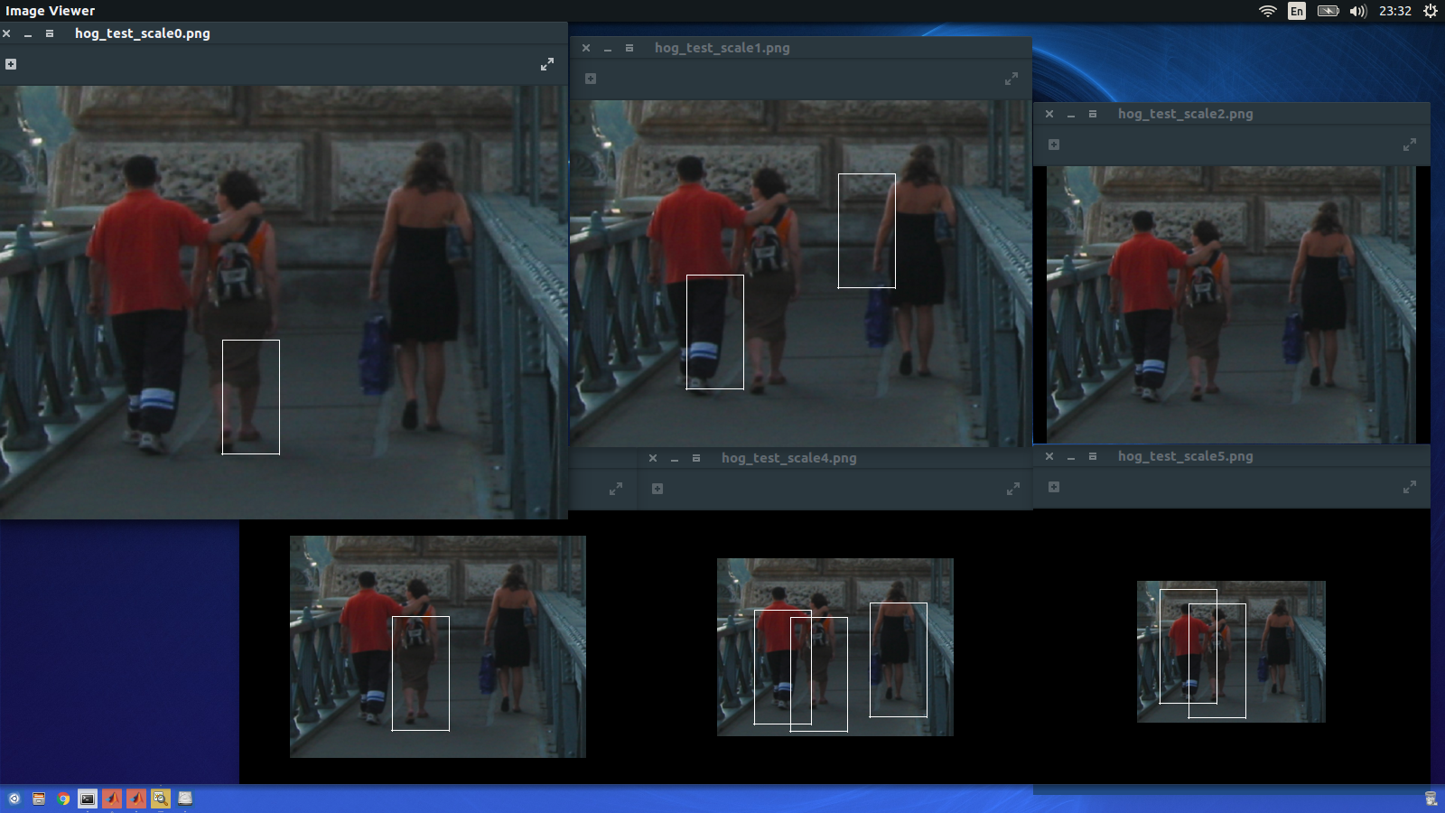

# Others

## Acknowledge

I sincerely thank you for my SISLAB (Laboratory for Smart Integrated Systems), especially Tu Teacher and Sinh-Ngoc Nguyen for supporting me in this project.

I do not have enough time to finish this project, but I will try my best if you give me one more chance.