C# Assignment I
- WAP – To check for sum,prod,sub,div – get 2 numbers from the user and use it for displaying the result. Use if to check for numbers above 0 – Use float, decimal, double int values. Update the Calculator to 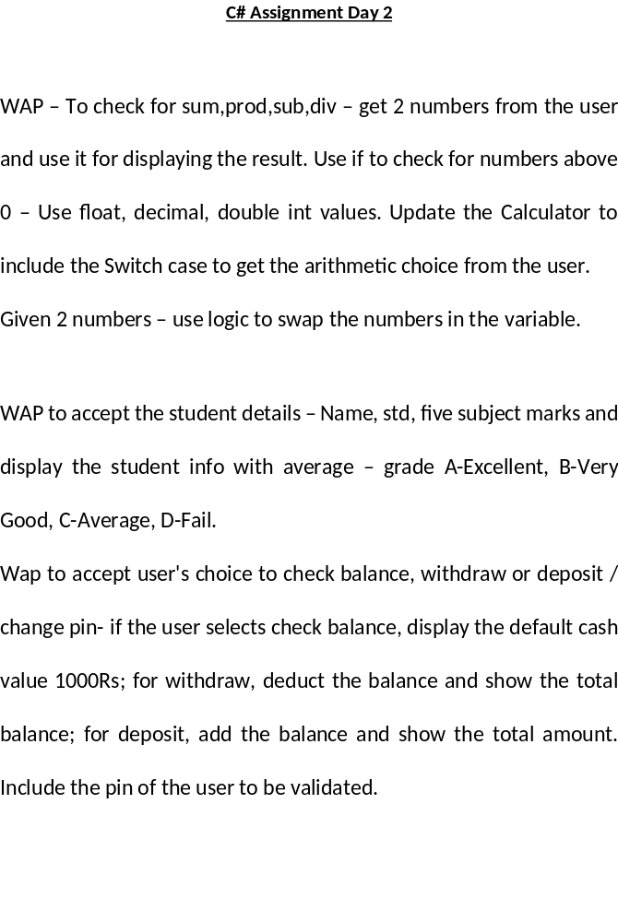include the Switch case to get the arithmetic choice from the user.
- WAP to accept the student details – Name, std, five subject marks and display the student info with average – grade A,b,c,d
- Wap to accept user's choice to check balance, withdraw or deposit / change pin- if the user selects check balance, display the default cash value 1000Rs; for withdraw, deduct the balance and show the total balance; for deposit, add the balance and show the total amount. Include the pin of the user to be validated.

