**C# Console Day5 – Proj Assignments**

1. WAP to accept 2 strings and do the foll:

->Compare if they are equal

->Reverse the string

->Check if its palindrome

-> Count the number of vowels & consonants in a given string

-> Convert to lower and upper case

-> Remove the spaces in the string

1. wap to create array which stores 5 Movie details and display the movie in the reverse order, retrieve 4th element, delete 3rd movie. Use foreach to access the movie names.
2. Create a student details array with Names and marks for five subjects - get the marks for each student from the user and find the average and display the grade accordingly - if the average is < 50 , grade fail; avg>50 & <70 ,grade pass-first class;avg> 70 & <80 grade: distinction; avg >80 grade:Excellent; Rank the students based on their average.

Raj Ram Radha Shyam Lavan

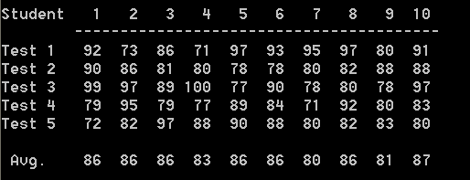

Math

Science

Computer

English

Hindi

Rank I 2 4 5 3

Grade First-class Pass Distinction Fail

1. In a movie theatre, there are 4 counters for each movie released, selling tickets. Get the no of movie goers waiting in each of the queue to buy the tickets. Find out the total number of ticket buyers, find out which movie has more demand and which has the least.
2. Use Movie details to create an enum of Movie actors and struct of movie details with functions – displaymovie() and reviewmovie(). Find the high rated movie of the year.
3. ArrayList of movie with all the records -> movie name, star, genre, review, collection. Get input of new movie record from user and update it. Delete record based on movie rating. Update the record based on movie name.