https://forum.arduino.cc/t/micro-sd-card-schematic/1424632/9
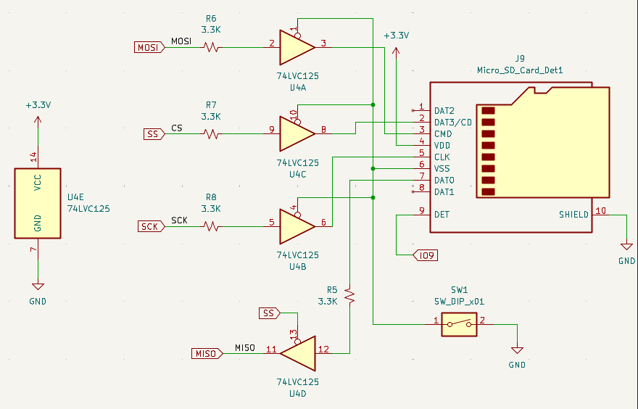

https://www.youtube.com/watch?v=7E5j2zDNkCk
https://pico.implrust.com/sdcard/circuit.html

