**Estimation**

**For Dynamic Dashboard**

|  |  |  |
| --- | --- | --- |
| **Module** | **Time** | **Technology** |
| ***Dashboard UI issues*** | | |
| **My Profile Name edit Link (clickable edit)**  Make editable input field for name | 3 hours | jQuery , Html , css |
| **Layout header section of dashboard**    Larger name is falling down | 1 hour | jQuery , Html , css |
| **Share button in fav adds**    On hover 3 sharing icons | 3 hours | jQuery , Html , css |
| **Total hours** | 7 hours | 1 days after receiving |

**Design Issue some are identified**

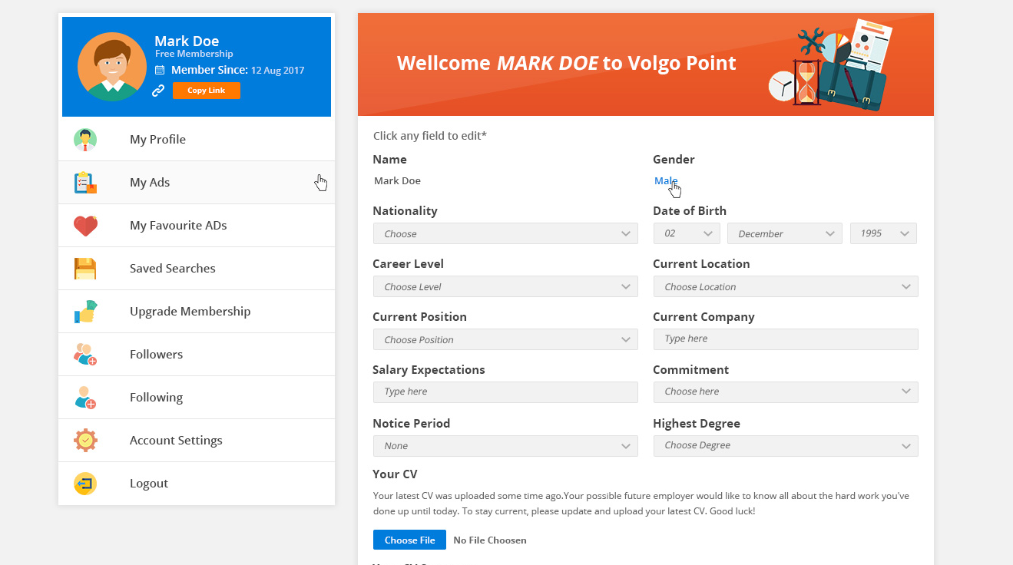

Select button design changed arrow in PSD

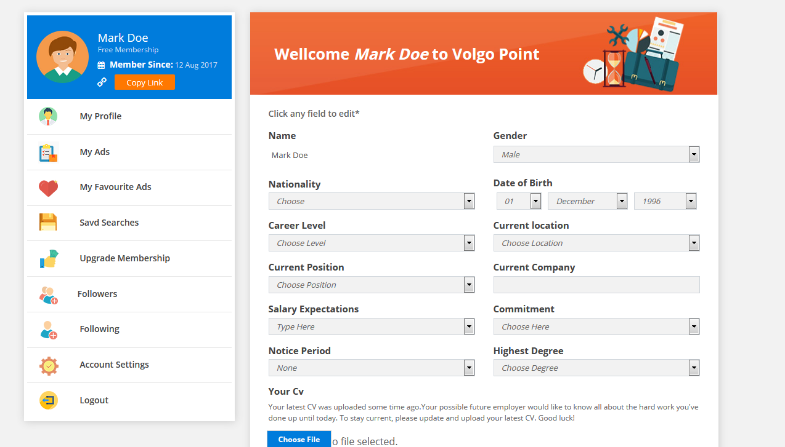

Actual design changed arrow in markup