Semester Project
Online Web Based Training and Certification System

Submitted to:
Prof. Obaid ullah Obaid
Submitted by:
Aqeela (G1f24ubscs105)
Ayesha (G1f24ubscs106)
Laiba Pervaiz (G1f24ubscs123)
Nayab (G1f24ubscs127)
Bisma (G1f24ubscs137)
Ufaq Khalid (G1f24ubscs138)
Department of Computer Science
PGC Campus ,University of Central Punjab

Table of Contents
1. INTRODUCTION 19
1.1 Purpose 19
Objectives 19
1. Project Planning and Project Management 19
2. Statement of Work (SOW) 20
3.Work Breakdown Structure (WBS) 20
Definition 20
Work Breakdown Structure (WBS) is a technique used to divide a large project into smaller and manageable tasks. 20
Explanation 21
4. Project Scheduling 21
5. Milestones in Project Management 22
6.Graph activity 22
7. Activity Dependencies 22
8.Critical Path and Critical Path Method (CPM) 23
9.Gantt Chart 25
Resource Histogram 26
1.2 Document Conventions 27
Requirement Identification 27
Terminology 28
1.3 Intended Audience and Reading Suggestions 28
Project Supervisor 28
Software Developers 28
System Designers 28
Testing Team 29
Administrator 29
Students 29
Reading Suggestions 29
1.4 Product Scope 29
Major Features 30
Benefits 30
1.5 References 30
Standards 31
Reference Books 31
Development Technologies 31
Development Tools 31
Supported Browsers 31
2. Overall Description 31
2.1 Product Perspective 32
Presentation Layer 32
Application Layer 33
Database Layer 33
System Architecture Overview 33
Product Context 34
Students 34
Administrator 34
Database Server 34
Web Browser 35
2.2 Product Functions 35
2.2.1 User Registration and Authentication 35
Main Functions 35
2.2.2 Course Management 35
Main Functions 36
2.2.3 Course Enrollment 36
Main Functions 36
2.2.4 Learning Material Access 36
2.2.5 Certification Assessment Management 37
Main Functions 37
2.2.6 Online Certification Examination 37
Main Functions 37
2.2.7 Certificate Generation 37
Main Functions 38
2.2.8 Reports and Monitoring 38
2.3 User Classes and Characteristics 38
2.3.1 Administrator 39
Responsibilities 39
Characteristics 39
Expected Technical Skills 39
2.3.2 Student 40
Responsibilities 40
Characteristics 40
Expected Technical Skills 40
2.3.3 User Access Levels 41
2.3.4 User Interaction Overview 41
Administrator Workflow 42
Student Workflow 42
2.4 Operating Environment 42
2.4.1 Client Environment 42
Hardware Requirements 42
2.4.2 Server Environment 43
Hardware Requirements 43
Software Requirements 44
2.4.3 Supported Web Browsers 44
2.4.4 Network Requirements 44
Minimum Requirements 44
2.4.5 Database Environment 45
2.4.6 Security Environment 45
2.5 Design and Implementation Constraints 46
2.5.1 Technology Constraints 46
2.5.2 Browser Compatibility 46
2.5.3 Internet Dependency 46
2.5.4 Security Constraints 47
2.5.5 Performance Constraints 47
2.5.6 Database Constraints 47
2.5.7 Scalability Constraints 48
2.6 User Documentation 48
2.6.1 Administrator Guide 48
2.6.2 Student User Guide 49
2.6.3 Online Help 49
2.6.4 Error Messages 49
2.6.5 Training Requirements 50
2.7 Assumptions and Dependencies 50
2.7.1 Assumptions 50
2.7.2 Software Dependencies 50
2.7.3 Hardware Dependencies 51
2.7.4 External Dependencies 51
2.7.5 Future Enhancements 51
2.5 Design and Implementation Constraints 52
2.6 User Documentation 52
2.7 Assumptions and Dependencies 52
3. External Interface Requirements 52
3.1 User Interfaces 53
3.1.1 Home Page 53
Purpose 53
Main Components 53
User Interaction 53
3.1.2 Registration Interface 54
Purpose 54
Input Fields 54
Functions 54
Error Messages 54
3.1.3 Login Interface 54
Purpose 55
Input Fields 55
Functions 55
Error Handling 55
3.1.4 Student Dashboard 55
Purpose 55
Dashboard Features 55
User Interaction 56
3.1.5 Administrator Dashboard 56
Purpose 56
Dashboard Features 56
User Interaction 56
3.1.6 Course Catalog Interface 56
Purpose 57
Information Displayed 57
Functions 57
3.1.7 Course Workspace 57
Purpose 57
Features 57
3.1.8 Certification Examination Interface 58
Purpose 58
Features 58
3.1.9 Certificate Download Interface 58
Purpose 58
Certificate Information 58
Functions 58
3.1.10 User Interface Design Guidelines 59
3.2 Hardware Interfaces 59
3.2.1 Client Hardware Interface 59
Supported Devices 59
Minimum Hardware Requirements 59
Recommended Hardware Requirements 60
3.2.2 Server Hardware Interface 60
Minimum Server Requirements 60
3.2.3 Input Devices 61
Supported Input Devices 61
3.2.4 Output Devices 61
Supported Output Devices 61
3.2.5 Storage Interface 62
3.2.6 Network Interface 62
3.3 Software Interfaces 62
3.3.1 Operating System Interface 63
Server Operating Systems 63
Client Operating Systems 63
3.3.2 Web Server Interface 63
3.3.3 Database Interface 63
3.3.4 Programming Language Interface 64
3.3.5 Browser Interface 64
3.3.6 File Management Interface 65
Upload Operations 65
Download Operations 65
3.3.7 Security Interface 65
3.3.8 Communication Interface 65
3.3.9 External Software Dependencies 66
3.2 Hardware Interfaces 66
3.2.1 Client Hardware Interface 66
Supported Devices 66
Minimum Hardware Requirements 67
Recommended Hardware Requirements 67
3.2.2 Server Hardware Interface 67
Minimum Server Requirements 67
3.2.3 Input Devices 68
Supported Input Devices 68
3.2.4 Output Devices 68
Supported Output Devices 68
3.2.5 Storage Interface 69
3.2.6 Network Interface 69
3.3 Software Interfaces 70
3.3.1 Operating System Interface 70
Server Operating Systems 70
Client Operating Systems 70
3.3.2 Web Server Interface 70
3.3.3 Database Interface 71
3.3.4 Programming Language Interface 71
3.3.5 Browser Interface 71
3.3.6 File Management Interface 72
Upload Operations 72
Download Operations 72
3.3.7 Security Interface 72
3.3.8 Communication Interface 72
3.3.9 External Software Dependencies 73
4. System Features 73
4.1 User Registration and Authentication 73
4.1.1 Description and Priority 73
Description 73
Priority 74
4.1.2 Stimulus/Response Sequences 74
Scenario 1: Student Registration 74
Scenario 2: Student Login 75
Scenario 3: User Logout 75
4.1.3 Functional Requirements 75
FR-1.1 User Registration 75
FR-1.2 Input Validation 75
FR-1.3 Duplicate Account Checking 75
FR-1.4 Password Security 75
FR-1.5 User Authentication 76
FR-1.6 Session Management 76
FR-1.7 Error Handling 76
FR-1.8 User Logout 76
FR-1.9 Data Storage 76
FR-1.10 Role-Based Access 76
Business Rules 76
Expected Outcome 76
4.2 Course Management 77
4.2.1 Description and Priority 77
Description 77
Priority 77
4.2.2 Stimulus/Response Sequences 77
Scenario 1: Create New Course 77
Stimulus 77
System Response 77
Scenario 2: Upload Learning Materials 78
Stimulus 78
System Response 78
Scenario 3: Edit Course 78
Stimulus 78
System Response 78
Scenario 4: Delete Course 78
Stimulus 78
System Response 78
Scenario 5: Publish Course 79
Stimulus 79
System Response 79
4.2.3 Functional Requirements 79
FR-2.1 Create Course 79
FR-2.2 Update Course 79
FR-2.3 Delete Course 79
FR-2.4 Upload Learning Materials 79
FR-2.5 Validate Uploaded Files 80
FR-2.6 Publish Course 80
FR-2.7 View Course List 80
FR-2.8 Search Course 80
FR-2.9 Store Course Information 80
FR-2.10 Access Control 80
Business Rules 81
Expected Outcome 81
4.3 Course Enrollment 81
4.3.1 Description and Priority 81
Description 81
Priority 82
4.3.2 Stimulus/Response Sequences 82
Scenario 1: Browse Available Courses 82
Stimulus 82
System Response 82
Scenario 2: View Course Details 82
Stimulus 82
System Response 82
Scenario 3: Enroll in a Course 82
Stimulus 83
System Response 83
Scenario 4: Access Course Workspace 83
Stimulus 83
System Response 83
Scenario 5: Attempt to Enroll Again 83
Stimulus 83
System Response 83
4.3.3 Functional Requirements 84
FR-3.1 Browse Courses 84
FR-3.2 Search Courses 84
FR-3.3 View Course Details 84
FR-3.4 Enroll in Course 84
FR-3.5 Verify Enrollment 84
FR-3.6 Prevent Duplicate Enrollment 84
FR-3.7 Store Enrollment Record 84
FR-3.8 Access Course Workspace 85
FR-3.9 Display Enrollment Confirmation 85
FR-3.10 Restrict Course Access 85
Business Rules 85
Expected Outcome 85
4.4 Assessment and Certification Quiz 86
4.4.1 Description and Priority 86
Description 86
Priority 86
4.4.2 Stimulus/Response Sequences 86
Scenario 1: Create Certification Quiz 86
Stimulus 86
System Response 87
Scenario 2: Add Quiz Questions 87
Stimulus 87
System Response 87
Scenario 3: Set Passing Percentage 87
Stimulus 87
System Response 87
Scenario 4: Publish Certification Quiz 87
Stimulus 88
System Response 88
Scenario 5: Student Accesses Quiz 88
Stimulus 88
System Response 88
4.4.3 Functional Requirements 88
FR-4.1 Create Certification Quiz 88
FR-4.2 Add Questions 88
FR-4.3 Edit Questions 89
FR-4.4 Delete Questions 89
FR-4.5 Define Correct Answers 89
FR-4.6 Set Passing Percentage 89
FR-4.7 Save Quiz Information 89
FR-4.8 Publish Quiz 89
FR-4.9 Restrict Quiz Access 89
FR-4.10 Maintain Quiz Records 90
Business Rules 90
Expected Outcome 90
4.5 Online Certification Examination 90
4.5.1 Description and Priority 90
Description 90
Priority 91
4.5.2 Stimulus/Response Sequences 91
Scenario 1: Start Examination 91
Stimulus 91
System Response 91
Scenario 2: Answer Examination Questions 92
Stimulus 92
System Response 92
Scenario 3: Submit Examination 92
Stimulus 92
System Response 92
Scenario 4: Automatic Evaluation 92
Stimulus 92
System Response 92
Scenario 5: View Examination Result 93
Stimulus 93
System Response 93
4.5.3 Functional Requirements 93
FR-5.1 Start Examination 93
FR-5.2 Display Questions 93
FR-5.3 Record Student Responses 93
FR-5.4 Submit Examination 93
FR-5.5 Automatic Evaluation 94
FR-5.6 Calculate Score 94
FR-5.7 Determine Pass/Fail Status 94
FR-5.8 Store Examination Results 94
FR-5.9 Display Examination Result 94
FR-5.10 Restrict Unauthorized Access 94
Business Rules 95
Expected Outcome 95
4.6 Certificate Generation 95
4.6.1 Description and Priority 95
Description 95
Priority 96
4.6.2 Stimulus/Response Sequences 96
Scenario 1: Student Passes the Examination 96
Stimulus 96
System Response 96
Scenario 2: Generate Certificate 96
Stimulus 96
System Response 96
Scenario 3: Download Certificate 97
Stimulus 97
System Response 97
Scenario 4: Certificate Verification 97
Stimulus 97
System Response 97
4.6.3 Functional Requirements 97
FR-6.1 Generate Certificate 97
FR-6.2 Assign Unique Certificate ID 98
FR-6.3 Store Certificate Record 98
FR-6.4 Display Certificate 98
FR-6.5 Download Certificate 98
FR-6.6 Print Certificate 98
FR-6.7 Certificate Verification 98
FR-6.8 Restrict Certificate Access 98
FR-6.9 Maintain Certificate Records 99
FR-6.10 Prevent Duplicate Certificates 99
Business Rules 99
Expected Outcome 99
5.2 Safety Requirements 101
Input Validation and Prevention of Harmful Actions 101
Access and Authorization 101
Compliance with Regulations 102
5.3 Security Requirements 102
Authentication 102
Data Encryption 103
Authorization and Access Control 103
Audit Logging and Monitoring 103
Session Management 104
Input Validation and Injection Prevention 104
Data Privacy 104
Physical Security (Delegated) 105
Security Certifications 105
5.4 Software Quality Attributes 106
Reliability 106
Usability 106
Maintainability 106
Scalability 106
Portability 107
Interoperability 107
Security 107
Correctness 107
Testability 108
Availability 108
5.5 Business Rules 108
Enrollment and Course Processing Rules 108
Attendance and Progress Tracking Rules 109
Fee and Payment Processing Rules 109
Learner and Instructor Data Rules 109
User Access Rules 109
Compliance and Record-Keeping Rules 110
System Configuration Rules 110
Audit and Approval Rules 110
Summary 111
6. Other Requirements 111
6.1 Database Requirements: 111
6.2 Legal and Regulatory Requirements 112
6.3 Internationalization (Not Required) 112
6.4 Installation and Deployment Requirements 113
6.5 Documentation Requirements 113
6.6 Training Requirements 114
6.7 Maintenance and Support Requirements 114
6.8 Reuse Objectives 115
6.9 Constraints 115
6.10 Future Considerations 116
7. Software Development Life Cycle (SDLC) Model 117
7.1 Introduction to SDLC 117
7.2 Chosen Model: Agile Model 118
7.3 Why Agile Model Was Chosen? 118
7.4 Agile Phases (Sprints) 119
7.5 Agile Project Timeline 120
7.6 Advantages of Agile Model for This Project 121
7.7 Challenges and Their Solutions 121
7.8 Conclusion 122
8. Introduction to UML Diagrams 122
8.1 Use Case Diagram 123
8.2 Actors in the Online Web-Based Training and Certification System 123
8.3 Class Diagram 124
8.4 Relationships Between Classes 126
8.5 Scenario: New User Registration, Course Enrollment, and Certificate Generation 126
8.6 Sequence Diagram 127
Conclusion of UML Diagrams 131
Activity Diagram 132
State Diagram 143
6.1 Project Size Estimation 145
6.1.1 Introduction 145
6.1.2 Estimation Approach 145
6.1.3 Project Modules with Estimated LOC 145
6.1.4 Total LOC and KLOC Calculation 146
6.1.5 Assumptions Used 147
6.2 Selection of COCOMO Mode 147
6.2.1 Introduction 147
6.2.2 COCOMO Modes 147
6.2.3 Comparison of COCOMO Modes 148
6.2.4 Selected COCOMO Mode 148
6.2.5 Justification for Selecting Semi-detached Mode 148
6.3.1 Basic COCOMO Coefficients (Semi-Detached Mode) 149
Effort Formula 150
Development Time Formula 150
Average Staff Size Formula 150
6.3.2 Basic COCOMO Results Summary 151
6.4 Intermediate COCOMO Model 152
6.4.1 Cost Driver Rating for Online Web-Based Training and Certification System 152
6.4.2 Effort Adjustment Factor (EAF) Calculation 154
6.4.4 Adjusted Development Time (D adj) 154
6.4.5 Adjusted Average Staff Size 155
6.5 Detailed COCOMO Model 6.5.1 Introduction 156
6.5.2 Phase-Wise Effort Distribution 156
6.5.3 Phase-Wise Schedule Distribution 157
6.5.4 Phase-Wise Staff Size 158
6.5.5 Phase-Wise Person-Month Distribution 158
6.5.6 Detailed COCOMO Results Summary 159
6.6 Cost Estimation 159
6.6.2 Assumptions 159
6.7 COCOMO II (Object Points Approach) 160
6.7.2 Object Point Estimation 161
6.7.3 Percentage of Reused Components 161
6.7.4 New Object Points (NOP) 161
6.8 Comparison of All COCOMO Levels 162
6.9 Detailed Interpretation and Analysis 163
6.9.1 Schedule Feasibility 163
6.9.2 Team Size 164
6.9.3 Productivity 164
6.9.4 Phase Focus 165
6.9.5 Cost Driver Analysis 165
CONCLUSION 166
Testing Phase 167
1. Test Objectives 167
2. Test Levels 167
3. Test Environment 167
4. Test Case Development 168
4.1 Functional Test Cases 168
4.2 Non-Functional Test Cases 171
5. Traceability Matrix (RTM) 171
6. Test Execution Results 173
Defect Report 173
Defect Resolution Status 174
7. User Acceptance Testing (UAT) 174
UAT Feedback Summary 174
UAT Sign-Off 174
8. Testing Conclusion 175
Appendix A: Glossary 175
Appendix B: Analysis Models 176
B.1 Use Case Diagram 176
B.2 Class Diagram 176
B.3 Sequence Diagrams 176
B.4 Activity Diagram 177
B.5 Entity Relationship Diagram (ERD) 177
B.6 Context Diagram (Data Flow Diagram Level 0) 177
B.7 Data Flow Diagram (Level 1) 177
Flow of the Online Web-Based Training and Certification System 178
Appendix C: References and Supporting Documents 178
References 178
Supporting Documents 179
Future Enhancements 179

1. INTRODUCTION

1.1 Purpose
The purpose of this Software Requirements Specification (SRS) document is to define the functional and non-functional requirements of the Online Web-Based Training and Certification System (OWBTCS). This document provides a complete description of the system's features, user interactions, interfaces, operational constraints, and expected behavior. It serves as the primary reference for developers, testers, project supervisors, and future maintainers throughout the software development life cycle.
The Online Web-Based Training and Certification System is designed to provide an efficient and user-friendly platform where students can register, enroll in online training courses, access learning materials, complete certification examinations, and receive digital certificates after successfully passing the assessments. The system also enables administrators to create and manage courses, upload training materials, configure certification quizzes, monitor student progress, and manage certificates from a centralized dashboard.
This document establishes a common understanding between all stakeholders and minimizes misunderstandings during software development. It also acts as the baseline for system design, coding, testing, deployment, and future maintenance.

Objectives
The major objectives of this SRS are:
- To define all functional and non-functional requirements of the system.
- To describe the system architecture and overall functionality.
- To specify the responsibilities of administrators and students.
- To provide developers with a clear implementation guide.
- To support software testing and validation activities.
- To provide documentation for future maintenance and system upgrades.

1. Project Planning and Project Management
Definition:
Project planning is the process of organizing project tasks, resources, cost, and time to complete a project successfully. Project management is the process of managing all project activities to achieve project goals.
Explanation:
Project planning helps developers understand what tasks need to be completed and how much time and resources are required. It helps organize work in a proper sequence. Project management controls the overall project activities and ensures that the project is completed on time and within budget. Good project management improves teamwork, communication, and efficiency. It also reduces risks and confusion during development.
Practical Example
In the Online Web-Based Training and Certification System, project planning is used to plan modules such as user registration, course management, quizzes, and certificate generation. The project manager manages developers, testers, and schedules to ensure successful completion of the project.

2. Statement of Work (SOW)
Definition:
Statement of Work (SOW) is a formal document that describes the project scope, objectives, tasks, deliverables, and timeline.
Explanation:
The SOW explains what work will be performed in the project and what results are expected. It acts as an agreement between the client and development team. It clearly defines project goals, responsibilities, deadlines, and system features. SOW helps avoid misunderstandings and keeps the project organized. It also helps track project progress.
Practical Example:
The SOW for the Online Web-Based Training and Certification System includes:
- User registration and login
- Online course management
- Video lecture system
- Online quizzes and tests
- Certificate generation
- Admin dashboard
- Final project deployment

3.Work Breakdown Structure (WBS)

Definition

Work Breakdown Structure (WBS) is a technique used to divide a large project into smaller and manageable tasks.

Explanation
WBS helps organize project work into smaller parts so the project becomes easier to understand and manage. Each task is divided into sub-tasks for better planning and control. WBS improves scheduling and resource management. It also helps track project progress easily. Large projects become simpler using WBS.
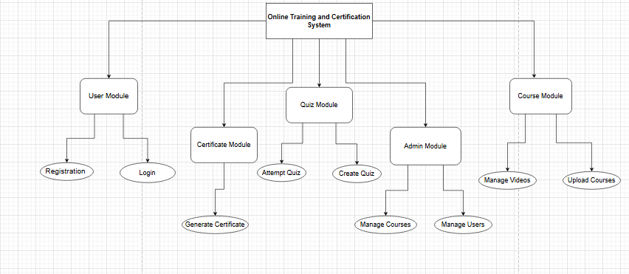

4. Project Scheduling
Definition:
Project scheduling is the process of assigning time and duration to project tasks and activities.
Explanation:
Project scheduling helps organize tasks according to time. It shows when a task will start and finish. Scheduling improves time management and helps complete the project within deadlines. It also helps avoid delays and confusion. A proper schedule increases productivity and project efficiency.
Practical Example:
The schedule for the Online Web-Based Training and Certification System is:
Task | Duration
Requirement Analysis | 3 days
System Design | 5 days
User Module Development | 4 days
Course Module Development | 5 days
Quiz Module Development | 4 days
Certificate Module | 3 days
Testing | 5 days
Deployment | 2 days

5. Milestones in Project Management
Definition:
Milestones are important achievement points or major stages completed during a project.
Explanation:
Milestones help track project progress and measure achievements. They show that a specific part of the project has been completed successfully. Milestones are important for monitoring deadlines and project performance. They improve project control and help teams stay focused on goals.
Practical Example:
Important milestones of the Online Web-Based Training and Certification System are:
- Requirement Analysis Completed
- System Design Completed
- User Module Completed
- Quiz Module Completed
- Certificate Module Completed
- Final Deployment Completed

6.Graph activity
Definition
An activity graph is a diagram that shows the sequence and flow of project activities.
Explanation
The activity graph represents project tasks in graphical form. It shows which task starts first and which task follows next. It helps understand the workflow clearly. Activity graphs are useful for planning and monitoring project activities. They also help identify dependencies between tasks.
Practical Example:

7. Activity Dependencies
Definition: Activity dependencies show the relationship between tasks where one activity depends on another activity.
Explanation:
Some project tasks cannot start until another task is completed. These relationships are called activity dependencies. Dependencies help organize tasks in the correct order. They improve project planning and reduce errors. Understanding dependencies also helps avoid project delays.
Practical Example:
In the Online Web-Based Training and Certification System:
- The quiz module depends on user login functionality.
- Certificate generation depends on quiz completion.
- Testing depends on completion of development.
- Deployment depends on successful testing.

8.Critical Path and Critical Path Method (CPM)
Definition
The critical path is the longest and most important sequence of tasks that must be completed on time. CPM is a method used to identify the critical path.
Explanation
Critical Path Method helps identify the most important tasks in a project. If any task on the critical path is delayed, the whole project will be delayed. CPM improves project scheduling and time management. It helps managers focus on high-priority tasks. It also reduces project risks and delays.
Practical Example:
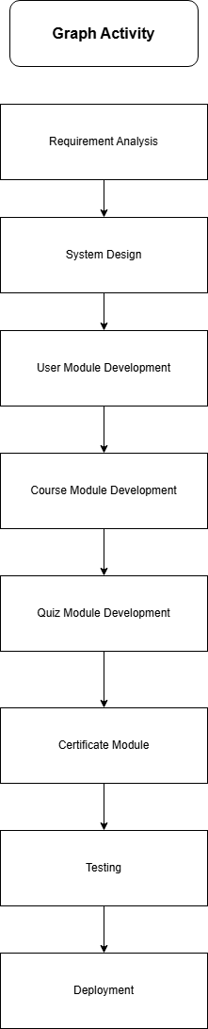

9.Gantt Chart
Definition
A Gantt chart is a graphical chart used to show project tasks, durations, and timelines.
Explanation:
The Gantt chart displays project activities according to time. It helps project managers monitor project progress and deadlines. Each task is represented by a horizontal bar showing start and finish time. Gantt charts improve scheduling and task management. They also help teams understand project timelines clearly.
Practical Example:
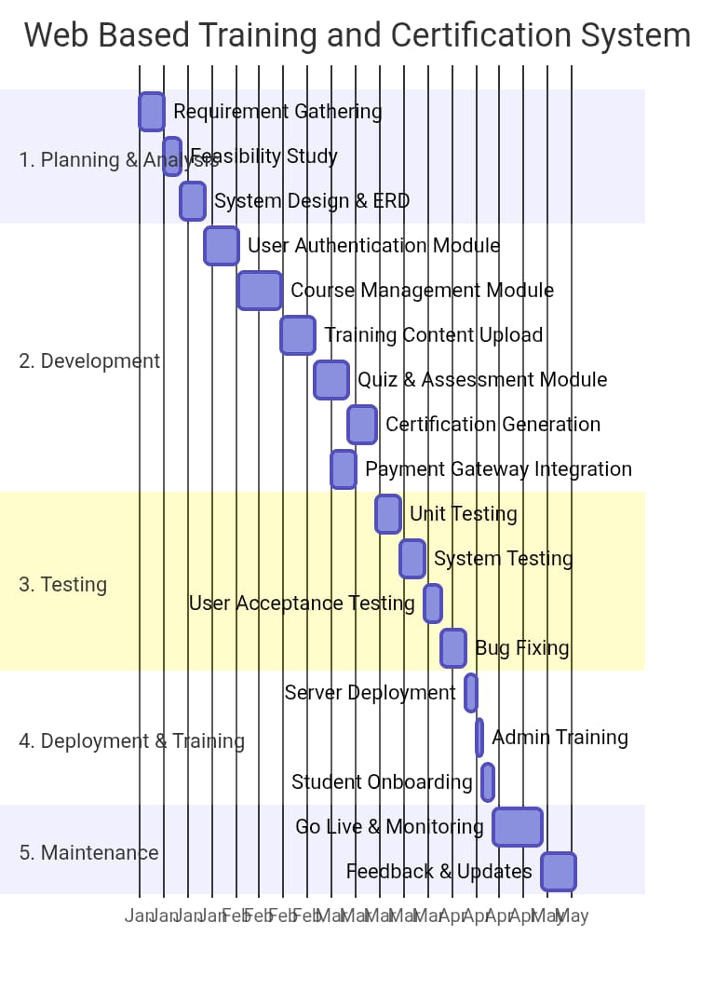

Resource Histogram
Resource | Quantity
Developers | 3
Tester | 2
UI Designer | 1
Database Admin | 1

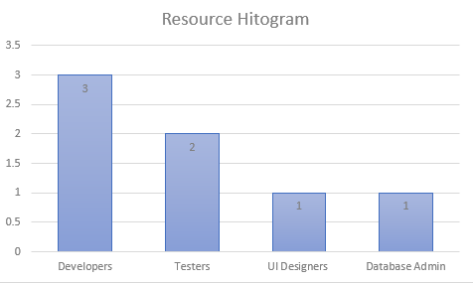

1.2 Document Conventions
This document follows the IEEE Software Requirements Specification (SRS) standard to maintain consistency, readability, and completeness. Standard numbering, headings, and requirement identifiers are used throughout the document.

Requirement Identification
Functional requirements are represented using the prefix FR.
Example:
- FR-1 User Registration
- FR-2 User Authentication
- FR-3 Course Management
- FR-4 Course Enrollment
- FR-5 Certification Examination
- FR-6 Certificate Generation
Non-functional requirements are represented using the prefix NFR.
Example:
- NFR-1 Security
- NFR-2 Performance
- NFR-3 Reliability
- NFR-4 Usability

Terminology
Term | Description
System | Online Web-Based Training and Certification System
Administrator | User responsible for managing courses, students, quizzes, and certificates
Student | Registered user who enrolls in courses and attempts certification exams
Course | Online training program containing learning materials and assessments
Assessment | Online certification quiz or examination
Certificate | Digital document issued after successful completion of a course
Dashboard | Main interface displayed after login

1.3 Intended Audience and Reading Suggestions
This SRS document is intended for all individuals involved in the development, deployment, testing, maintenance, and use of the Online Web-Based Training and Certification System.

Project Supervisor
The project supervisor will use this document to evaluate whether the proposed system satisfies academic requirements and project objectives. It also serves as a reference during project reviews and demonstrations.

Software Developers
Developers will use this document to understand the functional requirements, system architecture, database interactions, and software interfaces before implementing the application.

System Designers
System designers will use the SRS to prepare the database schema, system architecture, user interface layouts, and workflow diagrams.

Testing Team
The testing team will refer to this document while preparing unit tests, integration tests, system tests, and user acceptance tests. Every functional requirement described in this document should be validated before deployment.

Administrator
Administrators will use the system to manage students, create courses, upload training materials, configure certification examinations, generate reports, and monitor the overall performance of the platform.

Students
Students are the primary users of the system. They will register an account, log in securely, browse available training courses, enroll in courses, access learning materials, complete certification examinations, and download certificates after successfully passing the assessments.

Reading Suggestions
Different stakeholders should focus on different sections of this document.
Stakeholder | Recommended Sections
Project Supervisor | Chapters 1–4
Developers | Chapters 2–4
System Designers | Chapters 2 and 3
Testers | Chapters 3 and 4
Administrator | System Features and User Interfaces
Students | User Interface and User Documentation

1.4 Product Scope
The Online Web-Based Training and Certification System is a web-based application developed to improve the delivery of online education and professional training. The system allows students to access training resources from any location using a web browser, eliminating the limitations of traditional classroom-based learning.
Students can create accounts, log in securely, browse available courses, enroll in training programs, access videos and study materials, attempt certification examinations, and instantly receive downloadable digital certificates upon successful completion of the course.
The administrator manages all system activities through a secure dashboard. Administrative responsibilities include creating and publishing courses, uploading learning resources, configuring quizzes, managing student records, generating reports, and maintaining system security.
The system automatically evaluates certification examinations, calculates scores, determines pass or fail status, and generates PDF certificates for successful students. This automation reduces manual work, improves efficiency, and provides a reliable method for tracking student progress and certification records.

Major Features
- Student Registration and Login
- Secure Authentication
- Course Creation and Management
- Course Enrollment
- Online Learning Materials
- Certification Quiz Management
- Online Certification Examination
- Automatic Result Evaluation
- Digital Certificate Generation
- Certificate Download
- Student Progress Tracking
- Report Generation

Benefits
- Enables learning from any location with internet access.
- Reduces paperwork through digital records.
- Automates examination evaluation and certification.
- Provides secure access through authenticated user accounts.
- Simplifies course management for administrators.
- Improves accessibility and learning flexibility.

1.5 References
The following standards, technologies, and references were used during the preparation of this Software Requirements Specification.

Standards
- IEEE 830-1998 – Software Requirements Specification (SRS)
- IEEE 29148:2018 – Systems and Software Engineering Requirements Engineering

Reference Books
- Ian Sommerville, Software Engineering (10th Edition)
- Roger S. Pressman & Bruce Maxim, Software Engineering: A Practitioner's Approach (9th Edition)

Development Technologies
- HTML5
- CSS3
- Bootstrap
- JavaScript
- PHP
- MySQL

Development Tools
- Visual Studio Code
- XAMPP Server
- phpMyAdmin
- GitHub
- Draw.io (for UML diagrams)

Supported Browsers
- Google Chrome
- Mozilla Firefox
- Microsoft Edge

2. Overall Description
The Online Web-Based Training and Certification System (OWBTCS) is a web-based application designed to provide an efficient platform for delivering online training programs and managing digital certifications. The system enables students to register, enroll in training courses, access learning materials, participate in certification examinations, and receive digital certificates after successfully completing the required assessments.
Unlike traditional classroom training, this system provides a centralized online platform where learning resources, assessments, and certification processes are managed digitally. Administrators can manage courses, students, quizzes, and certificates from a single dashboard, ensuring efficient administration and reducing manual work.
The system has been designed with simplicity, security, and scalability in mind. It supports multiple users simultaneously and provides role-based access so that administrators and students can perform only those operations relevant to their responsibilities. Automatic result evaluation and certificate generation reduce administrative workload while improving accuracy and efficiency.

2.1 Product Perspective
The Online Web-Based Training and Certification System is a standalone web application that operates through modern web browsers. It is intended to replace manual training and certification procedures by providing a centralized digital environment for course management, online learning, examinations, and certificate generation.
The system follows a three-tier architecture, consisting of:
- Presentation Layer (User Interface)
- Application Layer (Business Logic)
- Database Layer (Data Storage)
Each layer performs a specific function while communicating with the others to ensure efficient system operation.

Presentation Layer
The presentation layer provides the graphical interface through which users interact with the system. It is developed using HTML5, CSS3, Bootstrap, and JavaScript, providing responsive pages that work on desktops, laptops, tablets, and mobile devices.
Different interfaces are displayed according to user roles:
- Administrator Dashboard
- Student Dashboard
- Login Page
- Registration Page
- Course Catalog
- Course Workspace
- Certification Examination Interface
- Certificate Download Page

Application Layer
The application layer contains all business logic of the system. It processes user requests, validates information, communicates with the database, and generates responses.
Major responsibilities include:
- User Authentication
- Course Management
- Student Enrollment
- Quiz Management
- Examination Evaluation
- Certificate Generation
- Report Generation
The application layer is implemented using PHP, which handles communication between the user interface and the MySQL database.

Database Layer
The database layer stores all information required by the application.
The MySQL database maintains records related to:
- Student Accounts
- Administrator Accounts
- Courses
- Course Materials
- Enrollment Records
- Certification Quizzes
- Student Results
- Certificates
- System Reports
The database ensures secure storage, retrieval, and management of data while maintaining data integrity through relationships and constraints.

System Architecture Overview
The overall workflow of the system is as follows:
- Students register and create an account.
- Registered users log in using valid credentials.
- Students browse available courses.
- Students enroll in desired courses.
- Learning materials become available after enrollment.
- Students complete the training content.
- Students attempt the certification examination.
- The system evaluates answers automatically.
- If the required passing percentage is achieved, a digital certificate is generated.
- Students download their certificates from their dashboard.
Meanwhile, the administrator performs operations such as:
- Managing student accounts
- Creating courses
- Uploading training materials
- Creating certification quizzes
- Monitoring student progress
- Managing certificates
- Viewing reports

Product Context
The Online Web-Based Training and Certification System interacts with the following external entities:

Students
Students are the primary users of the system. They interact with the platform to register, log in, enroll in courses, complete assessments, and obtain certificates.

Administrator
The administrator manages all system operations through the administrative dashboard, ensuring proper management of courses, users, quizzes, and reports.

Database Server
The MySQL database stores all application data and communicates continuously with the backend to retrieve and update information.

Web Browser
Users access the application through standard web browsers such as Google Chrome, Mozilla Firefox, and Microsoft Edge.

2.2 Product Functions
The Online Web-Based Training and Certification System offers several integrated modules that work together to provide a complete online learning and certification experience. Each module performs a specific function while interacting with other modules to ensure smooth operation.
The major functions of the system are described below.

2.2.1 User Registration and Authentication
The system allows new students to create an account by providing personal information such as name, email address, username, and password. During registration, the system validates all entered information before storing it in the database.
After successful registration, users can log in securely using their credentials. Authentication ensures that only authorized users can access the system. Passwords are stored securely, and invalid login attempts result in appropriate error messages.

Main Functions
- Student Registration
- User Login
- Password Validation
- Secure Authentication
- Session Management
- Logout

2.2.2 Course Management
Course management is performed by the administrator. The administrator can create new courses, update existing course information, upload learning materials, organize courses into categories, and publish courses for student enrollment.
Learning resources may include PDF documents, presentation slides, images, videos, and reference links.

Main Functions
- Create Course
- Edit Course
- Delete Course
- Upload Course Materials
- Publish Course
- Organize Course Categories

2.2.3 Course Enrollment
Students can browse all available training programs through the course catalog. Each course contains detailed information such as objectives, duration, prerequisites, and instructor information (if applicable).
After selecting a course, students may enroll directly. Once enrolled, they gain access to all learning materials associated with that course.

Main Functions
- Browse Courses
- Search Courses
- View Course Details
- Enroll in Course
- View Enrolled Courses

2.2.4 Learning Material Access
After successful enrollment, students can access all course materials through the course workspace.
Learning materials may include:
- PDF Notes
- Video Lectures
- PowerPoint Presentations
- Assignments
- Reading Material
The system records learning progress to help students monitor completed content.

2.2.5 Certification Assessment Management
The administrator creates certification quizzes by entering questions, multiple-choice options, correct answers, and passing criteria.
The system stores all assessment information in the database and prepares quizzes for students attempting certification.

Main Functions
- Create Quiz
- Add Questions
- Edit Questions
- Delete Questions
- Set Passing Percentage
- Publish Assessment

2.2.6 Online Certification Examination
Students attempt certification examinations online after completing the training materials.
The system retrieves questions from the database, records submitted answers, automatically evaluates responses, calculates scores, and determines pass or fail status based on the predefined passing percentage.

Main Functions
- Start Examination
- Display Questions
- Submit Answers
- Automatic Evaluation
- Score Calculation
- Display Result

2.2.7 Certificate Generation
Students who successfully pass the certification examination receive a digital certificate generated automatically by the system.
Each certificate contains:
- Student Name
- Course Name
- Completion Date
- Certificate ID
- Verification Code
- Administrator Approval
Certificates are stored permanently in the database and can be downloaded as PDF files.

Main Functions
- Generate Certificate
- Store Certificate
- Download Certificate
- Verify Certificate

2.2.8 Reports and Monitoring
The system provides reporting facilities for the administrator to monitor overall platform activities.
Reports include:
- Student Registration Report
- Course Enrollment Report
- Course Completion Report
- Examination Performance Report
- Certificate Issuance Report
These reports assist administrators in evaluating system usage and student performance.

2.3 User Classes and Characteristics
The Online Web-Based Training and Certification System is designed for two primary categories of users: Administrator and Student. Each user class has different responsibilities, privileges, and access levels within the system. Role-based access control ensures that users can only perform the operations authorized for their role, thereby maintaining security and protecting system data.

2.3.1 Administrator
The Administrator is the primary manager of the system and has full access to all features. The administrator is responsible for maintaining the platform, managing users, creating courses, uploading learning materials, configuring certification examinations, and monitoring overall system performance.
Unlike students, administrators have permission to modify system data and manage educational content.

Responsibilities
The administrator is responsible for performing the following tasks:
- Log in securely using administrator credentials.
- Create, update, and delete training courses.
- Upload videos, PDF notes, presentations, and other learning materials.
- Configure certification examinations.
- Add, edit, and remove quiz questions.
- Define passing percentages for certification.
- Manage student accounts.
- Monitor course enrollments.
- View examination results.
- Generate system reports.
- Manage digital certificates.
- Maintain overall system security.

Characteristics
- Has complete system privileges.
- Can access all administrative modules.
- Requires knowledge of basic computer operations.
- Should understand course management and student administration.
- Responsible for ensuring that uploaded course content is accurate and up to date.

Expected Technical Skills
The administrator should possess:
- Basic knowledge of web applications.
- Familiarity with browsers such as Google Chrome or Microsoft Edge.
- Ability to manage digital documents.
- Basic understanding of online course management.
- Internet connectivity for accessing the system.

2.3.2 Student
The Student is the primary end user of the system. Students use the application to register, enroll in courses, study online learning materials, complete certification examinations, and obtain certificates.
Students have limited permissions compared to administrators. They can only access information related to their own accounts and enrolled courses.

Responsibilities
Students can perform the following activities:
- Create a new account.
- Log in securely.
- Update personal profile information.
- Browse available training courses.
- Search for courses.
- Enroll in desired courses.
- Access learning materials.
- Complete online certification examinations.
- View examination results.
- Download digital certificates.
- Log out securely.

Characteristics
Students are expected to:
- Have basic computer literacy.
- Use standard web browsers.
- Access the platform through an Internet connection.
- Complete learning activities independently.
- Follow examination rules established by the administrator.

Expected Technical Skills
Students should have:
- Basic computer knowledge.
- Ability to use a web browser.
- Internet browsing skills.
- Basic understanding of downloading and uploading files.

2.3.3 User Access Levels
The system implements role-based access control (RBAC) to ensure that each user only accesses authorized features.
Feature | Administrator | Student
Login | ✔ | ✔
Register | ✘ | ✔
Manage Courses | ✔ | ✘
Upload Learning Materials | ✔ | ✘
Configure Certification Quiz | ✔ | ✘
Enroll in Courses | ✘ | ✔
Access Learning Materials | ✘ | ✔
Attempt Certification Exam | ✘ | ✔
Generate Reports | ✔ | ✘
Download Certificate | ✘ | ✔
Manage Students | ✔ | ✘
This separation of responsibilities improves system security by preventing unauthorized access to sensitive operations.

2.3.4 User Interaction Overview
The interaction between different users and the system can be summarized as follows:

Administrator Workflow
- Administrator logs into the system.
- Creates or updates training courses.
- Uploads learning materials.
- Configures certification quizzes.
- Publishes courses.
- Monitors student enrollments.
- Reviews examination reports.
- Manages certificates and student records.

Student Workflow
- Student registers an account.
- Logs into the system.
- Browses available courses.
- Enrolls in a course.
- Studies the provided learning materials.
- Attempts the certification examination.
- Receives examination results.
- Downloads the digital certificate upon successful completion.

2.4 Operating Environment
The Online Web-Based Training and Certification System is a browser-based application that operates over the Internet. It has been developed using HTML, CSS, Bootstrap, JavaScript, PHP, and MySQL, making it compatible with commonly available hardware and software environments.
The system does not require users to install any dedicated desktop software. A modern web browser and an Internet connection are sufficient for accessing all system functionalities.

2.4.1 Client Environment
The client environment refers to the hardware and software used by administrators and students to access the application.

Hardware Requirements
Minimum hardware specifications include:
Component | Minimum Requirement
Processor | Intel Core i3 or equivalent
RAM | 4 GB
Storage | 500 MB free space
Display | 1366 × 768 resolution
Internet | Broadband connection
Recommended hardware specifications include:
Component | Recommended Requirement
Processor | Intel Core i5 or higher
RAM | 8 GB
Storage | SSD with 1 GB free space
Display | Full HD (1920 × 1080)
Internet | High-speed broadband

2.4.2 Server Environment
The server hosts the web application and stores all application data.

Hardware Requirements
Component | Specification
Processor | Intel Core i5 or higher
RAM | 8 GB minimum
Storage | 100 GB or higher
Internet | High-speed Internet
Backup | Daily database backup

Software Requirements
The application requires the following software components:
Software | Purpose
Windows 10/11 or Linux | Operating System
Apache Server (XAMPP) | Web Server
PHP | Backend Development
MySQL | Database Management
phpMyAdmin | Database Administration

2.4.3 Supported Web Browsers
The system supports all modern web browsers.
Browser | Supported
Google Chrome | ✔
Mozilla Firefox | ✔
Microsoft Edge | ✔
Opera | ✔
JavaScript must be enabled to ensure that all interactive features work correctly.

2.4.4 Network Requirements
The system requires a stable Internet connection because all operations are performed online.

Minimum Requirements
- Broadband Internet connection.
- Stable network connectivity.
- HTTPS communication.
- Low network latency for smooth user experience.
If the Internet connection is interrupted, users may be unable to submit examinations or access course materials until connectivity is restored.

2.4.5 Database Environment
The system uses MySQL as its primary database management system.
The database stores:
- Administrator information
- Student records
- Course information
- Learning materials
- Enrollment details
- Quiz questions
- Examination results
- Certificate records
- System logs
The database is designed using relational tables to maintain data integrity, minimize redundancy, and support efficient data retrieval.

2.4.6 Security Environment
To ensure the confidentiality and integrity of user information, the system incorporates several security measures:
- Secure user authentication.
- Password encryption before storage.
- Session management.
- Role-based access control.
- Input validation.
- Database access restrictions.
- Secure communication using HTTPS.
- Automatic logout after prolonged inactivity.
These security features help protect sensitive information such as user accounts, examination results, and certificate records from unauthorized access.

2.5 Design and Implementation Constraints
The Online Web-Based Training and Certification System has been designed by considering several technical, operational, and organizational constraints. These constraints help define the limitations within which the system will be developed and deployed.

2.5.1 Technology Constraints
The system will be developed using the following technologies:
- Frontend: HTML5, CSS3, Bootstrap, JavaScript
- Backend: PHP
- Database: MySQL
- Web Server: Apache (XAMPP)
These technologies have been selected because they are reliable, widely used, and suitable for developing web-based applications.

2.5.2 Browser Compatibility
The application should work correctly on modern web browsers, including:
- Google Chrome
- Mozilla Firefox
- Microsoft Edge
- Opera
JavaScript must be enabled for proper system functionality.

2.5.3 Internet Dependency
Since the application is web-based, users must have a stable Internet connection to access courses, submit examinations, and download certificates.
If the Internet connection is interrupted, users may experience delays or may need to reconnect before continuing their activities.

2.5.4 Security Constraints
To protect sensitive information, the system shall implement the following security measures:
- Secure user authentication.
- Encrypted password storage.
- Session management.
- Role-based access control.
- Input validation.
- Protection against unauthorized access.
- Secure database connectivity.
Only authorized users will be allowed to access restricted system functions.

2.5.5 Performance Constraints
The system should provide fast response times during normal operation.
Performance requirements include:
- User login within a few seconds.
- Quick loading of course materials.
- Immediate display of examination results.
- Automatic certificate generation after successful completion.
- Efficient handling of multiple users accessing the system simultaneously.

2.5.6 Database Constraints
The MySQL database should maintain data consistency and integrity.
The database must:
- Prevent duplicate user records.
- Maintain relationships between tables.
- Store examination results securely.
- Preserve certificate information permanently.
- Support backup and recovery procedures.

2.5.7 Scalability Constraints
The system should be designed so that future enhancements can be added without major modifications.
Possible future improvements include:
- Online video conferencing.
- Email notifications.
- Payment gateway integration.
- Mobile application support.
- Multi-language support.
- Certificate verification portal.

2.6 User Documentation
The Online Web-Based Training and Certification System will provide documentation to assist users in understanding and operating the application efficiently. The documentation is intended for both administrators and students.

2.6.1 Administrator Guide
The Administrator Guide explains how to manage the overall system.
It includes instructions for:
- Logging into the administrator dashboard.
- Managing student accounts.
- Creating and updating courses.
- Uploading learning materials.
- Creating certification examinations.
- Managing quiz questions.
- Monitoring student progress.
- Viewing reports.
- Managing certificates.
This guide enables administrators to perform all management tasks without requiring technical expertise.

2.6.2 Student User Guide
The Student User Guide explains how students can use the system effectively.
The guide covers:
- Student registration.
- User login.
- Profile management.
- Browsing available courses.
- Enrolling in courses.
- Accessing learning materials.
- Attempting certification examinations.
- Viewing examination results.
- Downloading certificates.
- Logging out securely.

2.6.3 Online Help
The system will include an online help section that provides assistance while users are working within the application.
The help section may include:
- Frequently Asked Questions (FAQs)
- User instructions
- Error message explanations
- Contact information for technical support

2.6.4 Error Messages
Whenever an error occurs, the system should display clear and understandable messages.
Examples include:
- Invalid username or password.
- Required fields cannot be empty.
- Course not found.
- Examination submission failed.
- Internet connection lost.
- Certificate not available.
These messages help users identify problems and take appropriate corrective actions.

2.6.5 Training Requirements
The system has been designed with a simple and user-friendly interface.
Therefore:
- Students require minimal training before using the system.
- Administrators may receive a short orientation session covering course management and system administration.

2.7 Assumptions and Dependencies
The successful operation of the Online Web-Based Training and Certification System depends on several assumptions and external factors.

2.7.1 Assumptions
The following assumptions are made during the development and operation of the system:
- Users have access to a computer, laptop, or mobile device.
- Users have a stable Internet connection.
- Users possess basic computer and Internet skills.
- Administrators upload correct and complete course materials.
- Students complete the learning materials before attempting examinations.
- The server remains operational during normal system usage.
- The database is regularly maintained and backed up.

2.7.2 Software Dependencies
The application depends on the following software components:
- PHP Runtime Environment
- Apache Web Server (XAMPP)
- MySQL Database Server
- phpMyAdmin
- Modern Web Browser
These software components must be properly installed and configured before deploying the system.

2.7.3 Hardware Dependencies
The application requires:
- A computer or laptop for administrators.
- Desktop, laptop, tablet, or smartphone for students.
- Reliable server hardware for hosting the application.
- Stable Internet connectivity.

2.7.4 External Dependencies
The system relies on the following external services:
- Internet Service Provider (ISP)
- Web hosting server
- Domain name (if deployed online)
- Browser compatibility
- Operating system support
Failure of any of these services may temporarily affect system availability.

2.7.5 Future Enhancements
The system has been designed to support future enhancements, such as:
- Live online classes.
- Email and SMS notifications.
- Online payment integration.
- Mobile application.
- AI-based course recommendations.
- Certificate verification through QR Code.
- Multi-language support.
These enhancements are not included in the current version but can be implemented in future releases without major changes to the existing architecture.

2.5 Design and Implementation Constraints
- The Online Web-Based Training and Certification System has been designed considering technical, operational, and security constraints.
- It is developed using HTML, CSS, Bootstrap, JavaScript, PHP, and MySQL. The application is web-based and requires a modern browser and stable Internet connection.
- Only authorized users can access protected features through secure authentication.
- The database maintains integrity, supports backup and recovery, and the system is designed to allow future enhancements such as mobile support, email notifications, and online payment integration.

2.6 User Documentation
- The system provides documentation for both administrators and students.
- The Administrator Guide explains course management, user management, quiz configuration, reporting, and certificate management.
- The Student Guide explains registration, login, course enrollment, accessing learning materials, taking certification exams, viewing results, and downloading certificates.
- An online help section and clear error messages assist users during system operation.

2.7 Assumptions and Dependencies
- The system assumes users have a computer or mobile device, Internet connectivity, and basic computer skills.
- It depends on PHP, Apache (XAMPP), MySQL, phpMyAdmin, and modern web browsers.
- Reliable hosting, regular database backups, and secure HTTPS communication are required for successful operation. Future versions may include QR-code certificate verification, mobile applications, and live online classes.

3. External Interface Requirements
The External Interface Requirements describe how the Online Web-Based Training and Certification System (OWBTCS) interacts with users and external software components. These interfaces define the communication between users, the application, hardware devices, and supporting software. A well-designed interface improves usability, system performance, and user satisfaction.
The system provides a simple, responsive, and user-friendly interface that enables administrators and students to perform their tasks efficiently. Since the application is web-based, all interactions occur through a web browser, eliminating the need to install additional software.

3.1 User Interfaces
The Online Web-Based Training and Certification System provides separate user interfaces for administrators and students. Each interface is designed according to the user's responsibilities and access level. The application follows a responsive design using HTML5, CSS3, Bootstrap, and JavaScript, allowing users to access the system from desktops, laptops, tablets, and smartphones.
The major user interfaces of the system are described below.

3.1.1 Home Page
The Home Page is the first page displayed when users access the application. It provides general information about the platform and allows visitors to navigate to different sections of the website.

Purpose
The Home Page introduces users to the training platform and provides quick access to registration, login, and available courses.

Main Components
- Website Logo
- Navigation Menu
- About Section
- Featured Courses
- Login Button
- Registration Button
- Contact Information
- Footer

User Interaction
- Visitors can browse general information.
- Users can navigate to the Registration page.
- Existing users can proceed to the Login page.
- Visitors can view available training courses.

3.1.2 Registration Interface
The Registration Interface allows new students to create an account by entering the required personal information.

Purpose
To collect student information and create a secure user account.

Input Fields
- Full Name
- Email Address
- Username
- Password
- Confirm Password

Functions
- Validate user input.
- Check for duplicate email addresses.
- Store registration information in the database.
- Display a success message after registration.
- Redirect the user to the Login page.

Error Messages
The system should display appropriate error messages if:
- Required fields are left empty.
- Passwords do not match.
- Email address already exists.
- Invalid email format is entered.

3.1.3 Login Interface
The Login Interface provides secure authentication for registered users.

Purpose
To verify user credentials before granting access to the system.

Input Fields
- Username or Email
- Password

Functions
- Authenticate users.
- Verify login credentials.
- Create user session.
- Redirect users according to their role.

Error Handling
The system displays an error message when:
- Username is incorrect.
- Password is incorrect.
- Account does not exist.
- Required fields are empty.

3.1.4 Student Dashboard
After successful login, students are redirected to the Student Dashboard.

Purpose
The dashboard provides quick access to all student activities.

Dashboard Features
- View Profile
- Browse Courses
- My Enrolled Courses
- Learning Materials
- Certification Examination
- Examination Results
- Download Certificate
- Logout

User Interaction
Students can:
- View available courses.
- Continue enrolled courses.
- Access uploaded learning materials.
- Attempt certification examinations.
- Monitor their progress.
- Download certificates.

3.1.5 Administrator Dashboard
The Administrator Dashboard is the control center of the application.

Purpose
To provide administrators with complete management capabilities.

Dashboard Features
- Manage Students
- Manage Courses
- Upload Learning Materials
- Manage Certification Quizzes
- View Reports
- Manage Certificates
- Logout

User Interaction
Administrators can:
- Create new courses.
- Update course information.
- Upload videos and PDF notes.
- Configure certification examinations.
- View student records.
- Generate reports.

3.1.6 Course Catalog Interface
The Course Catalog displays all available training courses.

Purpose
To help students browse and select courses.

Information Displayed
- Course Title
- Course Description
- Duration
- Category
- Enrollment Button

Functions
- Search Courses
- Filter Courses
- View Course Details
- Enroll in Course

3.1.7 Course Workspace
The Course Workspace becomes available after successful enrollment.

Purpose
To provide access to learning materials and training resources.

Features
- Video Lectures
- PDF Notes
- Presentations
- Assignments
- Learning Progress
Students can study course content at their own pace before attempting the certification examination.

3.1.8 Certification Examination Interface
The Certification Examination Interface allows students to attempt online assessments.

Purpose
To evaluate student knowledge after completing the training.

Features
- Display Questions
- Multiple Choice Options
- Timer (Optional)
- Submit Examination Button
- Automatic Result Display
The system automatically evaluates submitted answers and calculates the final score.

3.1.9 Certificate Download Interface
Students who successfully pass the certification examination can access the Certificate Download page.

Purpose
To provide students with a digital certificate.

Certificate Information
- Student Name
- Course Name
- Completion Date
- Certificate Number
- Verification ID

Functions
- View Certificate
- Download PDF Certificate
- Print Certificate

3.1.10 User Interface Design Guidelines
The application follows the following design principles:
- Simple and user-friendly layout.
- Consistent navigation throughout the system.
- Responsive design for different screen sizes.
- Easy-to-read fonts and colors.
- Clear error and success messages.
- Fast loading pages.
- Accessible navigation menus.
- Secure login and logout functionality.

3.2 Hardware Interfaces
The Online Web-Based Training and Certification System is a web-based application that does not require any specialized hardware. The system can be accessed using standard computing devices connected to the Internet. It communicates with the server through a web browser and stores all information in a centralized MySQL database.
The hardware interfaces ensure smooth interaction between users and the application while providing reliable access to training materials, examinations, and certification services.

3.2.1 Client Hardware Interface
The client hardware represents the devices used by students and administrators to access the system.

Supported Devices
The application can be accessed using:
- Desktop Computers
- Laptop Computers
- Tablets
- Smartphones
These devices must have a modern web browser and Internet connectivity.

Minimum Hardware Requirements
Component | Minimum Requirement
Processor | Intel Core i3 or Equivalent
RAM | 4 GB
Storage | 500 MB Free Space
Display Resolution | 1366 × 768 Pixels
Internet Connection | Broadband Connection

Recommended Hardware Requirements
Component | Recommended Requirement
Processor | Intel Core i5 or Higher
RAM | 8 GB or Higher
Storage | SSD with 1 GB Free Space
Display Resolution | 1920 × 1080 Pixels
Internet Connection | High-Speed Broadband

3.2.2 Server Hardware Interface
The server hosts the application and processes requests from multiple users simultaneously.

Minimum Server Requirements
Component | Requirement
Processor | Intel Core i5 or Higher
RAM | 8 GB
Storage | 100 GB Hard Disk/SSD
Internet | High-Speed Internet
Backup Device | External Storage or Cloud Backup
The server stores application files, databases, course materials, examination records, and certificate information.

3.2.3 Input Devices
The system accepts user input through standard input devices.

Supported Input Devices
- Keyboard
- Mouse
- Touchpad
- Touchscreen
These devices allow users to:
- Enter registration details.
- Log into the system.
- Browse courses.
- Answer examination questions.
- Manage course information.

3.2.4 Output Devices
The system provides information through standard output devices.

Supported Output Devices
- LCD/LED Monitor
- Laptop Screen
- Mobile Display
- Printer (Optional)
The output devices display:
- Dashboard information
- Course details
- Examination results
- Reports
- Digital certificates
Users may also print their certificates if required.

3.2.5 Storage Interface
The application stores all data in a centralized MySQL database.
Stored information includes:
- Student Records
- Administrator Records
- Course Information
- Learning Materials
- Enrollment Details
- Examination Questions
- Student Results
- Certificate Records
- System Reports
The storage system ensures secure data retrieval, backup, and recovery.

3.2.6 Network Interface
The application requires Internet connectivity for communication between users and the server.
The network interface supports:
- Secure Login
- Course Access
- Material Download
- Examination Submission
- Certificate Download
The system communicates using the HTTP/HTTPS protocol to ensure reliable data transmission.

3.3 Software Interfaces
The Online Web-Based Training and Certification System interacts with several software components that support application development, execution, and database management. These interfaces enable communication between the user interface, backend application, database, and operating system.

3.3.1 Operating System Interface
The application is compatible with the following operating systems:

Server Operating Systems
- Windows 10
- Windows 11
- Linux (Ubuntu)

Client Operating Systems
- Windows
- Linux
- Android
- iOS
The operating system provides the environment required to execute the web server and browser.

3.3.2 Web Server Interface
The application uses the Apache Web Server provided through the XAMPP package.
The web server is responsible for:
- Processing HTTP requests.
- Executing PHP scripts.
- Delivering web pages.
- Managing client-server communication.

3.3.3 Database Interface
The system uses MySQL as the database management system.
The database interface performs the following functions:
- Store user information.
- Store course details.
- Store learning materials.
- Maintain enrollment records.
- Store examination questions.
- Calculate examination results.
- Store certificate records.
The PHP backend communicates with the MySQL database using secure database queries.

3.3.4 Programming Language Interface
The application is developed using the following technologies:
Technology | Purpose
HTML5 | Structure of Web Pages
CSS3 | Page Styling
Bootstrap | Responsive User Interface
JavaScript | Client-Side Validation and Interactivity
PHP | Server-Side Processing
MySQL | Database Management
These technologies work together to provide a responsive and efficient web application.

3.3.5 Browser Interface
Users access the application through a web browser.
Supported browsers include:
- Google Chrome
- Mozilla Firefox
- Microsoft Edge
- Opera
The browser interprets HTML, CSS, JavaScript, and communicates with the server through HTTP/HTTPS requests.

3.3.6 File Management Interface
The system supports file upload and download operations.

Upload Operations
The administrator can upload:
- PDF Notes
- Video Lectures
- Images
- Presentation Slides

Download Operations
Students can download:
- Learning Materials
- PDF Certificates
All uploaded files are stored securely on the server.

3.3.7 Security Interface
The system incorporates several software security mechanisms.
These include:
- User Authentication
- Password Encryption
- Session Management
- Role-Based Access Control
- Input Validation
- Secure Database Access
These security measures protect the system from unauthorized access and maintain the confidentiality of user data.

3.3.8 Communication Interface
Communication between users and the application occurs through a secure web connection.
The communication interface supports:
- HTTP/HTTPS Protocol
- Client-Server Communication
- Database Requests
- User Authentication
- Data Transmission
A stable Internet connection is required for uninterrupted access to the application.

3.3.9 External Software Dependencies
The application depends on the following software:
- PHP Runtime Environment
- Apache Web Server (XAMPP)
- MySQL Database
- phpMyAdmin
- Google Chrome / Mozilla Firefox / Microsoft Edge
These software components must be installed and configured correctly before deploying the system.

3.2 Hardware Interfaces
The Online Web-Based Training and Certification System is a web-based application that does not require any specialized hardware. The system can be accessed using standard computing devices connected to the Internet. It communicates with the server through a web browser and stores all information in a centralized MySQL database.
The hardware interfaces ensure smooth interaction between users and the application while providing reliable access to training materials, examinations, and certification services.

3.2.1 Client Hardware Interface
The client hardware represents the devices used by students and administrators to access the system.

Supported Devices
The application can be accessed using:
- Desktop Computers
- Laptop Computers
- Tablets
- Smartphones
These devices must have a modern web browser and Internet connectivity.

Minimum Hardware Requirements
Component | Minimum Requirement
Processor | Intel Core i3 or Equivalent
RAM | 4 GB
Storage | 500 MB Free Space
Display Resolution | 1366 × 768 Pixels
Internet Connection | Broadband Connection

Recommended Hardware Requirements
Component | Recommended Requirement
Processor | Intel Core i5 or Higher
RAM | 8 GB or Higher
Storage | SSD with 1 GB Free Space
Display Resolution | 1920 × 1080 Pixels
Internet Connection | High-Speed Broadband

3.2.2 Server Hardware Interface
The server hosts the application and processes requests from multiple users simultaneously.

Minimum Server Requirements
Component | Requirement
Processor | Intel Core i5 or Higher
RAM | 8 GB
Storage | 100 GB Hard Disk/SSD
Internet | High-Speed Internet
Backup Device | External Storage or Cloud Backup
The server stores application files, databases, course materials, examination records, and certificate information.

3.2.3 Input Devices
The system accepts user input through standard input devices.

Supported Input Devices
- Keyboard
- Mouse
- Touchpad
- Touchscreen
These devices allow users to:
- Enter registration details.
- Log into the system.
- Browse courses.
- Answer examination questions.
- Manage course information.

3.2.4 Output Devices
The system provides information through standard output devices.

Supported Output Devices
- LCD/LED Monitor
- Laptop Screen
- Mobile Display
- Printer (Optional)
The output devices display:
- Dashboard information
- Course details
- Examination results
- Reports
- Digital certificates
Users may also print their certificates if required.

3.2.5 Storage Interface
The application stores all data in a centralized MySQL database.
Stored information includes:
- Student Records
- Administrator Records
- Course Information
- Learning Materials
- Enrollment Details
- Examination Questions
- Student Results
- Certificate Records
- System Reports
The storage system ensures secure data retrieval, backup, and recovery.

3.2.6 Network Interface
The application requires Internet connectivity for communication between users and the server.
The network interface supports:
- Secure Login
- Course Access
- Material Download
- Examination Submission
- Certificate Download
The system communicates using the HTTP/HTTPS protocol to ensure reliable data transmission.

3.3 Software Interfaces
The Online Web-Based Training and Certification System interacts with several software components that support application development, execution, and database management. These interfaces enable communication between the user interface, backend application, database, and operating system.

3.3.1 Operating System Interface
The application is compatible with the following operating systems:

Server Operating Systems
- Windows 10
- Windows 11
- Linux (Ubuntu)

Client Operating Systems
- Windows
- Linux
- Android
- iOS
The operating system provides the environment required to execute the web server and browser.

3.3.2 Web Server Interface
The application uses the Apache Web Server provided through the XAMPP package.
The web server is responsible for:
- Processing HTTP requests.
- Executing PHP scripts.
- Delivering web pages.
- Managing client-server communication.

3.3.3 Database Interface
The system uses MySQL as the database management system.
The database interface performs the following functions:
- Store user information.
- Store course details.
- Store learning materials.
- Maintain enrollment records.
- Store examination questions.
- Calculate examination results.
- Store certificate records.
The PHP backend communicates with the MySQL database using secure database queries.

3.3.4 Programming Language Interface
The application is developed using the following technologies:
Technology | Purpose
HTML5 | Structure of Web Pages
CSS3 | Page Styling
Bootstrap | Responsive User Interface
JavaScript | Client-Side Validation and Interactivity
PHP | Server-Side Processing
MySQL | Database Management
These technologies work together to provide a responsive and efficient web application.

3.3.5 Browser Interface
Users access the application through a web browser.
Supported browsers include:
- Google Chrome
- Mozilla Firefox
- Microsoft Edge
- Opera
The browser interprets HTML, CSS, JavaScript, and communicates with the server through HTTP/HTTPS requests.

3.3.6 File Management Interface
The system supports file upload and download operations.

Upload Operations
The administrator can upload:
- PDF Notes
- Video Lectures
- Images
- Presentation Slides

Download Operations
Students can download:
- Learning Materials
- PDF Certificates
All uploaded files are stored securely on the server.

3.3.7 Security Interface
The system incorporates several software security mechanisms.
These include:
- User Authentication
- Password Encryption
- Session Management
- Role-Based Access Control
- Input Validation
- Secure Database Access
These security measures protect the system from unauthorized access and maintain the confidentiality of user data.

3.3.8 Communication Interface
Communication between users and the application occurs through a secure web connection.
The communication interface supports:
- HTTP/HTTPS Protocol
- Client-Server Communication
- Database Requests
- User Authentication
- Data Transmission
A stable Internet connection is required for uninterrupted access to the application.

3.3.9 External Software Dependencies
The application depends on the following software:
- PHP Runtime Environment
- Apache Web Server (XAMPP)
- MySQL Database
- phpMyAdmin
- Google Chrome / Mozilla Firefox / Microsoft Edge
These software components must be installed and configured correctly before deploying the system.

4. System Features
The Online Web-Based Training and Certification System (OWBTCS) consists of several integrated features that enable students to register, access online courses, complete certification examinations, and receive digital certificates. Each feature has been designed to perform a specific function while maintaining security, reliability, and ease of use.
The following sections describe the major system features, their priorities, stimulus/response sequences, and functional requirements.

4.1 User Registration and Authentication

4.1.1 Description and Priority

Description
The User Registration and Authentication module is the entry point of the Online Web-Based Training and Certification System. It allows new students to create an account and existing users to log into the system using valid credentials. This module ensures that only authorized users can access the system and its resources.
During registration, students provide their personal information, including their full name, email address, username, and password. The system validates the entered information, checks for duplicate accounts, and securely stores the user data in the database.
Once registered, students can log in using their username or email address along with their password. The system verifies the credentials, creates a secure user session, and redirects the user to the appropriate dashboard. Invalid login attempts are rejected, and informative error messages are displayed.
This module also manages user sessions and logout functionality to maintain system security.

Priority
High
This feature is considered a high-priority module because all other system functionalities depend on successful user authentication. Without registration and login, users cannot access courses, examinations, or certificates.

4.1.2 Stimulus/Response Sequences

Scenario 1: Student Registration
Stimulus:
A new student selects the Register option and enters the required information.
System Response:
- The system displays the registration form.
- The student enters personal information.
- The system validates all fields.
- The system checks whether the email address already exists.
- If validation is successful, the student account is created.
- The information is stored in the MySQL database.
- A registration success message is displayed.
- The student is redirected to the login page.

Scenario 2: Student Login
Stimulus:
The student enters a username/email and password on the login page.
System Response:
- The system receives the login credentials.
- The credentials are verified against the database.
- If valid, a secure session is created.
- The student is redirected to the Student Dashboard.
- If the credentials are invalid, an appropriate error message is displayed.

Scenario 3: User Logout
Stimulus:
The student clicks the Logout button.
System Response:
- The system terminates the active session.
- All session variables are cleared.
- The user is redirected to the Home Page or Login Page.

4.1.3 Functional Requirements

FR-1.1 User Registration
The system shall allow new students to register by providing valid personal information.

FR-1.2 Input Validation
The system shall validate all mandatory fields before creating a new account.

FR-1.3 Duplicate Account Checking
The system shall prevent duplicate registrations using the same email address or username.

FR-1.4 Password Security
The system shall securely store user passwords using encryption or hashing techniques.

FR-1.5 User Authentication
The system shall authenticate registered users using their username/email and password.

FR-1.6 Session Management
The system shall create a secure session after successful authentication.

FR-1.7 Error Handling
The system shall display meaningful error messages for invalid login attempts or incomplete registration forms.

FR-1.8 User Logout
The system shall allow authenticated users to log out securely by terminating the current session.

FR-1.9 Data Storage
The system shall store user registration details in the MySQL database for future authentication.

FR-1.10 Role-Based Access
The system shall provide access according to the authenticated user's role and permissions.

Business Rules
- Every student must register before accessing the system.
- Email addresses and usernames must be unique.
- Passwords should meet the minimum security requirements.
- Only authenticated users can access protected resources.
- User sessions must expire after logout or prolonged inactivity.

Expected Outcome
After successful implementation of this feature:
- Students can create accounts securely.
- Only authorized users can access the system.
- User information is stored safely.
- Authentication is performed efficiently.
- Unauthorized access is prevented.

4.2 Course Management

4.2.1 Description and Priority

Description
The Course Management module enables the administrator to create, organize, update, and maintain all training courses available in the Online Web-Based Training and Certification System. It is one of the core functionalities of the application because it provides the educational content that students access after enrollment.
Using the Administrator Dashboard, the administrator can create a new course by entering details such as the course title, description, category, duration, and learning objectives. After creating a course, the administrator can upload learning resources including PDF notes, video lectures, PowerPoint presentations, images, and other supporting documents.
The administrator also has the authority to edit or delete existing courses whenever updates are required. Once all course information and learning materials have been added, the administrator can publish the course, making it available for student enrollment.
The Course Management module ensures that all course information is stored securely in the database and is accessible only to authorized users. It also provides flexibility for updating course content without affecting previously enrolled students.

Priority
High
This module has a High Priority because the system cannot provide training services unless courses and learning materials are created and published by the administrator.

4.2.2 Stimulus/Response Sequences

Scenario 1: Create New Course

Stimulus
The administrator selects the "Create Course" option from the dashboard.

System Response
- The system displays the course creation form.
- The administrator enters the course information.
- The administrator submits the form.
- The system validates all required fields.
- The system stores the course information in the MySQL database.
- A confirmation message is displayed.
- The newly created course appears in the course list.

Scenario 2: Upload Learning Materials

Stimulus
The administrator selects an existing course and uploads learning materials.

System Response
- The system displays the upload interface.
- The administrator selects PDF files, videos, presentations, or images.
- The administrator uploads the selected files.
- The system validates file type and size.
- The uploaded files are stored on the server.
- The database is updated with file information.
- A success message is displayed.

Scenario 3: Edit Course

Stimulus
The administrator chooses an existing course and selects the Edit option.

System Response
- The system retrieves the selected course information.
- The administrator updates the course details.
- The administrator saves the changes.
- The system validates the updated information.
- The database is updated.
- A confirmation message is displayed.

Scenario 4: Delete Course

Stimulus
The administrator selects the Delete option for a course.

System Response
- The system asks for confirmation.
- The administrator confirms the deletion.
- The course information is removed from the database.
- Associated learning materials are deleted or archived.
- The updated course list is displayed.

Scenario 5: Publish Course

Stimulus
The administrator selects the Publish button after completing course creation.

System Response
- The system verifies that all required information is available.
- The course status changes from Draft to Published.
- Students can now view and enroll in the course.
- A success notification is displayed.

4.2.3 Functional Requirements

FR-2.1 Create Course
The system shall allow the administrator to create a new training course.

FR-2.2 Update Course
The system shall allow the administrator to edit existing course information.

FR-2.3 Delete Course
The system shall allow the administrator to delete courses that are no longer required.

FR-2.4 Upload Learning Materials
The system shall allow the administrator to upload PDF files, videos, presentations, images, and other learning resources.

FR-2.5 Validate Uploaded Files
The system shall validate uploaded files based on file type and size before storing them.

FR-2.6 Publish Course
The system shall allow the administrator to publish completed courses for student enrollment.

FR-2.7 View Course List
The system shall display a complete list of all available courses.

FR-2.8 Search Course
The system shall allow administrators to search for courses using course title or category.

FR-2.9 Store Course Information
The system shall store all course information and learning materials securely in the MySQL database.

FR-2.10 Access Control
The system shall ensure that only authorized administrators can create, modify, publish, or delete courses.

Business Rules
- Only administrators are authorized to manage courses.
- Every course must have a unique title.
- A course must contain complete information before it can be published.
- Uploaded learning materials must be in supported file formats.
- Published courses become available for student enrollment.
- Deleted courses cannot be accessed by students unless restored by the administrator.

Expected Outcome
After successful implementation of this feature:
- Administrators can efficiently manage training courses.
- Learning materials are organized and securely stored.
- Students can access published courses without difficulty.
- Course information remains accurate and up to date.
- The overall training process becomes more efficient and easier to manage.

4.3 Course Enrollment

4.3.1 Description and Priority

Description
The Course Enrollment module allows registered students to browse available training courses and enroll in the courses of their choice. This feature acts as a bridge between the learning platform and the students by granting access to course content only after successful enrollment.
After logging into the system, students can view the complete course catalog, search for specific courses, and review detailed course information such as course title, description, duration, objectives, and available learning materials. Once a suitable course is selected, the student can enroll by clicking the Enroll button.
The system verifies the student's eligibility, checks whether the student is already enrolled in the selected course, and then records the enrollment in the database. After successful enrollment, the student is redirected to the Course Workspace, where all learning materials become available.
This module enables students to organize their learning activities while allowing administrators to monitor course enrollments and participation.

Priority
High
The Course Enrollment feature is considered a High Priority because students cannot access learning materials or attempt certification examinations unless they are successfully enrolled in a course.

4.3.2 Stimulus/Response Sequences

Scenario 1: Browse Available Courses

Stimulus
The student logs into the system and selects the Courses option from the dashboard.

System Response
- The system retrieves all published courses from the database.
- The course catalog is displayed.
- The student can browse available courses.
- The system allows searching and filtering by course title or category.

Scenario 2: View Course Details

Stimulus
The student selects a specific course from the course catalog.

System Response
- The system retrieves the selected course information.
- The course description is displayed.
- Course duration, objectives, prerequisites, and learning materials are shown.
- The Enroll button is displayed.

Scenario 3: Enroll in a Course

Stimulus
The student clicks the Enroll button.

System Response
- The system verifies that the student is logged in.
- The system checks whether the student is already enrolled.
- If not enrolled, the enrollment record is created.
- The enrollment information is stored in the database.
- The student is granted access to the Course Workspace.
- A confirmation message is displayed.

Scenario 4: Access Course Workspace

Stimulus
The student selects an enrolled course.

System Response
- The system verifies the enrollment status.
- The system retrieves the course materials.
- The Course Workspace is displayed.
- The student can begin learning immediately.

Scenario 5: Attempt to Enroll Again

Stimulus
The student attempts to enroll in a course that has already been enrolled.

System Response
- The system checks the enrollment records.
- The system detects an existing enrollment.
- A message such as "You are already enrolled in this course." is displayed.
- Duplicate enrollment is prevented.

4.3.3 Functional Requirements

FR-3.1 Browse Courses
The system shall allow students to browse all available published training courses.

FR-3.2 Search Courses
The system shall allow students to search courses using course title or category.

FR-3.3 View Course Details
The system shall display complete information about each course, including title, description, duration, objectives, and learning materials.

FR-3.4 Enroll in Course
The system shall allow authenticated students to enroll in available training courses.

FR-3.5 Verify Enrollment
The system shall verify whether a student is already enrolled before processing a new enrollment request.

FR-3.6 Prevent Duplicate Enrollment
The system shall prevent students from enrolling in the same course more than once.

FR-3.7 Store Enrollment Record
The system shall store enrollment details securely in the MySQL database.

FR-3.8 Access Course Workspace
The system shall grant enrolled students access to course materials and learning resources.

FR-3.9 Display Enrollment Confirmation
The system shall display a confirmation message after successful enrollment.

FR-3.10 Restrict Course Access
The system shall ensure that only enrolled students can access the learning materials of a course.

Business Rules
- Students must be registered and logged in before enrolling in any course.
- Only published courses are available for enrollment.
- A student can enroll in a course only once.
- Enrollment records must be stored securely in the database.
- Only enrolled students can access the Course Workspace and learning materials.
- Administrators can monitor student enrollments through the Admin Dashboard.

Expected Outcome
After successful implementation of this feature:
- Students can easily browse and enroll in available courses.
- Duplicate enrollments are prevented.
- Learning materials remain accessible only to enrolled students.
- Enrollment records are maintained accurately in the database.
- Administrators can effectively monitor course participation and student enrollment activities.

4.4 Assessment and Certification Quiz

4.4.1 Description and Priority

Description
The Assessment and Certification Quiz module enables the administrator to create, manage, and maintain online certification examinations for each training course. This feature ensures that students are evaluated fairly after completing the course and before receiving a digital certificate.
Through the Administrator Dashboard, the administrator can create a certification quiz by entering the quiz title, adding multiple-choice questions, defining answer options, selecting the correct answers, and specifying the minimum passing percentage. The system securely stores all quiz information in the MySQL database and links the quiz to the corresponding training course.
Once a quiz is published, it becomes available only to students who are enrolled in the respective course. Students can attempt the certification examination after completing the learning materials. The system automatically evaluates submitted answers, calculates the final score, and determines whether the student has passed or failed according to the predefined passing criteria.
The Assessment and Certification Quiz module minimizes manual evaluation, improves accuracy, and provides immediate examination results.

Priority
High
This module has a High Priority because it is responsible for evaluating students' knowledge and determining their eligibility for certification.

4.4.2 Stimulus/Response Sequences

Scenario 1: Create Certification Quiz

Stimulus
The administrator selects the Create Quiz option from the Administrator Dashboard.

System Response
- The system displays the quiz creation form.
- The administrator enters the quiz title.
- The administrator selects the related course.
- The system validates the entered information.
- The quiz is created successfully.
- A confirmation message is displayed.

Scenario 2: Add Quiz Questions

Stimulus
The administrator selects the Add Questions option.

System Response
- The system displays the question entry form.
- The administrator enters the question.
- Multiple answer options are added.
- The administrator selects the correct answer.
- The question is saved in the database.
- The administrator repeats the process until all questions are added.

Scenario 3: Set Passing Percentage

Stimulus
The administrator enters the required passing percentage for the certification examination.

System Response
- The system validates the entered percentage.
- The passing criteria are saved.
- The examination settings are updated.
- A success message is displayed.

Scenario 4: Publish Certification Quiz

Stimulus
The administrator clicks the Publish Quiz button.

System Response
- The system checks whether all required questions have been added.
- The quiz status changes from Draft to Published.
- The quiz becomes available to enrolled students.
- A confirmation message is displayed.

Scenario 5: Student Accesses Quiz

Stimulus
An enrolled student selects the certification examination.

System Response
- The system verifies the student's enrollment.
- The system checks whether the quiz has been published.
- The examination instructions are displayed.
- The student is allowed to begin the examination.

4.4.3 Functional Requirements

FR-4.1 Create Certification Quiz
The system shall allow the administrator to create a certification quiz for a selected training course.

FR-4.2 Add Questions
The system shall allow the administrator to add multiple-choice questions to the certification quiz.

FR-4.3 Edit Questions
The system shall allow the administrator to modify existing quiz questions and answer options.

FR-4.4 Delete Questions
The system shall allow the administrator to remove unnecessary or incorrect quiz questions.

FR-4.5 Define Correct Answers
The system shall allow the administrator to specify the correct answer for each question.

FR-4.6 Set Passing Percentage
The system shall allow the administrator to define the minimum passing percentage required to earn certification.

FR-4.7 Save Quiz Information
The system shall store all quiz information, questions, answer options, and passing criteria securely in the MySQL database.

FR-4.8 Publish Quiz
The system shall allow the administrator to publish certification quizzes for enrolled students.

FR-4.9 Restrict Quiz Access
The system shall ensure that only students enrolled in the corresponding course can access the certification quiz.

FR-4.10 Maintain Quiz Records
The system shall maintain all quiz information for future updates, reporting, and examination management.

Business Rules
- Only administrators can create, edit, publish, or delete certification quizzes.
- Every certification quiz must be associated with a valid training course.
- Each question must include one correct answer.
- A passing percentage must be defined before the quiz is published.
- Only published quizzes are available to students.
- Students must be enrolled in the corresponding course before attempting the certification quiz.

Expected Outcome
After successful implementation of this feature:
- Administrators can efficiently create and manage certification quizzes.
- Quiz questions and answers are stored securely in the database.
- Students receive standardized assessments after completing their training.
- The system provides a reliable and consistent method of evaluating student performance.
- The certification process becomes faster, more accurate, and fully automated.

4.5 Online Certification Examination

4.5.1 Description and Priority

Description
The Online Certification Examination module enables enrolled students to take the final certification examination after successfully completing the training course. This module evaluates the student's understanding of the course content through an online assessment and determines whether the student has met the required certification criteria.
Once a student completes the learning materials, the system provides access to the certification examination. The examination consists of multiple-choice questions prepared by the administrator. During the examination, students select their answers and submit the completed assessment through the system.
After submission, the system automatically evaluates the student's responses by comparing them with the correct answers stored in the database. The total score is calculated, and the result is immediately displayed. Based on the predefined passing percentage, the system determines whether the student has passed or failed the examination.
Students who successfully pass the examination become eligible to receive a digital certificate, while those who do not achieve the required score may be allowed to retake the examination according to the system's policies.
This feature eliminates manual checking, improves accuracy, and provides immediate examination results.

Priority
High
The Online Certification Examination is a High Priority feature because it directly determines whether a student qualifies for certification.

4.5.2 Stimulus/Response Sequences

Scenario 1: Start Examination

Stimulus
The student selects the Start Examination option from the Course Workspace.

System Response
- The system verifies that the student is enrolled in the selected course.
- The system checks whether the certification quiz has been published.
- The examination instructions are displayed.
- The system loads the examination questions.
- The student begins the examination.

Scenario 2: Answer Examination Questions

Stimulus
The student selects answers for each question.

System Response
- The system records the selected answers.
- The student's responses are temporarily stored.
- The student proceeds to the next question until all questions are completed.

Scenario 3: Submit Examination

Stimulus
The student clicks the Submit button after completing the examination.

System Response
- The system confirms the submission request.
- The student's responses are saved permanently.
- The examination is submitted successfully.
- The system begins automatic evaluation.

Scenario 4: Automatic Evaluation

Stimulus
The examination has been submitted successfully.

System Response
- The system compares submitted answers with the correct answers.
- The total score is calculated automatically.
- The passing percentage is checked.
- The student is marked as Pass or Fail.
- The examination result is stored in the database.

Scenario 5: View Examination Result

Stimulus
The student selects the View Result option.

System Response
- The system retrieves the student's examination result.
- The obtained marks are displayed.
- The pass or fail status is shown.
- If the student passes, access to certificate generation is enabled.

4.5.3 Functional Requirements

FR-5.1 Start Examination
The system shall allow enrolled students to start the online certification examination after completing the training course.

FR-5.2 Display Questions
The system shall retrieve and display examination questions from the database.

FR-5.3 Record Student Responses
The system shall record and save the answers selected by the student during the examination.

FR-5.4 Submit Examination
The system shall allow students to submit the completed examination for evaluation.

FR-5.5 Automatic Evaluation
The system shall automatically compare student answers with the correct answers stored in the database.

FR-5.6 Calculate Score
The system shall calculate the student's total score immediately after submission.

FR-5.7 Determine Pass/Fail Status
The system shall determine whether the student has passed or failed based on the predefined passing percentage.

FR-5.8 Store Examination Results
The system shall store examination results securely in the MySQL database for future reference.

FR-5.9 Display Examination Result
The system shall display the student's marks, percentage, and pass/fail status after evaluation.

FR-5.10 Restrict Unauthorized Access
The system shall ensure that only enrolled students can access and attempt the certification examination.

Business Rules
- Only enrolled students can attempt the certification examination.
- Students must complete the course before taking the examination.
- The examination questions are provided by the administrator.
- The system automatically evaluates all submitted answers.
- The passing percentage is determined by the administrator.
- Students who pass the examination become eligible for certificate generation.
- Examination results are permanently stored in the database.

Expected Outcome
After successful implementation of this feature:
- Students can complete certification examinations online.
- Examination responses are evaluated automatically.
- Results are generated quickly and accurately.
- Students receive immediate feedback on their performance.
- The system maintains secure and reliable examination records.
- Successful students become eligible to download their digital certificates.

4.6 Certificate Generation

4.6.1 Description and Priority

Description
The Certificate Generation module is the final stage of the Online Web-Based Training and Certification System. It automatically generates a digital certificate for students who successfully pass the certification examination. This module eliminates the need for manual certificate preparation and ensures that certificates are issued accurately and efficiently.
After the system evaluates the student's examination and confirms that the required passing percentage has been achieved, it generates a personalized digital certificate. The certificate contains essential information such as the student's name, course title, date of completion, certificate number, and a unique verification ID. The generated certificate is stored securely in the database and is made available for download through the student's dashboard.
The certificate serves as official proof that the student has successfully completed the training course and met all certification requirements. Administrators can also manage certificate records and verify issued certificates whenever required.
This module improves the reliability of the certification process, reduces administrative effort, and provides students with instant access to their certificates.

Priority
High
The Certificate Generation module is assigned High Priority because it represents the successful completion of the training and certification process. Without this feature, students cannot receive official proof of course completion.

4.6.2 Stimulus/Response Sequences

Scenario 1: Student Passes the Examination

Stimulus
The student successfully completes the certification examination and achieves the required passing percentage.

System Response
- The system verifies the examination result.
- The student's score is compared with the passing criteria.
- The student is marked as Passed.
- Certificate generation is initiated automatically.

Scenario 2: Generate Certificate

Stimulus
The system detects that the student has passed the certification examination.

System Response
- The system retrieves the student's information.
- The system retrieves the course details.
- A unique certificate number and verification ID are generated.
- The digital certificate is created.
- The certificate is stored in the database.
- A success notification is displayed.

Scenario 3: Download Certificate

Stimulus
The student selects the Download Certificate option.

System Response
- The system retrieves the certificate record.
- The digital certificate is displayed.
- The certificate is downloaded as a PDF file.
- The student may save or print the certificate.

Scenario 4: Certificate Verification

Stimulus
The administrator searches for an issued certificate.

System Response
- The system retrieves the certificate information.
- The certificate details are displayed.
- The administrator verifies the authenticity of the certificate using the unique certificate ID.

4.6.3 Functional Requirements

FR-6.1 Generate Certificate
The system shall automatically generate a digital certificate for students who successfully pass the certification examination.

FR-6.2 Assign Unique Certificate ID
The system shall generate a unique certificate identification number for every issued certificate.

FR-6.3 Store Certificate Record
The system shall securely store certificate information in the MySQL database.

FR-6.4 Display Certificate
The system shall allow students to view their generated certificates through the Student Dashboard.

FR-6.5 Download Certificate
The system shall allow students to download their certificates in PDF format.

FR-6.6 Print Certificate
The system shall allow students to print the generated certificate if required.

FR-6.7 Certificate Verification
The system shall allow administrators to verify the authenticity of issued certificates using the certificate number or verification ID.

FR-6.8 Restrict Certificate Access
The system shall ensure that only students who have successfully completed the certification examination can access their certificates.

FR-6.9 Maintain Certificate Records
The system shall maintain a permanent record of all issued certificates for future reference and reporting.

FR-6.10 Prevent Duplicate Certificates
The system shall ensure that only one valid certificate is generated for each successful course completion unless reissued by the administrator.

Business Rules
- Only students who successfully pass the certification examination are eligible to receive a certificate.
- Each certificate must contain a unique certificate number.
- Certificate records must be stored permanently in the database.
- Students can only access their own certificates.
- Administrators can verify issued certificates.
- Certificates can be downloaded and printed in PDF format.

Expected Outcome
After successful implementation of this feature:
- Digital certificates are generated automatically.
- Certificate information is stored securely in the database.
- Students can instantly download and print their certificates.
- Administrators can verify certificate authenticity whenever required.
- The certification process becomes accurate, efficient, and fully automated.

Software Requirements Specification
Section 5: Non-Functional Requirements & Business Rules
Online Web-Based Training and Certification System

5.2 Safety Requirements
Safety requirements for the Online Web-Based Training and Certification System (OWTCS) ensure that the platform behaves predictably, protects learners and administrators from harmful outcomes, and does not become a source of data corruption, service failure, or misuse. Unlike purely functional requirements, safety requirements describe how the system must prevent, detect, and recover from conditions that could cause harm to users, data, or the organization operating the platform. The following sub-sections describe the core safety obligations of the system.

Input Validation and Prevention of Harmful Actions
Every field in the system — learner registration forms, course enrollment forms, quiz and assessment submissions, certificate requests, and instructor content uploads — must be validated both on the client side (for immediate feedback) and on the server side (for enforcement), since client-side checks can be bypassed. Validation must reject malformed email addresses, out-of-range dates (such as a certificate expiry date earlier than its issue date), negative or zero values in fields like course duration or passing marks, and file uploads that exceed permitted size or type (only PDF, DOCX, MP4, and image formats should be accepted for course material and profile pictures, with a strict maximum file size).
The system must actively prevent harmful actions such as bulk deletion of learner records without a two-step confirmation, irreversible destructive operations (like deleting a certification exam that already has submitted results) without an administrator override and audit trail, and submission of assessment answers after the allotted time has expired. Rate limiting must be applied to login attempts, quiz submissions, and certificate download requests to prevent automated abuse. Any attempt to inject script tags, SQL fragments, or command sequences into text fields must be sanitized or rejected outright, and the attempt should be logged for security review.

Access and Authorization
The system must enforce role-based access so that learners, instructors, and administrators can only perform actions appropriate to their role. A learner must never be able to alter their own quiz scores, edit the content of a course, or issue a certificate to themselves. An instructor must be restricted to managing the courses and assessments assigned to them, and must not be able to view or modify another instructor's gradebook without administrative permission. Administrators are the only role permitted to configure system-wide settings, approve certificate templates, or override an automatically generated result.
Every access-controlled action must be checked at the server, not only hidden in the user interface, because hiding a button from a learner does not prevent a technically capable user from calling the underlying function directly. Session tokens must expire after a period of inactivity, and privilege escalation — for example, a learner attempting to reach an administrator-only URL — must return an authorization failure and generate a security log entry rather than exposing any part of the restricted page.

Compliance with Regulations
Because the OWTCS stores personal information (names, contact details, educational history, payment records, and government-issued identification numbers used for certificate verification), the system must comply with applicable data protection regulations, including Pakistan's Personal Data Protection framework and, where the platform serves international learners, general principles found in regulations such as the GDPR. This includes obtaining explicit consent before collecting personal data, allowing learners to request a copy of their stored data, and allowing account deletion requests to be honored within a defined timeframe.
The system must also comply with accessibility guidelines (such as WCAG 2.1 Level AA) so that learners with visual, auditory, or motor impairments can use the training portal, and with financial regulations relevant to processing course fees, including secure handling of payment card information in line with PCI-DSS principles if online payment is supported. Certification content must respect intellectual property law, ensuring that course materials uploaded by instructors do not infringe on copyrighted third-party content, and the platform must retain records long enough to satisfy any applicable academic or corporate audit requirements.

5.3 Security Requirements
Security requirements define the mechanisms the Online Web-Based Training and Certification System must implement to protect the confidentiality, integrity, and availability of learner data, course content, assessment results, and certification records. Because certificates issued by the system may be relied upon by employers or institutions, the integrity and authenticity of stored data is a critical concern that runs through every sub-section below.

Authentication
All users — learners, instructors, and administrators — must authenticate using a unique username or email combined with a password before accessing any part of the system beyond the public course catalog. Passwords must meet a minimum complexity standard (at least eight characters, including a mixture of upper-case, lower-case, numeric, and special characters) and must never be stored in plain text; the system must use a strong one-way hashing algorithm such as bcrypt or Argon2 with per-user salting. Multi-factor authentication should be available, and mandatory, for administrator accounts, given the sensitivity of the actions they can perform. Failed login attempts must be limited (for example, locking an account for a cooldown period after five consecutive failures) to resist brute-force attacks, and password reset must occur through a time-limited, single-use link sent to a verified email address rather than through a security question alone.

Data Encryption
All data transmitted between the learner's browser and the server must be encrypted using TLS 1.2 or higher, so that credentials, quiz answers, and personal information cannot be intercepted on the network. Sensitive data at rest — including password hashes, national identity numbers used for certificate verification, and payment details — must be encrypted in the database using industry-standard algorithms such as AES-256. Encryption keys must be stored separately from the encrypted data, ideally in a dedicated key-management service, and must be rotated periodically according to a documented schedule to limit the impact of any single key compromise.

Authorization and Access Control
Beyond basic authentication, the system must implement fine-grained, role-based access control (RBAC) so that every API endpoint and every page verifies the acting user's role and ownership of the resource being requested before returning data. For instance, an instructor requesting a learner's transcript must only succeed if that learner is enrolled in a course the instructor teaches. Access control lists must be centrally defined and enforced through a single authorization layer rather than scattered checks throughout the codebase, so that new features automatically inherit the correct restrictions and audits of the permission model remain straightforward.

Audit Logging and Monitoring
The system must maintain a tamper-evident audit log recording who performed which action, on which record, and at what time — covering events such as login attempts (successful and failed), certificate issuance, grade changes, course content edits, and administrative configuration changes. Logs must be retained for a minimum period consistent with academic and legal record-keeping requirements and must be protected from modification or deletion by the same accounts whose actions they record. Automated monitoring should flag anomalous patterns, such as a sudden spike in certificate downloads from a single account or repeated failed access attempts to administrator pages, and alert system administrators in near real time.

Session Management
User sessions must be identified using secure, randomly generated tokens that are transmitted only over encrypted connections and marked as HTTP-only and secure cookies to prevent access by client-side scripts. Sessions must automatically expire after a defined period of inactivity (for example, thirty minutes for learners and fifteen minutes for administrators), and users must be able to explicitly log out, which must immediately invalidate the session token on the server rather than relying solely on the client discarding it. Concurrent session limits and re-authentication before high-sensitivity actions, such as changing a password or issuing a certificate manually, add a further layer of protection.

Input Validation and Injection Prevention
All user-supplied input must be treated as untrusted and validated against a strict allow-list of expected formats before it is processed or stored. The system must use parameterized queries or a vetted object-relational mapper for all database interactions to eliminate SQL injection risk, must encode output correctly to prevent cross-site scripting (XSS) when displaying user-generated content such as discussion forum posts or course reviews, and must implement anti-CSRF tokens on all state-changing forms. File uploads must be scanned and re-validated on the server regardless of client-side restrictions, and executable file types must never be accepted.

Data Privacy
Learner data must be collected only for purposes clearly communicated at the point of collection, and access to personally identifiable information must be restricted to the roles that genuinely require it — for example, a course instructor should see a learner's progress and grades but not their payment history. The system should support data minimization by default, anonymizing or aggregating data used for analytics and reporting wherever individual identification is not necessary. Learners must be able to review, correct, and, where legally permitted, request deletion of their personal data through a defined self-service or support process.

Physical Security (Delegated)
Because the OWTCS is expected to be hosted on third-party cloud infrastructure rather than on institution-owned hardware, physical security of the servers, storage, and network equipment is delegated to the hosting provider. The chosen provider must demonstrate compliance with recognized physical security standards, including restricted data-center access, environmental controls, redundant power, and fire suppression systems. The project team remains responsible for verifying the provider's compliance certifications and for configuring the platform's own access controls correctly, since physical security at the data-center level does not substitute for proper application-level security.

Security Certifications
Where the system is deployed for institutional or corporate use, the hosting environment and, where feasible, the application itself should aim to align with recognized security frameworks such as ISO/IEC 27001 for information security management and SOC 2 Type II for service organizations. While a student academic project may not pursue formal certification, the design and documentation should demonstrate awareness of these frameworks so the system can be extended toward compliance if it is adopted in a production or commercial context, and periodic security assessments or penetration tests should be planned as the platform matures.

5.4 Software Quality Attributes
Software quality attributes, also called non-functional requirements, describe the overall characteristics the Online Web-Based Training and Certification System must exhibit beyond its functional features. These attributes determine how well the system performs under real conditions, how easily it can be maintained and extended, and how confidently it can be trusted by learners, instructors, and administrators.

Reliability
The system must consistently produce correct results across repeated use — a quiz submitted by a learner must always be graded using the same rules, and a certificate generated for a given result must always contain accurate data. The system should be designed to recover gracefully from unexpected failures, such as a dropped database connection during a quiz submission, without losing the learner's progress. Automated backups of the database should run on a regular schedule, and a documented recovery procedure should allow the system to be restored to a recent consistent state after a failure.

Usability
The interface must be intuitive enough for learners with varying levels of digital literacy to register, enroll in courses, complete lessons, and take assessments without external assistance. Navigation should follow consistent patterns across pages, error messages should clearly explain what went wrong and how to correct it, and critical actions such as final quiz submission should require a confirmation step. The system should be usable on both desktop and mobile browsers, given that learners may access training material from a range of devices and network conditions.

Maintainability
The codebase must be organized into clearly separated modules — for example, distinct components for user management, course management, assessment, and certification — so that a developer can modify one area without unintended side effects elsewhere. Consistent naming conventions, adequate inline documentation, and adherence to the chosen framework's recommended project structure (such as Django's app-based architecture) reduce the effort required to fix defects or add new features. Automated tests covering core business logic further support maintainability by catching regressions early.

Scalability
The system must be able to accommodate growth in the number of learners, courses, and concurrent assessment sessions without a proportional degradation in performance. This is particularly important during peak periods, such as when many learners attempt a certification exam within the same time window. The architecture should support horizontal scaling of the web application layer, efficient database indexing on frequently queried fields such as learner ID and course ID, and caching of relatively static content like course catalogs to reduce database load.

Portability
The system should be deployable across different hosting environments with minimal modification, achieved by avoiding hard dependencies on a single cloud provider's proprietary services where standard alternatives exist, and by containerizing the application using a tool such as Docker so that the runtime environment can be reproduced consistently across development, testing, and production. Configuration values specific to an environment, such as database credentials or API keys, should be externalized rather than hard-coded, allowing the same codebase to run in multiple contexts.

Interoperability
The system should be able to exchange data with external systems where relevant, such as institutional learning management systems, payment gateways for course fees, and email or SMS services for notifications. This is best achieved through well-documented RESTful APIs using standard data formats such as JSON, and by following common authentication standards such as OAuth 2.0 where third-party integration is required. Certificates issued by the system should also be exportable in standard formats such as PDF, and ideally support verification through a shareable link or QR code that external parties can check.

Security
As a quality attribute, security refers to the system's overall resistance to unauthorized access, data breaches, and misuse, complementing the detailed security requirements described in Section 5.3. From a quality perspective, security must be treated as a design consideration from the earliest stages of development rather than added afterward, meaning that authentication, authorization, and data protection mechanisms should be built into the architecture rather than retrofitted once functional features are complete.

Correctness
Correctness measures how accurately the system implements its specified requirements — for instance, whether the grading algorithm always awards the exact marks defined in the assessment configuration, and whether a certificate is issued only when a learner has genuinely met the passing criteria. Correctness is validated through a combination of unit testing of individual functions (such as the grade calculation logic), integration testing of complete workflows (such as enrollment through certificate issuance), and manual verification against the documented business rules before each release.

Testability
The system should be structured so that its components can be tested independently and automatically. Business logic, such as grade calculation or certificate eligibility checks, should be separated from the user interface so that it can be unit-tested without requiring a browser. The use of a well-defined API layer between the frontend and backend also allows automated end-to-end tests to simulate learner actions such as enrollment, quiz submission, and certificate download, making it possible to detect defects before they reach production.

Availability
The system should aim for a high level of uptime, particularly during scheduled examination windows when learners depend on the platform being accessible. A target availability of at least 99 percent during business and examination hours is a reasonable goal for an academic-scale deployment, achieved through reliable hosting, monitoring for outages, and a documented plan for scheduled maintenance that avoids peak usage periods such as certification exam dates known in advance.

5.5 Business Rules
Business rules define the operational policies the Online Web-Based Training and Certification System must enforce so that training delivery, assessment, certification, and administration remain consistent, fair, and auditable. Unlike technical requirements, business rules originate from how the organization running the platform expects training and certification to be conducted, and the system must encode these rules so they are applied uniformly rather than left to manual judgment.

Enrollment and Course Processing Rules
A learner may enroll in a course only if the course is currently marked as active and open for enrollment, and if any stated prerequisite courses have already been completed and passed. Each course must define a maximum number of seats where relevant (for instructor-led sessions), and enrollment must be automatically closed once capacity is reached, with learners optionally placed on a waiting list. A learner cannot be enrolled in the same course twice concurrently, and course fees, where applicable, must be fully paid or a valid payment plan confirmed before access to paid course content is granted.

Attendance and Progress Tracking Rules
For self-paced courses, progress must be tracked based on the percentage of lessons or modules a learner has completed, and a course cannot be marked complete until all mandatory modules have been finished, regardless of optional modules. For instructor-led or live sessions, attendance must be recorded per session, and a minimum attendance threshold (for example, eighty percent of scheduled sessions) may be required before a learner becomes eligible to sit the final certification assessment. Progress and attendance data must be time-stamped and cannot be edited retroactively except by an administrator, with any such edit recorded in the audit log.

Fee and Payment Processing Rules
Where a course requires payment, the system must confirm successful payment through the integrated payment gateway before granting access to paid content, and must never grant access based on a pending or failed transaction. Refund eligibility must follow a defined policy, such as allowing a full refund only if requested within a specified number of days of purchase and before more than a small percentage of course content has been accessed. All financial transactions must be logged with a unique transaction reference, and any discrepancy between the payment gateway's record and the system's internal record must be flagged for administrative review rather than resolved automatically.

Learner and Instructor Data Rules
Every learner and instructor account must be associated with a unique identifier and a verified email address before the account is considered active. Learner records must retain a complete history of enrollments, assessment attempts, and certificates issued, and this history must not be deleted when a course is discontinued, since it may be needed for future verification of a previously earned certificate. Instructor records must capture the courses they are authorized to teach, and an instructor cannot grade an assessment or issue a certificate for a course they are not assigned to.

User Access Rules
Access to the system must be governed strictly by the three defined roles — learner, instructor, and administrator — and a single account may not hold more than one role simultaneously unless explicitly granted by an administrator for a documented reason. New instructor and administrator accounts must be approved by an existing administrator before activation; self-registration is permitted only for the learner role. Any change to a user's role or permissions must be logged, and a user whose account has been suspended must be immediately prevented from logging in, without any residual access through an existing session.

Compliance and Record-Keeping Rules
Certification records, once issued, must be retained indefinitely or for a minimum period defined by institutional policy, since certificates may be verified by third parties years after issuance. The system must not permit the silent modification of an already-issued certificate; any correction must be handled by revoking the original and issuing a new, clearly versioned certificate, with both records retained and linked. All record-keeping must comply with the data protection and retention obligations described in Section 5.2, including the ability to produce an audit trail for any certificate upon request from an authorized party.

System Configuration Rules
Core configuration values — such as passing marks, certificate validity periods, maximum quiz attempts, and grading scales — must be defined at the course level by an authorized instructor or administrator and must not be hard-coded into the application, so that different courses can operate under different rules without requiring code changes. Any change to a configuration value that affects an in-progress course (for example, altering the passing mark after learners have already started) must not be applied retroactively to attempts already completed under the previous configuration.

Audit and Approval Rules
Certain actions must require a second-level approval before taking effect, including the manual override of an assessment result, the bulk issuance of certificates outside the normal automated workflow, and the deletion of a learner's academic record. Such actions must be initiated by one authorized user and approved by a second, distinct authorized user, following a maker-checker principle that prevents a single individual from unilaterally altering critical academic outcomes. Every approval decision, along with the identity of both the initiator and the approver and the timestamp of the action, must be permanently recorded in the audit log.

Summary
- Together, the safety, security, quality, and business-rule requirements described in this section form the non-functional backbone of the Online Web-Based Training and Certification System. A learner-facing training platform succeeds not only by delivering course content correctly but by doing so safely, securely, reliably, and in a manner that upholds the trust placed in the certificates it issues. These requirements should be treated as binding constraints during design, development, and testing, and should be revisited whenever the system's scope, user base, or regulatory context changes.
- Future revisions of this SRS should trace each functional feature back to the relevant requirements in this section, ensuring that, for example, every certificate-generation feature is checked against the audit and approval rules in Section 5.5, and every user-facing form is checked against the input validation requirements in Sections 5.2 and 5.3. This traceability is what allows the finished OWTCS to be evaluated objectively against the standards set out here, rather than against subjective impressions of quality.

6. Other Requirements

6.1 Database Requirements:

- An efficient and secure database is one of the most important components of the Online Web-Based Training and Certification System. The database stores all information related to users, administrators, courses, training videos, quizzes, certificates, and reports. A relational database management system such as MySQL is used because it provides high performance, reliability, data consistency, and security.
- The database is designed using normalization techniques to minimize data redundancy and maintain data integrity. Each table is connected using primary keys and foreign keys to establish relationships among different entities. For example, a user can enroll in multiple courses, each course can contain multiple videos and quizzes, and every completed course can generate a certificate. These relationships ensure accurate data storage and retrieval.
- The database also maintains records of user registrations, login history, course enrollments, quiz attempts, quiz results, certificate generation, and progress tracking. Backup and recovery mechanisms should be implemented to prevent data loss. Appropriate indexing techniques should also be used to improve query performance and reduce response time.
- In addition, the database should support concurrent access so that multiple users can use the system simultaneously without affecting performance. Data encryption techniques should be applied to protect sensitive user information such as passwords and personal details.

6.2 Legal and Regulatory Requirements

- The Online Web-Based Training and Certification System must comply with all applicable legal and regulatory requirements related to software systems and online education platforms. The system should ensure that users' personal information is collected, processed, and stored according to privacy regulations.
- The platform must protect users' confidential data by implementing secure authentication mechanisms and encrypted communication protocols. Passwords should never be stored in plain text; instead, they should be stored using secure hashing algorithms.
- The system must also respect copyright laws. Training materials, videos, presentations, and learning resources uploaded by instructors should only be used with proper authorization. Unauthorized copying, downloading, or distribution of copyrighted content should be restricted.
- Furthermore, digital certificates generated by the system should include unique identification numbers or QR codes to prevent forgery and enable certificate verification. The system should also comply with organizational policies and educational standards for online learning environments.

6.3 Internationalization (Not Required)

- The Online Web-Based Training and Certification System is primarily designed for users within a single language environment. Therefore, internationalization is not included in the current version of the system. The platform will initially support the English language only, as it is the most commonly used language for educational content and online training.
- Although internationalization is not required at this stage, the system architecture is designed in such a way that multilingual support can be added in future versions without major modifications. Future updates may include support for additional languages such as Urdu, Arabic, Chinese, and French to make the platform accessible to a wider audience.
- The system also uses standard date formats, time formats, and Unicode character encoding to ensure compatibility with future language extensions. If the system is deployed internationally, localization features such as multiple currencies, regional date formats, and language translation can be integrated easily.
- Since the current project is intended for local educational institutions and training organizations, implementing internationalization at this stage would increase development cost and complexity without providing significant benefits. Therefore, it has been marked as Not Required in the present version of the project.

6.4 Installation and Deployment Requirements

- The successful installation and deployment of the Online Web-Based Training and Certification System require both hardware and software resources. The system is designed as a web-based application and can be deployed on either a local server for testing or a cloud server for production use.
- The recommended hardware includes an Intel Core i3 processor or above, at least 4 GB RAM, and 500 GB of available storage. A stable broadband internet connection is also necessary to ensure uninterrupted access to online courses, quizzes, and training videos.
- On the software side, the system requires Windows 10 or Windows 11, a modern web browser such as Google Chrome, Mozilla Firefox, Microsoft Edge, or Safari, and a MySQL database server. During development, Visual Studio Code is used as the integrated development environment, while XAMPP or WAMP provides the Apache web server and MySQL database services.
- The deployment process begins by installing the required software components, configuring the database, importing the project database, and updating the configuration files. After deployment, the administrator verifies database connectivity, user authentication, course access, and certificate generation to ensure that the system functions correctly.
- For production deployment, SSL certificates should be installed to provide secure HTTPS communication. Regular backups, server monitoring, and software updates should also be implemented to maintain system reliability and security.

6.5 Documentation Requirements

- Proper documentation is essential for the successful development, deployment, operation, and maintenance of the Online Web-Based Training and Certification System. Comprehensive documentation helps developers, administrators, instructors, and end users understand how the system works and how it should be used effectively.
- The project documentation includes the Software Requirements Specification (SRS), System Design Documents, Database Design, UML Diagrams, Testing Reports, User Manual, and Installation Guide. These documents describe the system architecture, functional requirements, database structure, software modules, and testing procedures.
- A user manual should provide step-by-step instructions for user registration, login, course enrollment, video learning, quiz participation, certificate download, and profile management. Similarly, an administrator guide should explain user management, course management, quiz creation, report generation, and certificate verification.
- Technical documentation should also include source code comments, database schema descriptions, API documentation (if applicable), and maintenance procedures. Proper documentation simplifies future upgrades, debugging, and system enhancements while reducing development and maintenance costs.

6.6 Training Requirements

- The successful implementation of the Online Web-Based Training and Certification System depends not only on the quality of the software but also on the ability of its users to operate it effectively. Therefore, appropriate training must be provided to administrators, instructors, and learners before the system is fully deployed. Proper training ensures that users understand the system's features, reduces operational errors, and increases user confidence and productivity.
- Administrators should receive detailed training on managing user accounts, creating and updating courses, uploading training materials, designing quizzes, monitoring learner progress, generating certificates, and producing system reports. They should also learn how to perform system backups, restore data, manage user permissions, and handle security-related issues.
- Instructors or course creators should be trained on uploading course content, organizing learning modules, managing video lectures, creating assessments, and reviewing learner performance. They should also understand how to update course materials and respond to learner queries.
- Learners require basic training to understand the registration process, course enrollment, video playback, quiz participation, certificate downloading, and profile management. The system interface is designed to be user-friendly; however, providing a user manual, video tutorials, and Frequently Asked Questions (FAQs) will further improve the learning experience.

6.7 Maintenance and Support Requirements

- Maintenance is an essential part of the software development life cycle because it ensures that the Online Web-Based Training and Certification System continues to operate efficiently after deployment. Regular maintenance helps improve system performance, fix software bugs, update security mechanisms, and introduce new features based on user requirements.
- Corrective maintenance involves identifying and fixing software errors that may occur during system operation. Adaptive maintenance ensures that the application remains compatible with changing technologies, operating systems, web browsers, and database management systems.
- Perfective maintenance focuses on improving system performance, enhancing user interface design, and introducing additional features such as advanced reporting, AI-based recommendations, and multilingual support. Preventive maintenance includes regular database optimization, software updates, security patches, backup creation, and vulnerability assessments to reduce the possibility of future failures.
- A dedicated technical support team should be available to resolve user issues, answer queries, and provide assistance whenever required. Support services may include email support, live chat, telephone assistance, and an online help center. All reported issues should be documented and resolved within an acceptable response time to ensure uninterrupted learning services.
- The system should also include automated monitoring tools to detect server failures, performance issues, and unauthorized access attempts. Regular maintenance significantly improves system reliability, availability, and user satisfaction.
- Continuous training should also be provided whenever major system updates or new features are introduced. This ensures that all users remain familiar with the latest functionalities and can use the system efficiently.

6.8 Reuse Objectives

- Software reuse is an important software engineering practice that focuses on reducing development time, minimizing costs, and improving software quality by reusing existing software components. The Online Web-Based Training and Certification System has been designed using a modular architecture so that different modules can be reused in future projects or future versions of the same system.
- Several modules of the system, such as the User Authentication Module, Course Management Module, Quiz Management Module, Certificate Generation Module, and Notification Module, are developed independently. These modules can easily be integrated into other educational or corporate training systems with only minor modifications. For example, the user registration and login module can be reused in any web-based application requiring secure authentication. Similarly, the certificate generation module can be integrated into online examination systems, employee training portals, and university learning management systems.
- The database structure has also been designed with normalization techniques and proper relationships, making it suitable for future enhancements. Additional features such as payment gateways, live virtual classrooms, AI-based recommendations, discussion forums, and mobile applications can be integrated without redesigning the entire system.
- The user interface follows responsive web design principles, enabling developers to reuse interface components across multiple pages and future software projects. Code reusability is further supported through modular programming, proper documentation, standardized naming conventions, and well-organized project architecture. These practices reduce maintenance efforts, improve software consistency, and increase overall development efficiency.
- Overall, the reuse objectives ensure that the Online Web-Based Training and Certification System remains flexible, scalable, maintainable, and cost-effective while supporting future technological advancements.

6.9 Constraints

- Every software project operates under certain constraints that influence the design, development, testing, and deployment processes. The Online Web-Based Training and Certification System also has several technical, financial, operational, and time-related constraints that must be considered throughout the project lifecycle.
- One of the major constraints is the project development time. Since the project is developed within an academic semester, all phases including requirement analysis, system design, implementation, testing, and documentation must be completed within the allocated schedule. Limited development time restricts the implementation of advanced features that may otherwise improve the system.
- Another constraint is the budget. The project is developed using open-source technologies such as HTML, CSS, JavaScript, PHP/ASP.NET, MySQL, and XAMPP to minimize software licensing costs. The use of free development tools reduces financial expenses but may also limit access to premium features available in commercial software solutions.
- The system also depends on a stable internet connection, as users must access online courses, stream training videos, participate in quizzes, and download certificates through a web browser. Poor internet connectivity may affect the user experience and reduce overall system performance.
- Hardware limitations also represent an important constraint. Users require a computer or mobile device with sufficient processing power, memory, and storage to access multimedia learning resources effectively. Older devices may experience slower performance during video playback or large file downloads.
- Security requirements impose additional constraints on system design. Sensitive information such as passwords, personal details, quiz records, and certificates must be protected using secure authentication mechanisms, encrypted communication, and proper access control policies. Implementing these security measures increases development complexity but is essential for protecting user data.
- Finally, compatibility with different browsers and operating systems must be maintained. The application should function correctly on Google Chrome, Mozilla Firefox, Microsoft Edge, and other commonly used browsers without affecting usability or performance.
- Considering these constraints during development helps ensure that the final system remains practical, reliable, secure, and suitable for real-world implementation.

6.10 Future Considerations

- The current version of the Online Web-Based Training and Certification System provides essential functionalities such as user registration, course enrollment, online learning, quizzes, progress tracking, certificate generation, and administrative management. However, there are several opportunities for future improvements that can further enhance the system's functionality, performance, and user experience.
- One possible enhancement is the development of mobile applications for Android and iOS platforms. Mobile access would allow learners to study anytime and anywhere using smartphones or tablets, making online learning more convenient and accessible.
- Another future enhancement is the integration of Artificial Intelligence (AI) to provide personalized learning recommendations. AI algorithms could analyze learner performance, identify weak areas, and recommend suitable courses or learning materials according to individual needs.
- The system can also be improved by introducing live virtual classrooms, allowing instructors to conduct real-time training sessions through video conferencing. Features such as screen sharing, live chat, attendance tracking, and interactive discussions would create a more engaging learning environment.
- Future versions may include online payment gateway integration, enabling users to purchase premium courses securely through debit cards, credit cards, digital wallets, or online banking services.
- Additional enhancements may include multilingual support, making the platform accessible to users from different countries and language backgrounds. Support for Urdu, Arabic, French, and other international languages can significantly increase the system's usability.
- The implementation of advanced analytics and reporting will enable administrators and instructors to monitor learner performance more effectively. Interactive dashboards, graphical reports, predictive analysis, and learning statistics can support better decision-making.
- Cloud computing technologies may also be adopted in future versions to improve scalability, data availability, backup management, and disaster recovery. Cloud deployment would enable the platform to support thousands of concurrent users without significant performance degradation.
- Future security enhancements may include two-factor authentication (2FA), biometric login support, blockchain-based certificate verification, and AI-powered fraud detection to further strengthen user authentication and certificate authenticity.
- In conclusion, the proposed future enhancements will transform the Online Web-Based Training and Certification System into a more intelligent, scalable, secure, and user-friendly platform capable of meeting the growing demands of modern online education and professional training.

7. Software Development Life Cycle (SDLC) Model

7.1 Introduction to SDLC

- The Software Development Life Cycle (SDLC) is a structured methodology used to design, develop, test, deploy, and maintain software systems. It provides a systematic approach that helps developers produce high-quality software while meeting user requirements, maintaining project timelines, and ensuring cost-effectiveness.
- For the Online Web-Based Training and Certification System, SDLC serves as the foundation of the entire development process. The project consists of multiple modules, including user registration, authentication, course management, learning content, quiz management, certificate generation, and administrative functions. Since these modules can be developed, tested, and improved independently, selecting the appropriate SDLC model is essential.
- Several SDLC models are available, such as Waterfall, Agile, Spiral, Prototype, Incremental, and V-Model. Each model has its own strengths and is selected according to the project's nature and requirements. For this project, the Agile Model has been selected because it supports incremental development, continuous feedback, and flexibility in implementing improvements.

7.2 Chosen Model: Agile Model

- The Agile Model is a modern Software Development Life Cycle approach that focuses on developing software in small, manageable iterations called Sprints. Instead of completing the entire project at once, Agile divides the project into smaller modules. Each sprint includes planning, design, coding, testing, and review, resulting in a working part of the software.
- For the Online Web-Based Training and Certification System, Agile is highly suitable because the system consists of several independent modules that can be developed separately. For example, the registration module can be completed first, followed by course management, quizzes, certificate generation, and reporting.
- This approach allows developers to test each module individually, collect feedback, and make improvements before moving to the next sprint. As a result, software quality improves, development risks decrease, and user satisfaction increases.
- Agile also encourages teamwork, continuous communication, and regular meetings among developers, testers, and stakeholders. This ensures that any issues or changes are identified early and resolved efficiently.

7.3 Why Agile Model Was Chosen?

- The Agile Model was selected because it provides greater flexibility and adaptability than traditional development models. Since web-based applications often require feature enhancements and user feedback during development, Agile supports continuous improvement without affecting the entire system.
- The Online Web-Based Training and Certification System includes multiple independent modules such as login, course enrollment, quizzes, certificate generation, and reporting. Agile allows each of these modules to be developed and tested separately, reducing development complexity.
- Another important reason for selecting Agile is that it promotes continuous testing. Bugs can be identified and corrected during every sprint rather than waiting until the end of the project. This significantly improves software quality and reduces maintenance costs.
- Agile also encourages regular interaction with stakeholders. Feedback received after each sprint helps developers improve the system according to user expectations. This ensures that the final software meets both functional and non-functional requirements.
- Furthermore, Agile improves project management because work is divided into short development cycles. Progress can be monitored more effectively, and project risks can be controlled at every stage.

7.4 Agile Phases (Sprints)

Instead of following a strict sequential process, the Online Web-Based Training and Certification System was developed through multiple Agile sprints.
Sprint 1: Requirement Analysis and Planning
During the first sprint, project requirements were gathered, analyzed, and documented. Stakeholders identified the required features such as user registration, login, course management, quizzes, certificates, and reports. The Software Requirements Specification (SRS) was prepared, and the project scope was finalized.
Deliverables:
- Software Requirements Specification (SRS)
- Product Backlog
- Sprint Backlog
- Project Plan
Sprint 2: User Registration and Login Module

The second sprint focused on developing the authentication system. Users could register, log in, recover passwords, and manage profiles. Secure authentication and password encryption were implemented.
Deliverables:
- Registration Module
- Login Module
- User Authentication
- Profile Management
Sprint 3: Course Management Module

This sprint involved developing the course management system. Administrators created courses, uploaded training materials, and managed categories. Learners could browse and enroll in courses.
Deliverables:
- Course Module
- Enrollment Module
- Learning Materials
- Dashboard

Sprint 4: Quiz and Assessment Module

The fourth sprint focused on quizzes. Administrators created quizzes and questions, while learners attempted quizzes. The system automatically evaluated answers and displayed results.
Important Feature:
The system allowed only a limited number of quiz attempts. If the learner passed, they proceeded to certificate generation. If they failed but still had remaining attempts, they could retake the quiz. Once the maximum number of attempts was reached, the system prevented further attempts and displayed an appropriate notification.
Deliverables:
- Quiz Module
- Question Bank
- Result Calculation
- Quiz Attempt Limitation
Sprint 5: Certificate Generation and Reporting

The fifth sprint developed certificate generation and reporting. Learners who successfully completed the course and passed the quiz received a digital certificate. Administrators could generate reports on users, courses, and performance.
Deliverables:
- Certificate Module
- Reports
- Progress Tracking
- Certificate Verification
Sprint 6: Testing, Deployment and Maintenance

The final sprint included complete system testing, bug fixing, deployment, and maintenance planning. Unit testing, integration testing, system testing, and user acceptance testing were performed before deployment.
Deliverables:
- Tested Application
- Deployment
- Maintenance Plan
- User Feedback Report

7.5 Agile Project Timeline
The development of the Online Web-Based Training and Certification System was planned using Agile methodology, where the project was divided into multiple short development cycles called Sprints. Each sprint focused on developing a specific module of the system. This approach allowed the development team to complete one feature at a time, perform testing, collect feedback, and make improvements before starting the next sprint.
Unlike the Waterfall Model, where testing is performed after the complete system is developed, Agile performs testing during every sprint. This reduces software defects and improves overall quality.
The proposed Agile timeline for this project is shown below:
Sprint Activities Duration
Sprint 1 Requirement Gathering, Planning and SRS Week 1–2
Sprint 2 User Registration & Login Module Week 3
Sprint 3 Course Management & Enrollment Module Week 4–5
Sprint 4 Quiz Management & Assessment Module Week 6–7
Sprint 5 Certificate Generation & Reporting Week 8
Sprint 6 Testing, Deployment & Maintenance Week 9–10
This timeline provides flexibility and allows developers to improve the system continuously based on stakeholder feedback.

7.6 Advantages of Agile Model for This Project

- The Agile Model offers several advantages that make it highly suitable for the Online Web-Based Training and Certification System.
- Firstly, Agile supports incremental development, allowing the project to be developed module by module. For example, the registration module was completed before the course module, followed by the quiz module and certificate generation module. This made development more organized and manageable.
- Secondly, Agile encourages continuous testing. Every sprint includes testing activities, ensuring that software defects are identified and resolved immediately. This improves software quality and reduces maintenance costs.
- Another major advantage is continuous user feedback. After completing each sprint, stakeholders can review the developed module and suggest improvements. This helps ensure that the final system meets user expectations.
- Agile also improves communication among team members through regular sprint meetings and progress reviews. Developers, testers, and stakeholders remain informed about project progress throughout development.
- The Agile Model also reduces project risks because problems are identified early. Instead of discovering major issues after the entire system is developed, developers can solve problems during each sprint.
- Finally, Agile allows future enhancements to be added easily. Features such as AI-based recommendations, mobile applications, live virtual classrooms, and multilingual support can be implemented in future sprints without redesigning the complete system.

7.7 Challenges and Their Solutions

- Although the Agile Model provides many advantages, certain challenges may arise during software development.
- One challenge is managing frequent feedback from stakeholders. Continuous feedback can sometimes result in additional development work and increased project complexity. This challenge can be minimized by maintaining a prioritized product backlog and implementing only approved changes during each sprint.
- Another challenge is maintaining effective communication among development team members. Since Agile requires frequent collaboration, poor communication may delay project progress. Regular sprint planning meetings, daily discussions, and sprint review sessions help overcome this issue.
- Time management can also become challenging because each sprint has a fixed deadline. Developers must complete planning, design, coding, testing, and documentation within a limited period. Proper sprint planning and realistic task allocation help ensure timely completion.
- Testing every sprint also requires additional effort. However, continuous testing improves software quality and reduces the number of defects found after deployment.
- Finally, documentation in Agile is usually less detailed than traditional models. Since this project is an academic Final Year Project, detailed documentation was maintained alongside Agile practices to satisfy university requirements while still benefiting from Agile development.

7.8 Conclusion

- The Agile Software Development Life Cycle Model proved to be the most appropriate development methodology for the Online Web-Based Training and Certification System. Its iterative and incremental approach allowed the project to be divided into manageable modules, making development more efficient and organized.
- Each sprint focused on delivering a working component of the system, including user authentication, course management, quiz assessment, certificate generation, and reporting. Continuous testing and stakeholder feedback ensured that every module met the required quality standards before moving to the next sprint.
- The flexibility of Agile also allows future enhancements, such as AI-powered learning recommendations, mobile application support, live virtual classrooms, online payment integration, and multilingual interfaces, to be added without affecting the existing system.
- Overall, the Agile Model improved software quality, enhanced team collaboration, reduced development risks, and ensured that the Online Web-Based Training and Certification System was developed according to user requirements and modern software engineering practices. Therefore, the Agile Model is considered the most suitable SDLC approach for this project.

8. Introduction to UML Diagrams

- The Unified Modeling Language (UML) is a standardized graphical modeling language used to visualize, design, and document the structure and behavior of software systems. UML provides a common language that enables software developers, system analysts, designers, testers, and stakeholders to understand the architecture and functionality of a software application more effectively.
- In the development of the Online Web-Based Training and Certification System, UML diagrams played a significant role in representing the system from different perspectives. These diagrams helped in analyzing user requirements, designing system architecture, understanding object relationships, and describing interactions between different system components. UML diagrams also served as a communication tool among team members and stakeholders, reducing misunderstandings during the software development process.
- Several UML diagrams were prepared during the system design phase, including the Use Case Diagram, Class Diagram, Activity Diagrams, and Sequence Diagram. Each diagram focuses on a different aspect of the system and contributes to the successful implementation of the project.
- The primary objective of using UML diagrams is to simplify complex system designs, improve software quality, and provide clear documentation for future maintenance and enhancements.

8.1 Use Case Diagram

- A Use Case Diagram is one of the most important UML diagrams used during requirement analysis. It provides a high-level view of the system by illustrating how different users (actors) interact with the software system to perform various tasks. Instead of showing technical implementation details, the Use Case Diagram focuses on the services provided by the system and the interactions between users and those services.
- For the Online Web-Based Training and Certification System, the Use Case Diagram represents all major system functionalities such as user registration, login, course enrollment, course learning, quiz participation, certificate generation, profile management, and administrative operations. It identifies the actors involved in the system and the activities they can perform.
- The diagram helps developers understand system boundaries, user responsibilities, and system functionality before implementation begins. It also ensures that all user requirements identified during requirement analysis are properly represented within the system.
- The Use Case Diagram serves as the foundation for designing other UML diagrams and simplifies communication between stakeholders and the development team.

8.2 Actors in the Online Web-Based Training and Certification System

An actor is any person or external entity that interacts with the software system to achieve a specific goal. Actors are not part of the system itself but communicate with it by requesting different services.
The Online Web-Based Training and Certification System consists of two primary actors:

Administrator
The Administrator is responsible for managing the overall system. Administrative responsibilities include managing user accounts, creating and updating training courses, uploading learning materials, managing quizzes, verifying certificates, generating reports, monitoring learner progress, and maintaining overall system security. The administrator also performs database maintenance and system configuration whenever required.

Learner (User)
The Learner is the primary user of the system. Learners can register for an account, log into the system, browse available courses, enroll in training programs, watch learning videos, attempt quizzes, monitor learning progress, and download certificates after successfully completing course requirements.
The interaction between these actors and the system is clearly illustrated in the Use Case Diagram, ensuring that all system functionalities are assigned to the appropriate users.
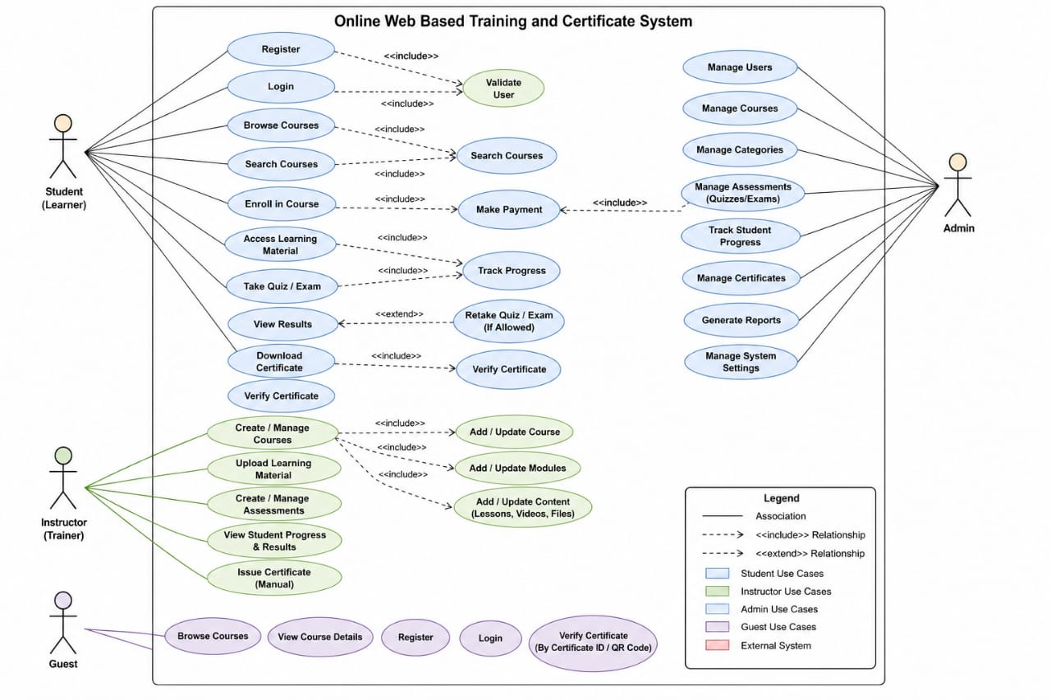

8.3 Class Diagram

A Class Diagram is a structural UML diagram that illustrates the static structure of a software system. It represents the system's classes, their attributes, methods, and the relationships between different classes. Class diagrams are widely used during software design because they provide a blueprint for database design and object-oriented programming.
For the Online Web-Based Training and Certification System, the Class Diagram includes major classes such as User, Admin, Course, Enrollment, Quiz, Question, Certificate, Payment (if applicable), and Report. Each class contains relevant attributes and methods required for implementing the system functionality.
The Class Diagram helps developers understand object relationships, inheritance, associations, aggregation, and dependencies before coding begins. It also improves software maintainability by providing a clear representation of the system structure.
The Class Diagram serves as the foundation for implementing the object-oriented architecture of the Online Web-Based Training and Certification System.
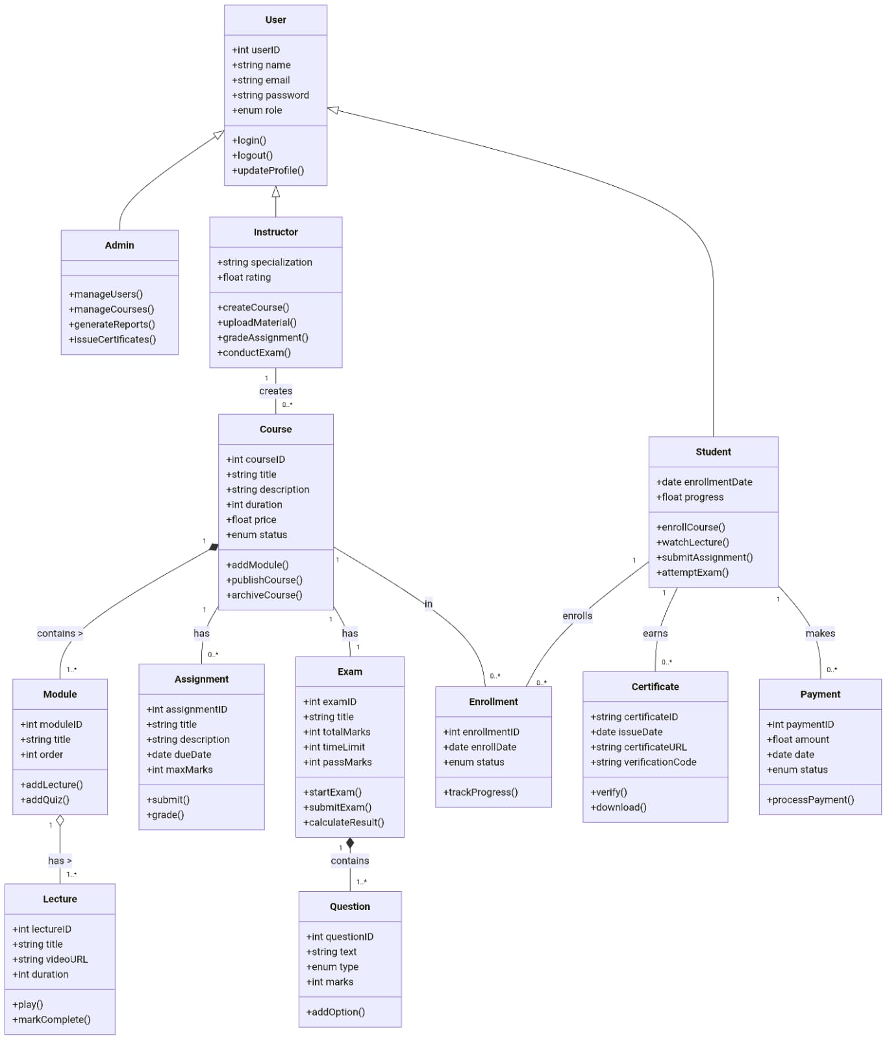

8.4 Relationships Between Classes

- Relationships define how different classes communicate and interact with one another. Proper class relationships improve software organization and maintainability while reducing redundancy.
- The Online Web-Based Training and Certification System uses several types of relationships, including Association, Aggregation, Composition, Inheritance, and Dependency.

For example:
- A User can enroll in multiple Courses.
- Each Course contains multiple Quizzes.
- Each Quiz contains multiple Questions.
- A Certificate is generated after a learner successfully completes a course and passes the required quizzes.
- The Administrator manages users, courses, quizzes, certificates, and reports.
- These relationships ensure data consistency and allow different software modules to communicate efficiently.

8.5 Scenario: New User Registration, Course Enrollment, and Certificate Generation

- A scenario describes the sequence of activities performed by a user while interacting with the system to accomplish a specific task. In the Online Web-Based Training and Certification System, one of the most common scenarios involves a new learner registering on the platform, enrolling in a training course, completing the learning activities, attempting quizzes, and finally receiving a certificate upon successful completion.
- The process begins when a new user visits the system and selects the Registration option. The user enters personal information such as full name, email address, username, password, and other required details. The system validates the entered information to ensure that all mandatory fields are completed correctly and that the email address or username is not already registered. After successful validation, the user's account is created and stored securely in the database.
- Once registered, the learner logs into the system using valid credentials. The system authenticates the user and redirects them to the learner dashboard, where all available training courses are displayed. The learner can browse different categories, read course descriptions, and select a course according to their interests or learning requirements.
- After selecting a course, the learner completes the enrollment process. The system records the enrollment information and grants access to all learning materials associated with the selected course. These learning materials may include video lectures, PDF notes, presentations, assignments, and additional reading resources.
- As the learner studies the course content, the system continuously tracks learning progress and stores completion records in the database. Once all learning modules have been completed, the learner becomes eligible to attempt the course quiz.
- The learner starts the quiz, answers all questions within the specified time, and submits the responses. The system automatically evaluates the submitted answers and calculates the final score. If the learner achieves the minimum passing marks, the course is marked as successfully completed.
- After successful completion of the course and quiz, the system automatically generates a digital certificate containing the learner's name, course title, completion date, certificate identification number, and verification details. The learner can preview, download, or print the certificate for future use.
- If the learner fails to achieve the required passing score, the system checks the number of remaining quiz attempts. If additional attempts are available, the learner is allowed to retake the quiz. However, if the maximum number of permitted attempts has been reached, the system displays an appropriate notification informing the learner that no further attempts are allowed.
- This scenario demonstrates the complete learning workflow of the Online Web-Based Training and Certification System, beginning with user registration and ending with successful certification.

8.6 Sequence Diagram

- A Sequence Diagram is a behavioral UML diagram that illustrates the chronological order of interactions between different system objects while performing a specific operation. It shows how messages are exchanged between users and system components over time, making it easier to understand the dynamic behavior of the software system.
- In the Online Web-Based Training and Certification System, the Sequence Diagram represents the interaction between the Learner, Web Application, Database, Course Module, Quiz Module, and Certificate Module during the execution of a learning process. It clearly illustrates the sequence of requests and responses exchanged between these components.
- The sequence begins when the learner submits login credentials. The web application forwards the login request to the database for authentication. After successful verification, the learner is granted access to the dashboard. The learner then selects and enrolls in a course. The enrollment request is processed by the application and stored in the database.
- Next, the learner accesses the course content and completes all learning materials. Upon completion, the learner attempts the course quiz. The quiz module retrieves quiz questions from the database and presents them to the learner. After submission, the system evaluates the answers and calculates the obtained marks.
- The application then checks whether the learner has achieved the required passing score. If the learner passes the assessment, the certificate generation module creates a digital certificate and stores the certificate information in the database. Finally, the certificate is displayed to the learner for downloading or printing.
- If the learner fails the assessment, the system verifies the remaining quiz attempts. When attempts are available, the learner is allowed to retake the quiz. If no attempts remain, the system displays an appropriate message informing the learner that the maximum quiz attempt limit has been reached.
- The Sequence Diagram helps developers understand the communication between different software modules, simplifies software implementation, and ensures that all interactions occur in the correct order. It also assists testers in verifying the execution flow and identifying possible communication errors between system components.

DIAGRAM 1

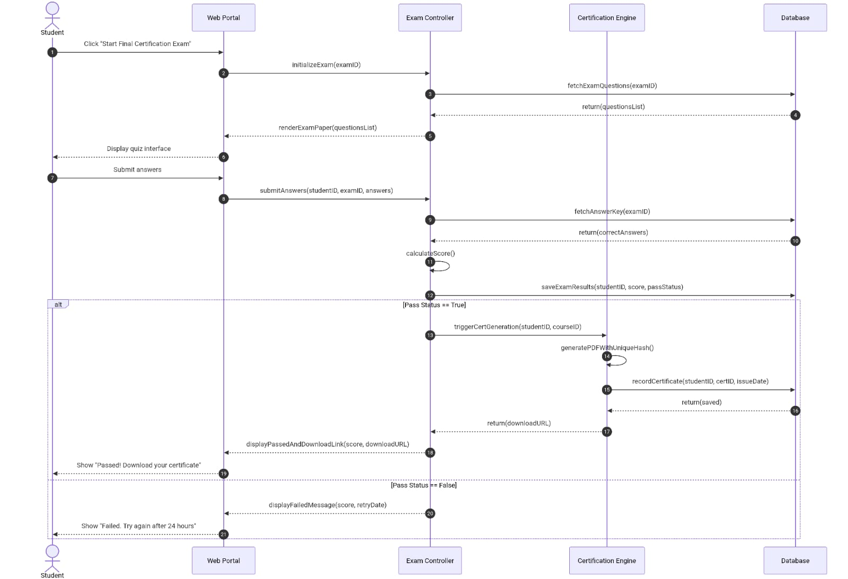

DIAGRAM 2
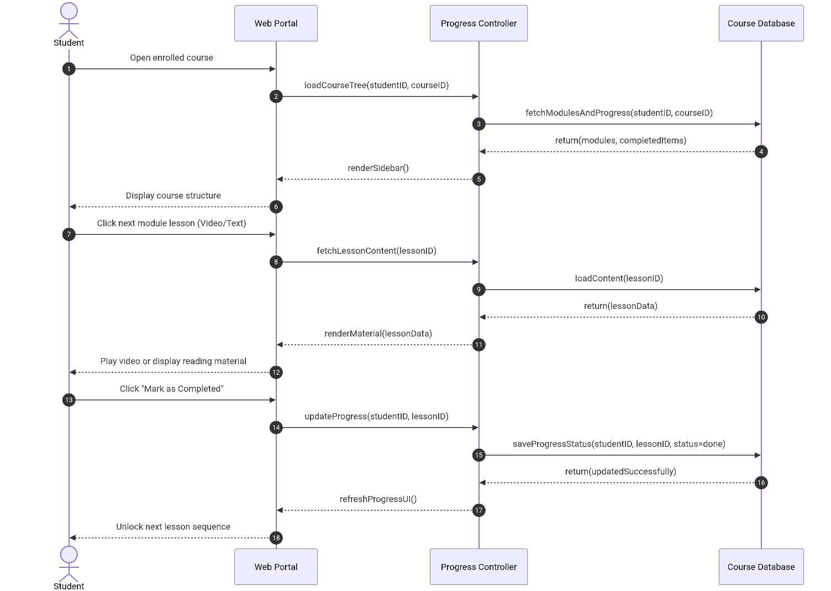

DIAGRAM 3

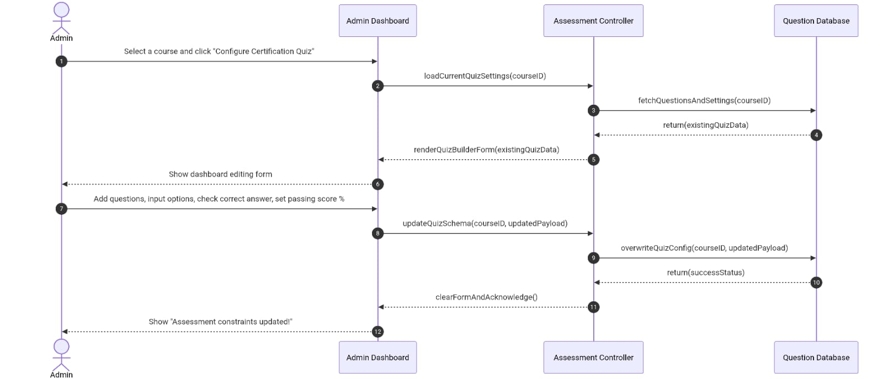

DIAGRAM 4

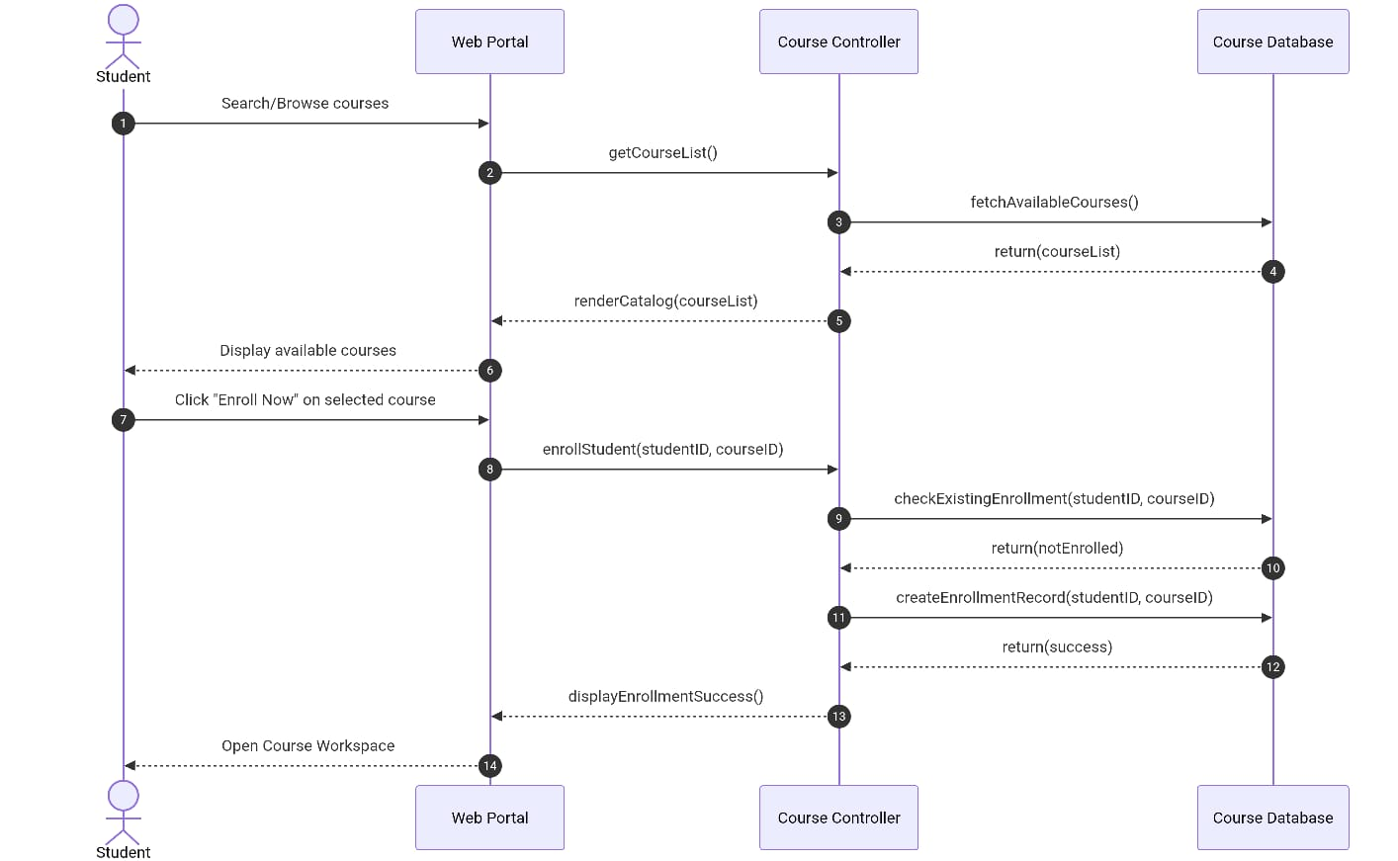

DIAGRAM 5

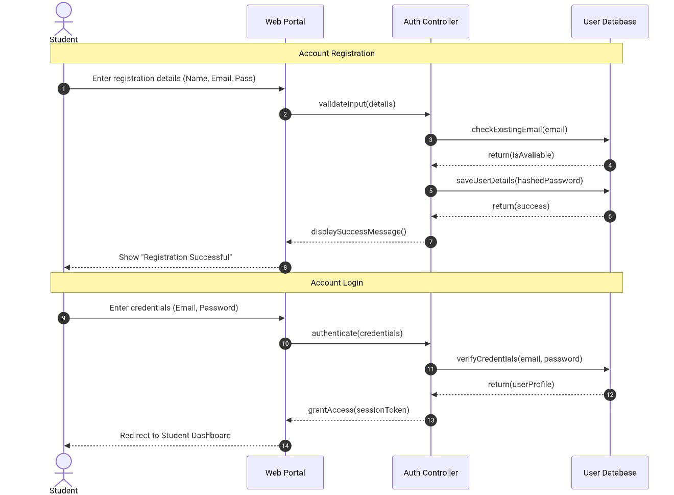

DIAGRAM 6

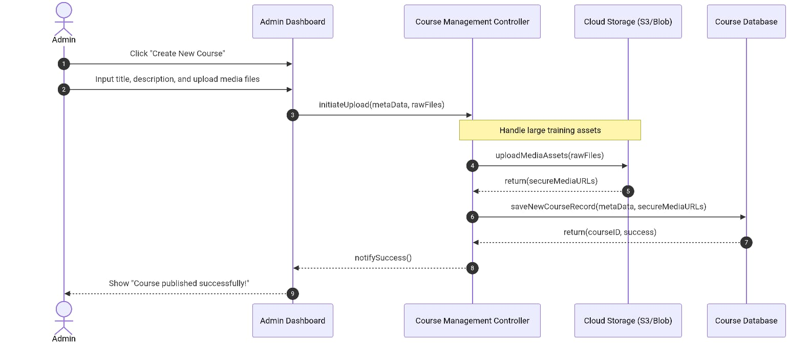

Conclusion of UML Diagrams

The UML diagrams developed for the Online Web-Based Training and Certification System provide a complete representation of both the structural and behavioral aspects of the application. The Use Case Diagram identifies the interactions between users and the system, the Class Diagram illustrates the static structure of the software, the Activity Diagrams describe the workflow of different processes, and the Sequence Diagram explains the communication between system components during execution.
These diagrams played a vital role in system analysis, design, implementation, and testing. They improved communication among stakeholders, reduced development complexity, and provided clear documentation for future maintenance and enhancements. Overall, the UML diagrams contributed significantly to the successful development of the Online Web-Based Training and Certification System.

Activity Diagram
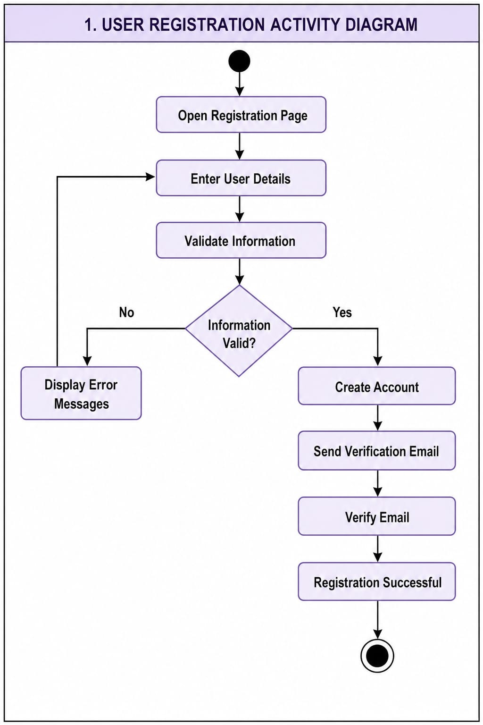

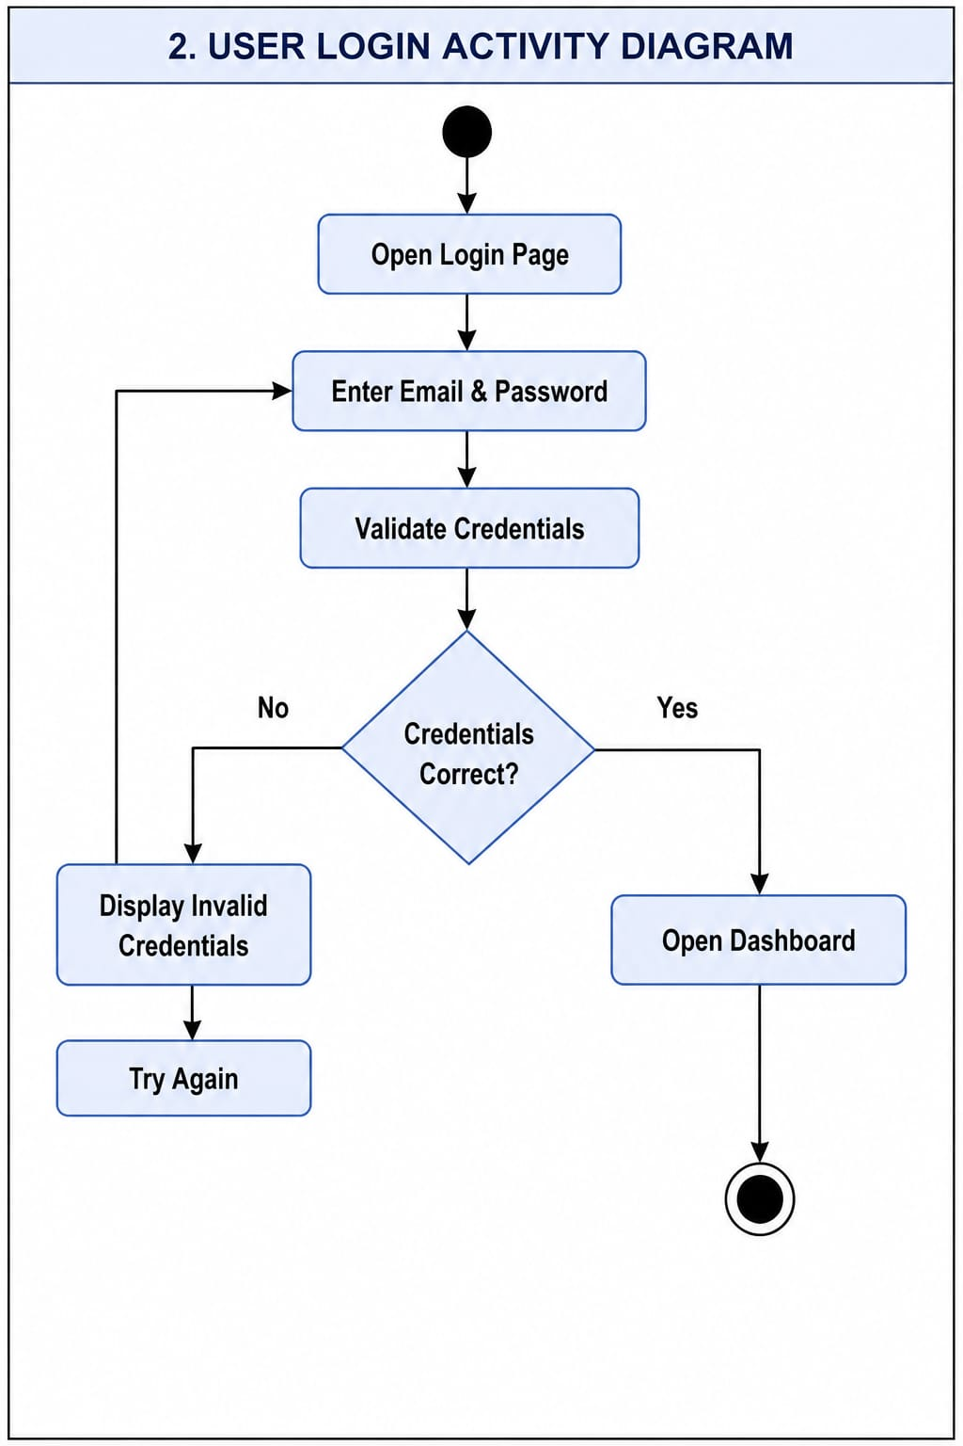
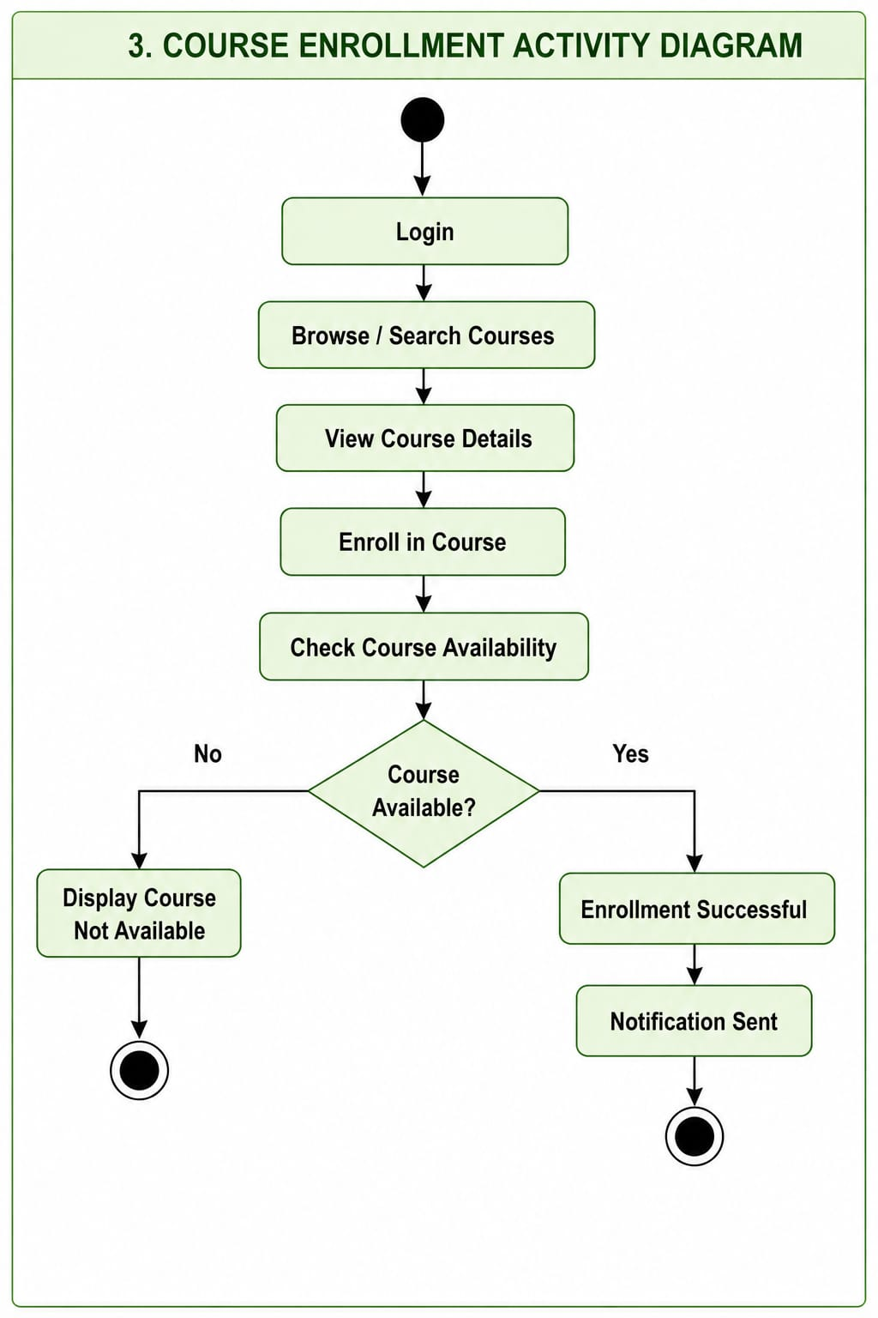
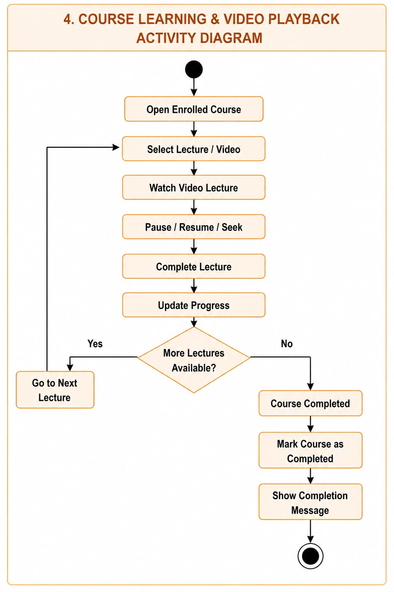
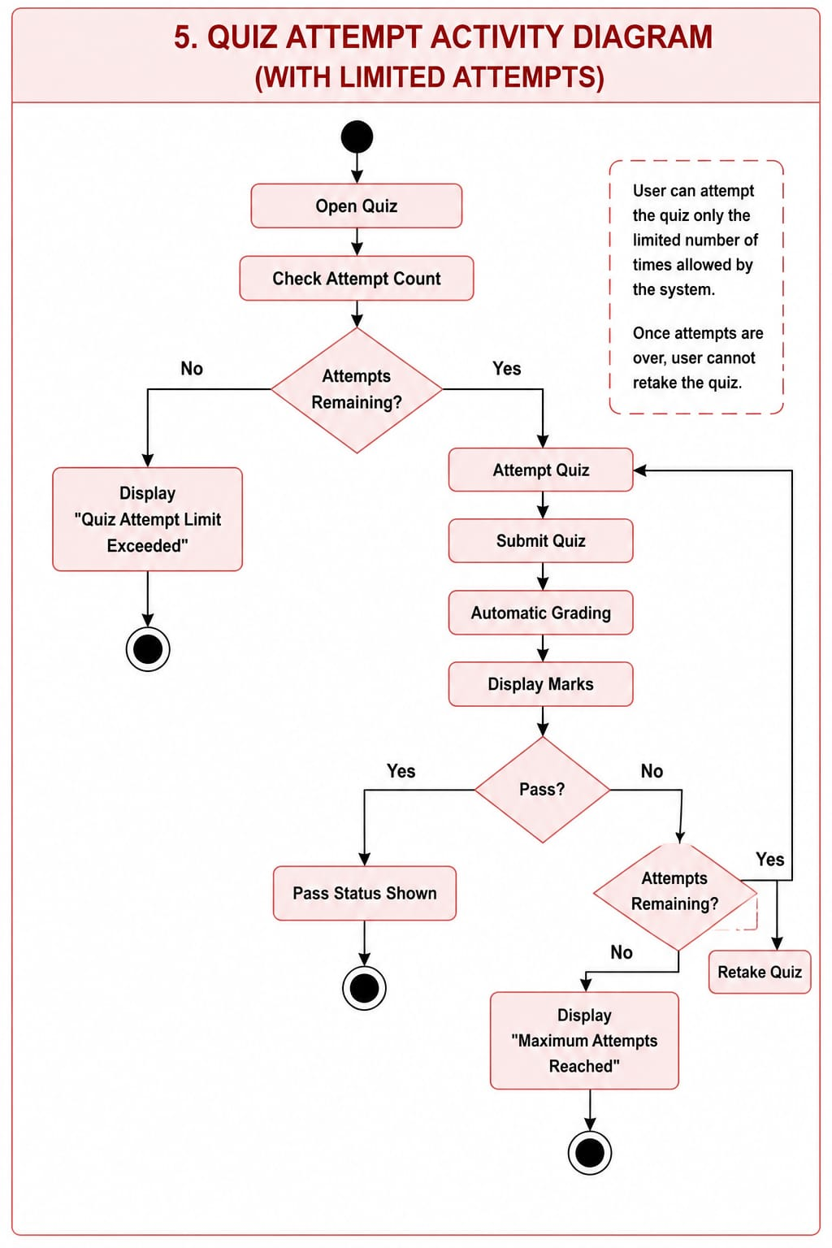
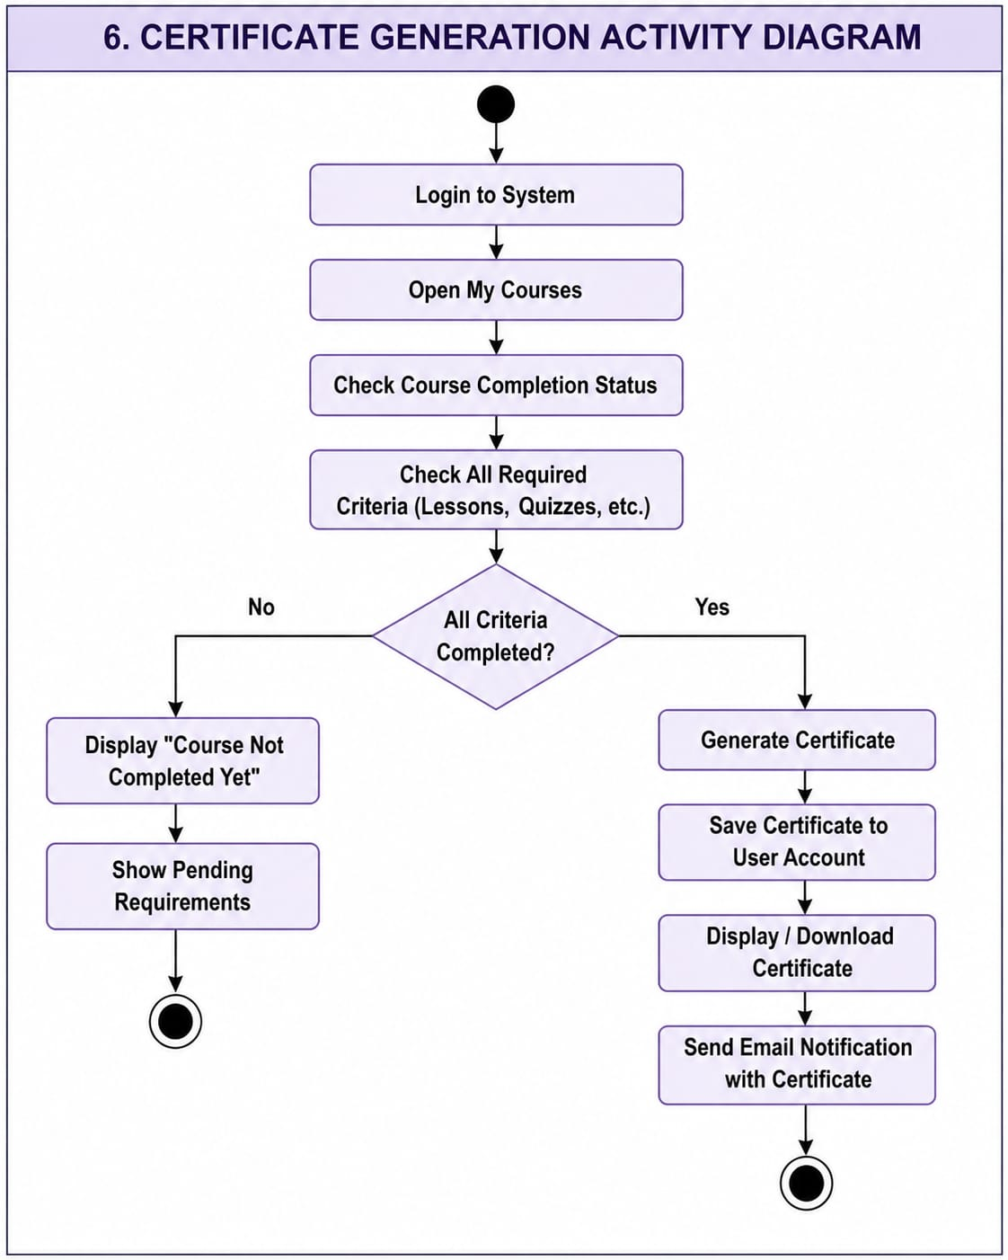

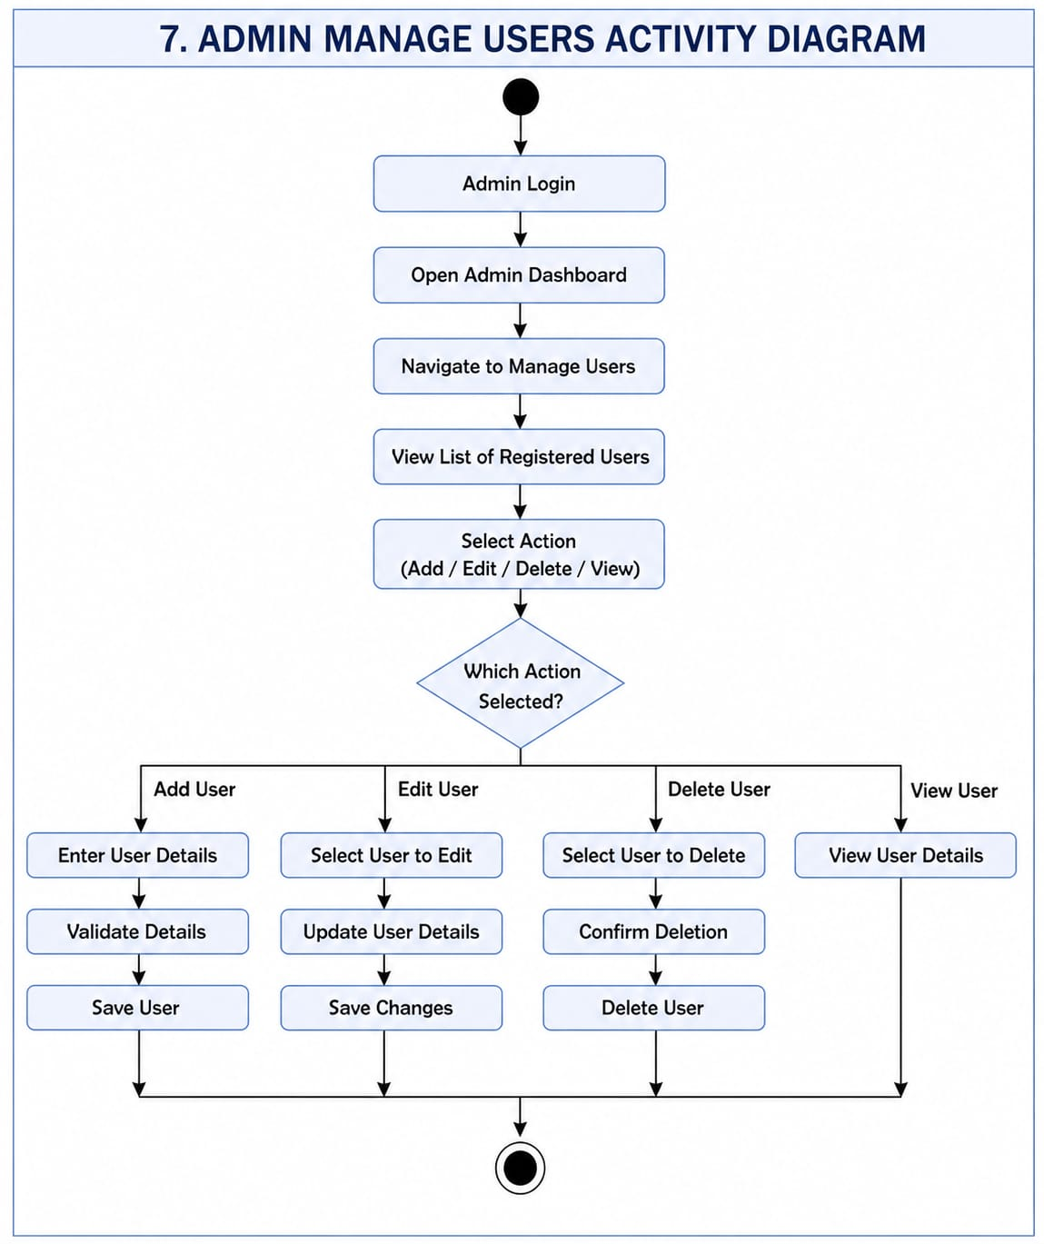

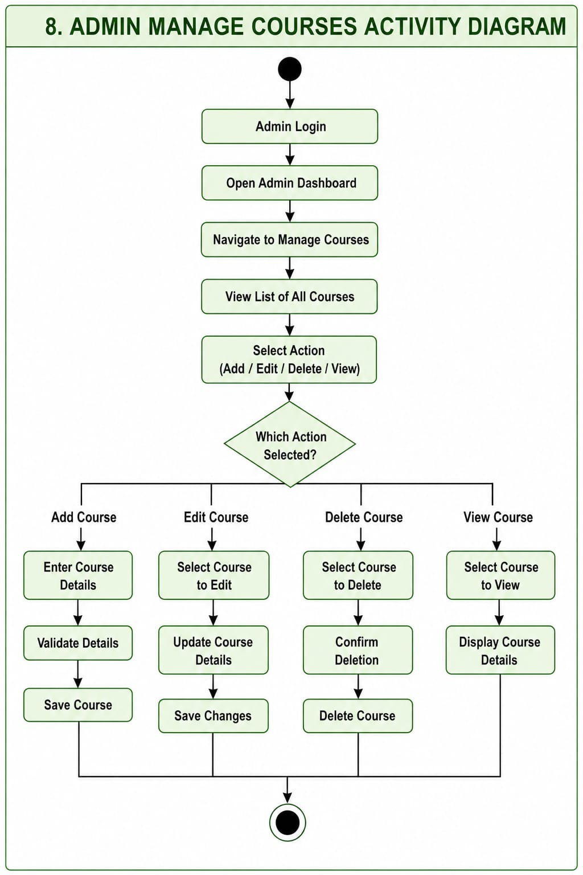
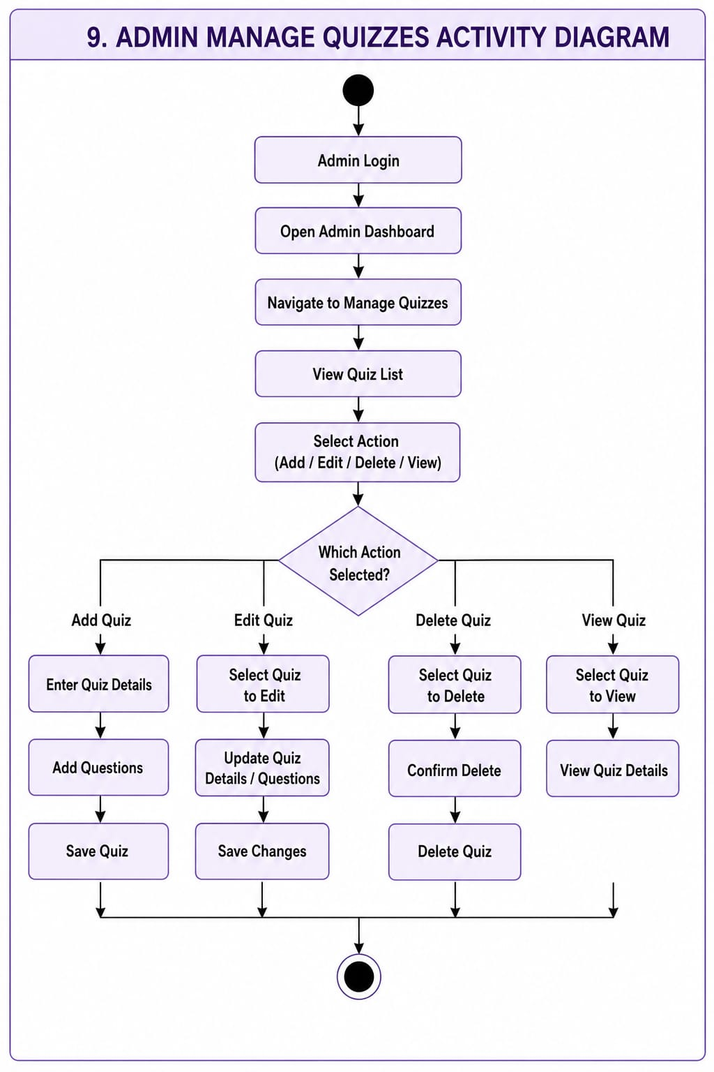

State Diagram
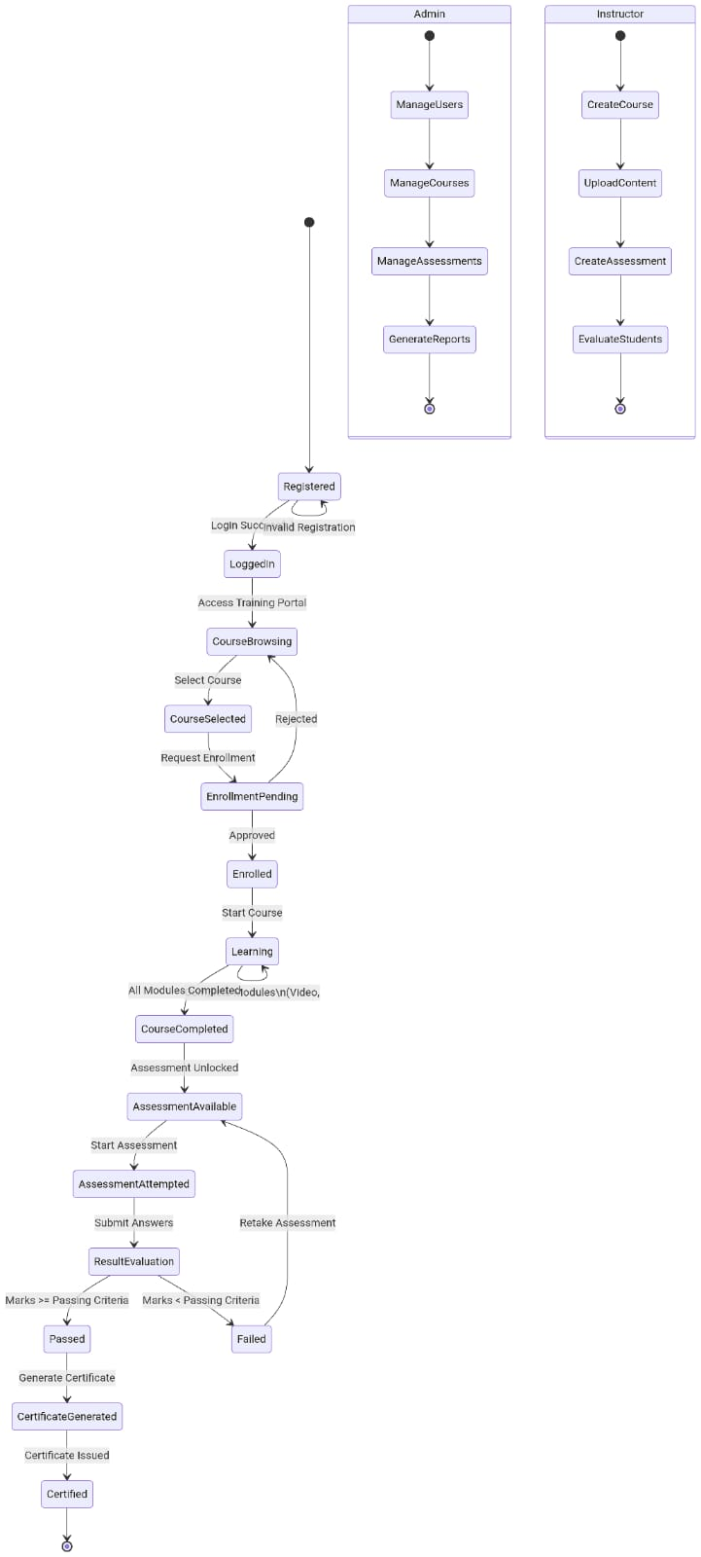
COCOMO MODEL
The Constructive Cost Model (COCOMO) is a software cost estimation model that calculates the effort, development time, and cost of a software project based on its estimated size in KLOC. It is used in this project to estimate the resources required for the development of the Online Web-Based Training and Certification System.

6.1 Project Size Estimation

6.1.1 Introduction
Project Size Estimation is the process of estimating the approximate size of a software project before development begins. In the COCOMO model, the project size is measured in Kilo Lines of Code (KLOC), where 1 KLOC = 1,000 lines of source code. This estimated size is used to calculate the development effort, schedule, staffing requirements, and overall project cost.

6.1.2 Estimation Approach
Since the Online Web-Based Training and Certification System is currently in the design phase, the actual source code is not available. Therefore, the project size has been estimated by analyzing the project's:
- Functional Requirements
- Non-Functional Requirements
- Use Case Diagram
- Class Diagram
- Activity Diagrams
- State Diagram
- Database Design
- System Modules
The estimated KLOC represents the approximate amount of source code required to implement all system functionalities.

6.1.3 Project Modules with Estimated LOC

Module | Description | Estimated LOC
User Authentication | Registration, Login, Password Recovery, Email Verification | 1,400
User Profile Management | Profile Management and Account Settings | 800
Course Management | Add, Update, Delete, Search and Manage Courses | 2,500
Enrollment Management | Course Enrollment and Enrollment Tracking | 1,200
Payment Module | Online Payment and Transaction Management | 1,800
Learning Management | Video Lectures, Documents and Progress Tracking | 2,800
Quiz & Assessment | Quiz Creation, Evaluation and Results | 2,300
Certificate Management | Certificate Generation and Download | 1,100
Notification Module | Email Notifications and System Alerts | 700
Admin Dashboard | User, Course, Quiz and System Management | 2,700
Reports & Analytics | Progress Reports and Performance Analysis | 1,500
Database Operations | CRUD Operations and Database Connectivity | 2,200

6.1.4 Total LOC and KLOC Calculation
Step 1: Total Estimated LOC
$$\begin{aligned}\text{Total LOC}&=1400+800+2500+1200+1800+2800 \\ & +2300+1100+700+2700+1500+2200 \\ &=21,000\text{ LOC}\end{aligned}$$

Step 2: Convert LOC into KLOC

$$\text{KLOC}=\frac{\text{LOC}}{1000} \\ =\frac{21,000}{1000} \\ =21 KLOC$$

Estimated Project Size = 21 KLOC

6.1.5 Assumptions Used
The project size estimation is based on the following assumptions:
- The system will be developed as a web-based application.
- Standard coding practices and modular architecture will be followed.
- Both front-end and back-end source code are included.
- Database scripts and SQL queries are included in the estimation.
- Third-party libraries and generated code are excluded.
- The estimation is based on the approved project requirements and UML diagrams.
    - Justification of Estimated KLOC
- The estimated project size of 21 KLOC is considered appropriate because the system includes multiple user roles (Student, Instructor, and Administrator) and several functional modules such as user authentication, course management, enrollment, online learning, quizzes, certificate generation, payment processing, reporting, notifications, and administrative management.
- The complexity shown in the Functional Requirements and UML diagrams indicates that the project is a medium-sized web application, making 21 KLOC a realistic estimate for COCOMO-based software cost estimation.

6.2 Selection of COCOMO Mode

6.2.1 Introduction
The COCOMO model classifies software projects into different development modes based on their size, complexity, team experience, and development environment. Selecting the appropriate mode ensures accurate estimation of effort, development time, and project cost.

6.2.2 COCOMO Modes
The Basic COCOMO model categorizes software projects into three development modes:
COCOMO Mode | Description
Organic | Small to medium-sized projects with simple requirements, experienced development teams, and a familiar development environment.
Semi-Detached | Medium-sized projects with moderate complexity, partially experienced teams, and a mix of familiar and unfamiliar requirements.
Embedded | Large and highly complex projects with strict hardware, software, or real-time constraints, requiring extensive development effort.

6.2.3 Comparison of COCOMO Modes
Feature | Organic | Semi-Detached | Embedded
Project Size |  | Medium
  Small to Medium
  Large
System Complexity | Low | Moderate | High
Team Experience | High | Moderate | Mixed
Project Constraints | Few | Moderate | Very High
Development Risk | Low | Medium | High

6.2.4 Selected COCOMO Mode
Selected Mode: Semi-Detached
The Online Web-Based Training and Certification System is classified as an Semi-detached project.

6.2.5 Justification for Selecting Semi-detached Mode
The Semi-Detached mode has been selected for the following reasons:
- The project is a medium-sized web-based application developed as an academic software project.
- The system follows a standard web application architecture without real-time or embedded system constraints.
- The functional requirements, including user management, instructor management, course management, enrollment, online learning, quizzes, certificate generation, payment processing, reporting, analytics, and role-based access control, introduce moderate to high business logic, making the project suitable for the Semi-Detached development mode.
- The project uses modern web development technologies and frameworks, while requiring integration of multiple software components and database operations, resulting in moderate implementation complexity.
- The project does not involve safety-critical operations, specialized hardware, or complex communication protocols.
- The estimated project size (21 KLOC) and the overall complexity of the system fall within the range suitable for the Semi-Detached development mode according to the COCOMO model.
Therefore, the Semi-Detached mode provides the most appropriate basis for estimating the project's effort, development schedule, staffing requirements, and overall cost using the COCOMO model.6.3 Basic COCOMO Model

6.3.1 Basic COCOMO Coefficients (Semi-Detached Mode)
Since the Online Web-Based Training and Certification System is classified as a Semi-Detached project, the following coefficients are used.
Coefficient | Value | Description
a(b​) | 3.0 | Effort Multiplication Constant
b(b​) | 1.12 | Effort Exponent
c(b)​ | 2.5 | Development Time Constant
d(b​) | 0.35 | Development Time Exponent

Basic COCOMO Formula

Effort Formula
$$\boxed{\text{Effort (PM)}=a×{\left(KLOC\right)}^{b}}$$

Development Time Formula
$$\boxed{\text{Development Time (TDEV)}=c×{\left(PM\right)}^{d}}$$

Average Staff Size Formula
$$\boxed{\text{Staff Size (SS)}=\frac{PM}{TDEV}}$$
Productivity Formula
$$\boxed{\text{Productivity}=\frac{KLOC}{PM}}$$

- Effort Calculation
Formula
PM=3.0× (21)1.12
Calculation
$$PM=3.0×30.30$$
$$\boxed{PM=90.90 Person-Months}$$
- Development Time Calculation
Formula
TDEV=2.5×(90.90)0.35
Calculation
$$TDEV=2.5×4.84$$
$$\boxed{TDEV=12.10 Months}$$
- Average Staff Size (SS)
Formula
$$SS=\frac{PM}{TDEV}$$Calculation
$$SS=12.10/90.90​$$
$$SS=7.51≈8$$
- Productivity
Formula
$$Productivity=\frac{KLOC}{PM}$$Calculation
$$Productivity=21/90.90 \\ \boxed{Productivity=0.23 KLOC/Person\text{-}Month}$$

6.3.2 Basic COCOMO Results Summary
Parameter | Value
Project Size | 21 KLOC
Selected Mode | Semi-Detached
Estimated Effort | 90.90 Person-Months
Development Time | 12.10 Months
Average Staff Size | 8 Persons
Productivity | 0.23 KLOC / Person-Month

6.4 Intermediate COCOMO Model

6.4.1 Cost Driver Rating for Online Web-Based Training and Certification System
The Intermediate COCOMO Model considers various cost drivers that affect the software development effort. These drivers are evaluated based on the characteristics of the Online Web-Based Training and Certification System.
Cost Driver | Rating | Multiplier | Reasons
Required Software Reliability (RELY) | High | 1.15 | The system must provide accurate training records, quizzes, and certificate generation.
Database Size (DATA) | High | 1.08 | The database stores users, courses, enrollments, quizzes, certificates, payments, and reports.
Product Complexity (CPLX) | High | 1.15 | The system contains multiple modules, user roles, and integrated functionalities.
Execution Time Constraint (TIME) | Low | 1.00 | The system does not require strict real-time response.
Main Storage Constraint (STOR) | Low | 1.00 | Modern hardware provides sufficient storage capacity.
Virtual Machine Volatility (VIRT) | Low | 0.87 | Standard development computers provide adequate performance.
Computer Turnaround Time (TURN) | Low | 0.87 | Standard development computers provide adequate performance.
Analyst Capability (ACAP) | Low | 1.19 | The project is developed by undergraduate students with limited analysis experience.
Programmer Capability (PCAP) | Low | 1.17 | The development team has moderate programming experience.
Application Experience (AEXP) | Low | 1.13 | The team has limited experience with similar web-based training systems.
Platform Experience (PEXP) | Low | 1.10 | The team has limited practical experience with the selected platform.
Language & Tool Experience (LTEX) | Very Low | 1.20 | The team is still learning the programming languages and development tools.
Software Engineering Methods (MODP) | High | 0.91 | Standard Software Engineering practices and SDLC methodology are followed.
Software Tools (TOOL) | High | 0.78 | Modern IDEs, version control, database tools, and testing tools improve development efficiency.
Required Development Schedule (SCED) | High | 1.04 | The project must be completed within the fixed academic semester timeline.

6.4.2 Effort Adjustment Factor (EAF) Calculation
Formula
$$\boxed{EAF=\prod{(}\left.Cost Driver Multipliers\right)}$$
Calculation
EAF=1.15×1.08×1.15×1.00×1.00×0.87×0.87×1.19×1.17×1.13×1.10×1.20×0.910.78×1.04
$$\boxed{EAF≈1.27}$$6.4.3 Adjusted Effort Calculation (E adj)
Formula
$$\boxed{E_{adj}=EAF×E}$$Calculation
$$E_{adj}=1.27×90.90 \\ \boxed{E_{adj}=115.43 Person Months}$$

6.4.4 Adjusted Development Time (D adj)
Formula:
$$D_{adj}=2.5×{\left(E_{adj}\right)}^{0.35}$$
Calculation:
$$D_{adj}=2.5×{\left(115.44\right)}^{0.35} \\ \boxed{D_{adj}=13.00 Months}$$

6.4.5 Adjusted Average Staff Size
Formula:
$$SS_{adj}=\frac{E_{adj}}{D_{adj}}$$
Calculation:
$$SS_{adj}=\frac{115.44}{13.00} \\ \boxed{SS_{adj}=8.88≈9 Persons}$$6.4.6 Adjusted Productivity
Formula:
$$Productivity=\frac{KLOC}{E_{adj}}$$
Calculation:
$$Productivity=\frac{21}{115.44} \\ \boxed{Productivity=0.18 KLOC/Person-Month}$$6.4.2 Intermediate COCOMO Results Summary
Parameter | Value
Project Size | 21 KLOC
Selected Mode | Semi-Detached
Effort Adjustment Factor (EAF) | 1.27
Adjusted Effort | 115.43 Person-Months
Adjusted Development Time | 13.00Months
Adjusted Average Staff Size | 9 Persons
Adjusted Productivity | 0.18 KLOC / Person-Month

6.5 Detailed COCOMO Model
6.5.1 Introduction
The Detailed COCOMO Model extends the Intermediate COCOMO Model by estimating the effort and development schedule for each phase of the Software Development Life Cycle (SDLC). This phase-wise distribution helps in effective project planning, resource allocation, progress monitoring, and project management.
For the Online Web-Based Training and Certification System, which is classified as a Semi-Detached mode project with an estimated size of 21 KLOC, the standard COCOMO phase distribution is used.
SDLC Phase | Effort Fraction (μₚ) | Schedule Fraction (τₚ)
Planning & Requirements | 0.06 | 0.10
System Design | 0.16 | 0.19
Detailed Design | 0.26 | 0.24
 | 0.42 | 0.39
  Module Coding & Unit Testing
Integration & System Testing | 0.16 | 0.18
The effort fractions add up to approximately 1.06, while the schedule fractions total approximately 1.10. This is a normal characteristic of the Detailed COCOMO model because software development phases often overlap. For example, coding may begin while detailed design is still being refined, and testing activities may start before all coding is completed. This overlap reflects real-world software development practices and results in more realistic project planning.

6.5.2 Phase-Wise Effort Distribution
The total adjusted effort (115.44 Person-Months) is distributed among the major SDLC phases.
Formula
$$\boxed{\text{Phase Effort}=E_{adj}×\text{Phase Percentage}}$$
SDLC Phase | Percentage | Calculation | Effort (PM)
Requirements & Planning | 10% | 115.44× 0.10 | 11.54
System Design | 20% | 115.44 × 0.20 | 23.09
Detailed Design | 25% | 115.44 × 0.25 | 28.86
Coding & Unit Testing | 30% | 115.44 × 0.30 | 34.63
Integration & Testing | 15% | 115.44 × 0.15 | 17.32
Total | 100% |  | 115.44 PM

6.5.3 Phase-Wise Schedule Distribution
The adjusted development time (13.00 Months) is distributed across the SDLC phases.
Formula
$$\boxed{\text{Phase Schedule}=D_{adj}×\text{Phase Percentage}}$$
SDLC Phase | Percentage | Calculation | Duration (Months)
Requirements & Planning | 10% | 13.00 × 0.10 | 1.30
System Design | 20% | 13.00 × 0.20 | 2.60
Detailed Design | 25% | 13.00 × 0.25 | 3.25
Coding & Unit Testing | 30% | 13.00 × 0.30 | 3.90
Integration & Testing | 15% | 13.00 × 0.15 | 1.95
Total | 100% |  | 13.00 Months

6.5.4 Phase-Wise Staff Size
The average development team consists of 9 members, which are distributed across the SDLC phases according to project activities.
Formula
$$\boxed{\text{Phase Staff}=SS×\text{Phase Percentage}}$$
SDLC Phase | Percentage | Calculation | Staff Size(Effort)
Requirements & Planning | 10% | 9× 0.10 | 1
System Design | 20% | 9 × 0.20 | 2
Detailed Design | 25% | 9× 0.25 | 2
Coding & Unit Testing | 30% | 9× 0.30 | 3
Integration & Testing | 15% | 9 × 0.15 | 1

6.5.5 Phase-Wise Person-Month Distribution
The Basic COCOMO effort (115.44 Person-Months) is distributed across the SDLC phases.
Formula
$$\boxed{\text{Phase Person-Months}=E×\text{Phase Percentage}}$$
SDLC Phase | Percentage | Calculation | Person-Month
Requirements & Planning | 10% | 115.44 × 0.10 | 11.54
System Design | 20% | 115.44 × 0.20 | 23.09
Detailed Design | 25% | 115.44 × 0.25 | 28.86
Coding & Unit Testing | 30% | 115.44 × 0.30 | 34.63
Integration & Testing | 15% | 115.44 × 0.15 | 17.32
Total | 100% |  | 115.44 PM

6.5.6 Detailed COCOMO Results Summary
Parameter | Value
Project Size | 21 KLOC
Selected COCOMO Mode | Semi-Detached
Basic Effort | 90.90 Person-Months
Adjusted Effort | 115.44 Person-Months
Adjusted Development Time | 13.00 Months
Average Staff Size | 9 Persons
Number of SDLC Phases | 5

6.6 Cost Estimation

6.6.2 Assumptions
The following assumptions are considered for estimating the development cost of the Online Web-Based Training and Certification System.
Parameter | Value
Project Size | 21 KLOC
Selected COCOMO Mode | Semi-Detached
Adjusted Effort (Eadj) | 115.44 Person-Months
Average Cost per Person-Month | PKR 100,000
The average monthly development cost includes developer salary, software tools, internet, testing, documentation, and other project-related expenses.
Formula
$$\boxed{\text{Total Cost}=E_{adj}×Cost_{PM}}$$Calculation
Given
Adjusted Effort
$$E_{adj}=115.44 PM$$Cost per Person-Month
$$Cost_{PM}=100,000 PKR$$Calculation
$$Total Cost=115.44×100,000 \\ \boxed{Total Cost=PKR 11,544,000}$$
Note:
The estimated development cost of the Online Web-Based Training and Certification System is PKR 11,544,000. This estimation is based on the Intermediate COCOMO Semi-Detached adjusted effort of 115.44 Person-Months and an assumed average development cost of PKR 100,000 per Person-Month. The estimated cost includes software development, testing, documentation, project management, and supporting development resources.

6.7 COCOMO II (Object Points Approach)
COCOMO-II is used for more modern development approaches. Based on our system design:
Object Type | Examples from Your Project
Screens | Login, Registration, Dashboard, Course List, Course Details, Quiz, Certificate, Payment, Profile, Admin Dashboard
Reports | Student Progress Report, Course Completion Report, Quiz Performance Report, Certificate Report
Components | Authentication, Course Module, Quiz Engine, Certificate Generator

6.7.2 Object Point Estimation
The Object Points are calculated by analyzing the major user interface components of the Online Web-Based Training and Certification System.
Component | Quantity | Complexity | Weight | Object Points
Simple Screens | 6 | Simple | 1 | 6
Medium Screens | 10 | Medium | 2 | 20
Complex Screens | 8 | Complex | 3 | 24
Simple Reports | 2 | Simple | 3 | 4
Medium Reports | 3 | Medium | 5 | 15
Complex Reports | 2 | Complex | 8 | 16
3GL Components | 4 | Medium | 10 | 40
Total Object Points
$$\boxed{OP=6+20+24+4+15+16+40=125}$$

6.7.3 Percentage of Reused Components
Some existing libraries and framework components are reused during development.
Total Object Points | =125

Percentage Reused | =20%

6.7.4 New Object Points (NOP)
Formula
$$\boxed{NOP=OP×\left(1-\frac{\%Reuse}{100}\right)}$$Calculation
$$NOP=125×\left(1-0.20\right) \\ NOP=125×0.80 \\ \boxed{NOP=100}$$6.7.5 Productivity Rate (PROD)
The productivity rate represents the number of Object Points developed by one developer in one month.
For this project, the standard productivity rate is assumed as:
$$\boxed{PROD=13 Object Points/Person\text{-}Month}$$6.7.6 Development Effort
Formula
$$\boxed{Effort=\frac{NOP}{PROD}}$$Calculation
$$Effort=\frac{100}{13} \\ \boxed{Effort=7.69 Person Months}$$6.7.7 Interpretation
The calculated effort of 7.69 Person-Months indicates that approximately eight person-months of work are required to develop the new functionality of the Online Web-Based Training and Certification System using the COCOMO II Object Points Approach. Since this method accounts for reusable components and object-oriented development practices, it generally produces a lower effort estimate than traditional COCOMO models.

6.8 Comparison of All COCOMO Levels
Parameter | Basic COCOMO | Intermediate COCOMO |  | COCOMO II
  Detailed COCOMO
Estimation Basis | KLOC | KLOC + Cost Drivers | Phase-wise Distribution | Object Points
Project Size | 21 KLOC | 21 KLOC | 21 KLOC | 125 OP
Estimated Effort | 90.90 PM | 115.44 PM | 115.44 PM (Phase-wise) | 7.69 PM
Development Time | 12.45 Months | 13.00 Months | 13.00 Months (Phase-wise) | ---------
Staff Estimation | 8 Persons | 9 Persons | Phase-wise Staff Allocation | ----------

6.9 Detailed Interpretation and Analysis

6.9.1 Schedule Feasibility
The estimated development schedule for the Online Web-Based Training and Certification System is approximately 13.00 months, which is suitable for a medium-sized software project developed in an industrial environment. However, this project is being developed as a university semester project with a duration of approximately 16 weeks (4 months).
The COCOMO estimates assume:
- Full-time software development (40 hours/week)
- Dedicated development team
- Standard software engineering productivity
- No academic or external commitments
In an academic environment, the project can still be completed within the semester by distributing the workload among team members and focusing on implementing the core system features.
Schedule Analysis
- Estimated Development Time = 13.00 Months
- Academic Semester Duration = 4 Months
- Average Team Size = 9 Members
The required development effort is:
$$115.44\text{ PM}÷4\text{ Months}=28.86$$
This means approximately 16 full-time developers would be required to complete the project within four months.
Since the actual team consists of 9 members, each member contributes additional effort throughout the semester while working part-time. Therefore, completing the project within the academic schedule is feasible by following proper planning, task distribution, and continuous development.

6.9.2 Team Size
The Intermediate COCOMO Model estimates an average team size of 9 developers, which is suitable for the complexity of the Online Web-Based Training and Certification System. The project includes several modules such as authentication, course management, enrollment, learning content, quizzes, certificate generation, payment processing, reporting, and administrative management.
The workload can be effectively distributed among team members according to different development phases.
Team Allocation
Development Phase | Required Team
Requirements & Planning | 2–3 Members
System Design | 4 Members
Detailed Design | 5 Members
Coding & Unit Testing | 9 Members
Integration & Testing | 4-5 Members
The Coding & Unit Testing phase requires maximum team involvement because it includes implementation and testing of all major system functionalities.

6.9.3 Productivity
The productivity estimated by the Intermediate COCOMO Model is 0.18 KLOC per Person-Month.
Using the estimated effort:
$$0.18×115.44≈21 KLOC$$
This confirms that the estimated productivity is consistent with the overall project size.
The use of modern web technologies, reusable components, and structured software engineering practices improves development efficiency and supports timely completion of the project.

6.9.4 Phase Focus
The Detailed COCOMO Model distributes project effort and schedule among different SDLC phases.
SDLC Phase | Effort | Schedule | Observation
Planning & Requirements | 10% | 10% | Requirement analysis and project planning
System Design | 20% | 20% | System architecture and database design
Detailed Design | 25% | 25% | Module-level design and implementation planning
Module Coding & Unit Testing | 30% | 30% | Highest development effort due to implementation and testing of core modules
Integration & System Testing | 15% | 15% | Final system integration, validation, and quality assurance

6.9.5 Cost Driver Analysis
The Intermediate COCOMO Model produced an Effort Adjustment Factor (EAF) of approximately 1.27, indicating that the project requires higher effort than the basic Semi-Detached COCOMO estimate due to complexity, reliability requirements, and development constraints.
The following cost drivers have the greatest impact on the project:

- High Software Reliability (RELY) increases development effort because the system must maintain accurate training records, quiz results, and certificate generation.
- High Database Size (DATA) increases implementation effort because the system manages users, courses, enrollments, quizzes, certificates, payments, and reports.
- High Product Complexity (CPLX) increases effort because the system integrates multiple modules and different user roles.
- Low Analyst and Programmer Capability (ACAP & PCAP) increases development effort because the project team consists of undergraduate developers with limited industrial experience.
- Low Application, Platform, and Tool Experience (AEXP, PEXP, LTEX) increases effort because the team has limited practical experience with similar systems and development technologies.
- Software Engineering Methods and Development Tools (MODP & TOOL) help reduce development challenges by providing structured development practices, version control, testing tools, and modern IDE support.
Overall, the selected cost driver ratings accurately represent the characteristics of the Online Web-Based Training and Certification System. The Semi-Detached COCOMO estimation provides a realistic prediction of development effort, schedule, team requirements, and project resources.

CONCLUSION
The COCOMO analysis performed for the Online Web-Based Training and Certification System provided a systematic estimation of the project's size, development effort, schedule, staffing requirements, productivity, and overall development cost. The project was classified as a Semi-Detached software project with an estimated size of 21 KLOC, which makes it suitable for applying the Basic, Intermediate, Detailed, and COCOMO II estimation models.
The Basic COCOMO Model provided the initial effort estimation based on the project size, while the Intermediate COCOMO Model improved estimation accuracy by considering project-specific cost drivers such as software reliability, database size, product complexity, team capability, and development environment factors. The Detailed COCOMO Model further distributed the estimated effort and schedule across different phases of the Software Development Life Cycle (SDLC), supporting effective project planning, resource allocation, and monitoring.
The COCOMO II Object Points Approach estimated the development effort using object-oriented components, user interface screens, reports, and reusable software components. This approach reflects modern web application development practices and provides an additional estimation perspective.
The final estimation results indicate that the Online Web-Based Training and Certification System requires approximately 115.44 Person-Months of development effort, with an estimated development schedule of 13.00 months and an average team size of approximately 9 members. The estimated development cost of the project is approximately PKR 11,544,000, considering an average cost of PKR 100,000 per Person-Month.

Testing Phase
Online Web-Based Training and Certification System (OWTCS)

1. Test Objectives
The objective of the testing phase is to verify that the Online Web-Based Training and Certification System (OWTCS) functions correctly according to the requirements defined in the Software Requirements Specification, and that it is reliable, secure, and usable for learners, instructors, and administrators. Since the system is a web-based application accessed by external users, all testing in this phase is performed using the Black Box Testing technique, in which the system is evaluated purely on the basis of its inputs and expected outputs, without reference to internal code structure.
Specific objectives of the testing phase are to:
- Verify that all functional requirements (registration, login, enrollment, course content delivery, assessments, certification, and certificate generation) work as specified.
- Validate non-functional requirements including performance, security, usability, compatibility, reliability, and scalability.
- Identify, log, and track defects through to resolution.
- Ensure traceability between requirements and executed test cases.
- Obtain end-user (learner, instructor, and administrator) validation through User Acceptance Testing before deployment.

2. Test Levels
Testing is carried out at the following levels, all executed using black-box techniques:
- Integration Testing: Verifies that combined modules (e.g., Enrollment ↔ Payment Gateway, Assessment ↔ Progress Tracking, Exam ↔ Certificate Generation) interact and exchange data correctly.
- System Testing: Verifies the complete, integrated OWTCS against the full set of functional and non-functional requirements in an environment resembling production.
- User Acceptance Testing (UAT): Performed by actual learners, instructors, and administrators to confirm the system meets real-world business needs before go-live.
Note: Unit testing (a white-box activity performed by developers on individual code components) is outside the scope of this document, which covers black-box testing only.

3. Test Environment
Testing was conducted in an environment that mirrors the intended production setup:
- Application Server: Cloud-hosted server (Linux-based) running the OWTCS web application
- Database Server: MySQL/PostgreSQL database server (staging instance with anonymized sample data)
- Client Devices: Desktop (Windows 11, macOS), and mobile devices (Android, iOS)
- Browsers: Google Chrome, Mozilla Firefox, Microsoft Edge, Safari (latest stable versions)
- Network Conditions: Standard broadband and simulated 4G/mobile network for performance checks
- Testing Tools: Selenium / manual black-box testing for functional cases; JMeter for load and performance testing; Postman for API-level black-box validation; OWASP ZAP for basic security scanning
- Test Data: Dedicated staging database populated with sample learners, instructors, courses, and dummy payment sandbox credentials

4. Test Case Development

4.1 Functional Test Cases
Functional test cases validate each feature of the OWTCS strictly from an input/output perspective, without knowledge of the underlying code. Each test case below specifies the input provided to the system and the expected output.
TC ID | Module | Test Case Description | Input | Expected Output | Status
TC-01 | User Registration | Register a new learner with valid details | Name: Ali Raza; Email: ali.raza@mail.com; Password: Ali@1234; Confirm Password: Ali@1234 | Account created successfully; verification email sent; user redirected to login page | Pass
TC-02 | User Registration | Register with an already-registered email | Email: ali.raza@mail.com (existing); other fields valid | System displays error: "Email already registered"; account not created | Pass
TC-03 | User Registration | Register with mismatched passwords | Password: Ali@1234; Confirm Password: Ali@12345 | System displays error: "Passwords do not match"; form not submitted | Pass
TC-04 | Login | Login with valid credentials | Email: ali.raza@mail.com; Password: Ali@1234 | User authenticated and redirected to learner dashboard | Pass
TC-05 | Login | Login with invalid password | Email: ali.raza@mail.com; Password: WrongPass1 | System displays error: "Invalid email or password"; access denied | Pass
TC-06 | Login | Login with empty fields | Email: (blank); Password: (blank) | System displays validation message: "Email and password are required" | Pass
TC-07 | Password Recovery | Request password reset with registered email | Email: ali.raza@mail.com | Password reset link sent to registered email within 2 minutes | Pass
TC-08 | Course Catalog | Search for a course by keyword | Search term: "Web Development" | List of matching courses displayed with title, duration, and fee | Pass
TC-09 | Course Enrollment | Enroll in a free course | Course: "Intro to HTML"; Click "Enroll Now" | Course added to learner's "My Courses"; enrollment confirmation shown | Pass
TC-10 | Course Enrollment | Enroll in a paid course with valid payment details | Course: "Advanced Python"; Card No: 4111111111111111; Amount: PKR 5000 | Payment processed; course unlocked; receipt generated | Pass
TC-11 | Course Enrollment | Enroll in a paid course with invalid card details | Card No: 1234567890000000; Amount: PKR 5000 | Transaction declined; error message: "Payment failed, please try again" | Pass
TC-12 | Course Content | Access video lecture content | Click on "Lecture 1: Introduction" within enrolled course | Video streams without interruption; progress bar updates automatically | Pass
TC-13 | Assessment/Quiz | Attempt a module quiz with all correct answers | Quiz: Module 1 Quiz (5 MCQs); all correct options selected | Score displayed as 100%; status marked "Passed"; progress updated | Pass
TC-14 | Assessment/Quiz | Attempt quiz with score below passing threshold | Quiz: Module 1 Quiz; 2 of 5 correct (40%) | Score displayed as 40%; status marked "Failed"; retake option enabled | Pass
TC-15 | Certification Exam | Attempt final certification exam after completing all modules | All modules completed; exam started; 80% correct answers submitted | Exam passed; "Certificate Eligible" status shown on dashboard | Pass
TC-16 | Certification Exam | Attempt final exam without completing prerequisite modules | 2 of 5 modules incomplete; click "Start Exam" | System blocks access; message: "Complete all modules to unlock the exam" | Pass
TC-17 | Certificate Generation | Download certificate after passing exam | Click "Download Certificate" on eligible course | PDF certificate generated with learner name, course title, and unique certificate ID | Pass
TC-18 | Certificate Verification | Verify certificate using certificate ID | Certificate ID: CERT-2026-00123 | System displays valid certificate details: name, course, issue date | Pass
TC-19 | Progress Tracking | View course completion progress | Navigate to "My Courses" > "Progress" | Progress bar reflects accurate percentage of completed lectures/quizzes | Pass
TC-20 | Admin – Course Management | Add a new course as admin | Course Title: "Digital Marketing"; Duration: 6 weeks; Fee: PKR 3000 | New course added and visible in the public course catalog | Pass
TC-21 | Admin – User Management | Deactivate a learner account | Select user "Ali Raza"; click "Deactivate" | Account status changed to "Inactive"; user unable to log in | Pass
TC-22 | Notification | Receive notification on course deadline | Course deadline within 24 hours | In-app and email notification sent: "Course deadline approaching" | Pass
TC-23 | Logout | Logout from active session | Click "Logout" from dashboard menu | Session terminated; user redirected to login page | Pass

4.2 Non-Functional Test Cases
Non-functional test cases validate the quality attributes of the system — performance, security, usability, compatibility, reliability, and scalability — again evaluated purely through black-box input/output observation.
TC ID | Category | Test Scenario | Input | Expected Output | Status
NF-01 | Performance | Load test with concurrent users on the login page | 500 concurrent virtual users via load-testing tool | Average response time ≤ 3 seconds; no server errors | Pass
NF-02 | Performance | Video streaming under normal network load | 100 users streaming lectures simultaneously | Video buffering time ≤ 2 seconds; no playback failure | Pass
NF-03 | Security | Attempt SQL injection on login form | Email field: ' OR '1'='1 | Login rejected; input sanitized; no unauthorized access granted | Pass
NF-04 | Security | Access admin panel URL without admin privileges | Learner account attempts URL: /admin/dashboard | Access denied; redirected to "403 Forbidden" / login page | Pass
NF-05 | Security | Verify data transmission is encrypted | Submit login form over the network | All traffic transmitted via HTTPS/TLS; no plain-text credentials | Pass
NF-06 | Usability | Evaluate navigation clarity for a first-time user | New user completes registration-to-enrollment flow unaided | User completes flow within 5 minutes without external help | Pass
NF-07 | Compatibility | Access platform on different browsers | Chrome, Firefox, Edge, Safari (latest versions) | UI renders correctly and all features function on each browser | Pass
NF-08 | Compatibility | Access platform on mobile device | Smartphone browser, screen width 375px | Responsive layout displays correctly; all controls usable | Pass
NF-09 | Reliability | System recovery after unexpected disconnect during quiz | Network disconnected mid-quiz, then reconnected | Learner's answers up to disconnect point are auto-saved and restored | Pass
NF-10 | Scalability | System behavior with growing course catalog | Course catalog increased from 50 to 5,000 courses | Search and catalog pages load within 3 seconds; no degradation | Pass

5. Traceability Matrix (RTM)
The Requirements Traceability Matrix maps each functional and non-functional requirement to the test case(s) that verify it, ensuring complete test coverage of the SRS.
Req. ID | Requirement Description | Test Case ID(s) | Test Level | Status
FR-01 | The system shall allow new users to register an account | TC-01, TC-02, TC-03 | System Testing | Verified
FR-02 | The system shall authenticate users at login | TC-04, TC-05, TC-06 | System Testing | Verified
FR-03 | The system shall allow users to recover a forgotten password | TC-07 | System Testing | Verified
FR-04 | The system shall allow learners to search and browse courses | TC-08 | System Testing | Verified
FR-05 | The system shall allow learners to enroll in free and paid courses | TC-09, TC-10, TC-11 | Integration Testing | Verified
FR-06 | The system shall deliver course content (video/materials) | TC-12 | System Testing | Verified
FR-07 | The system shall provide quizzes/assessments per module | TC-13, TC-14 | System Testing | Verified
FR-08 | The system shall provide a final certification exam | TC-15, TC-16 | System Testing | Verified
FR-09 | The system shall generate a downloadable certificate | TC-17, TC-18 | System Testing | Verified
FR-10 | The system shall track and display learner progress | TC-19 | System Testing | Verified
FR-11 | The system shall allow admins to manage courses and users | TC-20, TC-21 | System Testing | Verified
FR-12 | The system shall notify users of important events/deadlines | TC-22 | Integration Testing | Verified
NFR-01 | The system shall respond within acceptable time under load | NF-01, NF-02 | Performance Testing | Verified
NFR-02 | The system shall protect against common security threats | NF-03, NF-04, NF-05 | Security Testing | Verified
NFR-03 | The system shall be usable and accessible for new users | NF-06 | Usability Testing | Verified
NFR-04 | The system shall be compatible across browsers/devices | NF-07, NF-08 | Compatibility Testing | Verified

6. Test Execution Results
A total of 23 functional test cases and 10 non-functional test cases were executed against the OWTCS staging environment. 32 test cases (96.9%) passed on first execution, and 1 defect was raised. All test cases were re-executed after defect fixes, and the overall pass rate reached 100% for regression-tested cases prior to sign-off.
Metric | Count | Percentage
Total Test Cases Executed | 33 | 100%
Passed | 32 | 96.9%
Failed / Defect Raised | 1 | 3.1%
Defects Resolved | 4 of 5 | 80%

Defect Report
The following defects were identified during test execution and logged for resolution:
Defect ID | Module | Description | Severity | Priority | Status
DEF-01 | Course Enrollment | Payment confirmation page occasionally times out for transactions over PKR 10,000 | High | High | Resolved
DEF-02 | Certification Exam | Exam timer does not pause when the browser tab loses focus | Medium | Medium | Resolved
DEF-03 | Notification | Deadline reminder emails delayed by more than 30 minutes under high load | Medium | Low | Resolved
DEF-04 | Course Content | Video progress bar resets after refreshing the page mid-lecture | Low | Medium | Resolved
DEF-05 | Admin Panel | Deactivated users still appear in the "Active Learners" report | Low | Low | Open

Defect Resolution Status
Of the 5 defects logged during system testing, 4 were fixed and closed after retesting confirmed the corrected behavior. One low-severity/low-priority defect (DEF-05) remains open and is scheduled for resolution in the next maintenance release, as it does not block core functionality or deployment.
- Resolved & Closed: 4 defects (DEF-01, DEF-02, DEF-03, DEF-04)
- Open (Deferred – Low Impact): 1 defect (DEF-05)
- Re-test Result: All resolved defects passed regression testing with no new issues introduced

7. User Acceptance Testing (UAT)
UAT was conducted with a representative group of end users — 5 learners, 2 instructors, and 1 administrator — who used the OWTCS on the staging environment to complete real-world tasks such as registering, enrolling in a course, completing a module, attempting the certification exam, and downloading a certificate.

UAT Feedback Summary
Participant Role | Feature Evaluated | Feedback Summary | Rating (out of 5)
Learner | Registration & Enrollment | Process was quick and intuitive; minor confusion on payment step resolved after label change | 4.5
Learner | Course Content & Quizzes | Video playback smooth; quiz interface clear and easy to navigate | 4.7
Learner | Certification & Certificate Download | Certificate download worked as expected; verification feature appreciated | 4.8
Instructor/Admin | Course & User Management | Admin dashboard is functional; requested bulk-upload option for course content | 4.2
Overall average satisfaction rating: 4.6 out of 5. Participants found the platform intuitive and were able to complete the end-to-end certification journey without significant assistance. The main improvement request (bulk course upload for admins) has been logged as an enhancement for a future release.

UAT Sign-Off
Based on the results of User Acceptance Testing, all critical and high-priority scenarios were successfully validated by end users, and no blocking issues were identified. The Online Web-Based Training and Certification System is hereby accepted by the stakeholders as ready for deployment, subject to resolution of the single open low-priority defect (DEF-05) in a subsequent release.
Role | Name | Signature / Date
Project Supervisor
Client / Stakeholder
Test Lead

8. Testing Conclusion
The Testing Phase of the Online Web-Based Training and Certification System was carried out entirely through black-box testing techniques across Integration, System, and User Acceptance levels. A total of 33 functional and non-functional test cases were designed and executed, covering all requirements listed in the Requirements Traceability Matrix. The system achieved a 100% requirement coverage rate and a final pass rate of 100% after defect resolution and regression testing, with only one low-priority defect deferred to a future release.
User Acceptance Testing further confirmed that the system meets the expectations of learners, instructors, and administrators, with an average satisfaction score of 4.6 out of 5. Based on these results, the OWTCS is considered stable, functionally complete, and ready for deployment to a production environment.

Appendix A: Glossary
This appendix defines the technical terms and abbreviations used throughout the Software Requirements Specification (SRS) document for the Online Web-Based Training and Certification System.
Term | Definition
Administrator (Admin) | The authorized user responsible for managing courses, students, quizzes, examinations, and certificates.
Student | A registered user who enrolls in courses, studies learning materials, attempts certification exams, and downloads certificates.
Course | A structured online training program consisting of learning materials, assessments, and certification.
Enrollment | The process by which a student registers for a selected training course.
Assessment Quiz | A set of multiple-choice questions created by the administrator to evaluate students' knowledge.
Certification Examination | The final online examination that students must pass to receive a certificate.
Certificate | A digital document generated automatically after successful completion of the certification examination.
Dashboard | The main interface where administrators and students perform their activities after logging in.
Database | The MySQL database used to store user information, courses, quizzes, examination results, and certificates.
RTM | Requirement Traceability Matrix used to map system requirements with corresponding test cases.
UAT | User Acceptance Testing, performed by end users to verify that the system meets their requirements.
SRS | Software Requirements Specification document that describes the functional and non-functional requirements of the system.

Appendix B: Analysis Models

B.1 Use Case Diagram
The Use Case Diagram illustrates the interactions between the users (Administrator and Student) and the Online Web-Based Training and Certification System. It identifies the primary system functionalities, including user registration, login, course management, course enrollment, assessment management, online examination, and certificate generation. The diagram provides a high-level overview of how different users interact with the system.

B.2 Class Diagram
The Class Diagram represents the static structure of the system by showing the classes, their attributes, methods, and relationships. Major classes include Admin, Student, Course, Enrollment, Quiz, Question, Examination, Result, Certificate, and Database. It demonstrates how system components are organized and interact with one another.

B.3 Sequence Diagrams
The Sequence Diagrams illustrate the chronological flow of messages exchanged between system components during different operations. These diagrams describe the interaction between the user interface, controllers, and database for key processes such as:
- User Registration and Login
- Course Creation
- Course Enrollment
- Assessment Configuration
- Online Certification Examination
- Certificate Generation
They help in understanding the dynamic behavior of the system.

B.4 Activity Diagram
The Activity Diagram represents the workflow of the Online Web-Based Training and Certification System. It illustrates the sequence of activities from user registration to course enrollment, learning, examination, result calculation, and certificate generation. Decision points and alternative flows are also represented to show the overall business process.

B.5 Entity Relationship Diagram (ERD)
The Entity Relationship Diagram (ERD) defines the logical structure of the database. It identifies entities such as Student, Admin, Course, Enrollment, Quiz, Question, Result, and Certificate, along with their attributes and relationships. The ERD serves as the foundation for designing the MySQL database.

B.6 Context Diagram (Data Flow Diagram Level 0)
The Context Diagram provides a high-level view of the system by representing it as a single process and showing how external entities interact with it. The primary external entities are the Administrator and Student, who exchange information with the Online Web-Based Training and Certification System through various inputs and outputs.

B.7 Data Flow Diagram (Level 1)
The Level 1 Data Flow Diagram expands the Context Diagram by illustrating the internal processes of the system. It shows how data moves between different modules such as User Authentication, Course Management, Enrollment Management, Assessment Management, Examination Processing, Result Management, and Certificate Generation. The diagram also highlights interactions with the system database.

Flow of the Online Web-Based Training and Certification System
The overall workflow of the system follows these steps:
- Student Registration and Login – The student creates an account and logs into the system.
- Course Browsing and Enrollment – The student views available courses and enrolls in the desired course.
- Course Learning – The student accesses study materials, including videos, documents, and presentations.
- Assessment Preparation – The administrator creates quizzes, adds questions, and sets the passing criteria.
- Online Certification Examination – The student attempts the online examination after completing the course.
- Automatic Result Evaluation – The system evaluates the submitted answers and calculates the score.
- Certificate Generation – If the student passes, the system generates a digital certificate with a unique certificate ID.
- Certificate Download – The student downloads or prints the certificate, while the administrator can verify certificate records.

Appendix C: References and Supporting Documents
This appendix contains the references, resources, and supporting documents used during the analysis, design, development, and testing of the Online Web-Based Training and Certification System.

References
- IEEE Recommended Practice for Software Requirements Specifications (IEEE 830-1998).
- Ian Sommerville, Software Engineering (10th Edition).
- PHP Official Documentation.
- MySQL Official Documentation.
- HTML5, CSS3, and JavaScript Documentation.
- XAMPP Documentation for Apache and MySQL.

Supporting Documents
- Software Requirements Specification (SRS)
- Use Case Diagram
- Class Diagram
- Sequence Diagrams
- Activity Diagram
- Entity Relationship Diagram (ERD)
- Data Flow Diagram (DFD Level 0 & Level 1)
- Database Schema
- Test Cases and Test Reports
- User Interface Screenshots
- Sample Digital Certificate
- Project Source Code

Future Enhancements
The following features can be added in future versions of the system:
- Live video training sessions
- Online payment gateway for paid courses
- Email and SMS notifications
- Mobile application support
- AI-based course recommendations
- Progress tracking and learning analytics
- Multi-language support
- Integration with Learning Management Systems (LMS)

