ATILIM UNIVERSITY
SCHOOL OF FOREIGN LANGUAGES
DEPARTMENT OF MODERN LANGUAGES

Instructor: Nergis ÇAĞILTAY

CMPE341 PROJECT: MOVIE/TV SERIES DATABASE

Ahmet Berkay GİDİRİŞLİOĞLU
Ezgi ÇAVAŞ
Mert BULUT
Yiğit Fatih KILIÇ

Faculty of Engineering
Department of Computer Engineering

Ankara
Fall 2020

I. INTRODUCTION
I.I Company Information
The name of the company is Noktacom Medya İnternet Hizmetleri San. ve Tic. A.Ş. It is established at Ankara – Turkey in November 2006.
They have a few sites. One of them is Sinemalar.com that shares information about movies. Sinemalar.com is one of the biggest websites about movies in Turkey.

II SYSTEM ANALYSIS
In this company, there is a database that collects information about movies and shows them on the company’s website for the users to see details about movies. For example, the name of the movie, the name of the producer, screenwriter, actors and actresses, budget required to make this movie, crews who take care of makeup, costume design etc. However, the database’s design and architecture is old and not efficient. The company expects from us to fix the slowness and ineffectiveness of their database. We realized that this creates a necessity for an update to make the database faster and more effective and our purpose is to design a new database to avoid these problems and make it better. We will design a new database so that it will fulfill the requirements in an optimal state.
The current database the company has comprised of entities that were unrelated and this independence slowed down both the database and the respond time of queries. To make the database faster and more efficient, we will reconstruct the database and get rid of unnecessary information and entities by using superclasses and subclasses. By doing so, we will help the company reach the data much faster. Our database also provides more efficient and useful relationships between entities, minimizing the complexity and creating a powerful tool.

III SYSTEM DESIGN
III.I GENERAL DESIGN
III.I.I Purpose and Need Assessment
When this database management system is finished, the customer's system will work more efficiently than it was before. The customer will be able to reach the desired data and provide this data to the user through simplified queries in the website. For example, a user will use the company’s website to learn the information of a movie and they will know the author of the script of a movie, which producer contributed to it and the crew’s personal information etc.

III.I.II Proposed Solution
All the data about the movies’ information, the crew’s personal information, the movies’ genre, users’ reviews, and the series’ information, their types and orders will be held in the database system. The usage will be simple. The users will not look elsewhere when we hold this information properly.

III.II Database Design
The first entity is “movie”. It includes genres, reviews and crew and the general information. The second entity is “genre” and the third one is “review”. The fourth one is “Crew” and it is also a superclass. “Crew” subclasses are "writer", "cast", "director", "musician" and "producer". “Crew” is designed as a superclass because the subclasses each have their own attributes and all of them also share attributes. The tenth entity is "TV Series" which is nearly the same with movie except for the season and “Episode”. The eleventh entity is "Episode" which is weak entity that is connected to the series and holds the number of the episodes.

ER DIAGRAMS
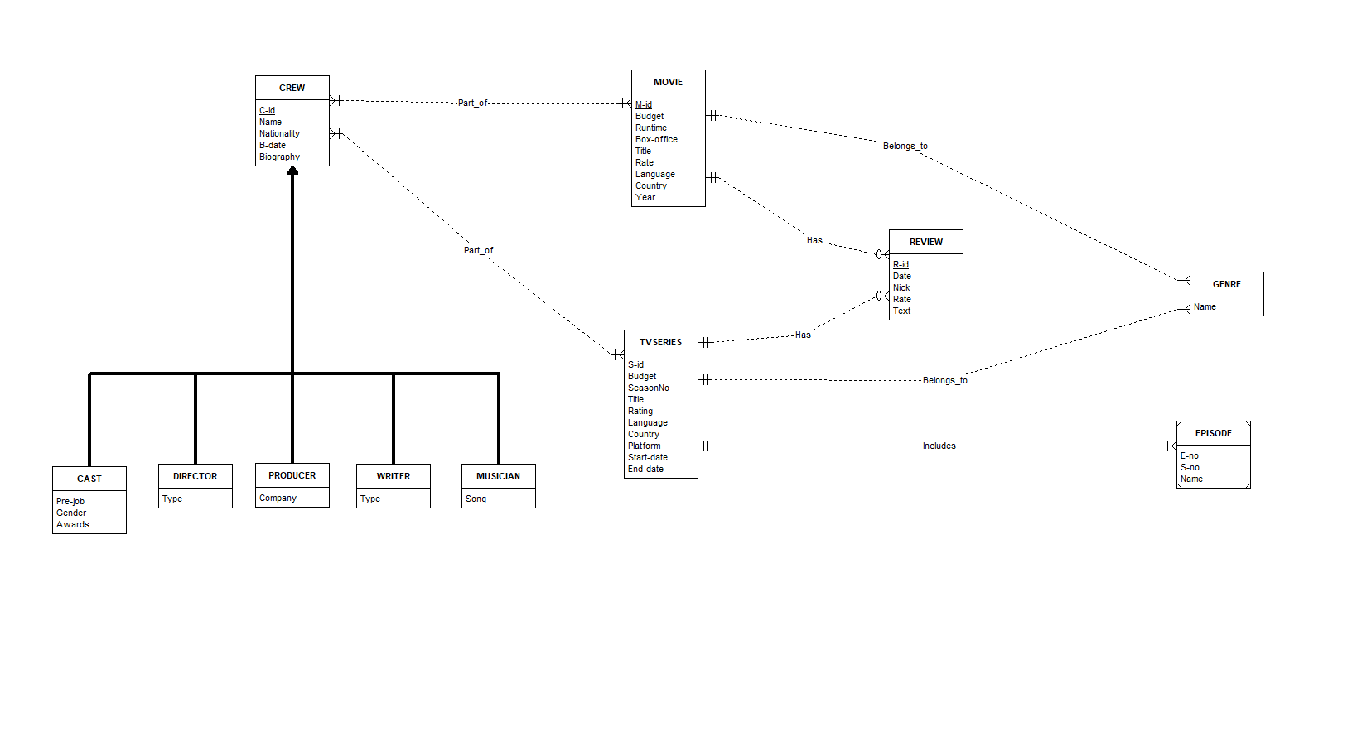
Figure 1: ER Diagram (ERD Assistant)

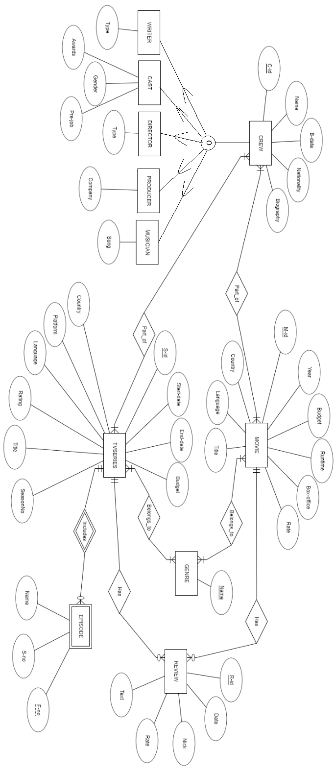
Figure 2: ER Diagram (ERDPlus.com)
III.II.I ER DIAGRAM MAPPING
Step 1
Movie (m-id, budget, runtime, box-office, title, rate, language, country, year)
TVseries (s-id, budget, seasonNo, rating, title, rate, language, country, platform, start-date, end-date)
Genre (name)
Review (r-id, date, nick, rate, text)
Crew (c-id, name, nationality, b-date, biography)

Step 2
Movie (m-id, budget, runtime, box-office, title, rate, language, country, year)
TVseries (s-id, budget, seasonNo, rating, title, rate, language, country, platform, start-date, end-date)
Genre (name)
Review (r-id, date, nick, rate, text)
Crew (c-id, name, nationality, b-date, biography)
Episode (e-no, s-no, name, sid) (sid FK refers to TVseries)

Step 3
Movie (m-id, budget, runtime, box-office, title, rate, language, country, year)
TVseries (s-id, budget, seasonNo, rating, title, rate, language, country, platform, start-date, end-date)
Genre (name)
Review (r-id, date, nick, rate, text)
Crew (c-id, name, nationality, b-date, biography)
Episode (e-no, s-no, name, sid) (sid FK refers to TVseries)
Part_of (cid, mid) (cid FK refers to Crew) (mid FK refers to Movie)
Part_of (cid, sid) (cid FK refers to Crew) (sid FK refers to TVseries)
Has (mid, rid) (mid FK refers to Movie) (rid FK refers to Review)
Has (sid, rid) (sid FK refers to TVseries) (rid FK refers to Review)
Belongs_to (mid, gid) (mid FK refers to Movie) (gid FK refers to Genre)
Belongs_to (sid, gid) (sid FK refers to TVseries) (gid FK refers to Genre)

Step 4
Movie (m-id, budget, runtime, box-office, title, rate, language, country, year)
TVseries (s-id, budget, seasonNo, rating, title, rating, language, country, platform, start-date, end-date)
Genre (name)
Review (r-id, date, nick, rate, text)
Crew (c-id, name, nationality, b-date, biography)
Episode (e-no, s-no, name, sid) (sid FK refers to TVseries)
Part_of (cid, mid) (cid FK refers to Crew) (mid FK refers to Movie)
Part_of (cid, sid) (cid FK refers to Crew) (sid FK refers to TVseries)
Has (mid, rid) (mid FK refers to Movie) (rid FK refers to Review)
Has (sid, rid) (sid FK refers to TVseries) (rid FK refers to Review)
Belongs_to (mid, gid) (mid FK refers to Movie) (gid FK refers to Genre)
Belongs_to (sid, gid) (sid FK refers to TVseries) (gid FK refers to Genre)
Writer (cid, type) (cid FK refers to crew)
Cast (cid, pre-job, gender, awards) (cid FK refers to crew)
Director (cid, type) (cid FK refers to crew)
Producer (cid, company) (cid FK refers to crew)
Musician (cid, song) (cid FK refers to crew)

III.II.II Normalization
All entities are in BCNF. There is no redundancy in the tables. All entities except “Crew” have different primary keys, so none of the attributes depend on each other.
Table | FDs
Movie | M-ID → budget, runtime, box-office, title, rate, language, country, year
TVseries | S-ID → budget, seasonNo, rating, title, rate, language, country, platform, start-date, end-date
Genre | NAME
Review | R-ID → date, nick, rate, text
Crew | C-ID → name, nationality, b-date, biography
Episode | E-NO → s-no, name, sid
Writer | C-ID → type
Cast | C-ID → pre-job, gender, awards
Director | C-ID → type
Producer | C-ID → company
Musician | C-ID → song

Table 1: Normalization of Database

III.II.III CREATE TABLES
Movie: REGULAR ENTITY
M-id: [PK] ATTRIBUTE Type: INTEGER
Budget: ATTRIBUTE Type: INTEGER
Runtime: ATTRIBUTE Type: DECIMAL
Box-office: ATTRIBUTE Type: FLOAT
Title: ATTRIBUTE Type: VARCHAR Length=50
Rate: ATTRIBUTE Type: DECIMAL
Language: ATTRIBUTE Type: VARCHAR Length=50
Country: ATTRIBUTE Type: VARCHAR Length=50
Year: ATTRIBUTE Type: INTEGER

TVseries: REGULAR ENTITY
S-id: [PK] ATTRIBUTE Type: INTEGER
Budget: ATTRIBUTE Type: INTEGER
Season_no: ATTRIBUTE Type: INTEGER
Title: ATTRIBUTE Type: VARCHAR Length=50
Rating: ATTRIBUTE Type: DECIMAL
Language: ATTRIBUTE Type: VARCHAR Length=50
Country: ATTRIBUTE Type: VARCHAR Length=50
Platform: ATTRIBUTE Type: VARCHAR Length=50
Start-date: ATTRIBUTE Type: DATE
End-date: ATTRIBUTE Type: DATE

Genre: REGULAR ENTITY
Name: [PK] ATTRIBUTE Type: VARCHAR Length=50

Review: REGULAR ENTITY
R-id: [PK] ATTRIBUTE Type: INTEGER
Date: ATTRIBUTE Type: DATE
Nick: ATTRIBUTE Type: VARCHAR Length=50
Rate: ATTRIBUTE Type: DECIMAL
Text: ATTRIBUTE Type: VARCHAR Length=250

Crew: REGULAR ENTITY
C-id: [PK] ATTRIBUTE Type: INTEGER
Name: ATTRIBUTE Type: VARCHAR Length=50
Nationality: ATTRIBUTE Type: VARCHAR Length=50
B-date: ATTRIBUTE Type: DATE
Biography: ATTRIBUTE Type: VARCHAR Length=250

Episode: WEAK ENTITY
E-no: [PK] ATTRIBUTE Type: INTEGER
S-no: ATTRIBUTE Type: INTEGER
Name: ATTRIBUTE Type: VARCHAR Length=50

Writer: REGULAR ENTITY
C-id: [PK] ATTRIBUTE Type: INTEGER
Type: ATTRIBUTE Type: VARCHAR Length=50

Cast: REGULAR ENTITY
C-id: [PK] ATTRIBUTE Type: INTEGER
Pre-job: ATTRIBUTE Type: VARCHAR Length=50
Gender: ATTRIBUTE Type: VARCHAR Length=10
Awards: ATTRIBUTE Type: VARCHAR Length=50

Director: REGULAR ENTITY
C-id: [PK] ATTRIBUTE Type: INTEGER
Type: ATTRIBUTE Type: VARCHAR Length=50

Producer: REGULAR ENTITY
C-id: [PK] ATTRIBUTE Type: INTEGER
Company: ATTRIBUTE Type: VARCHAR Length=50

Musician: REGULAR ENTITY
C-id: [PK] ATTRIBUTE Type: INTEGER
Song: ATTRIBUTE Type: VARCHAR Length=50

III.II.IV Relationships
Part_of: REGULAR RELATIONSHIP Movie MANY MANDATORY to Crew MANY MANDATORY
Part_of: REGULAR RELATIONSHIP TVseries MANY MANDATORY to Crew MANY MANDATORY
Has: REGULAR RELATIONSHIP Movie ONE MANDATORY to Review MANY OPTIONAL
Has: REGULAR RELATIONSHIP TVseries ONE MANDATORY to Review MANY OPTIONAL
Belongs_to: REGULAR RELATIONSHIP Movie ONE MANDATORY to Genre MANY MANDATORY
Belongs_to: REGULAR RELATIONSHIP TVseries ONE MANDATORY to Genre MANY MANDATORY
Includes: IDENTIFYING RELATIONSHIP TVseries ONE MANDATORY to Episode MANY MANDATORY

IV. SYSTEM IMPLEMENTATION
Using the program is so simple. User can search an actor/actress, movie, TV series they want to know about. Users also can search through genres and episode names. Users can see other reviews by entering the movie’s/TV series’ name. They can add reviews and ratings for a movie/TV series they choose. They must enter a nickname first.
Users can directly look at movies, TV series, crews and genres in the database by using the buttons with the names on them respectively.
Users can not add new movies/TV series and their information to the database. It could be only done by the moderators at the company.

“CREATE” CODE
CREATE TABLE MOVIE
(
M_ID INT NOT NULL,
Budget INT,
Runtime DECIMAL(4,2) NOT NULL,
Box_office INT,
Title VARCHAR(50) NOT NULL,
Rate DECIMAL(4,2),
Lang VARCHAR(50) NOT NULL,
Country VARCHAR(50) NOT NULL,
Year_ INT,
PRIMARY KEY (M_ID)
);

CREATE TABLE TVSERIES
(
S_ID INT NOT NULL,
Budget INT,
Season_no INT,
Title VARCHAR(50) NOT NULL,
Rating DECIMAL(4,2),
Lang VARCHAR(50) NOT NULL,
Country VARCHAR(50) NOT NULL,
Platform VARCHAR(50),
Start_date DATE NOT NULL,
End_date DATE,
PRIMARY KEY (S_ID));
CREATE TABLE GENRE
(NAME VARCHAR(50) NOT NULL,
PRIMARY KEY (NAME)
);

CREATE TABLE REVIEW
(
R_ID INT NOT NULL,
Date_ DATE NOT NULL,
Nick VARCHAR(50) NOT NULL,
Rate DECIMAL(4,2) NOT NULL,
Text_ VARCHAR(250) NOT NULL,
PRIMARY KEY (R_ID)
);

CREATE TABLE CREW
(
C_ID INT NOT NULL,
Name VARCHAR(50) NOT NULL,
Nationality VARCHAR(50) NOT NULL,
B_date DATE NOT NULL,
Biography VARCHAR(250),
PRIMARY KEY (C_ID)
);
CREATE TABLE EPISODE_INCLUDES
(
S_ID INT NOT NULL,
E_NO INT NOT NULL,
S_no INT NOT NULL,
Name VARCHAR(50),
PRIMARY KEY (S_ID,E_NO),
FOREIGN KEY (S_ID) REFERENCES TVSERIES ON DELETE CASCADE);
CREATE TABLE WRITER
(C_ID INT NOT NULL,
FOREIGN KEY (C_ID) REFERENCES CREW(C_ID),
Type_ VARCHAR(50) NOT NULL,
PRIMARY KEY (C_ID,Type_)
);
CREATE TABLE CAST_
(
C_ID INT NOT NULL,
FOREIGN KEY (C_ID) REFERENCES CREW(C_ID),
Pre_job VARCHAR(50),
Gender VARCHAR(10) NOT NULL,
Awards VARCHAR(50),
PRIMARY KEY (C_ID,Gender)
);
CREATE TABLE DIRECTOR
(
C_ID INT NOT NULL,
FOREIGN KEY (C_ID) REFERENCES CREW(C_ID),
Type_ VARCHAR(50) NOT NULL,
PRIMARY KEY (C_ID,Type_)
);
CREATE TABLE PRODUCER
(
C_ID INT NOT NULL,
FOREIGN KEY (C_ID) REFERENCES CREW(C_ID),
Company VARCHAR(50) NOT NULL,
PRIMARY KEY (C_ID,Company)
);
CREATE TABLE MUSICIAN
(
C_ID INT NOT NULL,
FOREIGN KEY (C_ID) REFERENCES CREW(C_ID),
Song VARCHAR(50) NOT NULL,
PRIMARY KEY (C_ID,Song)
);

CREATE TABLE PART_OF_M
(
M_ID INT NOT NULL,
FOREIGN KEY (M_ID) REFERENCES MOVIE(M_ID),
C_ID INT NOT NULL,
FOREIGN KEY (C_ID) REFERENCES CREW(C_ID),
PRIMARY KEY (M_ID,C_ID)
);
CREATE TABLE PART_OF_S
(
S_ID INT NOT NULL,
FOREIGN KEY (S_ID) REFERENCES TVSERIES(S_ID),
C_ID INT NOT NULL,
FOREIGN KEY (C_ID) REFERENCES CREW(C_ID),
PRIMARY KEY (S_ID,C_ID)
);
CREATE TABLE HAS_M
(
M_ID INT NOT NULL,
FOREIGN KEY (M_ID) REFERENCES MOVIE(M_ID),
R_ID INT NOT NULL,
FOREIGN KEY (R_ID) REFERENCES REVIEW(R_ID),
PRIMARY KEY (M_ID,R_ID)
);

CREATE TABLE HAS_S
(
S_ID INT NOT NULL,
FOREIGN KEY (S_ID) REFERENCES TVSERIES(S_ID),
R_ID INT NOT NULL,
FOREIGN KEY (R_ID) REFERENCES REVIEW(R_ID),
PRIMARY KEY (S_ID,R_ID)
);
CREATE TABLE BELONGS_TO_M
(
M_ID INT NOT NULL,
FOREIGN KEY (M_ID) REFERENCES MOVIE(M_ID),
NAME VARCHAR(50) NOT NULL,
FOREIGN KEY (NAME) REFERENCES GENRE(NAME),
PRIMARY KEY (M_ID,NAME)
);
CREATE TABLE BELONGS_TO_S
(
S_ID INT NOT NULL,
FOREIGN KEY (S_ID) REFERENCES TVSERIES(S_ID),
NAME VARCHAR(50) NOT NULL,
FOREIGN KEY (NAME) REFERENCES GENRE(NAME),
PRIMARY KEY (S_ID,NAME)
);

DATA LOADING

INSERT INTO MOVIE (M_ID,Budget,Runtime,Box_office,Title,Rate,Lang,Country,Year_) VALUES ('1','165000000','2,49','696300000','Interstellar','8,6','English','USA','2014');
INSERT INTO MOVIE (M_ID,Budget,Runtime,Box_office,Title,Rate,Lang,Country,Year_) VALUES ('2','4500000','1,42','7400000','Requiem for a Dream','8,3','English','USA','2000');
INSERT INTO MOVIE (M_ID,Budget,Runtime,Box_office,Title,Rate,Lang,Country,Year_) VALUES ('3','5000000','1,57','55700000','Dallas Buyers Club','8,0','English','USA','2013');
INSERT INTO MOVIE (M_ID,Budget,Runtime,Box_office,Title,Rate,Lang,Country,Year_) VALUES ('4',NULL,'2,33',NULL,'PK','8,1','Indian','India','2014');
INSERT INTO MOVIE (M_ID,Budget,Runtime,Box_office,Title,Rate,Lang,Country,Year_) VALUES ('5',NULL,'2,16',NULL,'The Matrix','8,7','English','USA','1999');
INSERT INTO MOVIE (M_ID,Budget,Runtime,Box_office,Title,Rate,Lang,Country,Year_) VALUES ('6',NULL,'2,06',NULL,'Iron Man','7,9','English','USA','2008');
INSERT INTO MOVIE (M_ID,Budget,Runtime,Box_office,Title,Rate,Lang,Country,Year_) VALUES ('7',NULL,'2,28',NULL,'Inception','8,8','English','USA','2010');
INSERT INTO MOVIE (M_ID,Budget,Runtime,Box_office,Title,Rate,Lang,Country,Year_) VALUES ('8',NULL,'1,47',NULL,'Olumlu Dunya','7,7','Turkish','Turkey','2018');
INSERT INTO MOVIE (M_ID,Budget,Runtime,Box_office,Title,Rate,Lang,Country,Year_) VALUES ('9',NULL,'2,02',NULL,'Joker','8,5','English','USA','2019');
INSERT INTO MOVIE (M_ID,Budget,Runtime,Box_office,Title,Rate,Lang,Country,Year_) VALUES ('10',NULL,'2,28',NULL,'Into the Wild','8,1','English','USA','2007');
-------------------------------------------------------------------------------------------------
INSERT INTO TVSERIES (S_ID,Budget,Season_no,Title,Rating,Lang,Country,Platform,Start_date,End_date) VALUES ('1',NULL,'1','Dracula','6,8','English','UK','Netflix',to_date('01/01/2020','DD/MM/RRRR'),to_date('01/01/2020','DD/MM/RRRR'));
INSERT INTO TVSERIES (S_ID,Budget,Season_no,Title,Rating,Lang,Country,Platform,Start_date,End_date) VALUES ('2',NULL,'1','Chernobyl','9,4','Russian','Russia','HBO',to_date('06/05/2019','DD/MM/RRRR'),to_date('03/06/2019','DD/MM/RRRR'));
INSERT INTO TVSERIES (S_ID,Budget,Season_no,Title,Rating,Lang,Country,Platform,Start_date,End_date) VALUES ('3',NULL,'5','Fringe','8,4','English','USA','Fox',to_date('09/09/2008','DD/MM/RRRR'),to_date('18/01/2013','DD/MM/RRRR'));
INSERT INTO TVSERIES (S_ID,Budget,Season_no,Title,Rating,Lang,Country,Platform,Start_date,End_date) VALUES ('4',NULL,'4','Sherlock','9,1','English','UK','BBS',to_date('05/06/2011','DD/MM/RRRR'),to_date('15/01/2017','DD/MM/RRRR'));
INSERT INTO TVSERIES (S_ID,Budget,Season_no,Title,Rating,Lang,Country,Platform,Start_date,End_date) VALUES ('5',NULL,'1','The Queens Gambit','8,6','English','USA','Netflix',to_date('23/10/2020','DD/MM/RRRR'),to_date('23/10/2020','DD/MM/RRRR'));
INSERT INTO TVSERIES (S_ID,Budget,Season_no,Title,Rating,Lang,Country,Platform,Start_date,End_date) VALUES ('6',NULL,'1','WandaVision','7,7','English','USA','Disney+',to_date('15/01/2021','DD/MM/RRRR'),NULL);
INSERT INTO TVSERIES (S_ID,Budget,Season_no,Title,Rating,Lang,Country,Platform,Start_date,End_date) VALUES ('7',NULL,'1','Messiah','7,6','English','USA','Netflix',to_date('01/01/2020','DD/MM/RRRR'),to_date('01/01/2020','DD/MM/RRRR'));
INSERT INTO TVSERIES (S_ID,Budget,Season_no,Title,Rating,Lang,Country,Platform,Start_date,End_date) VALUES ('8',NULL,'4','La Casa de Papel','8,3','Spanish','Spain','Antena 3/Netflix',to_date('02/05/2017','DD/MM/RRRR'),NULL);
INSERT INTO TVSERIES (S_ID,Budget,Season_no,Title,Rating,Lang,Country,Platform,Start_date,End_date) VALUES ('9',NULL,'1','Rise of Empires: Ottoman','8,0','English','Turkey','Netflix',to_date('24/01/2020','DD/MM/RRRR'),to_date('24/01/2020','DD/MM/RRRR'));
INSERT INTO TVSERIES (S_ID,Budget,Season_no,Title,Rating,Lang,Country,Platform,Start_date,End_date) VALUES ('10',NULL,'1','11.22.63','8,2','English','USA','HULU',to_date('15/02/2016','DD/MM/RRRR'),to_date('04/04/2016','DD/MM/RRRR'));
-------------------------------------------------------------------------------------------------
INSERT INTO GENRE (NAME) VALUES ('Horror');
INSERT INTO GENRE (NAME) VALUES ('Drama');
INSERT INTO GENRE (NAME) VALUES ('Sci-fi');
INSERT INTO GENRE (NAME) VALUES ('Thriller');
INSERT INTO GENRE (NAME) VALUES ('Comedy');
INSERT INTO GENRE (NAME) VALUES ('Musical');
INSERT INTO GENRE (NAME) VALUES ('Mystery');
INSERT INTO GENRE (NAME) VALUES ('Action');
INSERT INTO GENRE (NAME) VALUES ('Adventure');
INSERT INTO GENRE (NAME) VALUES ('Crime');
-------------------------------------------------------------------------------------------------
INSERT INTO REVIEW (R_ID,Date_,Nick,Rate,Text_) VALUES ('1',to_date('01/10/2019','DD/MM/RRRR'),'AhmadNeda','10','THIS IS A MANKIND ACHIEVEMENT. THE BEST MOVIE EVER MADE. IS ANYONE HAS DOUBT?');
INSERT INTO REVIEW (R_ID,Date_,Nick,Rate,Text_) VALUES ('2',to_date('03/01/2020','DD/MM/RRRR'),'svader','4','First two episodes were brilliant. Hour into the third and it is a mess. Another BBC drama let down by the final episode...');
INSERT INTO REVIEW (R_ID,Date_,Nick,Rate,Text_) VALUES ('3',to_date('27/08/2001','DD/MM/RRRR'),'j_mrf','10','Killer Performances by Ellen Burstyn... Darren Aronofsky: Stanley Kubrik has called for you to pull up a chair!');
INSERT INTO REVIEW (R_ID,Date_,Nick,Rate,Text_) VALUES ('4',to_date('20/11/2013','DD/MM/RRRR'),'Rebel_With_A_Cause_94','9','A Facisnating True Story with Gritty Realism and Excellent Performances');
INSERT INTO REVIEW (R_ID,Date_,Nick,Rate,Text_) VALUES ('5',to_date('30/10/2019','DD/MM/RRRR'),'MihaVrhunc','10','Outstanding movie with a haunting performance and best character development ever seen');
INSERT INTO REVIEW (R_ID,Date_,Nick,Rate,Text_) VALUES ('6',to_date('29/04/2008','DD/MM/RRRR'),'jaredmobarak','8','Dont waste it');
INSERT INTO REVIEW (R_ID,Date_,Nick,Rate,Text_) VALUES ('7',to_date('27/04/2000','DD/MM/RRRR'),'MercurioKnight','9','A great epic that sets the stage for the next level in sci-fi');
INSERT INTO REVIEW (R_ID,Date_,Nick,Rate,Text_) VALUES ('8',to_date('21/07/2009','DD/MM/RRRR'),'ccthemovieman-1','10','Beautiful Film, Even Better Than The Book');
INSERT INTO REVIEW (R_ID,Date_,Nick,Rate,Text_) VALUES ('9',to_date('11/04/2020','DD/MM/RRRR'),'arjunrajkss','6','Could have stopped in season 2');
INSERT INTO REVIEW (R_ID,Date_,Nick,Rate,Text_) VALUES ('10',to_date('01/03/2016','DD/MM/RRRR'),'redwingsm','10','All I can say is WOW.');
INSERT INTO REVIEW (R_ID,Date_,Nick,Rate,Text_) VALUES ('11',to_date('27/06/2017','DD/MM/RRRR'),'hudson-11704','9','Dont waste your life, Stark');
INSERT INTO REVIEW (R_ID,Date_,Nick,Rate,Text_) VALUES ('12',to_date('13/03/2010','DD/MM/RRRR'),'marcusdean118','10','Nolan at his most intelligent best..');
INSERT INTO REVIEW (R_ID,Date_,Nick,Rate,Text_) VALUES ('13',to_date('01/09/2019','DD/MM/RRRR'),'johnnash-18420','10','Joaquin "OSCAR", Joker = best Dark suspense thriller ... Darker than dark Knight.');
INSERT INTO REVIEW (R_ID,Date_,Nick,Rate,Text_) VALUES ('14',to_date('30/08/2013','DD/MM/RRRR'),'flashcortex','10','A perfect concoction of intelligence and feelings');
INSERT INTO REVIEW (R_ID,Date_,Nick,Rate,Text_) VALUES ('15',to_date('25/10/2020','DD/MM/RRRR'),'bilgedeger','10','Best Netflix Original of 2020');
INSERT INTO REVIEW (R_ID,Date_,Nick,Rate,Text_) VALUES ('16',to_date('01/01/2018','DD/MM/RRRR'),'amytgr-1','10','One of the best Ive seen!');
INSERT INTO REVIEW (R_ID,Date_,Nick,Rate,Text_) VALUES ('17',to_date('05/04/2016','DD/MM/RRRR'),'jesperjensen-11365','10','It really made me think, what if........');
INSERT INTO REVIEW (R_ID,Date_,Nick,Rate,Text_) VALUES ('18',to_date('25/01/2020','DD/MM/RRRR'),'Amazing-Stories','8','Powerful and bingeworthy');
INSERT INTO REVIEW (R_ID,Date_,Nick,Rate,Text_) VALUES ('19',to_date('15/01/2021','DD/MM/RRRR'),'georgefligos','8','This one probably should have been releashed as a season.');
INSERT INTO REVIEW (R_ID,Date_,Nick,Rate,Text_) VALUES ('20',to_date('11/05/2019','DD/MM/RRRR'),'stelmakh','10','Goosebumps and tears');
-------------------------------------------------------------------------------------------------
INSERT INTO CREW (C_ID,Name,Nationality,B_date,Biography) VALUES ('1','Claes Bang','Denmark',to_date('28/04/1967','DD/MM/RRRR'),'Claes Kasper Bang is a Danish actor and musician. He is best known for playing the leading role of Christian in Ruben Ostlunds 2017 film The Square.');
INSERT INTO CREW (C_ID,Name,Nationality,B_date,Biography) VALUES ('2','Christopher Nolan','UK',to_date('30/07/1970','DD/MM/RRRR'),'Best known for his cerebral, often nonlinear, storytelling, acclaimed writer-director Christopher Nolan was born on July 30, 1970, in London, England.');
INSERT INTO CREW (C_ID,Name,Nationality,B_date,Biography) VALUES ('3','Matthew McConaughey','USA',to_date('04/11/1969','DD/MM/RRRR'),'American actor and producer Matthew David McConaughey was born in Uvalde, Texas. His mother, Mary Kathleen (McCabe), is a substitute school teacher originally from New Jersey.');
INSERT INTO CREW (C_ID,Name,Nationality,B_date,Biography) VALUES ('4','Steven Moffat','UK',to_date('18/11/1961','DD/MM/RRRR'),'Steven Moffat was born on November 18, 1961 in Paisley, Scotland as Steven William Moffat. He is a writer and producer, known for Sherlock (2010)');
INSERT INTO CREW (C_ID,Name,Nationality,B_date,Biography) VALUES ('5','Hans Zimmer','Germany',to_date('12/09/1957','DD/MM/RRRR'),'German-born composer Hans Zimmer is recognized as one of Hollywoods most innovative musical talents.');
INSERT INTO CREW (C_ID,Name,Nationality,B_date,Biography) VALUES ('6','Ellen Burstyn','USA',to_date('07/12/1932','DD/MM/RRRR'),'Ellen Burstyn was born in Detroit, Michigan, to Correine Marie (Hamel) and John Austin Gillooly.');
INSERT INTO CREW (C_ID,Name,Nationality,B_date,Biography) VALUES ('7','Anne Hathaway','USA',to_date('12/11/1982','DD/MM/RRRR'),'Anne Jacqueline Hathaway was born in Brooklyn, New York, to Kate McCauley Hathaway, an actress, and Gerald T. Hathaway, a lawyer, both originally from Philadelphia.');
INSERT INTO CREW (C_ID,Name,Nationality,B_date,Biography) VALUES ('8','Dolly Wells','UK',to_date('05/12/1971','DD/MM/RRRR'),'Dolly Wells was born on December 5, 1971 in Merton, London, England as Dorothy Perpetua Gatacre.');
INSERT INTO CREW (C_ID,Name,Nationality,B_date,Biography) VALUES ('9','Jared Leto','USA',to_date('26/12/1971','DD/MM/RRRR'),'Jared Leto is a very familiar face in recent film history. Although he has always been the lead vocals, rhythm guitar, and songwriter for American band Thirty Seconds to Mars.');
INSERT INTO CREW (C_ID,Name,Nationality,B_date,Biography) VALUES ('10','Darren Aronofsky','USA',to_date('12/02/1969','DD/MM/RRRR'),'Darren Aronofsky was born February 12, 1969, in Brooklyn, New York. Growing up, Darren was always artistic: he loved classic movies and, as a teenager, he even spent time doing graffiti art.');
INSERT INTO CREW (C_ID,Name,Nationality,B_date,Biography) VALUES ('11','Melisa Wallack','USA',to_date('01/04/1968','DD/MM/RRRR'),NULL);
INSERT INTO CREW (C_ID,Name,Nationality,B_date,Biography) VALUES ('12','Jessie Buckley','Ireland',to_date('28/12/1989','DD/MM/RRRR'),NULL);
INSERT INTO CREW (C_ID,Name,Nationality,B_date,Biography) VALUES ('13','Aamir Khan','India',to_date('14/03/1965','DD/MM/RRRR'),'Aamir is doubtless one of the most dedicated actors in this world. With his recent successes in both the Indian and Chinese markets he has shouldered his way into becoming one of the worlds biggest superstars.');
INSERT INTO CREW (C_ID,Name,Nationality,B_date,Biography) VALUES ('14','Anushka Sharma','India',to_date('01/05/1988','DD/MM/RRRR'),NULL);
INSERT INTO CREW (C_ID,Name,Nationality,B_date,Biography) VALUES ('15','Spephen King','USA',to_date('21/09/1947','DD/MM/RRRR'),NULL);
INSERT INTO CREW (C_ID,Name,Nationality,B_date,Biography) VALUES ('16','Kevin Feige','USA',to_date('02/06/1973','DD/MM/RRRR'),NULL);
INSERT INTO CREW (C_ID,Name,Nationality,B_date,Biography) VALUES ('17','Ramin Djawadi','Germany',to_date('19/07/1974','DD/MM/RRRR'),NULL);
INSERT INTO CREW (C_ID,Name,Nationality,B_date,Biography) VALUES ('18','Bridget Carpenter','USA',to_date('01/01/1975','DD/MM/RRRR'),NULL);
INSERT INTO CREW (C_ID,Name,Nationality,B_date,Biography) VALUES ('19','Sean Penn','USA',to_date('17/08/1960','DD/MM/RRRR'),NULL);
INSERT INTO CREW (C_ID,Name,Nationality,B_date,Biography) VALUES ('20','Jon Krakauer','USA',to_date('12/04/1954','DD/MM/RRRR'),NULL);
INSERT INTO CREW (C_ID,Name,Nationality,B_date,Biography) VALUES ('21','Mark Gatiss','USA',to_date('17/10/1966','DD/MM/RRRR'),NULL);
INSERT INTO CREW (C_ID,Name,Nationality,B_date,Biography) VALUES ('22','Stan Lee','USA',to_date('28/12/1922','DD/MM/RRRR'),NULL);
INSERT INTO CREW (C_ID,Name,Nationality,B_date,Biography) VALUES ('23','Christophe Beck','Canada',to_date('28/12/1922','DD/MM/RRRR'),NULL);
INSERT INTO CREW (C_ID,Name,Nationality,B_date,Biography) VALUES ('24','Katherine Keizer','USA',to_date('01/01/1970','DD/MM/RRRR'),NULL);
INSERT INTO CREW (C_ID,Name,Nationality,B_date,Biography) VALUES ('25','Rajkumar Hirani','India',to_date('20/11/1962','DD/MM/RRRR'),NULL);
INSERT INTO CREW (C_ID,Name,Nationality,B_date,Biography) VALUES ('26','Lilly Wachowski','USA',to_date('29/12/1967','DD/MM/RRRR'),NULL);
INSERT INTO CREW (C_ID,Name,Nationality,B_date,Biography) VALUES ('27','Lana Wachowski','USA',to_date('21/06/1965','DD/MM/RRRR'),NULL);
INSERT INTO CREW (C_ID,Name,Nationality,B_date,Biography) VALUES ('28','Don Davis','USA',to_date('04/02/1957','DD/MM/RRRR'),NULL);
INSERT INTO CREW (C_ID,Name,Nationality,B_date,Biography) VALUES ('29','Alex Heffes','USA',to_date('02/09/1971','DD/MM/RRRR'),NULL);
INSERT INTO CREW (C_ID,Name,Nationality,B_date,Biography) VALUES ('30','Johnny Klimek','USA',to_date('01/01/1970','DD/MM/RRRR'),NULL);
INSERT INTO CREW (C_ID,Name,Nationality,B_date,Biography) VALUES ('31','Gabriel Isaac Mounsey','USA',to_date('01/01/1970','DD/MM/RRRR'),NULL);
INSERT INTO CREW (C_ID,Name,Nationality,B_date,Biography) VALUES ('32','Ivan Martinez Lacamara','Spain',to_date('01/01/1970','DD/MM/RRRR'),NULL);
INSERT INTO CREW (C_ID,Name,Nationality,B_date,Biography) VALUES ('33','Manel Santisteban','Spain',to_date('01/01/1970','DD/MM/RRRR'),NULL);
INSERT INTO CREW (C_ID,Name,Nationality,B_date,Biography) VALUES ('34','Carlos Rafael Rivera','USA',to_date('18/08/1970','DD/MM/RRRR'),NULL);
INSERT INTO CREW (C_ID,Name,Nationality,B_date,Biography) VALUES ('35','Scott Frank','USA',to_date('10/03/1960','DD/MM/RRRR'),NULL);
INSERT INTO CREW (C_ID,Name,Nationality,B_date,Biography) VALUES ('36','Jesus Colmenar','Spain',to_date('01/01/1960','DD/MM/RRRR'),NULL);
INSERT INTO CREW (C_ID,Name,Nationality,B_date,Biography) VALUES ('37','Joe Chappelle','USA',to_date('01/01/1965','DD/MM/RRRR'),NULL);
-------------------------------------------------------------------------------------------------
INSERT INTO EPISODE_INCLUDES (S_ID,E_NO,S_no,Name) VALUES ('1','1','1','The Rules of the Beast');
INSERT INTO EPISODE_INCLUDES (S_ID,E_NO,S_no,Name) VALUES ('1','2','1','Blood Vessel');
INSERT INTO EPISODE_INCLUDES (S_ID,E_NO,S_no,Name) VALUES ('1','3','1','The Dark Compass');
INSERT INTO EPISODE_INCLUDES (S_ID,E_NO,S_no,Name) VALUES ('2','1','1','1:23:45');
INSERT INTO EPISODE_INCLUDES (S_ID,E_NO,S_no,Name) VALUES ('2','2','1','Please Remain Calm');
INSERT INTO EPISODE_INCLUDES (S_ID,E_NO,S_no,Name) VALUES ('2','3','1','Open Wide, O Earth');
INSERT INTO EPISODE_INCLUDES (S_ID,E_NO,S_no,Name) VALUES ('2','4','1','The Happiness of All Mankind');
INSERT INTO EPISODE_INCLUDES (S_ID,E_NO,S_no,Name) VALUES ('2','5','1','Vichnaya Pamyat');
INSERT INTO EPISODE_INCLUDES (S_ID,E_NO,S_no,Name) VALUES ('10','1','1','The Rabbit Hole');
INSERT INTO EPISODE_INCLUDES (S_ID,E_NO,S_no,Name) VALUES ('10','2','1','The Kill Floor');
INSERT INTO EPISODE_INCLUDES (S_ID,E_NO,S_no,Name) VALUES ('10','3','1','Other Voice, Other Rooms');
INSERT INTO EPISODE_INCLUDES (S_ID,E_NO,S_no,Name) VALUES ('10','4','1','The Eyes of Texas');
INSERT INTO EPISODE_INCLUDES (S_ID,E_NO,S_no,Name) VALUES ('10','5','1','The Truth');
INSERT INTO EPISODE_INCLUDES (S_ID,E_NO,S_no,Name) VALUES ('10','6','1','Happy Birthday, Lee Harvey Oswald');
INSERT INTO EPISODE_INCLUDES (S_ID,E_NO,S_no,Name) VALUES ('10','7','1','Soldier Boy');
INSERT INTO EPISODE_INCLUDES (S_ID,E_NO,S_no,Name) VALUES ('10','8','1','The Day in Question');
-------------------------------------------------------------------------------------------------
INSERT INTO WRITER (C_ID,TYPE_) VALUES ('4','Screen Writer');
INSERT INTO WRITER (C_ID,TYPE_) VALUES ('11','Screen Writer');
INSERT INTO WRITER (C_ID,TYPE_) VALUES ('15','Book Writer');
INSERT INTO WRITER (C_ID,TYPE_) VALUES ('18','Screen Writer');
INSERT INTO WRITER (C_ID,TYPE_) VALUES ('19','Screen Writer');
INSERT INTO WRITER (C_ID,TYPE_) VALUES ('20','Book Writer');
INSERT INTO WRITER (C_ID,TYPE_) VALUES ('21','Screen Writer');
INSERT INTO WRITER (C_ID,TYPE_) VALUES ('22','Characters');
INSERT INTO WRITER (C_ID,TYPE_) VALUES ('25','Screen Writer');
INSERT INTO WRITER (C_ID,TYPE_) VALUES ('26','Screen Writer');
INSERT INTO WRITER (C_ID,TYPE_) VALUES ('27','Screen Writer');
INSERT INTO WRITER (C_ID,TYPE_) VALUES ('35','Screen Writer');
-------------------------------------------------------------------------------------------------
INSERT INTO CAST_ (C_ID,Pre_job,Gender,Awards) VALUES ('1',NULL,'Male',NULL);
INSERT INTO CAST_ (C_ID,Pre_job,Gender,Awards) VALUES ('3','Dallas Buyers Club','Male','Best Actor Oscar');
INSERT INTO CAST_ (C_ID,Pre_job,Gender,Awards) VALUES ('6','Requiem for a Dream','Female',NULL);
INSERT INTO CAST_ (C_ID,Pre_job,Gender,Awards) VALUES ('7','Passengers','Female',NULL);
INSERT INTO CAST_ (C_ID,Pre_job,Gender,Awards) VALUES ('8',NULL,'Female',NULL);
INSERT INTO CAST_ (C_ID,Pre_job,Gender,Awards) VALUES ('9','Dallas Buyers Club','Male','Best Supporting Actor Oscar');
INSERT INTO CAST_ (C_ID,Pre_job,Gender,Awards) VALUES ('12',NULL,'Female',NULL);
INSERT INTO CAST_ (C_ID,Pre_job,Gender,Awards) VALUES ('13',NULL,'Male',NULL);
INSERT INTO CAST_ (C_ID,Pre_job,Gender,Awards) VALUES ('14',NULL,'Female',NULL);
INSERT INTO CAST_ (C_ID,Pre_job,Gender,Awards) VALUES ('21',NULL,'Male',NULL);
-------------------------------------------------------------------------------------------------
INSERT INTO DIRECTOR (C_ID,TYPE_) VALUES ('2','General');
INSERT INTO DIRECTOR (C_ID,TYPE_) VALUES ('10','General');
INSERT INTO DIRECTOR (C_ID,TYPE_) VALUES ('19','General');
INSERT INTO DIRECTOR (C_ID,TYPE_) VALUES ('24','Assistant');
INSERT INTO DIRECTOR (C_ID,TYPE_) VALUES ('25','General');
INSERT INTO DIRECTOR (C_ID,TYPE_) VALUES ('26','General');
INSERT INTO DIRECTOR (C_ID,TYPE_) VALUES ('27','General');
INSERT INTO DIRECTOR (C_ID,TYPE_) VALUES ('35','General');
INSERT INTO DIRECTOR (C_ID,TYPE_) VALUES ('36','Second Unit Director');
INSERT INTO DIRECTOR (C_ID,TYPE_) VALUES ('37','General');
-------------------------------------------------------------------------------------------------
INSERT INTO PRODUCER (C_ID,Company) VALUES ('4','Tiger Aspect Productions');
INSERT INTO PRODUCER (C_ID,Company) VALUES ('16','MARVEL');
INSERT INTO PRODUCER (C_ID,Company) VALUES ('15','King');
INSERT INTO PRODUCER (C_ID,Company) VALUES ('18','Carpenter');
INSERT INTO PRODUCER (C_ID,Company) VALUES ('21','Tiger Aspect Productions');
INSERT INTO PRODUCER (C_ID,Company) VALUES ('22','MARVEL');
INSERT INTO PRODUCER (C_ID,Company) VALUES ('26','The Wachowski Brothers');
INSERT INTO PRODUCER (C_ID,Company) VALUES ('27','The Wachowski Brothers');
INSERT INTO PRODUCER (C_ID,Company) VALUES ('35','Frank');
INSERT INTO PRODUCER (C_ID,Company) VALUES ('36','Colmenar');
-------------------------------------------------------------------------------------------------
INSERT INTO MUSICIAN (C_ID,Song) VALUES ('5','Main Theme');
INSERT INTO MUSICIAN (C_ID,Song) VALUES ('17','Main Theme');
INSERT INTO MUSICIAN (C_ID,Song) VALUES ('23','Main Theme');
INSERT INTO MUSICIAN (C_ID,Song) VALUES ('28','Main Theme');
INSERT INTO MUSICIAN (C_ID,Song) VALUES ('29','Main Theme');
INSERT INTO MUSICIAN (C_ID,Song) VALUES ('30','Main Theme');
INSERT INTO MUSICIAN (C_ID,Song) VALUES ('31','Main Theme');
INSERT INTO MUSICIAN (C_ID,Song) VALUES ('32','Main Theme');
INSERT INTO MUSICIAN (C_ID,Song) VALUES ('33','Main Theme');
INSERT INTO MUSICIAN (C_ID,Song) VALUES ('34','Main Theme');
-------------------------------------------------------------------------------------------------
INSERT INTO PART_OF_M (M_ID,C_ID) VALUES ('1','2');
INSERT INTO PART_OF_M (M_ID,C_ID) VALUES ('1','3');
INSERT INTO PART_OF_M (M_ID,C_ID) VALUES ('1','5');
INSERT INTO PART_OF_M (M_ID,C_ID) VALUES ('1','6');
INSERT INTO PART_OF_M (M_ID,C_ID) VALUES ('1','7');
INSERT INTO PART_OF_M (M_ID,C_ID) VALUES ('2','6');
INSERT INTO PART_OF_M (M_ID,C_ID) VALUES ('2','9');
INSERT INTO PART_OF_M (M_ID,C_ID) VALUES ('2','10');
INSERT INTO PART_OF_M (M_ID,C_ID) VALUES ('3','3');
INSERT INTO PART_OF_M (M_ID,C_ID) VALUES ('3','10');
INSERT INTO PART_OF_M (M_ID,C_ID) VALUES ('3','11');
INSERT INTO PART_OF_M (M_ID,C_ID) VALUES ('4','13');
INSERT INTO PART_OF_M (M_ID,C_ID) VALUES ('4','14');
INSERT INTO PART_OF_M (M_ID,C_ID) VALUES ('10','19');
INSERT INTO PART_OF_M (M_ID,C_ID) VALUES ('4','25');
INSERT INTO PART_OF_M (M_ID,C_ID) VALUES ('5','26');
INSERT INTO PART_OF_M (M_ID,C_ID) VALUES ('5','27');
INSERT INTO PART_OF_M (M_ID,C_ID) VALUES ('5','28');
-------------------------------------------------------------------------------------------------
INSERT INTO PART_OF_S (S_ID,C_ID) VALUES ('1','1');
INSERT INTO PART_OF_S (S_ID,C_ID) VALUES ('1','4');
INSERT INTO PART_OF_S (S_ID,C_ID) VALUES ('1','8');
INSERT INTO PART_OF_S (S_ID,C_ID) VALUES ('2','12');
INSERT INTO PART_OF_S (S_ID,C_ID) VALUES ('4','4');
INSERT INTO PART_OF_S (S_ID,C_ID) VALUES ('10','15');
INSERT INTO PART_OF_S (S_ID,C_ID) VALUES ('10','18');
INSERT INTO PART_OF_S (S_ID,C_ID) VALUES ('6','16');
INSERT INTO PART_OF_S (S_ID,C_ID) VALUES ('4','21');
INSERT INTO PART_OF_S (S_ID,C_ID) VALUES ('6','22');
INSERT INTO PART_OF_S (S_ID,C_ID) VALUES ('7','30');
INSERT INTO PART_OF_S (S_ID,C_ID) VALUES ('7','31');
INSERT INTO PART_OF_S (S_ID,C_ID) VALUES ('8','32');
INSERT INTO PART_OF_S (S_ID,C_ID) VALUES ('8','33');
INSERT INTO PART_OF_S (S_ID,C_ID) VALUES ('5','34');
INSERT INTO PART_OF_S (S_ID,C_ID) VALUES ('5','35');
INSERT INTO PART_OF_S (S_ID,C_ID) VALUES ('3','37');
-------------------------------------------------------------------------------------------------
INSERT INTO HAS_M (M_ID,R_ID) VALUES ('1','1');
INSERT INTO HAS_M (M_ID,R_ID) VALUES ('2','3');
INSERT INTO HAS_M (M_ID,R_ID) VALUES ('3','4');
INSERT INTO HAS_M (M_ID,R_ID) VALUES ('9','5');
INSERT INTO HAS_M (M_ID,R_ID) VALUES ('6','6');
INSERT INTO HAS_M (M_ID,R_ID) VALUES ('5','7');
INSERT INTO HAS_M (M_ID,R_ID) VALUES ('10','8');
INSERT INTO HAS_M (M_ID,R_ID) VALUES ('6','11');
INSERT INTO HAS_M (M_ID,R_ID) VALUES ('7','12');
INSERT INTO HAS_M (M_ID,R_ID) VALUES ('9','13');
-------------------------------------------------------------------------------------------------
INSERT INTO HAS_S (S_ID,R_ID) VALUES ('1','2');
INSERT INTO HAS_S (S_ID,R_ID) VALUES ('8','9');
INSERT INTO HAS_S (S_ID,R_ID) VALUES ('10','10');
INSERT INTO HAS_S (S_ID,R_ID) VALUES ('3','14');
INSERT INTO HAS_S (S_ID,R_ID) VALUES ('5','15');
INSERT INTO HAS_S (S_ID,R_ID) VALUES ('8','16');
INSERT INTO HAS_S (S_ID,R_ID) VALUES ('10','17');
INSERT INTO HAS_S (S_ID,R_ID) VALUES ('9','18');
INSERT INTO HAS_S (S_ID,R_ID) VALUES ('6','19');
INSERT INTO HAS_S (S_ID,R_ID) VALUES ('2','20');
-------------------------------------------------------------------------------------------------
INSERT INTO BELONGS_TO_M (M_ID,NAME) VALUES ('1','Drama');
INSERT INTO BELONGS_TO_M (M_ID,NAME) VALUES ('1','Sci-fi');
INSERT INTO BELONGS_TO_M (M_ID,NAME) VALUES ('2','Drama');
INSERT INTO BELONGS_TO_M (M_ID,NAME) VALUES ('3','Drama');
INSERT INTO BELONGS_TO_M (M_ID,NAME) VALUES ('4','Comedy');
INSERT INTO BELONGS_TO_M (M_ID,NAME) VALUES ('4','Musical');
INSERT INTO BELONGS_TO_M (M_ID,NAME) VALUES ('5','Action');
INSERT INTO BELONGS_TO_M (M_ID,NAME) VALUES ('6','Action');
INSERT INTO BELONGS_TO_M (M_ID,NAME) VALUES ('6','Sci-fi');
INSERT INTO BELONGS_TO_M (M_ID,NAME) VALUES ('6','Adventure');
INSERT INTO BELONGS_TO_M (M_ID,NAME) VALUES ('9','Crime');
INSERT INTO BELONGS_TO_M (M_ID,NAME) VALUES ('9','Drama');
-------------------------------------------------------------------------------------------------
INSERT INTO BELONGS_TO_S (S_ID,NAME) VALUES ('1','Horror');
INSERT INTO BELONGS_TO_S (S_ID,NAME) VALUES ('1','Sci-fi');
INSERT INTO BELONGS_TO_S (S_ID,NAME) VALUES ('2','Drama');
INSERT INTO BELONGS_TO_S (S_ID,NAME) VALUES ('2','Thriller');
INSERT INTO BELONGS_TO_S (S_ID,NAME) VALUES ('4','Mystery');
INSERT INTO BELONGS_TO_S (S_ID,NAME) VALUES ('4','Drama');
INSERT INTO BELONGS_TO_S (S_ID,NAME) VALUES ('4','Crime');
INSERT INTO BELONGS_TO_S (S_ID,NAME) VALUES ('10','Mystery');
INSERT INTO BELONGS_TO_S (S_ID,NAME) VALUES ('10','Drama');
INSERT INTO BELONGS_TO_S (S_ID,NAME) VALUES ('10','Sci-fi');

EXAMPLE QUERIES
- SELECT NAME
FROM CREW
WHERE C_ID IN (SELECT C_ID
FROM PART_OF_M
WHERE M_ID IN (SELECT M_ID
FROM BELONGS_TO_M
WHERE NAME = 'Drama'));
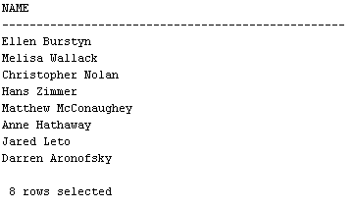

- SELECT TEXT_
FROM REVIEW
WHERE R_ID IN (SELECT R_ID
FROM HAS_M
WHERE M_ID IN (SELECT M_ID
FROM PART_OF_M
WHERE C_ID IN (SELECT C_ID
FROM CREW
WHERE NAME = 'Matthew McConaughey')));
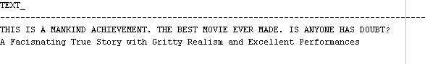
- SELECT NAME
FROM CREW
WHERE C_ID IN (SELECT C_ID
FROM CAST_
WHERE AWARDS != 'NULL');

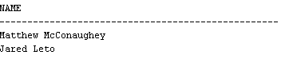

- SELECT CREW.NAME, CAST_.GENDER, CREW.BIOGRAPHY
FROM CAST_
INNER JOIN CREW ON CREW.C_ID = CAST_.C_ID
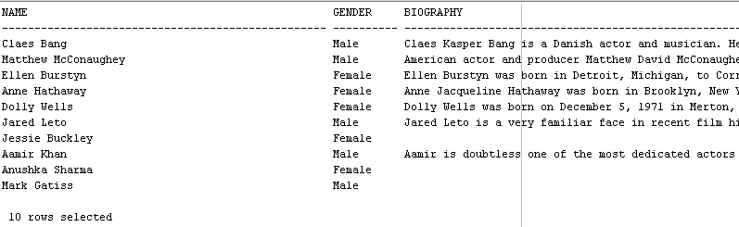
- SELECT CREW.NAME,CAST_.GENDER
FROM CREW
INNER JOIN CAST_ ON CAST_.C_ID = CREW.C_ID
WHERE CREW.C_ID IN (SELECT C_ID
FROM PART_OF_M
WHERE M_ID IN (SELECT M_ID
FROM BELONGS_TO_M
WHERE NAME = 'Drama'));
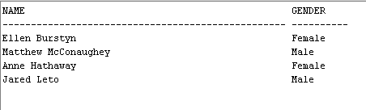

- SELECT CREW.NAME,CAST_.GENDER,CREW.B_DATE,CREW.BIOGRAPHY
FROM CREW
INNER JOIN CAST_ ON CAST_.C_ID = CREW.C_ID
WHERE CREW.C_ID IN (SELECT C_ID
FROM PART_OF_M
WHERE M_ID IN (SELECT M_ID
FROM MOVIE
WHERE TITLE = 'Interstellar'));
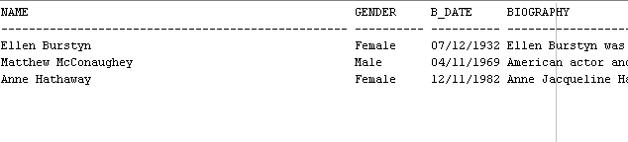
- SELECT NAME FROM GENRE WHERE NAME IN (SELECT NAME
FROM BELONGS_TO_M WHERE M_ID IN (SELECT M_ID
FROM MOVIE WHERE TITLE = 'Interstellar'));
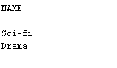
- SELECT NAME FROM EPISODE_INCLUDES WHERE S_ID IN (SELECT S_ID
FROM TVSERIES WHERE TITLE = 'Dracula');
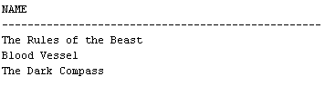
- SELECT NAME
FROM CREW
WHERE C_ID IN (SELECT C_ID
FROM PART_OF_S
WHERE S_ID IN (SELECT S_ID
FROM EPISODE_INCLUDES
WHERE NAME = 'The Dark Compass'));
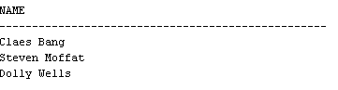
- SELECT TEXT_
FROM REVIEW
WHERE R_ID IN (SELECT R_ID
FROM HAS_M
WHERE M_ID (SELECT M_ID
FROM BELONGS_TO_M
WHERE NAME = 'Drama'));
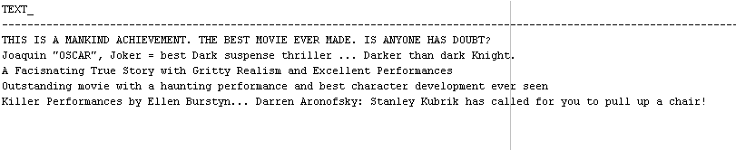

User Interface
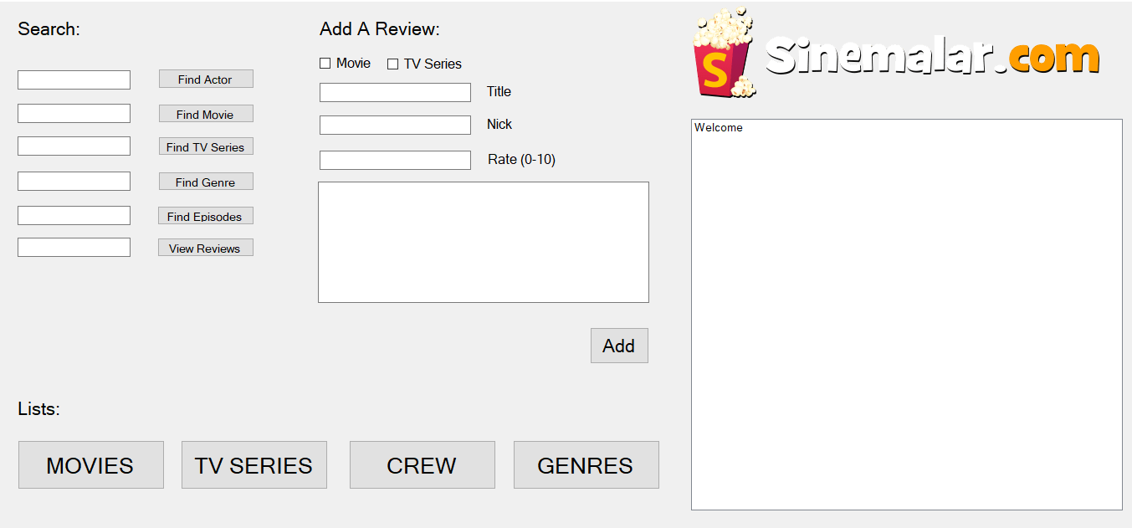
Figure 3: User Interface, First Screen

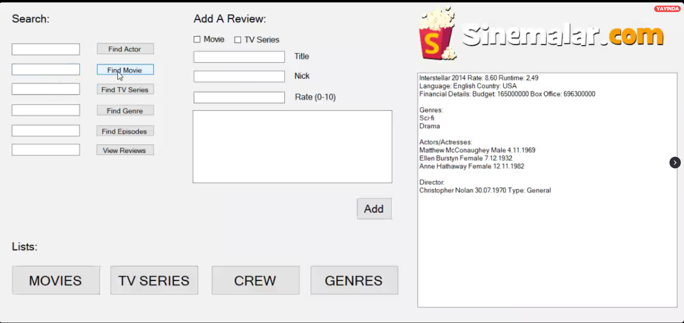
Figure 4: Interstellar’s information on the interface.
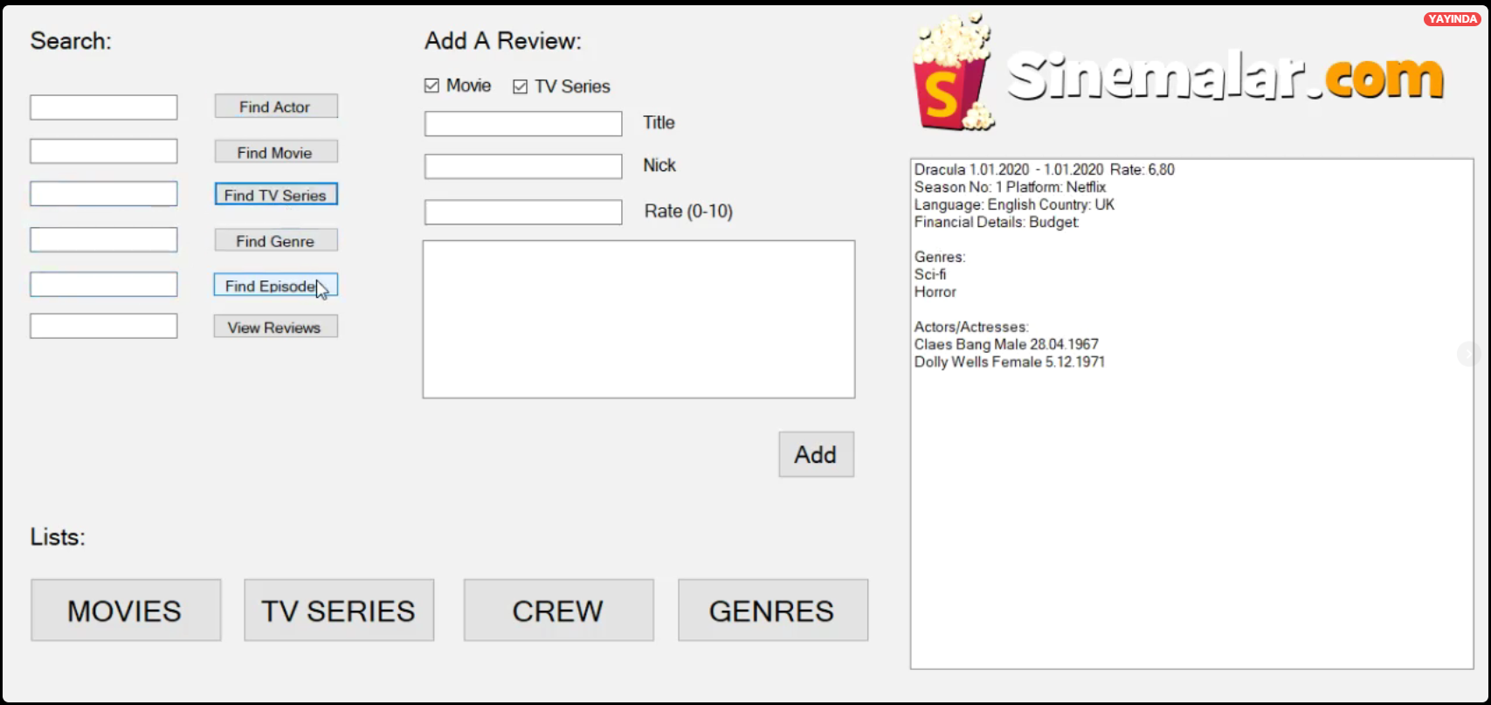
Figure 5: Dracula’s information on the interface.

CONCLUSION
Our project helped us learn how to design a database and consider all of the requirements and definitions of a database.
We analyzed the problem and we came up with a solution. We tried to solve the problem in many ways and normalization, mapping, ER diagram helped us find the correct solution. We are so proud of the result. Now, users can reach all the information about their desired movie/TV series much faster and in a simple way. They can learn crew members who worked on these movies/TV series, such as writers, producers, musicians etc. We believe that our database uses an all-inclusive approach which the end users will appreciate.
In the end, we learned lots of new things and methods while designing this database.

