Analyzing EBR partitions manually

Use image1 for manual analysis

DOS Partition Table
Offset Sector: 0
Units are in 512-byte sectors

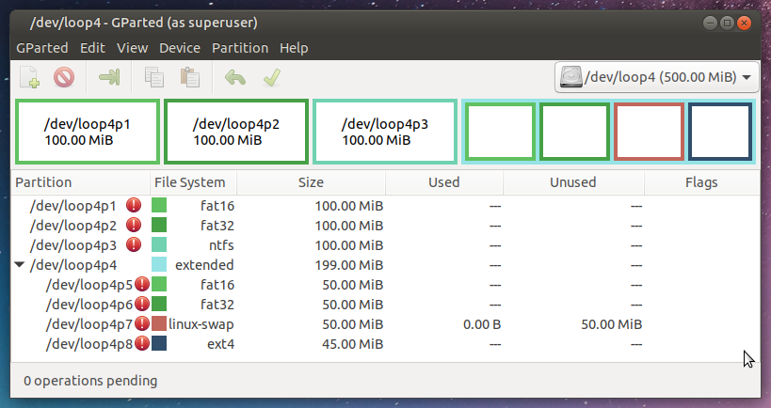

Part | Slot | Start | End | Length | Description
000: | Meta | 0000000000 | 0000000000 | 0000000001 | Primary Table (#0)
001: | ------- | 0000000000 | 0000002047 | 0000002048 | Unallocated
002: | 000:000 | 0000002048 | 0000206847 | 0000204800 | DOS FAT16 (0x06)
003: | 000:001 | 0000206848 | 0000411647 | 0000204800 | Win95 FAT32 (0x0b)
004: | 000:002 | 0000411648 | 0000616447 | 0000204800 | NTFS / exFAT (0x07)
005: | Meta | 0000616448 | 0001023999 | 0000407552 | DOS Extended (0x05)
006: | Meta | 0000616448 | 0000616448 | 0000000001 | Extended Table (#1)
007: | ------- | 0000616448 | 0000618495 | 0000002048 | Unallocated
ET1 | PE1 | 616448+2048(S1)=618496 |  | L1=102400
008: | 001:000 | 0000618496 | 0000720895 | 0000102400 | DOS FAT16 (0x06)
009: | ------- | 0000720896 | 0000722943 | 0000002048 | Unallocated
ET1 | PE2 | 616448+106222(S2)=722670 |  | L2=102674 | (S2,L2) points Next DOS Extended
010: | Meta | 0000722670 | 0000825343 | 0000102674 | DOS Extended (0x05)
011: | Meta | 0000722670 | 0000722670 | 0000000001 | Extended Table (#2)
ET2 | PE1 | 722670+274(S1)=722944 |  | L1=102400
012: | 002:000 | 0000722944 | 0000825343 | 0000102400 | Win95 FAT32 (0x0b)
013: | ------- | 0000825344 | 0000827391 | 0000002048 | Unallocated
ET2 | PE2 | 616448+210772(S2)=827220 |  | L2=102572 | (S2,L2) points Next DOS Extended
014: | Meta | 0000827220 | 0000929791 | 0000102572 | DOS Extended (0x05)
015: | Meta | 0000827220 | 0000827220 | 0000000001 | Extended Table (#3)
ET3 | PE1 | 827220+172(S1)=827392 |  | L1=102400
016: | 003:000 | 0000827392 | 0000929791 | 0000102400 | Linux Swap / Solaris x86 (0x82)
017: | ------- | 0000929792 | 0000931839 | 0000002048 | Unallocated
ET3 | PE2 | 616448+315322(S2)=931770 |  | L2=92230 | (S2,L2) points Next DOS Extended
018: | Meta | 0000931770 | 0001023999 | 0000092230 | DOS Extended (0x05)
019: | Meta | 0000931770 | 0000931770 | 0000000001 | Extended Table (#4)
ET4 | PE1 | 931770+70(S1)=931840 |  | L1=92160
020: | 004:000 | 0000931840 | 0001023999 | 0000092160 | Linux (0x83)
ET4 | PE2 | S2=0 |  | L2=0 | PE2=0 or (S2,L2)=(0,0) means the end of the EBR list.

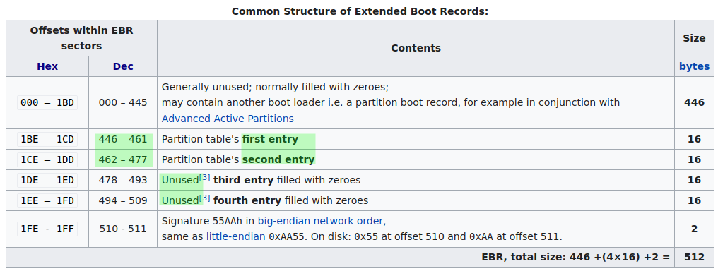
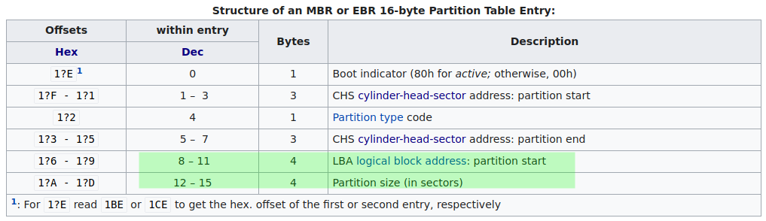

005: | Meta | 0000616448 | 0001023999 | 0000407552 | DOS Extended (0x05)
006: | Meta | 0000616448 | 0000616448 | 0000000001 | Extended Table (#1)

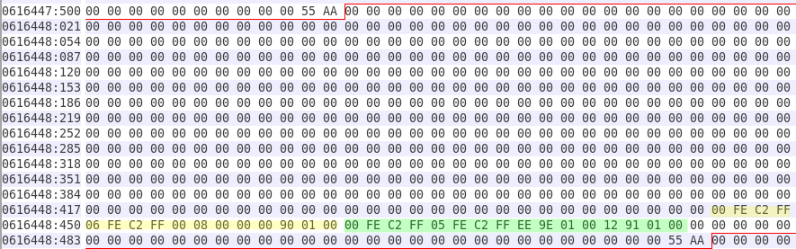
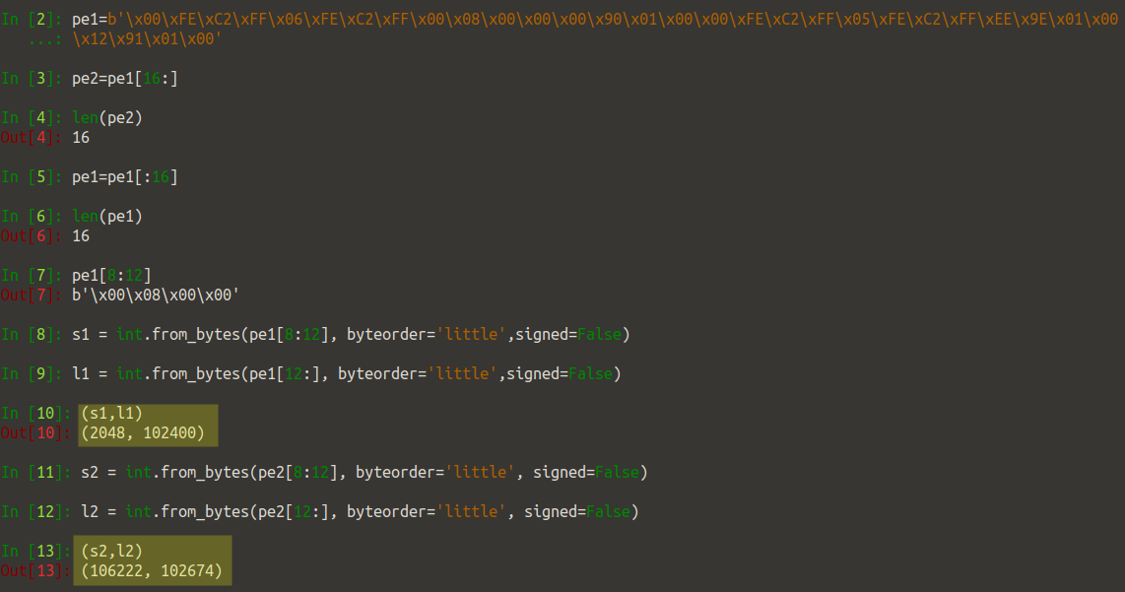

010: | Meta | 0000722670 | 0000825343 | 0000102674 | DOS Extended (0x05)
011: | Meta | 0000722670 | 0000722670 | 0000000001 | Extended Table (#2)

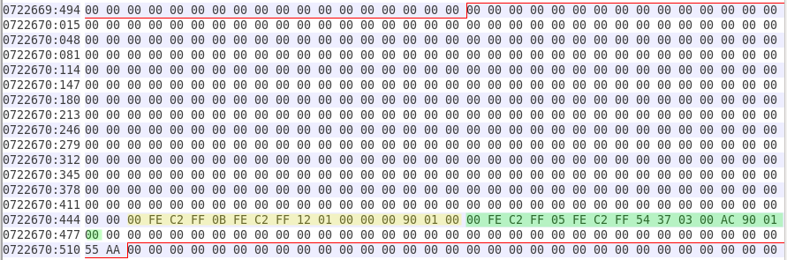
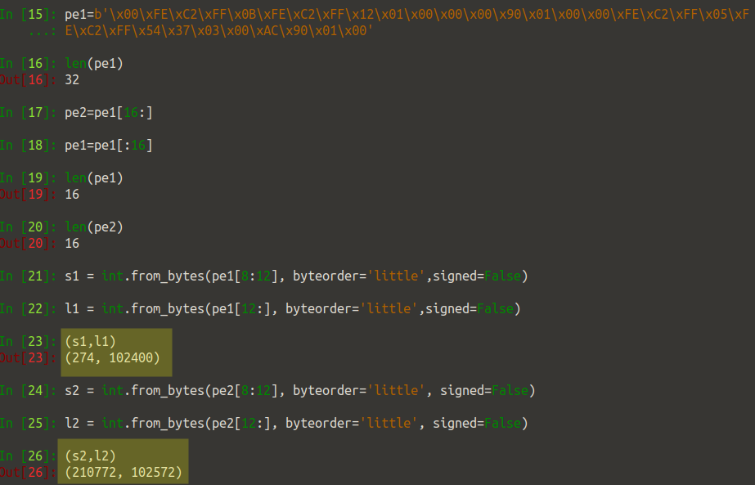

014: | Meta | 0000827220 | 0000929791 | 0000102572 | DOS Extended (0x05)
015: | Meta | 0000827220 | 0000827220 | 0000000001 | Extended Table (#3)

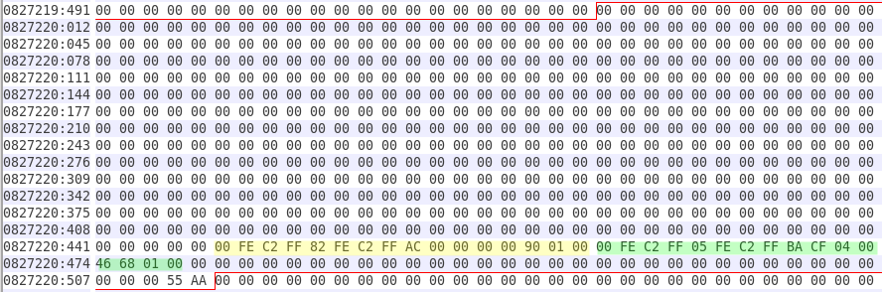
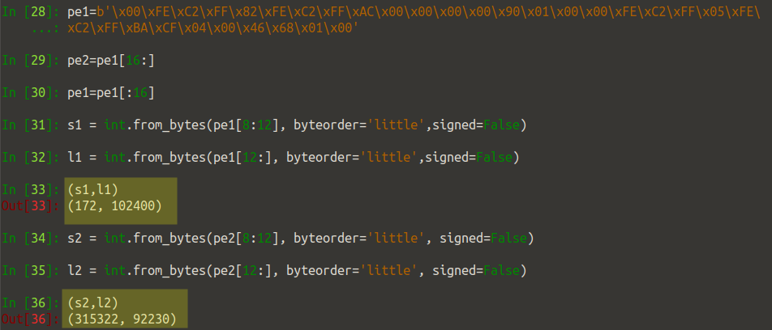

018: | Meta | 0000931770 | 0001023999 | 0000092230 | DOS Extended (0x05)
019: | Meta | 0000931770 | 0000931770 | 0000000001 | Extended Table (#4)

