Pulse of American Domestic Tourism OD Flow Map Dashboard – User Manual
Dr. Yang Yang (Temple University)
Dr. Chenfeng Xiong (Villanova University)

1. Introduction and Purpose
The Pulse of American Domestic Tourism – OD Flow Map Dashboard is an interactive analytical tool designed to visualize and explore large-scale domestic travel flows within the United States. The dashboard focuses on origin–destination (OD) relationships and provides an intuitive way to examine how travel volumes vary across space, time, and trip purpose.
Rather than presenting raw geographic data, the dashboard emphasizes spatial structure, relative intensity, and network patterns in domestic tourism mobility. By integrating flow maps, ranked routes, and summary tables, the tool allows users to move seamlessly between a national overview and detailed corridor-level insights.
The dashboard is intended for academic research, teaching, and policy-oriented analysis. Typical use cases include identifying major domestic tourism corridors, comparing leisure and business travel patterns, exploring temporal changes across years, and communicating complex mobility patterns in a visually accessible way.
2. Data Structure and Underlying Assumptions
The dashboard operates on an origin–destination dataset provided in CSV format. Each record represents a travel flow between an origin region and a destination region for a given year. The dataset includes travel volumes disaggregated by trip purpose, as well as geographic coordinates for both origins and destinations.
Latitude and longitude values are used internally to position origins and destinations on the map. However, these geographic coordinates are intentionally hidden from the user interface. Once locations are correctly positioned, displaying raw coordinates adds little analytical value and may distract from interpretation. The design choice reflects a focus on mobility patterns rather than precise geodesic detail.
Travel volumes shown in the dashboard represent weighted or aggregated measures of trips. As a result, values should be interpreted as indicators of relative magnitude rather than exact counts of individual travelers.

3. File Connection and Data Loading
When the dashboard is loaded, it attempts to automatically connect to a data file hosted on the server. The file connection status is displayed in the top-right corner of the interface.

A green indicator labeled “File connected” confirms that the dataset has been successfully loaded and is available for analysis. A red indicator labeled “File not found” signals that no valid dataset is currently connected. In this case, users may upload a CSV file manually using the upload interface provided on the page.
This dual mechanism ensures flexibility. The dashboard can function as a hosted visualization with a preloaded dataset, or as a standalone exploratory tool where users supply their own compatible data.

4. Global Filters and Controls
The upper control panel allows users to interactively filter and explore the dataset. All controls are synchronized, meaning that any selection immediately updates the map, ranked routes, and data table.
The Year selector enables users to examine all available years simultaneously or focus on a specific year. This is particularly useful for identifying temporal shifts in domestic travel patterns or isolating conditions in a single period.
The Trip Purpose selector allows users to switch between total travel, leisure travel, and business travel. This selection not only changes the underlying travel volume being analyzed, but also affects the color coding of OD flows on the map and the ranking of busiest routes. In doing so, the dashboard highlights how different travel motivations shape distinct spatial patterns.
The Map Top-N control determines how many OD flows are displayed on the map at one time. By default, the map shows the top 50 flows based on the selected travel volume. Users may expand this view to include the top 100 or top 200 flows. Increasing the number of displayed flows reveals more secondary and tertiary corridors, but may also introduce visual density. This control allows users to balance completeness and clarity depending on their analytical goal.
Text-based search fields for Origin and Destination provide additional flexibility. These fields allow users to focus on specific regions or pairs of regions by filtering the dataset dynamically as text is entered.

5. Records Indicator and User Manual Access
The Records indicator in the top-right corner displays the total number of OD records currently loaded in the dashboard. This value reflects the size of the underlying dataset and remains constant regardless of filtering.
Directly below the record count, a link labeled User manual (PDF) provides access to this documentation. The manual opens in a new browser tab, allowing users to consult methodological details and usage instructions without interrupting their analysis.

6. OD Flow Map Visualization
The OD Flow Map is the central visual component of the dashboard. It presents travel flows across the contiguous United States using an interactive basemap that supports zooming and panning.
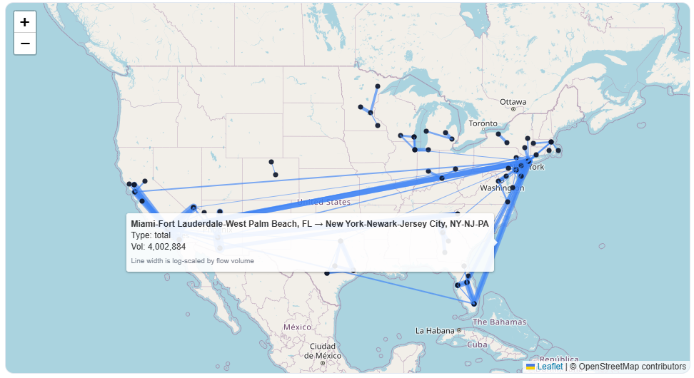
Each line on the map represents a travel flow between an origin and a destination. Line color indicates trip purpose, with leisure and business travel displayed in distinct hues. Line width encodes travel volume and is calculated using a logarithmic transformation. This transformation reduces the influence of extreme values while preserving meaningful differences among smaller flows.
To further enhance interpretability, line widths are normalized within the set of flows currently displayed on the map. As a result, the visual contrast adapts dynamically when users change the Top-N setting or apply filters. Line thickness should therefore be interpreted as a relative indicator within the current view, not as a linear or absolute scale.
Hovering over a flow line reveals a tooltip with the origin and destination names, the selected trip purpose, and the corresponding travel volume. Hovering over a point displays only the name of the origin or destination, reinforcing geographic context without exposing raw coordinate data.

7. Top Busiest Routes Panel
Adjacent to the map, the Top 15 busiest routes panel presents a ranked horizontal bar chart of the most heavily traveled OD pairs under the current filters. This component provides a concise summary of dominant corridors and complements the spatial view offered by the map.
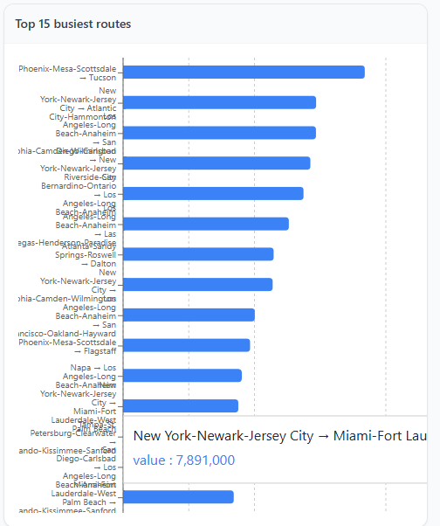
The ranking updates automatically as users change the year, trip purpose, or search filters. Together, the map and the ranked routes panel offer both spatial and quantitative perspectives on domestic travel intensity.

8. Data Table
The bottom section of the dashboard displays a data table containing the top 100 OD records under the current filtering conditions. The table includes the year, origin name, destination name, and travel volumes by purpose.
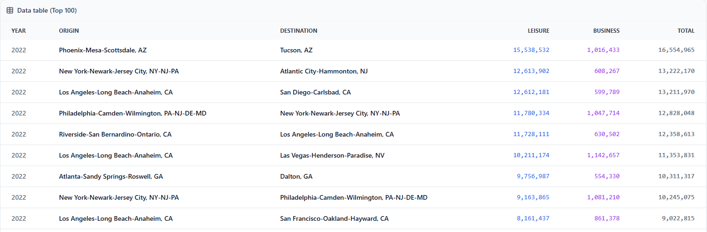
The table is designed primarily for inspection, validation, and reference. By omitting geographic coordinates, the table remains focused on substantive travel information and avoids unnecessary technical detail.

9. Interpretation Guidelines and Best Practices
Users are encouraged to begin with a smaller Top-N setting to identify dominant national patterns before expanding the view to include additional flows. When interpreting line widths, it is important to remember that the visualization emphasizes relative differences rather than exact proportional relationships.
Combining insights from the flow map, ranked routes, and data table provides the most robust understanding of domestic tourism dynamics. The dashboard is best used as an exploratory and communicative tool, complementing formal statistical analysis rather than replacing it.

10. Attribution and Contact
This dashboard was developed by
Dr. Yang Yang (yangy@temple.edu)
Dr. Chenfeng Xiong (chenfeng.xiong@villanova.edu).
For academic use only, please cite the tool and underlying data appropriately.

