OPERATOR GUIDE
PDW v5.5.2
Paging Decoder for Windows
2026 Release
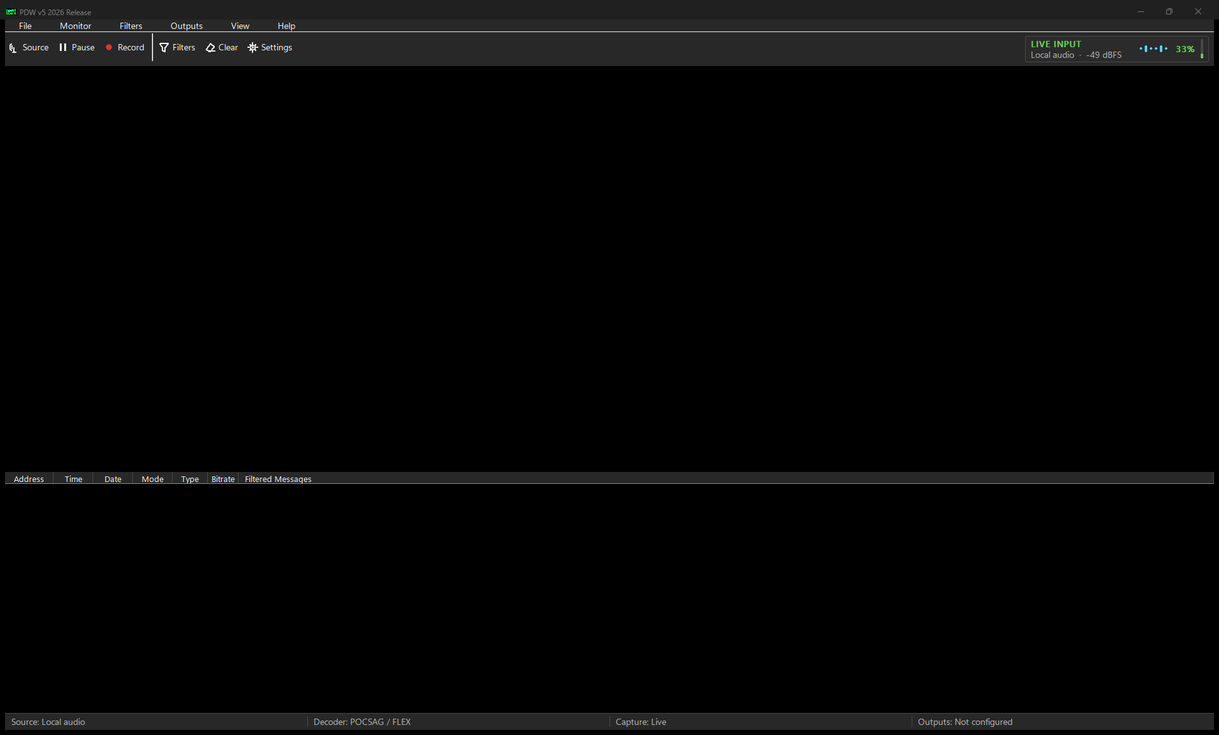
Figure 1. Content-free PDW v5 command bar and live-input layout.
Edition 3.0 | 12 August 2026 | Covers PDW v5.5.2
Native x64 and Win32 applications for supported Windows 10/11 and Windows Server systems
All addresses, messages, accounts, endpoints and credentials in this guide are synthetic or masked.

How to use this guide
Training data: Use only synthetic, redacted or explicitly licensed examples for setup, screenshots and acceptance. Never place private pager traffic, recordings, credentials, Windows endpoint IDs or operator settings in a public report.
This manual replaces the 2010 PDW v3.1 guide and the interim v4.1 draft. It keeps the established protocol, decoder, filter and logging concepts, but follows the v5.5.2 installer, dual-architecture packages, 2026 command bar, Settings Center, Capcode Directory, message history, secure outputs and named local-audio profile.

Feature status used in this manual
Status | Meaning
Release | Included in the published, signed PDW v5.5.2 release.
Preserved legacy | Established decoder, serial, slicer, WinMM, filter or display behaviour intentionally retained for compatibility.
Optional / off | Included but disabled until an operator deliberately enables and configures it.
Hardware-unverified | Automated checks pass, but representative physical-device acceptance remains incomplete.
Hardware-unverified UI | Automated checks cover the retained message state, but real sleep, lock, display-off and physical-device acceptance remain open.

Ten-minute first run
- Download the v5.5.2 Setup only from the maintained GitHub release, verify its published SHA-256 checksum and confirm the trusted publisher.
- Run Setup, read the unknown-publisher warning, and choose x64 for normal current Windows use or Win32 only when a legacy 32-bit receiver or integration requires it.
- Choose Standard PDW settings. Select the Adelaide FLEX profile only for the documented SDR# and VB-Audio Cable workflow.
- Start PDW, open Settings, and choose the intended source under Signal & radio. Use only transmissions you are authorised to receive.
- Select POCSAG/FLEX, ACARS, MOBITEX or ERMES and confirm the live meter responds without persistent clipping.
- Open Filters > Capcode Directory and create one synthetic training rule. Keep external output routing off for the first test.
- If local history is required, enable it under View > Message history and decide separately whether message text may be retained.
- Run configuration-only tests for any approved email, notification, transfer, publishing or data-output destination before enabling live delivery.
- Create an encrypted Settings > General > Backup / Restore file after configuration and protect its password separately.

Contents
Use the linked chapter names below or Word's Navigation Pane to move through the manual. Page numbers are intentionally omitted because they vary between Word/PDF renderers.
1. Read this first
2. Install and first start
3. Interface tour
4. Choose a signal source
5. Decode and improve a signal
6. Understand decoded messages
7. Build filters and alerts
8. Log, copy, display and review
9. Email and push notifications
10. Secure file transfer
11. Publish to a website or webhook
12. Data outputs and delivery health
13. Daily operation and troubleshooting
14. Reference

1. Read this first

What PDW does
PDW is a native Windows application that receives, decodes, displays, filters, logs and optionally routes supported digital radio messages. Current development is deliberately additive: modern Windows input, user-interface and output features sit beside established decoder and hardware paths rather than replacing them.
Protocol | Supported role | Compatibility boundary
POCSAG | 512, 1200 and 2400 baud | Established parser and serial/audio routes retained.
FLEX | 1600, 3200 and 6400 baud | Established parser retained; optional fragment assistance is separately gated.
ERMES | 6250 baud | Established decoder route retained.
ACARS | Aircraft data messages | Parity and label/database options remain operator controlled.
MOBITEX | 8000 baud in normal use | Established base/mobile and message controls retained.

What v5.5.2 includes
Area | Included capability | Default / evidence boundary
Windows | Guided Setup, portable packages, x64 and Win32, light/dark UI and modeless Settings Center. | Full DPI, keyboard, High Contrast and physical-radio matrices require representative acceptance.
Signal | WinMM, exact-endpoint WASAPI, serial/slicer, RTL-TCP, RTL-SDR, WAV/SigMF record and replay. | Named Adelaide profile is opt-in and hardware-unverified.
Local tools | Capcode Directory with CSV upsert, optional SQLite history, CSV export, local dashboard, Local Gateway Outbox and isolated extra receiver workers. | History, dashboard, gateway outbox and extra channels are off until enabled.
Routing | Email, Apprise, FTPS/SFTP, publishing, MQTT, SQLite, MySQL/ODBC, Telnet and Windows notifications. | Every network/output path is disabled by default and must fail independently from decoding.
FLEX | Optional bounded fragment reassembly waits for a complete chain and emits one normal joined message. | Disabled by default; recording-backed live acceptance remains open.

Privacy and law: PDW cannot determine whether reception, storage, forwarding or publication is lawful in your location. Confirm authority, radio rules, privacy obligations, retention and publication requirements before use. Treat capcodes, aliases and decoded content as potentially identifying information.
Release status: PDW v5.5.2 is gated by automated x64/Win32 build, test, package, installer, Defender and trusted-publisher checks. Physical SDR, SDR#, VB-CABLE, legacy receiver and complete UI acceptance remain separate evidence and must not be inferred from automated results.

2. Install and first start

Supported Windows boundary
Setup enforces Windows build 10586 as the technical API floor. Normal use requires a Windows 10 or Windows 11 edition/build still receiving Microsoft security servicing, or a serviced Windows Server 2016-or-newer release. Windows 7, 8 and 8.1 are outside the current Visual Studio 2026 and Windows SQLite support boundary.

Choose an architecture
Package | Choose it for | Native dependency rule
x64 | Current 64-bit Windows, Windows audio, RTL-TCP and matching x64 receiver libraries. | All loaded native DLLs must be x64.
Win32 | Bundled x86 RTL-SDR, historical slicer/receiver libraries or another known 32-bit integration. | All loaded native DLLs must be x86/Win32.

Architecture: A 32-bit DLL cannot load into x64 PDW, and a 64-bit DLL cannot load into Win32 PDW. Decoder, filter and configuration behaviour are shared between the builds.

Guided Setup
- Verify the downloaded Setup checksum against the value published with v5.5.2.
- Run Setup and choose the destination folder. The default is under the current user's Local Programs folder.
- On 64-bit Windows, choose x64 or Win32 compatibility. Setup selects Win32 automatically on 32-bit Windows.
- For a new settings file, choose Standard PDW settings or the optional SDR# + VB-Audio Cable (Adelaide FLEX) profile.
- Choose Start Menu, optional Desktop and optional delayed Windows-startup shortcuts.
- Launch PDW and confirm the title/About identity and selected architecture before configuring hardware or outputs.
Unknown publisher: Download only from the maintained release, verify the checksum and confirm that Windows reports the expected trusted publisher. Do not bypass a warning for an unverified copy.

Upgrade and uninstall
- Normal upgrades preserve PDW.INI, Capcode Directory/history database, receiver additions, WAV files, logs, recordings, queues and other operator-created data.
- A pre-existing PDW.INI always wins; Setup does not silently apply a clean-install profile during an upgrade.
- Architecture changes preserve the active RTL-SDR DLL to a verified recovery backup before replacing or removing the active slot.
- Uninstall leaves configuration and operator data by default. Review and remove it manually only after an authorised backup.

Portable packages
The portable x64 and Win32 packages remain supported. Extract the complete package to a writable folder and keep the executable, PDW.INI, Capcode Directory/history database, receivers, WAV files and logs together. Do not run PDW from inside a ZIP file or mix files from different releases.

Important local data
Path / item | Purpose and handling
PDW.INI | Primary saved configuration beside PDW. Protect it as operator configuration.
pdw-history.sqlite3 | Capcode Directory and, when enabled, message history. The directory remains usable with history capture off.
filters.ini.migrated | Recoverable backup created after a successful one-time legacy filter migration.
Wavfiles / Receivers | Optional alert audio and receiver packages. Native receiver DLLs must match PDW architecture.
Logfiles / Published / queues | May contain decoded or transformed content. Apply access, retention and disposal controls.
.pdwbackup | Password-encrypted configuration export that can include supported saved credentials.

3. Interface tour

Figure 2. PDW v5 command bar, panes, live meter and status bar (content-free native capture).

Main window
Area | Use
Menus | File, Monitor, Filters, Outputs, View and Help organise the complete command set.
Command bar | Source, Pause, Record, Filters, Clear and Settings provide the primary daily actions.
Live input meter | Shows source state, source name, level/quality and real sample activity. It is not calibrated RF power.
Monitor pane | Upper pane for displayed decoded messages.
Filtered pane | Lower pane for rules whose Filter action is enabled and that are not rejected or Monitor Only.
Status bar | Reports source, decoder, capture state and output-health summary without displaying decoded text.

The six menus
Menu | Main tasks
File | Log, save/print copied data, configuration backup/restore and exit.
Monitor | Pause, decoder mode, input setup, radio/replay, statistics and volume.
Filters | Capcode Directory, filter controls, counters and legacy compatibility actions.
Outputs | Email, Apprise, transfer, publishing, data outputs, Delivery Health, dashboard and guarded channels.
View | Message history, display/column options, appearance and window tools.
Help | User guide, diagnostics, About, licence and project links.

Settings Center
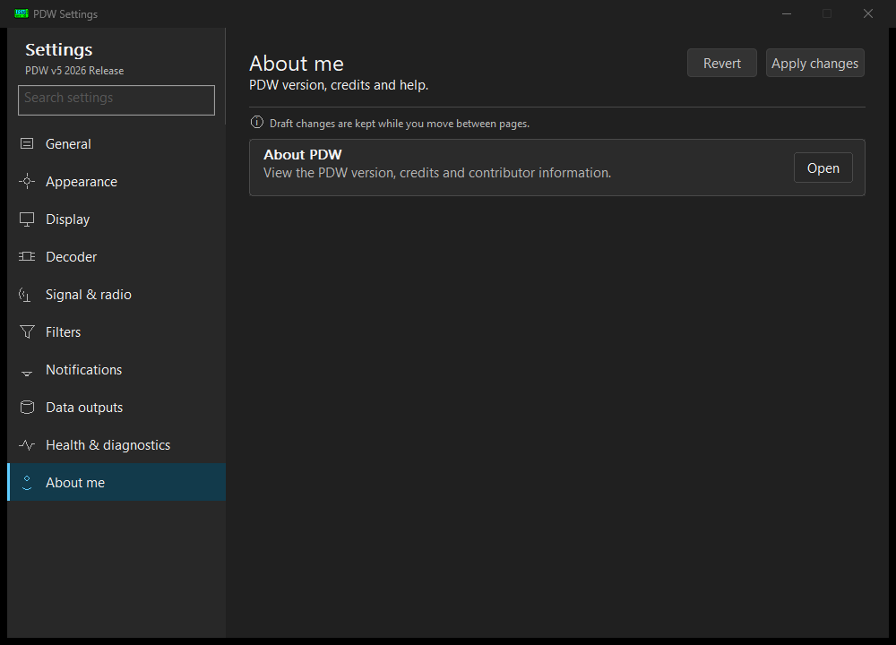
Figure 3. Modeless Settings Center navigation used by the v5 family.
Settings is modeless: monitoring continues while it is open. Draft changes are retained while moving between pages, and retained legacy editors return to the same page when closed. Opening Settings again focuses the existing window instead of creating a second copy.
Accessibility: Use clear message fonts and only the columns you need. Confirm keyboard navigation, High Contrast and 125-200% scaling on the intended computer before relying on PDW in an accessibility-sensitive workflow.

Consolidated Settings
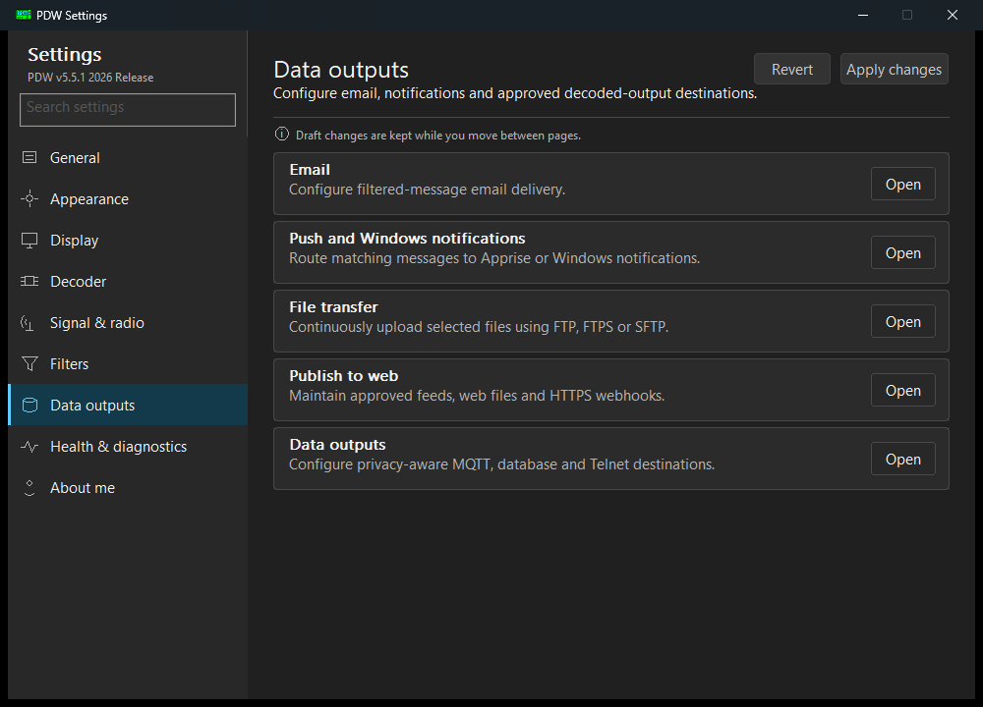
Figure 4. 11 August 2026 development preview of consolidated Data outputs navigation.
Current layout: PDW v5.5.2 consolidates duplicate Settings cards and groups email, push/Windows notifications, transfer, publishing and optional data outputs on one page.

4. Choose a signal source

Source decision guide
Source | Use it when | Important boundary
Local audio | A receiver or virtual cable supplies audio. | Identityless profiles try legacy WinMM first; saved named endpoints open exact-ID WASAPI and fail closed if missing.
Serial / slicer / RS232 | Known compatible legacy hardware is available. | Win32 remains the compatibility choice for x86-only integrations; obsolete VXD packages are not shipped.
RTL-TCP | A local or trusted-network rtl_tcp-compatible server supplies IQ. | Architecture-neutral TCP path; enhanced IQ filtering is optional and disabled by default.
Direct RTL-SDR | A compatible USB receiver is attached. | Win32 includes the reviewed x86 receiver pack; x64 needs a matching trusted x64 library or RTL-TCP.
Replay | A synthetic, redacted or licensed WAV/SigMF recording is available. | Runs through normal decoder functions and restores the previous live source.

Local audio and serial
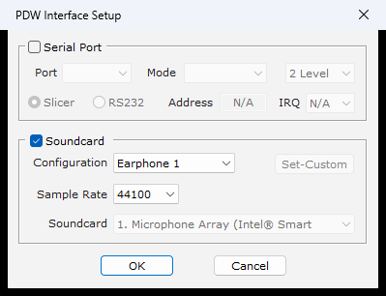
Figure 5. Legacy Input Setup remains available beside modern source controls.
- Connect the intended receiver output, virtual cable or compatible serial interface before opening PDW.
- Open Settings > Signal & radio and choose the current source or retained legacy input editor.
- For audio, select the exact device and the closest supported configuration. Avoid persistent clipping.
- For serial, select the exact COM port, Slicer or RS232 mode and the required two- or four-level path.
- Select the matching protocol family and confirm valid synthetic/licensed traffic before saving automation settings.

SDR# + VB-Audio Cable (Adelaide FLEX)
The named profile is an explicit clean-install or operator-confirmed choice. SDR# sends unfiltered NFM audio to CABLE Input; PDW captures the matching CABLE Output recording endpoint. PDW stores the exact Windows endpoint identity and does not silently fall back to a microphone when that identity is missing or ambiguous.
- SDR# and VB-Audio Cable are separate products; PDW does not install, license, tune or configure them.
- The documented profile uses 148.8125 MHz, NFM, Filter Audio off, unmuted audio, FLEX 1600 and the audited decoder/slicer values.
- Existing/portable users may preview Apply Adelaide FLEX. The confirmation defaults to No and creates a verified PDW.INI backup before an approved change.
- The profile does not create, replace or delete Capcode Directory rules, message history, receivers or WAV files.
Physical validation: Automated endpoint, fail-closed, profile and installer checks do not prove the exact physical SDR#/VB-CABLE workflow. Describe a setup as configured or operator-reported until representative acceptance is recorded.

RTL-TCP and direct RTL-SDR
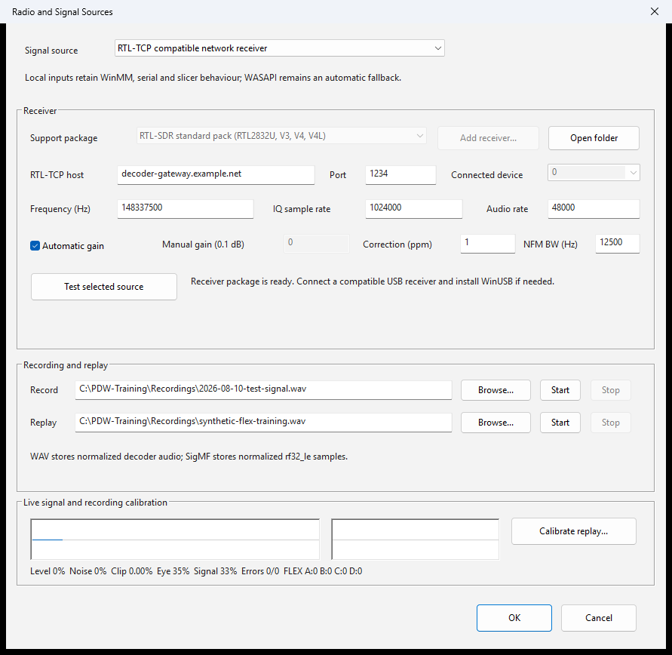
Figure 6. RTL-TCP setup using fictional training values.
RTL-TCP validates the RTL0 header, configures the tuner, demodulates NFM and reconnects after a drop. Direct RTL-SDR lists devices and checks library architecture/API compatibility. Add receiver imports only a trusted matching-bitness librtlsdr package. PDW never launches Zadig or changes a USB driver automatically.

Record, replay and diagnose
- WAV records normalized mono 16-bit samples; SigMF records rf32_le plus sample-rate metadata.
- Replay accepts supported PCM8, PCM16 or float32 WAV and real float32 SigMF, resets timing, then restores the prior source.
- The diagnostics view includes waveform, spectrum, waterfall, quality history, level, noise, clipping, eye opening and FLEX phase/error totals.
- Calibration tests 1,000 threshold/centering/resync combinations and offers an operator-approved suggestion; it is not protocol-level proof.

Guarded multi-channel receivers
Outputs > Guarded multi-channel receivers can run up to four additional rtl_tcp or direct RTL-SDR channels. Each uses an isolated PDW worker process because the established decoders contain process-global state. Local history must be enabled, and each endpoint/device must be unique.
Isolation: Workers write channel-labelled events to shared local history but disable publishing, email, Apprise, data outputs, FTP, Telnet, dashboard and legacy logs. This release does not split one wideband IQ stream into several tuned channels.

5. Decode and improve a signal

Choose the decoder family
Use Monitor > Decoding mode or the Source/Mode route and select POCSAG/FLEX, ACARS, MOBITEX or ERMES. PDW monitors one protocol family at a time. Activity without valid messages often indicates the wrong family, tuning, bandwidth, level or source.

Improve reception in the right order
- Confirm the source and protocol family.
- Confirm frequency, receiver mode, sample rate and expected baud/rate.
- Correct gross under-level or clipping and improve the antenna/signal path.
- For SDR, adjust PPM, gain/AGC and NFM bandwidth using the same authorised recording or signal.
- Compare the live meter, waveform, eye/phase information and corrected/uncorrectable totals.
- Only then change custom thresholds or apply a calibration suggestion, keeping a reversible backup.

Optional RTL IQ conditioning
Enhanced IQ filtering and resampling applies only to RTL input. It uses a 60 dB windowed-sinc channel filter and anti-alias resampling before the existing decoder boundary. It is disabled by default; with it off, the established one-pole/averaging path remains. Compare the same lawful diagnostic recording before retaining the option.

Duplicate and message boundaries
Duplicate blocking, reject rules and protocol-specific display rules remain ahead of external output delivery. Optional output adapters receive an immutable event copy and cannot change the decoder, display or original filter result.

Multipart assistance
When the option is enabled, PDW v5.5.2 holds valid non-group FLEX alpha/secure fragments and bounded explicit Part X of Y text until one complete message is available. The joined result enters the normal message path without a synthetic joined-message banner. Missing, conflicting, timed-out or capacity-rejected observations do not create a guessed joined message. FLEX Group Mode remains on its legacy path.
Live evidence: Automated fragment-order, replay, timeout, capacity and identity tests do not replace recording-backed live acceptance. Use only synthetic, redacted or licensed recordings.

Joined-only FLEX and Part X of Y
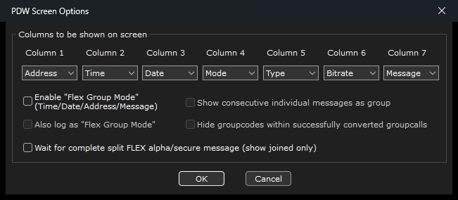
Figure 7. Joined-only FLEX screen option.
The enabled FLEX option holds valid fragments until one joined event enters display, filtering, logging and routing. It also recognises bounded explicit text markers such as Part 1 of 2 and can join 2-32 parts for one visible identity. Recording-backed acceptance remains open.

6. Understand decoded messages
Synthetic examples: The addresses, times, names and messages below are invented training data and do not identify a real person, aircraft or service.

Paging message fields
Address | Time | Mode | Type | Bitrate | Synthetic message
1234567 | 14:17:25 | POCSAG-1 | ALPHA | 1200 | TEST ONLY - maintenance drill complete
1765432 | 14:19:08 | FLEX-A | ALPHA | 1600 | TRAINING - airport operations standby
1002048 | 14:22:31 | FLEX-C | NUMERIC | 3200 | 5550102

Address remains the raw decoded capcode/Riccode. Mode identifies protocol and function/phase. Type distinguishes alpha, numeric, tone-only or other protocol-specific content. Bitrate records the detected/selected rate. A current Capcode Directory name may be displayed beside the raw address but never replaces it.

ACARS and MOBITEX
ACARS records may include aircraft address/registration, flight, label, block/ack and message text. MOBITEX records may include network, base/mobile identity and protocol-specific message type. Keep only the columns and databases needed for an authorised workflow.

Capcode Directory
The local SQLite archive stores operator-maintained names, agencies, colours, notes and filter/routing rules. Protocol-specific mappings win over all-protocol mappings. The raw capcode remains available for audit and export.

Message history
Open View > Message history. History capture is disabled by default, and storing message text is a separate disabled-by-default choice. Retention may be set from 1 to 3650 days. The Capcode Directory remains available when history capture is off, and purging message history does not delete directory entries.
- The default archive is pdw-history.sqlite3 beside PDW unless another path is selected.
- The viewer searches and pages through 200-row displays without implying that only the visible page exists.
- Corrupt or unrelated SQLite databases are refused unchanged; PDW does not silently repair or convert them.

Export message history to CSV
Export CSV writes every stored row matching the current Search, Protocol and Filtered controls, not just the displayed page. The UTF-8 file uses current enabled directory aliases at export time and leaves Message blank when text was not retained.
Received,Protocol,Capcode,Name,Agency,Type,Message,Filter

Exported data: A CSV is an unencrypted copy outside SQLite retention and purge controls. Formula-leading values are protected, but the file still requires authorised storage, sharing and deletion.

Local live dashboard
Outputs > Local live dashboard provides a read-only browser view and JSON API. It is disabled by default, requires message history, binds only to 127.0.0.1 and accepts only localhost/127.0.0.1 Host headers. It cannot accept remote connections or change PDW.

7. Build filters and route selected messages
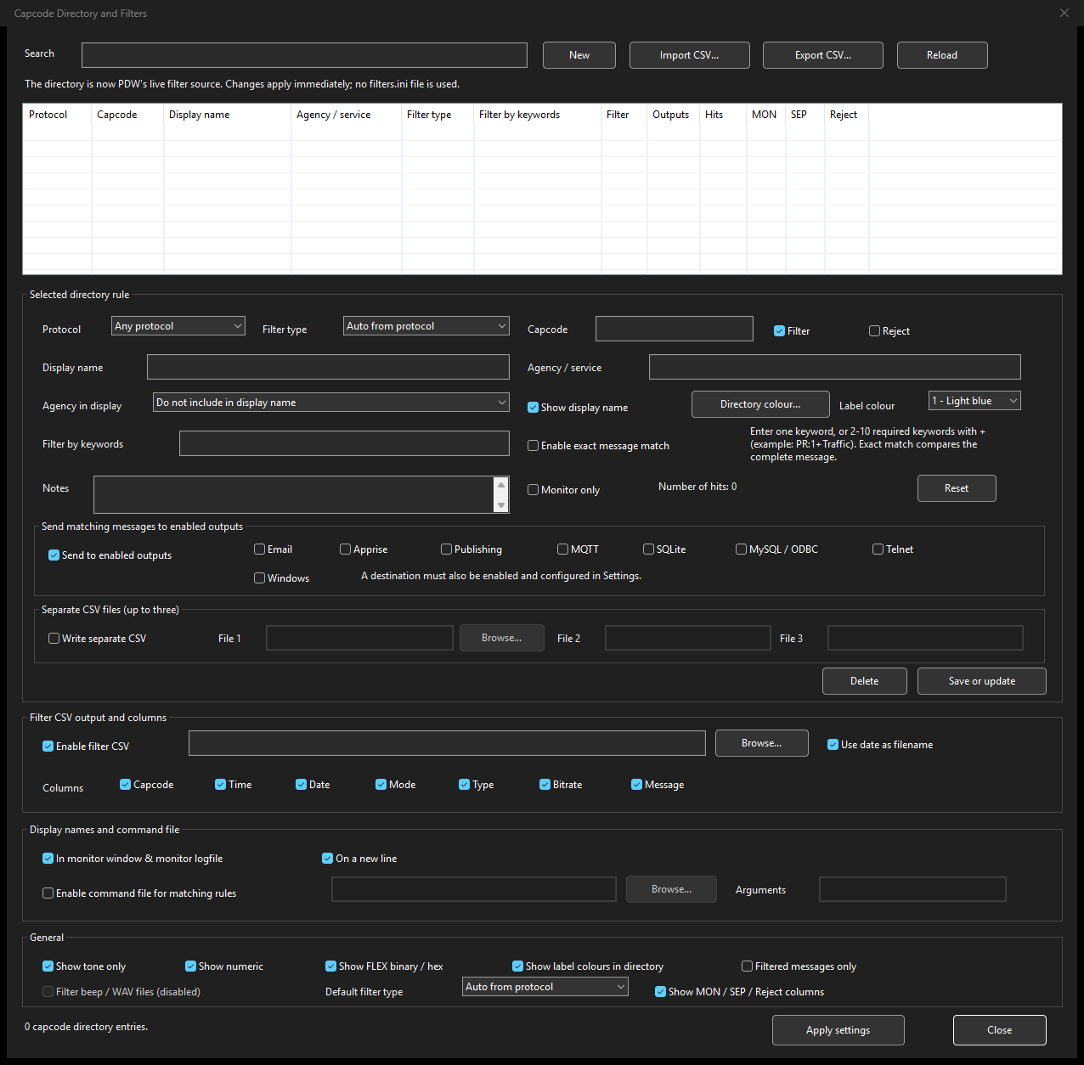
Figure 8. Capcode Directory rule editor with explicit output destinations (content-free native capture).

One directory, three separate decisions
Decision | Control | Effect
Display | Display name, agency placement, colour | Adds operator-maintained context while retaining the raw capcode.
Pane | Filter, Monitor Only or Reject | Sends a match to the lower pane, keeps it in the upper pane, or discards it completely.
Delivery | Send to enabled outputs plus named destinations | Routes only to destinations that are also enabled/configured in Settings.

Create a rule
- Open Filters > Capcode Directory and choose New.
- Choose one protocol or Any protocol, then enter the exact capcode/address.
- Add a synthetic display name, optional agency/service, colour and notes.
- Choose capcode-only, one required keyword, two-to-ten required keywords joined with +, or exact whole-message matching.
- Choose Filter, Monitor Only or Reject. Filter and Monitor Only are mutually exclusive.
- Leave Send to enabled outputs off until each intended destination is separately approved, configured and tested.
- Save or update. The live in-memory filter reloads immediately without replacing decoder logic.

Matching precedence
For the same capcode, PDW evaluates the most specific message condition first: exact whole-message, multi-keyword, single-keyword, then capcode-only. Keyword matching ignores case. A + expression requires every listed keyword in any order. Legacy & expressions remain supported for compatibility.

Per-rule outputs
A rule may select Email, Apprise, Publishing, MQTT, SQLite, MySQL/ODBC, Telnet and Windows notifications. Selecting a destination on the rule does not enable it. The destination and any required output-group/privacy acknowledgement must also be enabled in Settings. This two-step gate prevents a directory row from silently activating external delivery.

CSV import/export and legacy migration
- Directory Import and Export use UTF-8 CSV. Invalid rows are rejected and reported.
- Fresh packages do not include filters.ini. If an older readable file exists, PDW performs a transactional one-time merge into the directory.
- After success, the original file is renamed to a unique .migrated recovery backup; a failed import leaves it unchanged.
- Retire any scheduled legacy generator after migration and use the directory CSV controls for future bulk maintenance.

8. Log, display, copy and review

Display and columns
View/display settings control the seven message columns, colours, fonts, scrollback and pane arrangement. Keep the raw address, time and protocol/type information needed for interpretation, but remove unused columns to improve readability. Long v5 messages can use the wider layout without changing decoder content.

Figure 9. Current development Screen Options layout; the seven column selectors also exist in the v5 family.

Copy, save and print
- Select decoded rows or text, then use Edit/Copy or the appropriate menu command.
- Save copied data creates a separate operator-controlled file; it is not covered by message-history retention.
- Print only to an approved device or secured PDF location and dispose of output under policy.

Main logfile
Logging is operator-controlled. Choose a protected location and confirm whether monitor and filtered content, labels and line layout meet the authorised purpose. A logfile may contain private decoded content even when external publishing has message omission enabled.

Separate filter CSV files
A directory rule can write the same matching row to up to three selected CSV paths using the shared subset of Capcode, Time, Date, Mode, Type, Bitrate and Message. These local files are independent from Message History CSV export and require their own access/retention controls.

Data boundary
Store/output | Contains | Retention boundary
Main logfile | Displayed/logged decoded records according to local settings. | Operator-controlled file.
Message history | Optional bounded SQLite events; text optional. | 1-3650 day configured retention and purge.
History CSV | All stored rows matching current viewer filters. | Unencrypted export outside archive retention.
Published / queues | Transformed publishing copies and pending/dead-letter events. | Publishing profile and manual queue review.
Delivery Health | Destination names, counters, timestamps and sanitized outcomes. | Never stores capcodes or decoded message text.

9. Email and notifications

Two independent message gates
A Capcode Directory rule first decides whether a message is filtered/displayed and whether it selects an output. The email, Apprise or Windows-notification destination must then be enabled and configured in Settings. A rule never activates a destination by itself.

SMTP email
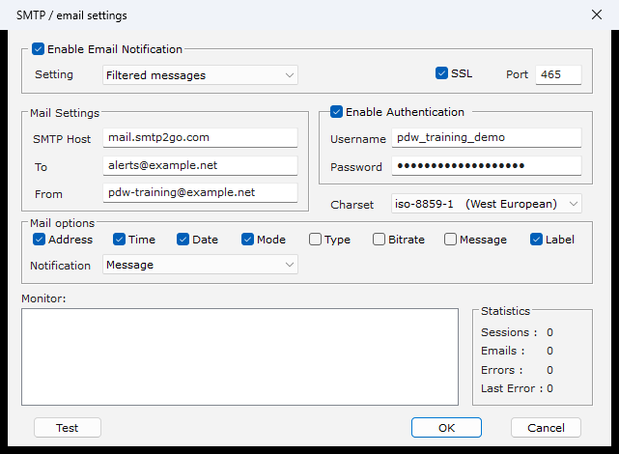
Figure 10. SMTP configuration using fictional, masked training values.
- Use a current authenticated SMTP relay account and the provider's required TLS/port settings.
- Test with a synthetic message and a non-production recipient before enabling matching-message delivery.
- Do not place mail passwords or decoded traffic in screenshots, logs or issue reports.

Apprise filtered-message push
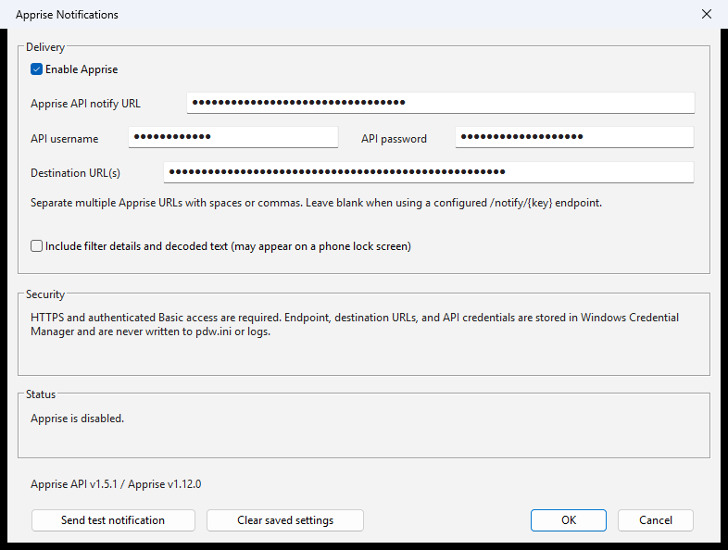
Figure 11. Apprise notification settings with masked fictional values.
PDW connects to an operator-managed HTTPS Apprise API. PDW v5.5.2 sends only messages selected by the established filtered/output routing boundary. Monitor Only, rejected, duplicate and unselected messages are not pushed. Delivery uses a bounded background queue so an unavailable phone service does not block decoding.
- Use HTTPS and authentication; do not expose an unauthenticated Apprise API to an untrusted network.
- Keep decoded text off unless lock-screen exposure has been specifically approved.
- Use Send test notification before Enable Apprise. Testing must use synthetic content.

Native Windows notifications
Windows notifications are a separate optional data-output destination. They load/register only when enabled or tested. Message text has its own opt-in because notifications may appear on the lock screen. Turning the adapter off leaves PDW's legacy tray behaviour unchanged.
Secrets: Supported destination credentials are held through Windows Credential Manager and the encrypted backup workflow. Never rely on an ordinary folder copy as a safe secret backup, and never publish an exported configuration file or its password.

10. Secure file transfer
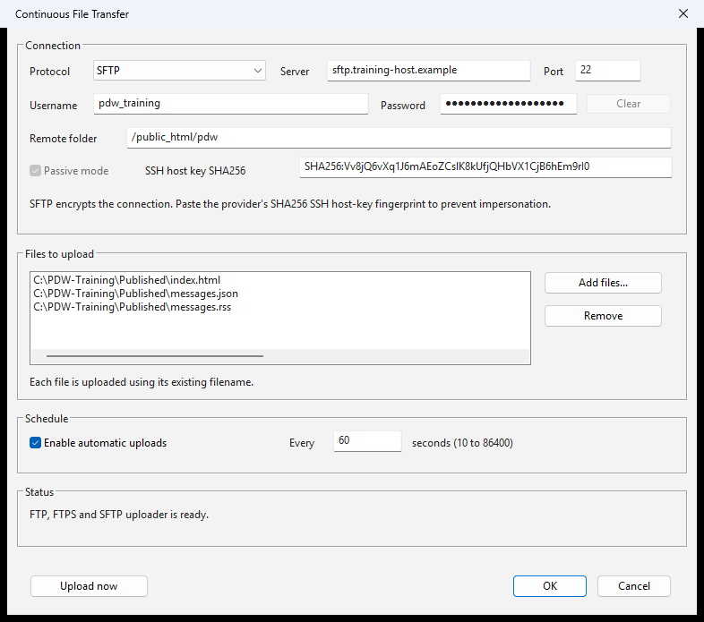
Figure 12. Secure file-transfer settings using fictional training values.

Supported protocols
Protocol | Protection | Required verification
FTP | No transport encryption | Use only inside an explicitly approved protected environment.
Explicit FTPS | TLS upgrade on the FTP control connection | Windows-trusted certificate and hostname validation.
Implicit FTPS | TLS from connection start | Windows-trusted certificate and hostname validation.
SFTP | SSH file transfer with password authentication | Exact operator/provider-verified SHA-256 host-key fingerprint.

Configure an upload
- Create and approve the remote account/folder outside PDW.
- Choose the secure protocol, host, port, username, remote folder and local source file.
- For SFTP, obtain the exact SHA-256 host-key fingerprint through a trusted channel. For FTPS, use the correct certificate hostname.
- Enter the password through PDW's credential control and run the configuration test.
- Confirm the synthetic/local test file arrives in the intended folder before enabling continuous transfer.
- Set a reasonable interval and review sanitized FileTransfer.log outcomes.
Fail closed: Do not bypass certificate or host-key validation to make a test pass. A changed SFTP host key or certificate error must be investigated through an independent trusted channel.

11. Publish to a website or webhook
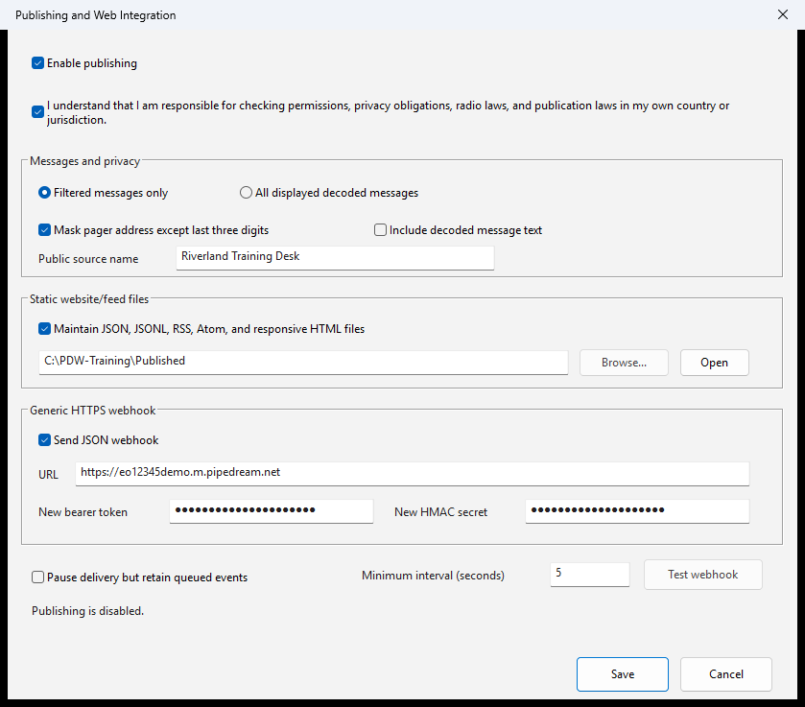
Figure 13. Publishing settings using fictional training values.

Start disabled and minimise data
Publishing is disabled by default and requires an operator acknowledgement of permissions, privacy, radio and publication responsibility. Start with filtered-only delivery, address masking and message omission. Those transforms affect only the published copy; they do not rewrite the local display, logs, email or Apprise source event.

Static publishing
PDW can generate JSON, JSONL, RSS, Atom and responsive HTML. Generate to a private local folder first, inspect only synthetic output, then use the separately configured transfer path if remote upload is approved.

HTTPS webhook
- Use an HTTPS endpoint with reviewed retention, region, access and account controls.
- Bearer authentication and HMAC signatures are optional tools; the receiving workflow must actually validate them.
- Use the stable event identifier for idempotency where the receiver supports it.
- Run Test webhook with a configuration-only synthetic object before enabling live delivery.

Queue and failure behaviour
- Delivery runs away from the capture/decoder thread.
- Transient failures retry with bounded exponential backoff; repeated failures move to DeadLetter for review.
- Pending/dead-letter payloads may contain transformed decoded data and require the same protection as the destination.
Third-party storage: A webhook or hosting provider may retain requests, headers, files and event history. Do not send live decoded content until the service and workflow are approved for that data.

12. Data outputs and delivery health
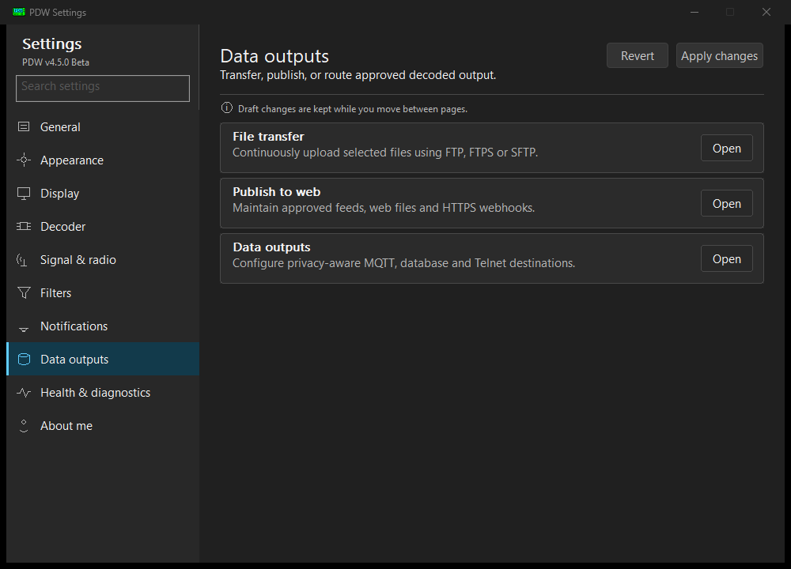
Figure 14. Data outputs area in the v5 Settings family.

Privacy-aware optional adapters
Optional routed adapters receive an immutable copy after PDW's established filtering and deduplication boundary. The output group and each adapter are disabled by default. Enabling the group requires an operator acknowledgement; filtered-only delivery, address masking and message omission are the privacy-safe defaults.
Adapter | Use | Important boundary
MQTT | Publish JSON to a broker/topic. | mqtts verifies certificate/hostname; plain mqtt needs explicit trusted-local opt-in; QoS 0 and no retain.
SQLite | Write prepared, indexed local rows. | Creates only when enabled/tested; event ID primary key makes replays idempotent.
MySQL / ODBC | Write through a current Windows ODBC DSN. | Driver, database and TLS policy are external; PDW uses prepared inserts.
Telnet JSON | Read-only one-JSON-object-per-line stream. | Loopback by default; non-loopback is explicit and unencrypted; no commands are accepted.
Windows | Native per-user notifications. | Message text separately opt-in because lock-screen display is possible.

Two-step routing gate
A live message reaches an adapter only when the matching directory rule selects that destination and Settings has both the output group and adapter enabled/configured. Legacy non-directory-backed rules retain their documented compatibility behaviour. Configuration tests use synthetic events; SQLite/MySQL tests may deliberately write one identified test row.

Queue and failure isolation
Each adapter runs on a bounded worker queue of 500 events. An adapter error is recorded for health reporting and never blocks decoding or prevents another selected adapter from receiving its copy.

Local Gateway Outbox
Local Gateway Outbox is a separate one-way local handoff for an independently operated gateway. When explicitly enabled, an isolated bounded worker appends decoder-finalized canonical events to a versioned SQLite WAL database. It contains no Firebase, Google Cloud, webhook or other network client, and a queue, database, retention or disk failure never stops decoding.
- The authoritative feed is independent of per-Capcode destination routing. Filter, rejected, duplicate, group-call, fragment and reconstructed states are recorded as metadata.
- Each event has a stable event ID, strictly increasing receiver sequence, receiver ID, decoder-finalized UTC timestamp and method, frequency provenance, protocol metadata, content hash, PDW version and synthetic flag.
- A gateway reader opens the database read-only, follows receiver sequence order and stores its checkpoint separately. Cloud acknowledgement never controls PDW retention.
- The dialog reports sequence gaps/drops, write failures, queue high-water mark, last committed sequence, oldest retained record, size/retention state and disk warnings.
- Generate synthetic gateway event bypasses the decoder and writes only fixed invented POCSAG or FLEX values with synthetic=true. It cannot contact a network or invoke another output.
Two SQLite stores: Message History and the routed SQLite output remain separate optional features. Enabling either one does not enable the Local Gateway Outbox, and enabling the outbox does not enable them.

Delivery Health
Outputs > Delivery Health shows per-destination enabled state, successes, failures, drops, consecutive failures, last outcome and bounded recent operational history. Alerts may flash the taskbar or play a warning after a configured threshold without stealing focus.
Content-free health: Delivery Health stores destination names, timestamps, counters and sanitized summaries only. It never stores capcodes or decoded message text and cannot alter routing, retry, capture or decoding.

13. Daily operation and troubleshooting

Start-of-session checklist
- Confirm the PDW version, architecture, instance/folder and selected profile.
- Confirm the intended source, decoder family and live meter without exposing private content.
- Check system date/time, disk space and message-history retention state.
- Confirm the correct Capcode Directory rules and whether Filter versus external routing is intended.
- Review Delivery Health and any publishing/transfer dead-letter items before enabling new delivery.
- Run a synthetic filtered and unfiltered test after a material configuration change.

Encrypted configuration backup
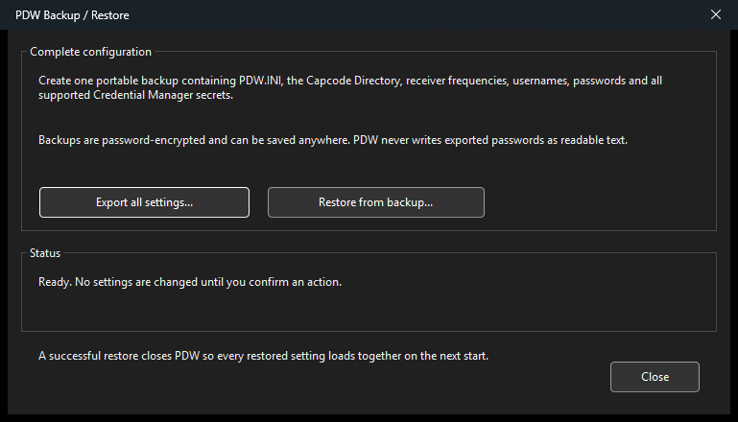
Figure 15. Password-encrypted Backup / Restore dialog (content-free native capture).
Settings > General > Backup / Restore creates one .pdwbackup file containing saved PDW.INI values, the complete Capcode Directory/filter rule set and supported Credential Manager records. AES-256-GCM protects the file with a user-chosen password derived using PBKDF2-HMAC-SHA256. PDW cannot recover a forgotten password.
- Restore authenticates and validates the complete file before confirmation and transactional replacement.
- A successful restore closes PDW so every restored setting loads together on restart.
- The backup does not contain decoded messages, logs, recordings, output queues, website files, receiver DLLs or program binaries.
Backup handling: A .pdwbackup can contain usernames and secrets. Store the file and its password separately, restrict access, test restore in an isolated copy, and securely delete superseded backups under policy.

Troubleshooting
Symptom | Checks
No live meter | Confirm exact source, Windows permission, cable/device, saved endpoint identity, COM/receiver selection and source test.
Activity, no messages | Confirm protocol family, frequency, PPM, rate, bandwidth, gain/level, antenna and clipping.
Named endpoint missing | Reconnect/enable the exact VB-Cable endpoint or deliberately choose another input; PDW should not capture the default microphone.
RTL-SDR not listed | Close other SDR software, confirm the exact USB interface/driver, and use a matching-bitness trusted receiver library.
Rule does not match | Check protocol/capcode, exact versus + keywords, precedence, enabled state, Reject and Monitor Only.
No external delivery | Confirm both the rule destination and Settings destination/group are enabled, configured and passing a synthetic test.
History CSV seems short | Check Search, Protocol and Filtered controls; blank Message means text was not retained.
Queue grows | Pause exposure if needed, correct the destination, review Delivery Health/dead letter, then retest with synthetic data.
Settings layout clips | Record exact release, architecture, Windows build, DPI, theme and content-free screenshot; do not attach operator configuration.

Safe acceptance
- Use an isolated training folder or test installation.
- Use synthetic, redacted or explicitly licensed recordings and directory rows.
- Exercise one known matching and one non-matching event through display, history and local outputs.
- Use disposable external test destinations and keep message text omitted.
- Confirm wrong TLS, authentication and SFTP host-key conditions fail closed.
- Record the exact release, architecture and Windows environment without endpoint IDs, credentials or private traffic.
- Remove disposable credentials, exports and test rows after acceptance.

14. Reference

Quick menu reference
Menu | Use
File | Local logs/copies, configuration backup and exit.
Monitor | Source, pause, mode, input/radio/replay, statistics and volume.
Filters | Capcode Directory, rule behaviour, counters and migration compatibility.
Outputs | Email, notification, transfer, publishing, adapters, health, dashboard and extra channels.
View | Message history, columns, display and appearance.
Help | Manual, diagnostics, About, licence and project resources.

Safe defaults
Capability | Default
Network and external outputs | Disabled until deliberately configured and enabled.
Message history | Disabled; storing message text separately disabled.
Local dashboard | Disabled; loopback-only when enabled.
Guarded extra channels | Disabled; each slot must be enabled and started.
FLEX fragment assembly | Disabled by default in PDW v5.5.2.
Enhanced RTL IQ filtering | Disabled; established RTL signal path retained.
Adelaide FLEX profile | Standard settings remain the default; named profile is explicit and reversible.

Architecture and file reference
Item | Reference
Executable | PDW v5.5.2 2026 Release.exe
x64 role | Current Windows and matching x64 libraries; RTL-TCP is architecture-neutral.
Win32 role | Bundled x86 RTL-SDR and legacy 32-bit integrations.
Configuration | PDW.INI beside the executable.
Directory/history | pdw-history.sqlite3 by default.
Configuration export | Password-encrypted .pdwbackup.
History export | UTF-8 CSV outside archive retention.

Glossary
Term | Meaning
Capcode / Riccode | Raw paging address used for matching; an operator alias never replaces it.
Filtered pane | Lower pane selected by a rule's Filter action; independent from external delivery.
Monitor Only | Keeps a match in the upper pane and does not make it a lower-pane filtered result.
WASAPI | Modern Windows audio capture API used for exact saved endpoints and as a controlled fallback.
WinMM | Established Windows multimedia audio path retained for compatibility.
RTL-TCP | TCP service supplying tuner IQ samples; no decoded message text is sent to it.
SigMF | Signal Metadata Format used here for real float32 diagnostic samples plus metadata.
FTPS / SFTP | TLS-protected FTP / SSH File Transfer Protocol; they use different verification models.
Dead letter | Repeatedly failed queued delivery retained for authorised operator review.
Hardware-unverified | Automated validation passes while representative physical-device acceptance remains open.

Credits and licence
PDW retains credits to Jason Petty, Peter Hunt, the 2013 open-source release and later contributors, including the current modernization work credited by the application. The application and source identify GNU General Public License version 3 or later. Review the supplied License and THIRD_PARTY_NOTICES.md for complete terms and component notices.
Manual maintenance: This edition targets the immutable v5.5.2 release. Re-check version, menus, security guidance, third-party service requirements and hardware acceptance before packaging a later release.

