Incident Report

Team X

January 5, 2026

1. Executive Summary

Incident ID: INC-2026-01-05-XX

Time of Incident Start or Discovery: 2026-01-05 HH:MM:SS

Incident Category:

☐ DoS or DDoS
☐ Malware (e.g., virus, worm, Trojan)
☐ Data Breach
☐ Man-in-the-middle
☐ Injection (e.g., SQL injection, XSS)
☐ Physical Breach
☐ Insider Threat
☐ Social Engineering and Phishing
☐ Other:

Incident Status: ☐ Resolved ☐ Unresolved

Incident Summary:

On January 5, 2026 at HH:MM:SS, Team X detected a [incident type (ex: DoS, ransomware, data breach)]. Using [methods], an unauthorized entity [action (ex. gained access to, compromised, exfiltrated data from)] [impacted assets]. In response, Team X [response actions (ex: contained, revoked access, recovered from backups)].

2. Incident Detection & Analysis

2.1. Aﬀected Systems & Data

This section:
- defines the scope of system(s) and data impacted by the incident and
- identifies the incident’s impact on operations (NIST CSF DE.AE-04) .

IP, hostname, OS | Compromised data and impact on service
Ex: 10.10.32.132 – fruit (Windows Server 2025) | Ex: Customer billing data, including 50 names, credit card numbers, and addresses, stored on this server’s SQL database was compromised. The threat actor disrupted the connection between the website and the customer billing database, preventing customers from paying bills.

2.2. Indicators of Compromise (IoCs)

This section lists the key pieces of evidence used to determine that an incident has occurred (NIST CSF DE.AE-08).

2.3. Root Cause Analysis

This section identifies attack vectors and IP address(es) of involved threat actors (NIST CSF RS.AN-03).

Threat actor IP address(es):

Method of initial access:

2.4. Incident Priority Classification

Based on the findings from the investigations, an incident is given an incident priority and classification to help guide and activate response efforts (NIST CSF RS.MA-03).
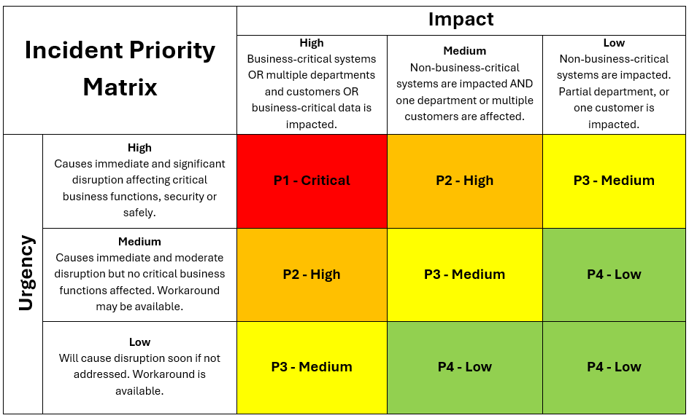

Impact:
☐ High
☐ Medium
☐ Low

Urgency:
☐ High
☐ Medium
☐ Low

Priority Rating:
☐ P1 - Critical ☐ P2 - High ☐ P3 - Medium ☐ P4 - Low

3. Response and Recovery

This section describes:
- the immediate response to contain the threat and prevent further damage upon incident identification, such as disabling user accounts, resetting credentials, and isolating devices (NIST CSF RS.MI-01).
- the steps taken to patch vulnerabilities and eradicate any malware, backdoors, persistence methods, and other things left by the threat actor (NIST CSF RS.MI-02).
- outlines the steps taken to validate, rebuild, and restore data and systems to normal operation after verifying the eradication of the threat (NIST CSF RC.RP).

Technical Timeline

Date & Time | Activity
1/5/2026 HH:MM
1/5/2026 HH:MM
1/5/2026 HH:MM

The NIST Cybersecurity Framework (CSF) 2.0 (https://doi.org/10.6028/NIST.CSWP.29)

