Incident Report

Team X

February 19, 2025

1. Executive Summary

Incident ID: INC-2025-02-19-XX

Incident Priority:

☐P1 - Critical ☐P2 – High ☐P3 - Medium ☐P4 - Low

Incident Classification:

☐ Compromised System
☐ Compromised User Credentials
☐ Network Attack (e.g., DoS)
☐ Malware (e.g., virus, worm, Trojan)
☐ Reconnaissance (e.g., scanning, sniﬃng)
☐ Lost Equipment/Theft
☐ Physical Break-in
☐ Social Engineering (e.g., phishing)
☐ Policy Violation (e.g., acceptable use)
☐ Other:

Incident Summary:

On February 19, 2025 at [time], Team [X] detected [incident]. Using [methods], an unauthorized entity [action (ex. gained access to, compromised, exfiltrated)], impacting [impacted assets].

2. Incident Detection & Analysis

2.1. Aﬀected Systems & Data

The following is a list of system(s) impacted by the incident, along with the data on or accessible by the aﬀected systems (NIST CSF DE.AE-04) .

Click or tap here to enter text.

The following is a list of user(s) impacted by the incident, including system access levels and privileges (NIST CSF DE.AE-04).

Click or tap here to enter text.

2.2. Indicators of Compromise (IoCs)

This section lists the key pieces of evidence used to determine that an attack has occurred (NIST CSF DE.AE-08).

Click or tap here to enter text.

2.3. Root Cause Analysis

This section explains the primary factors that enabled the incident to occur (NIST CSF RS.AN-03).

Click or tap here to enter text.

2.4. Incident Classification & Priority

Based on the findings from the investigations, an incident is given an incident priority and classification to help guide and activate response efforts (NIST CSF RS.MA-03).
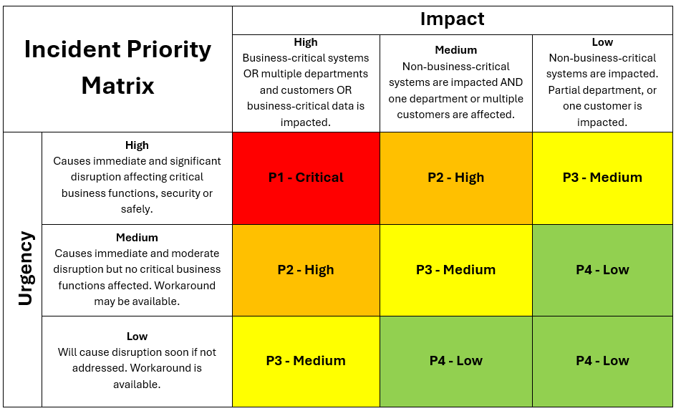

With an impact score of [High, Medium, Low] and an urgency score of [High, Medium, Low], this incident is given [P1, P2, P3, P4] priority. The incident is classified as [look at classifications on page 1].

3. Response and Recovery Analysis

This section describes:
- the immediate response to contain the threat and prevent further damage upon incident identification, such as disabling user accounts, resetting credentials, and isolating devices (NIST CSF RS.MI-01).
- the steps taken to patch vulnerabilities and eradicate any malware, backdoors, persistence methods, and other things left by the threat actor (NIST CSF RS.MI-02).
- outlines the steps taken to validate, rebuild, and restore data and systems to normal operation after verifying the eradication of the threat (NIST CSF RC.RP).

Click or tap here to enter text.

4. Recommendations

The following lists further recommendations related to:
- users and personnel, such as security awareness training and staffing (NIST CSF PR.AT).
- policies, procedures and processes for improving incident prevention and response (NIST CSF GV.PO, ID.IM).
- technology solutions for improving organizational security posture against threats (NIST CSF PR.DS, PR.PS).

Click or tap here to enter text.

Appendix: Technical Timeline

Date & Time | Activity
2/19/2025 HH:MM
2/19/2025 HH:MM
2/19/2025 HH:MM

The NIST Cybersecurity Framework (CSF) 2.0 (https://doi.org/10.6028/NIST.CSWP.29)

