

VILNIUS GEDIMINAS TECHNICAL UNIVERSITY

FACULTY OF FUNDAMENTAL SCIENCES

DEPARTMENT OF INFORMATION SYSTEMS

**ALGORITHMS AND DATA STRUCTURES**

Homework No. 3

Prepared by: ITfuc-21 stud.

UFUK SAYLAN

Accepted by: lect. Urtė Radvilaitė

Vilnius, 2022

**Task No. 13**

Algorithms:

* Quicksort. Pivot – the median of the first, middle and last element.
* Mergesort.

The goal –

The goal is to determine and analyze the factors influencing the sorting speed of algorithms.

Tests:

1. Data – randomly generated numbers. Analyze 5 different sizes of data. Generate 5 sets of random numbers with each size of data and perform 10 tests on each of them.
2. Data – numbers generated in descending order. Analyze 5 different sizes of data. Perform at least 10 tests with the same size of data.

**Testing environment.** *(0,2 point)*

Parameters of a computer:

Asus Tuf laptop with a Ryzen 7 CPU, NVIDIA GeForce GTX 1650 graphics card, 16 GB of Ram Memory.

Programming language: C

Data structure used to store data: ARRAY

Other: The operating system (OS) running on the computer can also influence the performance and behavior of a program. In this case, I am using Ubuntu as the OS.

**Study No. 1.**

**Evaluating the Performance of Quick Sort and Merge Sort on Random Data**

**Testing process.** *(0,2 point)*

1. The first size of data selected – 5,000. Using a C program, numbers were generated 5 sets of random numbers and stored in different text files. They were stored in a array.
2. Each set of random numbers was sorted in both sorting algorithms 10 times. Sorting times were saved in a table and the average of all sorting times was calculated.
3. Steps 1 and 2 were repeated with the following sizes of data: 50,000; 500,000; 750,000; 1,000,000.
4. The overall test results were presented in a graph and the results were analyzed.

**Results**.

The results are presented in tables and graphs.

**The results presented in the table.** *(0,6 point)*

**Table 1**. Results when n=5,000;50,000;500,000;5,000,000;10,000,000

|  |  |  |  |  |  |  |  |  |  |  |  |
| --- | --- | --- | --- | --- | --- | --- | --- | --- | --- | --- | --- |
|  | Time of tests in Seconds | | | | | | | | | |  |
| **Data list 1** n:5,000 | T1 | T2 | T3 | T4 | T5 | T6 | T7 | T8 | T9 | T10 | Avg. |
| Quicksort | 0.001475 | 0.001483 | 0.001372 | 0.001407 | 0.001499 | 0.000740 | 0.000740 | 0.000650 | 0.000613 | 0.000650 | **0.001074** |
| Mergesort | 0.001658 | 0.001060 | 0.000764 | 0.000709 | 0.000690 | 0.000682 | 0.000735 | 0.000694 | 0.000643 | 0.000735 | **0.000837** |
| **Data list 2**  n:50,000 | T1 | T2 | T3 | T4 | T5 | T6 | T7 | T8 | T9 | T10 |  |
| Quicksort | 0.007465 | 0.008161 | 0.007535 | 0.007884 | 0.007477 | 0.007874 | 0.007517 | 0.007902 | 0.008244 | 0.007475 | **0.007753** |
| Mergesort | 0.012735 | 0.008137 | 0.009072 | 0.009279 | 0.008969 | 0.009141 | 0.008948 | 0.008604 | 0.008053 | 0.008626 | **0.009156** |
| **Data list 3**  n:500,000 | T1 | T2 | T3 | T4 | T5 | T6 | T7 | T8 | T9 | T10 |  |
| Quicksort | 0.081283 | 0.081850 | 0.092144 | 0.099762 | 0.081821 | 0.088144 | 0.084925 | 0.089463 | 0.085043 | 0.079023 | **0.086346** |
| Mergesort | 0.115971 | 0.110757 | 0.095270 | 0.116394 | 0.119320 | 0.096058 | 0.095905 | 0.095516 | 0.108807 | 0.096898 | **0.105090** |
| **Data list 4**  n:750,000 | T1 | T2 | T3 | T4 | T5 | T6 | T7 | T8 | T9 | T10 |  |
| Quicksort | 0.120674 | 0.130712 | 0.147754 | 0.135213 | 0.123653 | 0.148836 | 0.149245 | 0.122883 | 0.148304 | 0.125301 | **0.135257** |
| Mergesort | 0.146477 | 0.178179 | 0.152651 | 0.152377 | 0.147918 | 0.147145 | 0.148102 | 0.147347 | 0.154569 | 0.155116 | **0.152988** |
| **Data list 5**  n:1,000,000 | T1 | T2 | T3 | T4 | T5 | T6 | T7 | T8 | T9 | T10 |  |
| Quicksort | 0.164418 | 0.165159 | 0.164071 | 0.177865 | 0.191831 | 0.183071 | 0.166402 | 0.204378 | 0.168716 | 0.175110 | **0.176102** |
| Mergesort | 0.246169 | 0.245776 | 0.214918 | 0.196808 | 0.239519 | 0.202795 | 0.197091 | 0.202148 | 0.198354 | 0.196184 | **0.213976** |

**Table 2**. General results.

**The results presented in the graph.** *(0,6 point)*

**Figure 1**. Random number sorting results.

**Analysis of results.**

**Statement 1 – theoretical evaluation.** *(0,2 point)*

The obtained testing results of Quicksort corresponds to theoretical evaluation.

The obtained testing results of Mergesort corresponds to theoretical evaluation.

**Justification. *(0,2 point –* *derivation of increase from theoretical estimate, 0,3 point – calculations, 0,3 point – analysis)***

**Statement 1.1**

Quicksort has a worst-case time complexity of O(n^2), although it has an average-case time complexity of O(n log n). This means that in the worst case, the algorithm will take O(n^2) time to sort an array of size n. However, the average-case time complexity is O(n log n), which means that on average, the algorithm will take O(n log n) time to sort an array of size n.

Theoretical estimate of an Quicksort when data is random: .

The size of data was increased twice each time, therefore:

Conclusion: Doubling the size of data should increase the sorting time by a factor of about 2.22.

Calculations with testing results:

In the study, there is only one data that is the double size of the data 1,000,000. The actual running time of an algorithm can vary significantly from the theoretical estimate, depending on a variety of factors such as the specific implementation of the algorithm and the characteristics of the input data. Therefore, 2.04 close enough to 2.22 to be said to be within the theoretical estimate.

**Statement 1.2**

Merge sort has a worst-case time complexity of O(n log n). This means that in the worst case, the algorithm will take O(n log n) time to sort an array of size n.

Theoretical estimate of an Merge sort when data is random: .

The size of data was increased twice each time, therefore:

Conclusion: Doubling the size of data should increase the sorting time by a factor of about 2.22.

2.04, again, close enough to 2.22 to be said to be within the theoretical estimate.

**Statement 2 – speed comparison.** *(0,2 point)*

Results showed that Quicksort is faster than Merge sort in every case of the study.

One disadvantage of Merge sort is that it uses additional space, an auxiliary array to store the sorted element, to sort the element. Quicksort is an in-place sorting algorithm, meaning that it does not require any additional space to sort the input data. This can make Quicksort more efficient than other sorting algorithms that require additional space

Justification. *(0,3 point)*

**Statement 3 - Choosing a good pivot element.** *(0,2 point)*

While implementing Quicksort algorithm, there are number of ways to choose a pivot element. The left most, rightmost element, or the middle element. In the study, median of three was chosen and implemented using binary arithmetic’s, which is much faster. This implementation is another reason why Quicksort never run with its worst-case time complexity of O(n^2),

Justification. *(0,3 point)*

**Study No. 2**

**Efficiency Comparison of Merge Sort and Quick Sort on Descending Order Data**

**Testing process.** *(0,2 point)*

1. The first size of data selected – 5,000. Using a C program, numbers were generated 5 sets of descending numbers and stored in different text files. They were stored in a array.
2. Each set of random numbers was sorted in both sorting algorithms 10 times. Sorting times were saved in a table and the average of all sorting times was calculated.
3. Steps 1 and 2 were repeated with the following sizes of data: 50,000; 500,000; 750,000; 1,000,000.
4. The overall test results were presented in a graph and the results were analyzed.

**Results**.

The results are presented in tables and graphs.

**The results presented in the table.** *(0,6 point)*

|  |  |  |  |  |  |  |  |  |  |  |  |
| --- | --- | --- | --- | --- | --- | --- | --- | --- | --- | --- | --- |
|  | Time of tests of descending data sets in Seconds | | | | | | | | | |  |
| **Data list 1** n:5,000 | T1 | T2 | T3 | T4 | T5 | T6 | T7 | T8 | T9 | T10 | Avg. |
| Quicksort | 0.000862 | 0.000733 | 0.000738 | 0.000727 | 0.000732 | 0.000735 | 0.000738 | 0.000469 | 0.000400 | 0.000366 | **0.000650** |
| Mergesort | 0.000404 | 0.000397 | 0.000444 | 0.000496 | 0.000484 | 0.000509 | 0.000556 | 0.000568 | 0.000559 | 0.000555 | **0.000497** |
| **Data list 2**  n:50,000 | T1 | T2 | T3 | T4 | T5 | T6 | T7 | T8 | T9 | T10 |  |
| Quicksort | 0.003444 | 0.004412 | 0.003861 | 0.004389 | 0.004661 | 0.005083 | 0.005027 | 0.004683 | 0.004822 | 0.003277 | **0.004366** |
| Mergesort | 0.013563 | 0.005759 | 0.005816 | 0.005883 | 0.006265 | 0.005743 | 0.005766 | 0.005707 | 0.005743 | 0.005095 | **0.006534** |
| **Data list 3**  n:500,000 | T1 | T2 | T3 | T4 | T5 | T6 | T7 | T8 | T9 | T10 |  |
| Quicksort | 0.034779 | 0.035933 | 0.035933 | 0.034948 | 0.040549 | 0.042442 | 0.044040 | 0.037059 | 0.035094 | 0.034817 | **0.037559** |
| Mergesort | 0.058178 | 0.057837 | 0.060389 | 0.063925 | 0.067406 | 0.071071 | 0.070329 | 0.070420 | 0.059938 | 0.067990 | **0.064748** |
| **Data list 4**  n:750,000 | T1 | T2 | T3 | T4 | T5 | T6 | T7 | T8 | T9 | T10 |  |
| Quicksort | 0.052983 | 0.052585 | 0.054253 | 0.054960 | 0.064910 | 0.067057 | 0.059224 | 0.056095 | 0.057541 | 0.054103 | **0.057371** |
| Mergesort | 0.090180 | 0.088850 | 0.088486 | 0.089443 | 0.088879 | 0.088255 | 0.091546 | 0.088968 | 0.106205 | 0.112697 | **0.093351** |
| **Data list 5**  n:1,000,000 | T1 | T2 | T3 | T4 | T5 | T6 | T7 | T8 | T9 | T10 |  |
| Quicksort | 0.074144 | 0.089151 | 0.088498 | 0.092786 | 0.070539 | 0.072345 | 0.070858 | 0.070879 | 0.070934 | 0.071320 | **0.077145** |
| Mergesort | 0.117929 | 0.146225 | 0.145398 | 0.144719 | 0.133487 | 0.127474 | 0.146810 | 0.144861 | 0.131968 | 0.119075 | **0.135795** |

**The results presented in the graph.** *(0,6 point)*

***Figure 1****. Descending number sorting results.*

**Analysis of results.**

**Statement 1 – theoretical evaluation.** *(0,2 point)*

The obtained testing results of **Quicksort** corresponds to theoretical evaluation.

The obtained testing results of **Mergesort** corresponds to theoretical evaluation.

Justification. *(0,2 point –* *derivation of increase from theoretical estimate, 0,3 point – calculations, 0,3 point – analysis)*

**Statement 1 – Quicksort**

Theoretical estimate of an Quicksort when data is random: .

The size of data was increased twice each time, therefore:

Conclusion: Doubling the size of data should increase the sorting time by a factor of about 2.22.

Calculations with testing results:

**Statement 1 – Merge sort**

Theoretical estimate of an Merge sort when data is random: .

The size of data was increased twice each time, therefore:

Conclusion: Doubling the size of data should increase the sorting time by a factor of about 2.22.

**Statement 2 – speed comparison.** *(0,2 point)*

Quicksort is considered to be a faster sorting algorithm than Mergesort, due to its in-place sorting and relatively small constant factors in its time complexity. However, the actual running time of Quicksort can vary significantly depending on the choice of pivot element and the characteristics of the input. Since our choice of median was intelligent, Quicksort outrun the Merge sort in every case in both studies.

Justification. *(0,3 point)*

**Statement 3 –algorithm speed dependence on data set.** *(0,2 point)*

**Merge sorts** the data in study of *Evaluating the Performance of Quick Sort and Merge Sort on Random Data* ***slower*** than *the data in the study of Efficiency Comparison of Merge Sort and Quick Sort on Descending Order Data*

Justification. *(0,3 point)*

Merge sort is a divide and conquer algorithm that works by dividing the input array into smaller subarrays, sorting those subarrays, and then merging them back together. The merge step of the algorithm is typically the most efficient part, because it involves combining two sorted arrays into a single sorted array in a single pass through the data.In the case of an array that is already in descending order, the subarrays produced by the divide step will already be partially sorted, which means that the merge step can more efficiently combine them into a single sorted array. This will lead to faster overall runtime for merge sort on such arrays.

Quick sort does not generally perform better on arrays that are already partially sorted or in descending order. In fact, quick sort tends to perform worse on such arrays because the pivot selection process is less effective at partitioning the array into two balanced subarrays. However, our choice of pivot element was median. That’s why it is more likely to partition the array into two subarrays of approximately equal size.

**General conclusions.**

1. conclusion. *(0,3 point)*

Quicksort is generally faster than Merge sort for sorting random data. The results of the study show that Quicksort had a lower average sorting time than Merge sort for all sizes of data tested, with the difference in performance becoming more pronounced as the size of the data increased. This suggests that Quicksort is generally faster than Mergesort for sorting random data.conclusion. *(0,3 point)*

1. conclusion. *(0,3 point)*

One possible explanation for the faster performance of Quicksort is its in-place sorting, which allows it to sort the data without requiring additional space. In addition, Quicksort has a relatively small constant factor in its time complexity, which may have contributed to its faster performance in this study.

1. conclusion. *(0,3 point)*

Quicksort has relatively small constant factors in its time complexity, meaning that the running time of the algorithm is dominated by the size of the input data rather than the specific implementation of the algorithm. This can make Quicksort faster than other algorithms with larger constant factors, such as Mergesort, which has a larger constant factor in its time complexity.

The results of the study show that Quicksort was generally faster than Mergesort in sorting random data. Quicksort had a lower average sorting time than Mergesort for all sizes of data tested, with the difference in performance becoming more pronounced as the size of the data increased.

**ANNEXES.**

Quicksort with 500,000 random numbers data:

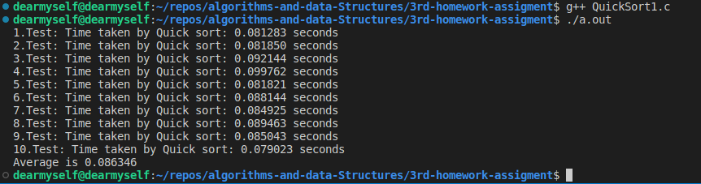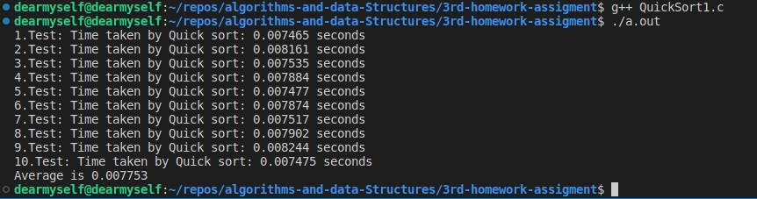Quicksort with 50,000 random numbers data:

Quicksort with 5,000 random numbers data:

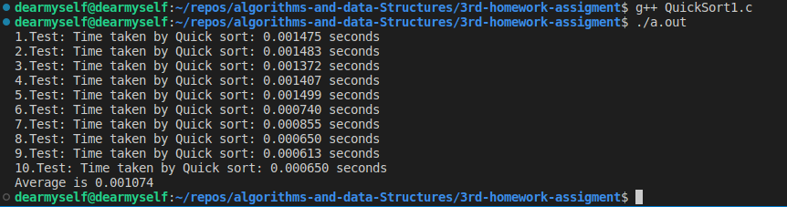

Mergesort with 5,000 random numbers data:

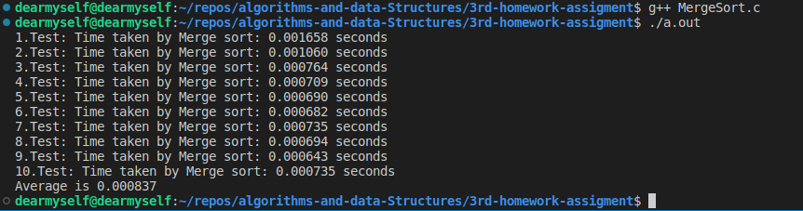Mergesort with 50,000 random numbers data:

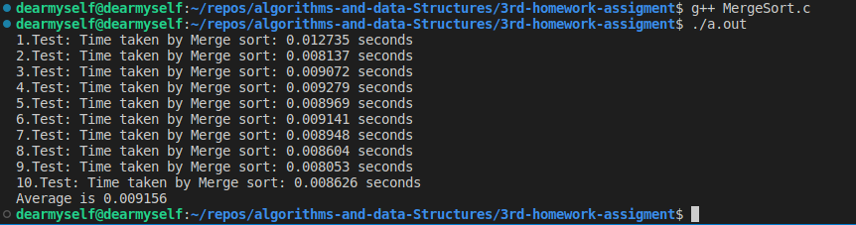

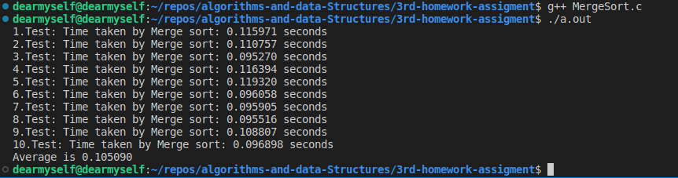Mergesort with 750,000 random numbers data:

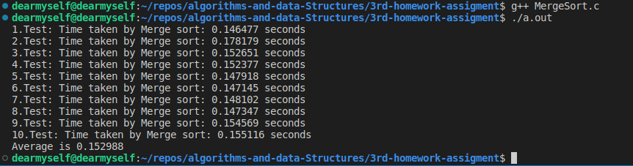a

Mergesort with 1,000,000 random numbers data:

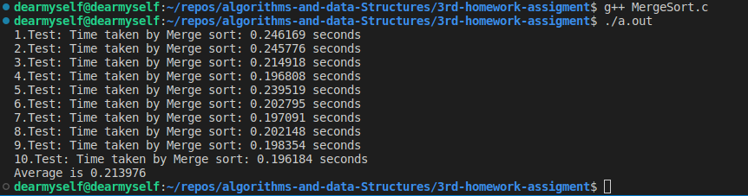Quicksort with 750,000 random numbers data:

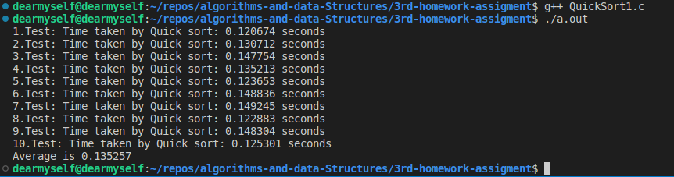Quicksort with 1,000,000 random numbers data:

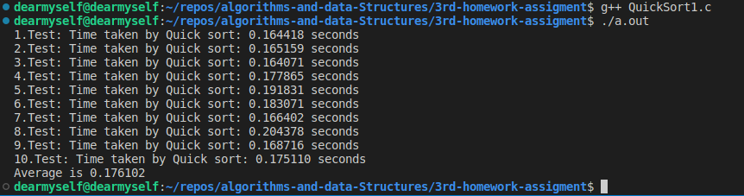

Quicksort with 1,000,000 descending numbers data:

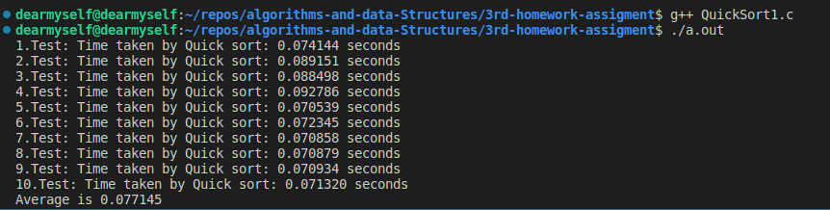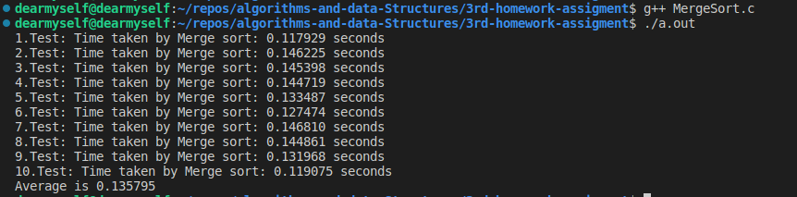Mergesort with 750,000 descending numbers data:

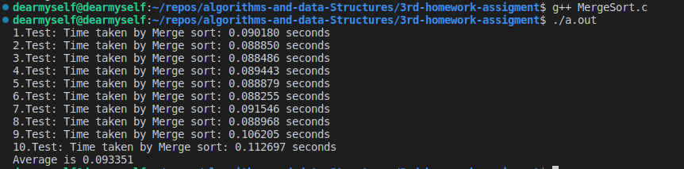Quicksort with 750,000 descending numbers data:

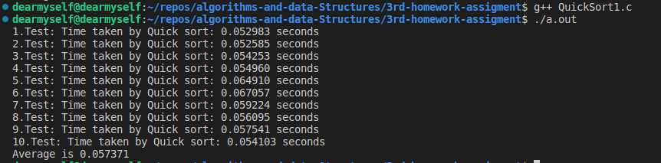

Quicksort with 500,000 descending numbers data:

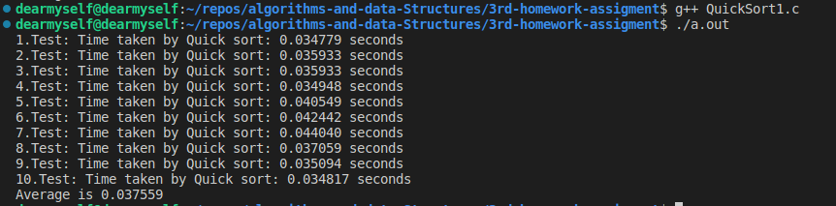

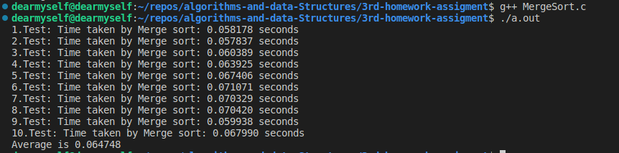Mergesort with 50,000 descending numbers data:

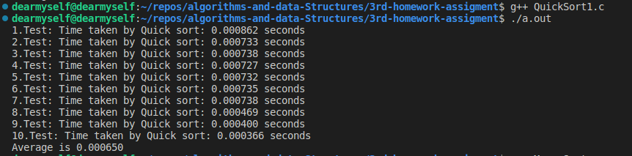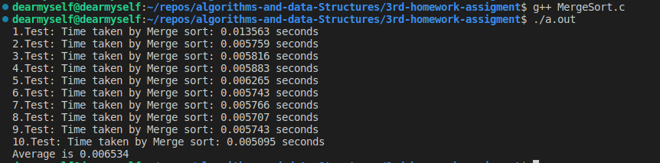Quicksort with 5,000 descending numbers data: