

**SEN114 COMPUTER PROGRAMMING-II**

**WikiBook**

**Assoc.Prof.TANER ÇEVİK**

**Ufuk Barış Tunca**

B1705.090027

**CONTENTS**

**1. INTRODUCTION 3**

**2. PURPOSE 3**

**3. DESIGN 4 3.1 UML DIAGRAM 4**

**4. DEVELOPMENT 5**

**4.1 PROGRAMING LANGUAGE 5 4.2 PROGRAMING TOOL (IDE) 5**

**5. RESOURCES 6**

2

**1. INTRODUCTION**

We are now living in a world of links which are supposed to help us in our daily lives. Often we now find searching for solutions brings us to databases of links to suggested problem solving or forums.

The issue is these are often circular, one doesn’t always know exact terms to bring up a solution, and you can spend a good portion of time without getting the answer needed. Computer generated answers to our searches are unlikely to be what we need, and often following them don’t work.

Librarians are in a unique position to find those URL links, phone numbers, and people by collecting these undocumented bits of information, and this collection can be facilitated by certain apps.

**2. PURPOSE**

As technology changes and evolves, so do our reading habits. While this age-old pastime used to mean trips to the library or bookstore, devices like smartphones and iPads have made reading a digital habit, one that’s accessible to virtually anyone, anywhere.

Wikibook is a social networking app for book lovers. It’s the premier place to discover new books, get information about books, discover writers, and read their biography. Once you start tracking your books with Wikibook, you’ll see recommendations that are surprisingly on-point.

3

**3. DESIGN**

**3.1 UML DIAGRAM**

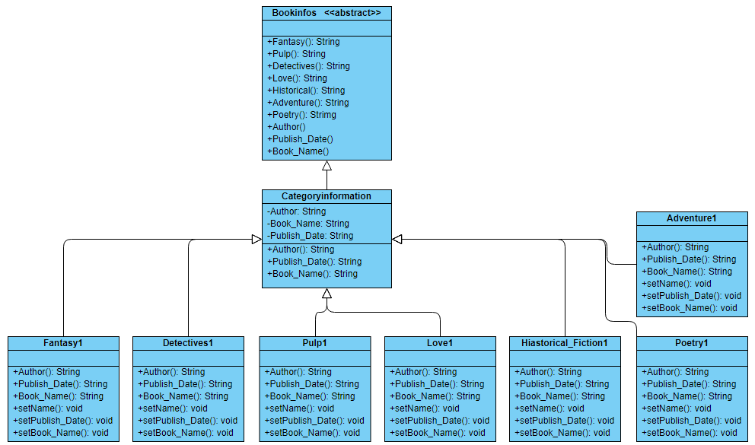

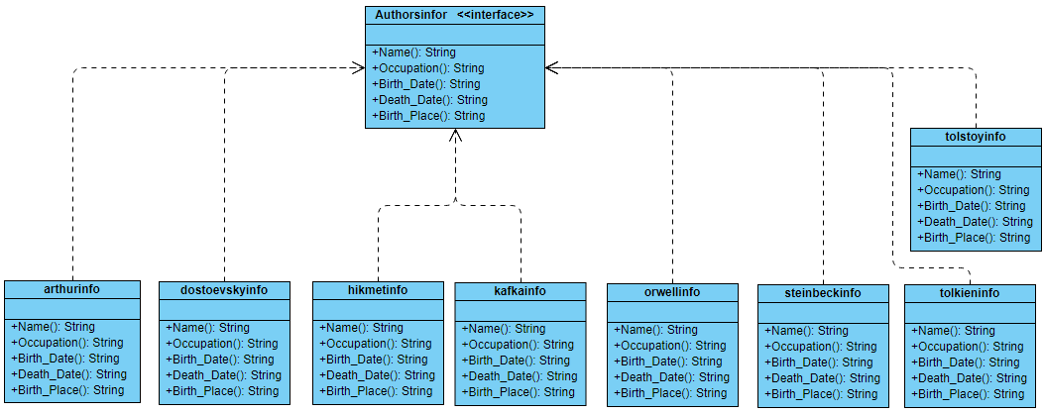

4

**4. DEVELOPMENT**

**4.1 PROGRAMING LANGUAGE**

Java is a programming language that produces software for multiple platforms. When a programmer writes a Java application, the compiled code (known as bytecode) runs on most operating systems (OS), including Windows, Linux and Mac OS. Java derives much of its syntax from the C and C++ programming languages.  
  
Java was developed in the mid-1990s by James A. Gosling, a former computer scientist with Sun Microsystems.

1. **Object-Oriented Programming Language -** It is based on the concept of class and objects.
2. **Distributed -** It is network aware and hence, java programs can easily be run on any platform.
3. **Interpreted -**Java language is known to be compiled to byte-codes, which are then interpreted to Java Run-Time Environment.
4. **Robust -** It is designed especially to remove certain types of programming errors.
5. **Secure -**Java provides one with the most secure environment. Even though it is running on a network, one can be sure about the online security with java run-time environment.
6. **Portability -**Portability is another important concept that java programming language follows.
7. **Dynamic -**Java is one of the most dynamic programming language.
8. **Easy Learning -** Most of the programming languages are very hard to understand and one might require to put a lot of effort but using java as a programming language.

**4.2 PROGRAMING TOOL (IDE)**

Eclipse is a platform that has been designed from the ground up for building integrated web and application development tooling. By design, the platform does not provide a great deal of end user functionality by itself. The value of the platform is what it encourages: rapid development of integrated features based on a plug-in model.

Eclipse provides a common user interface (UI) model for working with tools.  It is designed to run on multiple operating systems while providing robust integration with each underlying OS.  Plug-ins can program to the Eclipse portable APIs and run unchanged on any of the supported operating systems.

At the core of Eclipse is an architecture for dynamic discovery, loading, and running of plug-ins. The platform handles the logistics of finding and running the right code. The platform UI provides a standard user navigation model.  Each plug-in can then focus on doing a small number of tasks well. What kinds of tasks? Defining, testing, animating, publishing, compiling, debugging, diagramming...the only limit is your imagination.

5

**5. RESOURCES**

1. https://help.eclipse.org.

2. <https://www.quora.com>