(get Picture from Website)
Engr. DANIEL OSAGIE has over four decades of cognate experience in the civil, building, mechanical,
electrical and public health engineering industry.
Since 1987 when he led the establishment of O’SANIEL AND COMPANY, he has
executed the construction and structural design of several civil engineering and
public health engineering projects nationwide.
He is a registered member of
the Nigerian Society of Engineers (NSE) and Council for the Regulation of Engineering practice in Nigeria
(COREN).

JEFFERSON UWOGHIREN, ESQ
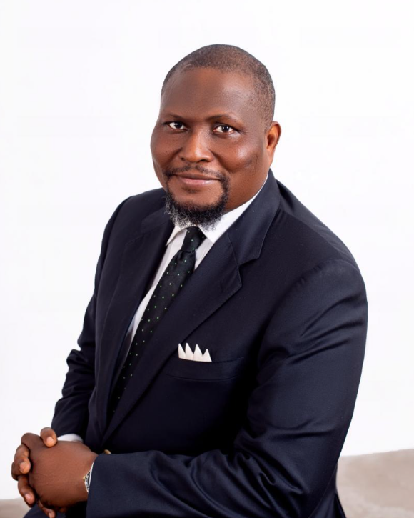
Jefferson Uwoghiren, Esq., is a distinguished legal practitioner whose life journey reflects resilience, integrity, intellectual growth, and an unwavering commitment to excellence. His professional path began in journalism, where he cultivated strong analytical abilities, effective communication skills, and a deep respect for truth and public enlightenment. His experience as a journalist laid a solid foundation for his future endeavours, instilling in him a keen sense of responsibility and a passion for societal impact.

In addition to his journalism career, Jefferson Uwoghiren is a lawyer of many years standing and the Managing Director of Trafex Ltd, a perception management company incorporated in 1992. Under his leadership, the company has successfully executed high-profile projects for several government organizations and reputable private companies, earning a reputation for excellence, professionalism, and strategic impact. earning a reputation for integrity, diligence, and professionalism. Throughout his career, he has remained committed to upholding the rule of law, advocating for justice, and providing exceptional legal services to his clients. His contributions to the legal field have garnered him respect among his peers and within the broader legal community.

CHARLES AKHIGBE

Charles Akhigbe is business executive, management and strategy consultant with over three decades of multifaceted experience spanning financial services, agribusiness, real estate advisory, sales and marketing which has provided him the opportunity of developing valuable relationships at C-suite levels in various private and public sector growth markets and institutions.

In addition to a robust risk management, business development and deal execution capacity, he has over the years profitably led multiple business and turnaround teams in Allstates Trust Bank, FSB International Bank Plc, Fidelity Bank Plc and Wondar Mills Limited.

Charles Akhigbe was Head, Public Sector, Midwest Region at Fidelity Bank Plc prior to leading the Zehava Concepts Nigeria Limited team.

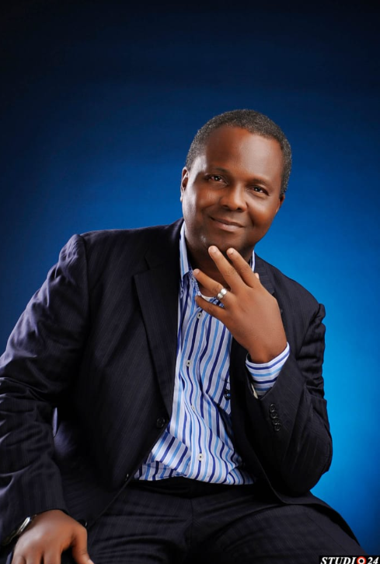

Lets build a Single-page website for a real estate project using best in industry standard with animations and parallax effects. The name of the project is AUSTINKATE COURTS. Create spaces to showcase the Developers, Contractors and Facilitators. we should also showcase Potential Finishings

