Zoom → Slack Status Sync
Setup Guide
Automatically sets your Slack status when you join a Zoom call,
then restores your previous status when the call ends.
Requirements: macOS · Python 3.9+ · ~15 minutes

Overview
Each person runs their own copy of this tool. You will:
- Create your own personal Slack app (5 min)
- Download the project to your Mac
- Add your Client ID to a config file
- Run a one-time Slack sign-in
- Install the background watcher (runs automatically at login)

💡 Note: Each person must do this individually — do not share Client IDs or config files.

Step 1: Create Your Slack App
Open a web browser and go to: api.slack.com/apps
You'll see a list of your existing apps (may be empty). Click Create New App.

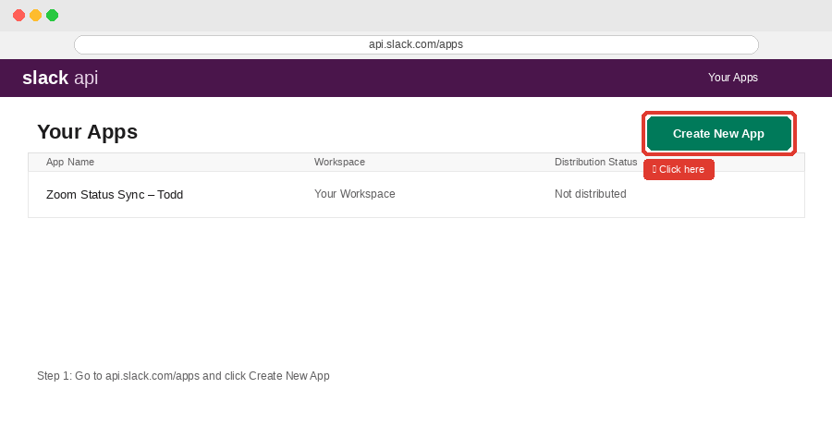

Choose "From scratch"
In the modal that appears, select From scratch.
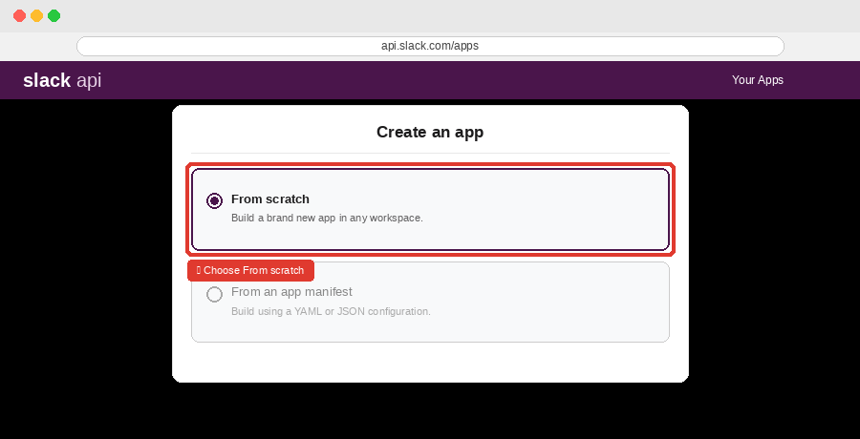

Name Your App & Choose a Workspace
Give your app a personal name so you can identify it later. Include your name to keep it distinct from teammates' apps:
Zoom Status Sync – Todd
Then select your work Slack workspace from the dropdown and click Create App.
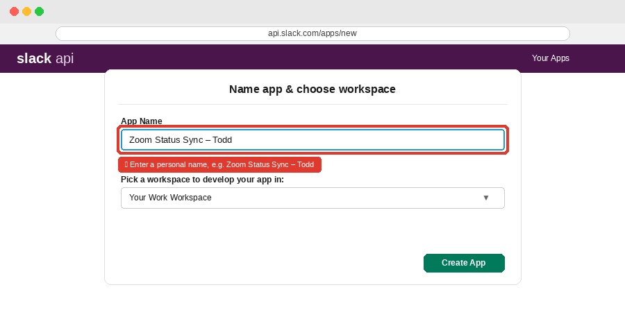

Add a Redirect URL
In the left sidebar, click OAuth & Permissions. Scroll to Redirect URLs, click Add New Redirect URL, and paste exactly:
http://localhost:8765/slack/oauth/callback
Click Add, then Save URLs.
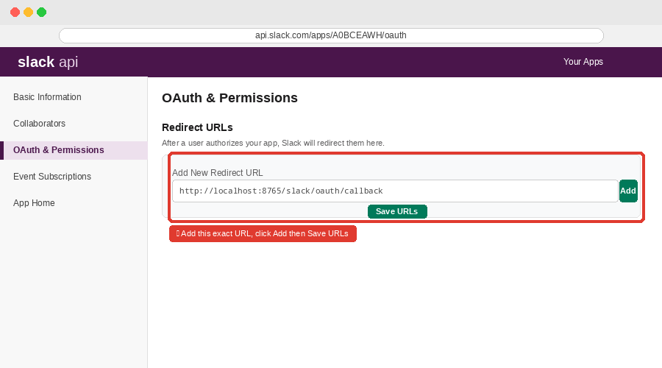

Enable PKCE
Still on OAuth & Permissions, find the PKCE section and turn it On. This app runs on your Mac and has no client secret, so PKCE is required.
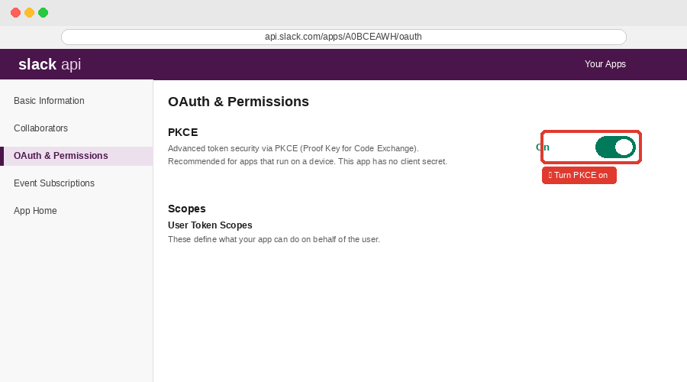

Add User Token Scopes
Scroll down to Scopes. Under User Token Scopes (not Bot Token Scopes), add both:
- users.profile:read
- users.profile:write
⚠️ Do NOT add Bot Token Scopes — only User Token Scopes are needed.
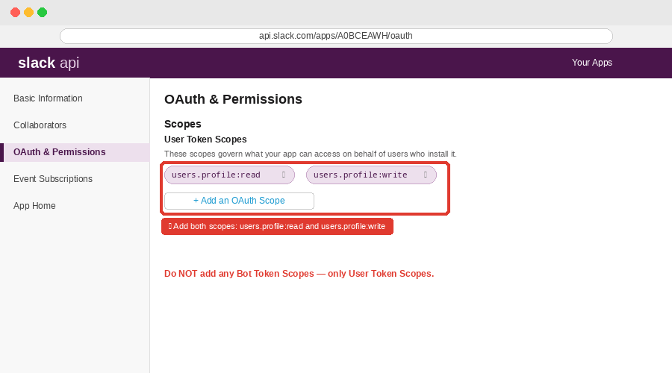

Copy Your Client ID
In the left sidebar, click Basic Information. Scroll to App Credentials and find your Client ID. Click Copy to save it — you'll need it in Step 3.
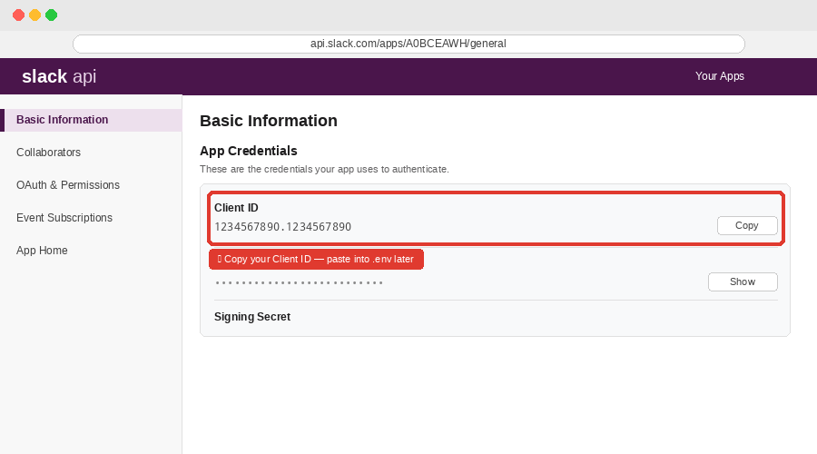
💡 Note: Your Client ID looks like: 1234567890.1234567890. Keep it handy.

Step 2: Download the Project
Open Terminal (Applications → Utilities → Terminal) and run these commands:
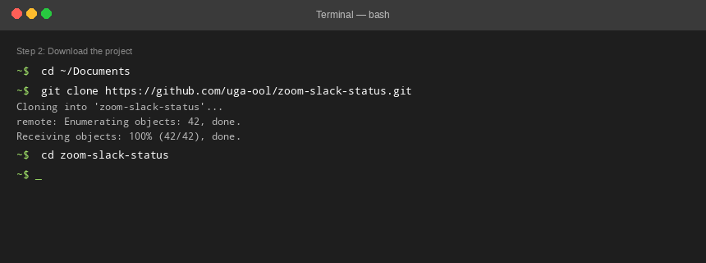
If macOS asks you to install Xcode Command Line Tools, click Install and then re-run the commands.
💡 Note: Your project folder will be at ~/Documents/zoom-slack-status

Step 3: Configure Your .env File
Still in Terminal (in ~/Documents/zoom-slack-status), run:
cp .env.example .env
open -e .env
This creates your personal config file and opens it in TextEdit. Find the SLACK_CLIENT_ID= line and paste your Client ID from Step 1 after the equals sign:
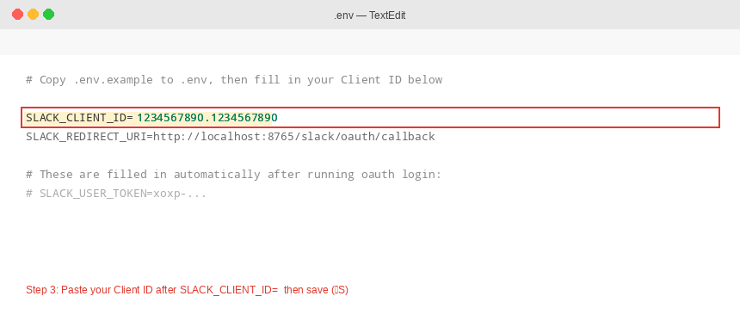
Save the file (⌘S) and close TextEdit.
⚠️ Never share your .env file. It will contain your personal Slack token after Step 4.

Step 4: Connect Slack
Back in Terminal, run:
/usr/bin/python3 -m zoom_slack_status oauth login --env-file .env
Terminal will open Slack in your browser. Click Allow, then return to Terminal — you should see a success message.
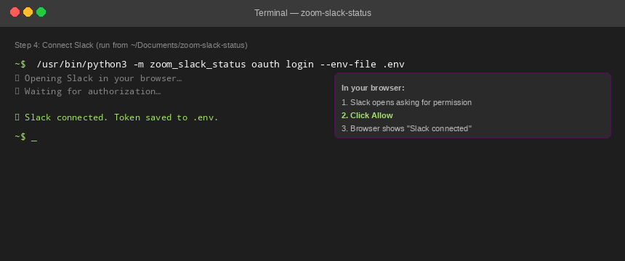
If it fails, double-check your redirect URL, PKCE setting, and scopes from Step 1, then run the command again.

Step 5: Install the Background Watcher
Run this final command from ~/Documents/zoom-slack-status:
/usr/bin/python3 -m zoom_slack_status launch-agent install --env-file .env
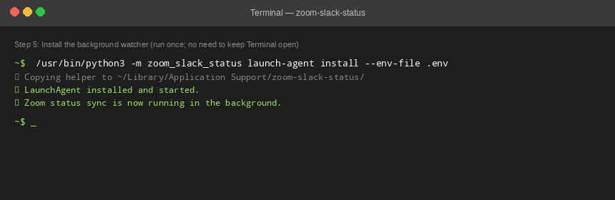
The watcher is now running in the background. You can close Terminal. It will automatically start again when you log in to your Mac.
💡 Note: From now on: join a Zoom call → your Slack status changes to "On a Zoom call" within ~5 seconds. Leave → your previous status is restored.

Verify It's Working
Join a Zoom test call and check your Slack status. To manually check what the watcher sees, run:
/usr/bin/python3 -m zoom_slack_status status --env-file .env

Troubleshooting
Status stopped updating after a few weeks
Token rotation may have expired your token. Re-run Steps 4 and 5:
/usr/bin/python3 -m zoom_slack_status oauth login --env-file .env
/usr/bin/python3 -m zoom_slack_status launch-agent install --env-file .env

Status takes too long to clear after leaving a call
Add this line to your .env file and reinstall the agent:
ZOOM_SLACK_IDLE_CONFIRMATIONS=2

View logs
~/Library/Logs/zoom-slack-status.log
~/Library/Logs/zoom-slack-status.err.log

Uninstall
/usr/bin/python3 -m zoom_slack_status launch-agent uninstall

Project: github.com/uga-ool/zoom-slack-status | Each person sets up their own app and .env. Do not share credentials.

