Level 3
Deterministic symbolic engine
Hand written parser and rule based question answering program

Main question
At which point, if any, would you attribute some understanding of Chinese to the system?

What this level is
A short Python program recognizes several Chinese templates, looks up event tuples, answers who questions, accepts one paraphrase family, and tracks ownership across two transfers.

What this level adds
The people and paper packet become executable software. The program also composes a result from two stated transfers rather than consulting only one stored event.

How it works
Regular expressions bind named roles such as actor, object, and recipient. Tuples store events. Explicit branches select yes or no, missing actor, missing recipient, or transfer-chain behavior. The entire accepted language is visible in one file.

Example interaction
Input
Output | 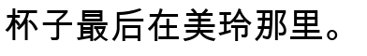
Status | Reproducible output from symbolic_engine.py.

What it still cannot show
- Every accepted construction and reasoning step is hand written.
- It rejects unfamiliar synonyms and word order even when a person understands them.
- The two-step rule does not generalize to arbitrary stories.

Interact with this level
- Run python3 symbolic_engine.py followed by a quoted Chinese prompt.
- Add --trace to display the matched rule and intermediate owner states.
- Edit one event tuple or grammar alternative and observe exactly which inputs change.

Suggested inputs
- 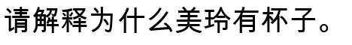

Questions to notice
- Does speed or replacement of people by software affect attribution?
- Is composing two explicit rules importantly different from table lookup?
- Could the program's complete transparency count against it?

Transition to the next level
Level 4 removes the requirement for an exact grammar match. It chooses an answer by graded similarity to stored examples.

