Level 7
UER Chinese GPT 2
Published transformer base language model

Main question
At which point, if any, would you attribute some understanding of Chinese to the system?

What this level is
A Chinese GPT-2 checkpoint uses twelve transformer layers and broad-corpus pretraining to continue text over a 21,128-token vocabulary.

What this level adds
Learned attention replaces a fixed three-character context. Many layers build context-sensitive internal vectors, and a much larger corpus supplies broader syntax and vocabulary.

How it works
The transformer predicts one token at a time from all tokens within its context window. It is a base language model, so a question may be continued rather than answered as a request.

Example interaction
Input | 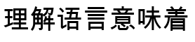
Output
Status | Illustrative continuation form, not a saved run. Sampling output varies.

What it still cannot show
- Pretraining optimizes continuation, not obedience to user requests.
- It can repeat common associations without reliably following a task.
- Broad linguistic behavior does not establish grounding outside its training text.

Interact with this level
- Open the official model card and inspect its files, configuration, and usage example.
- Run python3 run_model.py followed by a Chinese prefix to download and sample the checkpoint.
- Try both an unfinished sentence and a direct question. Compare completion with instruction following.

Suggested inputs
- 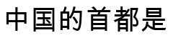
- 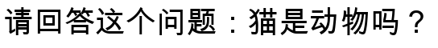
- 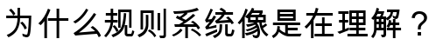

Questions to notice
- Does attention over a longer context differ in kind from the n-gram table?
- Does learning representations across layers make the system less like a rule book?
- Should knowledge acquired from text count as contact with meaning?

Transition to the next level
Level 8 adds instruction post-training to a small multilingual transformer so that it treats the input as a request and produces a conversational answer.

Sources and links
- Official model card
- UER py repository

