Level 11
Qwen3 235B A22B Instruct
Server scale sparse mixture of experts language model

Main question
At which point, if any, would you attribute some understanding of Chinese to the system?

What this level is
This model expands the sparse instruction-tuned paradigm to 235 billion total parameters and 22 billion active per token.

What this level adds
The organization remains recognizable while breadth, stored statistical structure, and task performance increase. The level exists to prevent frontier behavior from appearing as one unexplained jump.

How it works
A transformer routes tokens among many learned experts while maintaining shared attention and residual state. Only a fraction of the stored parameters participates in each token's forward pass.

Example interaction
Input
Output | 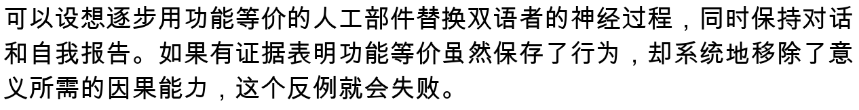
Status | Illustrative answer form, not a saved run. It is included to show the intended test, not a benchmark claim.

What it still cannot show
- Server-scale sophistication remains behavioral evidence under one experimental interface.
- The model may produce persuasive but unsupported philosophical arguments.
- The absence of a sharp architectural threshold leaves the attribution question unresolved.

Interact with this level
- Open the official model card and use an offered inference provider or another compatible hosted deployment.
- Self-host only with appropriate server hardware and deployment expertise.
- Use the same prompts as Level 10 before adding harder long-form synthesis or counterfactual tasks.

Suggested inputs
- 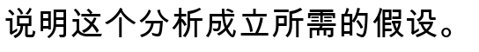

Questions to notice
- Did your rating rise smoothly or jump despite a mostly quantitative change?
- Does a more coherent self-defense count as evidence, or is it only another output?
- What would this model need besides text to satisfy your criterion?

Transition to the next level
Level 12 adds native visual input, a one-million-token context, and tool-oriented agentic behavior while greatly scaling the sparse model.

Sources and links
- Official model card
- Qwen3 repository

