Level 4
Approximate retrieval bot
Character n gram TF IDF nearest neighbor system

Main question
At which point, if any, would you attribute some understanding of Chinese to the system?

What this level is
The program measures how similar a new Chinese prompt is to stored examples and returns the answer paired with the nearest example.

What this level adds
Matching becomes graded rather than all or nothing. Unseen wording can succeed when its characters and short character sequences resemble a stored question.

How it works
Each question becomes counts of characters and two-character sequences. TF IDF weights rarer features more heavily. Cosine similarity selects the nearest stored prompt, subject to a minimum threshold.

Example interaction
Input | 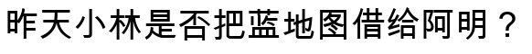
Output
Status | Reproducible output. The nearest stored prompt scores about 0.669 with the included data.

What it still cannot show
- The chosen answer is copied from a stored pair rather than derived from the prompt.
- Small wording changes can cause a different neighbor to win.
- Similarity does not ensure that roles, negation, or factual relations match.

Interact with this level
- Run python3 retrieval_bot.py followed by a quoted Chinese prompt.
- Add --show-match to reveal the stored question and cosine similarity score.
- Add or delete one example pair in EXAMPLES and test the same prompt again.

Suggested inputs
- 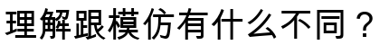
- 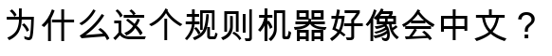

Questions to notice
- Is approximate recognition a qualitative change from explicit rules?
- Does a continuous similarity score resemble human categorization more than a branch does?
- If the output is copied, does it matter how flexibly the input was matched?

Transition to the next level
Level 5 learns the mapping from text features to response category as neural weights instead of calculating a stored neighbor directly.

