Level 5
Tiny neural intent classifier
Small learned network with hand written responses

Main question
At which point, if any, would you attribute some understanding of Chinese to the system?

What this level is
A 3,986-parameter neural network learns to classify Chinese prompts into six intentions, then selects a response template and applies a small name heuristic.

What this level adds
Some input-output organization now comes from training examples and learned weights rather than a programmer writing every classification branch.

How it works
Stable hashed character features feed a 192 by 20 hidden layer and a six-way output layer. Gradient descent trains the weights at startup. The final response sentences and name extraction remain explicit code.

Example interaction
Input
Output
Status | Reproducible output with the included training data; reported confidence is about 0.978.

What it still cannot show
- The network learns categories, not the response language itself.
- Confidence measures competition among its six labels, not correctness or understanding.
- The last-name heuristic can answer for the wrong reason.

Interact with this level
- Install NumPy in any Python environment.
- Run python3 tiny_neural_bot.py --show-class followed by a quoted Chinese prompt.
- Change a training example, retrain by rerunning the file, and compare the predicted intent.

Suggested inputs
- 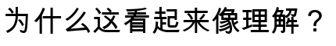
- 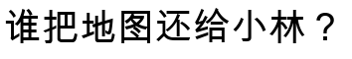
- 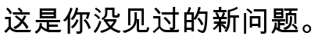

Questions to notice
- Does learning from examples matter even when the learned representation is tiny?
- Are opaque weights less syntactic than readable rules?
- Would the same behavior deserve a different judgment if every weight were hand selected?

Transition to the next level
Level 6 learns character-to-character transition statistics and generates the response text itself, although with only three characters of context.

