Level 9
Qwen3 4B Instruct
Medium dense instruction tuned language model

Main question
At which point, if any, would you attribute some understanding of Chinese to the system?

What this level is
A four-billion-parameter dense model extends the same general approach with more learned capacity, thirty-six layers, and a 262,144-token context.

What this level adds
The mechanism does not change dramatically. The model can preserve and transform more context, represent more patterns, and usually handle more involved instructions.

How it works
Every token passes through the same dense transformer layers. Attention relates tokens across the context, and post-training shapes the model for conversational tasks.

Example interaction
Input
Output | 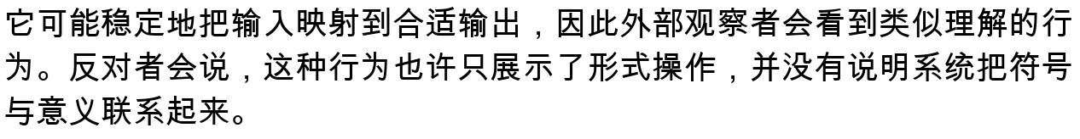
Status | Illustrative answer form, not a saved run. Actual generations vary.

What it still cannot show
- More capacity can improve performance without creating a visible conceptual boundary.
- Long context is available memory, not guaranteed faithful use of every detail.
- The model remains vulnerable to hallucination, framing, and adversarial phrasing.

Interact with this level
- Open the official model card and choose an offered inference provider, or use the included runner.
- Run python3 run_model.py followed by a Chinese request.
- Give it a multi-paragraph story, ask role-binding questions, then introduce a counterfactual change.

Suggested inputs
- 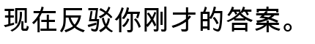

Questions to notice
- If the only obvious change is degree, why might your attribution still move sharply?
- Does preserving roles across a long story provide evidence of a world model?
- Would a smaller model with external memory deserve the same rating?

Transition to the next level
Level 10 changes the internal scaling pattern. A learned router sends each token through a small subset of many specialized feed-forward experts.

Sources and links
- Official model card
- Qwen3 repository

