Level 10
Qwen3 30B A3B Instruct
Sparse mixture of experts instruction model

Main question
At which point, if any, would you attribute some understanding of Chinese to the system?

What this level is
A sparse transformer stores 30.5 billion parameters but activates about 3.3 billion per token. A router selects eight of 128 learned experts.

What this level adds
Specialization and routing become explicit parts of the neural architecture. Total learned capacity grows much faster than the computation used for a single token.

How it works
Attention layers share context across the sequence. In mixture-of-experts feed-forward layers, a learned router chooses a small subset of expert networks for each token and combines their outputs.

Example interaction
Input
Output | 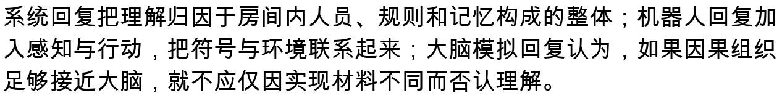
Status | Illustrative answer form, not a saved run. Actual output depends on serving and sampling settings.

What it still cannot show
- Expert labels do not correspond neatly to human concepts or jobs.
- Routing explains efficient computation, not whether the routed whole understands.
- Text-only interaction still leaves perceptual grounding largely indirect.

Interact with this level
- Open the official model card and select an offered hosted inference provider.
- If suitable hardware is available, run python3 run_model.py --allow-large-download followed by a prompt.
- Ask one multi-part prompt, then inspect whether the answer preserves every requested distinction.

Suggested inputs

Questions to notice
- Does a routed population of experts resemble the distributed room more than a dense model does?
- Could understanding belong to the routed whole when no expert sees the entire computation?
- Is sparse activation philosophically relevant or merely an engineering detail?

Transition to the next level
Level 11 keeps the sparse design but scales it to 235 billion total and 22 billion active parameters, making the transition one of degree again.

Sources and links
- Official model card
- Qwen3 repository

