Level 12
Kimi K3
Frontier native multimodal agentic sparse model

Main question
At which point, if any, would you attribute some understanding of Chinese to the system?

What this level is
Kimi K3 is an open-weight model with 2.8 trillion total parameters, 104 billion active, native image and video input, and a one-million-token context.

What this level adds
The final level combines frontier-scale sparse computation with perception-like inputs, very long working context, tool calls, and sustained multi-step action.

How it works
Kimi K3 uses a highly sparse mixture-of-experts architecture with 896 experts and sixteen active, together with Kimi Delta Attention and Attention Residuals. Its deployed interface can coordinate text, visual input, tools, and long interaction histories.

Example interaction
Input | 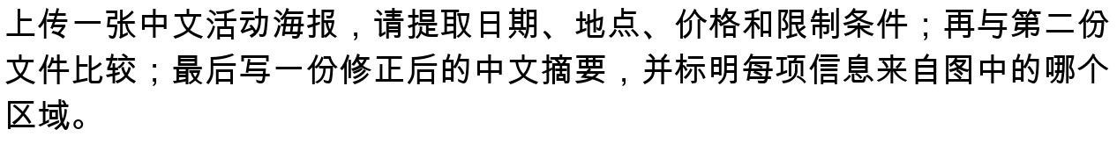
Output
Status | Illustrative multimodal task, not a saved run or performance claim.

What it still cannot show
- A broader interface supplies more behavioral evidence but does not select a theory of understanding.
- Tool results and retrieved material can be mistaken for knowledge internal to the model.
- Capability, semantic grounding, system-level cognition, and conscious experience remain distinct claims.

Interact with this level
- Open https://platform.kimi.ai and select kimi-k3, as directed by the official repository.
- Begin with the six common text probes so the comparison with earlier levels remains controlled.
- Then add an image, a long document, or a tool-based task to expose what is genuinely new at this level.
- API users can set KIMI_API_KEY and run python3 kimi_k3_api.py followed by a quoted prompt.

Suggested inputs

Questions to notice
- Did multimodality or agency change your judgment more than parameter count did?
- Where should the system boundary fall when external tools and documents participate?
- If you still deny understanding, what non-question-begging test could change your mind?

Transition to the next level
There is no designated next level and no answer key. Plot the ratings and ask whether participants found a threshold, a transition region, gradual degrees, or no understanding at all.

Sources and links
- Kimi K3 official repository
- Kimi K3 official model card
- Kimi platform

