**ASSIGNMENT 1**

Image Processing and Application - 9804

JEWEL MAHMUD NIMUL SHAMIM

201890846

**Answer to the question no. 1**

We know,

$\frac{X}{Z}= \frac{x}{f}$

Where, X = target size,

Z = distance from the lens

x = height of CCD array

f = distance between pinhole and CCD

$$\frac{X}{500mm}= \frac{7mm}{35mm}$$

$X=100mm$

So the target size = 100mm on the size.

Given that we have total of 1024 elements per line, so the resolution of 1 line will be:

$\frac{1024}{100} ≈10 elements$/ mm

For line pairs, we divide by 2. We get, $\frac{10}{2} =5$ line pairs / mm.

Therefore, the number of line pairs per mm is 5-line pairs / mm.

**Answer to the question no. 2**

Given, Affine transformation matrix, $A=\left[\begin{matrix}0.25 & 0.433 & 0 \\ -0.2598 & 0.15 & 0 \\ 50 & 75 & 1\end{matrix}\right]$

Without homogeneous coordinates we can write,

|  |
| --- |
| Where, $x_{c}$ = translation in x axis |
| $y_{c}$ = translation in y axis |
| $s_{x}$ = scaling in x axis |
| $s_{y}$ = scaling in x axis |
| $θ$ = angle of rotation |
|  |

$\left[\begin{matrix}s_{x}cosθ & s_{y}cosθ \\ {-s}_{x}sinθ & s_{y}cosθ \\ x_{c} & y_{c}\end{matrix}\right]$

angle of rotation,

$θ= \frac{0.15}{\sqrt{{0.2598}^{2} + {0.15}^{2}}}$

$$θ= \frac{0.15}{\sqrt{0.8999604}}= \frac{0.15}{0.3} =0.5$$

Scaling in x-axis,

$$s_{x}= \sqrt{{0.25}^{2}+{0.433}^{2}}=0.5$$

Scaling in y-axis,

$$s_{y}= \sqrt{{0.2598}^{2}+{0.15}^{2}}=0.3$$

**Answer to the question no. 3**

Obtaining the transformation function T(r)

As we know,

$$s=T\left(r\right)$$

$$= \int_{0}^{r}{p_{r}\left(w\right)dw}$$

$$= \int_{0}^{r}{\left(-2w+2\right)dw}$$

$$= {-r}^{2}+2r$$

Obtaining the transformation function G(z)

$$v=G\left(z\right)= \int_{0}^{z}{p_{z}\left(w\right)dw}= \int_{0}^{z}{2wdw}= z^{2}$$

Obtaining the transformation function $G^{-1}$

z = $G^{-1}\left(v\right)= ±\sqrt{v},$

$$so, z= +\sqrt{v}$$

z = $\sqrt{{2r-r}^{2}}$

Therefore, we can say that $0≤z≤ 1$ when $0≤r≤ 1$

**Answer to the question no: 4**

1. The boundary points number between the black and white regions is larger in the image on the right. When the images are blurred with a 3×3 averaging mask, the boundary points will increase to a larger number of different values for the image on the right, that why the histograms of the two blurred images will be different.
2. Assume the image size is N x N, with the surrounded border of 0s. Blurring the image with a 3x3 averaging mask coefficient is 1/9. A larger N would result in a more significant number of 0/255 in the output histogram, where smaller N would result in a lower value. But we have to sure that the summation is equal to N x N.

If we consider the image as 80 x 80 and the black as 0 pixel and white as 1 pixel. The histogram can be plotted as:

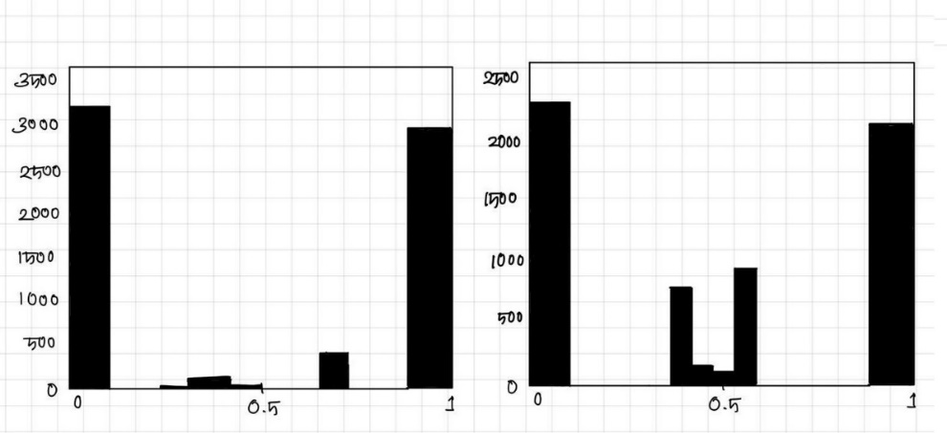

**Answer to the question no: 5**

If center pixel depth is > depth of all the neighbors, then it will reduce the center pixel’s depth.

Similarly, if center pixel depth < depth of all neighbors then it will increase the depth of the center pixel.

For Z, it the pixel value will be unchanged which is V = 0 and z’ = z.

The IF-THEN rules are:

Using notation for positive as P, negative as N and zero as Z.

IF $d_{2}$ is P AND $d_{4}$ is P AND $d_{6}$ is P AND $d_{8}$ is P THEN v is P

IF $d_{2}$ is N AND $d_{4}$ is N AND $d_{6}$ is N AND $d_{8}$ is N THEN v is negative

ELSE v is *zero*

1. The values of $d_{i}$ is from –(L-1) to (L-1)

Here, we can use the triangular membership functions for P, N and Z. So, we can find the membership functions are:

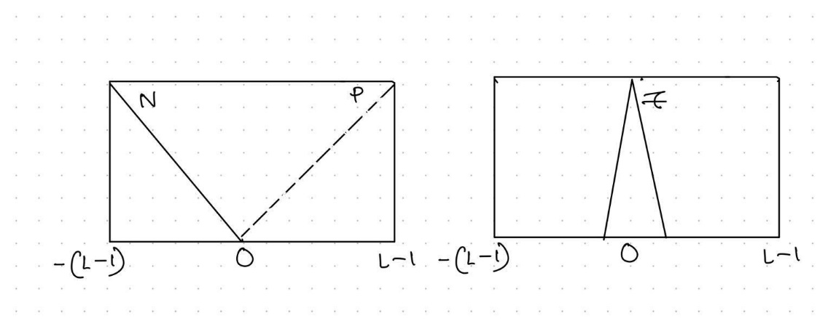

1. graphical representation of the rule set:

