**ASSIGNMENT 2**

Image Processing and Application - 9804

JEWEL MAHMUD NIMUL SHAMIM

201890846

Answer to the question no: 1

**MATLAB Code**

clc;

clear all;

close all;

% Read image

image = imread('moonlanding.png');

imshow(image)

%Convert image from spatial domain to Frequency Domain

FD = fft2(image);

FS = fftshift(log(1+abs(FD)));

%Find the maximum frequency in S

FSmax = max(FS(:));

imshow(FS,[]) % Display The figure in frequency domain

disp(FSmax)

findex = 1;

F = getframe;

imwrite(F.cdata, 'spectrum.png')

**OUTPUT**

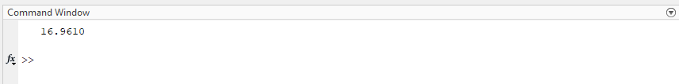

The maximum value of the frequency spectrum: 16.9610

Answer to the question no: 2

**The frequency spectrum obtained from the Question: 1**

**OUTPUT**

Answer to the question no: 3

**MATLAB Code**

clc;

clear all;

close all;

image = imread('moonlanding.png');

F = fft2(image); %Convert spatial domain to Frequency Domain

FS = fftshift(log(1+abs(F))); %Calculate the DFT.

FSmax = max(FS(:)); %Find the maximum frequency

[A B] = size(FS);

CRDr = 100;

CRx = B/2;

CRy = A/2;

th = 0:pi/5:2*pi;

% Display The figure in frequency domain

imshow(FS,[])

hold on

th = 0:pi/4:2*pi;

xunit = CRDr * cos(th) + CRx;

yunit = CRDr * sin(th) + CRy;

%scatter(xunit, yunit, 20,'filled');

scatter(xunit,yunit,1,'MarkerEdgeColor',[1 1 1], 'LineWidth', 2.0)

hold off

frame_index = 1;

F = getframe ;

imwrite(F.cdata, 'data.png')

**OUTPUT**

Answer to the question no: 4

**MATLAB Code**

clc;

clear all;

close all;

image = imread("moonlanding.png");

FFT = fft2(image); % 2D DFT using FFT

spatial = imresize(ifft2(FFT),size(image));

figure('Name',"Spatial Domain")

imshow(spatial,[]);

title("Spatial Domain")

noise = 0.5;

size = rand(size(image));

noisy = find(size < noise/2);

image(noisy) = 0;

noisy = find(size >= noise/2 & size < noise);

image(noisy) = 1;

figure('Name',"Noisy")

imshow(image)

title("Periodic Noisy Image")

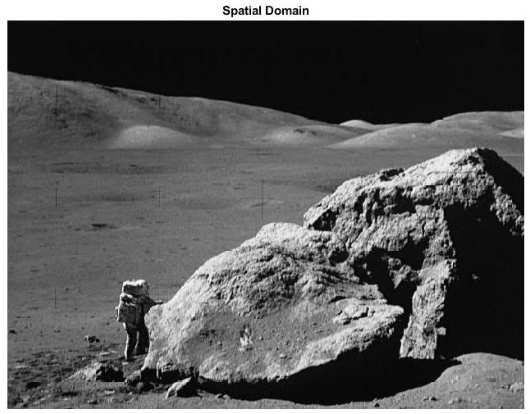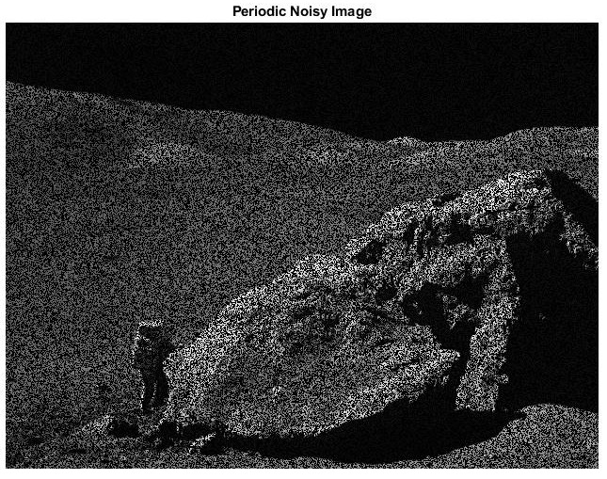**OUTPUT**

Comments:

After adding the periodic noise, the image is unclear and loses a lot of information from the image. Also, the brighter area has more noise.

Answer to the question no: 5

**MATLAB Code**

clc;

clear all;

close all;

image = (imread("moonlanding.png"));

FFT = fft2(image); %perform 2D DFT using FFT algorithmfigure,

%FS = fftshift(log(1+abs(F)));

spatial = imresize(ifft2(FFT), size(image))

points = 0.5;

x = rand(size(image));

noisy = find(x < points/2);

image(noisy) = 0;

noisy = find(x >=points/2 & x < points);

image(noisy) = 1;

FFT = fft2(image);

ShiftedImage = fftshift(log(1+abs(FFT)));

imshow(ShiftedImage,[]);

title('Spectrum with Periodic Noice');

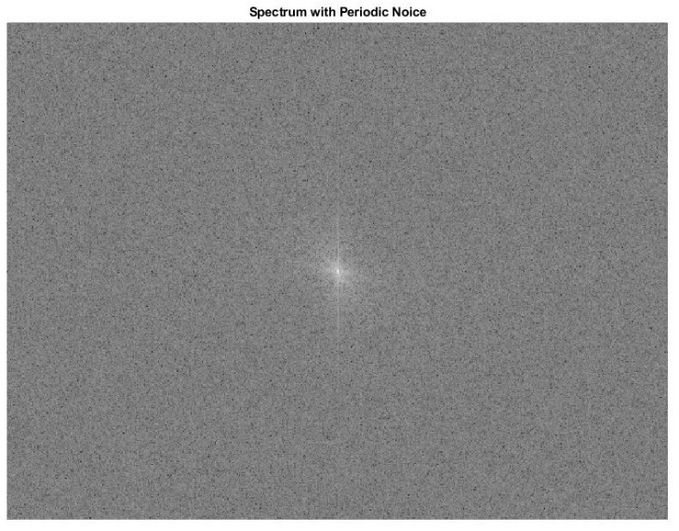**OUTPUT**



Comments:

Manually created spectrum and from the periodic noisy image spectrum are not the same. Also The frequency domain without noise compared to brighter on this image.

Answer to the question no: 6

**MATLAB Code**

function y = distmatrix(M,N)

u = 0:(M - 1);

v = 0:(N - 1);

ind_u = find(u > M/2);

u(ind_u) = u(ind_u) - M;

ind_v = find(v > N/2);

v(ind_v) = v(ind_v) - N;

[V, U] = meshgrid(v, u);

%calculate distance matrix

y = sqrt((U .^ 2) + (V .^ 2));

end

function b = ideal_lp(M,N,cut_off)

dist = distmatrix(M,N);

H = zeros(M,N);

ind = dist <= cut_off;

H(ind) = 1;

b = double(H);

end

function b = ideal_hp(M,N,cut_off)

dist = distmatrix(M,N);

H = ones(M,N);

ind = dist<= cut_off;

H(ind) = 0;

b = double(H);

end

function b = ideal_br(M,N,cut_off1,cut_off2)

if cut_off1 > cut_off2

h_cut_off = cut_off1;

l_cut_off = cut_off2;

else

h_cut_off = cut_off2;

l_cut_off = cut_off1;

end

H1 = ideal_hp(M,N,l_cut_off);

H2 = ideal_lp(M,N,h_cut_off);

Hbr = H2 - H1;

ind = Hbr == -1;

Hbr(ind) = 1;

b = Hbr;

end

function b = gaussian_br(M,N,cut_off1,cut_off2)

if cut_off1 > cut_off2

h_cut_off = cut_off1;

l_cut_off = cut_off2;

else

h_cut_off = cut_off2;

l_cut_off = cut_off1;

end

dist = distmatrix(M,N);

W = h_cut_off - l_cut_off;

D0 = l_cut_off;

Hbr = 1 - exp((-1/2)*(((dist.^2)-(D0^2))./ (dist*W)).^2);

b = Hbr;

end

function b = butter_br(M,N,cut_off1,cut_off2, ord)

if cut_off1 > cut_off2

h_cut_off = cut_off1;

l_cut_off = cut_off2;

else

h_cut_off = cut_off2;

l_cut_off = cut_off1;

end

W = h_cut_off - l_cut_off;

D0 = l_cut_off;

dist = distmatrix(M,N);

Hbr = 1 ./ (1+((dist*W)./((dist.^2)-(D0^2))).^(2*ord));

b = Hbr;

end

**OUTPUT**

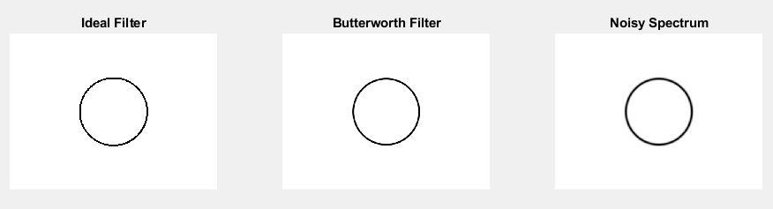

Answer to the question no: 7

**MATLAB Code**

clc

clear all

close all

image=imread('moonlanding.png');

image = double(image);

imafft = fft2(image);

FS = fftshift(imafft);

% % Fourier Spectrum of Image

s = size(image); ma=max(max((FS)));

maxium = 0.5*sqrt(s(1)^2+s(2)^2);

cutoff1 = maxium*30;

cutoff2 = maxium*120;

butterworth_filter = fftshift(butter_br(474,630,100,105,4));

gussian_filter = fftshift(gaussian_br(s(1),s(2),cutoff1,cutoff2));

Ideal_filter = fftshift(ideal_br(s(1),s(2),100,105));

butter = (immultiply(real(FS),butterworth_filter));

gussian = (immultiply(real(FS),gussian_filter));

ideal = (immultiply(real(FS),Ideal_filter));

figure(1);

imshow(butter)

title("Butter Filtered Image")

figure(2);

imshow(gussian)

title("Gussian Filtered Image")

figure(3);

imshow(ideal)

title("Ideal Filtered Image")

**OUTPUT**

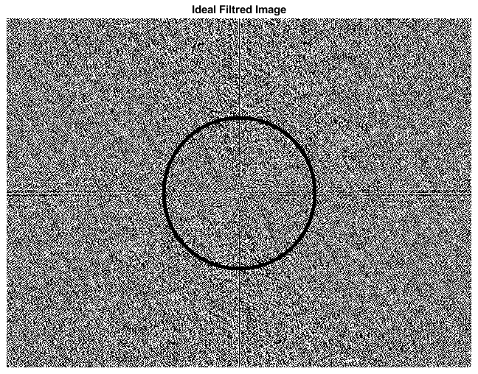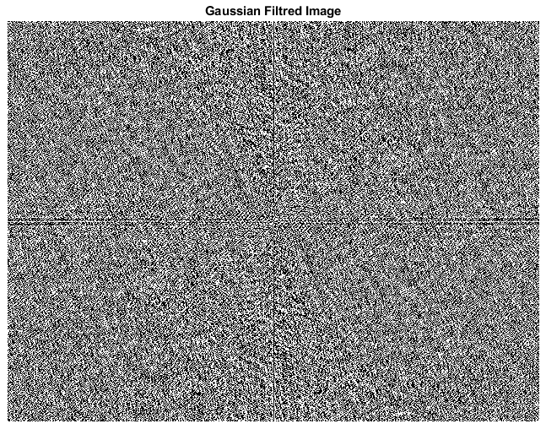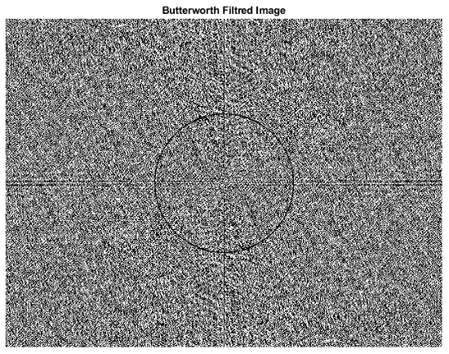

Answer to the question no: 8

**MATLAB Code**

clc

clear all

close all

image = imread('moonlanding.png');

image = double(image);

figure(1);

imshow(image,[]);

title('Original Image');

imafft = fftshift(fft2(fftshift(image)));

% Fourier Spectrum of Image

imafft2 = fft2(image);

imafft3 = fftshift(imafft2);

size = size(image); ma=max(max((imafft)));

butterworth_filter = fftshift(butter_br(474,630,100,105,4));

gussian_filter = fftshift(gaussian_br(s(1),s(2),cutoff1,cutoff2));

Ideal_filter = fftshift(ideal_br(s(1),s(2),100,105));

butter = (immultiply(real(FS),butterworth_filter));

gussian = (immultiply(real(FS),gussian_filter));

ideal = (immultiply(real(FS),Ideal_filter));

imafft=imafft.*z/255;

image_out = fftshift(ifft2(fftshift(imafft)));

image_out =image_out-image; image_out = 1-image_out;

figure(1); imshow(image_out,[]);

title(Butterworth Filtered Image');

figure(2); imshow(image_out,[]);

title('Gaussian Filtered Image');

figure(3); imshow(image_out,[]);

title(Ideal Filtered Image');

**OUTPUT**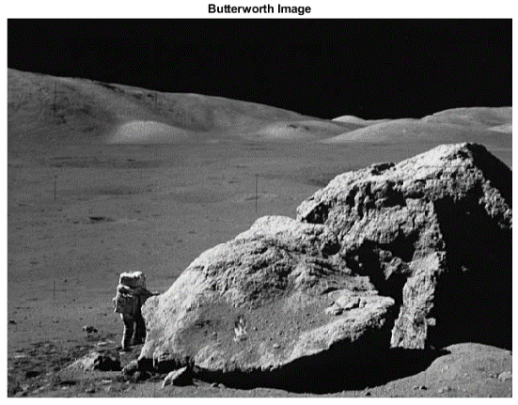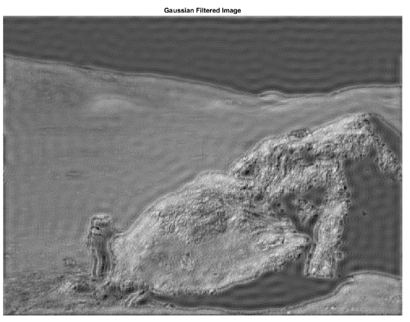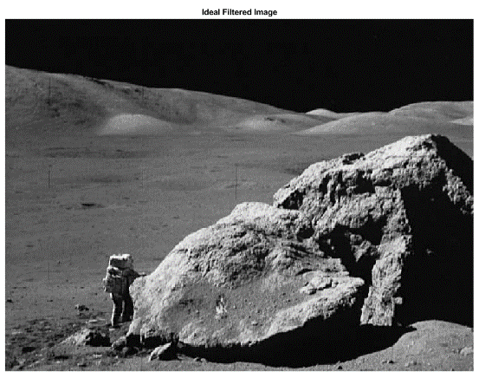

Answer to the question no: 9

Band rejects filters are applied to provide a large band of frequencies while rejecting a small band of frequencies. And also filter out in the selected region image by canceling out the frequencies.

From the output of Butterworth, Gaussian, and ideal filter, we can say that the idea band-reject filter produces a sharper image. The Gaussian band-reject filter provides a heavy, darker image and filtered out periodic noise.