**LAB REPORT 1**

JEWEL MAHMUD NIMUL SHAMIM

201890846

**Geometric Transformation:**

## Answer to the question no: 7

OUTPUT/RESULTS:

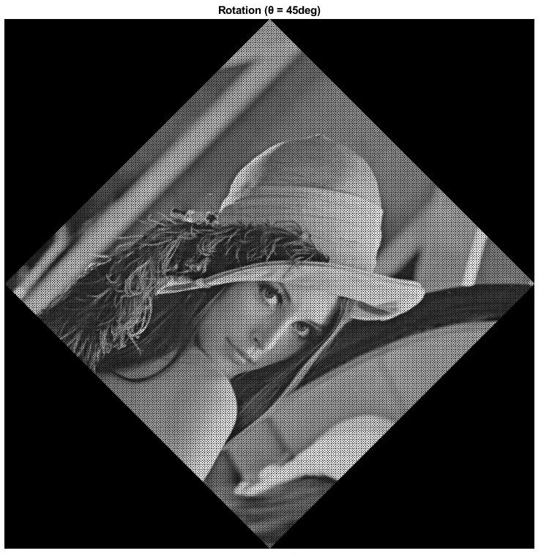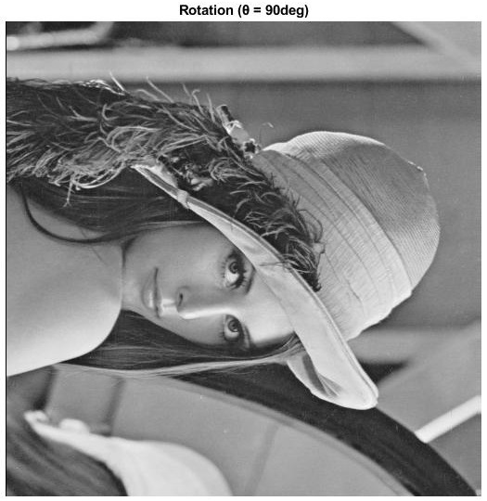

45 degree 90 degree

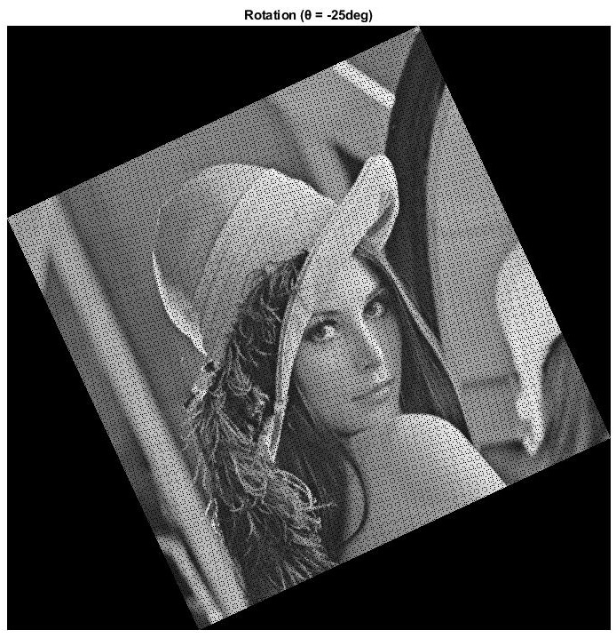

-25 degree

## Answer to the question no: 8

OUTPUT/RESULTS:

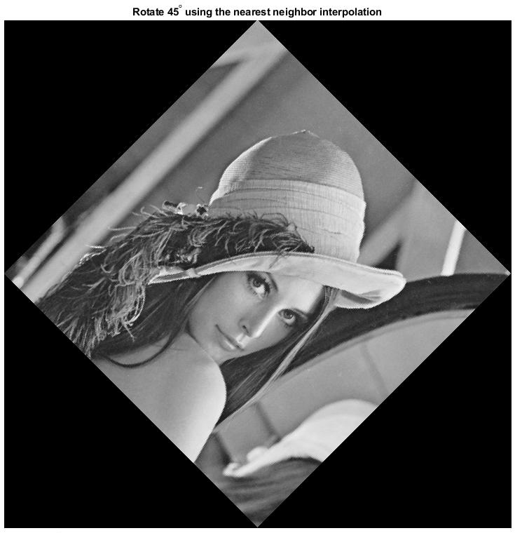

Before After

**Why some images have these black dots:**

The geometric transformation of an image is applied to the spatial coordinate system. In this transformation, each point of an image mapped to a point in a new image. As we can see that, the size of the given image is 512X512, and after doing the spatial transformation, the size of the image increased to 724X724. So, when we map the image's spatial coordinates, it is not entirely covered the new image. That is the reason we see black dots in this image.

## Answer to the question no: 10

OUTPUT/RESULTS: 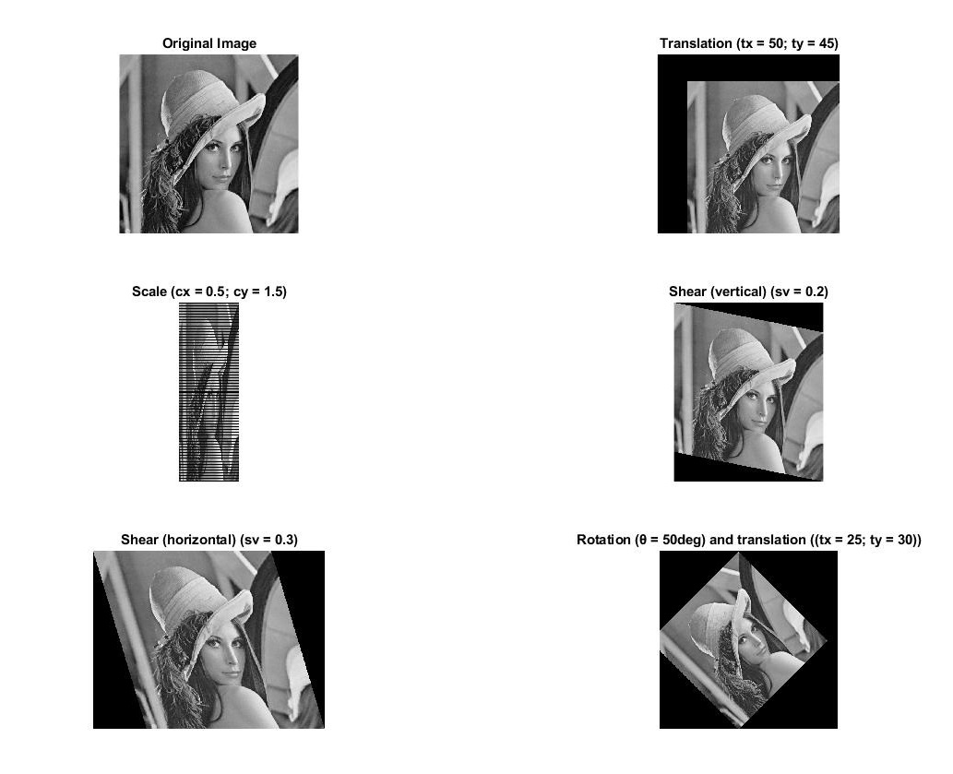

**Histogram Equalization:**

## Output:

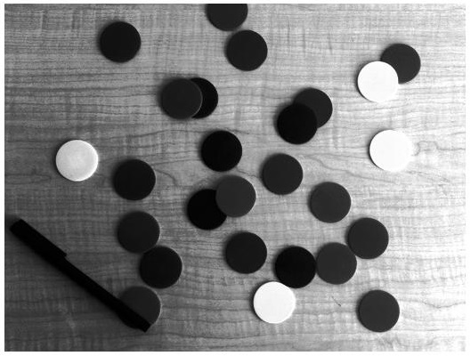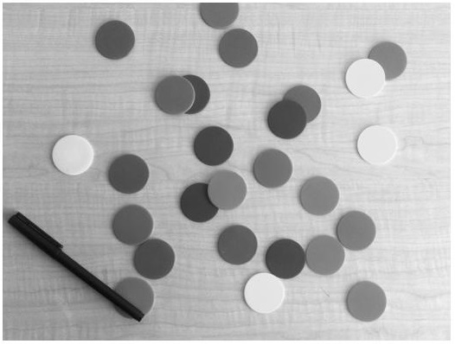

1. **Gray Scale Image: 2. Hight Contrast Image**

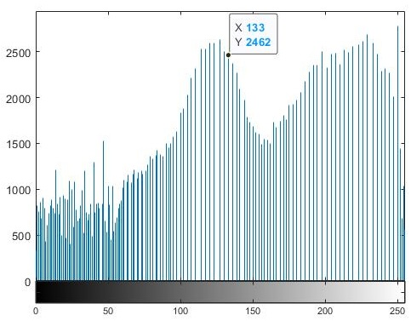

**3. Histogram After Modification**

## Performance evaluation

**Problem 1:**

When we do the inverse transformation, the program will take more time then build in function. So that why the inbuilt function does not take that much of time like inverse function.

**Problem 2:**

The histogram after equalization represents the number of pixels of various gray levels in the image. Also, it modifies the dynamic range and the contrast of an image. And it accomplishes by stretching out the intensity range of an image. After equalization, the histogram produces the non-regular discrete jumps. That is why the equalization is not uniform. Whereas histogram equalization discrete set of 256.