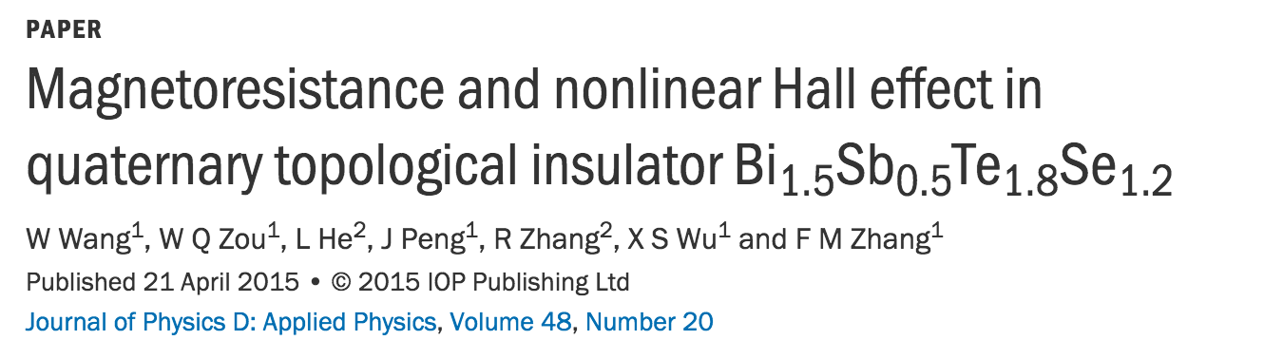

Solar cells using antimony selenide

Effect of pressure on the Raman modes of antimony

X. Wang, K. Kunc, I. Loa, U. Schwarz, and K. Syassen

Phys. Rev. B **74**, 134305 – Published 24 October 2006