

From Rejection to Radicalisation: The Making of the Incel Identity

Table of contents
Glossary 5
1. Introduction 6
2.1Literature review 6
Hegemonic Masculinity 6
Incelverse 7
Social media influencer 10
Methodology 11
Aims/Research Question 11
Gender Order Theory 11
Parameters of Secondary Research 12
Search terms 12
Database 12
Include and exclusion criteria 12
Design 13
Procedure 13
Ethics 14
Analysis 14
Findings 16
Internet Pipeline 17
Ideological dogma 18
Incel- Adjacent Content and the Mainstream Reinforcement of Incel Ideology 21
Discussion 25
Reflexivity Account 27
Conclusion 28
Reference 29
Appendix 32
Appendix 1: Table of search term 32
Appendix 2: Field Research Risk Assessment 33
Location 34
Name/position of contact 34
Place for fieldwork/organisation 34
Address 34
Tel: 34
Email: 34
1. 34
2. 34
3. 34
Appendix 3: Ethics application 36
Appendix 4: Supervisor meeting checkup 36

Glossary
SMV | “Sexual Market Value” is a concept to an individuals perceived overall desirability or attractiveness and a potential mate within the dating marketplace
Manosphere | A loose network where men express opinions about issues concerning contemporary masculinity and male relationships with women, especially those associated with views that are hostile to feminism and women’s rights
Red pill | A belief system “Removing a rose-tinted glasses” where men claim to wake up to the idea that the system is rigged against them
Black pill | A nihilistic perspective of the red pill associated with incels, which claims that self-improvement is pointless and everything is predetermined from the minute you were born
MGTOW | “Men Going Their Own Way” is a movement where men reject relationship with women and opt out of traditional gender roles for self-preservation
Looksmaxxing | The practice aimed at enhancing one’s physical appearance, from everyday skincare routines to more extreme measures like cosmetic surgery
Chads | A term used to describe men (primarily White Western Men) who embody a form of masculinity that is most desirable to women
Stacys | A sexually attractive [white] women are figures constructed by incels are perceived as both highly desirable but unattainable
Chad Thundercock | Chad Thundercock is a meme caricature of the idealised, hypermasculine man—confident, attractive, and sexually dominant. In incel communities, he represents the unattainable standard of hegemonic masculinity, often contrasted with the “Virgin” figure in memes like Virgin vs. Chad. This symbolism reinforces feelings of exclusion and grievance central to incel identity.
Podcast bros | An internet driven label used to describe a certain style of male podcast host typically associated with hyper-masculine, self-help or red pill commentary
Hypergamous/Hypergamy | The practise or tendency of marrying or dating a person of higher social, economic or professional status, “Marrying up”

1. Introduction
The incel phenomenon is not merely an internet trend or a reactionary trend or a reactionary response to feminism, it is a deeply embedded cultural crisis shaped by shifting gender power relations and the radicalising influence of digital subcultures. The rise of online subcultures and the Netflix TV show Adolescence at the beginning of the year has brought renewed attention to the formation of incel (involuntary celibate) identities, particularly among young men navigating digital spaces. This research is relevant giving the increasing visibility of online male communities and influence of manosphere figures such as Andrew Tate and Myron Gaines from the Fresh and Fit podcast, who’s content often promotes reductive and harmful models of masculinity. Many young men nowadays, those with a lack of a male figure at home seek to find them online (Reeves, 2022). These communities, often formulated through process of grievance with the caveat of misogyny and ideological rigidity, has become increasingly visible through platforms such as YouTube and TikTok for its fast and short formed content, which has been the main driver of these manosphere content and Reddit for hosting its forums for these incels to congregate (Ging, 2017). By using secondary qualitative thematic analysis (Braun and Clarke, 2006), we would be able to identify the key discourse and narratives within the incel communities and understand their worldview clearly.

2.1Literature review

Hegemonic Masculinity
In recent years, the term incel short for involuntary celibate has evolved from obscure internet slang describing individuals who perceive themselves as unable to form sexual or romantic relationships (Whittaker, Costello and Thomas, 2025), into a subject of intense public scrutiny and media sensationalism. Frequently depicted as synonymous with misogyny, violence and radicalisation, the incel identity has come to symbolise wider societal anxieties surrounding gender relations, sexual norms, and the influence of digital subcultures. Misogynistic violence, whilst not common, is visibly surged following Elliot Rodger’s Isla Vista attack, which was described by him to be his “Day of Retribution” (Scaputra and Boyle, 2020). His manifesto and video were closely aligned with the incel ideology, particularly with the belief that women owe men sex and women’s autonomy was an attack on men’s social reward. The violent behaviour was a means of reclaiming their masculinity identity and pushing back against their oppressors (Ging, 2017). This was a cultural moment where online aggression transformed into offline violence.
While attackers such as the Isla Vista shooter may be upheld as a sort of secularized saint in the eyes of some incels, it is important to note that the majority of incels do not commit acts of physical violence. Instead, many incels engage in an online practice called “shit-posting,” where members of the community post memes or shocking comments which are meant to provoke members of society, such as “Chads,” “Stacys,” and the average person (deemed “normie”; Lindsay, 2020). Such shit-posts often include memes, such as “Chad Thundercock” and “The Stacy” (memes which serve as caricatures of both “Chads” and “Stacys”, (see in Image 1 and 2), both of which seek to provoke members of those social identities (Høiland, 2019).
Connell’s (2002, as stated in 1995) concept of hegemonic masculinity provides a foundation to understanding how dominant gender norms marginalise women through characteristics associated with traditional male roles in society, authority, control and aggression. While incels reject hegemonic masculinity, they often express the traits of hegemonic masculinity but formulate it by having their own hegemony through the black pill, they often express feelings of loneliness, rejection and reject the social norms (Ging, 2017). Messner (1997) expands this further by exploring the concept of “aggrieved entitlement”, a sense of injustice felt by men who think they have lost the social rewards promised by the patriarchal structures of society. This sense of entitlement is crucial to the discussion of incels, as it constitutes a central theme; it frames romantic rejection because of the system’s failure to acknowledge them.
While mainstream media portrays incels as dangerous outsiders or psychologically disturbed individuals. Messner (1997) challenges the common assumption that misogyny is simply hatred towards women. Misogyny functions as a policing of mechanism of the patriarchal societies, pushing women who deviate from expected gender norm, awarding compliant women and penalising those who assert autonomy.

Incelverse
Beyond ideological framing, online communities play a crucial role in offering emotional validation and identity formation for disenfranchised men who feel excluded from dominant gender norms. Incels, Red Pill follower and MGTOW participants have a very common experience of feeling lonely, rejection and self-loathing in forums that’s praises vulnerability with solidarity.
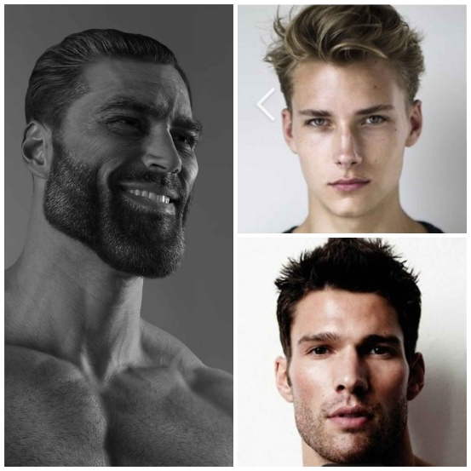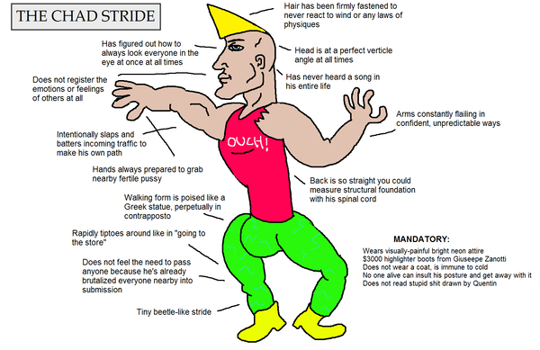
(Image A: The incels perception of what a Chad would look like)
Researchers have evaluated the impact of gender on members of the incel community through content analysis of websites like Reddit (Høiland, 2019; Lindsay, 2020; Maxwell et al., 2020) and incels.co (Jones, 2020; Lindsay, 2020). Incels perception of “Chads” a term used to describe men (primarily White Western Men) who embody a form of masculinity that is most desirable to women, is a recurring theme across most analyses (Høiland, 2019; Lindsay, 2020; Maxwell et al., 2020). This includes physical attractiveness, strength, financial wealth, popularity and frequent sex. Furthermore, when comparing themselves to “Chads”, they often do user created scales from 1 to 10, where a 10 is associated with positive traits like height, muscularity and strong facial features (e.g Square Jawline, defined cheekbones, slightly flared nostrils, puckered lips and slanted eyebrows).
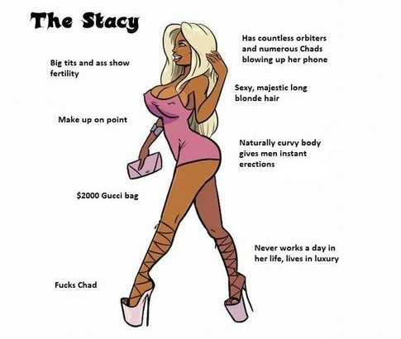
(Image B: The incels perception of what a Stacy would typically look like)
On the other hand, incels themselves frequently describe themselves as grotesque and undatable compared to “Chads” (Brace, 2023). Alongside “Chads”, “Stacy” [See image B], a sexually attractive [white] women are figures constructed by incels are perceived as both highly desirable but unattainable (Jones, 2020; Lindsay, 2020) “Stacys” are simultaneously idolised as objects [prise possessions] of desire but not only vilified as agents who withhold sex from them when exploiting their SVM but are also far intellectual inferior, strength and morality compared to men according to the incels (Baele et al., 2019). Despite the definition “Stacys” are viewed as the “ultimate women”, incels often attempt to vilify women who embody this socially constructed identity. For instance, one study of a top reddit post (on a now defunct subreddit) r/Braincels, commenters posted responses indicating that all women are evil but “Stacys” are particularly deserving of criticism due to the socially constructed idea that they are sexually successful to the point they have more hatred to “Stacys” than “Chads” (Lindsay, 2020; Maxwell et al., 2020)
This infection of the incel ideology has spread far among selective fringe forums; rather it has manifested and infected the worldwide web (YouTube, TikTok and Reddit), where the algorithm rewards grievance-based content (Shin and Jitakjornwanich, 2024). The Guardian’s article “Getting fit is great, but it could turn you into a right-wing jerk”, while the title is absurd, it does have some merit in the idea that right wing groups utilize the aspect of gym culture, mainly the fitness communities as a form of recruitment by linking self-improvement to the righteous ideas that everything would come to you if you were shredded and looked jacked, but what was never stated is that you will never feel satisfied and would want more and more to the point that you abuse yourself (Williams, 2024). You’ll begin to self-loath and keep chasing the ever so low endorphins or channel hatred to people who had no interest in you (Williams, 2024).

Social media influencer
Influencers like Andrew Tate played a central role in contemporary discussion of digital masculinities. Frequently identified in mainstream commentary as embolic of the ‘toxic masculinity’ crisis. His videos follow a very common program of motivational rhetoric that everyone talks about which doesn’t require any thinking behind it since it’s true, but quickly turns into anti-feminist logic, stating that you are suffering as a result of women/feminism. Tate has been portrayed as both a cause and a consequence of male disaffection (Love, Prskalo and Moloney, 2025). Whilst Tate didn’t originally create male disaffection, rather he capitalised on an already existing sense of alienation felt by these young men who perceived themselves as failed by modern society (Love, Prskalo and Moloney, 2025). Although public discourse often depicts him as dangerous influence who radicalizes young men, like in Wescott, Roberts and Zhao’s 2024 Australian school study, Melbourne students admire how Tate emits the idea of success. With a teaching recalling the transformation of a boy currently in year 9 who knew him for years as “wholesome and creative” yet writing “disturbingly misogynistic messages” saying “Andrew Tate is being vilified. He’s in the right” in which the teacher stated “Who is that boy? Because that’s not the boy i have seen for the last couple of years. Yet his main content usually focusses on the success more than his views on women (Feltham, 2024) with 89% of his content devoted to reifying “traditional, capitalist-centric notions of what it means to be a real and successful man” (Roberts et al., 2025 cited in Love, Prskalo and Moloney, 2025) Alternative perspectives suggest that his popularity is symptomatic of boarder socio-cultural neglect (King-Hill and Russell, 2023), leading to this belief stated that society has neglected young men. Ging (2019) argues that the appeal of figures like Tate steam from the idea that he can articulate the frustration of young men who feel alienated from the dominant gender ideology has appeal not only in the message in but in the median; a more visual meme based short form video with emotionally and algorithmically charged language that resonates exclusively with men.
Tate’s content illustrated vividly in a video essay such as Daskin (2019) “The Alt-Right Playbook: How to Radicalize a Normie” and Evens (2018) article “From Memes to Info wars: How 75 Fascist Activist were Red-Pilled” demonstrates the processes through which disillusioned young men are drawn into online communities that promise empowerment and belonging. Tate illustrates this through constructing a form of masculinity that appears to reclaim power from a culture that was once present in the past (1950s), which reasserts traditional hierarchies and misogynistic logic, highlighting Connell’s (1995) argument that hegemonic masculinity hasn’t disappeared, it just transformed into a new form.
Tate can be understood not as the origin of male radicalization but as a cultural response to a wider identity (masculinity) crisis among young men. His rise and popularity reflect the failure of mainstream institutions (education, politics and the media) to engage in meaningfully discussion with male vulnerability without patronising them as it was deemed problematic since it could potentially tear down progress that women have made over the past couple of decades. White (2000) goes on to say that since men and their practices was the cause of gender inequality, that they should be the solution towards the gender inequality. But what she didn’t take into account was that it would be internet masculine influencers (Internet Dads) who would comment on the issue since they would be the only ones to address this issue, abet creating a very toxic image of masculinity that has drawn the attention to men since those videos comment on that men should be proud for being men, but have turned a male issue and turn it into a problem with society and the problems with the other gender, rather than working on themselves, which creates a feedback loop of a shared idea, resulting this movement into a cult like ideology.
Whilst Tate remains as the most prominent figure in mainstream discourse, he is not alone in shaping online masculinity. Figures such as Myron Gain and Walter Weeks from the Fresh and Fit podcast reductive models of masculinity. Often targeting young men specifically. The influence of these figures and their role in incel-adjacent content will be examined further in the findings and analysis chapter.

Methodology

Aims/Research Question
The research question is: How are incel identities among young men shaped by social media and the dynamics outlined in gender order theory? The aim of this research is to critically explore how incel identities among young men on social media and the gendered power structures by applying Connell’s Gender Order Theory into existing research within the topic. Using this theoretical lens, it allows us to highlight masculinity, online subculture and ideological group think.

Gender Order Theory
Connell's (2005) gender order theory proved the most analytically generative framework throughout, explaining why young men are structurally predisposed to find these spaces compelling. Incel identity cannot be addressed through platform moderation alone. So long as the gender order ties masculine worth to sexual and romantic success, the conditions that produce incel identity will persist.

Parameters of Secondary Research

Search terms
Search terns were developed from the research questions to maintain the status quo. The initial search terms were used to identify relevant literature to form a specific research question. For example, “incel Reddit YouTube” is used to see how they communicate since they are vocal about their identity online and YouTube, where (gendered hateful content) is extremely popular on with repost of “Podcast bros” (See in Appendix 1). Other search terms used like:
- “online incel communities”
- “ideological groupthink incels”
- “toxic masculinity online”
- “incel grievance narratives”
often highlight the grievances that is spreads across online communities and how they view society from the eyes of the sexually frustrated young men.

Database
This study used academic literature searches across multiple databases including Google Scholar, JSTOR and SAGE Journals. Search terms like “incel Reddit YouTube” “online incel communities” and “toxic masculinity online” to ensure the coverage of contemporary sources.

Include and exclusion criteria
Include | Exclude
Studies published between January 2018 – Present | Studies before January 2020
Studies focused on young men over the age of 18 years old | Studies focused on young men under the age of 18
All research method (This can entail Primary qualitative research like interviews down to qualitative research, which involves) | /
Publicly available academic research, videos and even videos available on archives | Confidential documents, cases that requires approval from original creator
Identity of the incels and how they navigate and view wider society | Violent or sensitive information that might be uncomfortable to the researcher and the supervisor

Design
Based on the approach and the topic of this study, this dissertation will use secondary qualitative thematic analysis. Incels are a highly anonymous, distrustful and hard to access population. Many members avoid direct engagement with researchers, with former subreddits have openly stated that any researchers would be banned from the subreddit if they DM (direct message) the moderator. Also collecting primary data raises ethical concerns on the researcher’s safety and the participant, which publicised videos mitigates the issue. Online videos contain naturally occurring data, visual cues and tones that reveals how incels construct meaning, articulate grievances and how they interact with wider society.
Primary quantitative research would not have been feasible method for addressing the research aim. Quantitative research requires large statistically representative samples to produce rich and reliable findings (Bryman, 2016), which would not be available given that incels are mainly accessible only online. And if these disenfranchised young men are accessible, they are more likely to troll as that’s how they engage conversations with people who are not engaged with the subculture.

Procedure
The analytical procedure was guided loosely by the six phases framework of Braun and Clarke (2006), adapted to suit the nature of secondary thematic analysis. The process began with an extended familiarisation of the two sources. This began with Anderson (2024) study was read closely on multiple occasions with initial observations noted around the participants engagement of those who were current/former incels, their experiences, their level of involvement and attachment to the incel subculture over time. The SBS The Feed (2023) documentary was watched on repeat with attention paid with how they frame the participants, the language that was used in these discord groups and their ideological positions explicitly and implicitly. Initial codes were generated inductively from both sources, meaning codes emerged from the material itself rather than imposed from a premediated framework. These codes captured the position of which both sources were within the internet pipeline through algorithmic exposure, romantic failure and hostility towards dissent. With a highlight of algorithmic exposure, I managed to explain how the alt right takes advantage of the use of misogyny to effect bring young men whose masculinity is effectively recognised to be emotional controlled, recruiting them to their cause.

Ethics
The procedure of the research was structured to ensure that each step can be followed by another researcher and result in a comparable body of literature.The procedure consists of ethical approval, database selection, search term strategy development, study identification screening and selection and data organisation.
Considering that this is secondary qualitative research, no ethics approval was necessary to produce this dissertation, however given that this is a sensitive topic, this had to go through ethical guidelines that will protect me from harm as I conduct this research in the Field Research Risk Assessment (See Appendix 2) like the effects that I will most likely go through as I am doing this dissertation. For example:
- Emotional fatigue - Exposure to gendered hateful video which may trigger the person
- Desensitisation (Might be a rare case if you have been exposed to this prior of research for an extensive amount of time)
- Eye straining (staring on a screen might cause some eye sore to the persons eye)
- Sitting down for too long
The type of project I will be do and which social media platform I will be using all had to be stated beforehand so this wouldn’t raise any issues with infringement of copyrighted material. Whilst there was no direct contact with the human participants since the research used will be publicly available videos, no ethics approval was necessary to produce this dissertation, however given that this is a sensitive topic, This had to go through ethical guidelines that will protect me, the supervisor and the reader from harm as I conduct this research in the Field Research Risk Assessment (See Appendix 2) like the effects that I will most likely go through as I am doing this research (e.g as stated in the bullet points in Produce). The type of project I will be using and which social media platform I will be using all had to be stated beforehand so this wouldn’t raise any issues with infringement of copyrighted material.

Analysis
The analysis followed Bruan and Clarke’s (2006) six phase framework for thematic analysis adapted for secondary qualitative data. The purpose of this section is to outline how the data is going to be examined, coded and interpreted based on the context of the research question. and Connell’s gender order theory. This approach was chosen to explore the social phenomenon of incels and the online subculture. With this framework, this began with involves familiarising myself with the selected videos and literature, generalising the case study, down to the initial codes, organising these codes into potential themes, reviewing and defining and naming the themes.

Findings
This section presents the findings derived from a secondary thematic analysis of three primary sources. The first is Anderson's (2024) qualitative study of incel subculture, which examined the lived experiences and patterns of participation among fourteen individuals engaged with incel online communities, with a mean participant age of 29.2 years and a median of 28.5 years. The study offers granular insight into the early and mid-stages of incel identity formation, capturing the fluidity of participation, community attachment and the gradual absorption of incel ideology. The second source is the SBS The Feed (2023) documentary, which provides a journalistic account of men at the more entrenched end of incel identification, documenting the transformation of social isolation and self-loathing into organised misogynistic grievance. The third source is the Fresh and Fit podcast, accessed through SpartanClips (2025), a widely consumed mainstream content channel whose material consistently reproduces incel adjacent ideology under the guise of dating advice and male self-improvement, reaching audiences who would never self-identify as incels.
Source | Type | Focus | Sub-theme
Anderson (2024) | Academic qualitative study | Participation patterns and identity formation | Internet pipeline, ideological dogma
SBS The Feed (2023) | Documentary | Entrenched incel identification and grievance | Internet pipeline, ideological dogma
SpartanClips/ Fresh and Fit (2025/2026) | YouTube podcast and clips | Mainstream reproduction of incel adjacent ideology | Incel adjacent mainstream content
Together these three sources were selected because they represent distinct but interconnected layers of the same digital ecosystem through which incel identity is shaped, from academic community spaces to journalistic documentation of extreme identification to mainstream platform content that normalises the underlying ideology before men ever encounter dedicated incel communities. The overarching theme unifying the findings is the digital architecture of incel identity, understood as the interlocking online environments, algorithmic mechanisms and ideological frameworks that collectively produce and sustain incel identification among young men. Three sub-themes emerge from this architecture: the internet pipeline, ideological dogma and incel adjacent mainstream content.

Internet Pipeline
In conducting a secondary thematic analysis, a noted interpretive theme that emerges in Andersons qualitative study and SBS: The Feed’s incel documentary is the notion of an incel pipeline (Anderson, 2024., SBS: The Feed, 2023). While the direction of Anderson’s study was focused on the fluidity of individuals rate of participation within the incel subculture, this pattern can be understood as a non-linear pathway in a way that users gradually exposed so said content, withdraw and re-enter incel spaces depending on emotional status. However, the angle of the YouTube documentary took was the self-loathing of their mental state which had transformed into the hatred of the opposite sex and with said emotion, had nudged the people into these subcultures. This is demonstrated through Anderson’s study through the perspective of Hakim, who spends time in specific incels spaces online, he distances himself by pointing out his unfamiliarity of incel literature with his identity “feel kind of fluid”, whereas SBS: The Feed’s documentary showcases “Tom” showcasing defeatist language stating that he doesn’t think a “single female on the planet that would be willing to date me.” This highlights that digital radicalisation may shape a person’s perspective based on algorithmic exposure and community reinforcement of the culture.
Both sources reveal the pathway is shaped by pressures associated with hegemonic masculinity around this narrative; The belief that sexual and romantic success is central to masculine worth. This single pressure shapes how participants interpret their struggles, rending romantic rejection not just a personal attack but a perceived failure of masculinity (Connell, 2005). This failure is experienced as especially destabilising because it is measured against what incel communities and adjacent content creators refer to as the “golden age of society”, an imagined historical period in which rigid gender roles naturalised male dominance and female subservience, guaranteeing men access to partnership, family and social status by a virtue of masculinist nostalgia (Messner, 1993).
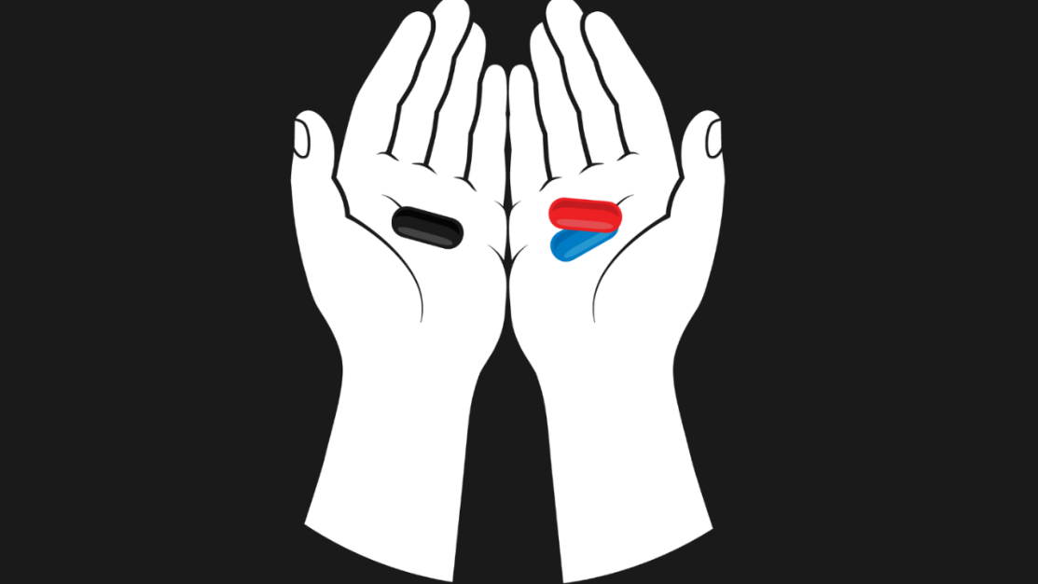
(Image C: Red pill or Black pill)
The study descriptions of participants activities on these online spaces shows the beginning process of these pipelines. Participants often entered these spaces through sudden ideological conversion, but through a gradual drift shaped by emotional vulnerability and social isolation. Many arrived within an existing nihilistic perspective of romantic relationships, something associated with a ‘black pill’ ideology, which frames male romantic failure as a biologically and socially predetermined. This ideology often stays within these spaces as a form of inclusion to their already present lonely life. At this stage of the pipeline, the engagement around these spaces is not really the primary ideology, rather the community engagement. In Ryan’s case, he has explained that he had found people he can trust within these spaces receiving birthday greetings and genuine concern about himself “They wish me the very best and all that” (Anderson, 2024) showing that he doesn’t have someone he can call a friend in real life. Within Connell’s gender order framework, this dynamic is significant. These young men are not simply seeking misogynistic validation; they seek recognition of a masculine selfhood that the broader social order has implicitly denied them. The pipeline begins not with hatred but with unmet attention.
In contrast, the YouTube video alters this process of the pipeline highlighting the very end of the pipeline where the person involved, bases their entire personality blaming modern feminist movements, “attractive men” (SBS The Feed, 2023) and discriminatory sexual selection for the lack of sexual relationships and male loneliness and the uncommon but extreme measures of violence and even mass premeditated attacks against women, “Having all these violent fantasies... r***, violence and murder” (SBS The Feed, 2023). This represents what Kimmel (2013) coined the term aggrieved entitlement; the belief that what men perceive as rightfully theirs (female attention, sexual access, romantic partnership) has been unjustly withheld. The documentary makes this entitlement legible without its subjects naming it directly; it was implied that the “Misogyny would dissipate if a female showed interest in them” (SBS The Feed, 2023) reveals that hostility towards women is understood by participants not as an independent ideological position, but as a reactive consequence of gendered grievance. Critically, the documentary also surfaces the most extreme outcomes of this pipeline including rationalising violence and premediated attacks against women, demonstrating that what begins as loneliness and exclusion can, under conditions of sustained community reinforcement and algorithmic amplification, can escalate to genuine danger.
Together, both sources reveal how the pipeline is sustained at each stage by a shared set of gendered assumptions. Anderson’s (2024) participants and the documentary subjects alike interpret their romantic failures through the lens of hegemonic masculinity as evidence of their inadequacy within a gender order that defines masculine worth through sexual and romantic success. But what differs between the early and late pipeline is not the underlying logic but the degree of which the logic has been collectivised and weaponised.

Ideological dogma
Before we delve into this theme, Ideological dogma, understood here as a fixed system of beliefs accepted without questions and organised around political, cultural or social identity (Cambridge Dictionary, 2019), provides the conceptual anchor for this theme. In the Documentary, it represents the ideological dogma as the Extreme end where the discord group was filled with people who were nudged into incel adjacent content where they have now formed a group where they make sure the masses maintain the dogmatic belief, showing how actively engaged these incels are with the ideology. Whereas the Anderson’s research emphasises that the participants spend more time engaging with incel content than interacting with others. The fluidity of participation within this ideology is not straightforward. Whilst many individuals may internalise the black pill worldview, this does not always manifest as visible platform activity, suggesting that the transformation of the ideology runs deeper than engagement metrics alone can capture (Anderson, 2024. pg. 448).
In the Documentary, the discord group full of incels doesn’t just attract sexually frustrated men, but it produces a closed ideological system that reinforces their experiences through a dogmatic lens, making any forms of interjection will be faced with “edgy statements” with some user going a step further with sexual violence comments “F***… f****in leave” (SBS The Feed, 2023). This hostility is not random; it is a predicable reaction to perceived ideological intrusion. Kimmel’s (2013) concept of aggrieved entitlement helps explains why men have organised their entire identity around the belief that they have been unjustly denied what was rightfully theirs. So, the incel’s reaction to “normies” challenging these pre-made identities is an attack of a worldview that is constantly reinforced, therefore it is deemed not just a disagreement but a personal attack on selfhood. These sexual violent comments are rooted within hegemony masculinities as the women’s response was itself a performance of masculine dominance, therefore violating the male only sanctuary, resulting in sexual violent rhetoric as an assertion of gendered power (Connell, 2005). With an exclusively male space, a women’s voice represents not just disagreement but a structured threat to the gendered hierarchy that defines the groups' identity.
But the implication of the ideological capture extends beyond individual identity formation, raising broader questions about the political exploitation of these spaces; a dimension that will be explored later in the dissertation.
In contrast to the Documentary, Anderson’s (2024) research highlights that the involvement of community isn’t rigid as many of the participants actively participate but might not necessarily be involved with the dogmatic viewpoint. In the case with Gabriel, he posts himself promoting the ideology, such as Just Be White theory, which emphasises that whiteness is to be the most desirable race and hence the most successful in the dating realm (Gheorghe, 2023). It’s a belief among incels that by pursuing whitemaxxing (skin bleaching, lying about one’s ethnicity and legal name changes to appear whiter) (Wallace, 2021), whiteness embodies a larger SMV since they believe that women are attracted to white people the most. While Gabriel positions himself as subculturally knowledgeable about the ideology, he specifically doesn’t really believe in the theory to trolling the outsiders who doesn’t get the joke. However, Alexander belongs with the incel community as the concept of relationship in his words ‘above and beyond what most people have’ has pushed him towards the community but disagrees with the one-sided contradictory logic of other incels due to only focusing on the male discrimination of looks while ignoring grievances affecting women or femcels (female incels). This reflection highlights their loose attachment with the community. Therefore, those who challenge the said dogma can freely enter, exit and decide whether they want to participate adopt or discard the dogma.
The findings established from the incel identity is shaped from ideological capture, gendered vulnerability and algorithmic exposure within a closed off ecosystem. However, these sources do not consider about the political vacuum. The men documented across both sources who feel that their masculinity is unrecognised are suspectable to be nudged within these far-right movements. Misogyny and far right ideologies often share the ideal of a social hierarchy that put (white) men on top while women life task is to birth make raise the next generation (Pruden et al, 2022). It acts as low barrier entry point to far-right spaces. In addition, with the role of victimhood caused by feminism, as promoted by the manosphere, the frustration among these young men which trains them to further engage with misogynistic content (Wetzels et al, 2024)

Incel- Adjacent Content and the Mainstream Reinforcement of Incel Ideology
The proliferation of the incel ideology cannot be understood specifically through the lens of incel spaces such as forums or closed online communities. Increasingly, its core tenants; females blame, male victimhood, sexual entitlement and the belief that society has structurally disadvantaged men been being reproduced and normalised through mainstream content creators (Lindsay, 2020). Whilst these figures do not advertise themselves and incels, their content serves to reinforce and legitimise incel thinking for young male audience.
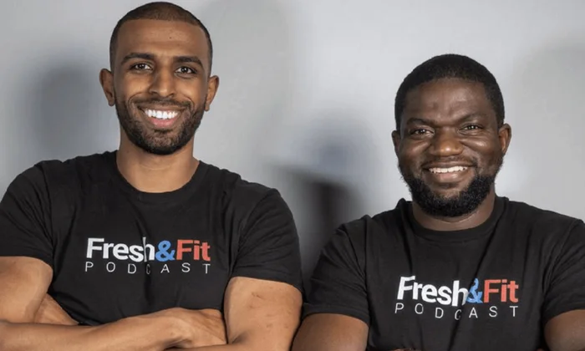
(Image D: Myron (left) and Walker (right) of Fresh and Fit podcast)
This phenomenon is exemplified by Myron Gains and Walter Weekes of the Fresh and Fit podcast (Image X), whose channel is highly influential with a broad reach, with over 297 million views and 1.6 million subscribers since their channel launched in 2020 on YouTube and other streaming services who’s content consistently echoes incel adjacent narratives under the guise of dating advice and male self-improvement.
Fresh and Fit presents itself as a lifestyle and relationship podcast, yet its recurring theme in many of their clips is that framing female romantic behaviours as inherently mercenary and self-serving. Myron articulates this implicitly stating that “I don’t think women want to get with normal men anymore... you’ve already seen the top echelon of earners” (SpartanClips, 2025, 3:00). Whilst Myron and Walker do not identify as incels, their content operates ideologically within the same framework, presenting women as rational actors optimising for male value whilst simultaneously framing men who fail to meet this standard as victims of female nature rather than circumstances (SpartanClips, 2025). The hosts routinely invoke statistical and pseudoscientific language to lend authority to these claims, presenting what is essentially ideological doctrine as empirical truth; a rhetorical strategy consistent with broader patterns across the manosphere, where scientific research is routinely misinterpreted and taken out of context to validate misogynistic beliefs about female behaviour (Bachaud and Johns, 2023). Data shows that women swipe right only about 4.5% to 5% compared to men who swipe right 60% of profiles (Neyt, Vandenbulcke and Baert, 2019). What these podcasts bros interpret is that women have unrealistic standards for dating, what they don’t tell you is that the gender demographic is that there is an average of 3:1 ratio of men to women (75% v 25%) (Iqbal, 2025).
The podcast does not mealy discuss relationships, it actively reproduces a gendered hierarchy in which masculine worth is measured through dominance, sexual access and the subordination of female autonomy.
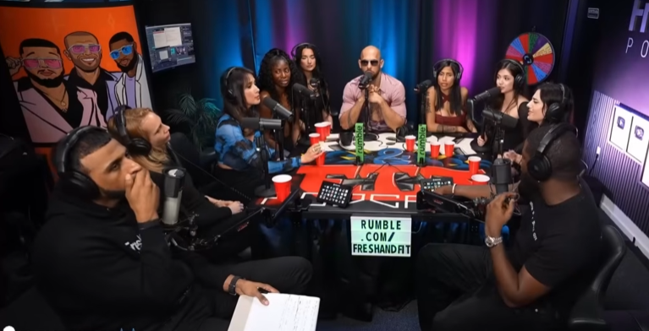
(Image E: The image shows where the women sitting around the table, the show host siting at the front and the guest would sit in the middle)
During the episodes, they invite women (usually OF creators or feminist) to be interrogated, contradicted and used as live “props” for the host theories about female behaviour (SpartanClips, 2025), a dynamic that Connel (2005) would be recognised as performance of hegemonic masculinity in action, where female voices are stripped of independent authority through sounds effects through a sound board and repositioned as data points that confirm an already established ideological framework. The audience engages in a worldview in which men are sovereign evaluators and women are objects to assess and analyse them, comments like “When a women be like I only attract bad boy_____ broke ____ and disloyal boys... yall allow men between your legs” (Fresh and Fit, 2026) reveal how the ideological framework of the podcast is absorbed and reproduced by its viewership. The comment repositions the women's romantic experiences because of her own sexual behaviour, transferring blame entirely onto the women whilst simultaneously invoking the logic of hypergamy and female sexual gatekeeping that the host consistently promote (Marsales, 2023). This framework is not only produced from the host but reinforced by the audience, suggesting that Fresh and Fit functions not just as entertainment but as a community reinforcing the incel ideology in which misogynistic assumptions about female nature are collectively validated.
The deeper appeal of this content cannot be separated from the nostalgic masculinity argument developed earlier in this dissertation. Fresh and Fit is not ultimately about dating tactics but about mourning a gender order that no longer operates in the way these men believe it once did. The imagined golden age invoked across incel spaces, in which male dominance was assumed, female subservience was structural, and masculine worth was socially guaranteed, is the same lost world that Fresh and Fit implicitly promises to help its audience reclaim. Messner (1993) identifies precisely this romanticisation of a previous patriarchal arrangement as the defining emotional logic of backlash masculinity movements, and the podcast operates within that tradition entirely. Feminist progress is presented throughout their content not as a development that has benefited society but as the main cause for male romantic and social suffering, a narrative that resonates with young men who have already be conditioned by the gender order to experience their struggles. Empirical research supports this pattern, finding that men who perceive feminism as a threat are significantly more likely to adopt manosphere attituded that frame women and feminist progress as responsible for male suffering (Bukowski et al., 2025)
The algorithmic function of Fresh and Fit is where its influence becomes most analytically significant. Ging (2019) maps manosphere content across a spectrum running from mainstream self-improvement material at one end to explicit and organised misogyny at the other, with creators at every point along that continuum sharing a common ideological grammar whilst varying in how directly they express it. Fresh and Fit sit deliberately at the accessible end of this spectrum. Its high production values, entertainment framing and aspirational presentation of its hosts ensure that it does not trigger the resistance a more overtly extreme source might provoke in a casual viewer. A young man who begins by watching general dating advice content is algorithmically guided toward Fresh and Fit, where incel adjacent assumptions are introduced gradually and presented as common sense. By the time explicitly incel content appears in his recommendations, the ideological groundwork has already been laid, making radicalisation feel less like a conversion and more like a natural deepening of understanding. This is ideological priming operating through entertainment, and it is far more effective for being largely invisible to its audience.
Ultimately the significance of Fresh and Fit lies not in what it explicitly says but in what it normalises. Unlike dedicated incel forums which require active seeking and community membership, Fresh and Fit deliver ideologically equivalent assumptions about female nature and male entitlement passively to audiences who would likely reject the incel label entirely. The algorithmic architecture of YouTube ensures this content reaches young men before any explicitly incel material enters their recommendations, embedding the gendered logic that sustains incel identity gradually rather than through any single radicalising encounter. This is precisely what Ging (2019) identifies as the ideological function of mainstream adjacent manosphere content. The boundary between mainstream masculinity content and incel ideology has not held but has become permeable, and it is through that permeability that incel adjacent identity among young men is most invisibly and most effectively shaped (Bukowski et al., 2025).

Discussion
The findings presented across all three themes: Incel pipeline, ideological dogma and incel adjacent mainstream content all collectively reveal that the incel identity among men is formed through a structured process operating across multiple digital environments at the same time. Taken together, the themes demonstrate that Connell’s (2005) gender order doesn’t merely provide the backdrop to this process but actively produces the conditions that make it possible. By positioning masculinity as the be all end all alongside sexual and romantic success, the gender order generates accumulates gendered vulnerability that incel spaces, ideological communities and mainstream content creators all draw upon, each reinforcing the other.
Where the two primary sources complement one another most clearly is in mapping the trajectory from vulnerability to entrenchment. Anderson (2024) documents the early and middle stages of this process; men drifting into incel spaces not through conviction but through loneliness, finding community before they find ideology. While the SBS documentary (2023) captures the endpoint of the same trajectory, where community has long since been replaced by consolidated grievance and the ideological framework has become indistinguishable from personal identity. By engaging with these sources, you would naturally conclude that the pipeline is running precisely because it meets emotional needs firsts and ideological framing second.
However, the sources also contradict one another in analytically productive ways. Anderson's (2024) findings complicate any straightforward radicalisation narrative by documenting participants like Gabriel and Alexander whose relationship to incel ideology is ironic, ambivalent or partial. These cases reveal that ideological dogma does not operate uniformly, as some men inhabit these spaces without fully internalising the belief system, suggesting the community and the ideology are separable in ways the documentary does not capture. The documentary, by focusing on the most entrenched participants, risks presenting the extreme end of the pipeline as representative of incel identity broadly, a limitation that Anderson's more nuanced participant data usefully corrects.
A notable gap across all three themes is the limited engagement with the algorithmic mechanisms that connect them. Both primary sources predate the more developed body of research on algorithmic radicalisation, and neither directly addresses how platform recommendation systems move individual users from self-improvement content through mainstream adjacent material like Fresh and Fit and into explicitly incel communities. This is arguably the missing piece of the analysis. Understanding the precise algorithmic pathway would strengthen the empirical foundation of the pipeline argument considerably and would have meaningful implications for how platforms and policymakers might intervene. Without it, the analysis can map the ideological terrain young men travel through but cannot fully account for the infrastructure that determines the route.

Reflexivity Account
Reflexivity in qualitative and interpretive research requires the researcher to examine how their own social position, experiences and motivations may have shaped the research process and its interpretive outcome (Holmes, 2020). My initial exposure to the content ecosystem analysed in this dissertation did not begin with incel communities but with self-improvement spaces around May 2024 – June 2025; content centred around fitness, discipline and financial responsibility. These spaces are where many young men, myself included first encounter the algorithmic environment that this dissertation identifies as a precursor to incel content. That content has helped me improved my body and taught myself financial responsibility. But on the other hand, I started to notice that the algorithms have started to shift towards the same content by personally speaking to me as a man. The gym, as a site of masculine self-improvement, sits at the respectable and socially sanctioned end of the same content spectrum that Fresh and Fit and eventually more explicit manosphere material occupies further along. Recognising that trajectory from my own experience was part of what motivated this research question in the first place.
Throughout this research, I had approached this material with an understanding of the emotional logic of these spaces, somewhat of unique take that much external research may lack. I fully understand why the community in Anderson (2024) documents is genuinely meaningful to socially isolated young men and I understand why content that validates masculine grievances feels like truth rather than ideology to its own audience, since it removes all fault on the individual and places it on something that one cannot control themselves, which is a much healthier cope than admitting fault. With that in mind, I believe, produced a more empathetic and therefore more accurate analysis than one which treats incel identity as simply pathological. However, I must acknowledge the risk of over-identifying with the male subjects of this research at the expense of the women these spaces consistently harm. I have attempted to maintain analytical balance throughout by keeping the harms of incel ideology clearly in view alongside the social conditions that produce it.

Conclusion
The dissertation set out to answer the following research question: How are incel identities among young men shaped by social media and the dynamics outlined in gender order theory? The findings across three themes suggest the answer is neither simple nor reducible to individual pathology. Incel identity is shaped by a structured process in which the gender order produces gendered vulnerability, social media communities capture and validate that vulnerability, and mainstream adjacent content normalises the ideology which spreads amongst audiences far beyond the incel space.
The internet pipeline theme established that entry is driven by social isolation rather than ideological conviction. The ideological dogma theme demonstrated that once absorbed, the blackpill worldview becomes a self-sealing framework that makes exit psychologically costly. The incel adjacent content theme revealed that radicalisation begins not in incel forums but in mainstream digital environments where creators like Fresh and Fit normalise incel adjacent assumptions under the cover of entertainment.

Reference
Baele, S.J., Brace, L., Coan, T.G., (2019). From 'Incel' to 'Saint': Analyzing the violent worldview behind the 2018 Toronto attack. Terrorism and Political Violence, 33, 1667–1691. https://doi.org/10.1080/09546553.20 19.1638256
Bachaud, L. and Johns, S. (2023) 'The use and misuse of evolutionary psychology in online manosphere communities: the case of female mating strategies', Evolutionary Human Sciences, 5, e20. doi: 10.1017/ehs.2023.22. [Accessed 25 Mar. 2026]
Brace, L. (2023) Incels and the Incelosphere: An Overview of Current Research and Understanding. University of Exeter. Available at: https://crestresearch.ac.uk/download/4498/23-008-01-incels_and_the_incelosphere_report_v2.pdf. [Accessed 6 Nov. 2025]
Bryman, A. (2016) Social research methods. 5th edn. Oxford: Oxford University Press.
Braun, V. and Clarke, V. (2006) ‘Using thematic analysis in psychology’, Qualitative Research in Psychology, 3(2), pp. 77–101.
doi: 10.1191/1478088706qp063oa. [Accessed 01 Nov. 2025]
Bukowski, M. et al. (2025) 'From privilege to threat: unraveling psychological pathways to the manosphere', PLOS ONE, [online]. Available at: https://pmc.ncbi.nlm.nih.gov/articles/PMC12011899/ [Accessed: 26 March 2026].
Cambridge Dictionary (2019). DOGMA | meaning in the Cambridge English Dictionary. [online] Cambridge.org. Available at: https://dictionary.cambridge.org/dictionary/english/dogma. [Accessed: 23 Mar. 2026]
Connell, R.W., (1995). Masculinities. Berkeley: University of California Press.
Costello, W., Whittaker, J. & Thomas, A.G., (2025). The dual pathways hypothesis of incel harm: A model of harmful attitudes and beliefs among involuntary celibates. Archives of Sexual Behavior. Advance online publication. https://doi.org/10.1007/s10508-025-03161-y [Accessed: 21 September 2025]
Daskin, I., (2019). The Alt-Right Playbook: How to Radicalize a Normie [video]. Innuendo Studios. Available at: https://www.youtube.com/user/InnuendoStudios [Accessed 6 Nov. 2025]
Evens, R., (2018). From Memes to Infowars: How 75 Fascist Activists Were “Red-Pilled”. Bellingcat, 11 October. Available at: https://www.bellingcat.com/news/americas/2018/10/11/memes-infowars-75-fascist-activists-red-pilled [Accessed 6 Nov. 2025]
Feltham, F. (2024). I’m Andrew Tate’s audience and I know why he appeals to young men. The Guardian. [online] 6 Jan. Available at: https://www.theguardian.com/news/2024/jan/06/im-andrew-tates-audience-and-i-know-why-he-appeals-to-young-men. [Accessed: 19 Mar. 2026]
Ging, D., (2017). Alphas, Betas, and Incels: Theorizing the Masculinities of the Manosphere. Men and Masculinities, 22(4), pp.638–657. https://doi.org/10.1177/1097184X17706401 [Accessed: 21 September 2025]
Ging, D., (2019). Masculinity, violence and digital culture: Towards a critical masculinity studies. Palgrave Communications, 5(1), pp.1–11. https://doi.org/10.1057/s41599-019-0302-2 [Accessed: 21 September 2025]
Gheorghe, R.M. (2023). ‘Just Be White (JBW)’: Incels, Race and the Violence of Whiteness. Affilia, 39(1), p.088610992211442. doi:https://doi.org/10.1177/08861099221144275. [Accessed: 28 Mar. 2026]
Høiland, T., (2019). Incels and the stories they tell: A narrative analysis of Incels’ shared stories on Reddit. Master’s Thesis. University of Oslo. Available at: https://www.academia.edu/73516671 [Accessed: 21 September 2025]
Holmes, A. (2020). Researcher positionality - A consideration of its influence and place in qualitative research - A new researcher guide. [online] ResearchGate. Available at: https://www.researchgate.net/publication/344072065_Researcher_Positionality_-_A_Consideration_of_Its_Influence_and_Place_in_Qualitative_Research_-_A_New_Researcher_Guide. [Accessed: 28 Nov. 2025]
Iqbal, M. (2025). Tinder Revenue and Usage Statistics (2025). [online] Business of Apps. Available at: https://www.businessofapps.com/data/tinder-statistics/. [Accessed: 26 Mar. 2026]
Jones, A., (2020). Incels and the Manosphere: Tracking Men's Movements Online. Master’s Thesis. University of Central Florida. Available at: https://stars.library.ucf.edu/etd2020/65 [Accessed 6 Nov. 2025]
King-Hill, S. & Russell, D., (2023). The toxic influence of Andrew Tate: How society has failed a generation of young men and boys. University of Birmingham Blog, 8 February. Available at: https://blog.bham.ac.uk/socialsciencesbirmingham/2023/02/08/andrew-tate [Accessed 6 Nov. 2025]
Kimmel, M. (2013) Angry White Men: American Masculinity at the End of an Era. New York: Nation Books.
Lindsay, A., (2020). Incel violence as a reclamation of masculinity and defence of patriarchy on three distinct levels. Unpublished manuscript. Available at: https://www.researchgate.net/publication/356360476 [Accessed: 3 November 2025]
Love, T.P., Prskalo, E. and Moloney, M.E. (2025). Hatespeech or Tatespeech? Andrew Tate and the rise of the radical misogynist. New Media & Society. doi:https://doi.org/10.1177/14614448251374158. [Accessed: 19 Mar. 2026 ]
Marsales, E. (2023). Join the Brotherhood!: How ‘Alpha Male’ Podcasts are Targeting Men. The Ethnograph: Journal of Anthropological Studies, [online] 7(1), pp.6–13. Available at: https://ojs.library.ubc.ca/index.php/EJAS/article/view/198299/192591. [Accessed: 26 Mar. 2026]
Maxwell, D., Robinson, S.R., Williams, J.R. & Keaton, C., (2020). “A Short Story of a Lonely Guy”: A Qualitative Thematic Analysis of Involuntary Celibacy Using Reddit. Sexuality & Culture, 24, pp.1–22. https://doi.org/10.1007/s12119-020-09724-6 [Accessed: 3 November 2025]
Messner, M.A., (1997). Politics of Masculinities: Men in Movements. Thousand Oaks, CA: Sage Publications.
Messner, M.A. (1993) 'Changing men and feminist politics in the United States', Theory and Society, 22(5), pp. 723–737.
Neyt, B., Vandenbulcke, S. and Baert, S. (2019). Are men intimidated by highly educated women? Undercover on Tinder. Economics of Education Review, [online] 73, p.101914. doi: https://doi.org/10.1016/j.econedurev.2019.101914. [Accessed: 25 Mar. 2026]
Reeves, R.V. (2022) Of boys and men: Why the modern male is struggling, why it matters, and what to do about it. Washington, DC: Brookings Institution Press.
Scaptura, M.N. & Boyle, K.M., (2020). Masculinity threat, “incel” traits, and violent fantasies among heterosexual men in the United States. Feminist Criminology, 15(3), pp.278–298. https://doi.org/10.1177/1557085119896415
SpartanClips (2025). Myron EXPOSES Delusional 304s... Who Think THEY Are The Prize... [online] YouTube. Available at: https://www.youtube.com/watch?v=rWvrdmbDjjw [Accessed 25 Mar. 2026].
Shin, J. and Jitkajornwanich, K. (2024) 'How algorithms promote self-radicalization: audit of TikTok's algorithm using a reverse engineering method', Social Science Computer Review, 42(4). doi:10.1177/08944393231225547. [Accessed: 28 Mar. 2026]
Wallace, R. (2021) The Black Pill. Independently published
Wescott, S., Roberts, S. and Zhao, X. (2024). The problem of anti-feminist ‘manfluencer’ Andrew Tate in Australian schools: Women teachers’ experiences of resurgent male supremacy. Gender and Education, [online] 36(2), pp.167–182. doi:https://doi.org/10.1080/09540253.2023.2292622. [Accessed: 19 Mar. 2026]
White, A., (2000). ‘Did the Earth Move?’ The Hazards of Bringing Men and Masculinities into Gender and Development. IDS Bulletin, 31(2), pp.33–41. https://doi.org/10.1111/j.1759-5436.2000.mp31002005.x [Accessed: 21 September 2025]
Williams, Z., (2024). Getting fit is great, but it could turn you into a right-wing jerk. The Guardian, 6 June. Available at: https://www.theguardian.com/commentisfree/2024/jun/06/getting-fit-right-wing-jerk [Accessed: 3 November 2025]

Appendix

Appendix 1: Table of search term
Search Terms
“incel identity formation”; “online incel communities”; “incel subculture social media”; “incel forums and echo chambers”
“masculinity and incels”; “Connell gender order theory”; “hegemonic masculinity online”; “masculinity crisis social media”; “masculinity and disenfranchised youth”
“ideological groupthink incels”; “incel grievance narratives”; “incel narratives and victimhood”; “incel ideology and gender theory”
“incel YouTube content”; “incel Reddit threads”; “toxic masculinity Reddit”; “incels and digital radicalisation”; “incels and digital masculinity performance” “incel and right wing pipeline”
“incel identity and social rejection”; “incel culture and masculinity politics”; “incel identity and social isolation”; “gendered power structures”

Appendix 2: Field Research Risk Assessment

Research Fieldwork Risk Assessment

This form is for students and staff undertaking any type of research fieldwork

The Principal Investigator/Supervisor is responsible for completing a risk assessment of their research activities i.e., identifying any potential hazard which could occur during data collection activities and determining appropriate actions to minimise the risk of harm, accident or illness. The results of risk assessments should be shared with all project staff. All team members should be given a copy of the completed risk assessment(s) to ensure that they have a full understanding of all issues identified and addressed.

PLEASE NOTE: applicants completing data collection in an external institution/organization may need to complete and submit the risk assessment documentation provided by the institution/organisation, as required for insurance purposes.

Project Title/ Reference/ID No. | Project Title: From Rejection to Radicalisation: The Making of the Incel Identity | Reference/ID no:
Researcher details: | Name: Ugonna Ezenekwe  Student no. if applicable: | Role: Principal Investigator/Supervisor/Data Collector
Researcher details: | Name: Lisa Overton  Student no. if applicable: | Role: Principal Investigator/Supervisor/Data Collector
Next-of-kin for ………………………… | Name: | Contact Details:
Next-of-kin for …………………………. | Name: | Contact Details:
Date of risk assessment: | 12/11/2025 | Review Date:

DECLARATION: By submitting this form you are agreeing to allow us to be in contact with your next-of-kin in the case of an emergency.
Please give details where the research/data collection will be completed:
Location | Name/position of contact | Place for fieldwork/organisation | Address | Tel: | Email:
1. | Ugonna | Home/Middlesex University |  |  | UE055@live.mdx.ac.uk

2.

3.

POTENTIAL HAZARDS: please inform us of any hazards you may face whilst on location
Examples of Potential Hazards:
- Adverse weather: exposure (heat, sunburn, lightening, wind, hypothermia)
- Terrain: rugged, unstable, fall, slip, trip, debris, and remoteness. Traffic: pollution.
- Demolition/building sites, assault, getting lost, animals, disease.
- Working on/near water: drowning, swept away, disease (weils disease, hepatitis, malaria, etc), parasites’, flooding, tides and range.
- Lone working: difficult to summon help, alone or in isolation, lone interviews.
- Dealing with the public: personal attack, causing offence/intrusion, misinterpreted, political, ethnic, cultural, socio-economic differences/problems. Known or suspected criminal offenders.
- Safety Standards (other work organisations, transport, hotels, etc), working at night, areas of high crime.
- Ill health: personal considerations or vulnerabilities, pre-determined medical conditions (asthma, allergies, fitting) general fitness, disabilities, persons suited to task.
- Articles and equipment: inappropriate type and/or use, failure of equipment, insufficient training for use and repair, injury.
- Substances (chemicals, plants, bio- hazards, waste): ill health - poisoning, infection, irritation, burns, cuts, eye-damage.
- Manual handling: lifting, carrying, moving large or heavy items, physical unsuitability for task

Location | Potential risk/hazard | Who might be harmed and how? | Precautions to be taken to control this risk | Additional safety measures/ equipment that may be needed | Action by who? | Action by when? | Done
1. | Desensitisation | Me – Emotionally numb from repeated exposure to said content | Limit the exposure during the research, which includes regular breaks |  | Supervisor | Weekly
1. | Emotional fatigue | Me/Reader – exposure to misogynistic and extreme media | Take some days off |  | Me/Supervisor | Weekly
2. | Ethical Misrepresentation | Me- Risk of representing online communities. | Maintain non partial content without calling out each individual person and attributing it to a whole group of people | Completing ethical monitor form | Me/Supervisor | Before submission
2.
3.
3.

Appendix 3: Ethics application
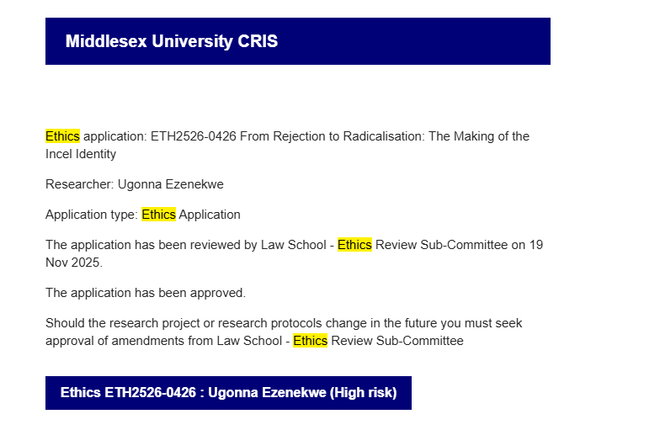

Appendix 4: Supervisor meeting checkup
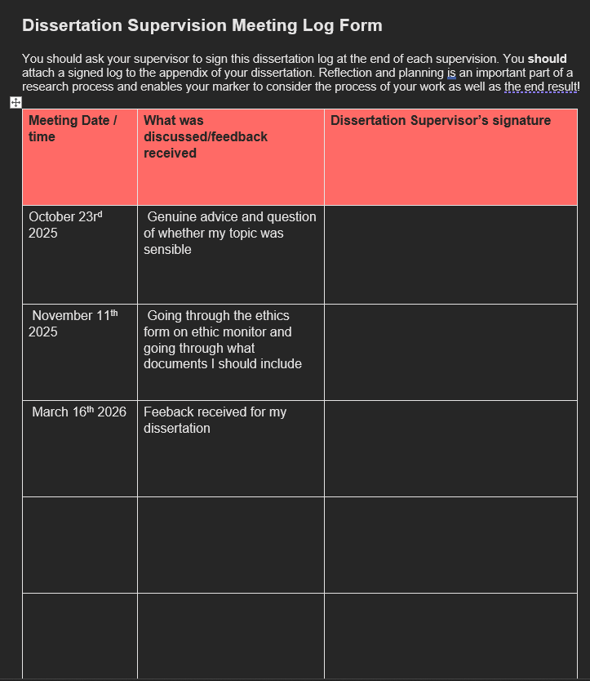
(THIS WASN’T INCLUDED AS LISA HAS LET YOU PEOPLE KNOW)

The Chad Stride: The Chad walks with a tiny beetle-like stride, perpetually in contrapposto like a Greek statue, with his arms constantly flailing, his back perfectly straight, always looking everyone in the eye, wearing bright neon attire and $3000 Giusepe Zanotti boots, completely immune to cold, while brutally dominating everyone around him without registering the emotions or feelings of others.
The Stacy: The Stacy is a blonde woman with a naturally curvy body, perfect makeup, and sexy long hair, who carries a $2000 Gucci bag, has countless orbiters and Chads blowing up her phone, and never works a day in her life while living in luxury.
I want to contextualise this issue, while this has been an issue for years, with everyone being brought to social media because of COVID, had drawn people away from the real world and able to distribute memes, information at a faster rate on social media.
This isn’t from the original channel where the clips come from, it’s a clip channel where they post the content on YT which is unavailable on the main channel or locked behind a paywall from Kick.com
Fieldwork is ‘any work carried out by staff of students for the purposes of teaching, research or other activities while representing’ Middlesex ‘University off site’. (UCEA Guidance on Health and Safety in Fieldwork 2011).

