UGCad.io
Platform Flow Documentation
Creator · Brand · Admin — Current (As-Is) & Ideal (To-Be) flows
21 diagrams · 5 sections · mapped from live source code
Generated 2026-06-24

UGCad.io — Platform Flow Documentation
Purpose: A complete map of the software's flows across Creator, Brand (Business), and Admin sides — both the AS-IS (current, implemented) flows and the TO-BE (ideal, production-grade) flows — plus the linkages and dependencies between them.
>
Source of truth: Backend = Backend/server.py (FastAPI, ~9.1k lines) + campaign_models.py, campaign_helpers.py, gigs.py, creator_features.py, storage.py. Frontend = C:\Users\meetr\Frontend\src (React, react-router, axios).

Document index
File | Contents
00-OVERVIEW.md (this) | System map, roles, entities, the two acquisition models, status vocabulary
01-CREATOR-FLOW.md | Creator side — current vs ideal
02-BRAND-FLOW.md | Brand/Business side — current vs ideal
03-ADMIN-FLOW.md | Admin/Ops side — current vs ideal
04-LINKAGES-AND-GAPS.md | Cross-role linkages, dependency matrix, gap analysis & production roadmap
Rendering note: Diagrams are written in Mermaid. They render natively on GitHub, in VS Code (with a Mermaid preview extension), Obsidian, and most Markdown viewers.

1. What the product is
A UGC (User-Generated Content) marketplace connecting Brands that need short-form video content with Creators who produce it, mediated by an Ops/Admin team that gates trust, holds money in escrow, and resolves disputes.
It is an India-first platform: rupee (₹) pricing, GST validation on brand onboarding, TDS (Tax Deducted at Source) on creator payouts, and Razorpay/Cashfree payment rails.

The three actors (+ ops sub-roles)
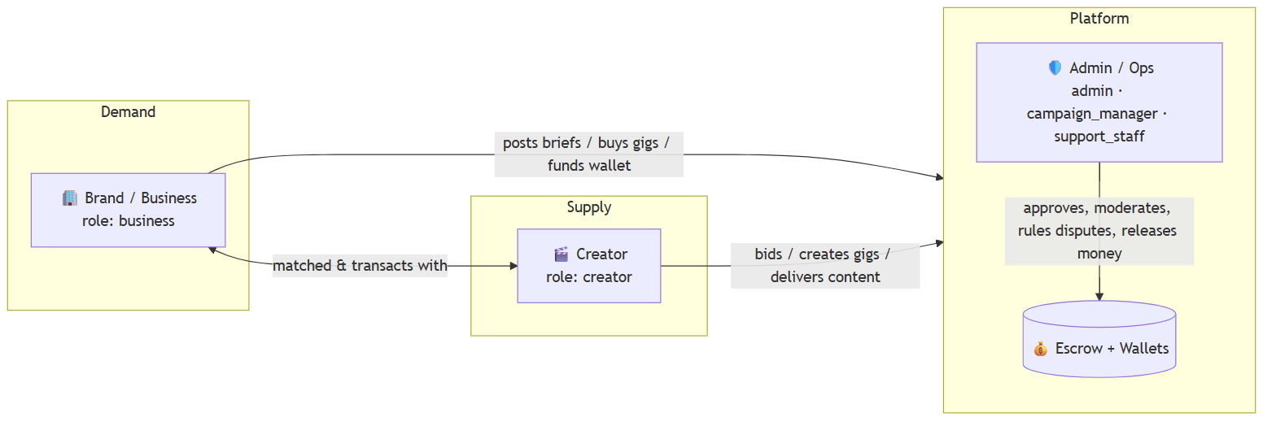
Role (backend value) | Who | Core job
creator | Content creator | Build profile → win work → deliver → get paid
business | Brand | Fund wallet → source content → review → approve → own the content
admin | Founder / super-admin | Everything, incl. money, bans, settings, roles
campaign_manager | Ops (senior) | Approvals, shortlists, disputes (capped), payouts
support_staff | Ops (regular) | Approvals, moderation, lower-authority ops
Permission model lives in utils/adminRoles.js (frontend gating) and OPS_ROLES in server.py:3776 (backend enforcement). Capability-based: can(user, capability). Dispute authority is money-capped by role (Ops Regular ₹25K, Ops Senior ₹1L, Founder unlimited).

2. The two acquisition models (critical to understand)
The platform supports two parallel ways a brand and creator transact. Understanding the difference is the key to the whole system.
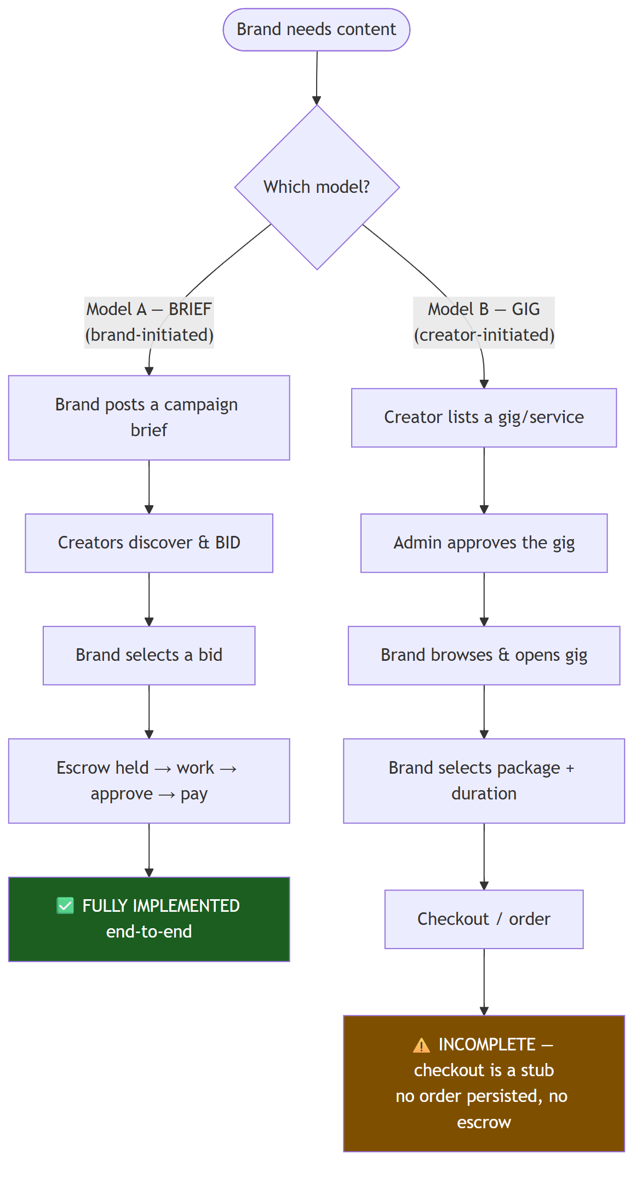
 | Model A — Campaigns / Briefs | Model B — Gigs
Initiated by | Brand | Creator
Discovery | Creators browse briefs (BrowseBriefs) | Brands browse gigs (BrowseApprovedGigs)
Matching | Bidding or ops-curated shortlist | Direct selection of a gig package
Admin gate | None today — briefs auto-publish (server.py:3576) | Yes — gig needs approve (gigs.py)
Money / escrow | ✅ Full escrow, TDS, payout, disputes | ❌ Not wired — purchase is a toast() stub (GigDetailsPage.js:261)
Status | LIVE & complete | PARTIAL — listing + approval + wishlist only
Takeaway: Today the platform effectively runs on Model A (Briefs). Model B (Gigs) is a half-built second channel: creators can list, admins can approve, brands can browse/wishlist — but no brand can actually buy a gig because checkout is unimplemented.

3. Core entities & relationships
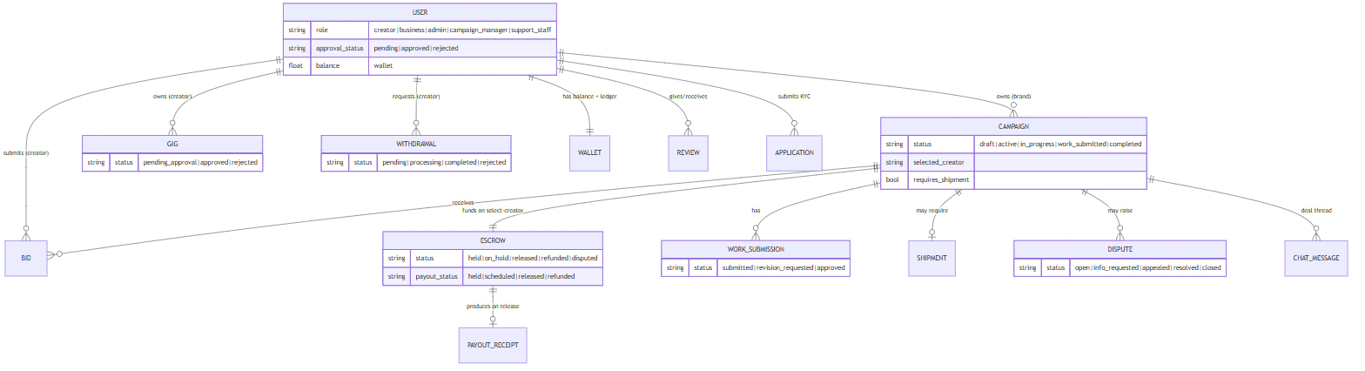

4. Status vocabulary (the state machines at a glance)
These statuses drive every screen. Full transition diagrams live in each role file; this is the master reference.
Entity | States | Source
User approval | `pending → approved \ | rejected` (rejected → re-apply) | server.py:157-165, :6664
Application (KYC) | `pending → more_info → approved \ | rejected` | applications.py:28-32
Campaign/Brief | draft → active → in_progress → work_submitted → completed (rejected legacy) | campaign_models.py:9-15
Gig | `pending_approval → approved \ | rejected (in_progress,completed,cancelled` future) | gigs.py:46-52
Bid | `pending → accepted (becomes selected_creator) \ | rejected/lapsed` | server.py /bid, /select-creator
Work submission | `submitted → approved \ | revision_requested → submitted …` (auto-approve @5d) | server.py:171-175, :5434
Escrow | `held → on_hold → released \ | refunded \ | disputed` | server.py:4163, :5399, :5960
Payout (within escrow) | `held → scheduled → released \ | refunded` | server.py:5322, :5384
Withdrawal | `pending → processing → completed \ | rejected` | server.py:177-181, :6988
Shipment | pending → shipped/in_transit → delivered → received (+ disputed) | server.py:1307, :6484
Dispute | open → info_requested → appealed → resolved → closed | server.py:6012-6276
User account | active → suspended → banned | server.py:6924

5. The money flow (one picture)
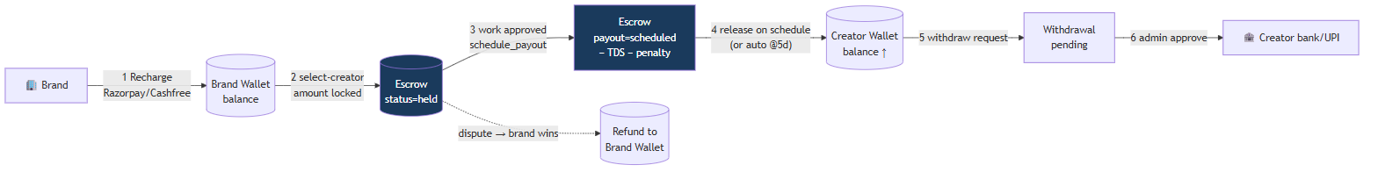
Key facts (verified in code):
- Platform commission ≈ 20–25% + ₹500 listing fee per brief (AdminSettings, PostABrief Step 7).
- Revisions: first 2 free; ₹500 each after; admin escalation past 5 (creator_features.py, server.py:5610).
- Late delivery penalty ladder: minor 5% / moderate 10% / severe 15% (server.py:5222, :5474).
- Auto-approval: unreviewed work auto-approves & pays creator after 5 days (server.py:5434).
- TDS withheld on payout unless creator.tds_exempt (server.py:5322).
- Payout speed tiered by creator level (New 12d → Elite 48h).

6. How to read the role files
Each of 01/02/03 is structured identically:
- Current (AS-IS) journey — ordered steps + flowchart + the real screens/APIs.
- Current state machine — what actually transitions today.
- Gaps & dead-ends — what's stubbed, broken, or missing.
- Ideal (TO-BE) journey — production-grade flow with the gaps closed.
- AS-IS vs TO-BE delta table.
04 ties it together: the cross-role sequence diagrams, the dependency matrix, and the prioritized roadmap to production.

Creator Side — Flow (Current vs Ideal)
Role: creator. Entry landing: /creator. Gated by approval_status === 'approved'.

PART A — CURRENT (AS-IS) FLOW

A.1 End-to-end journey (current)
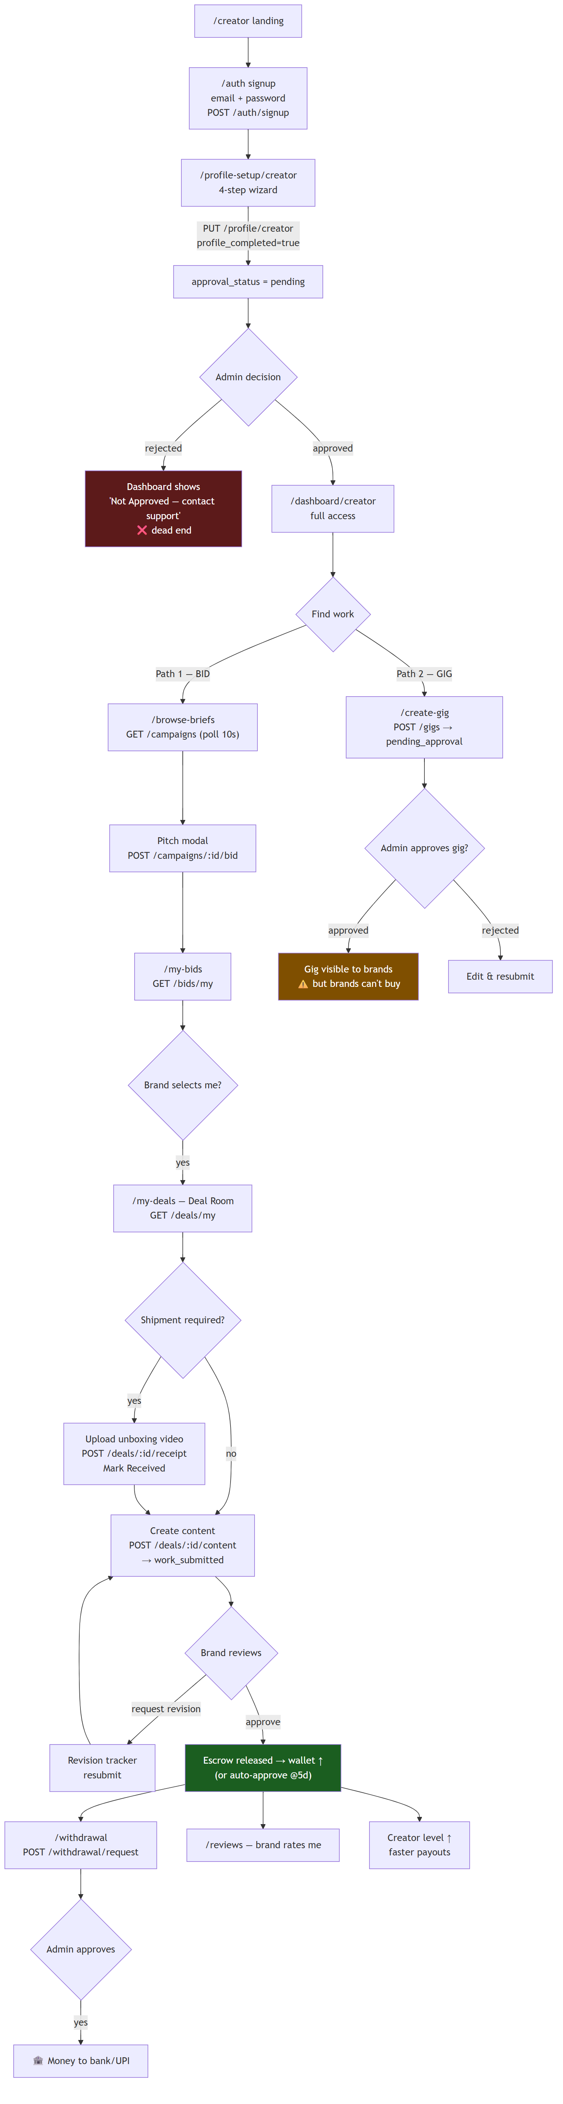

A.2 Screens, what they do, key APIs
Step | Screen (src/pages) | What the creator does | Key API(s)
Land | CreatorLanding.js | Marketing; CTA to signup | — (static)
Sign up | CreatorSignup.js | Email + password (Google = "coming soon" stub) | POST /auth/signup
Profile | CreatorProfileSetup.js | 4 steps: basics → contact → portfolio/skills/socials/languages → equipment/availability/rate | POST /upload/file, PUT /profile/creator
Dashboard | CreatorDashboard.js | Stats, level banner, active campaigns, earnings chart; blocked until approved | GET /campaigns, /reviews/creator/:id, /auth/me
Find work A | BrowseBriefs.js | Filter briefs (search, category, payout range, match score), bid | GET /campaigns, /payout-ranges; POST /campaigns/:id/bid
Bids | MyBidsPage.js | Track pending bids | GET /bids/my
Find work B | CreateGig.js | Create a service listing (title, category, budget, deadline, niches, styles, platforms, attachments) | POST /gigs
Deal room | MyDealsPage.js | The core workspace: brief, activity feed, shipment receipt, content submission, revisions, chat, payout summary | GET /deals/my; POST /deals/:id/{receipt,content,chat,revision-response,damage-report,dispute,escalate}
Active work | MyActiveWorkPage.js | Filtered list of assigned campaigns | GET /campaigns
Submit | WorkSubmission.js | Upload deliverables | POST /work/submit
Portfolio | PortfolioPage.js | Add/remove showcase items | PATCH /profile/portfolio
Reviews | ReviewsPage.js | Read brand ratings | GET /reviews/creator/:id
Payout | WithdrawalPage.js / PayoutWithLayout.js | KPIs, payment history, bank details, request withdrawal | GET /payout/overview, /withdrawal/history; POST /withdrawal/request

A.3 Creator state — what actually transitions
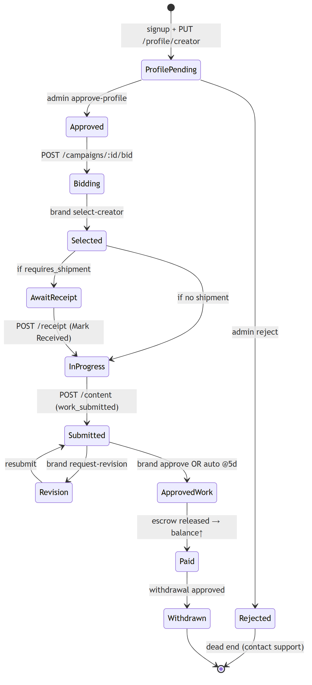

A.4 Gaps & dead-ends (current)
# | Gap | Where | Impact
1 | Google sign-up is a toast stub | CreatorSignup.js:53 | Only email/password works
2 | Gig channel dead for creators — they can list & get approved, but no brand can buy | CreateGig.js + GigDetailsPage.js:261 | Wasted effort; Model B is a dead end
3 | Rejected profile = hard dead end — no re-apply / appeal UI | CreatorDashboard.js | Lost supply
4 | `/messages` & `/settings` referenced in nav, thin/partial pages | nav links | Confusing navigation
5 | No real-time — everything polls every 10s (t=Date.now()) | most pages | Laggy deal room & chat
6 | Dispute vs Escalate both hit similar endpoints | MyDealsPage.js:367 | Ambiguous creator intent
7 | Earnings chart is dummy data (Jan–Jun hardcoded) | CreatorDashboard.js | Misleading metric
8 | Portfolio has no in-place edit / versioning | PortfolioPage.js | Limited curation
9 | No onboarding nudge between approval and first bid | flow gap | Slow time-to-first-bid

PART B — IDEAL (TO-BE) FLOW

B.1 Production-grade creator journey
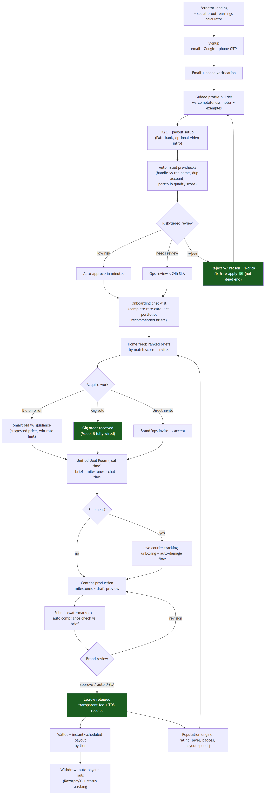

B.2 What changes from current → ideal
Area | Current (AS-IS) | Ideal (TO-BE)
Auth | Email/password only; Google stub | Email + Google + phone OTP; verified email/phone
Approval | Manual binary, reject = dead end | Risk-tiered (auto-approve low risk), <24h SLA, reject-with-fix loop
Onboarding | Drop into empty dashboard | Checklist + recommended briefs + earnings calculator
Work discovery | Browse + poll; dummy match score | Ranked feed, real match score, invites, win-rate hints
Gig channel | Listing dead-ends (no checkout) | Fully transactional (order → escrow → deliver)
Deal room | 10s polling | Real-time (WebSocket/SSE), milestones, draft previews
Compliance | Manual; brand catches issues | Auto-check submission against brief must-include/avoid
Payouts | Manual admin approval per withdrawal | Automated payout rails (RazorpayX/Cashfree Payouts) + receipts
Reputation | Level by count; dummy chart | Real analytics, badges, transparent payout-speed ladder
Reject/Disputes | Hard dead ends | Appeal + guided resolution paths

B.3 Ideal creator state machine (adds the missing transitions)
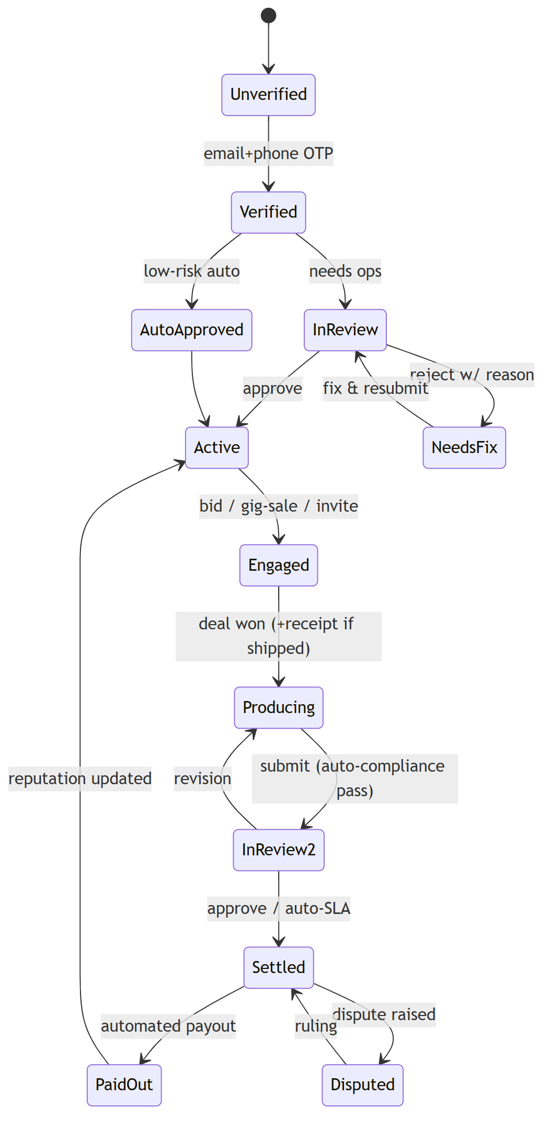

Brand / Business Side — Flow (Current vs Ideal)
Role: business (= brand). Landing: /. Gated by approval_status === 'approved'. Main hub: BusinessDashboard.js (renders sub-pages via a page prop).

PART A — CURRENT (AS-IS) FLOW

A.1 End-to-end journey (current)
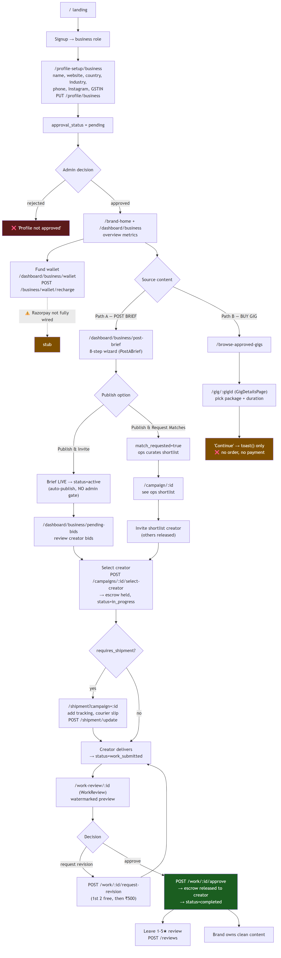
Important reconciliation: Frontend AdminCampaigns.js implies an admin *approves* briefs, but the backend auto-publishes briefs on submit (server.py:3576-3577, status → active, reason "auto-published"). So the brief approval gate is legacy/inactive. Gigs, by contrast, do require admin approval.

A.2 Screens & sub-pages
Area | Screen / sub-page | What the brand does | Key API(s)
Landing | Landing.js | Marketing, signup | —
Profile | BusinessProfileSetup.js | Business details + GSTIN | PUT /profile/business
Welcome | BrandWelcomePage.js | Status, curated gigs, search | GET /campaigns, /gigs?status=approved, /categories
Overview | BusinessDashboard page="overview" | Metrics, performance chart, creator funnel, active deals | GET /business/dashboard, /campaigns
Post brief | PostABrief.js (8 steps) | Basics → deliverables → must-include → must-avoid → style → usage rights → timeline/budget → review/publish | POST /campaigns/draft, PATCH /campaigns/:id, POST /campaigns/:id/submit
Bids | page="pending-bids" | Review bids; view profile; chat; select | GET /campaigns; POST /campaigns/:id/select-creator
Shortlist | CampaignDetails.js | View ops shortlist, invite, request new | GET /campaigns/:id/shortlist; POST …/invite, …/request-new
Browse creators | page="browse-creator" | Directory w/ filters; invite | GET /business/creator-directory; POST …/:id/invite
Browse gigs | BrowseApprovedGigs.js | Filter approved gigs | GET /gigs?status=approved
Gig detail | GigDetailsPage.js | Package/duration; wishlist; (buy = stub) | GET /gigs/:id, /profile/:creatorId, /reviews/creator/:id; POST /gigs/:id/wishlist
Work review | WorkReview.js | Approve / request revision; rate | GET /work/:id; POST /work/:id/approve, …/request-revision; POST /reviews
Shipments | page="shipments" + ShipmentTracking.js | Add tracking, checklist, view unboxing | GET /shipment/:campaignId; POST /shipment/update
Wallet | page="wallet" | Balance, recharge, transactions | GET /business/wallet; POST /business/wallet/recharge
All campaigns | page="all-campaigns" | List/manage campaigns + drafts | GET /campaigns, ?status=draft

A.3 Brand state — what actually transitions
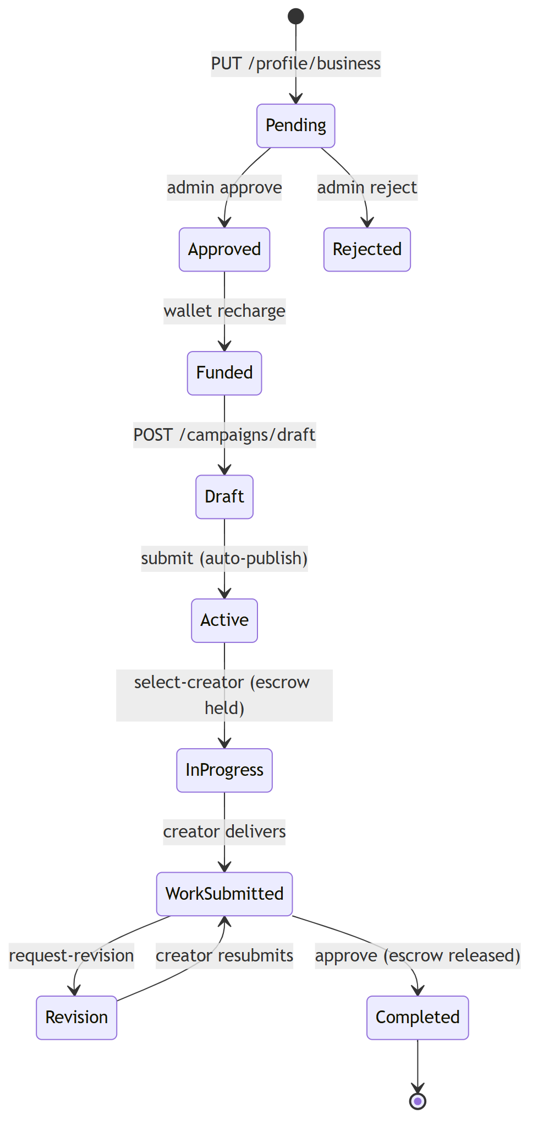

A.4 Gaps & dead-ends (current)
# | Gap | Where | Impact
1 | Wallet recharge not fully wired to Razorpay SDK | BusinessDashboard.js:531 | Brands can't reliably add funds
2 | Gig purchase (Path B) is a stub — "Continue" only toasts | GigDetailsPage.js:261 | Entire direct-buy channel non-functional
3 | Contact-creator from gig browse is a toast stub | BrowseApprovedGigs.js:124 | Can't initiate from gig
4 | Creator-directory may 404 if backend missing | BusinessDashboard.js:439 | Browse-creator empty
5 | Escrow funding ambiguity — escrow created on select-creator but wallet debit timing unclear vs recharge | backend | Reconciliation risk
6 | Brief approval is legacy — frontend admin approval contradicts backend auto-publish | AdminCampaigns.js vs server.py:3576 | Confusing/dead admin path
7 | Dispute from brand side skeletal in shipment | ShipmentTracking.js:310 | No resolution path UI
8 | No campaign performance after-the-fact (views, ROAS) | overview | Limited proof of value

PART B — IDEAL (TO-BE) FLOW

B.1 Production-grade brand journey
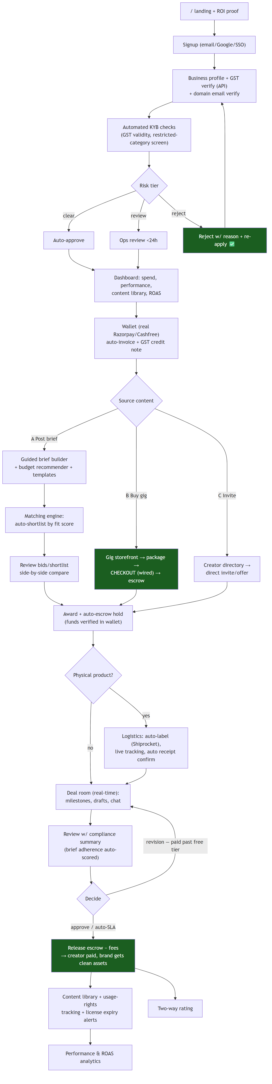

B.2 Current → ideal delta
Area | Current | Ideal
Onboarding | Manual GSTIN text field | GST verified via API; KYB auto-screen; reject-with-fix loop
Wallet | Recharge stub | Live payments + auto GST invoices/credit notes
Gig channel | Browse only (no buy) | Full storefront → checkout → escrow → delivery
Matching | Manual ops shortlist or raw bids | Fit-score matching engine + side-by-side bid compare
Escrow | Created on select, debit timing fuzzy | Verified hold against funded wallet; clear ledger
Shipping | Manual tracking entry | Auto-label + live tracking + auto receipt
Review | Watermark preview, manual judgment | Auto compliance score vs brief; structured feedback
Post-sale | None | Content library, usage-rights/license tracking, ROAS
Approval gate | Legacy/contradictory | Removed for briefs (consistent) or risk-based moderation

B.3 Ideal brand state machine
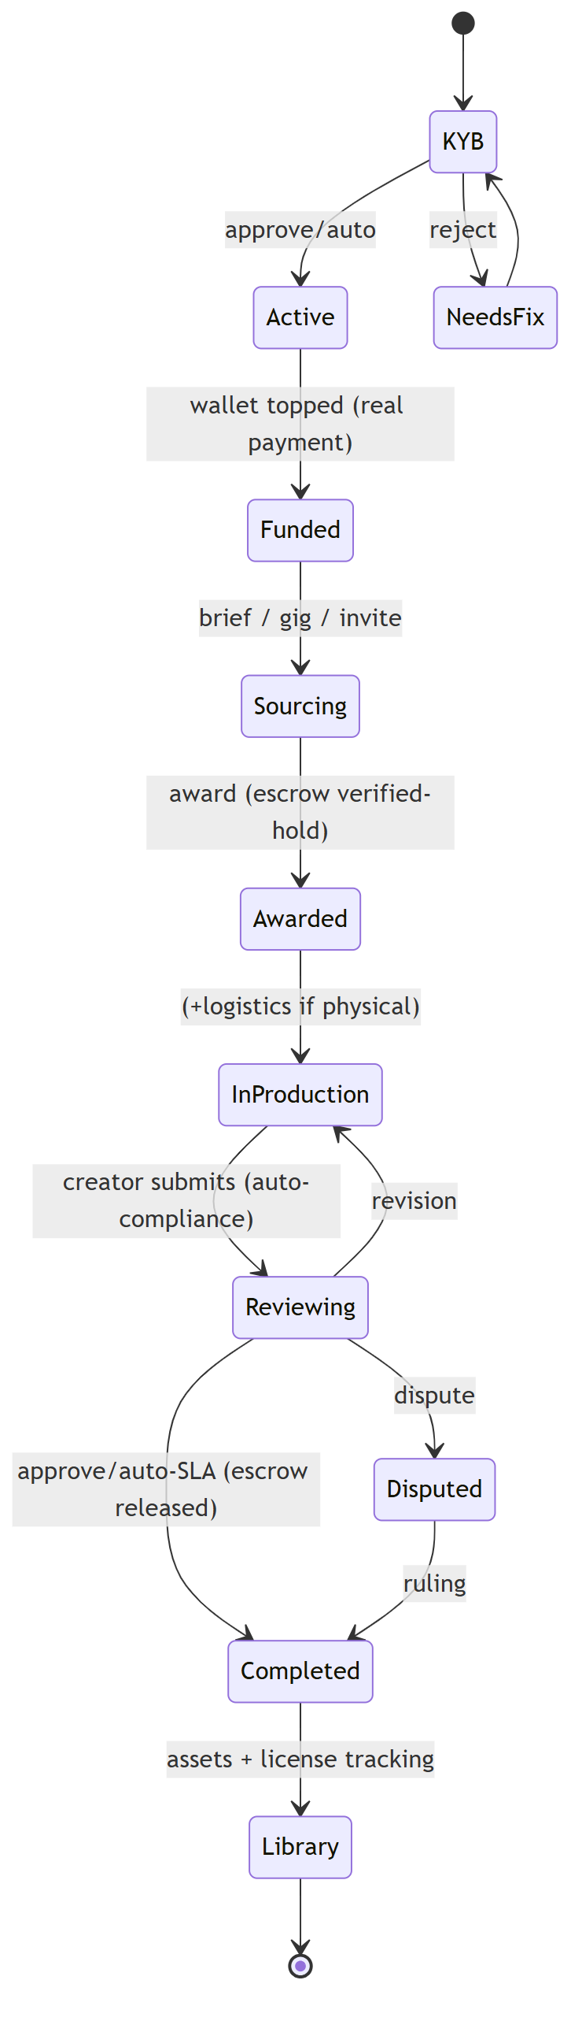

Admin / Ops Side — Flow (Current vs Ideal)
Roles: admin (Founder), campaign_manager (Ops Senior), support_staff (Ops Regular) + a Finance role in the capability model. Hub: AdminDashboard.js + AdminLayout/Sidebar/Topbar. Permission model: utils/adminRoles.js (can(user, capability)); backend OPS_ROLES (server.py:3776).

PART A — CURRENT (AS-IS) FLOW

A.1 The admin sits on the critical path as a set of GATES
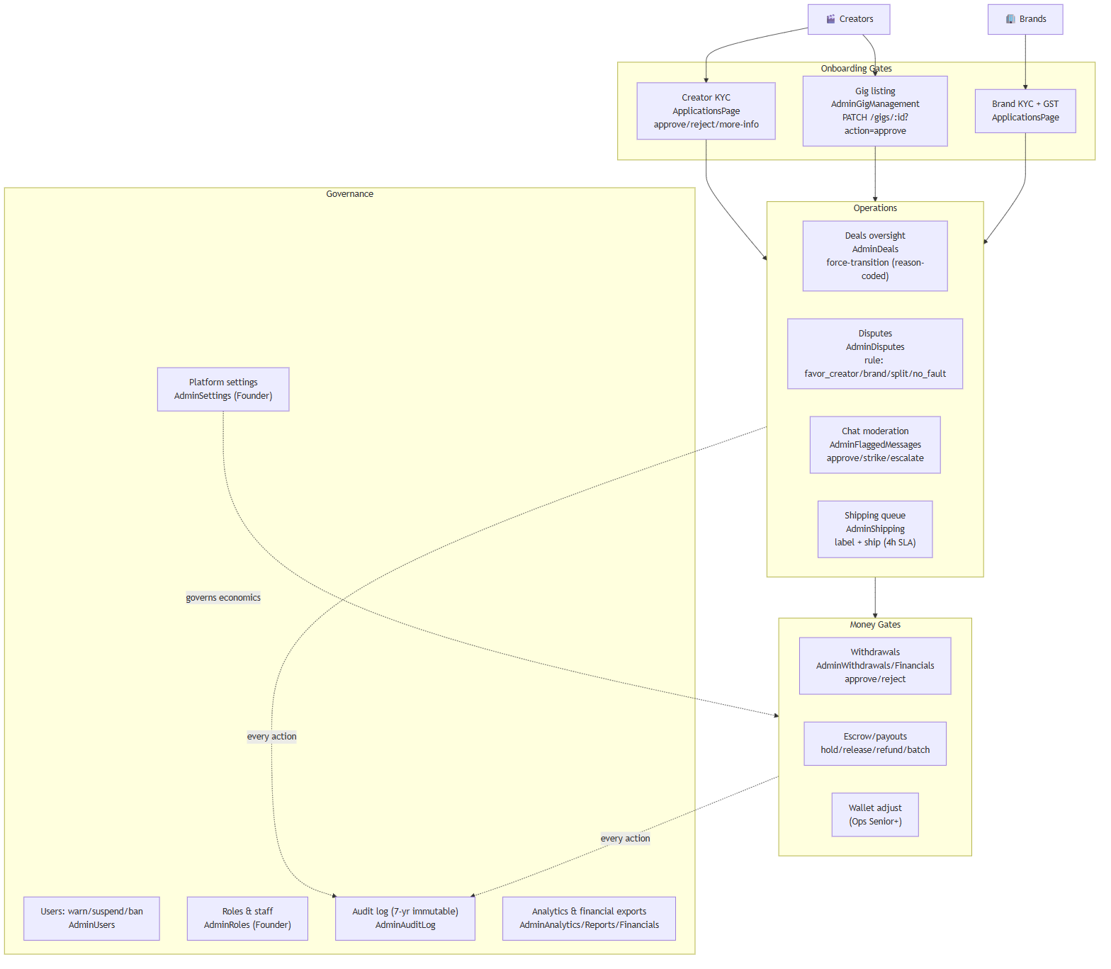

A.2 Capability / role matrix (from `adminRoles.js`)
Capability | Founder | Ops Senior | Ops Regular | Finance
review_applications | ✅ | ✅ | ✅ | —
manage_deals | ✅ | ✅ | ✅ | —
rule_disputes (cap) | ✅ ∞ | ✅ ₹1L | ✅ ₹25K | —
manage_shipping | ✅ | ✅ | ✅ | —
release_payouts | ✅ | ✅ | ✅ | —
adjust_wallet | ✅ | ✅ | — | —
warn_suspend_users | ✅ | ✅ | — | —
ban_users | ✅ | — | — | —
view_financials | ✅ | ✅ | — | ✅
generate_reports / export_tax | ✅ | ✅ | ✅ | ✅
user_management | ✅ | ✅ | — | —
content_moderation | ✅ | ✅ | ✅ | —
manage_roles / edit_settings | ✅ | — | — | —
view_audit | ✅ | ✅ | ✅ | ✅

A.3 The gates with APIs & transitions
Gate | Screen | API | Transition
Creator/Brand KYC | ApplicationsPage.js | `POST /admin/applications/:type/:id/{approve\ | reject\ | request-more-info}` | `pending → approved \ | rejected \ | more_info`
Gig | AdminGigManagement.js | `PATCH /gigs/:id?action=approve\ | reject` | `pending_approval → approved \ | rejected`
~~Campaign~~ (legacy) | AdminCampaigns.js | POST /admin/approve-campaign | Inactive — briefs auto-publish (server.py:3576)
Deal | AdminDeals.js | POST /admin/deals/:id/force-transition | any → any (reason-coded)
Dispute | AdminDisputes.js | POST /admin/disputes/:id/rule | open → resolved (+ escrow split)
Moderation | AdminFlaggedMessages.js | POST /admin/message/moderate | flagged → approved \ | strike \ | escalate
Shipping | AdminShipping.js | `POST /admin/shipping/:id/{label\ | ship}` | pending → shipped
Withdrawal | AdminWithdrawals.js | `POST /admin/withdrawals/:id/{approve\ | reject}` | `pending → processing \ | rejected`
Escrow/payout | AdminFinancials.js | POST /admin/payouts/{:id/hold,:id/release,batch-release}, /admin/escrow/:id/{release,refund} | held → released \ | refunded
Users | AdminUsers.js | `POST /admin/user/{ban\ | update}` | active → suspended \ | banned
Roles | AdminRoles.js | `POST /admin/staff/{role\ | revoke\ | categories}` | —
Settings | AdminSettings.js | PUT /admin/settings | commission, fees, payout delays, etc.
Audit | AdminAuditLog.js | GET /admin/audit-logs | read-only, 7-yr, before/after snapshots

A.4 Dispute resolution flow (current)
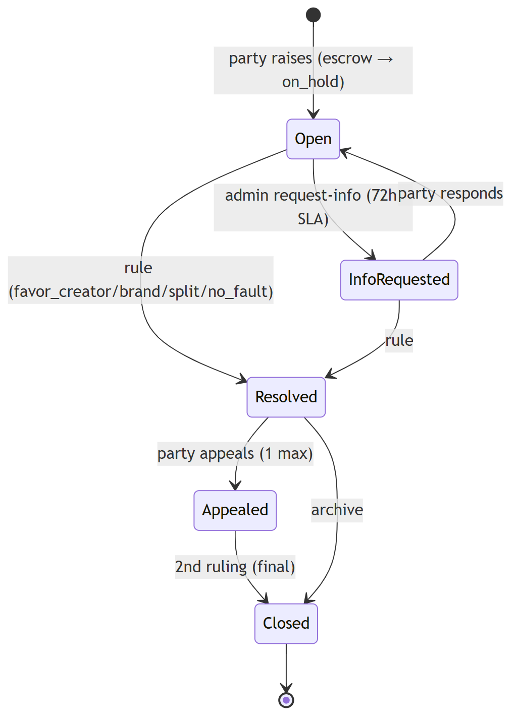

A.5 Gaps & dead-ends (current)
# | Gap | Where | Impact
1 | Shipping label auto-gen not live — manual Shiprocket | AdminShipping.js:147 | 4h SLA at risk; manual toil
2 | Legacy campaign approval contradicts auto-publish | AdminCampaigns.js | Dead/confusing path; no real moderation of briefs
3 | Two gig/profile approval surfaces (AdminGigManagement vs ApplicationsPage) | both | Unclear ownership
4 | Redundant campaign views (AdminCampaigns vs AdminAllCampaigns) | both | Clutter
5 | Filter-rule proposal lacks senior-approval workflow | AdminFlaggedMessages.js:147 | Governance gap
6 | Old "stats" dashboard tab = dead code | AdminDashboard.js | Maintenance burden
7 | Manual, reactive everything — no SLA dashboards/queues prioritization beyond color codes | global | Doesn't scale
8 | No fraud/risk scoring feeding the gates | global | Manual judgment only

PART B — IDEAL (TO-BE) FLOW

B.1 From manual gatekeeper → risk-based control tower
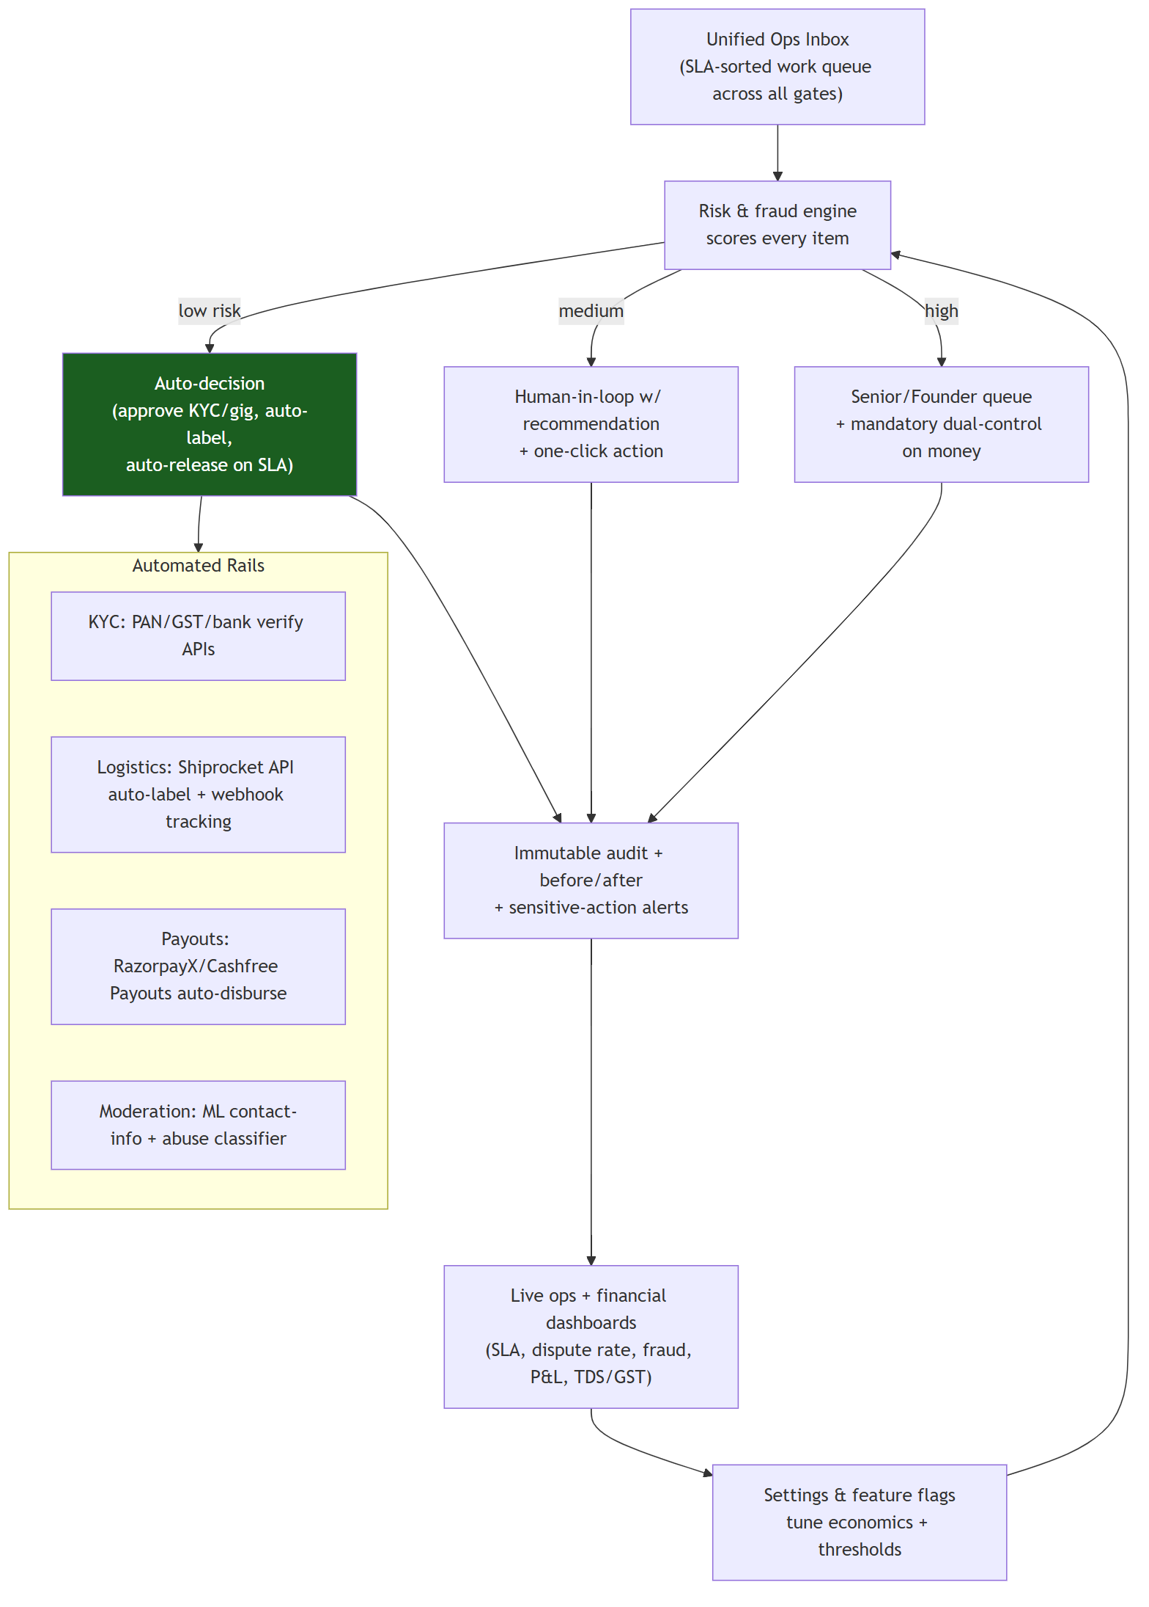

B.2 Current → ideal delta
Area | Current | Ideal
Work intake | Per-page queues, color-coded | Single SLA-sorted ops inbox across all gates
Decisions | Fully manual | Risk-tiered: auto / assisted / escalated
KYC/KYB | Manual review + regex GST check | PAN/GST/bank verification APIs, auto-screen
Shipping | Manual labels in Shiprocket | API auto-label (<60s) + webhook tracking
Payouts | Manual approve each withdrawal | Automated disbursement rails + exception-only review
Moderation | Regex + manual | ML classifier + proposal→senior-approval workflow
Money controls | Single-admin actions | Dual-control + role money-caps enforced server-side
Visibility | Static reports/exports | Live dashboards: SLA, dispute %, fraud, P&L, TDS/GST
Governance | Audit log exists | Audit + anomaly alerts + periodic access review
Brief moderation | Legacy/contradictory | Either none (consistent auto-publish) or risk-based spot-check

B.3 Ideal: a single ops work-item lifecycle
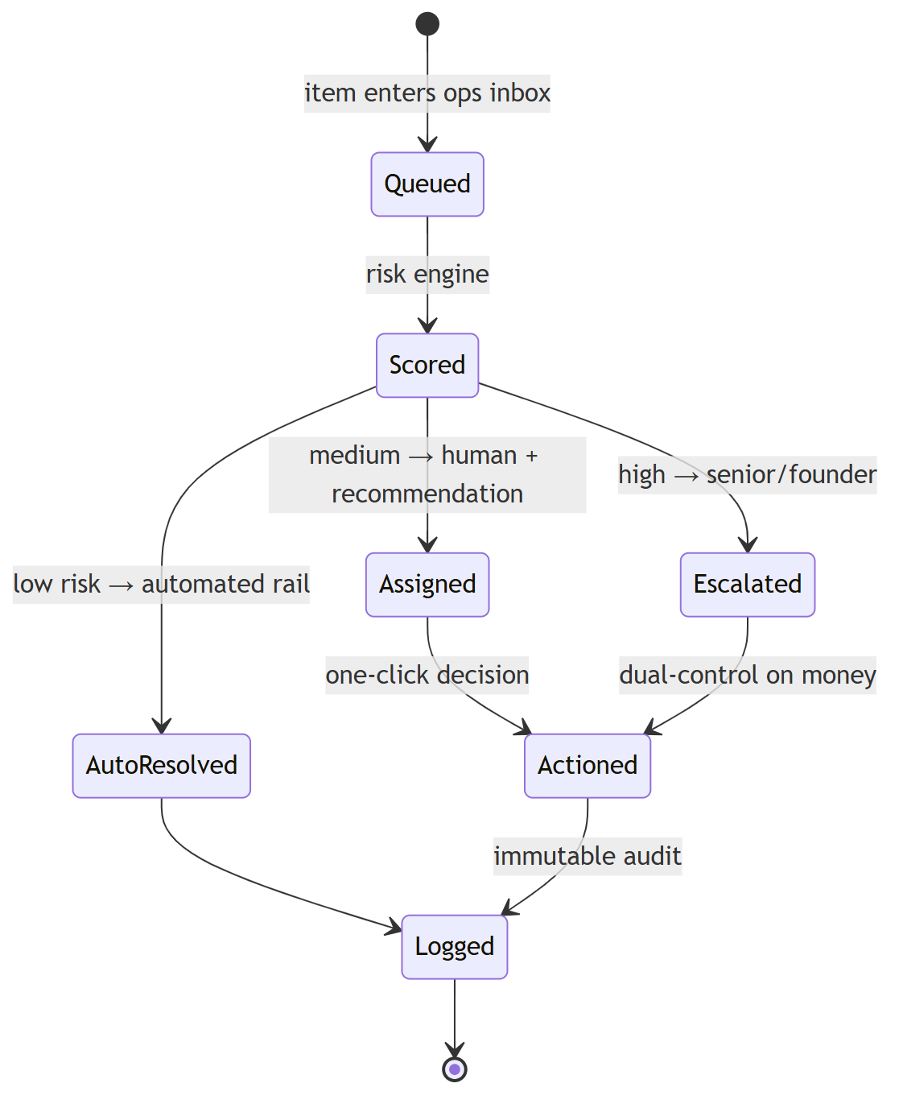
North star: the admin's role shifts from *approving everything* to *governing thresholds and handling exceptions* — automation clears the low-risk bulk, humans focus on judgment calls, and every money movement carries dual-control + an immutable trail.

Linkages, Dependencies & Production Roadmap
How the three sides connect, what each side depends on from the others, where the chain breaks today, and the prioritized path to a production-grade platform.

1. The full cross-role lifecycle (Model A — Briefs, the live path)
This is the canonical end-to-end sequence that all three actors participate in.
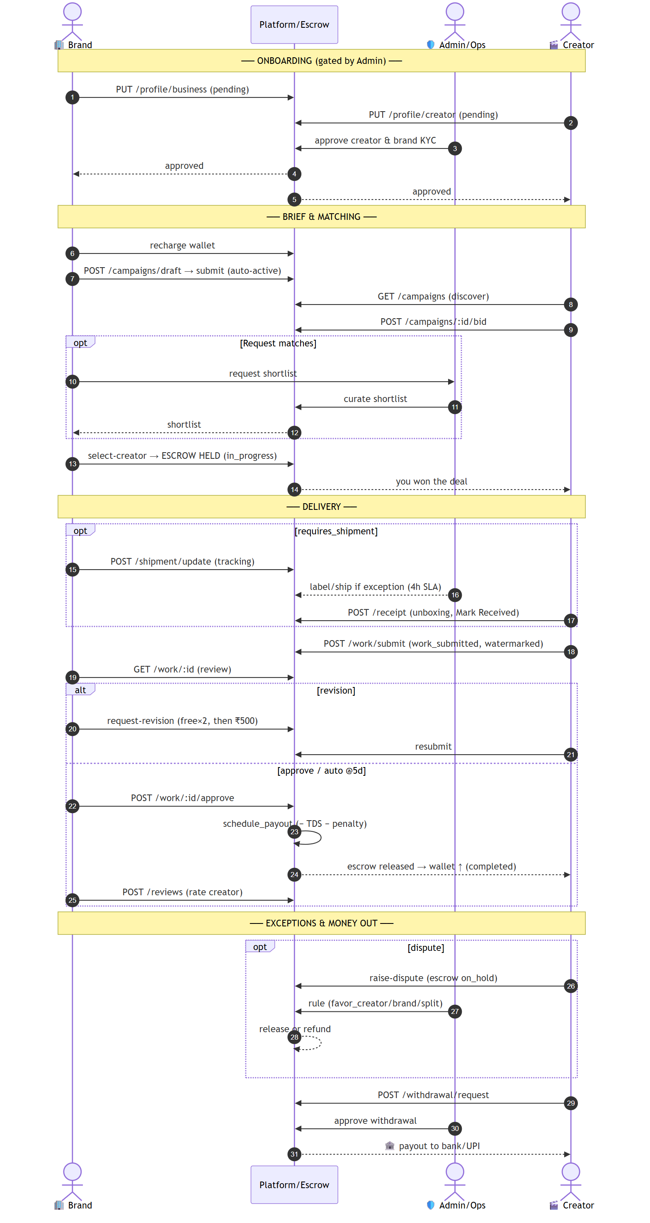

2. Dependency matrix — who depends on whom
This step… | …is blocked until | Owner | Cross-dependency
Creator can bid | creator approval_status=approved | Admin | Creator → Admin
Brand can post brief | brand approval_status=approved | Admin | Brand → Admin
Creator can be paid | brand funded wallet + selected + approved work | Brand | Creator → Brand
Brief visible to creators | brief submitted (auto-publish) | Brand | Creator → Brand
Gig visible to brands | gig approved | Admin | Creator → Admin
Escrow released | brand approves OR 5-day auto-approve | Brand/System | Creator → Brand/System
Withdrawal paid | admin approves withdrawal | Admin | Creator → Admin
Shipment received gate | brand ships + creator confirms | Brand+Creator | mutual
Dispute resolved | admin ruling (within role money-cap) | Admin | Brand+Creator → Admin
Chat stays open | brand wallet ≥ min_chat_balance (₹5K) | Brand | Creator ↔ Brand → Brand wallet

Dependency graph
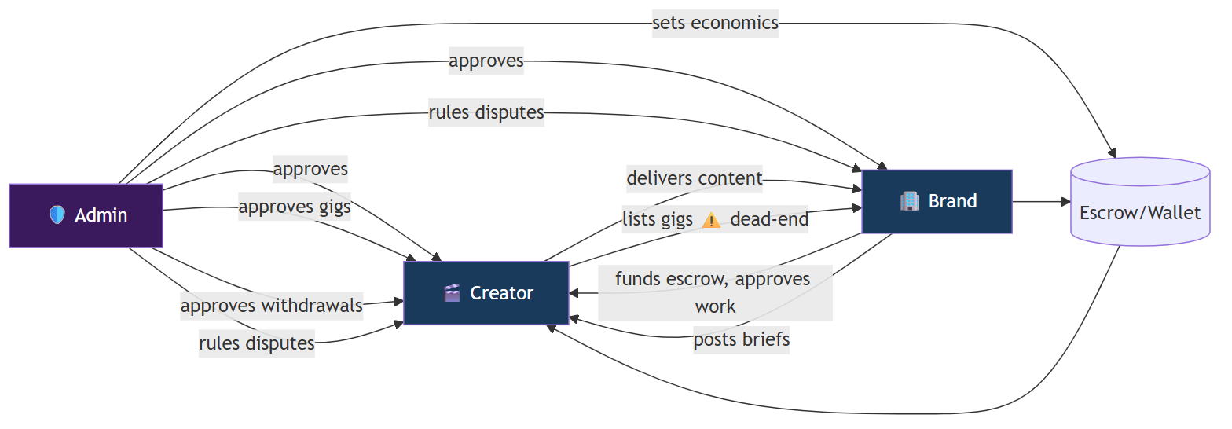
Critical-path insight: the Admin gates both ends of supply and demand *and* the money exit. Any latency in KYC approval, dispute ruling, or withdrawal approval directly throttles GMV. This is the #1 reason the ideal flow (file 03) pushes for risk-tiered automation of these gates.

3. Where the chain breaks today (consolidated gap register)
Severity | Gap | Side | File / ref | Consequence
🔴 Critical | Gig checkout unimplemented (Model B) | Brand+Creator | GigDetailsPage.js:261 | Half the marketplace (creator-initiated) earns ₹0
🔴 Critical | Wallet recharge not fully wired to gateway | Brand | BusinessDashboard.js:531 | Brands struggle to fund → no escrow → no deals
🔴 Critical | Withdrawal & payout fully manual | Creator+Admin | server.py:6988 | Ops bottleneck; slow creator payouts
🟠 High | Legacy brief-approval vs auto-publish mismatch | Brand+Admin | AdminCampaigns.js vs server.py:3576 | Dead admin path; no brief quality control
🟠 High | No real-time (10s polling everywhere) | All | most pages | Laggy deal room/chat, stale data
🟠 High | Reject = dead end (creator & brand) | Creator+Brand | dashboards | Lost supply/demand, no appeal
🟠 High | Shipping labels manual | Admin | AdminShipping.js:147 | SLA risk, ops toil
🟡 Medium | Dummy analytics (earnings chart, some metrics) | Creator+Brand | dashboards | Misleading; no real proof of value
🟡 Medium | Creator-directory may 404 | Brand | BusinessDashboard.js:439 | Browse-creator empty
🟡 Medium | Dispute vs escalate ambiguity | Creator | MyDealsPage.js:367 | Mis-routed exceptions
🟡 Medium | Redundant/duplicate admin surfaces | Admin | AdminCampaigns/AllCampaigns; GigMgmt/Applications | Maintenance + confusion
🟢 Low | Google sign-up stub; settings/messages thin | All | CreatorSignup.js:53 | Minor friction

4. AS-IS vs TO-BE at a glance (per side)
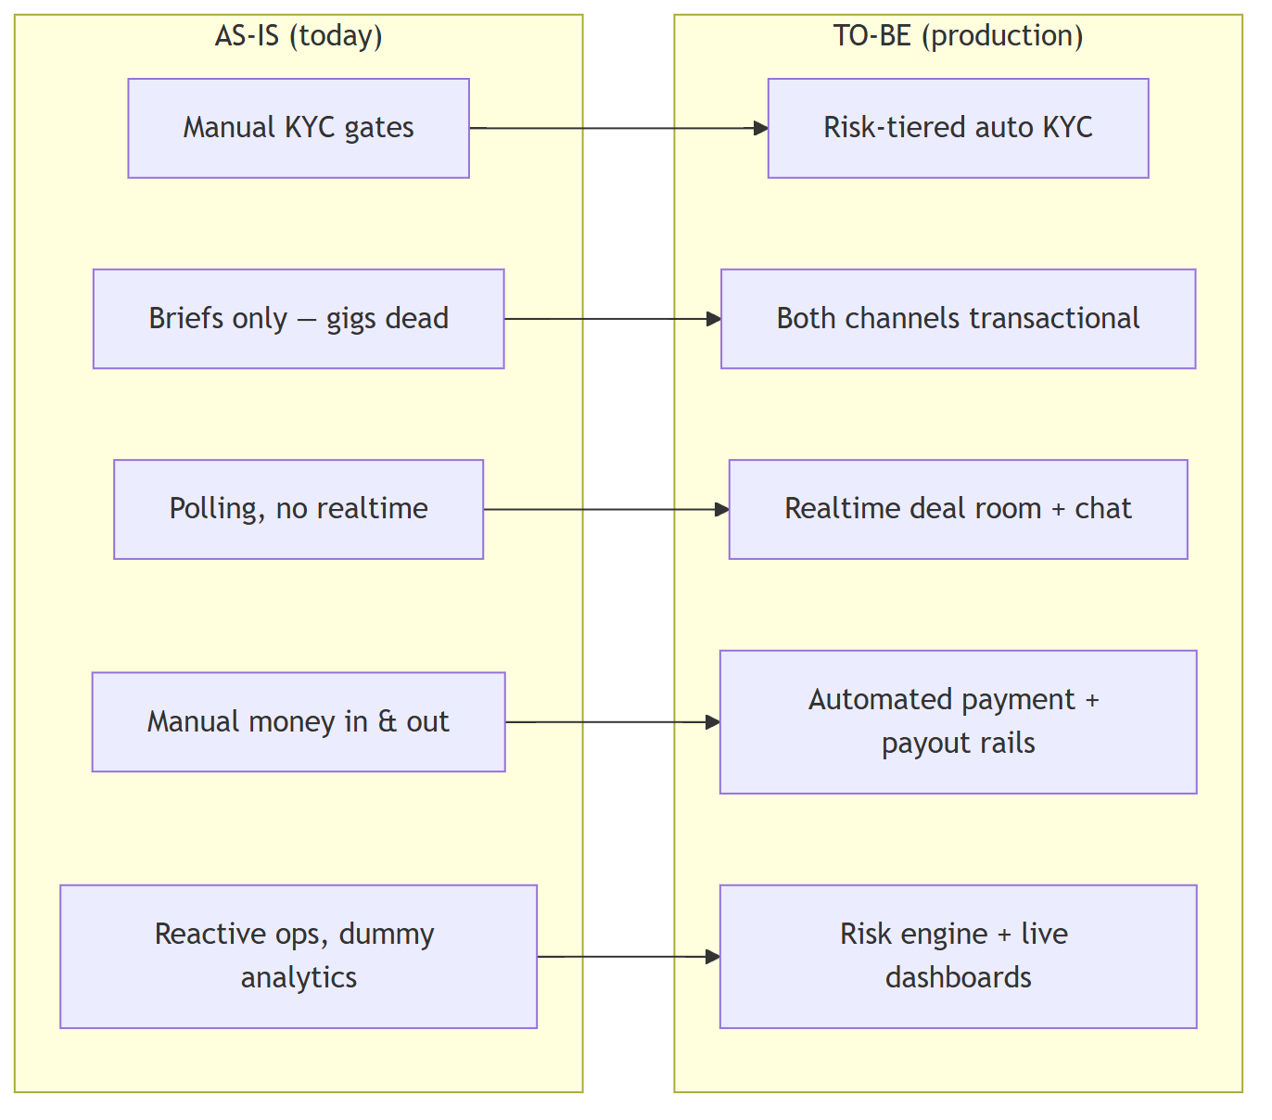

5. Prioritized roadmap to production
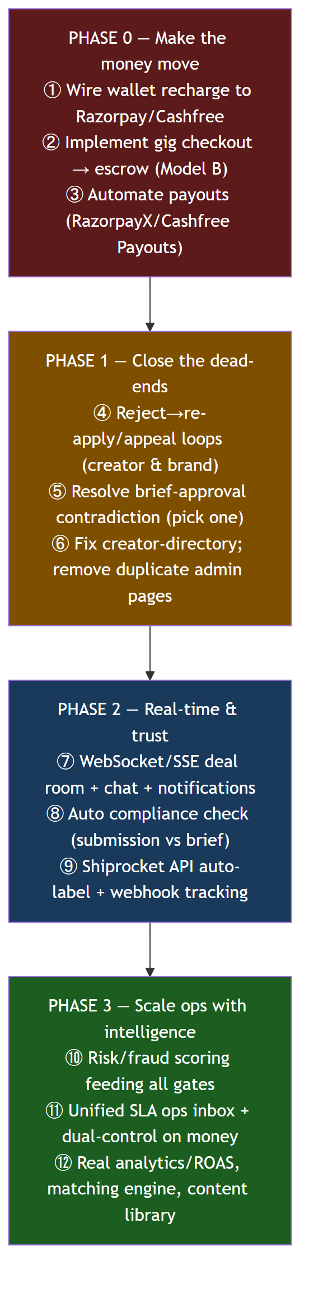
Phase | Theme | Why first | Unblocks
0 | Money plumbing | Without funding + payout + gig checkout, the marketplace can't transact at scale | All revenue
1 | Remove dead-ends & contradictions | Stops silent supply/demand leakage and confusion | Conversion, data integrity
2 | Real-time + trust automation | UX parity with competitors; reduces disputes | Retention, lower dispute rate
3 | Ops intelligence | Lets the team scale GMV without linear headcount | Margin, throughput

6. One-page mental model
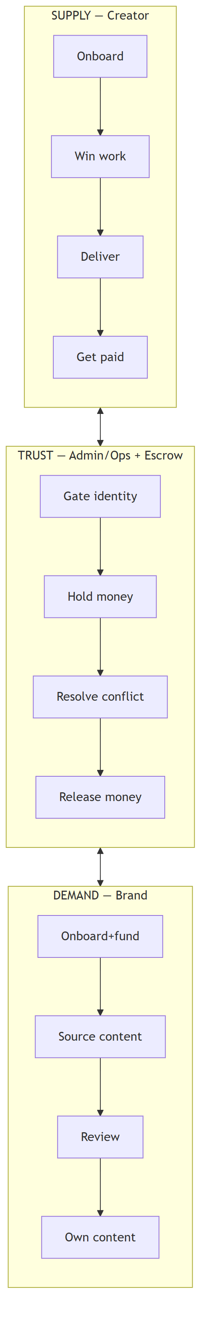
The product in one sentence: Admin gates trust and holds money so that Brands can source content with confidence and Creators can get paid reliably — and the path to production is to automate that trust + money machinery so it works without a human on every step.

