Interpretation of the Thematic Map (Strategic Diagram)
A thematic map (strategic diagram) was constructed following Cobo et al. (2011) from the keyword co-occurrence network of the 232 included documents (Scopus Index Keywords; top 250 terms, minimum frequency 50 per thousand). Themes were obtained by Louvain community detection on the association-strength network and positioned according to their centrality (relevance degree, i.e. the strength of a theme's links to the other themes) and density (development degree, i.e. the internal cohesion of the theme). Four themes emerged, one for each quadrant of the diagram (Figure 1); circle area is proportional to the total occurrences of the theme's keywords. Their interpretation follows.

Motor theme — human, health care quality, humans
The motor theme occupies the upper-right quadrant of the strategic diagram, with above-mean centrality (482.21) and density (14.36), and is by far the largest theme of the network (59 keywords, 2 611 keyword occurrences across the 232 documents). High centrality indicates that the theme is strongly linked to all other themes of the network, while high density shows that it is internally cohesive and conceptually mature. Research framing health-care quality around human subjects and patients is therefore both the most developed and the most central strand of this literature: the conceptual core that drives and structures the whole field, with shared definitions, accumulated evidence and dense internal debate. Because motor themes can saturate, periodic re-mapping is advisable to monitor whether its density keeps rising and which quality dimensions (safety, effectiveness, timeliness, patient experience) carry the theme.

Niche theme — mortality, time factor, time factors
The niche theme shows the highest density of the map (19.08) but below-mean centrality (381.81), with 31 keywords and 656 occurrences. This signature — strong internal cohesion with weak external connection — identifies a specialised sub-field: mortality endpoints, follow-up duration and timing of care, i.e. the time-to-event methodological toolkit. It is a mature, self-contained specialty with its own outcomes and study designs, yet it sits at the periphery of the field's centre of gravity, exchanging little with the health-care-quality core. The most valuable development for this theme is bridging work that connects its rigorous outcome measurement to the motor theme, transferring methodological rigour to the core of the field.

Basic theme — female, male, major clinical study
The basic theme combines above-mean centrality (423.57) with low density (10.63) and is the second largest theme of the map (27 keywords, 1 216 occurrences). Its keywords are transversal descriptors — sex and demographic categories together with the study-design tag major clinical study — that recur across most documents of the corpus, which explains their strong links to every other theme, but that do not constitute a coherent theory of their own, which explains the weak internal cohesion. Practically, this theme is the shared foundational vocabulary of the field rather than an independent research front, and should be read as cross-cutting covariates of the literature. Should its density grow in future periods, that would signal maturation into an autonomous sub-literature — for instance on sex/gender equity in the quality of care.

Emerging or declining theme — practice guideline, protocol compliance, clinical practice
The smallest theme of the map (10 keywords, 207 occurrences) falls below the mean on both centrality (146.28) and density (7.58), placing it at the margin of the field. It captures the implementation-science angle — whether routine clinical practice adheres to practice guidelines and protocols — and is at present weakly developed and weakly connected to the core. A static map cannot separate an embryonic research front from a fading topic: longitudinal thematic-evolution analysis is required. If its centrality is rising, this theme marks the clearest opportunity space of the field — the well-known “care gap” between recommended and delivered practice; if it is falling, the topic should be treated as background.

Synthesis
Taken together, the four themes describe a core–periphery structure: a dominant human-centred health-care-quality motor hubs the network; a mature methodological niche (mortality and time factors) and a transversal descriptor layer (sex and study-design tags) orbit it; and the guideline-adherence question — arguably the most consequential for patients — still lies outside the core, awaiting either emergence or confirmation of decline.

Figure
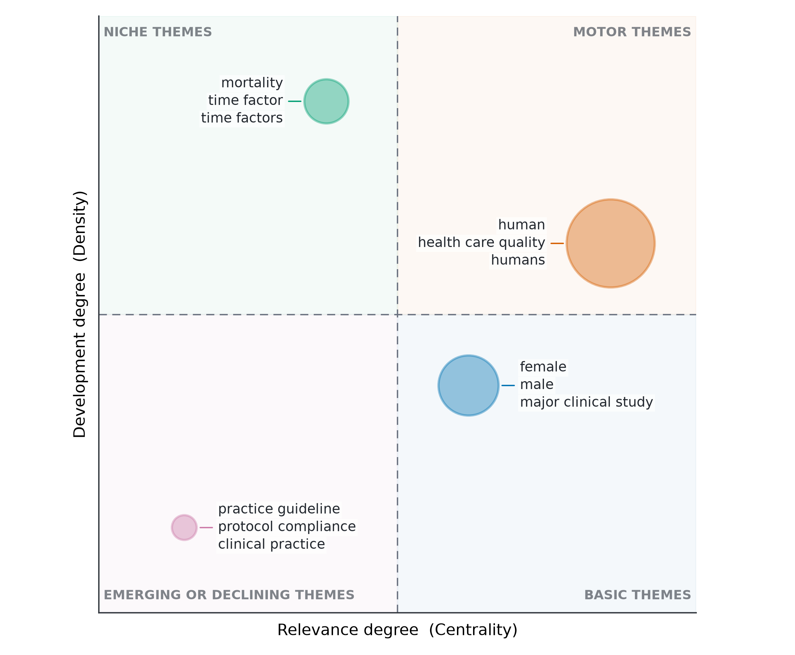
Figure 1. Thematic map (strategic diagram) of the research field, based on co-occurring Scopus Index Keywords in the 232 analysed documents. Themes (circles) are communities obtained by Louvain clustering of the association-strength keyword co-occurrence network (top 250 terms; terms with ≥ 11 occurrences retained). The horizontal axis reports centrality (relevance degree) and the vertical axis density (development degree), each expressed as centred ranks; dashed lines mark the mean of the two indices. Circle area is proportional to the total occurrences of the theme's keywords. Four themes were identified: the motor theme human–health care quality–humans, well developed and central to the field; the niche theme mortality–time factor–time factors, internally developed but peripheral; the basic theme female–male–major clinical study, transversal across studies yet conceptually undeveloped; and practice guideline–protocol compliance–clinical practice, at the emerging-or-declining margin of the field. Analysis followed Cobo et al. (2011) as implemented in the bibliometrix R package.

Methods sentence (for the Methods section)
Keyword co-occurrence networks were constructed from Scopus Index Keywords of the 232 included documents (top 250 terms; minimum term frequency 50 per thousand, i.e. ≥ 11 occurrences). Themes were detected by Louvain community detection on the association-strength network; theme centrality (sum of external link weights on the cosine-normalised co-occurrence network) and density (mean internal association strength per keyword) were computed following Cobo et al. (2011) and plotted as a strategic diagram with the thematicMap workflow of the bibliometrix R package (Aria & Cuccurullo, 2017).

