Water Can Delivery App
Full System Flow — Chennai Market
Hybrid Model: Aggregator + Direct Shop

1. System Overview
The water can delivery app connects three actors: Customers, Shops, and an Admin. Two delivery models run together:

- Model 1 — Aggregator (Rapido-style): New customers discover nearby verified shops and place orders through the app.
- Model 2 — Direct Shop: Existing shop customers order digitally instead of calling, with the same approval and delivery flow.

Both models share the same backend, order lifecycle, and payment system. The shop always controls acceptance and delivery.

2. Full App Flow — Step by Step
The table below shows the complete 12-step order journey across all three actors.

Step | Actor | Action & Detail
1 | Customer App | Login — Enter mobile number and verify with OTP. First-time users register on the same screen.
2 | Customer App | Set location — App auto-detects GPS location or customer enters address manually.
3 | Customer App | Browse nearby shops — List of verified shops shown with name, price per can, and star rating.
4 | Backend | Fetch nearby shops — Backend filters shops by customer location (2–3 km radius) and returns active shops.
5 | Customer App | Place order — Customer selects shop, enters quantity and delivery address, chooses Cash or UPI payment.
6 | Backend | Create order — Order saved to database, status set to 'Requested', push notification sent to shop.
7 | Shop App | New order alert — Shop sees customer name, address, and quantity. Must Accept or Reject within time limit.
8 | Shop App | Accept order — Status updates to 'Accepted'. Shop assigns their delivery person.
9 | Customer App | Track order — Customer sees live status: Requested → Accepted → Out for Delivery → Delivered.
10 | Shop App | Out for delivery — Shop marks order in transit. Customer receives push notification.
11 | Customer App | OTP confirmation — Customer shares a one-time code with the delivery person to confirm receipt.
12 | Backend | Complete order — Payment confirmed, invoice generated, shop earnings logged, order marked Done.
13 | Customer App | Rate the shop — Customer leaves a star rating and optional feedback after delivery.

Colour key: Blue = Customer, Green = Backend/System, Orange = Shop
App Flow Diagram
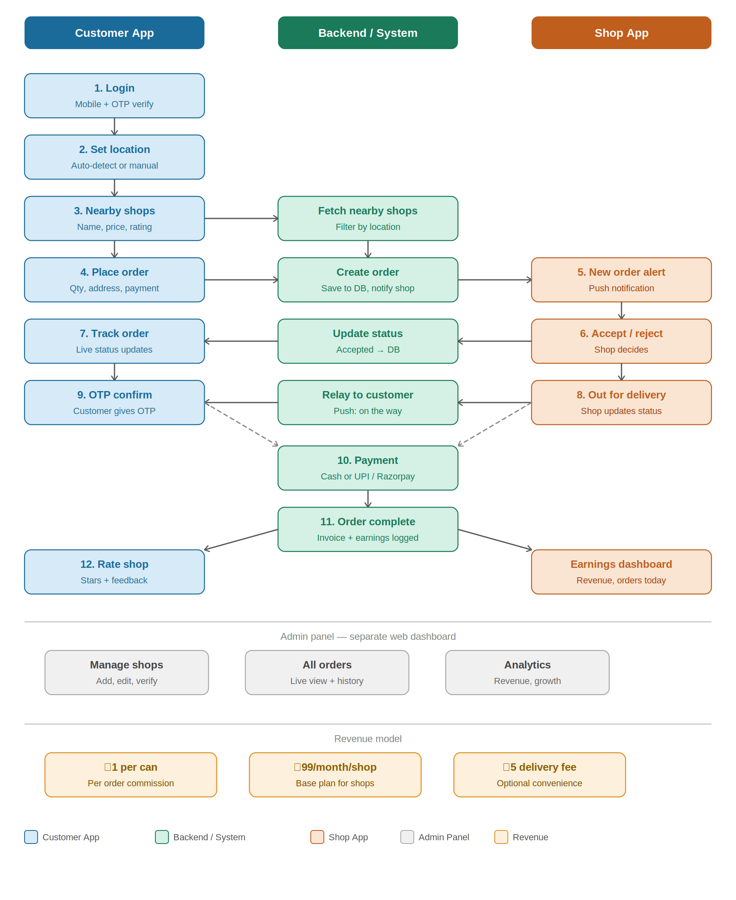

3. Admin Panel
The admin dashboard is a separate web interface for the business owner. It does not require a mobile app.

Core Admin Features
- Manage shops — Add, edit, verify, and deactivate shops. Assign the verified badge.
- View all orders — Real-time list of active orders across all shops with status and timestamps.
- Analytics dashboard — Daily orders, active users, top-performing shops, and total revenue.
- Customer management — View user accounts, order history, and block flagged accounts.

Safety Controls
- FSSAI licence verification before any shop goes live.
- Rating threshold — Shops below 3.0 stars after 50 orders are flagged for review.
- Complaint queue — Customer reports are visible in admin with one-click shop suspension.

4. Revenue Model
Three revenue streams are recommended — use all three from launch day for sustainable income.

Revenue Stream | How it works | Priority
Rs.1 per can | Per-order commission charged to the shop after delivery is confirmed. | Core
Rs.99/month per shop | Monthly base plan giving shops access to the platform and order system. | Core
Rs.5 delivery fee | Optional convenience fee charged to the customer per order. | Add-on
Subscription plan | Customer pays monthly for daily auto-delivery of 1 can per day. | Future
Office contracts | Bulk agreements with IT companies and PGs at a fixed monthly rate. | Future

Break-even Example (Month 3 target)
- 50 active shops x 100 orders/day x Rs.1 = Rs.5,000/day revenue from commission
- 50 shops x Rs.99/month = Rs.4,950/month from base plans
- Combined: ~Rs.1.55 lakh/month gross — well above Rs.30,000–60,000 operating cost

5. Safety & Trust System

Water Quality
- Only FSSAI-licensed shops onboarded — licence number visible on shop profile.
- Verified badge shown to customers on every shop card.
- Admin can suspend any shop instantly if a complaint is raised.

Delivery Safety
- OTP delivery confirmation — payment and order completion only unlock after OTP is entered.
- Delivery status tracking — customer always knows where their order is.
- Report button — single tap to flag a problem with any order.

Payment Safety
- UPI payments via Razorpay — no cash handling risk for digital orders.
- Auto-invoice generated for every completed order.
- Disputed payments flagged to admin with full order trail.

6. Launch Roadmap
Phase | Timeline | Goals
Phase 1 — Build | Week 1–2 | MVP app (customer + shop + admin). Backend API. OTP login. Basic order flow.
Phase 2 — Onboard | Week 3–4 | Visit 10–20 shops in one area (Velachery / Tambaram). Demo the shop app. First customers via apartments and WhatsApp.
Phase 3 — Validate | Month 2 | Hit 100 orders/day. Fix issues. Start charging Rs.99/month. Confirm retention.
Phase 4 — Scale | Month 3+ | Expand to 3–5 areas. Add subscription model. Approach angel investors with traction data.

7. Budget Estimate
Since you are a full-stack developer, app development cost is Rs.0. The budget below covers only operational needs.

- Domain + hosting (VPS): Rs.500 – Rs.1,500/month
- WHATSAPP SMS OTP (bulk): Rs.0 – Rs.300/month at early volume
- Shop onboarding (travel + flyers): Rs.3,000 – Rs.5,000 one-time
- Initial marketing (posters, referral offers): Rs.3,000 – Rs.5,000
- Trademark registration (brand protection): Rs.4,500 – Rs.9,000 one-time

Total MVP budget: Rs.12,000 – Rs.22,000 (developer builds app themselves)

Confidential — Water Can Delivery Startup, Chennai

Execution beats ideas. Launch fast, learn faster.

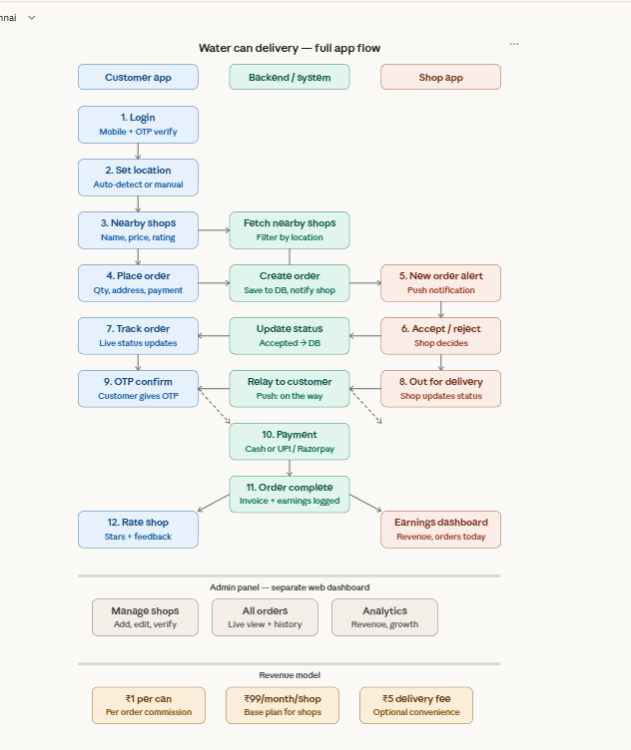

Water Can Delivery App
Next Level Upgrade & Market Strategy
Zero Cost Dev | Low Cost Ops | User-Friendly | Chennai Growth Plan

Category | Customer Side 👤 | Shop Side 🏪 | Your Strategy 🎯 | Risk if Fail ❌
Core Need | Convenience | More Orders | Balance both sides | One side fails → system breaks
Primary Goal | Easy ordering | Increase sales | Build strong network | No usage / no retention
Top Feature | One-tap reorder | 3-button system | Keep app simple | Complex app → drop
Ordering Method | App + WhatsApp | App notification | Add WhatsApp bot | App install barrier
Speed Expectation | Fast delivery | Quick order handling | Optimize flow | Delay → user leaves
Reliability | Same shop, no cancel | Valid orders only | Smart matching | Order rejection issue
Transparency | Order tracking | Clear earnings | Status + reports | Trust breaks
Payment | Easy (UPI/Cash) | Guaranteed payment | Secure system | Payment disputes
Repeat System | Subscription | Scheduled orders | Auto-delivery | No repeat users
Retention Tool | Loyalty points | Daily summary | Engagement system | Low retention
User Experience | 3 taps order | 3 actions only | Ultra simple UI | Confusion → churn
Trust Factor | Verified shops | Platform credibility | Ratings + checks | No trust → no growth
Biggest Fear | Late delivery | Fake orders | OTP + control | Drop-off both sides
Daily Value | Save time | More income | Win-win model | No value → exit
Revenue Source | Small fee | Commission + plan | Multi revenue streams | Low profit
Growth Driver | Referrals | More customers | Local expansion | Slow growth
Scalability | Area expansion | More shops onboard | City scaling | Operational chaos
Market Advantage | No calling needed | Digital upgrade | First mover | Competitor entry
Stickiness | Subscription | Daily demand | Lock-in system | One-time usage
Deal Breaker | Bad service | No benefit | Maintain quality | Immediate drop
Success Formula | Easy + Fast + Trust | Orders + Simple + Money | Strong bridge | System collapse

1. Your Cost Advantage (You Are Already Winning)
Since you are a full-stack developer, your startup cost structure is far better than 99% of competitors. Here is your real cost breakdown:

Cost Item | Your Cost | How / Free Alternative
App development (Customer + Shop + Admin) | Rs.0 | You build it — full-stack skill saves Rs.1–3 lakh
Backend / API server | Rs.0 | Railway.app or Render.com — free tier for MVP
Database (MySQL / PostgreSQL) | Rs.0 | PlanetScale free tier or Supabase free plan
WhatsApp OTP SMS (login verification) | Rs.500/mo | Twilio free trial (100 OTPs), then bulk Rs.0.20/SMS
Push notifications | Rs.0 | Firebase Cloud Messaging (FCM) — 100% free
Payment gateway (UPI / cash) | Rs.0 setup | Razorpay — 2% only on digital transactions
Domain name | Rs.700/yr | .in domain — cheapest and local trust
WhatsApp Business API | Rs.0 | Meta free tier: 1,000 conversations/month free
Marketing (initial) | Rs.0 | WhatsApp groups, apartment visits, referrals
Shop onboarding | Rs.3,000 | Travel + demo + simple printed flyer only
Trademark (brand protection) | Rs.4,500 | One-time — do this after first revenue

Total Month 1 real cash needed: Rs.4,200 only
Everything else is Rs.0 because you are the developer. This is your biggest competitive advantage.

2. User-Friendly Upgrades — Customer Side
These features make customers love the app and keep ordering again and again. All are low-effort to build since you are the developer.

2A. One-Tap Reorder
After first order, show a big button: "Order same as last time — Confirm?"
- No need to browse shops again
- No need to re-enter address
- Tap once → order placed in 3 seconds
Why it works: Most water can customers order from the same shop every week. This removes all friction.

2B. Scheduled / Subscription Delivery
Let customer set a recurring schedule: "Deliver every Monday and Thursday at 9 AM"
- Auto-order created by system — no customer action needed
- Shop gets auto-notification on delivery day
- Customer can pause or cancel anytime
Revenue impact: Rs.299/month subscription per customer = very predictable income.

2C. WhatsApp Ordering (Zero App Download)
Build a WhatsApp bot using Meta Business API (free tier available). Customer sends "1 can" on WhatsApp and the order is placed automatically.
- No app install needed — works on any phone
- Best for older customers and non-smartphone users
- Connects to same backend — same order flow
This removes the biggest barrier: convincing people to download a new app.

2D. Order Tracking Screen
Simple live status screen showing the current step with icons and estimated time:
- Order placed — waiting for shop
- Shop accepted — preparing delivery
- Out for delivery — arriving in ~20 mins
- Delivered — rate your experience
Even a simple static status update (no GPS needed) builds huge trust with customers.

2E. Loyalty Points System
Every 10 orders = 1 free can. Points shown on home screen.
- Costs you nothing — shop gives the free can (you negotiate this with shops)
- Keeps customer coming back instead of calling shop directly
- Simple integer counter in DB — very easy to build

3. User-Friendly Upgrades — Shop Side
Shops must find the app easier than their current WhatsApp/phone system. Keep it brutally simple.

3A. 3-Button Shop App
The entire shop interface should have only 3 primary actions:
ACCEPT ORDER REJECT ORDER MARK DELIVERED
No complicated dashboard for the shop owner. Just these 3 actions — everything else is automatic.

3B. Daily WhatsApp Summary to Shop
Every evening at 7 PM, auto-send a WhatsApp message to each shop:
"Today's summary: 45 orders received. 42 delivered. 3 cancelled. Platform earnings: Rs.45. Have a great evening!"
- Cost: Rs.0 (Meta free tier covers this easily at early stage)
- Makes shops feel valued and informed — increases retention
- No shop needs to open any dashboard for daily report

3C. Advance Order Scheduling for Shops
Shops can see tomorrow's scheduled orders today so they can prepare stock in advance.
- Reduces out-of-stock situations
- Shops love predictability — makes your platform more valuable than random calls

3D. Earnings Withdrawal (Simple)
Monthly statement auto-generated. Shop owner requests withdrawal via app — money transferred to their bank via Razorpay payout (Rs.0 setup, small per-payout fee).
- Transparent and automatic — builds trust with shops
- No manual calculation needed on either side

4. Next Level Market Strategy — Chennai
These moves will take your app from a local tool to a serious business. Prioritised by effort vs impact.

Strategy | Who Benefits | Build Effort | Revenue Impact
WhatsApp bot for ordering | Customer | Low | High
Subscription / auto-delivery | Customer | Low | High
One-tap reorder | Customer | Low | High
Loyalty points (10 orders = 1 free) | Customer | Low | Medium
Daily WhatsApp summary to shops | Shop | Low | High
3-button simple shop interface | Shop | Low | High
Apartment building partnerships | Both | Low | High
IT office / PG bulk contracts | Both | Medium | High
Premium water (RO/Alkaline) listing | Both | Medium | High
Multi-area expansion (city-wide) | Both | Medium | High
Referral system (give 1 free can) | Customer | Low | Medium
Festival special offers | Customer | Low | Medium

5. Zero Cost Marketing Plan
You do not need to spend money on marketing at the MVP stage. Here is a proven free plan for Chennai:

Week 1–2: Ground Marketing (Rs.0)
- Visit 5 apartments near your first shop area (Velachery / Tambaram)
- Talk to apartment secretary or WhatsApp group admin
- Ask permission to post in their WhatsApp group
- Message: "New app for water can delivery — faster than calling the shop. First order free."
- Get 20 customers — this proves your idea works

Week 3–4: Digital Spread (Rs.0)
- Post in Chennai Facebook groups: Chennai Apartments, PG Owners, IT Employees
- Create a simple Google My Business profile for your app — free and shows in Google Search
- Ask your first 20 customers to share with neighbours — word of mouth is free
- Post on LinkedIn: "I built a water delivery app in Chennai" — developers and investors will notice

Month 2+: Referral Engine (Low Cost)
- Every customer who refers a friend gets 1 free can — only pay when it works
- Every shop that refers another shop gets 1 free month — only pay in free access, not cash
- This grows your network automatically without any ad spend

Partnership Targets in Chennai (High Value, Rs.0 Cost)
- PG (Paying Guest) owners — they buy 5–20 cans per week. One PG = 20 customers.
- IT company cafeteria managers — bulk contracts, predictable daily orders
- Apartment management committees — post inside lifts and notice boards for free
- Gyms and yoga studios — they use water cans and love subscription services

6. Upgraded Revenue Model
Add these revenue streams as you grow — in this exact order:

Revenue Stream | When to Add | Detail
Rs.1 per can commission | Now | Charge shops Rs.1 for every can delivered via your platform. Start from day 1.
Rs.99/month shop plan | Month 1 | Monthly access fee per shop. After 1 free month trial, all shops pay this.
Rs.5 convenience fee | Month 2 | Optional delivery fee from customer. Add only after they trust the app.
Subscription plan (Rs.299/mo) | Month 2 | Customer pays monthly for auto-daily delivery. Recurring income — very powerful.
Premium water listing | Month 3 | Shops selling RO / Alkaline / Mineral water pay higher listing fee (Rs.199/mo).
Office / PG bulk contract | Month 3 | Fixed monthly deal with offices. Example: 50 cans/month at Rs.30/can = Rs.1,500/contract.
Featured shop placement | Month 4 | Shops pay Rs.299/month to appear at top of search results in customer app.
Multi-city licensing | Year 2 | License your platform to operators in Coimbatore, Madurai, Hyderabad.

7. Your 30-Day Action Plan
This is the exact sequence to follow. Do not skip steps.

Days 1–7: Build & Setup
- Set up Railway.app free hosting — deploy backend
- Set up Supabase free DB — connect to backend
- Register Firebase — enable push notifications (free)
- Create Razorpay account — enable UPI payments
- Build customer app — OTP login, shop list, order flow
- Build shop app — alert, accept, mark delivered
- Buy domain (Rs.700) — set up basic landing page

Days 8–14: Onboard Shops
- Pick one area: Velachery OR Tambaram only
- Visit 10 water shops physically — bring a printed demo on your phone
- Offer: Free for 2 months, no commission, no monthly fee
- Get 8–10 shops confirmed and added to the system
- Test 5–10 real orders with friends and family first

Days 15–21: First Customers
- Visit 3–5 apartment complexes near your shops
- Post in their WhatsApp groups with a clear message + app link
- Offer first order free — absorb this cost yourself (Rs.35–40 max)
- Target: 50 registered customers by end of week 3

Days 22–30: Validate & Improve
- Track daily orders — target 30–50 orders/day by day 30
- Call every customer personally — ask what they want improved
- Fix top 3 complaints immediately
- Start collecting shop feedback — what is hard for them?
- If orders growing: you have product-market fit — scale next month

8. Final Summary — Your Winning Formula

Your Strengths  - Full-stack developer — Rs.0 dev cost  - Idea is real and needed in Chennai  - No strong direct competitor exists  - Daily product — repeat customers guaranteed  - Free tools cover 90% of your tech stack | Your 3 Key Focuses  - Onboard shops first — supply before demand  - Keep app brutally simple — 3 taps to order  - Launch in 1 area, prove it, then scale

Your code is free. Your idea is proven. Your only job now is execution.
Confidential — Water Can Delivery Startup, Chennai

