

# Big Data CoE Demo Portal

# Main Contacts Document Information

## Document Revision History

|  |  |  |  |
| --- | --- | --- | --- |
| Version | Date | Author | Comments |
| 1 | July 31, 2015 | Tardy Paul |  |

# Project overview

## Objectives

The objective of this project is to create a “Demo Portal” for Big Data CoE which must displays every available demos, with its links.

## Infrastructure

Web server:

* Dev: <http://10.3.220.52/dev/demoportal/>
* Tableau Serv: <http://10.3.220.50/demoportal/>
* Tableau Serv (2) : <http://10.3.220.51/demoportal/>

## Tech

* Only HTML5 + CSS3 for the page itself
* A Python 3 script can be used to generate the HTML page from an MS-DOS formatted CSV. (see section “Generating Page”).

# File Structure

Demoportal uses relative URL so that it’s ready to duplicate on any webserver as long as file structure remain the same.

* ./css : contains stylesheet files.
* ./fonts : contains fonts.
* ./images : contains HP logo for favicons / navbar
* ./img : contains demos screenshot. N.B: File name specified in the Excel Table automatically refers to that folder.
* ./gen isn’t used by the page itself, it contains demo items file as .XLSX and .CSV and the Python3 script to generate HTML from CSV. The result of this script will be in index.html of the folder of the script. (Bascially ./gen/index.html)

# Generating Page

1. 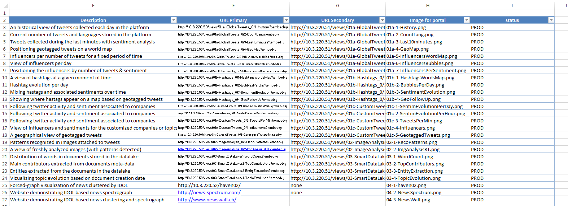Edit Demo Items information under Excel (./gen/demo-portal_items.xlsx)
2. Save (as XLSX), then save it as “MS-DOS CSV”
3. Run the script (in the gen folder, Shift+Right Click > Open Prompt > “python run.py”)
4. It’s ok if there is no error message. Still copy your old index.html as backup and replace it when you checked the generated file.