**SQL Fiddle Instructions**

**Part B1 Instructions:** Access <http://sqlfiddle.com/> and write the SQL code for the creation of all of your tables in the left pane labeled “Schema Panel.” Click on “Build Schema” to test your code and confirm the tables are built correctly without errors. Once this is completed, do a screen capture of what is showing in the SQL Fiddle environment, including the schema success message, and if all of your code is not visible in your screenshot, paste it into your project document.

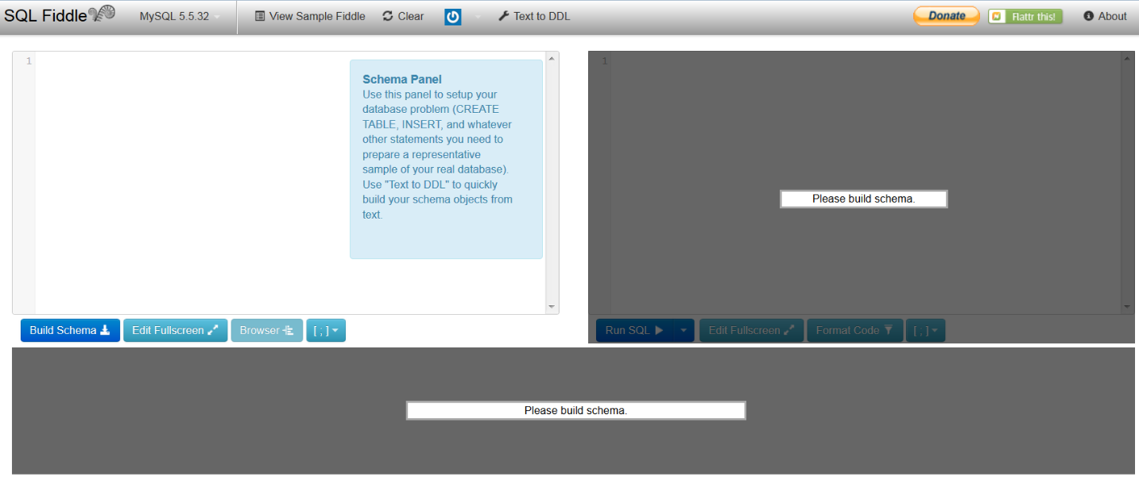

**Part B2 Instructions:** Access <http://sqlfiddle.com/> and write the SQL code for the creation of all of your tables and the insertion of all of your data into these tables in the left pane labeled “Schema Panel.” Click on “Build Schema” to test your code and confirm the tables are populated correctly without errors. Once this is completed, do a screen capture of what is showing in the SQL Fiddle environment, including the schema success message, and if all of your code is not visible in your screenshot, paste it into your project document.

**Part B3 Instructions:** Access <http://sqlfiddle.com/> and write the SQL code for the creation of all of your tables and the creation of the new view in the left pane labeled “Schema Panel.” Click on “Build Schema” to test your code and confirm the view is built correctly without errors. Once this is completed, do a screen capture of what is showing in the SQL Fiddle environment, including the schema success message, and if all of your code is not visible in your screenshot, paste it into your project document.

**Part B4 Instructions:** Access <http://sqlfiddle.com/> and write the SQL code for the creation of all of your tables and the creation of the new index in the left pane labeled “Schema Panel.” Click on “Build Schema” to test your code and confirm the index is built correctly without errors. Once this is completed, do a screen capture of what is showing in the SQL Fiddle environment, including the schema success message, and if all of your code is not visible in your screenshot, paste it into your project document.

**Part B5 Instructions:** Access <http://sqlfiddle.com/> and write the SQL code for the creation of all of your tables and the insertion of all of your data into these tables in the left pane labeled “Schema Panel.” Click on “Build Schema.” Once this is completed, type in your SFW (SELECT–FROM–WHERE) query in the right panel, and click on “Run SQL” to test your query code and confirm that the queries run correctly without errors. Do a screen capture of what is showing in the SQL Fiddle environment, including the schema success message, and if all of your code is not visible in your screenshot, paste it into your project document. Next, write all of the data displayed in the tables below the two panels. Paste this in your project document if all of your code is not visible in your screenshot.

**Part B6 Instructions:** Access <http://sqlfiddle.com/> and write the SQL code for the creation of all of your tables and the insertion of all of your data into these tables in the left pane labeled “Schema Panel.” Click on “Build Schema” Once this is completed, type in your table joins query (which should join together three different tables and include attributes from all three tables in its output) in the right panel and click on “Run SQL” to test your query code and confirm that the query ran correctly without errors. Do a screen capture of what is showing in the SQL Fiddle environment, including the schema success message, and if all of your code is not visible in your screenshot, paste it into your project document. Next, write all of the data displayed in the resulting table below the two panels. Paste this in your project document if all of your code is not visible in your screenshot.