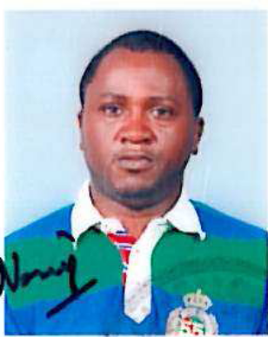

Marc Ndimukaga has eight years of working experience both in for-profit and non profit organizations. Most recently, he was awarded a Conservation leadership Program/Future Conservationist Award and Alcoa Foundation Practitioner Fellowship Award. Marc worked as a Senior Conservation Officer with the Association pour la Conservation de la Nature au Rwanda, a Birdlife International partner in Rwanda and then later with Association pour la Promotion des Etudes d’Impact Environnementaux au Rwanda (APEIER) as a consultant before joining STRAIGHTFORWARD DEVELOPMENT SERVICES LTD, a private company dedicated to providing to Rwandan people with multi services of best quality. Marc has conducted many sessions voluntarily to promote volunteerism, biodiversity conservation and sustainable development in Rwanda and brought a positive reputation of his country through poverty alleviation in Rwanda. Through these experiences, he has developed managerial and analytical skills, along with strong aptitude for planning, implementing and coordinating various projects. He has broad knowledge of community development and biodiversity conservation in Rwanda. Marc holds a Master’s (Agri.) in Apiculture from the University of Agricultural Sciences, Bangalore, India and a Bachelor’s degree in Zoology from the National University of Rwanda. He also holds a postgraduate certificate in Beekeeping for poverty alleviation from Ghent University, Belgium.

